COEPD–Prep Exam 3–Part 1/2

18 Questions – 100 Marks–Pass 60%

Instructions to follow:
- Copy paste (image, diagram or text) is not entertained. If done, the document will not be evaluated.
- After submission of the answers of this prep exam, you should be prepared to attend viva and justify your answers in the prep exams. If in Viva, participant is NOT justifying the answers, Viva will be repeated until Candidates justify 60% correctness.
- Mentor calls are scheduled only if the participant has submitted their task at least for one time.
(Should apply their knowledge in this task first)
- For attempting prep exams participant should be thorough on the topics using their references.
- Please format the document properly (Always have a question no., question and answer).
- Have a consistent format (Font name: Arial/Calibri-Fontsize12, Font Color: Black).
- Few Questions are related to the case study; check Questions thoroughly before you answer.
- Answers should be elaborated in detail (not as per the allotted marks).
- Please focus on learning and applying the knowledge as this knowledge will be help filling contributing at your BA job.
- In the evaluation, students must answer all questions and should be able to justify at least 60% content and correctness of each answer.

Case Study 1 (Q 1-Q 6-24 Marks)
A customer can make a payment either by Card or by Wallet or by Cash or by Net banking.
Q1. Draw a Use Case Diagram - 4 Marks

Q2. Derive Boundary Classes, Controller classes, Entity Classes-4 Marks
- Boundary Class – used to handle interactions between the system and external actors
- Controller Class – act as intermediaries between boundary and entity classes.
- Entity Class – represent the core data and business logic of the application.
Q3. Place these classes on a three tier Architecture. - 4 Marks
In a Three-Tier Architecture, the system is divided into three logical layers:
- Presentation Layer (User Interface Layer) – Handles interaction between the user and the system. Boundary Classes are placed here. Example: PaymentPage, CustomerInterface

- Application Layer (Business Logic Layer) – Manages communication between the presentation and data layers and contains the core logic. Controller Classes are placed here. Example: PaymentController, TransactionManager

- Data Layer (Database Layer) – Responsible for storing and retrieving data from the database.
Entity Classes are placed here. Example: Customer, Payment, BankAccount

Q4. Explain Domain Model for Customer making payment through Net Banking-4 Marks
- A Domain Model is a conceptual representation that defines the structure, relationships, and the behavior of entities within a specific problem domain.

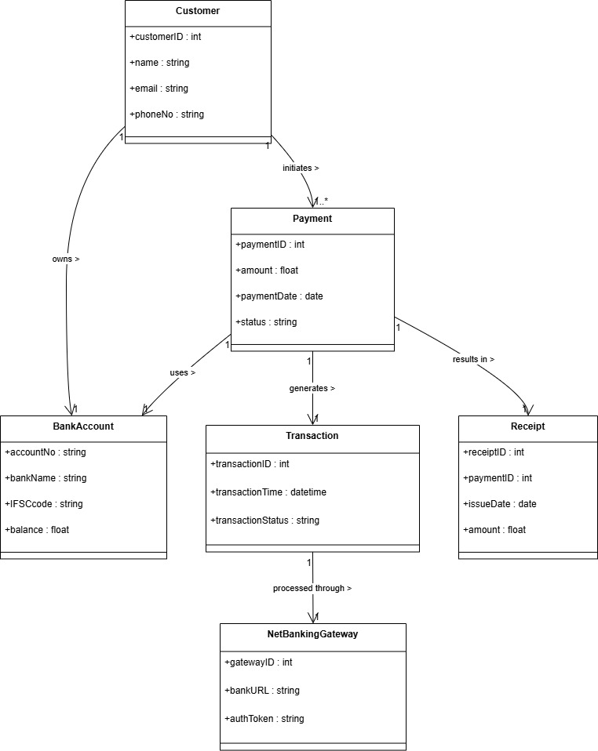

Q5. Draw a sequence diagram for payment done by Customer Net Banking - 4 Marks
- A sequence diagram is a type of interaction diagram used in software engineering and systems design to illustrate how processes operate with one another and in what order.

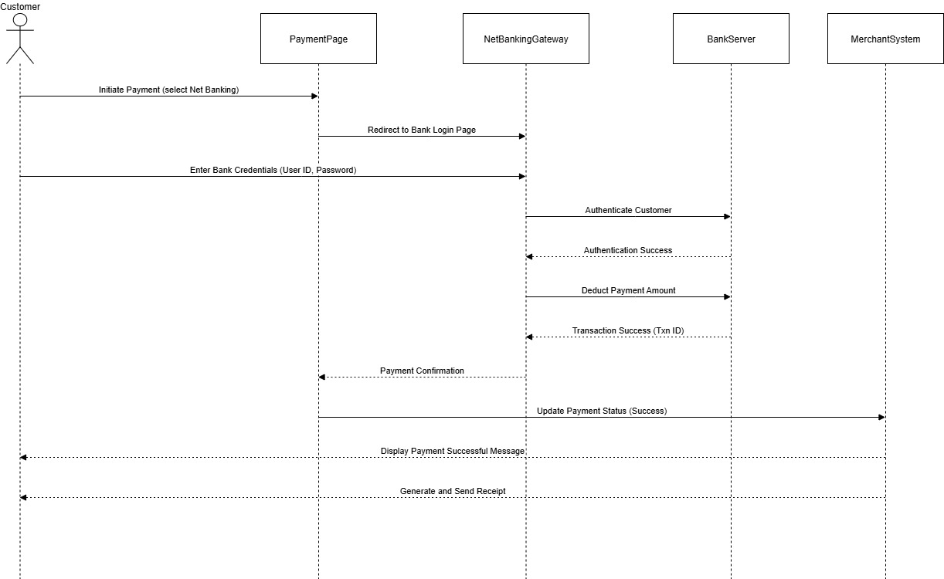

Q6.Explain Conceptual Model for this Case – 4 Marks
- A conceptual model is a high-level representation of a system that helps in understanding, visualizing, and communicating the essential aspects of a domain.
It provides s clear and simplified view of the domain, making it easier to understand.
Key Elements of a Conceptual Model:
- Entities- Customer, Product, Order & Payment
- Attributes- customerID, name, email, phoneNumber.
- Relationships – For example, a Customer places an Order.
Q7.What is MVC architecture? Explain MVC rules to derive classes’ from use case diagram and guidelines to place classes in 3-tier architecture - 8 Marks
- The Model – View Controller (MVC) framework is an architectural pattern that separates an application into three main logical components Model, View, and Controller.
View – Represents the presentation layer of the application.
Model- Represents the data and the business logic of the application.
Controller - Acts as an intermediary between Model and View.
Q8. Explain BA contributions in project (Waterfall Model–all Stages)–8Marks

Stage | Activities | Artifacts & Resources
Pre project | Identify business needs and problems.  • Conduct feasibility study and stakeholder analysis.  • Define business objectives and expected outcomes | Business Need Document (BND)  • Feasibility Report  • Stakeholder Register
Planning
  Participate in project scoping and estimation.
  • Define high-level requirements.
  • Assist in creating project plan and communication plan.
  • Project Scope Document
  • Requirements Management Plan
  • Project Charter
Project Initiation
  Conduct stakeholder meetings.
  • Finalize requirement elicitation plan.
  • Define BA roles and responsibilities.
  • Stakeholder Analysis Matrix
  • Elicitation Plan
  • Communication Plan
Requirements Gathering
  • Conduct interviews, workshops, and surveys.
  • Capture functional and non-functional requirements.
  • Manage requirement traceability.
  • Business Requirements Document (BRD)
  • Functional Requirements Specification (FRS)
  • Requirement Traceability Matrix (RTM)
Requirements Analysis and Design
  Analyze and validate requirements for feasibility.
  • Prioritize requirements and confirm with stakeholders.
  • Support creation of system design models and workflows.
  • Use Case Diagrams
  • Process Flow Diagrams
  • Data Models
Development
  Clarify requirements for developers.
  • Participate in design walkthroughs.
  • Ensure alignment between design and business needs.
  • Updated RTM
  • Change Request Document (if any)
  • Requirement Clarification Logs
Testing
  • Prepare test scenarios and validate test cases.
  • Support QA team in requirement-based testing.
  • Verify defect resolution matches business needs.
  • Test Case Document
  • Defect Logs
  • RTM (Updated)
UAT
  • Coordinate with end users for UAT sessions.
  • Validate the system against business needs.
  • Obtain final sign-off from stakeholders.
  • UAT Plan
  • UAT Test Cases & Results
  • Sign-off Document

Q9.What is conflict management? Explain using Thomas–Kilmann technique–6 Marks
- Conflict management is the process of resolving conflicts or disagreement between individuals or groups in a constructive manner.
Thomas Kilmann technique is a widely used tool for assessing conflict resolution styles & guiding individuals in selecting appropriate strategies to mange conflicts.
5 Steps of conflict managements-
- Identify the conflicts.
- Discuss the details.
- Agree with the root problem
- Check for every possible solution for the conflicts.
- Negotiate the solution to avoid future conflicts
Q10. List down the reasons for project failure – 6 Marks
- Poor Planning
- Unclear Objectives and Requirements
- Inadequate Risk Management
- Poor Communication
- Scope Creep
- Lack of Stakeholder Engagement
- Resource Constraints
- Technical Challenges

Q 11.List the Challenges faced in projects for BA– 6 Marks
- Unclear or Changing Requirements
- Managing Stakeholder Expectations
- Scope Creep and Scope Management
- Time and Resource Constraints
- Quality Assurance and Testing
- Documentation and Knowledge Management
- Technology Constraints and Complexity

Q 12.Write about Document Naming Standards–4 Marks
- A document numbering standard is a systematic approach to assigning unique identifiers to various documents created and used throughout the development process. Ex. Suppose we have a project with the ID ‘PROJ123’, and we’ are working with a Requirements Specification Document.
- Project ID: PROJ123
- Document Type: REQ
- Version: 1.0
- Date: 2024-05-26
The document identifier could be: PROJ123-REQ-1.0-2024-05-26
Q13.What are the Do’s and Don’ts of a Business analyst–6Marks

Sr. No. | DO’S | DON’T
1 | Consult an SME for clarification in requirements | Never say No to the client
2 | Go to the client with a plain mind with no assumptions. Listen carefully and completely until the clients is done, and then you can ask queries | There is no words as ‘By default’
3 | Try to extract maximum leads to the solution from the clients himself. | Never imagine anything in terms of GUI
4 | Concentrate on the important requirements. | Don’t interrupt the client when he is giving you the problem
5 | Question the existence of existence./Question everything | Never try to give solutions to the clients straight away with your previous experience and assumption

Q14. Write the difference between packages and sub-systems–4 Marks
- Packages: Collection of components which are not reusable in nature.
Ex. Application development companies work on packages.
- Sub system: Collection of components which are reusable in nature.
Ex. Product development companies work on Sub systems
Q15. What is camel-casing and explain where it will be used- 6 Marks
- Camel- casing is a naming convention used in computer programming. It is used for naming variables, functions, and identifiers
- Example: CamelCase: camelCaseExample
- In Camel casing, the first words start with a lower case letter and each subsequent word begins with an uppercase letter.
Q16. Illustrate Development server and what are the accesses does business analyst has?-6 Marks

- A development server refers to a dedicated environment or server that is used during the software development process.
- It provides a platform for developments and testers to build test and debug applications before they are deployed to a production environment.
- As a BA, we have only limited access only.

Marks
Q 17.What is Data Mapping? 6 Marks
- Data mapping is the process of connecting data from one source to another.
- It’s like creating a guide or map that shows how data in one place corresponds to data in another place.
- This is especially important when you’re moving data between different system or database to ensure that the data stays consistent and accurate.
Q 18. What is API? Explain how you would use API integration in the case of your application Date format is dd-mm-yyyy and it is accepting some data from Other Application from US who’s Date Format is mm-dd-yyyy 10 Marks
- An API or Application Programming Interface is a set of rules and tools that allows different software applications to communicate with each other.
- It defines the methods and data formats that applications can use to request and exchange information.

