CAPSTONE PROJECT 1
ONLINE AGRICUTURE PRODUCT STORE
Online Agriculture Products Store Mr. Henry, after being successful as a businessman and has become one of the wealthiest persons in the city. Now, Mr. Henry wants to help others to fulfil their dreams. One day, Mr. Henry went to meet his childhood friends Peter, Kevin and Ben. They live in a remote village and do farming. Mr. Henry asked his friends if they are facing any difficulties in their day-to-day work. Peter told Mr. Henry that he is facing difficulties in procuring fertilizers which are very important for farm. Kevin said that he is also facing the same problem in-case of buying seeds for farming certain crops. Ben raised his concern on lack of pesticides which could help in greatly reducing pests in crops. After listening to all his friends’ problems, Mr. Henry thought that this is a crucial problem faced not only by his friends but also by so many other farmers. So, Mr. Henry decided to make an online agriculture product store to facilitate remote area farmers to buy agriculture products. Through this Online Web / mobile Application, Farmers and Companies (Fertilizers, seeds and pesticides manufacturing Companies) can communicate directly with each other. The main purpose to build this online store is to facilitate farmers to buy seeds, pesticides, and fertilizers from anywhere through internet connectivity. Since new users are involved, Application should be user friendly. This new application should be able to accept the product (fertilizers, seeds, pesticides) details from the manufacturers and should be able to display them to the Farmers. Farmers will browse through these products and select the products what they need and request to buy them and deliver them to farmers location.
Mr. Henry has given this project through his Company SOONY. In SOONY Company, Mr Pandu is Financial Head and Mr Dooku is Project Coordinator. Mr. Henry , Mr Pandu , and Mr Dooku formed one Committee and gave this project to APT IT SOLUTIONS company for Budget 2 Crores INR and 18 months Duration under CSR initiative. Peter, Kevin and Ben are helping the Committee and can be considered as Stakeholders share requirements for the Project. Mr Karthik is the Delivery Head in APT IT SOLUTIONS company and he reached out to Mr Henry through his connects and Bagged this project. APT IT SOLUTIONS company have Talent pool Available for this Project. Mr Vandanam is project Manager, Ms. Juhi is Senior Java Developer, Mr Teyson, Ms Lucie, Mr Tucker, Mr Bravo are Java Developers. Network Admin is Mr Mike and DB Admin is John. Mr Jason and Ms Alekya are the Tester. And you joined this team as a BA. Your Team Project Manager - Mr Vandanam Senior Java Developer - Ms. Juhi Java Developers - Mr Teyson, Ms Lucie, Mr Tucker, Mr Bravo Network Admin - Mr Mike DB Admin - Mr John. Testers - Mr Jason and Ms Alekya BA - You Fertilizers, seeds, pesticides details from the manufacturers and should be able to display them to the Farmers. To gather the business requirements from the client, you went to SOONY and met Mr. Henry. When Mr. Henry was asked about the project and what are they expecting from the project, Mr. Henry stated that he is expecting to have a login for all its users (fertilizers, seeds, pesticides manufacturers and Farmers) , a product catalog of fertilizers, seeds, pesticides, a search option to search for products, payment process, and delivery tracking. After doing the stakeholder analysis, you have found out that Peter, Kevin, Ben are the key stakeholders and you have scheduled an appointment to meet them. After meeting with them and trying to gather the stakeholder requirements, Kevin said that, a Farmer should be able to browse through the products catalog once they visit the website and need to have a search option so that they can search for any product they need. Peter said that, if a farmer wants to buy any product or add them to buy-later list, they need to login first using their email id and password. If it is a new user, then they can create a new account by submitting their email ID and creating a secure password. Ben added saying that, Farmers needs to have an easy-to-use payment gateway which should include cash-on-delivery (COD), Credit/Debit card and UPI options so that the user’s experience should be better. Kevin mentioned that, a user gets an email confirmation regarding their order status. A delivery tracker to track the whereabouts of their order. Identify Business Requirements (which includes Stakeholder Requirements) BR001 – Farmers should be able to search for available products in fertilizers, seeds, pesticides
BR002 – Manufacturers should be able to upload and display their products in the application Make suitable Assumptions and identify at least 10 Business Requirements. List your assumptions Give Priority 1 to 10 numbers ( 1 being low priority – 10 being high priority) to these Requirements after discussions with the stakeholders Req ID Req Name Req Description BR001 Farmer Search for Products Priority Farmers should be able to search for available products in fertilizers, seeds, pesticides 8 BR002 Manufacturers upload their Products Manufacturers should be able to upload and display their products in the application 8 Once the requirements are finalized, as a business analyst, one of the major roles is to act as a liaison between the client and the project team. To gather the requirements correctly from the client side and then to deliver those requirements to the project team in a way they understand. To make the project team understand the requirements, you need to convert those requirements into UML diagrams and screen mock-ups. You will draw use case diagram Prepare use case specs for all use cases And you will all Activity diagrams required

✅ Assumptions
- The application will be accessible via both web and mobile platforms.
- All users (farmers and manufacturers) must register/login to access full features.
- Products will be classified under three categories: fertilizers, seeds, and pesticides.
- Manufacturers can upload product details including name, price, description, image, and stock availability.
- Farmers will be able to search, view, and purchase products after logging in.
- Orders placed by farmers are tracked via an integrated delivery tracking system.
- Payment can be made through UPI, Credit/Debit Card, or Cash on Delivery.
- Email confirmations are sent to farmers upon order placement and updates.
- Admin approval is required for manufacturer onboarding and product listings.
- The system will support multi-language interface for rural accessibility.

📋 Business Requirements (including Stakeholder Requirements)
Req ID | Req Name | Req Description | Priority
BR001 | Farmer Search for Products | Farmers should be able to search for available products in fertilizers, seeds, pesticides. | 8
BR002 | Manufacturers Upload Products | Manufacturers should be able to upload and display their products in the application. | 8
BR003 | User Login & Registration | Farmers and Manufacturers must be able to register and log in securely. | 9
BR004 | Product Catalog Browsing | Farmers should be able to browse categorized products without logging in. | 7
BR005 | Add to Buy-Later List | Logged-in farmers should be able to add products to a "Buy Later" or wishlist. | 6
BR006 | Secure Payment Gateway | The application should support payments through UPI, Credit/Debit card, and COD. | 9
BR007 | Email Order Confirmation | Farmers must receive email confirmations regarding order status and tracking updates. | 8
BR008 | Delivery Tracking | Farmers should be able to track the delivery status of their orders in real-time. | 8
BR009 | Admin Approval for Products | Manufacturer product uploads must be approved by admin before becoming visible to farmers. | 7
BR010 | Manufacturer Profile Management | Manufacturers should be able to manage their profiles, including contact info, business type, and product listings. | 6
BR011 | Product Rating & Review | Farmers should be able to rate and review products after purchase.

🧾 Next Steps in BA Deliverables
As the Business Analyst, you will now:
1. Create UML Diagrams
- Use Case Diagram – Showing interactions between actors (Farmers, Manufacturers, Admin) and system functions.
- Use Case Specifications – Detailed specs for each use case, e.g., "Upload Product", "Search Product", etc.
- Activity Diagrams – Representing workflow processes like "Place Order", "Upload Product", "Track Delivery".
2. Create Screen Mockups / Wireframes
- Registration/Login screens
- Product catalog and search page
- Product detail view
- Add to cart and checkout pages
- Manufacturer dashboard for uploads
- Delivery tracking screen

Question 1: Functional Requirements

✅ Functional Requirements

Functional requirements define the specific behaviour, functions of operations of a system. They describe what the system should do, outlining the necessary tasks, actions, or activities it must perform to achieve its objective.
Non-Functional requirements will describe the qualities and attributes of the system, focusing on how the system performs rather than specific behaviours or functions.

Req ID | Req Name | Req Description
FR0001 | Farmer Registration | Farmers should be able to register with the application.
FR0002 | Farmer Search for Products | Farmers should be able to search for available products in fertilizers, seeds, and pesticides.
FR0003 | Manufacturer Registration | Manufacturers should be able to register and create their business profile.
FR0004 | Manufacturer Login | Manufacturers should be able to log in using email and password.
FR0005 | Product Upload by Manufacturer | Manufacturers should be able to upload products with name, category, image, price, and description.
FR0006 | Product Catalog View | Farmers should be able to browse all available products categorized by type.
FR0007 | Add to Buy Later List | Farmers should be able to add products to a Buy Later (wishlist) list.
FR0008 | Product Detail View | Farmers should be able to view full product details including manufacturer info and reviews.
FR0009 | Place Order | Farmers should be able to select products and place an order.
FR0010 | Payment Integration | Farmers should be able to pay using UPI, Credit/Debit Cards, or COD.
FR0011 | Email Notification for Orders | Farmers should receive email confirmation after placing an order.
FR0012 | Delivery Tracking | Farmers should be able to track the status of their order delivery.
FR0013 | Admin Approval of Products | Admin should be able to approve or reject manufacturer product uploads.
FR0014 | Admin Approval of Users | Admin should be able to approve or reject manufacturer registrations.
FR0015 | Edit/Delete Product | Manufacturers should be able to edit or delete their product listings.
FR0016 | Login Validation | The system should validate user credentials during login.
FR0017 | Product Filtering | Farmers should be able to filter products by category, price, and manufacturer.
FR0018 | Order History | Farmers should be able to view past orders and their statuses.
FR0019 | Product Rating & Review | Farmers should be able to rate and review purchased products.
FR0020 | Bulk Product Upload | Manufacturers should be able to upload multiple products using a CSV or Excel file.

Question 2: 5 Page Designs

Point | Wireframe | Prototype
What it is | A simple drawing of the screen layout. | A working model that shows how the website will actually work.
Purpose | To show where buttons, images, and text will go. | To show how users will click and move through the website.
Looks like | Black and white sketch or outline. | Looks more like the real website with colors and content.
Can click? | No, not clickable. Just for viewing. | Yes, clickable and shows how things will work.
Used by | Designers, Business Analysts, and Developers. | Clients, testers, and team members for feedback.
When used | In the early planning stage. | In the later stage before final development.
Tools | Balsamiq is used | Axure is used

Example:
- Wireframe: Shows the homepage of the agriculture store with a box for the logo, buttons like "Shop Now", and spaces for product images.
- Prototype: You can click on "Shop Now", go to the product page, add items to the cart — like a real shopping experience.

✅ 1. Home Page (Landing Page)
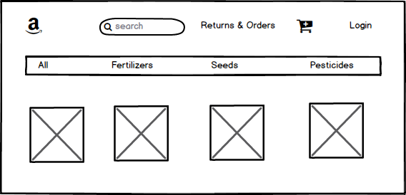

✅ 2. Farmer Registration/Login Page
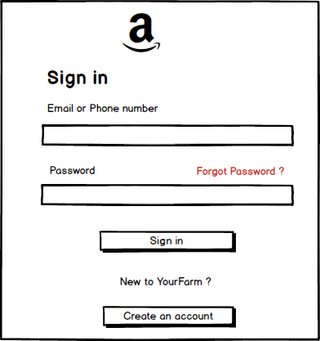

✅ 3. Product Catalog Page
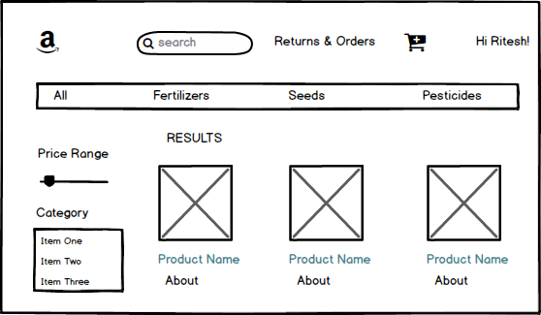

✅ 4. Product Detail Page
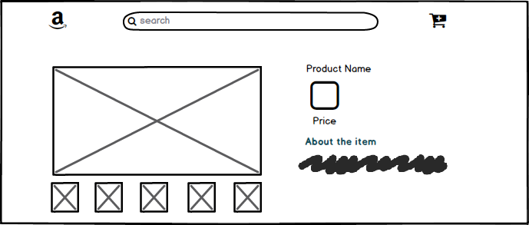

✅ 5. Checkout & Payment Page
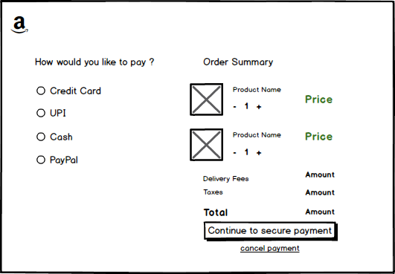

Question 3: Tools (Visio, Balsmiq)

Microsoft Visio
✅ What is Visio?
Microsoft Visio is a powerful diagramming tool used to create a wide variety of visual representations, including flowcharts, process diagrams, data flow diagrams (DFDs), organizational charts, network diagrams, UML diagrams, and more.
🔧 Uses in Business Analysis:
- Creating Use Case Diagrams
- Drawing Activity Diagrams
- Designing Data Flow Diagrams (DFD)
- Developing ER Diagrams (Entity Relationship Diagrams)
- Building Process Workflows
- Visualizing System Architecture
⭐ Features:
- Professional and clean diagramming interface
- A wide library of shapes, templates, and stencils
- Easy integration with other Microsoft tools (Excel, Word, SharePoint)
- Collaborative features with Microsoft 365
🎯 Best For:
- Formal documentation
- Presentations to stakeholders and technical teams
- Detailed system and data modeling

Balsamiq Mockups
✅ What is Balsamiq?
Balsamiq is a wireframing and prototyping tool focused on low-fidelity UI design. It helps Business Analysts and UX designers quickly sketch user interface layouts to visualize application design and structure.
🔧 Uses in Business Analysis:
- Creating wireframes for web and mobile apps
- Designing mockups for login pages, product catalogs, payment screens, etc.
- Simulating the user interface flow
- Validating UI/UX ideas early with stakeholders
⭐ Features:
- Simple drag-and-drop interface
- Hand-drawn look to focus on functionality, not design
- Reusable components (buttons, inputs, containers)
- Quick iterations and stakeholder feedback
🎯 Best For:
- Early design phases
- Requirement gathering sessions
- Quick visualization of user screens and workflows

📝 Summary Comparison:
Feature | Microsoft Visio | Balsamiq
Purpose | Diagrams & Modeling | Wireframes & UI Prototypes
Type | High-fidelity, formal | Low-fidelity, informal
Complexity | Moderate to high | Easy to use
Best Used For | Technical diagrams (UML, DFD, ER) | Mockups of user interfaces
Collaboration | Strong with Microsoft 365 | Strong via Cloud projects
Platforms | Windows (Desktop), Web (Online Plan) | Desktop & Web (Cloud)

Question 4: – RTM
To tackle Mr. Henry and Peter’s inquiry as a responsible Business Analyst, we will present them with a Requirements Traceability Matrix (RTM). This matrix helps ensure that each requirement is tracked through the design, development, testing, and UAT (User Acceptance Testing) phases—confirming that nothing is missed.
✅ Requirements Traceability Matrix (RTM)
Req ID | Req Name | Req Description | Design | T1 | T2 | T3 | T4 | UAT
FR0001 | Farmer Registration | Farmers should be able to register with the application | D1 | TC01 | TC02 |  |  | UAT01
FR0002 | Farmer Search for Products | Farmers should be able to search for available products in fertilizers, seeds, pesticides | D2 | TC03 | TC04 |  |  | UAT02
NFR0101 | Page Loading Time | Each Page should load within 2 seconds time | D3 | TC05 |  |  |  | UAT03
NFR0102 | WCAG 2.1 Compliance | The system must meet Web Content Accessibility Guidelines WCAG 2.1 | D4 | TC06 |  |  |  | UAT04

🔍 How This Tackles the Situation
- Transparency: Shows stakeholders that each requirement is being tracked and verified.
- Accountability: Helps demonstrate which requirements are in which phase.
- Progress Insight: Stakeholders (like Mr. Henry and Peter) can see what’s been covered so far and what remains.
- Change Control: Easily trace impacts if any requirements change.

Question 5: 10 Test Case Documents
- A Test Case Document is a file used by testers to check whether a software or website is working correctly or not.
It includes step-by-step instructions to test specific parts of the system, along with what to expect.
Purpose of a Test Case Document:
- To make sure all features work as expected.
- To help find and fix bugs or problems.
- To guide testers on what to test and how to test.
Test Case Document Includes:
- Test Case ID | - A unique number or name for each test (e.g., TC001).
- Test Case Name | - A short title of what is being tested.
- Description | - A brief note about what this test will check.
- Preconditions | - Things that should be ready before starting the test.
- Test Steps | - Step-by-step instructions on what to do.
- Expected Result | - What should happen after following the steps.
- Actual Result | - What really happened (filled during testing).
- Status | - Pass / Fail based on the result.
- Comments | - Notes or issues (if any).
- A test case document is a detailed outline used by the testers to ensure that a software application or system is working as expected
Test Case ID | TC001 | Test Case Name | Farmer Registration
Project ID | PRJ001 | Project Name | Online Agriculture Product Store
PM ID | PM001 | PM Name | Mr. Vandanam
Test Strategy ID | TS001 | Tester ID | TST001
Test plan ID | TP001 | Tester Name | Mr. Jason
Test schedule ID | SCH001 | Date of Test | 27-05-2025
Scenario | Register as a new farmer
Link to that page | Register.html
Input Data | Set 1 | Set 2 | Set 3
Input Data | Name
Input Data | Email ID
Input Data | Password
Expected Behaviour | Farmer account should be created successfully
Actual Behaviour | Account created successfully
Comments | None
Result (Pass/ Fail) | Pass

Test Case ID | TC002 | Test Case Name | Manufacturer Login
Project ID | PRJ002 | Project Name | Online Agriculture Product Store
PM ID | PM002 | PM Name | Mr. Vandanam
Test Strategy ID | TS002 | Tester ID | TST002
Test plan ID | TP002 | Tester Name | Mr. Jason
Test schedule ID | SCH002 | Date of Test | 27-05-2025
Scenario | Login as a manufacturer
Link to that page | Register.html
Input Data | Set 1 | Set 2 | Set 3 | Set 4 | Set 5
Input Data | Email ID
Input Data | Password
Expected Behaviour | Manufacturer should be logged in successfully
Actual Behaviour | Logged in successfully
Comments | None
Result (Pass/ Fail) | Pass

Test Case ID | TC003 | Test Case Name | Search fertilizer product
Project ID | PRJ003 | Project Name | Online Agriculture Product Store
PM ID | PM003 | PM Name | Mr. Vandanam
Test Strategy ID | TS003 | Tester ID | TST003
Test plan ID | TP003 | Tester Name | Mr. Jason
Test schedule ID | SCH003 | Date of Test | 27-05-2025
Scenario | Farmer searches for urea fertilizer
Link to that page | Register.html
Input Data | Set 1 | Set 2 | Set 3
Input Data | Keyword: Urea
Expected Behaviour | Matching Fertilizer product should appear
Actual Behaviour | Relevant fertilizer product appears
Comments | None
Result (Pass/ Fail) | Pass

Test Case ID | TC004 | Test Case Name | Add product to buy later
Project ID | PRJ004 | Project Name | Online Agriculture Product Store
PM ID | PM004 | PM Name | Mr. Vandanam
Test Strategy ID | TS004 | Tester ID | TST004
Test plan ID | TP004 | Tester Name | Mr. Jason
Test schedule ID | SCH004 | Date of Test | 27-05-2025
Scenario | Farmer adds product to Buy Later
Link to that page | Register.html
Input Data | Set 1 | Set 2 | Set 3 | Set 4 | Set 5
Input Data | Product: seeds
Expected Behaviour | Product added to Buy Later list
Actual Behaviour | Added successfully
Comments | None
Result (Pass/ Fail) | Pass

Test Case ID | TC005 | Test Case Name | Place order for Product
Project ID | PRJ005 | Project Name | Online Agriculture Product Store
PM ID | PM005 | PM Name | Mr. Vandanam
Test Strategy ID | TS005 | Tester ID | TST005
Test plan ID | TP005 | Tester Name | Mr. Jason
Test schedule ID | SCH005 | Date of Test | 27-05-2025
Scenario | Farmer places order for product
Link to that page | Register.html
Input Data | Set 1 | Set 2 | Set 3
Input Data | Product: seeds
Expected Behaviour | Order placed successfully
Actual Behaviour | order placed
Comments | None
Result (Pass/ Fail) | Pass

Test Case ID | TC006 | Test Case Name | Payment via COD
Project ID | PRJ006 | Project Name | Online Agriculture Product Store
PM ID | PM006 | PM Name | Mr. Vandanam
Test Strategy ID | TS006 | Tester ID | TST006
Test plan ID | TP006 | Tester Name | Mr. Jason
Test schedule ID | SCH005 | Date of Test | 27-05-2025
Scenario | Farmer selects COD
Link to that page | Register.html
Input Data | Set 1 | Set 2 | Set 3 | Set 4 | Set 5
Input Data | Payment: COD
Expected Behaviour | Payment method accepted
Actual Behaviour | Accepted
Comments | None
Result (Pass/ Fail) | Pass

Test Case ID | TC007 | Test Case Name | Payment via credit card
Project ID | PRJ007 | Project Name | Online Agriculture Product Store
PM ID | PM007 | PM Name | Mr. Vandanam
Test Strategy ID | TS007 | Tester ID | TST007
Test plan ID | TP007 | Tester Name | Mr. Jason
Test schedule ID | SCH007 | Date of Test | 27-05-2025
Scenario | Farmer selects credit card
Link to that page | Register.html
Input Data | Set 1 | Set 2 | Set 3
Input Data | Payment: Credit card
Expected Behaviour | Payment method accepted
Actual Behaviour | Accepted
Comments | None
Result (Pass/ Fail) | Pass

Test Case ID | TC008 | Test Case Name | Payment via UPI
Project ID | PRJ008 | Project Name | Online Agriculture Product Store
PM ID | PM008 | PM Name | Mr. Vandanam
Test Strategy ID | TS008 | Tester ID | TST008
Test plan ID | TP008 | Tester Name | Mr. Jason
Test schedule ID | SCH008 | Date of Test | 27-05-2025
Scenario | Farmer selects credit card
Link to that page | Register.html
Input Data | Set 1 | Set 2 | Set 3 | Set 4 | Set 5
Input Data | Payment: UPI
Expected Behaviour | Payment method accepted
Actual Behaviour | Accepted
Comments | None
Result (Pass/ Fail) | Pass

Test Case ID | TC009 | Test Case Name | Track Delivery
Project ID | PRJ009 | Project Name | Online Agriculture Product Store
PM ID | PM009 | PM Name | Mr. Vandanam
Test Strategy ID | TS009 | Tester ID | TST009
Test plan ID | TP009 | Tester Name | Mr. Jason
Test schedule ID | SCH009 | Date of Test | 27-05-2025
Scenario | Farmer tracks delivery status of order
Link to that page | Register.html
Input Data | Set 1 | Set 2 | Set 3
Input Data | Order ID:: 123456
Expected Behaviour | Order tracking details displayed
Actual Behaviour | Order shown "in transit"
Comments | None
Result (Pass/ Fail) | Pass

Test Case ID | TC010 | Test Case Name | Email confirmation after order
Project ID | PRJ010 | Project Name | Online Agriculture Product Store
PM ID | PM010 | PM Name | Mr. Vandanam
Test Strategy ID | TS010 | Tester ID | TST010
Test plan ID | TP010 | Tester Name | Mr. Jason
Test schedule ID | SCH010 | Date of Test | 27-05-2025
Scenario | Farmer gets an email confirming the order placement
Link to that page | Register.html
Input Data | Set 1 | Set 2 | Set 3 | Set 4 | Set 5
Input Data | Email: test@farmer.co.in
Expected Behaviour | Confirmation email sent
Actual Behaviour | Email received
Comments | None
Result (Pass/ Fail) | Pass

Question 6: Data base schema and ER Diagram

DB Schema is a blueprint that outlines the structure of database, including its tables, fields, relationships, constraints, and other characteristics.

An ER diagram is a visual representation of the relationships between entities in a database.

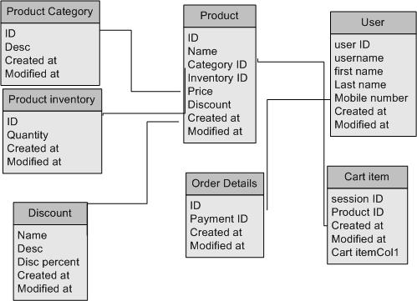

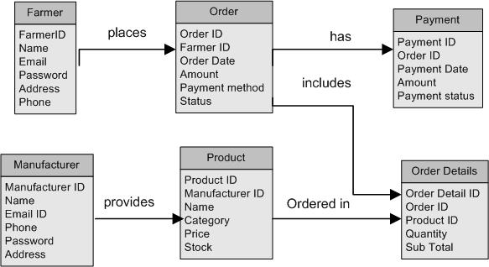

Question 7: Data Flow Diagram
✅ What is a Data Flow Diagram (DFD)?
A Data Flow Diagram (DFD) is a graphical representation used to visualize the flow of data through a system. It illustrates:
- Where data comes from (sources)
- Where it goes (destinations)
- How it is stored (data stores)
- What processes transform the data
DFDs are used in systems analysis to model functional aspects of systems. They do not show timing, control logic, or decision points, which makes them very useful for high-level overviews.

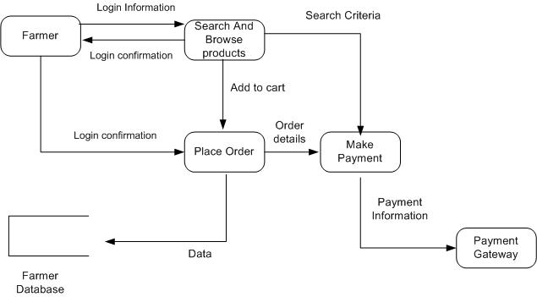

Question 8: Change Request

Handling change requests—like the update in government taxation structure—requires a structured and traceable approach to ensure project quality and stakeholder alignment

✅ Steps to Handle Change Requests in a Project:
1. Receive and Log the Request
- Document the change request (e.g., "Change in tax structure due to government policy").
- Log it in a Change Request Register or Change Control Log with a unique ID, date, requester name, and description.
2. Analyze the Impact
- Business Impact: How it affects product pricing, invoices, checkout totals, customer views.
- Technical Impact: Does it affect backend calculation logic, database tax tables, API calls, etc.?
- Timeline & Cost Impact: Will the change delay delivery? Require re-testing or additional development?
3. Discuss with Stakeholders
- Present the impact analysis to Mr. Henry, the Project Manager, and the Development Team.
- Seek inputs from the Finance team to validate the new tax rules.
4. Get Approval
- Conduct a Change Control Board (CCB) meeting or seek documented approval from key decision-makers.
- Update the scope document and project plan if the change is approved.
5. Update Requirements and Documentation
- Modify BRD (Business Requirements Document) and SRS (Software Requirement Specification) accordingly.
- Update test cases to reflect tax changes.
6. Communicate the Change
- Inform Developers, Testers, and the UAT Team about the update.
- Use tools like JIRA or Confluence to track updates and assign tasks.
7. Implement and Validate
- Developers implement the change.
- QA team executes regression testing and new test cases.
- UAT is conducted to ensure business compliance.
8. Closure and Record
- Update the Change Log with status: Completed/Implemented.
- Document the final outcome and lessons learned.

Question 9: Change Request V/S an Enhancement
Classification: This is an Enhancement.
✅ Reason:
- The original scope of the project focused on an online agriculture product store, where farmers could buy products (e.g., seeds, fertilizers, tools).
- Now, you are expanding the business functionality to allow:
  - Selling crops by farmers (peer-to-public selling)
  - Introducing auction capabilities (dynamic pricing based on demand)
These additions significantly extend the original system’s features and involve new business workflows, interfaces, and modules, which is characteristic of an enhancement rather than a correction or small change.

🛠️ Next Steps as a BA:
- Document the Enhancement Request
  - Title: Enable Farmer-to-Customer Crop Selling and Auction Feature
  - Stakeholders: Ben, Kevin
  - Description, Objectives, Priority, and Justification
- Gather Detailed Requirements
  - Product listing details
  - Image uploads, quantity, price, crop category
  - Auction start/end time, minimum bid, bidding logic, etc.
- Perform Feasibility & Impact Analysis
  - Technical feasibility with the current system
  - Database and architecture changes
  - Timeline and cost implications
- Update Project Documents
  - BRD, Use Cases, Process Flows
  - Wireframes or mockups for farmer product listing and auction page
- Review with PM and Development Team
  - Seek input for development & testing estimates
  - Confirm scope adjustment or phase-based implementation

Question 10: Man Hours
Man hours are the required effort of the resources to complete a project.
There are 3 types of project:
- Small: Upto 500 manhours
- Medium: upto 1000 manhours
- Large: upto 1500 manhours
As per the case stud, the duration is 18 Months and the current size is around 15. This will come under large project
Phase | Estimated Hours | Description
1. Requirements Gathering & Analysis | 80 hrs | Stakeholder meetings, documentation, RTM
2. UI/UX Design & Wireframes | 100 hrs | 5–6 page wireframes & screen designs
3. Database Design (ERD + Schema) | 100 hrs | Schema, ERD, normalization
4. Frontend Development | 300 hrs | Farmer & Manufacturer interfaces
5. Backend/API Development | 250 hrs | Logic, product upload, order, payment
6. Testing (Functional, UAT) | 200 hrs | 10 test cases, bug fixing, UAT
7. Deployment & Training | 70 hrs | Hosting, user documentation/training
8. Project Management & Buffer | 100 hrs | Coordination, review, buffer time

Total :: 1200 manhours

Question 11: UAT and project closure

It is the final phase of the software testing process, where the end users or clients test the system to verify if it works as intended and meets their business requirements.

- Planning: In this step, blue prints are made to implement UAT testing for every feature that needs to test and minimum standards for accepting the test
- Designing: Here the test cases are designed to hide all the possibilities of software packages in a real world environment.
- UAT Testers: A testing team consists of end user that meet the criteria for implementing testing. They should know the test cases to run and understand the functionalities
- Bug Fixing: Whatever bugs are found in the UAT testing, the development team should work on them and make the software error free
- Sign Off: After removing the bugs, the testing team indicates acceptance of the completion of the bugs. In this phase, all the stakeholders come to a conclusion that the software is ready to GO LIVE and sign it off.

Question 12: Project Closure Document

A Project Closure Document (also known as a Project Closure Report or Project Completion Report) is a formal document prepared at the end of a project to confirm that all project activities have been completed, deliverables have been handed over, and stakeholders have accepted the final product or service. It signifies the official closure of the project.

📘 Purpose of the Project Closure Document
- To confirm that the project has met its objectives
- To obtain formal sign-off from the client and stakeholders
- To summarize the project performance (scope, time, cost)
- To document lessons learned
- To release resources (people, budget, tools)
- To officially close contracts, accounts, and documentation

📄 Typical Contents of a Project Closure Document
Section | Description
1. Project Overview | Brief description of the project, goals, stakeholders, and sponsors
2. Objectives vs. Outcomes | A comparison of what was planned and what was actually delivered
3. Deliverables Summary | List of all deliverables completed and handed over
4. Final Budget and Timeline Summary | Planned vs. actual cost and schedule
5. UAT Status | Confirmation that User Acceptance Testing was completed and approved
6. Outstanding Issues | Any pending items, known issues, or future enhancements requested
7. Lessons Learned | Key takeaways from the project execution – what worked well and what didn’t
8. Resource Release Statement | Official release of the project team and reallocation
9. Client Sign-Off | Client’s formal acknowledgment that the project is completed and accepted
10. Appendices | Supporting documents (UAT report, final test results, deployment checklist, etc.)

✅ Benefits of Having a Project Closure Document
- Provides accountability and transparency
- Formal closure prevents scope creep after delivery
- Helps in future project planning by documenting lessons learned
- Assures all parties that contractual obligations are fulfilled

📌 When to Prepare It:
- After successful completion of User Acceptance Testing (UAT)
- When all deliverables have been formally accepted by the client

