Mock - 4
A company is having manufacturing plants and warehouses in various parts of the country. They manufacture ice-cream and milk products. They want to build software to achieve two goals.
- Manage the inventory
- Quickest delivery to the customers
Assignment 1:
1. Please make a BRD which can be presented to the client along with complete development and resource plan.
Answer - Business Requirement Document (BRD)
Project Title: Inventory and Delivery Management System
Client: ABC Ice Cream & Dairy Products Pvt. Ltd.
Prepared By: Anirudh Gottipamula – Business Analyst
Date: 06-11-2025
1. Project Overview
ABC Ice Cream & Dairy Products Pvt. Ltd. operates multiple manufacturing plants and warehouses nationwide.
Currently, the company faces challenges in managing inventory manually, leading to delays in dispatch and wastage of perishable goods.
The goal is to design a centralized digital system for efficient inventory management and quick delivery to customers.
2. Business Objectives
- To implement an automated inventory tracking system across all locations.
- To enable real-time visibility of stock, orders, and deliveries.
- To optimize delivery routes for faster dispatch.
- To minimize product wastage and improve customer satisfaction.
- To generate data-driven insights for management decisions.
3. Scope
In-Scope:
- Inventory tracking and synchronization
- Warehouse management
- Order and delivery management
- Reporting and analytics
Out-of-Scope:
- Payment gateway integration
- Third-party logistics automation (Phase 2)

4. AS-IS and TO-BE Process Summary
Process Area | AS-IS (Current System) | TO-BE (Proposed System)
Inventory Management | Manual entry using spreadsheets and calls | Automated real-time stock tracking across plants and warehouses
Order Processing | Orders handled through phone or paper | Orders processed digitally through a centralized system
Delivery Management | Routes decided manually by staff | AI-assisted delivery route optimization
Data Reporting | Generated manually at day-end | Real-time dashboards and instant reporting
Communication | Through calls and emails | Integrated notification and alert system
Decision Making | Based on manual data and experience | Based on real-time analytics and forecasting

5. Functional Requirements
- Inventory tracking module with real-time updates.
- Order management for distributors and customers.
- Smart delivery module with route optimization.
- Reports and analytics dashboards.
- Role-based user access control.

6. Non-Functional Requirements
- Availability: 99.5% uptime.
- Security: Data encryption and authentication.
- Performance: Must handle large transactions efficiently.
- Scalability: Support addition of new warehouses and users.

7. Development and Resource Plan
Phase | Activities | Duration | Resources Required
Requirement Gathering | Identify business and system needs | 1 week | BA, PM, Client
Design | UI design and database architecture | 2 weeks | Architect, Designer
Development | Build and integrate all modules | 4 weeks | 2 Developers, QA
Testing | Unit, integration, and UAT | 2 weeks | QA, BA
Deployment & Training | Go-live and client training | 1 week | BA, Developer, Client

Total Duration: 10 weeks
8. RACI Matrix
Activity / Phase | Responsible (R) | Accountable (A) | Consulted (C) | Informed (I)
Requirement Gathering | Business Analyst | Project Manager | Client | Developers
System Design | System Architect | Project Manager | BA | Client
Development | Developers | Technical Lead | BA | PM
Testing | QA Team | QA Lead | Developer | PM
Deployment | Developer, BA | Project Manager | Client | All Stakeholders
Training | Business Analyst | Project Manager | Client | Support Team

9. Expected Benefits
- Automated, error-free inventory management.
- Faster and optimized delivery process.
- Reduced wastage and operational costs.
- Improved coordination between plants and warehouses.
- Enhanced customer satisfaction and transparency.

10. Risks and Mitigation
Risk | Impact | Mitigation Plan
Data entry errors | High | Validation rules and staff training
Resistance to new system | Medium | Conduct awareness sessions and user training
Technical issues | Medium | Implement backup servers and maintenance plan

11. Conclusion
The TO-BE Inventory and Delivery Management System will replace manual operations with an automated, integrated, and data-driven process.
This transformation will help the company achieve faster deliveries, improved stock management, and increased operational efficiency.
2. Prepare process flow diagram using your imagination.
Answer - 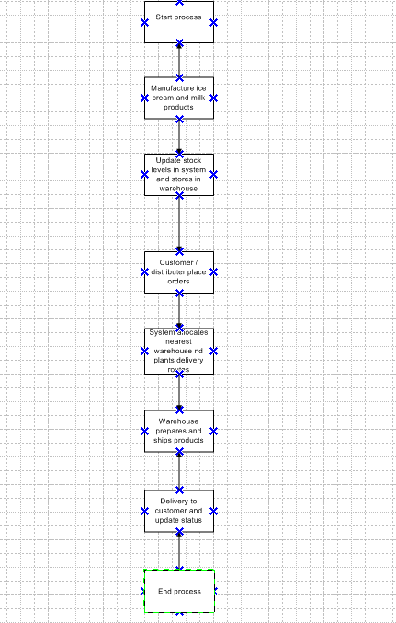
Assignment 2:
1. Write an introduction letter to a client introducing yourself as a business analyst in charge of working with the client and his team to start the business understanding process.
Answer - Introduction Letter to Client
To,
The Client,
ABC Ice Cream & Dairy Products Pvt. Ltd.
Subject: Introduction as Business Analyst for Inventory & Delivery Management System Project
Dear Client,
I hope this message finds you well.
My name is Anirudh Gottipamula, and I have been assigned as the Business Analyst for your Inventory and Delivery Management System Project. I will be working closely with you and your team to understand your current business processes, identify key challenges, and gather detailed requirements for the proposed system.
Our main objective will be to design a solution that efficiently manages your inventory, optimizes delivery operations, and improves overall visibility across manufacturing plants and warehouses. Throughout this process, I will act as the communication bridge between your business team and our development team to ensure that the final system aligns perfectly with your goals.
I look forward to collaborating with you to successfully initiate the Business Understanding Phase and move towards a smooth project execution.
Thank you for your time and cooperation.
Best regards,
Anirudh Gottipamula
Business Analyst
Email: gottipamulaanirudh@gmail.com
Contact: 8019181932
2. Prepare a brief BRD and SRS for a project- Horoscope or Ticketing system or online store.
Answer - Business Requirement Document (BRD)
Project Title: Online Store Management System
Prepared By: Anirudh – Business Analyst
Date: 06-11-2025
1. Project Overview
The purpose of this project is to design and develop an Online Store System that allows customers to browse, select, and purchase products digitally.
The system will handle product management, customer orders, payments, and delivery tracking in a seamless and secure manner.
2. Business Objectives
- To provide a user-friendly online platform for customers to purchase products.
- To manage product listings, pricing, and stock availability efficiently.
- To automate the order-to-delivery process.
- To track sales performance and customer data for business insights.
3. Scope
In-Scope:
- User registration and login.
- Product catalog and search filters.
- Online cart and checkout system.
- Payment gateway integration.
- Admin dashboard for managing products and orders.
Out-of-Scope:
- Third-party logistics tracking integration.
- Voice ordering and chatbot features.
4. Key Stakeholders
Column1 | Column2
Role | Responsibility
Client | Owner of the online business
Business Analyst | Requirement gathering and documentation
Developer | System design and coding
Tester | System validation and QA
Customer | End-user who places orders

5.Business Requirements (Summary)
Column1 | Column2 | Column3
ID | Requirement | Description
BR1 | User Account Management | Allow customers to register, log in, and manage profiles
BR2 | Product Management | Admin can add, edit, and delete products
BR3 | Shopping Cart | Customers can add/remove products before purchase
BR4 | Payment Processing | Enable secure payment through multiple methods
BR5 | Order Tracking | Allow users to view order history and delivery status

6. Expected Benefits
- Increased sales through online visibility.
- Reduced manual order handling.
- Enhanced customer satisfaction with faster service.
- Centralized data for better decision-making.

Software Requirement Specification (SRS)
Project Title: Online Store Management System
1. Introduction
The Online Store Management System provides an e-commerce platform for customers to browse and purchase products, and for administrators to manage the backend operations efficiently.
2. Functional Requirements
Column1 | Column2 | Column3
ID | Functionality | Description
FR1 | User Registration/Login | Users can create accounts and log in securely
FR2 | Product Listing | Display products with details like name, price, and stock
FR3 | Search and Filter | Search by category, price range, or keyword
FR4 | Shopping Cart | Add, remove, or update items in the cart
FR5 | Payment Gateway | Secure online payments through debit/credit cards or UPI
FR6 | Order Management | Admin can view, update, and process customer orders
FR7 | Reports | Admin can generate sales and product reports

3. Non-Functional Requirements
- Performance: The system should handle 1000+ concurrent users.
- Security: User data must be encrypted and payment secured via SSL.
- Usability: Simple and responsive UI for both desktop and mobile users.
- Scalability: System should allow future expansion (new categories, users).

4. Technology Stack
- Frontend: HTML, CSS, JavaScript (React)
- Backend: Node.js / Python
- Database: MySQL / MongoDB
- Hosting: Cloud-based (AWS / Azure)
5. System Users
- Admin: Manages product catalog, stock, and orders.
- Customer: Browses and purchases products.
6. Expected Output
- Functional e-commerce website.
- Admin dashboard for product and order management.
- Order confirmation and customer notification system.
7. Conclusion
The Online Store Management System will provide a complete digital shopping experience, improving business efficiency, sales, and customer satisfaction while offering a scalable and secure online platform.

3. Make an ERD of creating a support ticket/Ticketing life cycle.

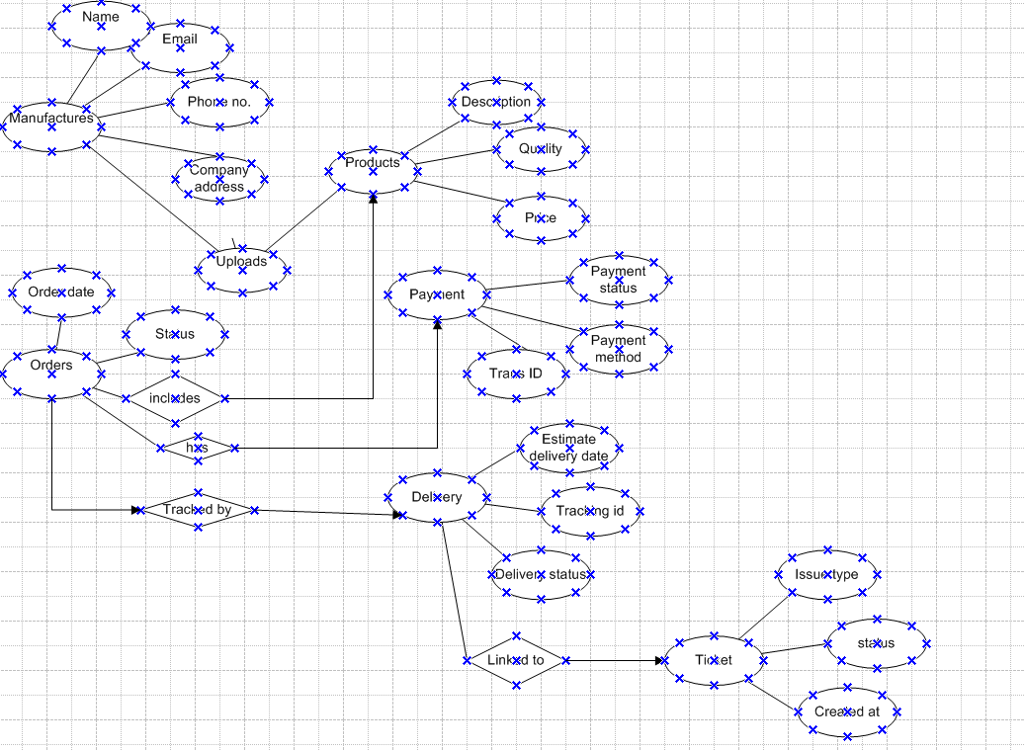

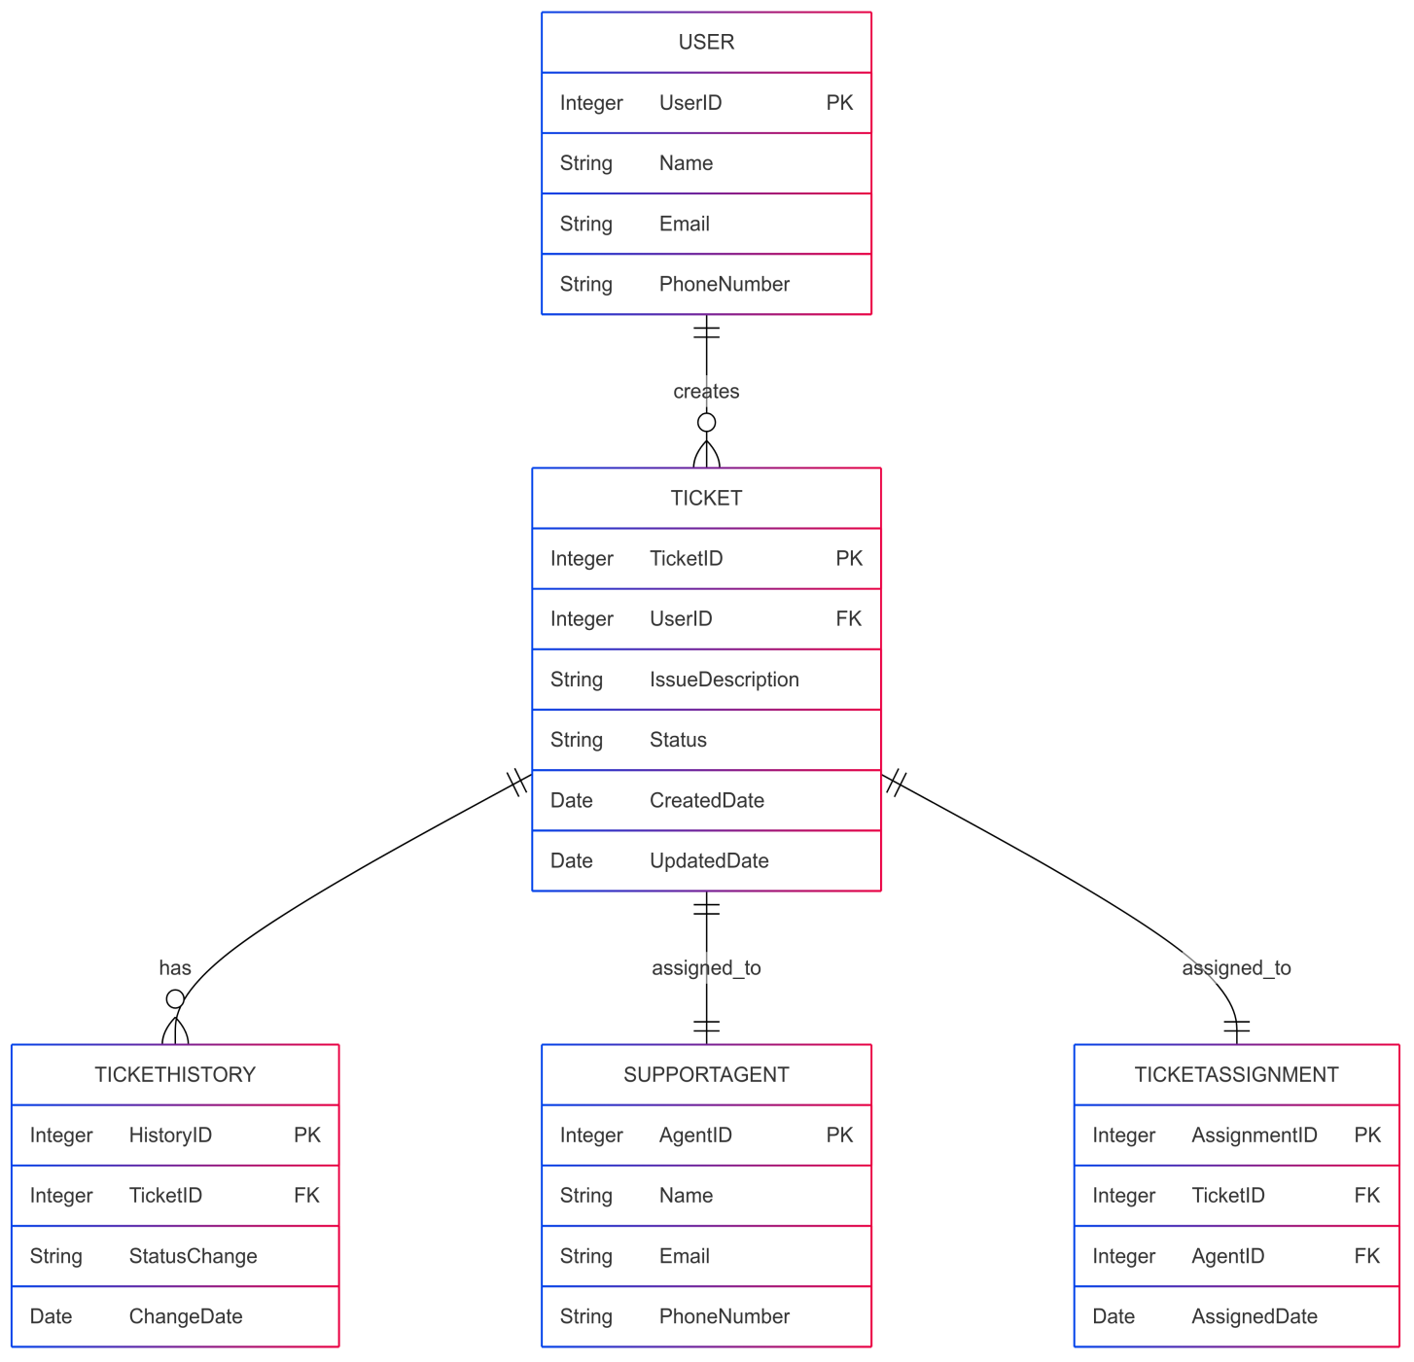

4. User story of shopping from ecommerce.
20 User stories I mentioned.

User Story ID | US-01
User Story Description | As a Warehouse Manager, I want to add and update product stock so that I can maintain accurate inventory records for all warehouses.
Acceptance Criteria | Manager can add, edit, or delete stock details. System automatically updates stock after dispatch or receipt. Alerts are generated for low stock levels.
Business Value (BV) | 100
Complexity Points (CP) | 1
Priority | Low

User Story ID | US-02
User Story Description | As a Delivery Manager, I want to track product deliveries so that I can ensure timely delivery to customers.
Acceptance Criteria | Delivery routes can be assigned automatically. status can be updated as “In Transit” or “Delivered.” Customers receive delivery notifications.
Business Value (BV) | 200
Complexity Points (CP) | 3
Priority | Medium

User Story ID | US-03
User Story Description | As a Sales Executive, I want to process and confirm customer orders so that production and delivery can be initiated efficiently.
Acceptance Criteria | Orders can be created, modified, or canceled. System validates stock availability before order confirmation. Automatic order number generation.
Business Value (BV) | 500
Complexity Points (CP) | 5
Priority | High

User Story ID | US-04
User Story Description | As an Admin, I want to generate inventory and delivery reports so that I can monitor performance and make business decisions.
Acceptance Criteria | Reports show stock movement, delivery time, and sales data. Reports can be exported in PDF or Excel. Admin can filter reports by date or warehouse.
Business Value (BV) | 200
Complexity Points (CP) | 3
Priority | Medium

User Story ID | US-05
User Story Description | As an Admin, I want to create and manage user accounts and roles so that system access is secure and organized.
Acceptance Criteria | Admin can create user accounts (Manager, Delivery, Staff). Access permissions are role-based. System logs user activities.
Business Value (BV) | 200
Complexity Points (CP) | 2
Priority | Medium

User Story ID | US-06
User Story Description | As a Customer, I want to track my order status so that I know when to expect delivery.
Acceptance Criteria | Customers can view live delivery status. Delivery ETA (Expected Time of Arrival) is displayed. Notifications sent on dispatch and delivery.
Business Value (BV) | 200
Complexity Points (CP) | 3
Priority | Medium

User Story ID | US-07
User Story Description | As a customer,  I want to browse available ice-cream and milk products  so that I can select what to buy
Acceptance Criteria | Customer can view product catalog with  images, prices, and availability.
Business Value (BV) | 500
Complexity Points (CP) | 5
Priority | High

User Story ID | US-08
User Story Description | As a customer,  I want to add products to a shopping cart  so that I can purchase multiple items together
Acceptance Criteria | Cart allows adding/removing items and  updates total price dynamically.
Business Value (BV) | 500
Complexity Points (CP) | 5
Priority | High

User Story ID | US-09
User Story Description | As a customer,  I want to view estimated delivery time before placing the order  so that I can plan accordingly.
Acceptance Criteria | System shows estimated delivery based on nearest warehouse stock.
Business Value (BV) | 200
Complexity Points (CP) | 3
Priority | Medium

User Story ID | US-10
User Story Description | As a warehouse manager,  I want inventory to automatically update when customer orders are placed  so that stock is always accurate.
Acceptance Criteria | Inventory reduces in real-time upon order confirmation.
Business Value (BV) | 500
Complexity Points (CP) | 5
Priority | High

User Story ID | US-11
User Story Description | As an admin,  I want to manage product listings (add/update/remove)  so that the catalog remains up to date.
Acceptance Criteria | Admin dashboard allows CRUD operations on products.
Business Value (BV) | 200
Complexity Points (CP) | 3
Priority | Medium

User Story ID | US-12
User Story Description | As a delivery agent,  I want to receive optimized routes for each delivery  so that I can deliver products faster.
Acceptance Criteria | Mobile app assigns delivery route based on shortest travel time.
Business Value (BV) | 200
Complexity Points (CP) | 3
Priority | Medium

User Story ID | US-13
User Story Description | As a customer,  I want to rate and review products after delivery  so that I can share my experience.
Acceptance Criteria | Rating and review option appears after order is marked delivered.
Business Value (BV) | 100
Complexity Points (CP) | 2
Priority | Medium

User Story ID | US-14
User Story Description | As a business owner,  I want to monitor sales and stock analytics  so I can make better inventory decisions.
Acceptance Criteria | Dashboard shows sales trends, low stock alerts, and popular products.
Business Value (BV) | 200
Complexity Points (CP) | 3
Priority | Medium

User Story ID | US-15
User Story Description | As a system,  I want to block the ordering of out-of-stock products  so that customers don’t place invalid orders.
Acceptance Criteria | "Out of stock" label appears, and product cannot be added to cart
Business Value (BV) | 200
Complexity Points (CP) | 3
Priority | Medium

User Story ID | US-16
User Story Description | As a quality officer,  I want to ensure expired products are not available for sale  so that customers receive fresh items.
Acceptance Criteria | Expired products are automatically removed from the active catalog.
Business Value (BV) | 500
Complexity Points (CP) | 3
Priority | High

User Story ID | US-17
User Story Description | As a customer,  I want to reorder from my past purchases  so that I can easily buy favorite products again.
Acceptance Criteria | Reorder button shows in order history and adds previous items to cart.
Business Value (BV) | 200
Complexity Points (CP) | 3
Priority | Medium

User Story ID | US-18
User Story Description | As a user,  I want to cancel before shipment,  so I avoid unwanted purchases.
Acceptance Criteria | Cancel option available before dispatch.
Business Value (BV) | 200
Complexity Points (CP) | 3
Priority | Medium

User Story ID | US-19
User Story Description | As a user,  I want to request returns,  so I can send back defective items.
Acceptance Criteria | Return initiated with reason selection.
Business Value (BV) | 500
Complexity Points (CP) | 5
Priority | High

User Story ID | US-20
User Story Description | As a user,  I want refunds processed,  so I get my money back.
Acceptance Criteria | Refund confirmation received.
Business Value (BV) | 200
Complexity Points (CP) | 3
Priority | Medium

