Online Agriculture Products Store
Q1. Functional Requirements:
FR ID | Requirement Name | Description
FR01 | User Registration & Login | Farmers, Manufacturers, and Admins can create accounts, log in/out, reset passwords, and manage profiles.
FR02 | Product Catalog | Display categorized list of fertilizers, seeds, and pesticides with details (price, stock, images, description).
FR03 | Product Search & Filters | Allow farmers to search products by keyword, category, crop type, and price range; support sorting (price, rating).
FR04 | Manufacturer Product Upload | Manufacturers can add/edit/delete products, set price/stock, and upload images for Admin approval.
FR06 | Checkout & Payment | Support checkout flow with shipping address, taxes, and payment methods (COD, Credit/Debit card, UPI).
FR07 | Order Management & Tracking | Maintain order lifecycle (Placed → Packed → Shipped → Delivered) with real-time tracking info.
FR08 | Email / Notification Service | Send email confirmations for registration, order placement, payment status, shipment, and delivery.
FR09 | Ratings & Reviews | Farmers can rate and review delivered products; ratings displayed in catalog.
FR11 | Delivery Integration | Integrate with logistics/delivery partners to update shipment status automatically.

Non-Functional Requirements

NFR ID | Category | Requirement / Target | Description
NFR01 | Performance | Response Time | Page load and search results must display within 3 seconds for 95 % of requests under normal load.
NFR03 | Availability | uptime | High availability excluding planned maintenance.
NFR04 | Security |  | Encrypt sensitive data in transit and at rest; follow secure-coding standards.
NFR05 | Usability | Mobile-responsive, easy navigation | New users should be able to complete a first purchase within 5 minutes of landing.
NFR06 | Reliability | Failover & Recovery ≤ 5 min | System must recover from server failure within 5 minutes with no confirmed-order data loss.
NFR07 | Maintainability | Modular code, <10 % defect leakage | Follow Java/Spring best practices and provide full documentation.
NFR08 | Compliance | GST & PCI-DSS | Must comply with Indian IT Act, GST rules, and PCI-DSS for payment processing.
NFR09 | Compatibility | Latest 2 major browser versions | Support Chrome, Edge, Firefox, and mobile browsers on Android & iOS.

Q2. Make wireframe and prototypes
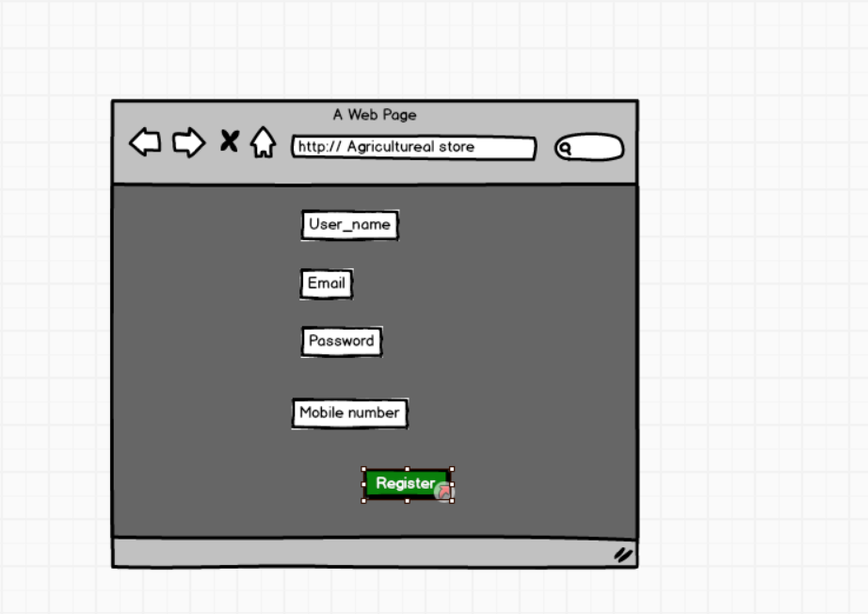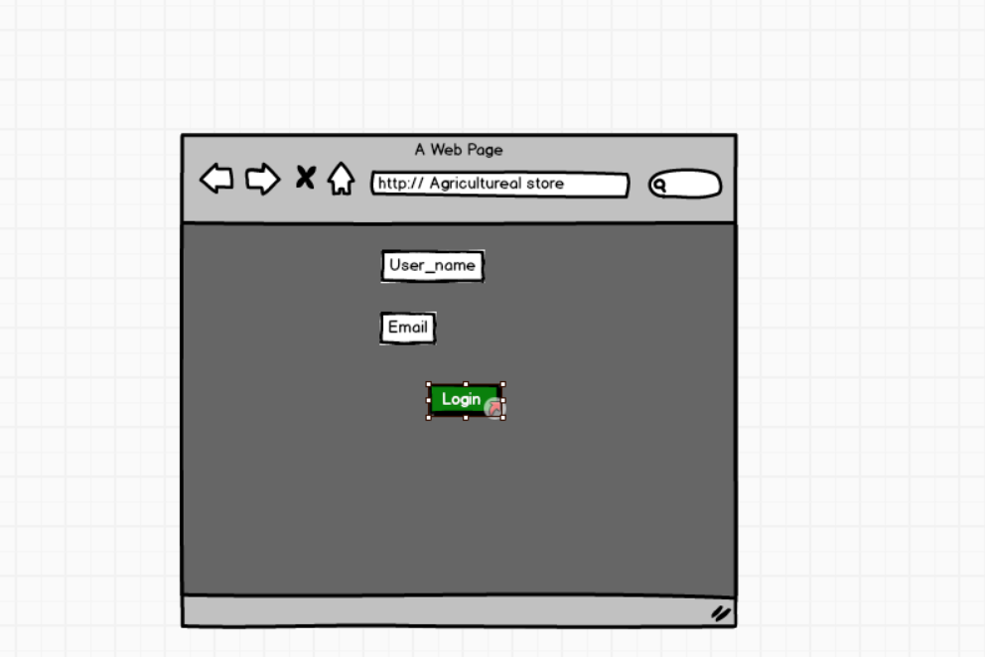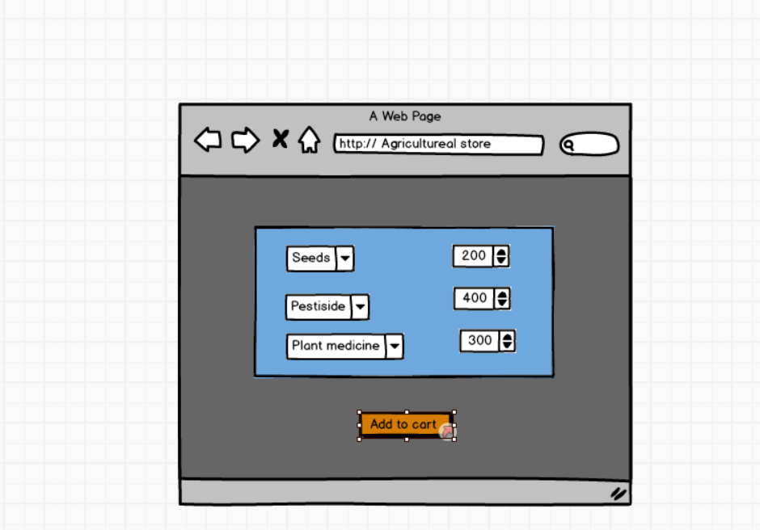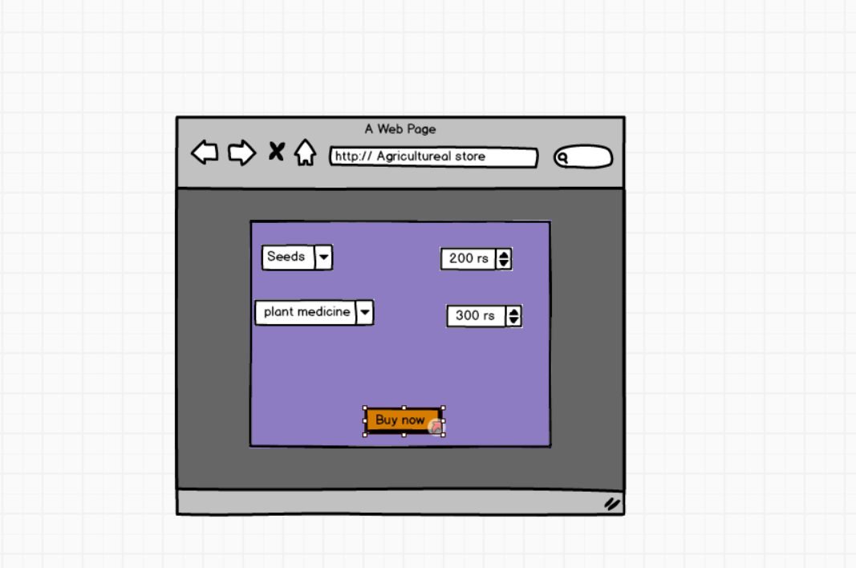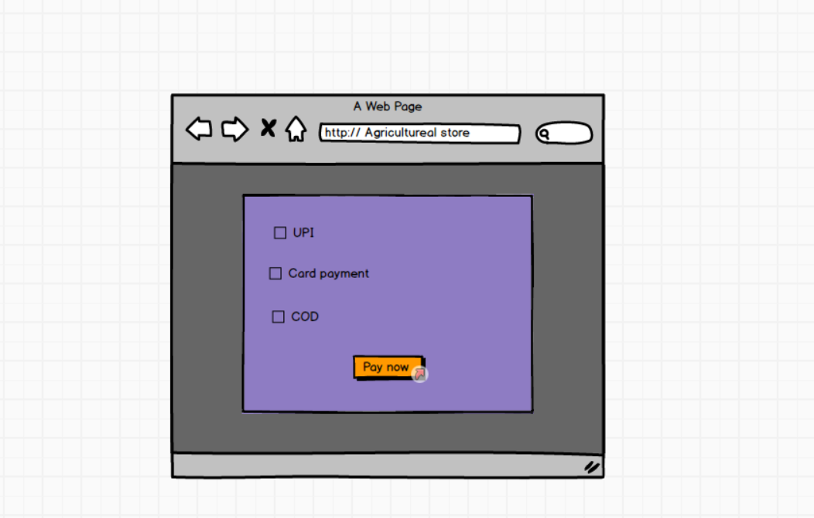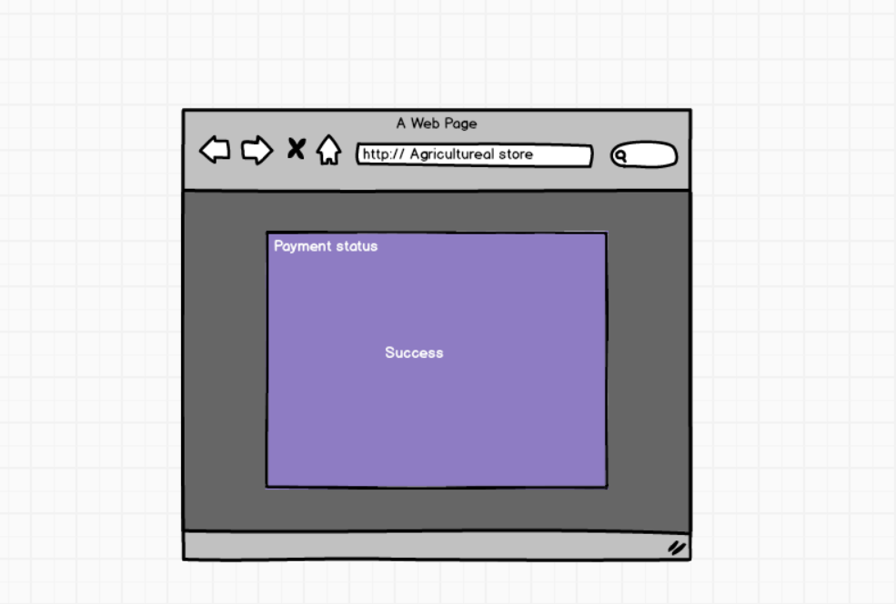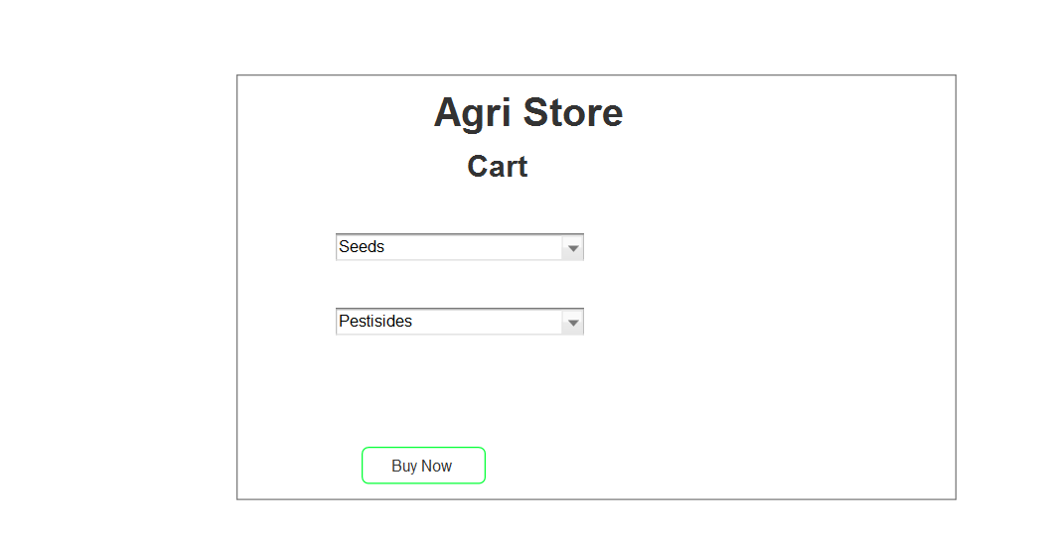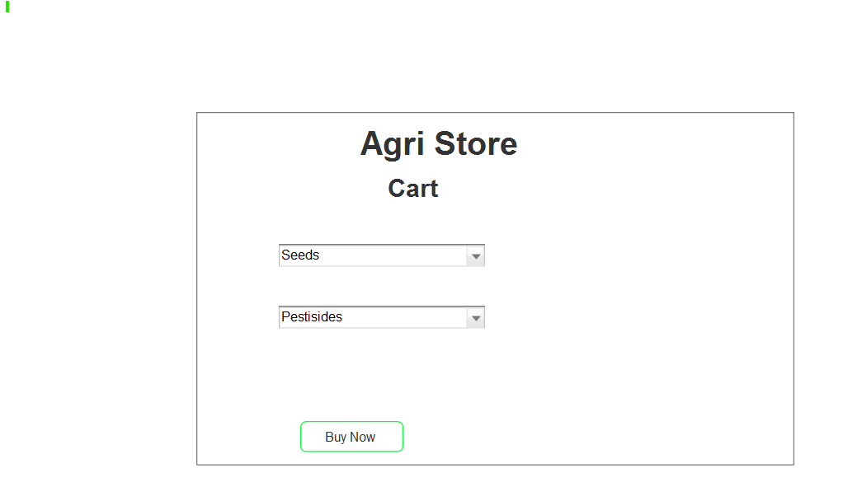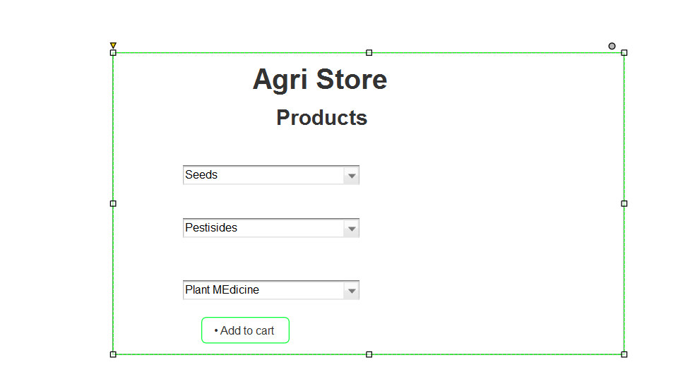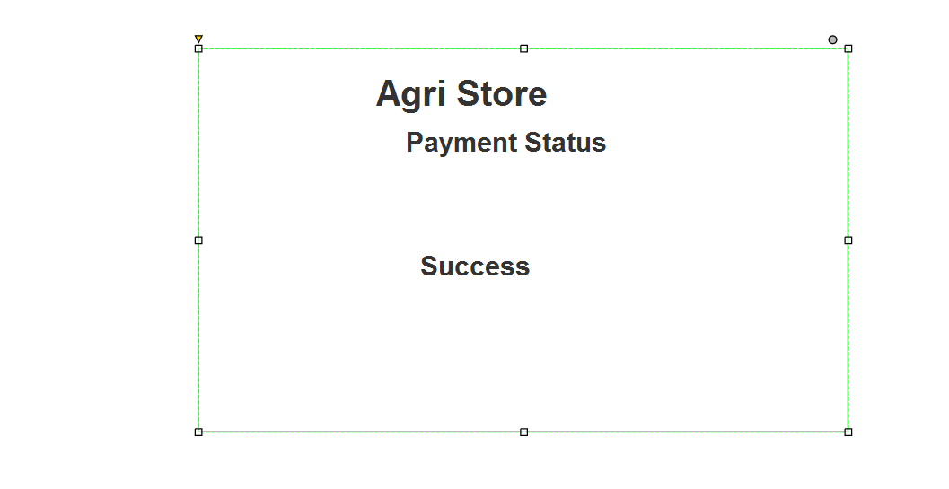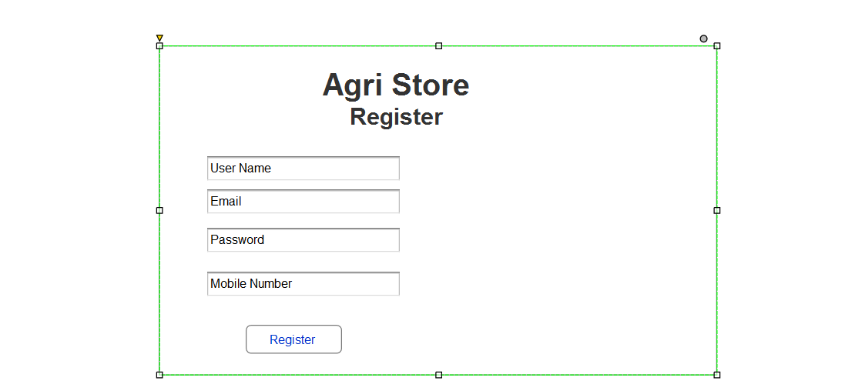

Q3 . Make a note of the Tools, which you are using for above concepts.

Balsamiq
Balsamiq is an easy-to-use wireframing tool for quickly sketching rough ideas of a website or app. Its simple, hand-drawn look keeps the focus on layout and usability instead of polished visuals. Teams use it to map out screens, test navigation flows, and get early feedback before moving to detailed design.

Axure
Is an advanced prototyping and wireframing tool that allows creation of interactive, high-fidelity web and mobile prototypes. It supports conditional logic, dynamic panels, and team collaboration. Business analysts and UX professionals use Axure to simulate complex user interactions and validate requirements before development begins, reducing rework costs.

Microsoft Visio
Microsoft Visio is a professional diagramming tool used to create a wide variety of visuals, including UML diagrams, flowcharts, and network designs. It offers templates, drag-and-drop shapes, and integration with Microsoft Office. Business analysts and project teams use Visio to communicate system requirements, workflows, and architecture with clarity.

Q4. Requirements Traceability Matrix (RTM)

Req ID | Business Requirement | Functional Requirement(s) | Design/Module Reference | Test Case IDs | Status
BR001 | Farmers should be able to search for products (fertilizers, seeds, pesticides). | FR01 – Implement product catalog search with filters (category, price, name). | UI: Product Search Page, Backend: Product Service API. | TC01, TC02 | In Progress
BR002 | Manufacturers should upload and display their products in the application. | FR02 – Enable manufacturer login and product upload with images, price, and details. | UI: Manufacturer Dashboard, DB: Product Table. | TC03, TC04 | In Progress
BR003 | Farmers must create an account or log in to buy products. | FR03 – User registration, email verification, secure login with password hashing. | UI: Registration & Login Pages. | TC05, TC06 | Not Started
BR004 | Farmers can add products to cart or buy later. | FR04 – Shopping cart with add/update/remove, wishlist option. | UI: Cart Page, DB: Cart Table. | TC07, TC08 | Not Started
BR005 | Secure payment gateway with COD, cards, and UPI. | FR05 – Integrate payment APIs (COD, credit/debit, UPI). | Payment Module. | TC09, TC10, TC11 | Not Started
BR006 | Email confirmation for orders. | FR06 – Auto-email notifications for order placement, dispatch, and delivery. | Notification Service, Email API. | TC12 | Not Started
BR007 | Delivery tracking for farmers. | FR07 – Real-time order tracking with status updates. | UI: Order Tracking Page, Delivery API. | TC13 | Not Started
BR008 | Application must be mobile and web accessible. | FR08 – Responsive web design and mobile-friendly interface. | Frontend Framework. | TC14 | In Progress
BR009 | Secure storage of user data. | FR09 – Implement encryption for sensitive data and secure authentication. | Security Module, Database. | TC15 | Not Started
BR010 | High availability and performance for rural connectivity. | FR10 – Optimize for low bandwidth, ensure uptime. | Infrastructure/Hosting Plan. | TC16 | Planned

Q 5

This document contains detailed test cases for BR001 Product Search functionality.
Test Case ID | Project ID | PM ID | Test Strategy ID | Test Plan ID | Test Schedule ID | Test Case Description | Preconditions | Test Steps | Expected Result | Actual Result | Status
TC01 | PROJ-AGRI-001 | PM-VDNM-01 | TS-STR-001 | TP-PLAN-001 | TS-SCH-001 | Verify farmers can search products using keywords. | User registered and logged in. | 1. Go to product search page  2. Enter 'fertilizer'  3. Click Search | Relevant fertilizer products are displayed. |  | Not Executed

Test Case Document - BR002 Manufacturer Upload
This document contains detailed test cases for BR002 Manufacturer Upload functionality.
Test Case ID | Project ID | PM ID | Test Strategy ID | Test Plan ID | Test Schedule ID | Test Case Description | Preconditions | Test Steps | Expected Result | Actual Result | Status
TC02 | PROJ-AGRI-001 | PM-VDNM-01 | TS-STR-001 | TP-PLAN-001 | TS-SCH-001 | Verify manufacturer can upload a new product. | Manufacturer logged in. | 1. Go to manufacturer dashboard  2. Click 'Add Product'  3. Enter details and upload image  4. Save | Product is listed in catalog. |  | Not Executed

Test Case Document - BR003 User Registration Login
This document contains detailed test cases for BR003 User Registration Login functionality.
Test Case ID | Project ID | PM ID | Test Strategy ID | Test Plan ID | Test Schedule ID | Test Case Description | Preconditions | Test Steps | Expected Result | Actual Result | Status
TC03 | PROJ-AGRI-001 | PM-VDNM-01 | TS-STR-001 | TP-PLAN-001 | TS-SCH-001 | Verify new farmer can register. | User is on registration page. | 1. Enter email, password  2. Submit form  3. Check email verification link | Account is created and email verification sent. |  | Not Executed

Test Case Document - BR004 Shopping Cart
This document contains detailed test cases for BR004 Shopping Cart functionality.
Test Case ID | Project ID | PM ID | Test Strategy ID | Test Plan ID | Test Schedule ID | Test Case Description | Preconditions | Test Steps | Expected Result | Actual Result | Status
TC04 | PROJ-AGRI-001 | PM-VDNM-01 | TS-STR-001 | TP-PLAN-001 | TS-SCH-001 | Verify adding products to cart works correctly. | User logged in with available products. | 1. Browse products  2. Add a product to cart  3. View cart | Product appears in cart with correct details. |  | Not Executed

Test Case Document - BR005 Payment Gateway
This document contains detailed test cases for BR005 Payment Gateway functionality.
Test Case ID | Project ID | PM ID | Test Strategy ID | Test Plan ID | Test Schedule ID | Test Case Description | Preconditions | Test Steps | Expected Result | Actual Result | Status
TC05 | PROJ-AGRI-001 | PM-VDNM-01 | TS-STR-001 | TP-PLAN-001 | TS-SCH-001 | Verify payment using UPI. | User has items in cart. | 1. Select UPI payment method  2. Enter UPI ID  3. Confirm payment | Order placed and payment confirmation displayed. |  | Not Executed

Test Case Document - BR006 Email Notification
This document contains detailed test cases for BR006 Email Notification functionality.
Test Case ID | Project ID | PM ID | Test Strategy ID | Test Plan ID | Test Schedule ID | Test Case Description | Preconditions | Test Steps | Expected Result | Actual Result | Status
TC06 | PROJ-AGRI-001 | PM-VDNM-01 | TS-STR-001 | TP-PLAN-001 | TS-SCH-001 | Verify email confirmation is sent for orders. | User placed an order. | 1. Place order  2. Check registered email inbox | Order confirmation email is received. |  | Not Executed

Test Case Document - BR007 Delivery Tracking
This document contains detailed test cases for BR007 Delivery Tracking functionality.
Test Case ID | Project ID | PM ID | Test Strategy ID | Test Plan ID | Test Schedule ID | Test Case Description | Preconditions | Test Steps | Expected Result | Actual Result | Status
TC07 | PROJ-AGRI-001 | PM-VDNM-01 | TS-STR-001 | TP-PLAN-001 | TS-SCH-001 | Verify delivery tracking shows current order status. | User has a placed order. | 1. Go to 'My Orders'  2. Select active order  3. View tracking details | Delivery tracker shows correct status. |  | Not Executed

. Test Case Document - BR008 Responsive Design
This document contains detailed test cases for BR008 Responsive Design functionality.
Test Case ID | Project ID | PM ID | Test Strategy ID | Test Plan ID | Test Schedule ID | Test Case Description | Preconditions | Test Steps | Expected Result | Actual Result | Status
TC08 | PROJ-AGRI-001 | PM-VDNM-01 | TS-STR-001 | TP-PLAN-001 | TS-SCH-001 | Verify application is mobile responsive. | Application deployed on staging server. | 1. Open site on mobile browser  2. Navigate pages | Layout adjusts and is usable on mobile screens. |  | Not Executed

Q8. – Change Request

Answer- Handling change requests in a project involves a systematic process to ensure that changes are effectively managed while minimizing disruption to the project's scope, timeline, and resources. Here are the steps typically followed to handle change requests.

1. Change Request Identification: Identify and document the change request, including the specific details of the requested change, the reason for the change, and its potential impact on the project.

2. Change Impact Analysis: Assess the impact of the change on various aspects of the project, such as scope, timeline, cost, resources, and risks. Evaluate the feasibility and implications of implementing the change.

3. Change Evaluation: Review the change request with key stakeholders, including project sponsors, clients, and relevant team members. Discuss the potential benefits,

isks, and trade-offs associated with the change. Consider the project's objectives, constraints, and priorities in the evaluation process.

4. Change Prioritization: Prioritize the change request based on its urgency, impact, and alignment with project goals. Determine whether the change is critical and must be implemented immediately or can be scheduled for a future phase or release.

5. Change Approval: Obtain formal approval from the appropriate stakeholders, such as project sponsors or change control boards. Ensure that all stakeholders agree regarding the change and its implications.

6. Change Implementation: Incorporate the approved change into the project plan, including any necessary adjustments to the scope, schedule, budget, or resources. Communicate the change to the project team and other relevant stakeholders. Update project documentation, such as requirements, design, and test plans, to reflect the approved change.

7.Change Communication: Communicate the approved change to all relevant parties, including team members, clients, and other stakeholders. Clearly explain the reasons for the change, its impact on the project, and any adjustments to expectations or deliverables.

8. Change Tracking and Documentation: Track and document all approved changes, including the rationale, approvals, and implemented modifications. Maintain a change log or change register to ensure transparency and accountability throughout the project.

9. Change Control and Monitoring: Continuously monitor the impact of implemented changes on the project's progress, risks, and quality. Maintain open lines of communication with stakeholders to address any concerns or issues related to the approved changes. Monitor the project's overall alignment with the revised scope, timeline, and objectives.

By following these steps, a project can effectively manage change requests, ensuring that changes are evaluated approved and implemented in a controlled.

Q9

Change Requests A Change Request (CR) is a formal proposal to modify a project, product, process, or system. It is typically used in project management, software development, and various industries to handle modifications and improvements. A Change Request can arise at any point during a project's
lifecycle, whether it's due to new requirements, unforeseen issues, or the need for enhancements.

Enhancements refer to improvements or additions made to the software after its initial release. These changes are aimed at increasing the software's value, performance, or functionality based on evolving business needs, user feedback, or technological advances. Enhancements can be part of the regular software maintenance cycle or occur as part of a new version or update.

As a Business Analyst, my response to Ben and Kevin's request would be to classify it as an enhancement rather than a change request. A change request typically involves modifications to existing functionality or requirements, while an enhancement introduces new features or capabilities that were not initially specified. In this case, the request to allow farmers to add their crop yields, display them to the general public, and enable selling through the application represents an enhancement because it introduces new functionality that goes beyond the initial scope of the project. Additionally, the introduction of an auction system for crop yields adds another layer of functionality to the application.
To address this enhancement request, I would follow the standard process for handling new requirements:

1. Requirement Gathering: I will meet with Ben and Kevin to gather detailed

requirements for the new functionality. This would involve understanding the specific features they envision, such as the process for farmers to add and manage their crop yields, the display of products to the public, and the implementation of the auction system.

2. Impact Analysis: I would analyze the impact of these enhancements on the existing project scope, timeline, budget, and resources. This assessment would help determine the feasibility and potential implications of incorporating the requested features.

3. Stakeholder Analysis: I would identify and involve relevant stakeholders, such as

the project sponsor, development team, and other key personnel, to assess their perspectives and gather their inputs on the potential enhancements.

4. Documentation and Communication: I would document the detailed requirements and changes in the project scope, and communicate them to the project team, stakeholders, and any other parties involved. This would ensure everyone is aware of the proposed enhancements and their implications.

5. Evaluation and Prioritization: I would work with the project team and stakeholders to evaluate the value and priority of the requested enhancements. This evaluation would consider factors such as the potential benefits, impact on project goals, alignment with business objectives, and available resources.
6.Planning and Execution: If the enhancements are deemed feasible and approved,I would update the project plan, schedule, and resources accordingly would collaborate with the development team and other stakeholders to incorporate the new features into the application, ensuring proper testing and quality assurance.

By treating this request as an enhancement, the project can effectively manage the additional requirements arid deliver the desired functionality while considering the impact on the ongoing project .

Q 10 Estimations -
Come up with estimations – How many Manhours required?

Estimation - Estimation in Software Development Life Cycle refers to the process of predicting the resources (time, cost, effort) required to complete a software development project or specific tasks within that project. Estimation is a critical part of the planning phase of SDLC, as it helps in setting realistic expectations, managing resources efficiently, and determining the project's feasibility.

Man-hours estimation in software development refers to the process of estimating the total amount of human effort required to complete a software development task, project, or feature. It is typically expressed in terms of the number of hours that a team or individual will spend working on the project. This estimation is crucial for planning, budgeting, and scheduling the project. It helps determine resource requirements, assess project timelines, and evaluate project feasibility.
Types of projects on the basis of Man-Hours:

1. Small project - Upto 500 Man-Hours

2. Medium project - Upto 1000 Man-Hours

3. Large project - Upto 1500 Man-Hours

Manhours Required = Total hours working per day x Total number of members x Total numbers of days worked over the specific period.

Number of Working Hours a day = 8 hours

Sid's

Number of Resources = 12

Time period provided = 18 months = 547 days = 78 weeks (Including Weekends and Public Holidays)

Assuming Weekends = 156
Assuming Public Holidays = 10

Go

Total = 166

Total working days = 547-166 = 381 working days
Hence, Estimated Manhours = 8 hours * 12 resources * 381 days = 36,576 Man hours required.

Q11. Assuming Public Holidays = 10

Go

Total = 166

Total working days = 547-166 = 381 working days

Hence, Estimated Manhours = 8 hours * 12 resources * 381 days = 36,576 Man hours required

Q11.Project has finally completed all the stages i.e., design, development, testing etc. Now, it is the role of a business analyst to contact the client for testing of the final product and have to successfully complete it. How are you going to handle this situation? And once it is done, what will be the process
to close the project?
Explain UAT Acceptance process.

User Acceptance Testing (UAT) UAT (User Acceptance Testing) is a crucial phase in the software development life cycle where the intended users of the system validate the software by testing it in a real-world or production-like environment. The primary goal of UAT is to ensure that the software meets the business requirements, functions as expected and is ready for deployment to the end users.
To handle the situation of testing the final product and successfully completing it, the business analyst can follow these steps:

1. UAT Planning: Prepare a plan for User Acceptance Testing (UAT) in consultation with the client. This plan should include the scope of testing, test scenarios, test data, and timelines.

2. Test Environment Setup: Ensure that the required test environment is set up and available for the client to perform testing. This may include providing access to the testing environment, necessary test accounts, and any additional resources needed for testing.
Test Execution: Coordinate with the client to execute the planned test scenarios. Monitor the testing progress, provide support for any questions or issues that arise, and track the test results.

4. Defect Management: If any defects are identified during UAT, work closely with the client to understand the issues, document them, and track their resolution. Collaborate with the development team to address the reported defects and verify their fixes.
5. UAT Sign-off: Once the client has completed testing and is satisfied with the product's functionality, obtain their formal sign-off or approval which includes RTM and closure documents. This indicates that the client has accepted the final product and is ready to move forward with its deployment.
6.UAT Closure: Document the UAT results, Including the test execution summary , any outstanding issues, and overall Assessment of the project.

Q 12 Explain Project closure document?
Project Closure Document A Project Closure Document is a formal document that signifies the conclusion of a project. It provides a detailed summary of the project's performance, achievements, lessons learned, and any remaining tasks or issues. The purpose of this document is to ensure that the project is officially closed and that all stakeholders have agreed that the project has met its objectives. The Project Closure Document is typically prepared by the project manager or the project team and is presented to stakeholders, including the client, team members, and management.

The project closure document typically includes the following sections:

- Project Overview: This section provides an overview of the project, including its objectives, scope, and stakeholders involved. It summarizes the project's purpose and sets the context for the closure report.

2.Project Achievements: Here, the document highlights the key achievements and
deliverables of the project. It outlines the successful completion of milestones, tasks, and any significant accomplishments that were achieved.
3. Project Timeline and Budget: This section provides an overview of the project
timeline, highlighting the start and end dates, major phases, and milestones. It also includes information on the project's budget, including any significant deviations or changes.

4. Lessons Learned: The lessons learned section reflects on the project successes

and challenges. It includes a comprehensive analysis of what worked well and what could have been improved. It highlights valuable insights and recommendations for future projects.

5.Stakeholder Feedback: This section gathers feedback from key stakeholders involved in the project. It includes their opinions, suggestions, and any concerns they may have expressed. The feedback helps in assessing the overall satisfaction and identifying areas for improvement.

6. Risks and Issues: The closure document discusses the risks and issues
encountered throughout the project. It outlines the actions taken to mitigate these risks and resolve any issues that arose during the project's lifecycle.

7. Project Performance: This section evaluates the project's performance against the defined objectives and success criteria. It assesses factors such as scope adherence, timeline adherence, budget performance, quality of deliverables, and customer satisfaction.

8. Project Sign-off: The closure document includes formal sign-off or approval from key stakeholders, indicating their acceptance and satisfaction with the project's
9. Project Documentation: This section provides an overview of the project documentation, including the list of documents produced, their location, and accessibility for future reference.

10. Next Steps and Recommendations: The closure document outlines any recommended actions or next steps following the project's closure. It may include suggestions for further improvements, additional tasks, or follow-up activities. The project closure document serves as a final report that captures the project's journey, outcomes, and key learnings. It provides a reference for future projects, helps in evaluating project success, and facilitates knowledge transfer to stakeholders involved in the project.

Project Closure Document

Project Details
Field | Details
Project Name | Online Agriculture Products Store
Client | SOONY Company
Vendor | APT IT SOLUTIONS
Project Manager | Mr. Vandanam
Business Analyst | [Your Name]
Budget | INR 2 Crores
Planned Duration | 18 Months
Actual Duration | 18 Months
Start Date | [Start Date]
End Date | [End Date]

Project Summary
The Online Agriculture Products Store project was completed successfully within the approved budget and timeline. It delivers a full-featured platform enabling farmers to search, purchase, and track fertilizers, seeds, and pesticides, while allowing manufacturers to upload and manage their products.

Final Deliverables
Deliverable | Status
Business Requirements Document (BRD) | Delivered
Functional & Non-Functional Specifications | Delivered
Database & ER Diagrams | Delivered
UML Diagrams & Mock-ups | Delivered
Test Case Documents & RTM | Delivered
Production Deployment | Completed

Client Acceptance & Sign-Off
Role | Name | Signature | Date
Client Sponsor | Mr. Henry
Financial Head | Mr. Pandu
Project Coordinator | Mr. Dooku
Project Manager | Mr. Vandanam

