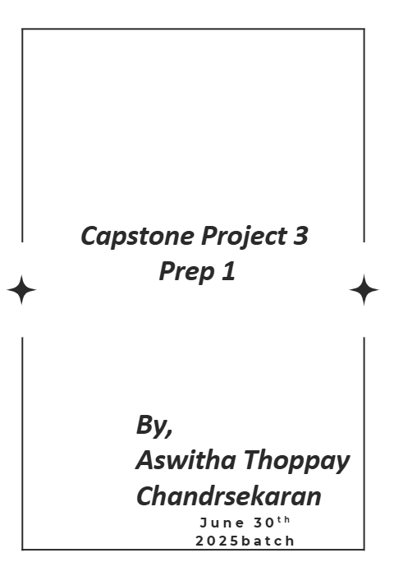
Case Study 1 (Q1-Q6 → 24 Marks)
Case Study 1 (Q1-Q6 → 24 Marks)
A customer can make a payment either by Card or by Wallet or by Cash or by Net banking. Q1. Draw a Use Case Diagram - 4 Marks
Q2. Derive Boundary Classes, Controller classes, Entity Classes. - 4 Marks Q3. Place these classes on a three tier Architecture. - 4 Marks
Q4. Explain Domain Model for Customer making payment through Net Banking - 4 Marks Q5. Draw a sequence diagram for payment done by Customer Net Banking - 4 Marks
Q6. Explain Conceptual Model for this Case - 4 Marks

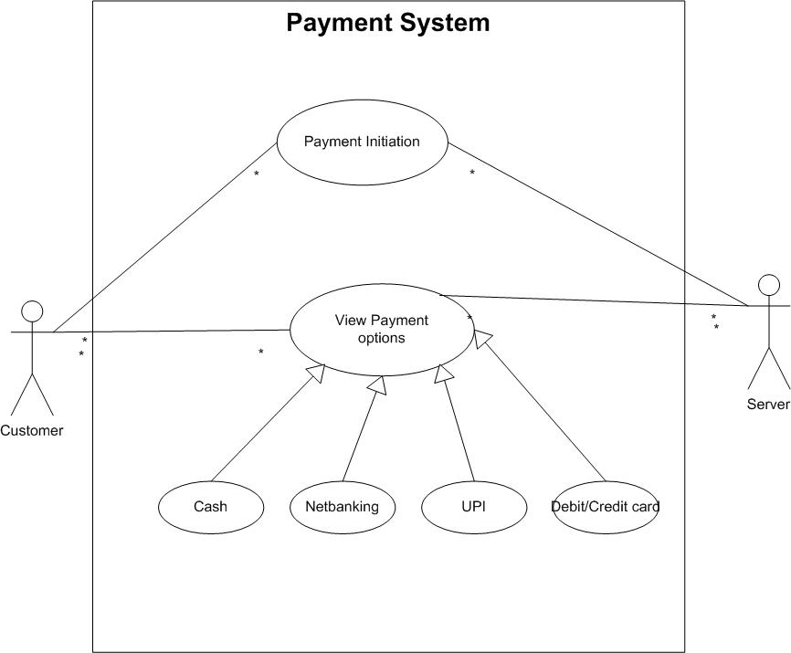
Q1-Use Case Diagram

Q2. Derive Boundary Classes, Controller classes, Entity Classes. - 4 Marks

Boundary Class — handles interactions between the system and external actors (UI, external servers, or devices). Boundary classes receive input from actors and present output back to them.
- combination of 1 actor and a use case is one boundary class
- combination of 2 actors and a use case is two boundary class
- And those actors should be primary actors. Primary actors means the actors who initiate the use case and interact with the system
Controller Class — acts as an intermediary between boundary and entity classes. Controllers orchestrate use-case behaviour: validate input, call entity operations, and coordinate transactions and responses. Use case will be considered as the controller classes
Entity Class — represents the core data and business logic of the application. Entity classes model the domain objects, their attributes and behaviour, and persistable state. Each Actor will be considered as one entity


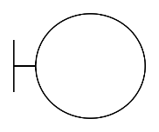
Boundary Class

Entity class
Controller class

Q3.Place these classes on a three tier Architecture.

Tier | Role / Responsibility
Presentation Tier (UI / Boundary) | Handles actor ↔ system input and output, UI screens, API endpoints/adapters to external parties.
Application / Business Tier (Controllers, Services) | Business rules and workflow orchestration; coordinates boundaries and entities; transaction management and integrations.
Data Tier (Entities, Persistence, External Gateways) | Domain model, persistence, external system adapters/gateways, audit/history. Implements core data and business logic that must be persisted.

- Presentation tier = screens and forms.
- Application tier = controllers and decision-making.
- Data tier = stored information and business rules

Q4. Explain Domain Model for Customer making payment through Net Banking - 4 Marks
A domain model is a formal representation of the key concepts, relationships, and rules that define a specific business or problem domain. It serves as a conceptual blueprint that helps developers understand and reason about the real-world system they are building. Domain Modelling is also known as Conceptual Modelling. A Conceptual Model depicts the concepts (idea, thing or object) that are easily identifiable in the problem description.
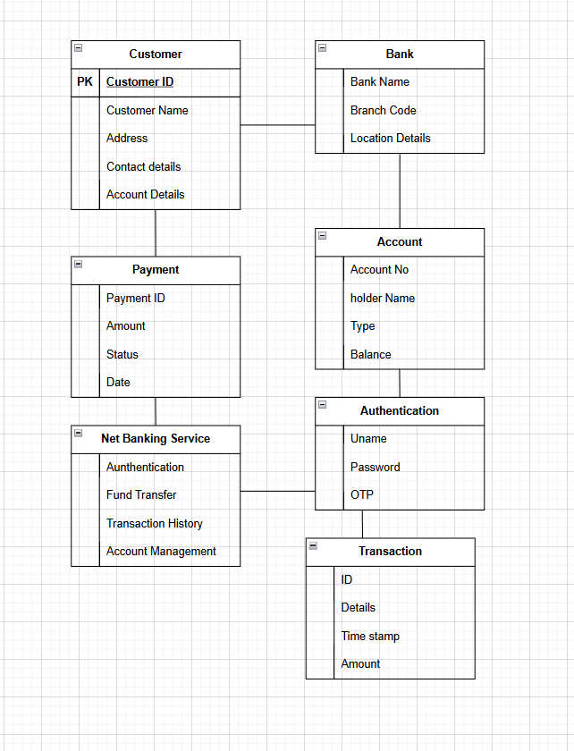
Domain Model

Q5. Draw a sequence diagram for payment done by Customer Net Banking - 4 Marks
The sequence diagram is used primarily to show the interactions between classes in the sequential order in which those interactions occur. It maps the scenario described by a use case in step by step detail to define how classes collaborate to achieve your application's goals. It is drawn by the developers. Sequence Diagrams are used primarily to design, document and validate the architecture, interfaces and logic of the system by describing the sequence of actions that need to be performed to complete a task or scenario. UML sequence diagrams are useful design tools because they provide a dynamic view of the system behavior which can be difficult to extract from static diagrams or specifications.
The Sequence Diagram which will be discussed by the Classes that are discovered (Boundary Classes, Controller Classes and Entity Classes) from MVC Architecture and then mapped on to the 3 Tier Architecture.
- Lifeline: Lifeline indicates the life of a class
- Camel Casing: entire first word will be in lowercase and subsequent words first letter should be in Upper Case. There will be no gap in between words.
- Return message: This will always flow towards the Controller; this is just a message and NOT a method.
- Note: Method always flows in timeline. Never Method will flow backward in timeline.
- Focus of Control: It shows the life of method
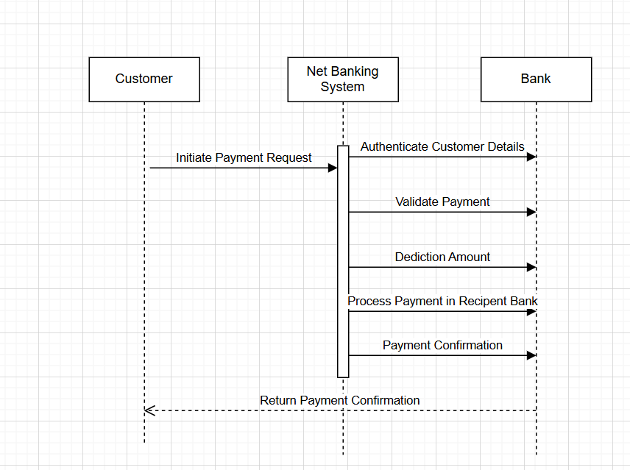

Q6. Explain Conceptual Model for this Case - 4 Marks
Domain Modelling is also known as Conceptual Modelling. A Conceptual Model depicts the concepts (idea, thing or object) that are easily identifiable in the problem description. A conceptual Model Is a high level representation of a system that helps in visualizing and communicating the essential aspecs of a domain.It provides a clear and simplified view of the domain make easier to understand.
Key elements
- Entities-Customer,Product, Order and Payment
- Attributes-CustomerID,name,email,phone number
- Relationships-Eg A customer places an order

Q7. What is MVC architecture? Explain MVC rules to derive classes from use case diagram and guidelines to place classes in 3-tier architecture - 8 Marks
Model View Controller(MVC) is an architectural pattern that seperates an application into three main logical reason
- View: The view is responsible for presenting the data to the user for handling the user interface. The view can be a web page, a desktop application or any form of UI. It takes the data from the Model and renders it in a way that is suitable for the user’s display or interaction.View class are represented as boundary class.
- Model: The Model Represents the data and the business logic of the application
Model is responsible for multiple tasks like managing the application’s data, performing data validation, implementing business rules and handling data access operations.
- Controller: The controller acts as an Intermediary between the Model and the view. It receives input from the user processes the input by invoking the appropriate methods on the model and then updates the view with the new data or state.It coordinates the flow of data between the Model and the view ensuring that they remain separated and independent of each other
Advantages of MVC
- MVC has the feature of scability, which in turn helps the growth of application
- The components are easy to maintain
- A model can be used by multiple views that provide reusability of code
- By using MVC, the application becomes more manageable
Rules to derive the classes from the use case diagram:
- 1.Combination of one actor and one use case results in one boundary class
Combination of two actor and one use case results in two boundary class
Combination of three actor and one use case results in three boundary class
2. Use case will result in controller class.
3. Each actor will result in one Entity class
Guidelines to place classes in 3 tier architecture
Presentation Layer
This layer is an user interface. These classes interact directly with the user.Presentation layer is responsible for displaying information and also recieiving the input from the user
Application Layer
This layer is a business logic. Controller handles the user inpurt for displaying information and also receiving the input from the user
Data Layer
Classes responsible for the data access and storage in this layer It contains DB, files and other data sources.

Q8. Explain BA contributions in project (Waterfall Model – all Stages) – 8 Marks
Here is a table explaining the Business Analyst (BA) contributions in the Waterfall Model across all stages:
Stage | BA Activities | Artifacts & Resources
Pre-Project | - Understand the problem and opportunity  - Gather initial requirements and constraints  - Perform stakeholder analysis  - Conduct feasibility study | - Project charter  - Feasibility report  - Stakeholder register
Planning | - Develop project scope statement  - Define project objectives and success criteria  - Identify project deliverables and milestones  - Estimate project timelines and resources  - Create project management plan | - Project scope statement  - Project management plan  - Work breakdown structure (WBS)
Project Initiation | - Facilitate project kickoff meeting  - Establish project governance and communication plans  - Identify project stakeholders and their requirements  - Define roles and responsibilities | - Project initiation documentation  - Stakeholder register  - RACI matrix
Requirements Gathering | - Elicit and document functional and non-functional requirements  - Prioritize and categorize requirements  - Validate requirements with stakeholders  - Manage requirements traceability | - Business requirements document (BRD)  - Requirements traceability matrix (RTM)
Analysis | - Analyze the current state and identify opportunities for improvement  - Define business processes and workflows  - Evaluate alternative solutions and recommend the best approach  - Develop user stories and use cases | - As-Is and To-Be process models  - Use case diagrams and narratives  - Functional specifications
Design | - Collaborate with the design team to translate requirements into technical specifications  - Ensure the design aligns with the business requirements  - Review and validate the design deliverables | - Technical design documents  - User interface (UI) prototypes  - System architecture diagrams
Development | - Participate in code reviews and provide feedback on implementation  - Assist in the development of test cases and test plans  - Validate the developed features against the requirements | - Test cases and test plans  - User acceptance criteria
Testing | - Coordinate and facilitate user acceptance testing (UAT)  - Manage the collection and resolution of UAT defects  - Validate the system's compliance with the requirements | - UAT test scripts and results  - Defect reports and resolution
UAT | - Ensure the final system meets the user requirements  - Gather feedback and recommendations from end-users  - Provide input on the final system acceptance | - UAT sign-off  - User feedback and recommendations

Q9. What is conflict management? Explain using Thomas – Kilmann technique – 6 Marks
Conflict management is the process of recognizing, understanding, and resolving conflicts in a constructive manner to minimize negative outcomes and maximize opportunities for learning and relationship growth.
It involves choosing appropriate strategies, communication, and negotiation to address differences in interests, values, or needs while preserving, and ideally improving, working relationships.
Thomas-Kilmann Conflict Management Technique
The Thomas-Kilmann Conflict Management Technique is a widely recognized framework for understanding and addressing conflicts. It is based on two key dimensions:
- Cooperativeness: The degree to which an individual attempts to satisfy the other party's concerns.
- Assertiveness: The degree to which an individual attempts to satisfy their own concerns.
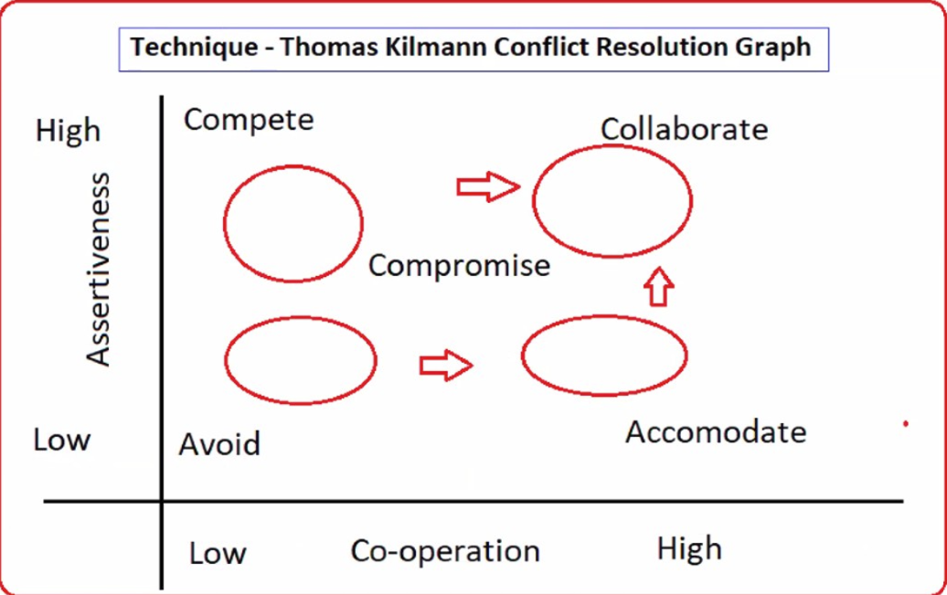
Using these two dimensions, the Thomas-Kilmann technique identifies five conflict management styles:
- Competing: High assertiveness, low cooperativeness. This style involves pursuing one's own interests at the expense of the other party's.
- Avoiding: Low assertiveness, low cooperativeness. This style involves sidestepping or postponing the conflict.
- Accommodating: Low assertiveness, high cooperativeness. This style involves sacrificing one's own interests to satisfy the other party's needs.
- Collaborating: High assertiveness, high cooperativeness. This style involves working together to find a mutually satisfactory solution.
- Compromising: Moderate assertiveness, moderate cooperativeness. This style involves finding a middle ground where both parties make concessions.
Importance of Conflict Management
Effective conflict management is essential for several reasons:
- Improves Communication: Addressing conflicts openly and constructively can lead to better understanding and improved communication between the parties involved.
- Facilitates Personal and Professional Growth: Navigating conflicts can provide opportunities for personal and professional development, as individuals learn to manage their emotions, negotiate, and find mutually beneficial solutions.
- Maintains Relationships: Effectively managing conflicts can help maintain healthy relationships, as it allows parties to address and resolve issues without causing permanent damage to the relationship.
- Steps for Effective Conflict Management
- Identify the Conflict: Clearly identify the nature and root cause of the conflict, including the perspectives and concerns of all parties involved.
- Discuss the Details: Engage in open and honest dialogue to understand the different viewpoints and the underlying issues driving the conflict.
- Agree on the Root Problem: Collaborate with the other party to reach a shared understanding of the core problem that needs to be addressed.
- Explore Possible Solutions: Brainstorm and evaluate various solutions that could resolve the conflict, considering the needs and interests of all parties.
- Negotiate the Solution: Negotiate a mutually acceptable solution that addresses the root problem and minimizes the risk of future conflicts.
By applying the Thomas-Kilmann Conflict Management Technique and following these steps, individuals and organizations can effectively manage conflicts, maintain healthy relationships, and foster personal and professional growth.

Q10. List down the reasons for project failure – 6 Marks
Reason | Description
1. Improper Requirement Gathering | - Inadequate analysis of stakeholder needs and expectations  - Failure to clearly define the project scope and objectives  - Lack of understanding of the business requirements and constraints
2. Continuous Change in Requirements | - Frequent and uncontrolled changes to project requirements  - Inability to manage and control requirement changes effectively  - Lack of a structured change management process
3. Lack of User Involvement | - Insufficient engagement and collaboration with end-users  - Failure to incorporate user feedback and input into the project  - Disconnect between the project deliverables and user needs
4. Lack of Executive Support | - Insufficient commitment and sponsorship from senior management  - Lack of clear direction, guidance, and decision-making from project stakeholders  - Inadequate resource allocation and funding for the project
5. Unrealistic Expectations | - Setting overly ambitious or unrealistic project goals and timelines  - Underestimating the complexity and challenges of the project  - Failure to manage stakeholder expectations effectively
6. Improper Planning | - Inadequate project planning and scheduling  - Lack of a comprehensive project management plan  - Ineffective risk identification and mitigation strategies
7. Scope Creep | - Uncontrolled expansion of the project scope beyond the original plan  - Failure to manage and control the scope of the project  - Inability to prioritize and manage competing requirements
8. Ineffective Risk Management | - Lack of a structured risk management process  - Failure to identify, assess, and mitigate project risks  - Inadequate contingency planning and risk response strategies

Q11. List the Challenges faced in projects for BA – 6 Marks

Challenge 1: Requirement Gathering
- Eliciting complete and accurate requirements from diverse stakeholders
- Addressing ambiguous, incomplete, or conflicting requirements
- Ensuring requirements are aligned with the business objectives
Challenge 2: Stakeholder Management
- Identifying and engaging with all relevant stakeholders
- Managing conflicting interests and expectations among stakeholders
- Maintaining effective communication and collaboration with stakeholders
Challenge 3: Changing Requirements
- Dealing with frequent and unpredictable changes in project requirements
- Implementing a robust change management process to handle requirement changes
- Ensuring traceability and impact analysis of requirement changes
Challenge 4: Unclear Changing Requirements
- Addressing vague or ambiguous changes in project requirements
- Clarifying the rationale and impact of requirement changes
- Facilitating effective communication and understanding of evolving requirements
Challenge 5: Managing Stakeholder Requirements
- Balancing and prioritizing the diverse requirements of multiple stakeholders
- Negotiating and compromising to find solutions that satisfy key stakeholders
- Ensuring stakeholder buy-in and commitment to the project deliverables
Challenge 6: Scope Management
- Defining and managing the project scope effectively
- Preventing scope creep and controlling changes to the project scope
- Prioritizing requirements and managing competing demands
Challenge 7: Scope Creep
- Uncontrolled expansion of the project scope beyond the original plan
- Failure to manage and control the scope of the project
- Inability to prioritize and manage competing requirements
Challenge 8: Time and Resource Constraints
- Ensuring project deliverables are completed within the specified time and budget
- Effectively allocating and managing limited resources (e.g., people, technology, funding)
- Addressing competing priorities and trade-offs between scope, time, and resources
Challenge 9: Quality Assurance (QA)
- Collaborating with the QA team to define and validate test scenarios
- Ensuring the project deliverables meet the specified quality standards
- Addressing and resolving quality-related issues during the development process
Challenge 10: Documentation and Knowledge Management
- Documenting the project requirements, design, and other artifacts effectively
- Maintaining comprehensive and up-to-date project documentation
- Facilitating knowledge transfer and sharing among the project team members
Challenge 11: Bridging the Business-IT Gap
- Translating business requirements into technical specifications
- Facilitating effective communication between business and IT teams
- Ensuring the proposed solutions address the underlying business needs
Challenge 12: Analytical Skills
- Analyzing complex business problems and identifying root causes
- Evaluating alternative solutions and making informed recommendations
- Applying critical thinking and problem-solving techniques

Q12. Write about Document Naming Standards – 4 Marks
Document naming standards help ensure consistency and easy retrieval across projects. Use a clear, hierarchical structure: ProjectCode/Component/DocumentType/Version/Date. Include version numbers (v1.0) and dates in YYYYMMDD format for sorting. Avoid spaces; use hyphens or underscores and consistent abbreviations. Store in a centralized repository with access controls and a documented naming convention guide.
Use a clear, consistent structure: ProjectCode-DocType-Version-Date.ext.
Include version numbers (V1.0, V2.1) to track revisions over time.
Use YYYYMMDD for dates to ensure proper sorting.
Example: PRJX-Reqs-BRD-V1-20240930.docx or PRJX-Design-V2-20241015.pdf

Q13. What are the Do’s and Don’ts of a Business analyst – 6 Marks

Category | Do’s | Don’ts
Stakeholder Engagement | - Identify and analyze stakeholders; build collaborative relationships. - Elicit requirements through structured techniques and gain stakeholder buy-in. | - Ignore stakeholder analysis or neglect key stakeholders. - Bypass stakeholder input or assume needs without engagement.
Elicitation & Collaboration | - Plan elicitation activities; use interviews, workshops, observation, and prototyping per BABOK techniques. - Validate findings with stakeholders; document assumptions. | - Rely on a single source; neglect triangulation. - Capture requirements informally without validation or traceability.
Requirements Life Cycle Management | - Trace requirements to business objectives; maintain a requirements backlog; manage changes with a formal baseline. - Ensure requirements are prioritized and linked to value. | - Allow requirements to drift without traceability. - Change baselines without impact analysis or stakeholder approval.
Strategy Analysis | - Analyze current state, define future state, and propose solution options aligned to strategy. - Assess risks, costs, and benefits to inform decisions. | - Jump to solutions without validating business needs or strategy alignment. - Ignore feasibility or value realization considerations.
Requirements Analysis & Design | - Define, model, and validate requirements; create clear acceptance criteria and traceability matrices. - Collaborate with solution designers to ensure feasible designs. | - Overlook non-functional requirements or ambiguous acceptance criteria. - Produce unattainable or vague designs without stakeholder review.
Solution Evaluation | - Assess delivered solutions against benefits realisation and success criteria; suggest improvements. - Facilitate post-implementation review. | - Declare success prematurely without evidence of value or KPIs. - Fail to re-evaluate after deployment or lessons learned.
Underlying Competencies | - Apply critical thinking, problem solving, and domain knowledge; use visual models and clear documentation. - Communicate in business terms and maintain a single source of truth. | - Use excessive jargon or opaque artifacts; neglect documentation standards. - Skip validation or domain expert review.
Requirements Quality & Validation | - Ensure requirements are well-formed, unambiguous, complete, consistent, and verifiable. - Use BABOK-approved techniques for validation. | - Accept vague or contradictory requirements; skip acceptance criteria. - Ignore quality checks or traceability.
Change & Configuration Management | - Manage change requests with impact analysis; maintain version control and baselines. - Communicate changes to all impacted stakeholders. | - Implement changes informally; fail to assess impact or re-baseline. - Change requirements without stakeholder agreement.
Ethics & Professionalism | - Adhere to BABOK ethical standards, maintain neutrality, and protect stakeholder confidentiality. - Document rationale and decisions transparently. | - Favor personal or vendor interests; disclose conflicts or biases poorly. - Neglect confidentiality or traceability of decisions.

Q14. Write the difference between packages and sub-systems – 4 Marks
Aspect | Package | Subsystem
Definition | A collection of components grouped for organization; components within a package are generally not reusable across packages.( Application Development Companies work on Packages) | A collection of components that together form a cohesive, reusable unit with a well-defined interface.( Product Development Companies work on Subsystems)
Reusability | Components within a package are typically not reusable outside that package. | Components within a subsystem are designed to be reusable across contexts.
Granularity | Usually finer-grained than a subsystem; focuses on grouping related components. | Higher-level/coarser-grained unit that encapsulates functionality.
Interaction | Packages organize structure; internal components interact but exports are limited by package boundaries. | Subsystems expose interfaces to interact with other subsystems or systems; encapsulation is key.

Q15. What is camel-casing and explain where it will be used- 6 Marks
Camel Casing means Initial word will be all small alphabets and from second word onwards beginning alphabet is Capital and the rest are small.
turnRightAndStop(); applyBreaksAndSlowDown();
Camel-casing is commonly used for naming variables, methods, and functions in programming languages, as it provides a clear and concise way to represent multi-word identifiers.
It is also used in file and folder naming conventions, as well as in certain domain-specific contexts, such as in naming conventions for web APIs and other software systems

Q16. Illustrate Development server and what are the accesses does business analyst has? -6 Marks
A development server is an environment that hosts an application during its development phase. It mirrors the production app but is isolated for testing, debugging, and feature work.
Typical characteristics:
- Separate from production to prevent accidental data changes.
- Configured for rapid deployment, hot-reload, and debugging.
- Often includes development tools, verbose logging, and mock data.
Common components:
- Application server (backend), web server, and database or mock data layer.
- Version control integration, CI/CD hooks, and environment-specific configurations.
Access Rights of a Business Analyst
A Business Analyst (BA) typically has a role-focused set of accesses, designed to read, analyze, and document requirements without granting privileged operations. Exact rights depend on the organization’s policy, but common access levels include:
Read access to:
- Business requirements, user stories, process models, and traceability matrices.
- Stakeholder directory, meeting notes, and decision logs.
- Non-production dashboards and analytics reports relevant to business analysis.
Limited write access to:
- Requirements artifacts (edit/add comments, update status, link to related items) within a requirements management tool.
- Collaborative documents (glossaries, RACI, business process diagrams) in shared repositories.
No access to:
- Production data or environments, configuration settings, deployment pipelines, or system administration tools.
- Ability to deploy code, alter production databases, or modify access controls.

Q17. What is Data Mapping 6 Marks
Data Mapping is the process of establishing a connection between data elements from different data sources or formats. It involves identifying the relationships between the source data and the target data, and then defining how the data will be transformed, integrated, or migrated from the source to the target.
Here's a more detailed explanation of data mapping:
What is Data Mapping?
- Identifying Data Elements: The first step in data mapping is to identify the data elements in both the source and target systems. This includes understanding the data structure, data types, and the semantics of the data.
- Mapping Data Elements: Once the data elements are identified, the process of mapping them begins. This involves establishing the relationships between the source and target data elements, ensuring that the data is correctly transformed and moved from the source to the target.
- Transforming Data: Data mapping often requires transforming the data to match the format, structure, or business rules of the target system. This may involve data conversion, data normalization, or data enrichment.
- Documenting the Mapping: The data mapping process is typically documented, creating a comprehensive reference that can be used to maintain and update the mappings as needed
Data mapping can take various forms, including schema-to-schema mapping (establishing relationships between database schemas), attribute-to-attribute mapping (mapping individual data elements), business-to-technical mapping (translating business requirements to technical implementation), one-to-one mapping (direct mapping of a single source to a single target), one-to-many mapping (mapping a single source to multiple targets), many-to-one mapping (mapping multiple sources to a single target), and hierarchical mapping (mapping data with parent-child or master-detail relationships). Understanding these different types of data mapping helps organizations choose the appropriate mapping techniques and strategies for their data integration and migration projects, ensuring accurate and efficient data transfer between systems

Q18. What is API. Explain how you would use API integration in the case of your application Date format is dd-mm-yyyy and it is accepting some data from Other Application from US whose Date Format is mm-dd-yyyy 10 Marks
API stands for Application Programming Interface. It is a software intermediary that allows the two applications to communicate with each other. It is the set of rules, protocols and tools that define how different software applications should interact with each other.
API allows sharing of only necessary information and keeps the internal system details hidden, which helps the system security.
For the given scenario, where your application has a date format of dd-mm-yyyy and it needs to accept data from another application in the US with a date format of mm-dd-yyyy, you can use API integration as follows:
Establish API communication: Set up API communication between your application and the other application to exchange data.
Data formatting: While sending the data from one application to the other, convert the date format from dd-mm-yyyy to mm-dd-yyyy.
Data parsing: While receiving the data from the other application, parse the data and extract the date, month and year, and re-arrange them accordingly.
Data validation: Perform data validation and ensure that the converted date remains in a valid format.
By using API integration, you can seamlessly connect your application with the other application, even though they use different date formats. The API integration allows your application to retrieve the necessary data, handle the date format conversion, and integrate the data into your application's ecosystem
Maintain and Update the Integration: Keep the API integration up-to-date as the other application's API or your application's requirements may change over time. Monitor the integration and make necessary adjustments to maintain the data flow and format consistency.
By using API integration, you can seamlessly connect your application with the other application, even though they use different date formats. The API integration allows your application to retrieve the necessary data, handle the date format conversion, and integrate the data into your application's ecosystem.

