Use-case Diagram & Use-case Specification Diagram: Client Relationship Management and Retention Framework

Prepared by: Nikhil H. Mali (Business Analyst)

Date: 16 August 2025

Use Case Diagram

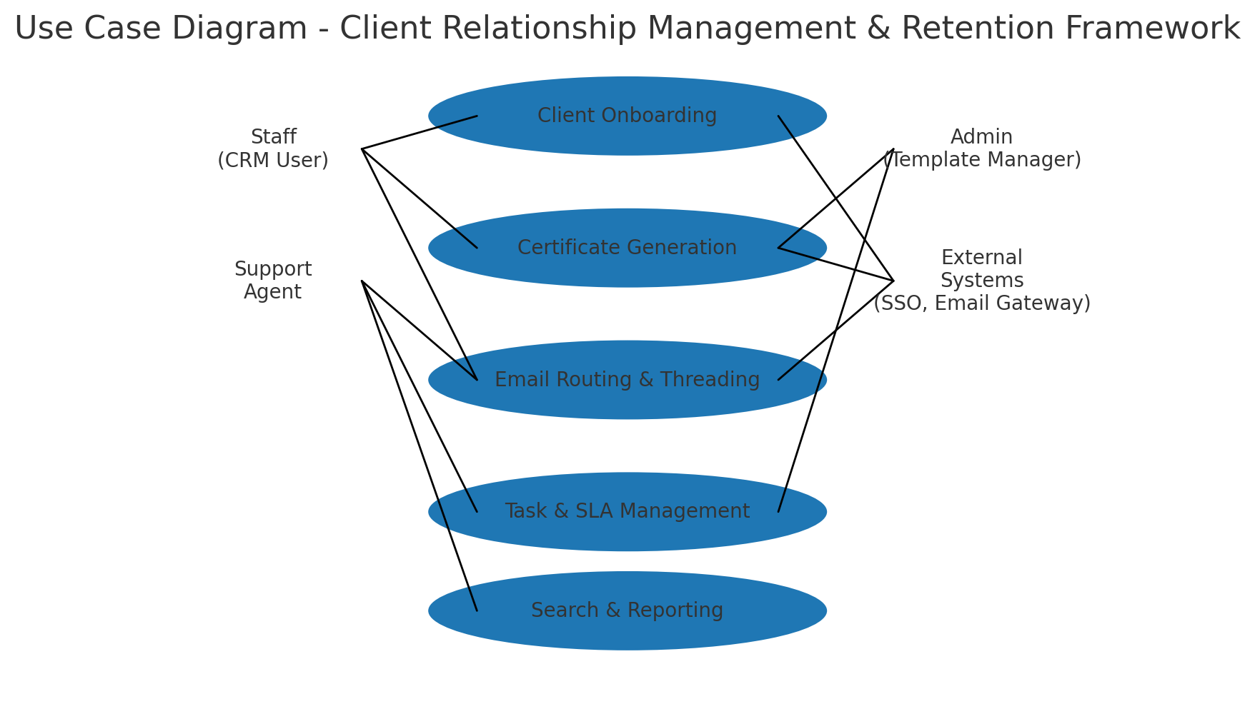

Activity Diagram
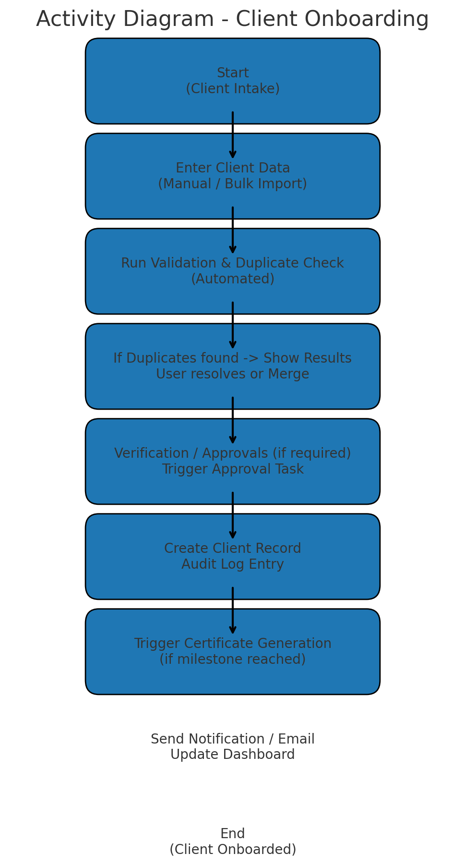

Use Case Specifications:
Use Case Name: Client Onboarding
Description: Create a new client record via manual entry or bulk import, validate data, resolve duplicates, and create initial tasks and certificates as applicable.
Actors: Primary Actors: Staff (CRM User), System (Data Importer)
Secondary Actors: Admin, Support Agent, External Systems (SSO, Billing)
Basic Flow:
1. Staff opens 'Create Client' form or uploads bulk import file.
2. System validates required fields and runs duplicate detection.
3. If duplicates not found or resolved, system saves client record and creates audit log.
4. System creates any required onboarding tasks and SLAs.
5. If onboarding milestone met, trigger certificate generation and notification.
6. System updates dashboards and notifies assigned owners.

Alternate Flows:
1. Staff saves a draft and returns later to complete data.
2. Bulk import produces a validation report; staff reviews failed rows and re-uploads corrected data.
3. Duplicate detected and staff chooses to merge, link or create a separate record after review.
Exceptional Flows:
1. Validation failures block save and show inline errors.
2. Import job fails due to malformed file — system emails the uploader and logs the error.
3. Approval required but approver not available — system queues the approval task and sends reminders.
Pre-Conditions:
- Staff is authenticated and authorised (RBAC).
- Template and mandatory field definitions configured by Admin.
- Bulk import files follow the prescribed schema.
Post-Conditions:
- Client record exists with unique client_id and audit trail.
- Onboarding tasks (if any) are created and assigned.
- Certificate issued if milestone conditions met; notification sent.
Assumptions:
- SMEs provide required template and field definitions prior to onboarding.
- Legacy data mapping availability for bulk migration.
- Email gateway reachable for notifications.
Constraints:
- RBAC restrictions apply to who can create/merge records.
- Bulk import file size and format limits.
- Waterfall delivery—changes to onboarding after sign-off require CR.
Dependencies:
- SSO service for authentication.
- Email gateway for notifications.
- Template engine for certificate generation.
Inputs and Outputs:
Inputs: Client profile data (name, contact, identifiers), documents, import CSV/Excel files
Outputs: Client record, audit log entry, onboarding tasks, notification emails, (optional) certificate PDF
Business Rules:
- Mandatory fields must be present before record creation.
- Duplicates must be reviewed before creating a new record.
- Only users with 'Admin' role may change template definitions.
Miscellaneous Information:
- UAT should include positive and negative test cases for imports and duplicate handling.
- Retention policy applies to client records as per compliance rules.

Use Case Name: Certificate Generation
Description: Automatically or manually generate a certificate PDF for a client when specific milestone conditions are met. Certificates use templates and data from client records.
Actors: Primary Actors: System (Certificate Engine), Staff (initiator)
Secondary Actors: Admin (Template Manager), External PDF Service
Basic Flow:
1. Triggered by onboarding milestone or manual request from Staff.
2. System selects appropriate template based on client type and context.
3. System populates template placeholders with client data and generates PDF.
4. System stores the certificate against client record and creates an audit log.
5. System sends certificate by email to client and notifies staff.

Alternate Flows:
1. Staff previews certificate and requests template changes (Admin reviews and updates template).
2. Bulk certificate generation for a batch of clients initiated by Admin.

Exceptional Flows:
1. Template contains missing placeholders — generation fails and system logs error.
2. Email delivery fails — certificate remains stored and a retry/sent-to-queue is marked.
Pre-Conditions:
- Template version exists and is active.
- Client record has all required data fields populated.
Post-Conditions:
- Certificate PDF saved and linked to client record.
- Notification sent; audit log recorded and certificate history updated.
Assumptions:
- Template content reviewed and approved by business SMEs.
- PDF service supports required fonts and encoding.
Constraints:
- Template edits require Admin privileges and maintain version history.
- Certificate generation performance limited by PDF service throughput.
Dependencies:
- Template engine / CMS
- Email gateway
- Storage service for attachments
Inputs and Outputs:
Inputs: Client data, selected template, generation trigger (event or manual)
Outputs: PDF certificate stored and emailed, audit log, notification
Business Rules:
- Only approved template versions are used for certificate generation.
- All certificates must include a unique cert_id and issue date.
Miscellaneous Information:
- Consider watermarking certificates in staging environments.
- Retention of certificates follows data retention policy.

Use Case Name: Email Routing & Threading
Description: Centralize incoming and outgoing client emails, link to client records, and maintain conversation threads within the CRM.
Actors: Primary Actors: Support Agent, Staff
Secondary Actors: System (Email Gateway), External Email Provider
Basic Flow:
1. Incoming email received by Email Gateway and forwarded to CRM.
2. CRM parses email, identifies client via email address or reference, and links to client timeline.
3. Email thread created or appended to existing thread; attachments stored.
4. Support Agent views thread in client timeline and replies using templates.
5. Outgoing replies are sent via Email Gateway and recorded in CRM.
Alternate Flows:
1. Unrecognized sender — system creates a new prospect record or flags for manual review.
2. High-priority email triggers SLA task creation and escalations.
Exceptional Flows:
1. Email parsing fails — email stored in quarantine for manual review.
2. Attachment exceeds size limits — attachment stored via link and reference added.
Pre-Conditions:
- Email gateway integration configured and authorised.
- Clients have registered contact emails.
Post-Conditions:
- Email stored against client; thread visible in timeline; attachments saved.
- SLA tasks created if required; notifications to assigned owners.
Assumptions:
- Email addresses are unique per client or mapping rules exist.
- Templates for common replies are maintained by Admin.
Constraints:
- Email retention policies and storage quotas.
- Parsing accuracy depends on email headers and consistent formats.
Dependencies:
- Email Gateway
- Client contact data accuracy
Inputs and Outputs:
Inputs: Incoming/outgoing emails, attachments, mapping rules
Outputs: Email threads, attachments stored, linked client timeline, SLA tasks
Business Rules:
- All client-related correspondence must be recorded within the CRM.
- Sensitive attachments must be redacted or stored in encrypted storage per policy.
Miscellaneous Information:
- Consider threaded view performance for clients with long histories.
- Provide opt-out for marketing communications per compliance rules.

Screens & Pages

Project: Client Relationship Management and Retention Framework
Prepared by: Nikhil H. Mali

Mockup Flow

- Home Page
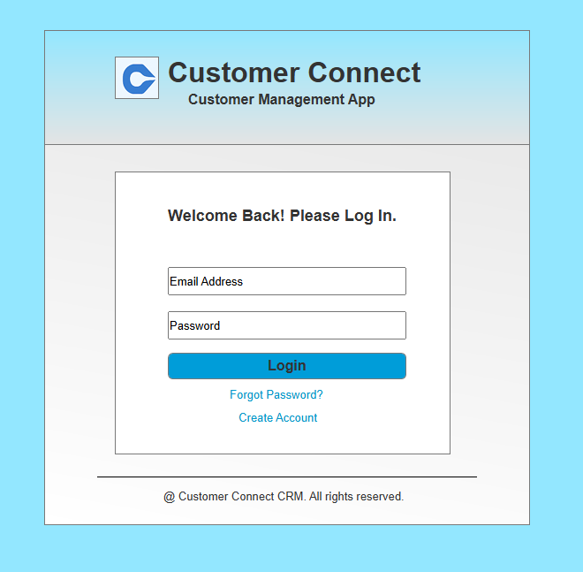

Notes:
- Support login.
- Provide 'Forgot password' and 'Create Account’ options.
Login Page
Purpose: Authenticate user to access personalized features.
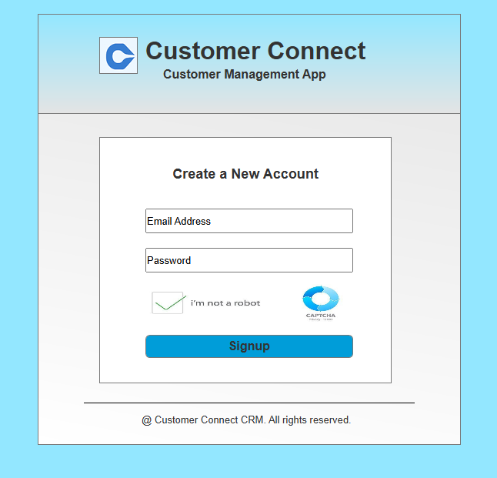
- Create Account

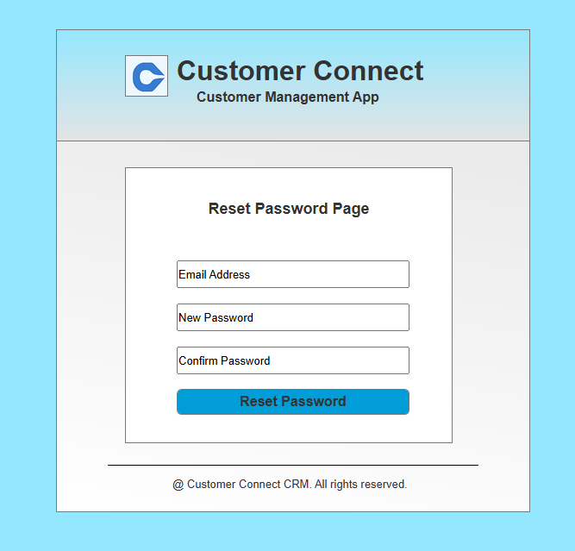
- Forgot Password

- Dashboard
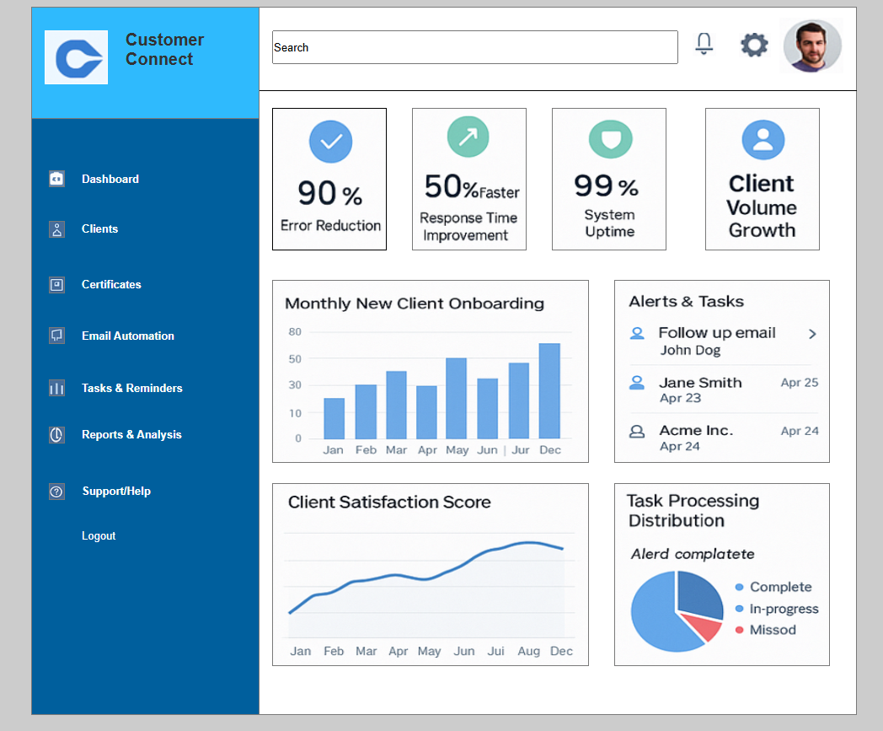

Notes:
- - Allow navigating to Clients, Certificates, Email Automation, Tasks & Reminders, Reports & Analysis & Help.
- - Redirect to Home after logout.
Add to Dashboard
Purpose: Allows navigating through various features.

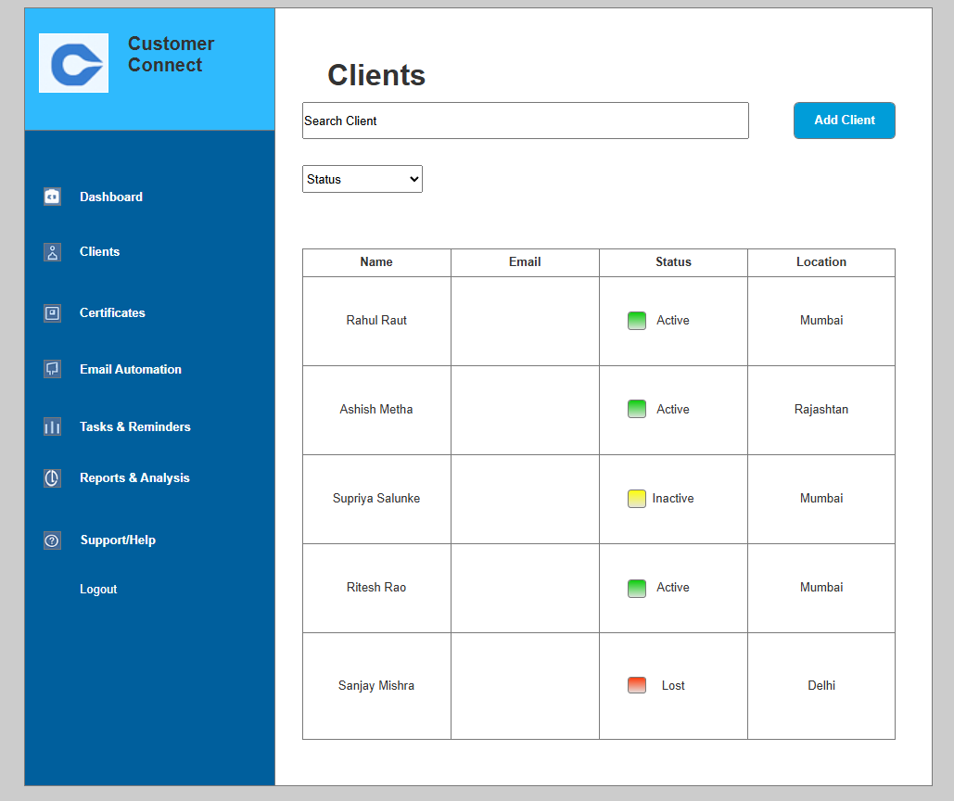
- Clients

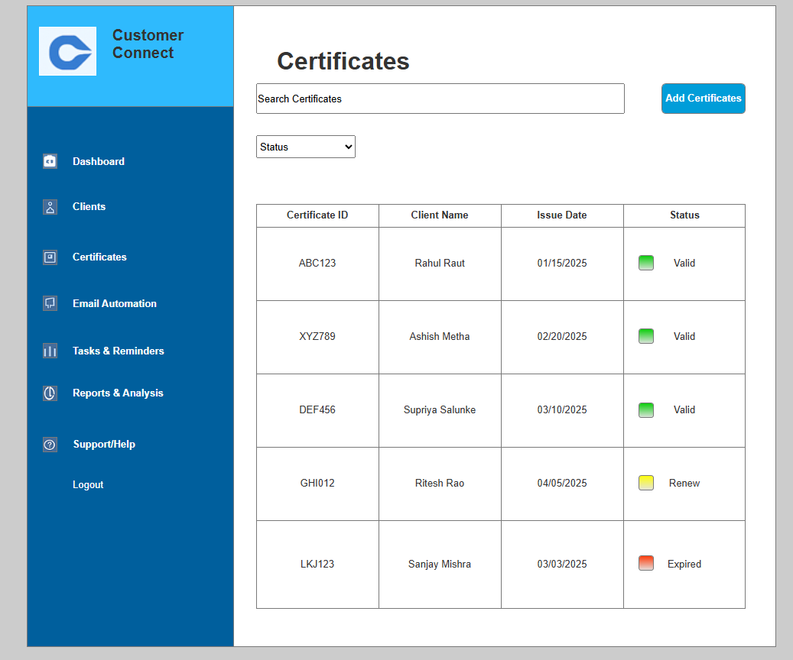
- Certificates

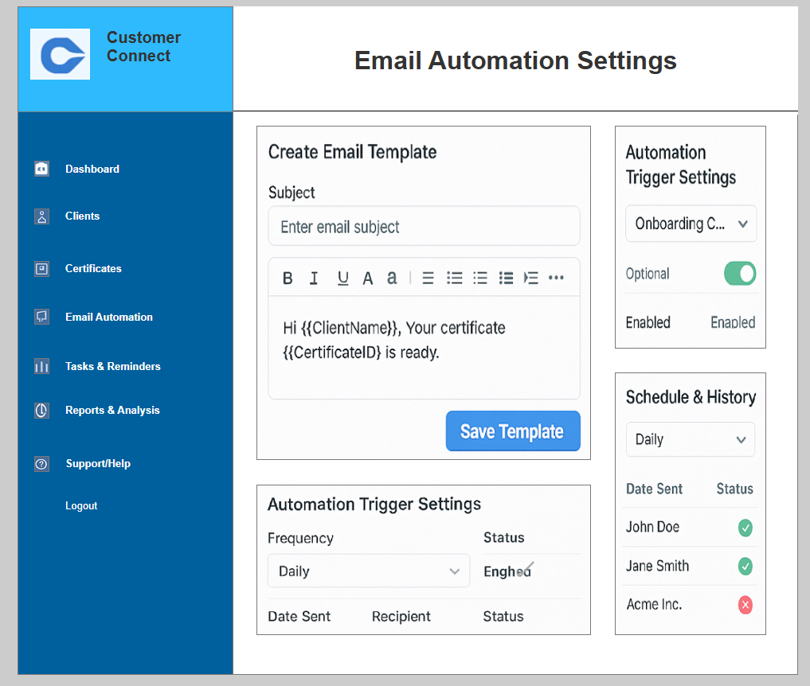
- Email Automation

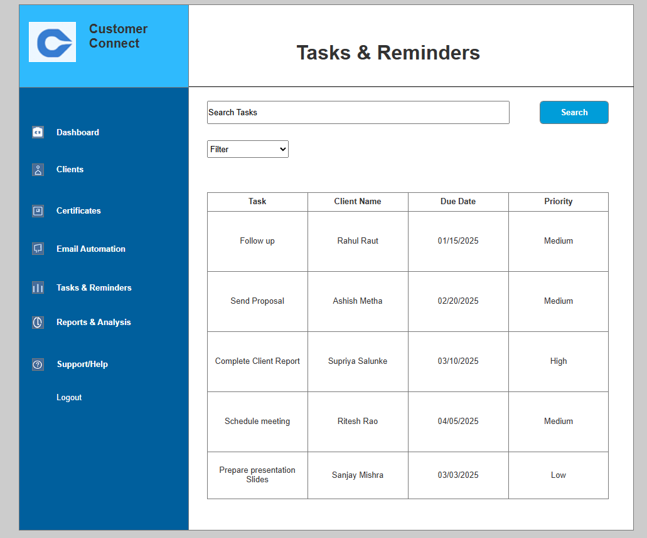
- Tasks & Reminders

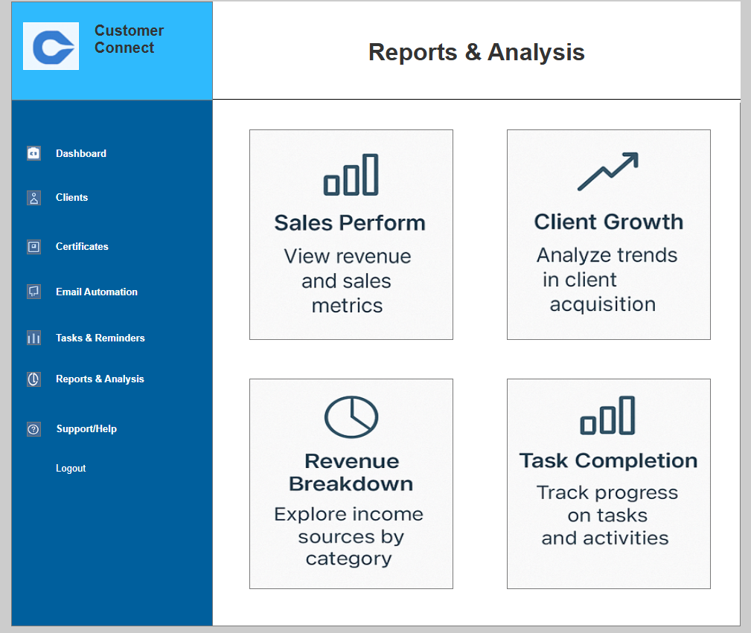
- Reports & Analysis

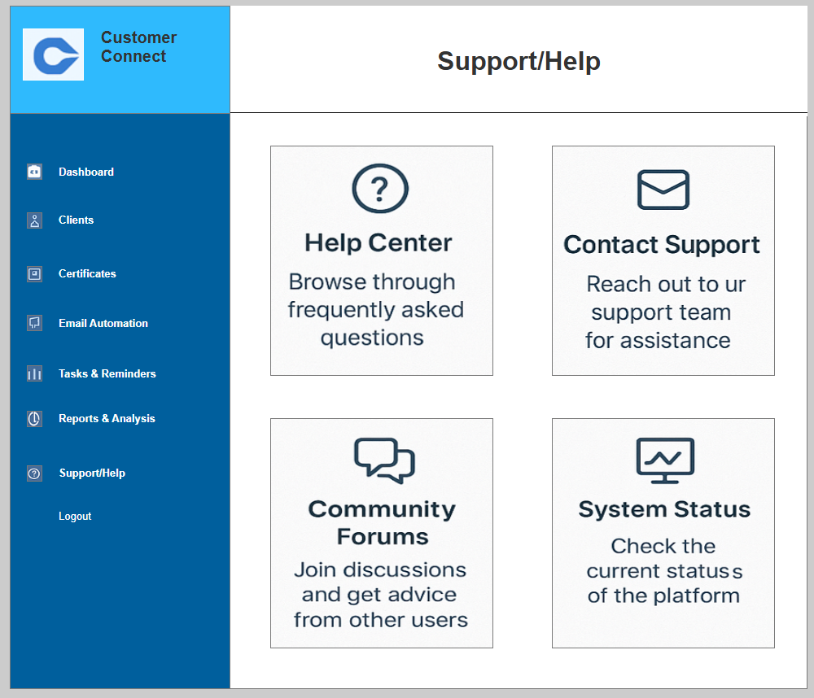
- Support/Help

Tools Experience
Overview: This document summarizes my practical experience using Microsoft Visio and Axure RP Pro 7.0 during the Client Relationship Management and Retention Framework project.
Microsoft Visio was my go-to tool for creating precise, standards-compliant diagrams such as UML use case diagrams, activity diagrams, and process flowcharts. I used Visio to model complex workflows, draw clear swimlane activity diagrams, and produce technical diagrams that were shared with architects and the development team. Visio's shape libraries and alignment/snapping features helped produce clean, printer-ready artifacts for inclusion in the BRS and SRS. I found Visio especially valuable when producing formal documentation that required a canonical, high-fidelity diagram style and where the output needed to be exported as vector images for presentations or inclusion in Word/PDF artifacts.
Axure RP Pro 7.0 (the version used on this project) was used to build interactive, high-fidelity prototypes that went beyond static wireframes. With Axure I created clickable flows for the critical user journeys (home → login → search → select → add-to-cart → payment → logout), used dynamic panels to simulate state changes, and annotated interactions for developers and testers. Axure's ability to generate an HTML prototype allowed stakeholders to interact with the design in a browser, significantly improving stakeholder understanding and accelerating approvals. Using Axure RP Pro 7.0, I also exported image assets and interaction specifications which were embedded into requirement documents and handed off to the dev team. Note: Axure RP Pro 7.0 is an older but stable release — it provided all core prototyping features needed for the project though it lacks some of the modern collaboration features present in newer releases.
Combined, Visio and Axure complemented each other well: Visio handled formal diagramming and documentation artifacts (UML, activity flows, RTM visuals), while Axure handled interactive prototypes and user validation. This dual-tool approach reduced ambiguity during requirements refinement, lowered rework during development, and improved the quality of UAT sessions. My workflow typically involved drafting process flows in Visio, iterating on wireframes, then translating them into Axure for interactive validation with stakeholders. The prototype exports and annotated widgets served as a direct reference for developers, QA, and client reviewers.

Additional Notes & Recommendations
- Keep a version-controlled folder for Axure .rp files and exported HTML snapshots for traceability.
- When using older Axure versions (like 7.0), export HTML prototypes and PNGs frequently to share with stakeholders who may not have Axure installed.
- Use Visio for final, formal diagrams included in SRS/BRS and use Axure for stakeholder demos and interaction specifications.
- Document interaction rules and widget properties inside Axure annotations to make handoff smoother for developers.
Prepared by: Nikhil H. Mali
Role: Business Analyst
Project: Client Relationship Management and Retention Framework

Business Analyst Experience: Client Relationship Management and Retention Framework

Prepared by: Nikhil H. Mali (Business Analyst)

Date: 16 August 2025

Summary
This document captures my hands-on Business Analyst experience across all SDLC phases for the Client Relationship Management and Retention Framework. It highlights the techniques used, decisions taken, typical challenges encountered and mitigation actions performed to keep the project on track.

1. Requirement Gathering
- Requirement elicitation primarily used the MoSCoW prioritization technique (Must, Should, Could, Won't) to align scope with business priorities.
- When the client was intermittently unavailable, I sourced alternate Points of Contact (PoCs) from the client organization to collect information and avoid schedule delays.
- Requirements validation used the FURPS model (Functionality, Usability, Reliability, Performance, Supportability) to ensure completeness and quality.
- Identified and removed duplicated or repeated requirements immediately to prevent scope creep and conflicting implementation.
- Used rapid prototyping (wireframes / mockups) to elicit more specific and testable requirements and to accelerate stakeholder alignment.

2. Requirement Analysis
- Converted requirements into visual UML artifacts (Use Case Diagrams, Class Diagrams where relevant) to provide a shared understanding of the system.
- Created Activity Diagrams to describe process flows and alternate/exception paths for clarity during design and testing.
- Communicated diagrams and requirements to cross-functional teams; accepted feedback and iterated diagrams where subject-matter experts or developers raised valid concerns.
- Prepared Business Requirement Specification (BRS) and Software Requirement Specification (SRS) documents, ensuring traceability to business objectives.

3. Design
- Derived test cases from use cases to ensure coverage from the early design phase — both positive and negative scenarios.
- Coordinated design and solution discussions with the client, capturing decisions in the design documents and obtaining sign-offs.
- Emphasized negative test case creation in addition to positive cases — a missed negative case can cause major defects later.
- Prepared test data to support functional and integration testing.
- Updated the Requirements Traceability Matrix (RTM) continuously to track requirement coverage across design, development and testing.

4. Development
- Organized and facilitated JAD (Joint Application Development) sessions to converge on solutions and clarify ambiguous requirements.
- Acted as the liaison between business stakeholders and the technical team — clarifying queries and unblocking developers during coding.
- Handled interpersonal challenges during JAD sessions gracefully: conducted one-on-one discussions with dissenting members, explained impact and aligned the team.
- Referred developers to UML and activity diagrams for accurate unit implementation and adherence to business logic.
- Conducted regular sync meetings with the technical team and the client. For stakeholders who missed meetings, I provided recordings and followed up with one-to-one sessions.

5. Testing
- Prepared functional test cases directly from use cases to ensure end-to-end scenario coverage.
- Performed high-level (smoke and sanity) testing to validate major flows before handing over to QA.
- Coordinated with client to request and obtain relevant test data required for realistic testing scenarios.
- Updated the RTM with testing outcomes and linked test cases to requirements for traceability.
- Organized and facilitated client sign-offs and prepared the organization for User Acceptance Testing (UAT).

6. Deployment
- Forwarded the final RTM to the client as part of the project closure package to demonstrate requirement coverage.
- Coordinated creation and distribution of end-user manuals and operational documentation.
- Planned and organized training sessions for end users and ensured attendance and engagement for successful adoption.
- Followed up to confirm that training participants completed required tasks and addressed any post-training queries.

Key Skills Demonstrated
- Requirement elicitation & prioritization (MoSCoW)
- Requirement validation (FURPS)
- UML modeling and process mapping (Use Case, Activity Diagrams)
- Documentation: BRS, SRS, RTM, Test Cases
- Stakeholder management and facilitation (JAD sessions, client coordination)
- Test planning support and UAT facilitation

Challenges & Mitigations
- Client unavailability causing delays — mitigated by identifying PoCs and asynchronous artifact reviews.
- Duplicate/ambiguous requirements — mitigated by requirement workshops, clean-up sessions and prototyping.
- Stakeholder resistance during JAD meetings — mitigated through one-on-one conversations and demonstrating impact.
- Gaps in test data — mitigated by proactively requesting datasets and preparing synthetic test data when needed.

Recommendations & Best Practices
- Maintain an up-to-date RTM from day one to avoid traceability gaps.
- Use prototypes and demos frequently to reduce ambiguity and accelerate approvals.
- Keep a prioritized requirements backlog using MoSCoW to manage scope during tight timelines.
- Document decisions and maintain version control for templates and artifacts (BRS/SRS/Design).

Appendix: Templates & Artifacts Mentioned
- MoSCoW prioritization template
- FURPS validation checklist
- Use Case template (Name, Description, Actors, Flows, Conditions, Business Rules)
- Activity Diagram examples
- BRS and SRS templates
- Requirements Traceability Matrix (RTM) template

