Question 1 – Functional Requirements:
Functional requirements are derived for every Business requirement. There might be multiple FR’s for a single BR.
BR01: | Enable farmers to discover and purchase agriculture products online.
FR ID | Functional Requirement | Priority
FR01.1 | The system shall allow farmers to browse all available products. | 10
FR01.2 | The system shall allow farmers to search for products by name, type, category, and keywords. | 10
FR01.3 | The system shall display product details such as price, quantity, description, manufacturer details, and stock availability. | 9
FR01.4 | The system shall allow farmers to add products to a shopping cart. | 8
FR01.5 | The system shall allow farmers to update quantities or remove items from the cart. | 6
FR01.6 | The system shall allow farmers to proceed to checkout and place an order. | 10
BR02: | Allow manufacturers to list and manage their products.
FR ID | Functional Requirement | Priority
FR02.1 | The system shall allow manufacturers to upload new product details. | 8
FR02.2 | The system shall allow manufacturers to update product price, stock, and description. | 8
FR02.3 | The system shall allow manufacturers to delete or disable a product. | 6
FR02.4 | The system shall allow manufacturers to view all their listed products in a dashboard. | 7
BR03: | Support farmer and manufacturer onboarding
FR ID | Functional Requirement | Priority
FR03.1 | The system shall allow users to register using mobile number or email. | 10
FR03.2 | The system shall verify user identity using OTP/email verification. | 10
FR03.3 | The system shall allow users to log in using email/mobile + password. | 10
FR03.4 | The system shall allow users to update their profile details such as name, address, and contact information. | 7
FR03.5 | The system shall allow users to reset their password. | 8
BR04: | Ensure secure access control for all user types.
FR ID | Functional Requirement | Priority
FR04.1 | The system shall restrict access to pages based on the user role. | 9
FR04.2 | The system shall lock accounts after multiple failed login attempts. | 7
FR04.3 | The system shall log all user login and logout activities. | 6
BR05: | Provide a seamless purchasing experience.
FR ID | Functional Requirement | Priority
FR05.1 | The system shall guide the user through a checkout process (cart → address → payment → confirmation). | 9
FR05.2 | The system shall allow users to save delivery addresses. | 7
FR05.3 | The system shall allow users to review order details before confirming. | 8
FR05.4 | The system shall generate an order confirmation screen after purchase. | 10
BR06: | Support safe and accessible payment options.
FR ID | Functional Requirement | Priority
FR06.1 | The system shall support UPI, Debit/Credit Cards, Net Banking, and COD. | 10
FR06.2 | The system shall validate payment details before processing the transaction. | 10
FR06.3 | The system shall integrate with a secure payment gateway. | 10
FR06.4 | The system shall display payment success or failure messages. | 9
FR06.5 | The system shall record payment transaction IDs. | 8
BR07: | Keep farmers informed about order processing and updates.
FR ID | Functional Requirement | Priority
FR07.1 | The system shall send SMS/email notifications when an order is placed. | 9
FR07.2 | The system shall send notifications when an order is packed, shipped, and delivered. | 9
FR07.3 | The system shall notify users about failed payments or cancelled orders. | 7
BR08: | Provide visibility and transparency in order fulfillment.
FR ID | Functional Requirement | Priority
FR08.1 | The system shall provide realtime order tracking in his account | 9
FR08.2 | The system shall display order status such as Placed, Packed, Shipped, Out for Delivery, Delivered. | 9
FR08.3 | The system shall allow users to view past orders and order history. | 8
BR09: | Enable administrators to manage platform operations effectively.
FR ID | Functional Requirement | Priority
FR09.1 | The system shall allow the admin to view and manage all users. | 10
FR09.2 | The system shall allow the admin to approve, edit, or remove manufacturer accounts. | 8
FR09.3 | The system shall allow the admin to view and manage all products. | 9
FR09.4 | The system shall allow the admin to view all transactions and orders. | 9
FR09.5 | The system shall allow the admin to generate reports (sales, user activity, product demand). | 7
BR10: | Maintain complete transaction and order documentation for audit and reporting.
FR ID | Functional Requirement | Priority
FR10.1 | The system shall store all order details including product, quantity, price, and user information. | 10
FR10.2 | The system shall store payment records including transaction IDs, timestamps, and payment mode. | 10
FR10.3 | The system shall allow admins to download order history and transaction data. | 8
FR10.4 | The system shall maintain invoices for every completed order. | 9

Question 2–Minimum 5-page designs

Balsamiq: Wireframing Tool

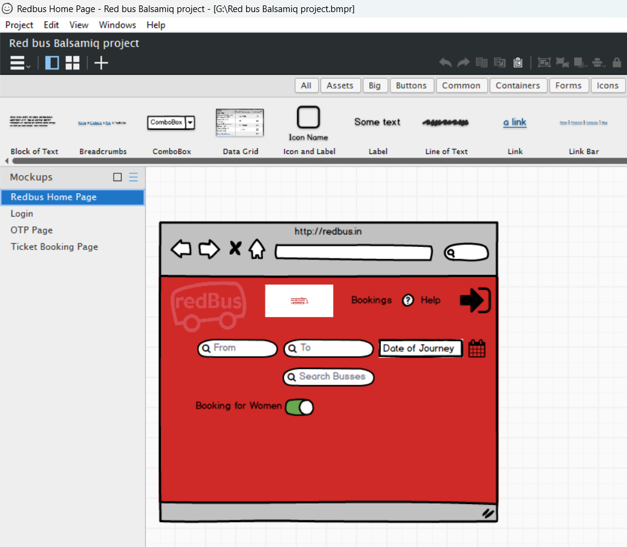

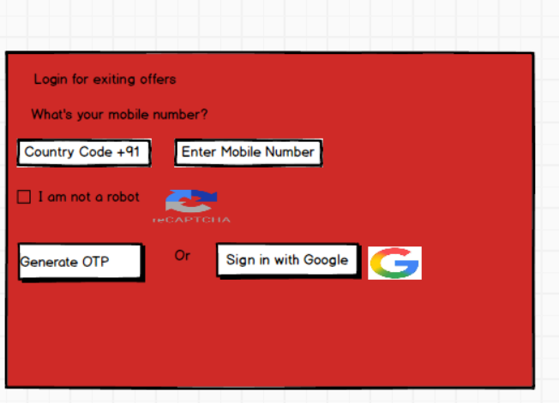

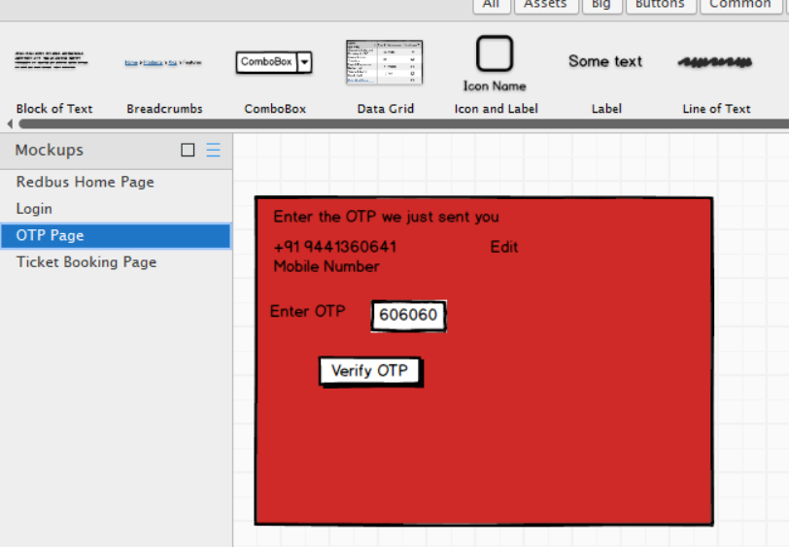

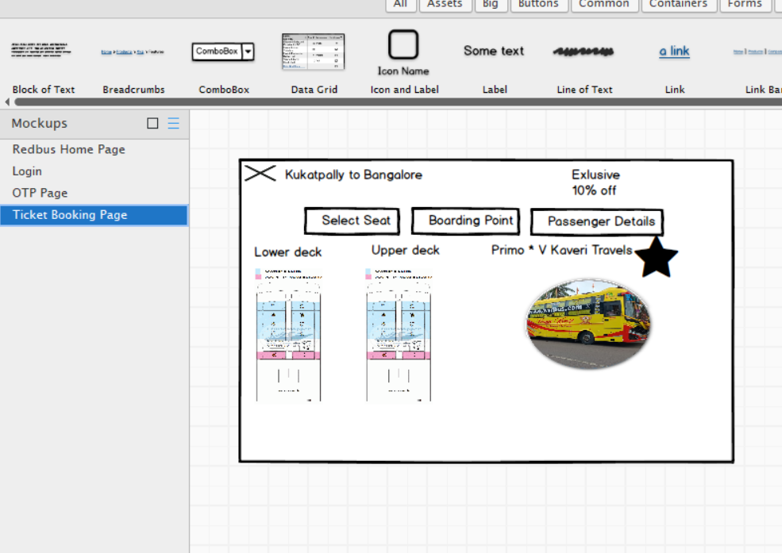

Axure RP
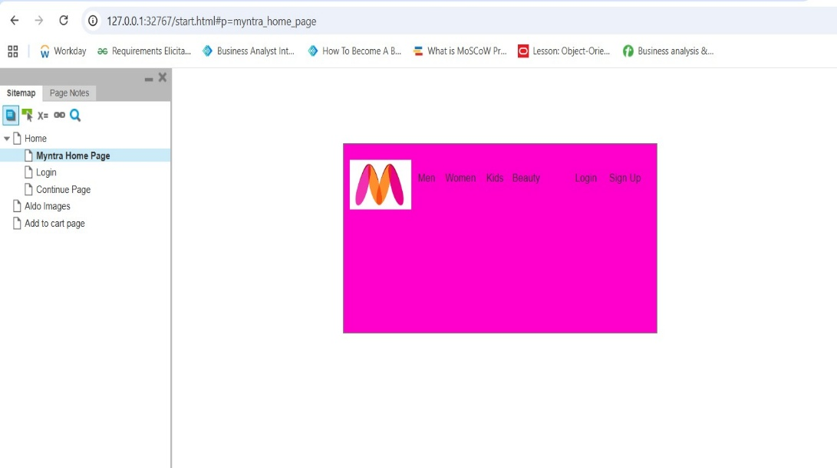

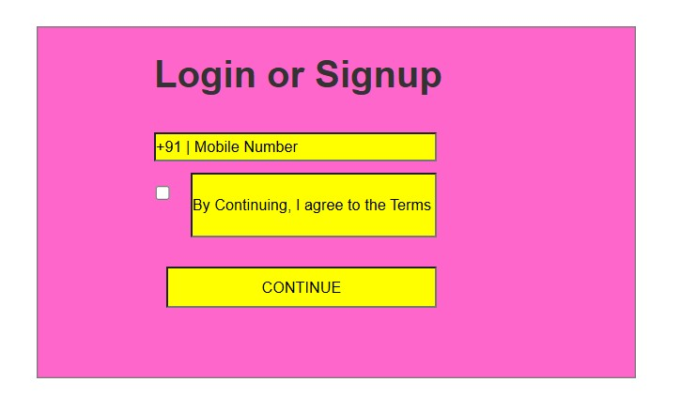

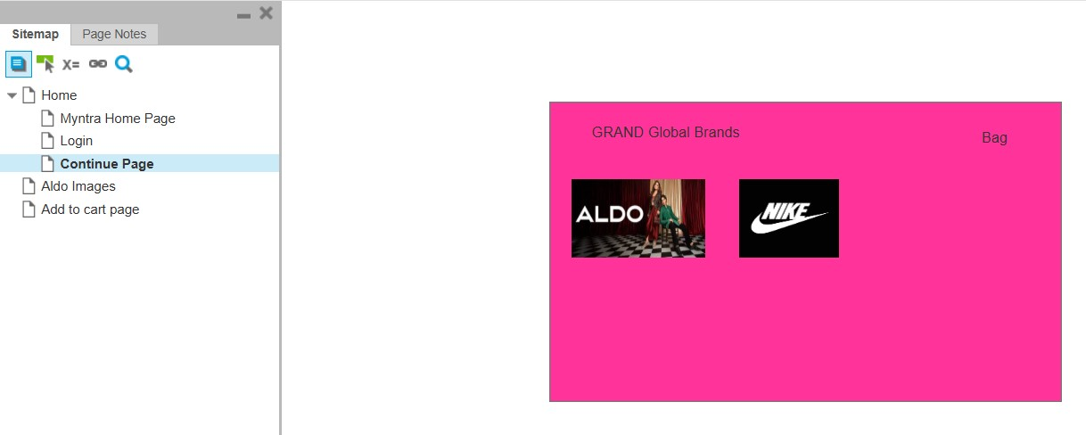

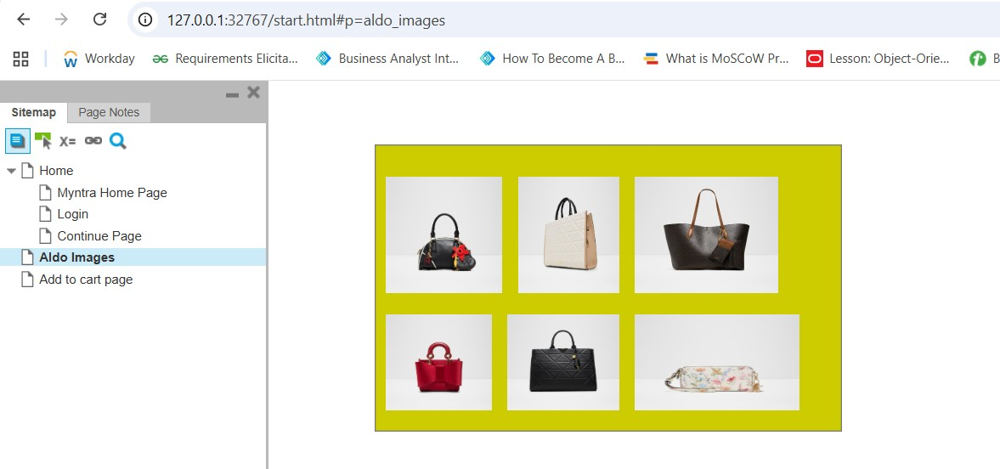

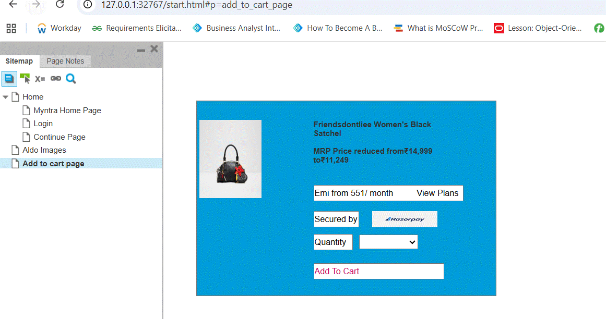

Question 3 – Tools (Visio, Balsamiq, Axure RP):
- I use Visio for diagramming activities, use cases, and process flows. It helps me visually represent system behaviour using components like actions, decisions, swim lanes, actors, use cases, and associations.
- For UI work, I use Balsamiq to create low-fidelity wireframes. It’s fast, sketch-like, and good for showing layout, but it’s not interactive.
- For advanced simulations, I use Axure RP, which supports interactive, high-fidelity prototypes that behave like real applications. It’s great for walkthroughs and validating user experience
Visio:
Visio is a diagramming tool used to create structured visuals like activity diagrams, use case diagrams, flowcharts. It helps Business Analysts represent flows clearly so stakeholders and developers understand the system behavior.
In Visio, I typically create Activity Diagram that shows the step-by-step flow of a process.
Components involved in Activity Diagram:
- Start node – Start node is represented with black circle
- Actions state / state- Represented with round edge rectangles
- Control Flow- connected between one state to another state
- Decision Box- To take decision Yes or No
- Fork & Join - Fork is a point where one action splits into multiple actions that run in parallel or simultaneously. All these parallel actions must complete, and they later join back into a single flow at the Join (It’s an AND Condition)
- Branch & Merge - Branch and Merge represent a decision point where the workflow splits into multiple alternative paths, but only one path is executed based on a condition or user choice. These alternative paths finally merge into a single common flow (It’s an OR Condition)
- End node – End note represents final steps in the activity
Use Case Diagram
Shows actors and how they interact with system functionalities.
Components involved in Use case Diagram:
- Actors (Primary & Secondary)
- Use Cases
- Relationships
- System Boundary
Relationships are of 4 types:
- Associations (lines between actor ↔ use case)
- Include (Mandatory Dependency)
- Extend (Optional Behaviour)
- Generalization (Inheritance, it is also referred to as Is a kind of. In simple terms a child actor inherits the properties of parent)
Balsamiq
Balsamiq is a low-fidelity wireframing tool used to sketch the layout of screens. It focuses on structure and content, not design.
Key points:
- Used for wireframes, not detailed UI
- Looks hand drawn
- Helps in early requirement discussions
- Shows what goes where on the screen
- Not interactive → Buttons don’t work in real-time
Axure RP
Axure RP is a high-fidelity prototyping tool that allows a Business Analyst or a UI designer to create interactive, clickable screens that behave like a real application.
Key points:
- Used for prototypes, not just wireframes
- Supports interactions:
- Button clicks
- Navigation
- Pop-ups
- Simulated forms
- Helps stakeholders experience the flow before development
- Good for demos, UAT discussions, and validating requirements
Question 4 – RTM
In the RTM, we don’t write the actual test case steps. We only reference the Test Case IDs to show traceability. The purpose of the RTM is to map Business Requirements to Functional Requirements, Use Cases, and the corresponding Test Case IDs. The detailed test cases are written separately by the QA team
BR01: Enable farmers to discover and purchase agriculture products online
BR ID | FR ID | FR Description | UC ID | Use Case Name | TC ID | Status
BR01 | FR01.1 | Browse products | UC01 | Browse Products | TC001 | In Progress
BR01 | FR01.2 | Search products | UC02 | Search Products | TC002 | Not Started
BR01 | FR01.3 | View product details | UC03 | View Product Details | TC003 | In Progress
BR01 | FR01.4 | Add to cart | UC04 | Add to Cart | TC004 | Not Started
BR01 | FR01.5 | Update/remove cart items | UC05 | Manage Cart | TC005 | Not Started
BR01 | FR01.6 | Checkout & place order | UC06 | Checkout & Place Order | TC006 | Not Started

BR02: Allow manufacturers to list and manage their products
BR ID | FR ID | FR Description | UC ID | Use Case Name | TC ID | Status
BR02 | FR02.1 | Upload new product | UC07 | Upload Product | TC007 | Not Started
BR02 | FR02.2 | Update product info | UC08 | Edit Product | TC008 | Not Started
BR02 | FR02.3 | Delete/disable product | UC09 | Manage Product Visibility | TC009 | Not Started
BR02 | FR02.4 | View listed products | UC10 | View Manufacturer Products | TC010 | Not Started

BR03: Support onboarding & profile management
BR ID | FR ID | FR Description | UC ID | Use Case Name | TC ID | Status
BR03 | FR03.1 | User registration | UC11 | Register User | TC011 | Completed
BR03 | FR03.2 | OTP/email verification | UC12 | Verify User | TC012 | In Progress
BR03 | FR03.3 | Login | UC13 | Login | TC013 | Completed
BR03 | FR03.4 | Update profile | UC14 | Update Profile | TC014 | Not Started
BR03 | FR03.5 | Reset password | UC15 | Reset Password | TC015 | Not Started

BR04: Ensure secure access control

BR ID | FR ID | FR Description | UC ID | Use Case Name | TC ID | Status
BR04 | FR04.1 | Role-based login | UC16 | Role-Based Access | TC016 | Completed
BR04 | FR04.2 | Role restriction | UC17 | Access Control | TC017 | Completed
BR04 | FR04.3 | Account lockout | UC18 | Account Lock | TC018 | Not Started
BR04 | FR04.4 | Login activity logging | UC19 | Login Audit | TC019 | Not Started

BR05: Provide a seamless purchasing experience

BR ID | FR ID | FR Description | UC ID | Use Case Name | TC ID | Status
BR05 | FR05.1 | Guided checkout | UC20 | Checkout Flow | TC020 | Not Started
BR05 | FR05.2 | Save delivery address | UC21 | Manage Address | TC021 | Not Started
BR05 | FR05.3 | Review order | UC22 | Review Order | TC022 | Not Started
BR05 | FR05.4 | Order confirmation | UC23 | Order Confirmation | TC023 | Not Started

BR06: Support safe and accessible payment options

BR ID | FR ID | FR Description | UC ID | Use Case Name | TC ID | Status
BR06 | FR06.1 | Multiple payment methods | UC24 | Select Payment Method | TC024 | Not Started
BR06 | FR06.2 | Validate payment details | UC25 | Validate Payment | TC025 | Not Started
BR06 | FR06.3 | Secure payment gateway | UC26 | Process Payment | TC026 | Not Started
BR06 | FR06.4 | Payment success/failure | UC27 | Payment Response | TC027 | Not Started
BR06 | FR06.5 | Record transaction | UC28 | Save Transaction | TC028 | Not Started

BR07: Keep farmers informed about order updates
BR ID | FR ID | FR Description | UC ID | Use Case Name | TC ID | Status
BR07 | FR07.1 | Order placed notification | UC29 | Notify Order Created | TC029 | Completed
BR07 | FR07.2 | Order progress notifications | UC30 | Notify Order Status | TC030 | In Progress
BR07 | FR07.3 | Failed/cancel notification | UC31 | Notify Order Issues | TC031 | Not Started

BR08: Provide visibility in order fulfilment

BR ID | FR ID | FR Description | UC ID | Use Case Name | TC ID | Status
BR08 | FR08.1 | Real-time tracking | UC32 | Track Order | TC032 | Not Started
BR08 | FR08.2 | Order status view | UC33 | Order Status View | TC033 | Not Started
BR08 | FR08.3 | Order history | UC34 | View Order History | TC034 | Not Started

BR09: Enable admin management

BR ID | FR ID | FR Description | UC ID | Use Case Name | TC ID | Status
BR09 | FR09.1 | Manage users | UC35 | Manage Users | TC035 | In Progress
BR09 | FR09.2 | Manage manufacturer accounts | UC36 | Manage Manufacturer Accounts | TC036 | Not Started
BR09 | FR09.3 | Manage products | UC37 | Manage Products | TC037 | Not Started
BR09 | FR09.4 | View transactions | UC38 | View Transactions | TC038 | Not Started
BR09 | FR09.5 | Reports/analytics | UC39 | Generate Reports | TC039 | Not Started

BR10: Maintain audit trail & documentation

BR ID | FR ID | FR Description | UC ID | Use Case Name | TC ID | Status
BR10 | FR10.1 | Store order details | UC40 | Save Order Details | TC040 | Completed
BR10 | FR10.2 | Store payment records | UC41 | Save Payment Records | TC041 | Completed
BR10 | FR10.3 | Download transaction history | UC42 | Download Reports | TC042 | Not Started
BR10 | FR10.4 | Maintain invoices | UC43 | Generate Invoice | TC043 | In Progress

Question 5: Test Case Documents
A Test Case is a set of actions or conditions written to verify whether a specific feature of a software application works correctly.
TC001 – User Registration
Field | Description
Test Case ID | TC001
Test Scenario | User Registration
Precondition | User should be on Registration Page
Test Steps | 1. Enter valid email
 | 2. Enter password
 | 3. Click Register
 | 4. Enter OTP
 | 5. Click Verify
Expected Result | User account should be created

TC002- Login
Test Case ID | TC002
Test Scenario | Login
Precondition | User account should exist
Test Steps | 1. Enter email
 | 2. Enter password
 | 3. Click Login
Expected Result | User should successfully log in

TC003 – Product Search

Field | Description
Test Case ID | TC003
Test Scenario | Search Products
Precondition | Products should be available
Test Steps | 1. Enter product name2. Click Search
Expected Result | Relevant products should be displayed

TC004 – View Product Details

Field | Description
Test Case ID | TC004
Test Scenario | View Product Details
Precondition | Search results must show products
Test Steps | 1. Click a product
Expected Result | Product details page should open

TC005 – Add to Cart

Field | Description
Test Case ID | TC005
Test Scenario | Add to Cart
Precondition | User should be logged in
Test Steps | 1. Open product page2. Click Add to Cart
Expected Result | Product should be added to cart

TC006 – Remove from Cart

Field | Description
Test Case ID | TC006
Test Scenario | Remove Item from Cart
Precondition | Cart must have a product
Test Steps | 1. Open cart
 | 2. Click Remove
Expected Result | Product should be removed

TC007 – Checkout

Field | Description
Test Case ID | TC007
Test Scenario | Checkout Process
Precondition | Cart must have items
Test Steps | 1. Open cart
 | 2. Click Checkout
 | 3. Select address
Expected Result | User should navigate to payment page

TC008 – Payment (UPI)

Field | Description
Test Case ID | TC008
Test Scenario | Make Payment
Precondition | User at payment page
Test Steps | 1. Select UPI
 | 2. Enter UPI ID
 | 3. Confirm payment
Expected Result | Payment success message should appear

TC009 – Order Tracking

Field | Description
Test Case ID | TC009
Test Scenario | Track Order
Precondition | Order must exist
Test Steps | 1. Go to My Orders
 | 2. Click Track
Expected Result | Order status should be displayed

TC010 – Manufacturer Upload Product

Field | Description
Test Case ID | TC010
Test Scenario | Upload Product
Precondition | Manufacturer must be logged in
Test Steps | 1. Open Add Product
 | 2. Enter product details
 | 3. Upload image
 | 4. Submit
Expected Result | Product should be added to catalog

Question 6: DB Design:
- A database schema is the blueprint or structure of a database.
- It tells what tables exist, what columns each table has, what data types those columns store, and how tables are connected to each other.
Primary Key:
Primary Key ensures that no two rows in a table have the same value for that column. it is always unique.
Let’s consider Aadhar number as the example
- It is unique for every person → No two people have the same Aadhaar number.
- It cannot be blank → You can’t exist in the system without an Aadhaar number.
- It acts as the identity → When someone searches for your Aadhaar number, your exact record is found.
Hence, Aadhar number is the primary key.
Foreign Key: Foreign Key is used to create a relationship between two tables.
It Points to the Primary Key of another table

Example for Foreign Key in Student System
Table 1: Students
Student ID | Name
1 | Aravind
2 | Vijay
3 | Kiran

Student ID is the primary key in the above table
Table 2: Marks
Marks ID | Student Id | Subject Name | Marks
10 | 1 | Maths | 97
11 | 2 | Physics | 65
12 | 3 | Biology | 56

Mark ID is the primary key and Student ID is the foreign key because Foreign key connects marks to students

TABLE: Users

Column | Type | Constraint
UserID | INT | PRIMARY KEY
Name | VARCHAR
Email | VARCHAR | UNIQUE
Mobile | VARCHAR
Password | VARCHAR
Role | VARCHAR | Farmer / Manufacturer / Admin
CreatedDate | DATETIME

TABLE: Manufacturers

Column | Type | Constraint
ManufacturerID | INT | PRIMARY KEY
UserID | INT | FOREIGN KEY REFERENCES Users(UserID)
CompanyName | VARCHAR
GSTNumber | VARCHAR

TABLE: Category

Column | Type | Constraint
CategoryID | INT | PRIMARY KEY
CategoryName | VARCHAR

TABLE: Product

Column | Type | Constraint
ProductID | INT | PRIMARY KEY
ManufacturerID | INT | FOREIGN KEY REFERENCES Manufacturers(ManufacturerID)
CategoryID | INT | FOREIGN KEY REFERENCES Categories(CategoryID)
ProductName | VARCHAR
Description | TEXT
Price | DECIMAL
Stock | INT
ImageURL | VARCHAR

TABLE: Cart

Column | Type | Constraint
CartID | INT | PRIMARY KEY
UserID | INT | FOREIGN KEY REFERENCES Users(UserID)
ProductID | INT | FOREIGN KEY REFERENCES Products(ProductID)
Quantity | INT

TABLE: Orders
Column | Type | Constraint
OrderID | INT | PRIMARY KEY
UserID | INT | FOREIGN KEY REFERENCES Users(UserID)
AddressID | INT | FOREIGN KEY REFERENCES Addresses(AddressID)
OrderDate | DATETIME
Status | VARCHAR

TABLE: Payments
Column | Type | Constraint
PaymentID | INT | PRIMARY KEY
OrderID | INT | FOREIGN KEY REFERENCES Orders(OrderID)
Amount | DECIMAL
PaymentMethod | VARCHAR | UPI / COD / Card
TransactionID | VARCHAR
PaymentStatus | VARCHAR | Success / Failed

ER Diagram:
An Entity Relationship (ER) Diagram is a visual representation of the data model that shows:
- Entities (tables)
- Attributes (fields/columns)
- Relationships (how tables are connected)

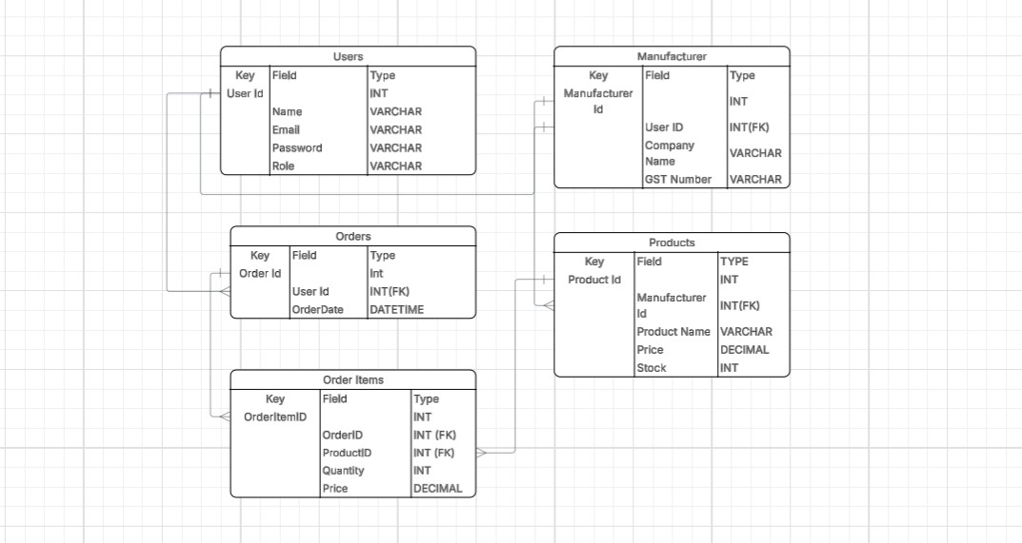

One User → One Manufacturer (A manufacturer must first register as a user, so every manufacturer corresponds to exactly one user account.)
One Manufacturer → Many Products (A manufacturer can list multiple products for sale, but every product belongs to only one manufacturer.)
One User → Many Orders (A user (farmer) can place multiple orders, but each order is linked to one user only.)
One Order → Many OrderItems (An order can contain multiple products, so each order has multiple line items.)
One Product → Many OrderItems (The same product can appear inside many different orders (purchased by different users)

Question 7 – Data Flow Diagram:
A Data Flow Diagram (DFD) is used to represent the flow of data between processes, data stores, and external entities in a system.
The below DFD shows how a Farmer places an order in the Agriculture Product Store system.
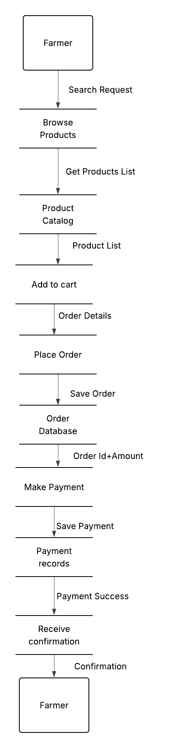
Question 8 – Change Request
Due to change in the Government Taxation structure, we should change the Tax structure.
How do you handle change requests in a project?
Answer: How I Handle Change Requests
When a change request comes in, such as changing the tax structure due to new government rules, I follow these steps:

1. Understand the Change
- First, I talk to the person who raised the request (like Mr. Henry or the finance head) to understand exactly what needs to change.
- In this case, the tax rate may have increased or changed for some products.

2. Document the Request
- I write down what the change is about — for example:

"Change the tax calculation for all products as per new rules."

3. Discuss with the Team
- I tell the project manager and the technical team (developers, testers) about this change.
- Together, we find out how much time it will take and what parts of the system it will affect.

4. Analyse Impact

I check how this change will impact:
- The cost (extra development time)
- The project timeline
- Other features

5. Get Approval
- I share the findings with the client or decision-making team.
- They decide whether to accept the change or not.

6. Implement the Change
- If approved, the development team makes the changes in the system.
- QA team tests the new tax calculation to make sure it works properly.

7. Update Documents
- I update the requirements and other documents to include this change.
- I also track it in a change log.

8. Inform Stakeholders
- Once the change is done and tested, I inform the client and stakeholders that it’s completed.

Question 9 – Change Request Vs Enhancement
Ben and Kevin’s request is asking to add new features to the project. Originally, this application was only meant to let farmers buy fertilizers, seeds, and pesticides. Now they want to let farmers sell their own crops and even have an auction system.
This is not just a small change to an existing function; it's a new feature that expands the scope of the system. To be specific, this is an enhancement.
Question 10: Come up with estimations – How many Manhours required
- The project duration: 18 months
- Involvement of multiple roles (Developer, Tester, BA, Project Manager, etc.)
- Working hours per month: 160 hours (8 hrs x 20 working days)
Team Size: 11 members that includes 1 BA, 1 Project Manager, 5 Java Developers, 2 Testers, 1 DB Admin and 1 Network Admin
Role | Number of People | Hours per Month | Duration | Total Manhours
Business Analyst | 1 | 160 hrs | 18 months | 2,880 hrs
Project Manager | 1 | 160 hrs | 18 months | 2,880 hrs
Developers (Java) | 5 | 160 hrs | 18 months | (5 × 160 × 18) = 14,400 hrs
Testers | 2 | 160 hrs | 18 months | (2 × 160 × 18) = 5,760 hrs
DB Admin | 1 | 80 hrs* | 18 months | 1,440 hrs
Network Admin | 1 | 40 hrs* | 18 months | 720 hrs
Total Project Manhours | 11 | 760 hours per Month | 18 months fixed | 28080 hours

Total Estimated Manhours for the project= 20080 hours
Question 11 – UAT (User Acceptance Testing)
Once the project is finished (design, development, testing), it’s time to let the client check the system. I will handle it like this:
1. Inform the Client:
I will contact Mr. Henry and tell him that the application is ready for testing. I will explain that this is the final test before going live.
2. Share Test Scenarios:
I will give them a list of things they should try — like:
- Logging in as a farmer
- Searching for a product
- Placing an order
- Making a payment
- Checking order status
These are based on real use cases.
3. Support During Testing:
I will be available while they test in case, they face any issues or don’t understand something. If they find any mistakes (bugs), I will tell the developers to fix it.
4. Get Approval (Sign-off):
After they finish testing and are happy with the system, they will give me a UAT Sign-off. This indicates that the system meets their expectations.
5. Project Closure:
Once UAT is signed off:
- I will prepare the project closure document
- Summarize what we delivered
- Share it with the client for final approval
- Close the project officially

Question12: Project Closure Document

- Project Details:
Project Name | Online Agriculture Product Store
Project Sponsor | Mr. Henry
Client Company | SOONY
Project Vendor | APT IT Solutions
Project Duration | 18 Months
Budget | 2 Crores INR

- Project Summary:
This project aimed to build a Web & Mobile Application for farmers in remote areas to buy fertilizers, seeds, and pesticides directly from manufacturers. It was undertaken as part of a CSR initiative by SOONY and successfully completed as per agreed requirements.
- Deliverables:
Deliverable | Delivered | Accepted
Farmer Registration Module | Done | Done
Product Catalog (Seeds, Fertilizers, Pesticides) | Done | Done
Search and Filter Functionality | Done | Done
Payment Gateway Integration | Done | Done
Delivery Tracking System | Done | Done
UAT Sign-off | Done | Done

- Final Outcome:
- All scope items were completed and accepted by the client.
- The application has passed all required test phases, including UAT.
- The system was deployed in the production environment and is now live for use.

- Project Evaluation
Planned | Actual
Timeline: 18 months | Timeline: 18 months
Budget: 2 Crores INR | Budget: Within limit
- Outstanding Tasks / Follow-ups
No pending tasks. All requirements covered.
7. Lessons Learned
- Early stakeholder involvement helps in clear requirement gathering.
- Regular reviews during development ensured fewer defects at UAT.
- Communication between client and development teams was smooth and timely.
8. Client Acknowledgment
We, the undersigned, confirm that:
- All objectives and deliverables of the project have been satisfactorily completed.
- The project is formally closed.
Name | Role | Signature / Date
Mr. Henry | Project Sponsor (SOONY)
Mr. Vandanam | Project Manager (APT)
Aravind Joshyam | Business Analyst | 16th Nov 2025

