Project Title: Travel and Compliance Hub

Document 1: Definition of Done (DOD)
The Definition of Done (DoD) is a checklist we used to ensure that every user story meets quality and completeness standards before marking it complete. Our DoD includes:

- User Story acceptance criteria met
- Code developed and tested
- QA validated the feature
- Product Owner approval
- Unit tests written and passed
- Feature deployed on test server
- Peer code review completed
- Documentation updated
- No critical bugs
- UI reviewed by UX Designer
- Work integrated with existing modules
- Security compliance check passed
- Performance testing completed
- Feature flagged (if rollout needed)
- Code coverage maintained above 80%
- Sprint demo conducted
- Code committed and pushed to repository
- All linked Jira tasks moved to "Done"

Document 2: Product Vision
Scrum Project Name: | Travel and Compliance Hub
Venue: | Pune
Date: | 14-07-2025 |  | Duration: 2 Weeks
Client: | World Foods LLP
Stakeholder list: | Amit Dhanyakumar Chordia (Project Sponsor) | Vickykumar Sancheti (Scrum Master) | Kunal Kadambande (Product Owner)
 | HR Department Representative | Admin Department Representative
Scrum Team
Scrum Master: | Vickykumar Sancheti
Product owner: | Kunal Kadambande
Scrum Developer 1: | Ajay Sharma (Frontend)
Scrum Developer 2: | Priya Deshmukh (Backend)
Scrum Developer 3: | Rakesh Mehta (QA)
Scrum Developer 4: | Sneha Kulkarni (DevOps)
Scrum Developer 5: | Rohit Verma (Full Stack)
Scrum Developer 6: | Anjali Patil (UX Designer)
Scrum Developer 7: | Nikhil Bansode (API Integration)

Vision: To create a cloud-based, scalable Travel and Compliance Hub that replaces all manual, email-based, and spreadsheet-driven travel approval workflows with a centralized, real-time, automated system.

Target group  Which market segment does the product address?  1.Medium to large-scale enterprises where employees frequently travel for business.  Who are the target users and customers?  1.Internal users: Employees, Managers, HR teams, Admin department, Compliance Officers.  External users: Auditors, IT support (for integration and reporting). | Needs  What problem does the product solve?  1.Missed travel document expiry alerts  2.Delayed approvals due to email overload  3.Manual reporting and document tracking  4.Poor transparency and audit readiness  Which benefit does it provide?  The system streamlines travel request management, reduces administrative burden, minimizes delays in approvals, ensures timely document renewals, and improves overall compliance tracking and employee experience. | Product  What product is it?  A digital travel and compliance platform with guided forms, document uploads, role-based dashboards, approval workflows, and expiry notifications.  What makes it desirable and special?  Its real-time alerts, integration with HRMS, mobile-friendly design, and role-based dashboards make it a practical and modern solution for travel and compliance management.  Is it feasible to develop the product?  Yes, it is feasible. The solution uses standard web technologies, Agile methodology, and cloud infrastructure already supported by the client. | Value  How is the product going to benefit the company?  It improves efficiency, reduces approval delays, lowers compliance risks, and ensures smoother audits by digitizing and automating the travel request lifecycle.  What are the business goals?  To implement the system within 3 months, reach 90% user adoption in 4 months, and achieve 80% user satisfaction, supporting the organization’s digital transformation efforts.  What is the business model?  This is an internal enterprise application intended to streamline company operations. Future potential: can be white-labeled and sold as SaaS to similar businesses in the future.  Reduces approval time by 50%, improves audit readiness, saves admin effort, ensures document validity, and improves user satisfaction.

Document 3: User Stories

User Story No: 1 | Tasks: 4 | Priority: High
As an Employee

I want to submit travel requests online

So that I can get approvals faster and track them easily
BV: 500 | CP: 05
Acceptance Criteria:

Request form includes destination, purpose, and dates
Upload option for travel documents is available
Request visible to manager and HR
Email confirmation is sent upon submission

User Story No: 2 | Tasks: 4 | Priority: High
As a Manager
I want to approve or reject travel requests
So that I can ensure policy compliance and control department budget
BV: 600 | CP: 08
Acceptance Criteria:

Manager dashboard displays pending requests
Remarks are mandatory for rejection
Status updates in real-time
Requester receives approval/rejection notification

User Story No: 3 | Tasks: 3 | Priority: Medium
As HR/Admin
I want to get alerts before passport/visa expiry
So that I can avoid last-minute renewal issues
BV: 550 | CP: 05
Acceptance Criteria:

Alerts triggered 30 days before expiry
Email notification sent to employee and admin
Status visible on HR dashboard

User Story No: 4 | Tasks: 3 | Priority: Medium
As a Compliance Officer,
I want to view audit logs of travel requests
So that I can ensure audit preparedness
BV: 450 | CP: 08
Acceptance Criteria:

Each action is time-stamped and recorded
Logs can be exported in standard formats
Only authorized users can view logs

User Story No: 5 | Tasks: 3 | Priority: Low
As an Employee
I want to check the real-time status of my request
So that I can follow up if needed
BV: 400 | CP: 03
Acceptance Criteria:

Status is shown on the employee dashboard
Notifications sent on status updates
Estimated approval time is shown

User Story No: 6 | Tasks: 4 | Priority: High
As an Admin
I want to upload and store travel documents
So that I can access them quickly during audits
BV: 600 | CP: 13
Acceptance Criteria:

Uploads include metadata (expiry, employee name)
System supports search and filters
Access is role-based and secure

User Story No: 7 | Tasks: 3 | Priority: Medium
As an Employee/Manager
I want to use the platform on mobile
So that I can submit or approve requests on the go
BV: 300 | CP: 08
Acceptance Criteria:

UI adapts to mobile screen sizes
All key features work on mobile
No layout/alignment issues

User Story No: 8 | Tasks: 3 | Priority: High
As a Admin
I want to define approval flows by roles
So that I can reduce manual follow-ups and errors
BV: 550 | CP: 13
Acceptance Criteria:

Admin can configure approval logic
Requests are auto-routed based on hierarchy
Escalation is triggered after timeout

Document 4: Agile PO Experience
As the Product Owner (PO) for the Travel and Compliance Hub project, I was responsible for defining the vision, managing the backlog, ensuring alignment with business goals, and delivering incremental value through Agile practices. My role required continuous collaboration between business stakeholders and the Scrum team, ensuring transparency, adaptability, and quality throughout the project lifecycle.

Responsibilities and Activities
1. Market Analysis
- Conducted research to understand the demand for automated travel and compliance systems.
- Analysed competitor products in the market and identified gaps in HRMS integration, real-time alerts, and document compliance features.
- Assessed organizational readiness for digital transformation in travel workflows.
2. Enterprise Analysis
- Performed a feasibility study to evaluate cost-benefit analysis of automating manual processes.
- Verified that the proposed solution aligns with enterprise goals such as reducing approval times, improving compliance, and enhancing transparency.
3. Product Vision and Roadmap
- Defined the product vision: “To build a centralized, cloud-based system to manage employee travel requests and compliance processes efficiently.”
- Developed a product roadmap including high-level epics:
  - Travel Request Management
  - Approval Workflow Automation
  - Expiry Alerts & Compliance Notifications
  - Secure Document Storage
  - Real-Time Dashboards
  - Audit Logs
  - Mobile Responsiveness
- Assigned timelines and mapped features across multiple sprints for iterative delivery.

4. Managing Product Features
- Collected requirements through stakeholder interviews and JAD sessions.
- Converted requirements into epics, user stories, and tasks.
- Used MoSCoW prioritization to classify features into Must-Have, Should-Have, Could-Have, and Won’t-Have categories.
- Evaluated ROI for each feature and prioritized accordingly.
5. Managing Product Backlog
- Created and maintained the product backlog in Jira.
- Broke down epics into user stories with BV (Business Value) and CP (Complexity Points) using Planning Poker and Fibonacci Series.
- Regularly performed backlog refinement sessions to clarify acceptance criteria and reprioritize based on stakeholder feedback.
6. Sprint Management
- Facilitated Sprint Planning Meetings to finalize user stories for each sprint and ensure proper estimation.
- Participated in Daily Scrum Meetings to monitor progress and address blockers.
- Conducted Sprint Review Meetings to demo completed features to stakeholders.
- Organized Sprint Retrospectives to identify improvements and implement them in subsequent sprints.
7. Collaboration and Communication
- Acted as the single point of contact between stakeholders and the Scrum team.
- Ensured all changes in requirements were communicated clearly and updated in the backlog.
- Maintained transparency on progress through Jira dashboards and reports.
8. Quality Assurance and Acceptance
- Defined acceptance criteria for each user story.
- Verified delivered features against acceptance criteria before marking them complete.
- Ensured the Definition of Done (DoD) was adhered to, including peer reviews, unit testing, and QA sign-off.

9. Risk and Dependency Management
- Identified risks such as data migration challenges, policy changes, and integration delays.
- Worked on mitigation strategies like early testing and stakeholder alignment meetings.
- Managed dependencies with HRMS and hosting vendors to ensure smooth integration.

Meetings and Agile Ceremonies Conducted
- Sprint Planning – Prioritized stories and assigned tasks.
- Daily Scrum – Monitored progress and resolved blockers.
- Sprint Review – Showcased completed functionality to stakeholders.
- Sprint Retrospective – Captured lessons learned and planned improvements.
- Backlog Refinement – Updated and clarified stories for upcoming sprints.

Learnings as PO
- Effective prioritization techniques like MoSCoW and MVP for maximum ROI.
- Importance of clear user stories with acceptance criteria and proper estimation.
- Handling scope changes and reprioritization without impacting sprint goals.
- Enhanced skills in stakeholder communication, risk management, and Agile ceremonies.
- Gained expertise in Jira for backlog management, sprint tracking, and burndown reporting.

Document 5: Product and sprint backlog and product and sprint burndown charts

Product Backlog:

User story ID | User story | Tasks | Priority | BV | CP | Sprint
1 | Travel request submission | 4 | High | 500 | 05 | Sprint 1
2 | Manager approval workflow | 4 | High | 600 | 08 | Sprint 1
3 | Document expiry alerts | 3 | Medium | 550 | 05 | Sprint 2
4 | Audit log tracking | 3 | Medium | 450 | 08 | Sprint 2
5 | Travel status tracking | 3 | Low | 400 | 03 | Sprint 3
6 | Document upload & storage | 4 | High | 600 | 13 | Sprint 3
7 | Mobile-friendly UI | 3 | Medium | 300 | 08 | Sprint 4
8 | Custom approval hierarchy | 3 | High | 550 | 13 | Sprint 4

Sprint Backlog (Sprint 1):

User story ID | User story | Tasks | Owner | Status | Estimated Effort
1 | Travel request submission | Design UI, Develop backend, Enable upload, Email setup | Ajay Sharma, Priya Deshmukh | In Progress | 16 hrs
2 | Manager approval workflow | Build dashboard, Approval logic, Notification, Testing | Rohit Verma, Rakesh Mehta | Not Started | 20 hrs

Sprint Backlog (Sprint 2):

User story ID | User story | Tasks | Owner | Status | Estimated Effort
3 | Document expiry alerts | Configure alerts, Cron job, Email template | Sneha Kulkarni | Not Started | 14 hrs
4 | Audit log tracking | Create DB schema, Track actions, Export feature | Nikhil Bansode | Not Started | 16 hrs

Sprint Burndown Chart -

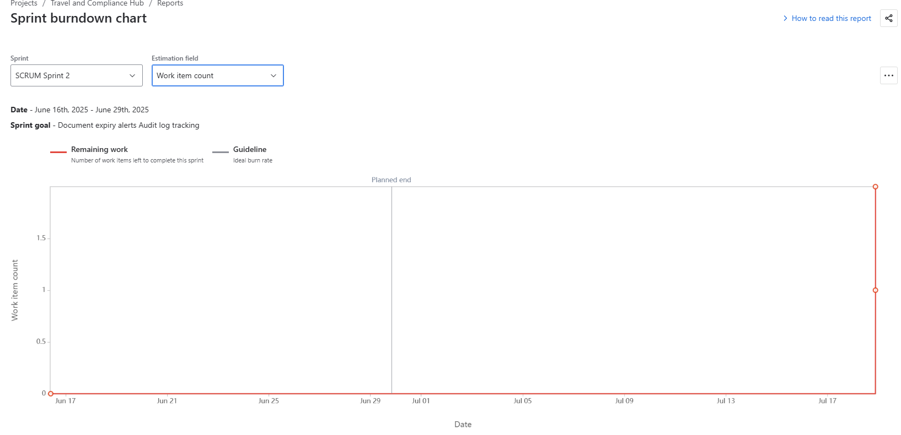

Product Burndown Chart –
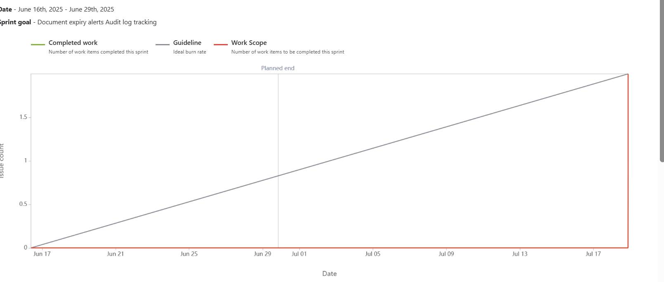

Document 6: Sprint Meetings

Meeting Type 1: Sprint Planning meeting
Date | 01-06-2025
Time | 10:00 AM – 12:30 PM
Location | World Foods LLP Conference Room
Prepared By | Kunal Kadambande (Product Owner)
Attendees | Scrum Master: Vickykumar Sancheti  Product Owner: Kunal Kadambande  Developers: Ajay Sharma, Priya Deshmukh, Rakesh Mehta, Sneha Kulkarni, Rohit Verma, Anjali Patil, Nikhil Bansode

Agenda Topics
Topic | Presenter | Time Allotted
Sprint Goal Discussion | Scrum Master | 20 mins
Review Product Backlog | Product Owner | 30 mins
Select Stories for Sprint | Development Team | 30 mins
Task Breakdown | Developers + PO | 40 mins
Estimation & Assignment | Scrum Master | 30 mins

Other Information: Sprint 1 will include user stories: Travel request submission, Manager approval.
Observers | HR Stakeholder (Amit Chordia)
Resources | Jira board, Burndown templates, Laptop, Projector
Special Notes | Emphasis on delivering core travel request features in Sprint 1

Meeting Type 2: Sprint Review Meeting
Date | 15-06-2025
Time | 10:00 AM – 11:00 AM
Location | MS Teams
Prepared By | Vickykumar Sancheti
Attendees | Product Owner, Scrum Master, Development Team, Stakeholders

Sprint status | Sprint 1 completed successfully.
Things to Demo | 1.Travel Request Form (UI + Backend Integration)  2.Manager Approval Flow
Quick updates | Email notifications pending for next sprint.
What is next | Start working on Document Expiry Alerts and Audit Logs in Sprint 2.

Meeting Type 3: Sprint retrospective meeting

Date | 15-06-2025
Time | 11:30 AM – 12:30 PM
Location | MS Teams
Prepared By | Kunal Kadambande
Attendees | Scrum Team

Agenda | What went well | What did not go well | Questions | Reference
Review what went well and what did not | On-time delivery of planned user stories | Delay in email notification configuration | How can QA be involved earlier in development? | Jira board and Sprint 1 backlog
Define action items for improvement | Clear communication during daily stand-ups | Some tasks underestimated

Meeting Type 4: Daily Stand-up Meeting
Week 1 (from 01-06-2025 to 07-06-2025)
Question | Name/Role | Monday | Tuesday | Wednesday | Thursday | Friday | Saturday | Sunday
What did you do yesterday? | Dev 1 (Ajay) | UI Design | Form Layout | API Connect | Testing | Bug Fixes | NA | NA
What did you do yesterday? | Dev 2 (Priya) | DB Setup | Backend Dev | Data Binding | Integration | Unit Test | NA | NA
What did you do yesterday? | Dev 3 (Rohit) | Setup Env | Test Cases | QA Review | Testing | Retest | NA | NA
What will you do today? | Dev 1 | API Link | Validation | Error Fix | Integration | Deployment | NA | NA
What will you do today? | Dev 2 | Validation | Logic Fix | Unit Tests | Email Logic | Bug Fix | NA | NA
What will you do today? | Dev 3 | Smoke Test | Test Review | Execute Test | Defect Log | Retest | NA | NA
What (if any) is blocking you? | Dev 1 | None | None | Pending API | None | None | NA | NA
What (if any) is blocking you? | Dev 2 | None | DB Issue | None | None | None
What (if any) is blocking you? | Dev 3 | Env Delay | None | None | None | None | NA | NA

