Agile Documents -
Document 1: Definition of Done Document 2- Product Vision Document 3: User stories Document 4: Agile PO Experience
Document 5: Product and sprint backlog and product and sprint burndown charts Document 6: Sprint meetings

Document 1: Definition of Done
As Per Agile Extension to the BABOK® Guide v2, Definition of Done is a technique where the team agrees on, and prominently displays, a list of criteria which must be met before a backlog item is considered done.
That is the team has to create a well-defined, unambiguous, measurable, agreed-upon, and shared Definition of Done between all team members.

The best form of Definition of Done representation is a checklist of activities that has to demonstrate the agreed value and quality of a user story. So, this checklist should include:
- acceptance criteria (to satisfy customer requirements for a product)
- quality criteria (to satisfy quality requirements for a product)
Definition of Done may be defined for different levels of project work. For example, in Agile
/ Scrum framework these levels of work could be user story, sprint, and release.
Checklist for DOD:

- Produced code for presumed functionalities
- Assumptions of User Story met
- Project builds without errors
- Unit tests written and passing
- Project deployed on the test environment identical to production platform
- Tests on devices/browsers listed in the project assumptions passed
- Feature ok-ed by UX designer
- QA performed & issues resolved
- Feature is tested against acceptance criteria
- Feature ok-ed by Product Owner
- Refactoring completed
- Any configuration or build changes documented
- Documentation updated
- Peer Code Review performed

Document 2- Product Vision

Scrum Project
Name:
Venue:
Date: | Start time: | End time: | Duration:
Client:
Stakeholder list:
Scrum Team
Scrum Master:
Product owner:
Scrum Developer 1:
Scrum Developer 2:
Scrum Developer 3:
Scrum Developer 4:
Scrum Developer 5:

Vision: What is your vision, your overarching goal for creating the product?
Target group  Which market segment does the product address?  Who are the target users and  customers? | Needs  What problem does the product solve?  Which benefit does it provide? | Product  What product is it?  What makes it desirable and special?  Is it feasible to develop the product? | Value  How is the product going to benefit the company?  What are the business goals?  What is the business model?

Document 3: User stories

User story No: | Tasks: |  | Priority:
Value statement:
As a user… I want to…
so that I can...
BV: |  | CP:
Acceptance criteria:

Document 4: Agile PO Experience
The Product Owner has a vision of the product keeping the domain/industry experience and the market need.
- Following are the responsibilities of PO in a project
- Market Analysis ▫ Analysis of market need/demand ▫ Availability of similar products in the market
- Enterprise Analysis ▫ Due diligence on the market opportunity
- Product Vision and Roadmap ▫ Product vision keeping the need analysis in mind ▫ Product roadmap with high-level features and timeline
- Managing Product Features ▫ Managing stakeholder expectations and prioritizing needs ▫ Prioritization of the epics, stories, and features based on criticality and ROI involved
- Managing Product Backlog ▫ Prioritization of user stories ▫ Reprioritization based on stakeholders' needs ▫ Epics planning
- Managing Overall Iteration Progress ▫ Sprint progress review ▫ Reprioritization of sprints and epics if needed ▫ Sprint retrospectives with Business Analyst
- From this project I have learned how to handle sprint meetings such as
- Sprint planning meeting

- Daily scrum meeting
- Sprint review meeting
- Sprint retrospective meeting
- Backlog refinement meeting
- Also, User stories creation and what things will be included in user stories such as
- Story no
- Tasks
- Priority
- Acceptance criteria
- BV & CP value
- In Scrum, a product owner serves as the liaison between multiple areas of an organization. This person communicates with business stakeholders and collaborates closely with Scrum teams to keep all areas of the business informed on a project's development.
- The product owner develops a vision of a product's function and operation, which in turn allows this Scrum team member to define product features and break those features into product backlog items.

Document 5: Product and sprint backlog and product and sprint burndown charts
Product backlog:

User story ID | User story | Tasks | Priority | BV | CP | Sprint

Sprint backlog:

User story ID | User story | Tasks | Owner | Status | Estimated effort

Product burndown
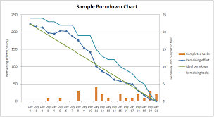

Sprint burndown
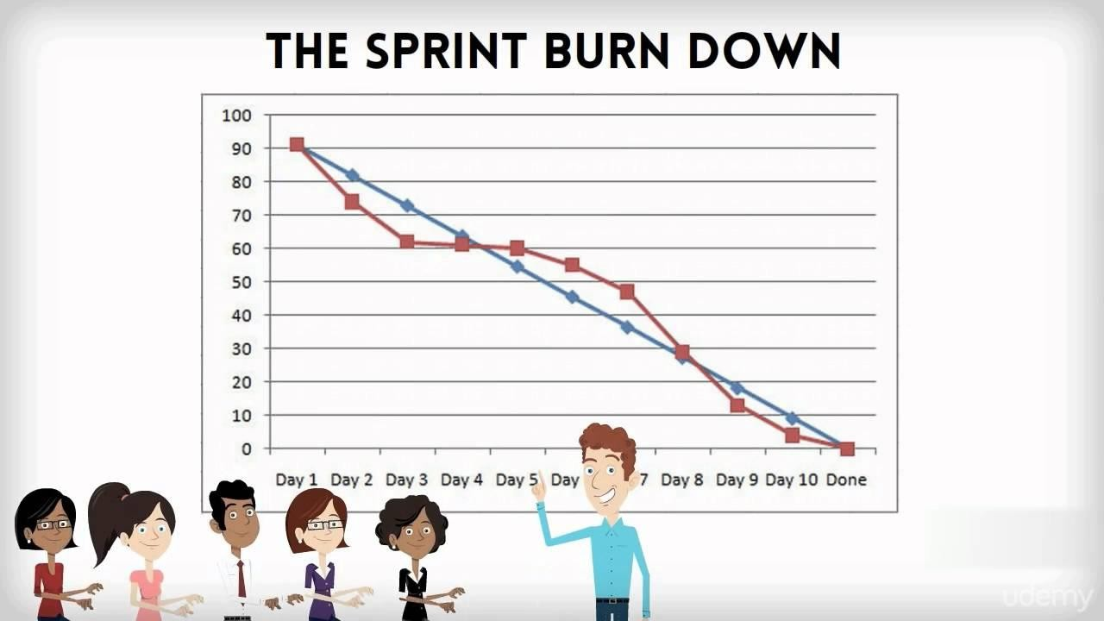

Document 6: Sprint meetings
Meeting Type 1: Sprint Planning meeting

Date
Time
Location
Prepared By
Attendees

Agenda Topics

Topic | Presenter | Time allotted

Other Information

Observers
Resources
Special Notes

Meeting Type 2: Sprint review meeting

Date
Time
Location
Prepared By
Attendees

Sprint status | Things to demo | Quick updates | What’s next

Meeting Type 3: Sprint retrospective meeting

Date
Time
Location
Prepared By
Attendees

Agenda | What went well | What didn’t go well | Questions | Reference

Meeting Type 4: Daily Stand-up meeting

Question | Name/Role |  |  | Week “X” (from dd-mm-yyyy to dd-mm-yyyy)
Question |  |  |  | Monday | Tuesday | Wednesday | Thursday | Friday | Saturday | Sunday
What did you do yesterday? |  | Developer 1
What did you do yesterday? |  | Developer 2
What did you do yesterday? |  | Developer 3
What will you do today? |  | Developer 1
What will you do today? |  | Developer 2
What will you do today? |  | Developer 3
What (if any) is blocking your progress? |  | Developer 1
What (if any) is blocking your progress? |  | Developer 2
What (if any) is blocking your progress? |  | Developer  3

