Document 1: Definition of Done
According to BABOK Definition of Done is a technique where the team agrees on, and prominently displays, a list of criteria which must be met before a backlog item is considered done. That is the team has to create a well-defined, unambiguous, measurable, agreed-upon, and shared Definition of Done between all team members.
The best form of Definition of Done representation is a checklist of activities that has to demonstrate the agreed value and quality of a user story. So, this checklist should include:
- acceptance criteria (to satisfy customer requirements for a product)
- quality criteria (to satisfy quality requirements for a product)
Definition of Done may be defined for different levels of project work. For example, in Agile / Scrum framework these levels of work could be user story, sprint, and release.

Checklist for DOD:
- Produced code for presumed functionalities
- Assumptions of User Story met
- Project builds without errors
- Unit tests written and passing
- Project deployed on the test environment identical to production platform
- Tests on devices/browsers listed in the project assumptions passed
- Feature ok-ed by UX designer
- QA performed & issues resolved
- Feature is tested against acceptance criteria
- Feature ok-ed by Product Owner
- Refactoring completed
- Any configuration or build changes documented
- Documentation updated
- Peer Code Review performed

Answer:
A DoD is a set of criteria that a product increment must meet for the team to consider it complete and ready for customers. It is a shared understanding among the team members of when a product increment is ready for release, even when the increment is large and consists of many items. By clearly defining what “done” means to the project, an Agile team can focus on delivering value with every sprint and minimizing rework.
It is important to note that one person does not create the Definition of Done. Instead, it is agreed upon by the entire project team, including developers, testers, product owners, and other stakeholders. This ensures a smoother process during sprints since everyone is using the DoD as a guide alongside any checklists before marking an item as complete.

DOD checklist:
Criteria | Description
Produced code for presumed functionalities | The code implementing the requested feature or user story has been written and committed.
Assumptions of User Story met | All business rules and expectations outlined in the user story are fulfilled
Project deployed on the test environment identical to production platform | The updated application is deployed and tested in an environment that mirrors production
Feature ok-ed by UX designer | User Interface (e.g., proposal generation templates, forms) is reviewed and approved by the UX team
QA performed & issues resolved | Quality Assurance team has completed testing and all reported issues have been resolved
Feature is tested against acceptance criteria | The output satisfies all acceptance criteria outlined in the user story
Feature ok-ed by Product Owner | Product Owner (PO) has reviewed the feature and confirmed it meets business expectations
Any configuration or build changes documented | Changes to environment variables, build scripts, or deployment processes are logged
Documentation updated | Related user guides, technical documentation, and internal wikis are updated
Peer Code Review performed | Code is reviewed and approved by one or more team members for quality, logic, and security
Acceptance criteria | All acceptance criteria defined during the User Story Workshop (based on client inputs like media type, zone, duration, etc.) are met.

Document 2: Product Vision:
Scrum Project Name: Proposal Automation – Mumbai Airport OOH Media
Date: 18 February 2025
Client: Times OOH
Stakeholder list:
National Sales Head: Sumit Chaddha
West head: Ashish Rathore
Technical head: Roshan kadam

Scrum team:
Scrum Master: Jayesh
Product Owner: Abhishek Bagul
Scrum Developer: Rohit, Akash, Kartik, Roshan, Bipin

Vision:
To develop a streamlined, intelligent, and highly responsive automated proposal creation for Mumbai Airport OOH media opportunities—based on real-time campaign data, client preferences, and media availability—resulting in faster deal closures and improved client satisfaction.
Target group:
The market segment addressed is the Outdoor advertising industry specifically the airport media.
The target user would be the Sales executives and the customers would be the Brands, media buyers and advertising agencies which are interested in the advertising at the airport.
Need:
Manual and error-prone proposal creation
Lack of real-time media availability data
Delayed response to client leads
Inefficiencies in lead assignment and tracking
Product:
The product is an enhanced Lead Management System integrated with a dynamic Proposal Generator
The special features of the product are that the system is able to create an proposal based on the requirement of the customer. They can select among the filters: media type, zone, quality, campaign duration. And based on the availability it will create a proposal . It would be created based on real-time data validation and reporting.
Feasibility: This system would reduce the manual work by 60%, which would help the sales executives being able to increase their chances of meeting new potential clients. The turnaround time for the sharing of the proposals with the clients is reduced. This would in turn elevate the trust of the client and improve their overall experience.
Value:
Benefit to the company:
- Increased conversion rate through quicker proposals
- Better visibility into sales pipeline and campaign planning
- Higher revenue due to improved media utilization
- Consistent proposal format aligned with brand standards

Business goals:
- Achieve a 50% reduction in lead-to-proposal time
- Increase monthly closed deals by 30%
- Maintain a central repository for lead and media insights

Business Model:
The business model centers around digitizing and automating the sales pipeline for advertising spaces at Mumbai Airport, which includes passenger-facing billboards, digital screens, kiosks, etc. The LMS streamlines client requirement collection, lead tracking, media planning, and proposal generation to optimize revenue and increase conversion rates.

Document 3: User stories:
User story no. 1 | Tasks: 2 |  | Priority: HIghest
Create login module for sales and proposal teams

Secure access to authorized system modules:
As a user I want to log into the LMS system securely
I want to access different modules based on my role
So that I can protect sensitive proposal and media data
BV: 8 |  | CP: 03
ACCEPTANCE CRITERIA

Login system must have role-based access
User credentials are validated against backend
Error message is displayed for incorrect login

User story no. 2 | Tasks: 2 |  | Priority: Highest
Create forms to input client requirements

Accurate capture of campaign needs:
As a user I want to fill client requirement details
I want to choose from dropdowns for media, zone, passenger type
So that I can generate client-specific media options
BV: 10 |  | CP: 05
ACCEPTANCE CRITERIA

All filters should be functional (media type, zone, etc.)
Form should validate mandatory fields
Data should be stored in LMS database

User story no. 3 | Tasks: 2 |  | Priority: Highest
Enable auto-lead assignment based on zone and media

Assign leads to right person without delay
As a user I want leads to be automatically assigned
I want to save time in manually assigning them
So that I can follow up immediately with the client
BV: 9 |  | CP: 03
ACCEPTANCE CRITERIA

Leads are assigned based on predefined rules
Notification sent to assigned user
Lead status updates logged

User story no. 4 | Tasks: 2 |  | Priority: Highest
Check media availability based on campaign dates

Prevents booking of unavailable sites
As a user I want to see only available media
I want to avoid media already booked during that period
So that I can propose viable options to the client
BV: 10 |  | CP: 05
ACCEPTANCE CRITERIA

System must cross-check input date with current bookings
Available/unavailable status displayed per media item

User story no. 5 | Tasks: 2 |  | Priority: Medium
Add campaign duration input logic

Classify proposals for pricing and planning
As a user I want to enter the campaign duration type
I want to differentiate pricing strategies
So that I can provide better budget alignment
BV: 7 |  | CP: 03
ACCEPTANCE CRITERIA

Duration field required
Options: Tactical (≤1 month), Short (1–3 months), Long (>3 months)

User story no. 6 | Tasks: 2 |  | Priority: Medium
Allow media selection by quality (impact/network)
Match client branding goals
As a user I want to choose between impact and network sites
I want to align with client strategy
So that I can better fulfill branding needs
BV: 8 |  | CP: 05
ACCEPTANCE CRITERIA

User can select one/both types
Reflected in proposal PPT

User story no. 7 | Tasks: 2 |  | Priority: Highest
Generate PowerPoint proposal based on inputs

Fast and consistent proposal creation
As a user I want to download proposals in PPT format
I want to include client-specific filters and available media
So that I can present to clients quickly
BV: 10 |  | CP: 05
ACCEPTANCE CRITERIA

PPT must include selected media options and availability
Branded formatting is maintained
Export option available

User story no. 8 | Tasks: 2 |  | Priority: Highest
View status of lead (New, In Progress, Proposal Sent, Closed)

Track lead lifecycle
As a user I want to see the current status of a lead
I want to know what stage it is in
So that I can take required actions
BV: 9 |  | CP: 03
ACCEPTANCE CRITERIA

Status updates reflected automatically
Only authorized users can change status

User story no. 9 | Tasks: 2 |  | Priority: Medium
Daily status reporting dashboard

Real-time insights for managers
As a user I want a dashboard to view daily progress
I want to track active leads and proposals
So that I can manage the sales pipeline
BV: 9 |  | CP: 08
ACCEPTANCE CRITERIA

Dashboard displays daily metrics
Charts updated automatically

User story no. 10 | Tasks: 2 |  | Priority: Highest
Auto-update of proposal availability if booking is done

Ensure proposal reflects current data
As a user I want media availability to auto-update post-booking
I want to avoid incorrect proposals
So that I can maintain proposal accuracy
BV: 9 |  | CP: 08
ACCEPTANCE CRITERIA

System refreshes media status post-booking
Conflict alerts raised if outdated proposal is reopened

Document 4: Agile PO Experience
As the Product Owner (PO) of the Lead Management System (LMS) Enhancement Project, I played a crucial role in ensuring the final product aligned with business objectives, stakeholder expectations, and the dynamic needs of the outdoor advertising market. The project followed the Agile-Scrum methodology, and my role spanned from strategic market assessment to hands-on sprint execution. Below is an in-depth overview of my contributions and learning experiences.
- Market Analysis:
As a PO, I began the project by conducting a comprehensive market analysis. This involved:
Understanding the Outdoor Media Industry: I analysed the existing practices in airport advertising, including static and digital media, to assess the pain points in managing media inventory, proposal generation, and client communication.
Identifying Market Demand: Through stakeholder discussions, I recognized the increasing demand for data-driven, timely, and personalized proposals for potential clients interested in advertising at Mumbai Airport.
Competitive Benchmarking: I reviewed similar LMS and proposal-generation tools in the market. The key differentiator for our system was the automated PPT generation with availability checks, which most other platforms lacked.
- Enterprise Analysis:
Business Case Justification: I worked with stakeholders to validate the business opportunity. The goal was to reduce turnaround time for media proposals, improve resource allocation, and minimize manual errors in lead handling.
SWOT Analysis: I facilitated discussions to identify the project's strengths (e.g., internal media database), weaknesses (manual proposal process), opportunities (digital transformation), and threats (competitive platforms).

- Product Vision and Roadmap:
Vision statement: To develop a smart, dynamic LMS that automates lead handling and proposal generation for Mumbai Airport outdoor media, ensuring accuracy, speed, and customized client offerings
Roadmap: I outlined a roadmap spanning multiple sprints, each focused on:
Building core LMS functionalities (lead intake, requirement mapping), Checking media availability, Generating automated PowerPoint proposals, Reporting and dashboard features
- Managing product features:
Stakeholder Communication: I held weekly alignment calls with key business users, media planners, and the airport commercial team to gather feedback and manage expectations.
Prioritization Techniques:
- Applied MoSCoW and MVP techniques to determine essential vs. optional features.
- Considered ROI and risk when prioritizing epics and user stories.
- Integrated BV (Business Value) and CP (Complexity Points) models to further evaluate value delivery.

- Managing product backlog:
As the Product Owner, one of my core responsibilities was the creation, organization, and maintenance of the product backlog, which is the heart of any Agile project. Here’s how I managed it:
Prioritization of User Stories: I converted stakeholder requirements into well-defined user stories, each with a clear value statement, BV (Business Value) points, CP (Complexity Points), tasks, and acceptance criteria. User stories were prioritized using MoSCoW (Must have, Should have, Could have, Won’t have) and MVP (Minimum Viable Product) principles.
Reprioritization Based on Stakeholder Needs: Stakeholder priorities evolved throughout the project, often due to market conditions or internal operational requirements. I kept a continuous feedback loop with stakeholders via demos, emails, and calls to ensure that the backlog reflected the most valuable outcomes at every stage.
Epics Planning: I grouped related user stories under high-level epics like: Lead Capture & Assignment, Media Availability Validation, Proposal Generation (PPT Output), Reporting & Dashboards. Each epic was broken into incrementally deliverable user stories, enabling better tracking and coordination across sprints.
- Managing Overall Iteration Progress:
Sprint Progress Review: I monitored sprint velocity and tracked user story completion using Jira, where I reviewed burndown charts and sprint boards. Regular daily Scrum meetings allowed me to get visibility into blockers, risks, and team bandwidth.
Reprioritization of Sprints and Epics if Needed: Based on sprint reviews or external business updates, I sometimes had to reshuffle priorities mid-project. For example, if a client demanded a quick turnaround for a proposal template update, I could move that user story into the current sprint and push a less critical item to the next one.
Sprint Retrospectives with Business Analyst: I participated in retrospectives with the BA and Scrum team to reflect on the sprint. Key discussion points included: What went well?, What could be improved?, Were all acceptance criteria met?, Were stakeholder expectations satisfied? These retrospectives helped us refine our user story creation, estimate complexity better, and enhance our collaboration and sprint execution quality in future iterations.
- From this project I have learned how to handle sprint meetings such as:

Sprint Planning meeting: I presented the prioritized user stories from the product backlog, ensuring clarity on the business value, acceptance criteria, and BV/CP points. Learned to negotiate scope by balancing stakeholder expectations with the team's velocity.

Daily Scrum meeting: Used these meetings to quickly unblock the team if any business clarifications were needed. Helped ensure the team stayed aligned with sprint goals and that any change in business requirements was communicated early.

Sprint review meeting: Acted as the bridge between the Scrum team and stakeholders, facilitating product demos focused on - Media availability logic, etc. Gathered feedback from stakeholders and incorporated required changes into the product backlog.

Sprint retrospective meeting: Participated in evaluating what went well, what didn’t, and what could be improved. Suggested improvements in: Communication flows between development and business.

Backlog refinement meeting: Conducted backlog grooming sessions with the Business Analyst, stakeholders, and development team. Updated stories with clearer requirements, refined acceptance criteria, and adjusted BV and CP points as needed. Focused on story clarity, stakeholder alignment, continuous backlog prioritization

In Scrum, a product owner serves as the liaison between multiple areas of an organization. This person communicates with business stakeholders and collaborates closely with Scrum teams to keep all areas of the business informed on a project's development.
The product owner develops a vision of a product's function and operation, which in turn allows this Scrum team member to define product features and break those features into product backlog items.

Document 5: Product and sprint backlog and product and sprint burndown charts

Product backlog:
This backlog outlines all planned user stories with business value, complexity points, and their assigned sprint
User Story ID | User Story Summary | Tasks | Priority | BV | CP | Sprint
US-1 | Create login module for sales and proposal teams | 2 | Highest | 8 | 3 | 1
US-2 | Create forms to input client requirements | 2 | Highest | 10 | 5 | 1
US-3 | Enable auto-lead assignment | 2 | Highest | 9 | 3 | 1
US-4 | Check media availability | 2 | Highest | 10 | 5 | 2
US-5 | Add campaign duration input logic | 2 | Medium | 7 | 3 | 2
US-6 | Allow media selection by quality | 2 | Medium | 8 | 5 | 2
US-7 | Generate PowerPoint proposal | 2 | Highest | 10 | 5 | 3
US-8 | View status of lead | 2 | Highest | 9 | 3 | 3
US-9 | Daily status reporting dashboard | 2 | Medium | 9 | 8 | 3
US-10 | Auto-update of proposal availability | 2 | Highest | 9 | 8 | 3

Sprint backlog:
This represents the scope of Sprint, with selected user stories, team assignments, and task-level effort/status.
 | User Story ID | User Story Summary | Tasks | Owner | Status | Estimated Effort (CP)
Sprint 1 | US-1 | Login module for sales and proposal teams | 2 | Rohit | Completed | 3
Sprint 1 | US-2 | Forms to input client requirements | 2 | Akash | Completed | 5
Sprint 1 | US-3 |  | 2 | Kartik | Completed | 3
  Auto-lead assignment
Sprint 2 | US-4 | Check availability | 2 | Roshan | Completed | 5
Sprint 2 | US-5 | Campaign duration input logic | 2 | Rohit | Completed | 3
Sprint 2 | US-6 | Media selection by quality | 2 | Akash | Completed | 5
Sprint 3 | US-7 | Generate PowerPoint proposal | 2 | Kartik | Completed | 5
Sprint 3 | US-8 | View lead status | 2 | Roshan | Completed | 3
Sprint 3 | US-9 | Daily status reporting dashboard | 2 | Rohit | In progress | 8
Sprint 3 | US-10 |  | 2 | Akash | In progress | 8
  Auto-update proposal post-booking

Sprint Burndown Chart:
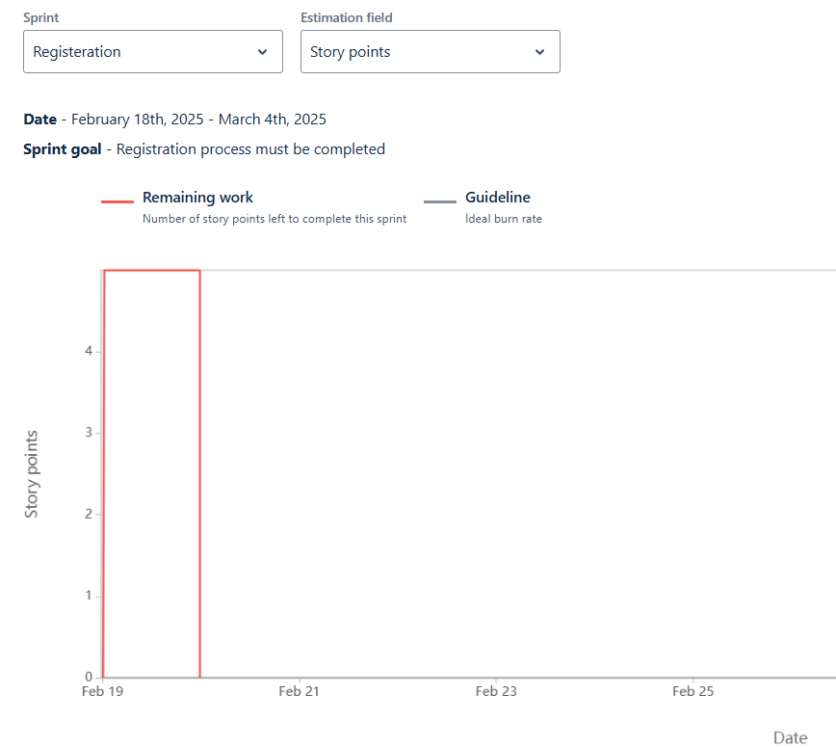

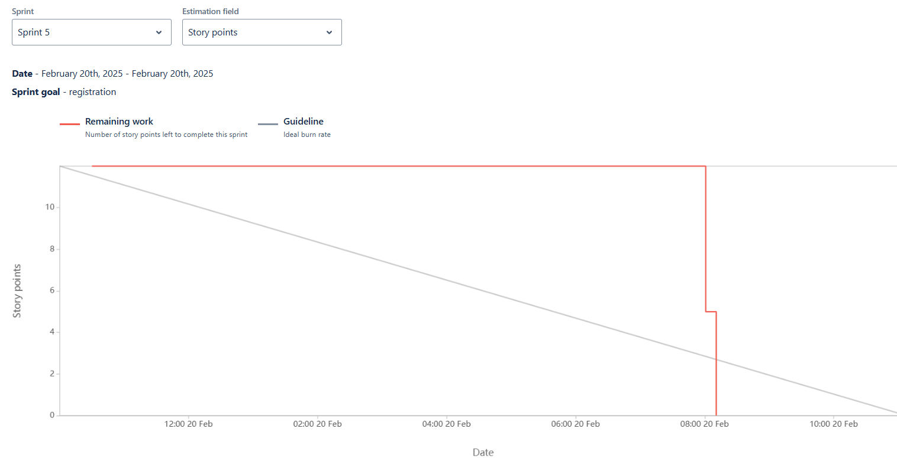

Product Burn Down Chart
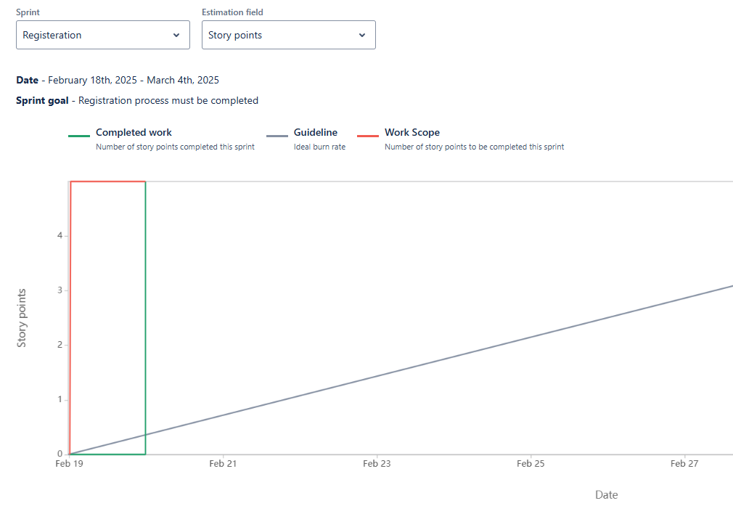

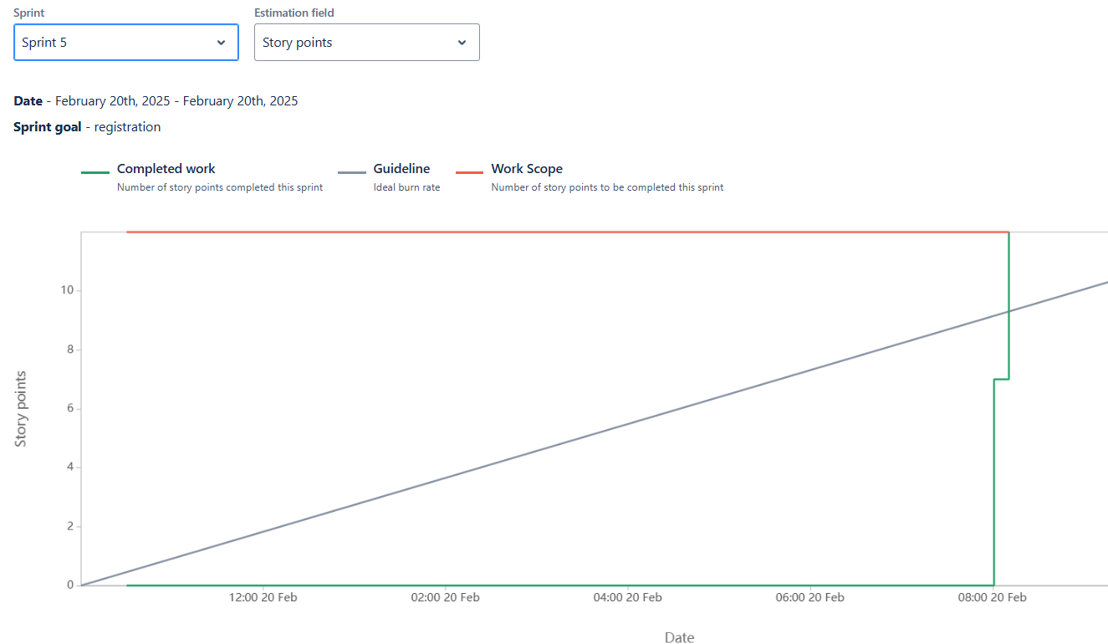

Document 6: Sprint meetings
Meeting Type 1: Sprint Planning meeting
Date | 18 February 2025
Time | 11:00 to 12:00
Location | Mumbai
Preparedness by | Abhishek Bagul
Attendees | Ashish  Rohit  Jayesh  Akshay

Agenda Topics
Topic | Presenter | Time Allocated
Overview of Sprint Goals | Abhishek (PO) | 10 mins
Review of Product backlog | Jayesh (SM) | 15 mins
User Story prioritization | Abhishek | 15 mins
Task assignment and estimation | Rohit | 30 mins
Risk identification and mitigation | Jayesh | 10 mins
Q&A and clarification | For everyone to ask ques, | 10 mins

Other Information
Observers | UI team,
Resources | Sprint backlog printouts, Whiteboard, Jira dashboard
Special Notes | Focused on delivering core user stories from login to auto lead assignment.

Meeting Type 2: Sprint review meeting
Date | 24 February 2025
Time | 12:00 to 01:00
Location | Mumbai
Preparedness by | Abhishek Bagul
Attendees | Ashish  Rohit  Jayesh  Akshay

Sprint status | Things to demo | Quick updates | What’s next
Sprint 1 – US-1,2,3 | Role-based login module (Sales vs Proposal team access).  Client requirement input form with dropdowns for media, zones, and passenger types.  Auto-assignment of leads based on zone/media. | Integration with the backend for credential validation successful.  Mandatory field validation and dropdown logic functional.  Data entries saving into LMS database.  Notifications and logs for assigned leads functioning. | Automate lead assignment logic (US-3).  Begin media availability engine development (US-4).
Sprint 2 – US-4, 5, 6 | Media availability check against campaign dates.  Duration-based logic for proposal classification (Tactical, Short, Long).  Impact/Network toggle for media selection.  PPT proposal generation with brand formatting.  Export functionality based on filtered media inputs. | Date filters functional; booked sites filtered out.  Duration types trigger pricing logic for internal use.  Proposal generation is aligned with media type, duration, and availability.  Branding guidelines embedded in slide template.  Proposal export takes under 10 seconds per user request. | Add media selection logic based on quality (Impact vs Network).  Begin development of auto-PPT generation module.  Add lead status tracking capability.  Start work on reporting dashboard.
Sprint 3 – US-7, 8, 9, 10 | Lead lifecycle visualization (New, In Progress, Proposal Sent, Closed).  User-based status change control.  Audit trail of status updates.  Manager dashboard with daily KPIs: active leads, conversion %, proposals sent.  Real-time charts and metrics auto-updated.  Auto-update of media availability post-booking, with alerts on conflict. | Role-based permissions confirmed.  Changes reflected in real time across team dashboard.  Lead history saved for future reporting.  Dashboard reflects data from past 24 hours.  Proposal logic now syncs availability once a site is booked.  Conflict alerts tested with expired or reused proposals. | Develop and integrate daily status dashboard for management.  Automate availability update upon proposal acceptance.  Sprint retrospective with team.  Minor UI/UX refinements based on feedback.  Prepare final deployment and UAT phase.

Meeting Type 3: Sprint retrospective meeting
Date | 7 March 2025
Time | 12:00 to 01:00
Location | Mumbai
Preparedness by | Abhishek Bagul
Attendees | Ashish  Rohit  Jayesh  Akshay

 | Meeting | Agenda | What went well | What didn’t go well | Questions | Reference
Meeting 1 |  | Review team collaboration and performance for Sprint 1 deliverables  User Stories: 1 & 2 – Login Module & Client Requirement Form | Seamless coordination between frontend and backend teams for login module.  Stakeholders appreciated the dropdown UX for requirement form.  Daily stand-ups improved clarity and task tracking | Minor delay in backend integration due to unclear API documentation.  Client validation rules required mid-sprint clarification. | How can we ensure all assumptions are clarified before Sprint starts?  Should we have a separate backend readiness check before each sprint? | Product Backlog & Sprint 1 Review Notes
 | Meeting 2 | Evaluate efficiency in implementing logic-based features  User Stories: 3, 4 & 5 – Auto Lead Assignment, Media Availability, Duration Logic | Lead assignment logic performed as expected during QA.  Availability feature prevented selection of booked sites effectively.  Campaign duration logic handled pricing categorization efficiently. | Lead assignment rules needed a late-stage revision from stakeholders.  Manual testing of overlapping booking logic consumed more time than expected. | Can we pre-validate business logic through user mock scenarios?  Should we automate availability test cases? | Sprint Review Docs & QA Report
 | Meeting 3 | Review feature quality and client-side usability of output  User Stories: 6 & 7 – Media Quality Filter & PPT Generation | PPT output met branding and functional requirements.  Impact/Network toggle was intuitive and user-friendly.  Export functionality completed within performance targets. | Initial version of PPT missed dynamic content tagging.  Testing on different screen resolutions showed minor UI distortions | Should we standardize PPT content format with client input before sprint?  Can we add automated visual regression testing for UI? | Design Guidelines & Feedback Logs
 | Meeting 4 | Review workflow management and visibility features | Status transitions were smooth and accurately logged.  Role-based control ensured clean access levels.  Sales team found real-time tracking very effective. | Some confusion on permission-based status changes during UAT.  Status change logs weren’t initially visible in audit reports. | Can we better visualize lead status history in the dashboard?  Should we offer role-specific onboarding on feature rollout? | UAT Feedback & Security Checklist
 | Meeting 5 | Analyze delivery of executive-level tools and backend synchronization. | Dashboard was appreciated by managers for its clarity.  Auto-refresh of availability after booking eliminated manual errors.  Conflict alert feature helped avoid proposal duplications. | Dashboard filtering took longer than expected to optimize.  Limited test data slowed early testing of auto-refresh logic. | Should we prepare sample data sets before dashboard sprints?  Can we log outdated proposal warnings more visibly? | Sprint Demo & Performance Testing Report

Meeting Type 4: Daily Stand-up meeting

Question | Name/Role | Monday | Tuesday | Wednesday | Thursday | Friday
What did you do yesterday? | Rohit | Worked on login module integration | Fixed validation issues in login | Completed form validation logic | Tested role-based access | Finalized login and form feature
 | Akash | Designed client requirement form | Implemented dropdown filters | Debugged form saving issue | Completed form database integration | Code reviewed form module
 | Kartik | Setup lead assignment logic | Added zone-based rules | Completed notification module | Validated assignment logic | Prepared for sprint demo
What will you do today? | Rohit | Start working on dashboard layout | Optimize form responsiveness | Assist with QA for login module | Attend sprint review | Update documentation
 | Akash | Work on media availability module | Connect with backend for dates | Begin testing of dropdown filters | Help QA team with test cases | Update form acceptance tests
 | Kartik | Develop media availability logic | Finalize rule engine | Sync with PO for demo prep | Create sprint demo slides | Review feedback from PO
What (if any) is blocking your progress? | Rohit | None | Delay in QA resource allocation | Waiting for backend testing | No blocker | None
 | Akash | Clarification on dropdown logic | Awaiting updated media data | Minor browser compatibility issue | None | None
 | Kartik | Delayed inputs from client | Awaiting rule changes confirmation | QA feedback pending | None | None

