Enhancement of order punching system

Document 1: Definition of Done (DoD) -
Project: Enhancement of order punching system
Definition of Done is a checklist that defines the criteria that a user story or product increment must meet to be considered complete. It ensures alignment among team members and sets expectations for quality.
Checklist for DoD:
- Code for functionalities written and committed
- User story assumptions validated
- Project builds successfully without errors
- Unit tests written and passed
- Code deployed to staging/test environment
- Cross-browser/device compatibility verified
- UX sign-off received
- QA validation completed
- Feature tested against acceptance criteria
- Product Owner approval obtained
- Refactoring and optimization done
- Configuration changes documented
- Documentation updated (functional/user docs)
- Peer review conducted and passed

Document: Definition of Ready (DoR)
Definition of Ready is a checklist that ensures a Product Backlog Item (PBI) or User Story is clear, actionable, and sufficiently detailed so the Scrum Team can commit to working on it in a sprint. It eliminates ambiguity and reduces rework.

Checklist for DOR:
- User Story is clearly defined and written
- Business Value (BV) and Complexity Point (CP) are assigned
- Acceptance Criteria are listed and testable
- Story is prioritized by the Product Owner
- Required UI/UX mockups or wireframes are available
- Dependencies and blockers are identified
- Technical feasibility is reviewed by the development team
- Story is estimated by the team (Planning Poker or equivalent)
- Non-functional requirements (e.g., performance, security) are captured
- Test data or test environment requirements are clarified
- Team understands the scope and story is discussed in backlog refinement
- Story size fits within a single sprint
- No open questions remain

Document 2: Product Vision -
"Product Vision is a high-level, future-oriented statement that explains what the product aims to achieve, who it serves, and how it creates value, aligning with the organization's strategic goals."
Scrum Project: Enhancement of order punching system
Venue: Solapur
Date: 03-06-2025 | Start: 10:00 AM | End: 12:00 PM | Duration: 2 hours
Client: Ultratech cement LTD
Stakeholders:
- Digital Transformation Head
- Product Manager – Mobile App
- Compliance & Risk Manager
- Customer Support Lead
- Development Team Lead
- End Users (Bank Customers)
Scrum Team
- Scrum Master: Ravi Kumar
- Product Owner: Kanika jagtap
- Scrum Developers:
  - Dev1: Aayush
  - Dev2: Sneha
  - Dev3: Mahesh
  - Dev4: Kavita
  - Dev5: Suraj

Vision
To Enhance the order punching system by enhancing usability, performance, and introducing key features such as personalized offers for dealers and retailers, faster login, and improved dispatch process, thereby increasing digital adoption and customer satisfaction.

Target Group
- Market: Cement & Building Materials.
- Target Users: Construction contractors, Builders and housing developers, Government contractors (PWD, highways)
Needs
- Faster order processing
- Simple & intuitive UI
- Error reduction
- Dealer engagement
- Seamless SAP Integration

Product

The product is a digital platform (web and mobile-based) that enables UltraTech’s dealers and internal sales teams to place, track, and manage cement orders in a faster, more accurate, and user-friendly manner.

Value
- Increased Efficiency
- Time Savings
- Real-time SAP Sync
- Supports Business Growth
- Enhanced Dealer Relationships

Document 3: User Stories - A User Story is a brief, value-focused requirement expressed from the user’s point of view that guides the development and its features in Agile projects.
User Stories – Enhancement of order punching system

User Story No. | User Story | Priority | Acceptance Criteria | BV | CP
US01 | As a dealer, I want to place an order digitally, so that I can avoid manual and call-based ordering. | Must | - Order form available online  - Validations in place  - Successful SAP sync | 10 | 5
US02 | As a dealer, I want to view my credit limit and stock availability, so that I only order what's available and approved. | Must | - Stock and credit check shown before order submission  - Order blocked if limit exceeded | 20 | 5
US03 | As a dealer, I want to track my order status, so that I know when it is dispatched or delivered. | Must | - Order status page displays real-time status  - Integrated with dispatch system | 50 | 3
US04 | As a sales officer, I want to view all orders from mapped dealers, so that I can assist or escalate if needed. | Should | - SO dashboard shows dealer orders with filters  - Download option available | 5 | 3
US05 | As a dealer, I want to receive SMS or app notifications when order is dispatched, so that I'm updated without logging in. | Should | - SMS sent on order dispatch  - Notification logs maintained | 100 | 3
US06 | As a rural dealer, I want to use the app in my regional language, so that I can understand and use it easily. | Could | - System supports 3+ regional languages  - Language switch works seamlessly | 5 | 8
US07 | As a dealer, I want to view and repeat past orders, so that I can quickly reorder common items. | Could | - Past order list visible  - "Repeat Order" button works correctly | 20 | 13
US08 | As an admin, I want to assign user roles and access, so that only authorized users can use specific features. | Must | - Role-based access enforced  - Admin panel for user control | 10 | 5
US09 | As a manager, I want to download dealer-wise reports, so that I can analyze performance. | Should | - Filter by date, dealer, product  - Export to Excel | 200 | 21
US10 | As a system, I want to automatically validate orders with SAP, so that data is consistent and error-free. | Must | - Orders must pass SAP checks  - Errors logged and reported | 20 | 7

Business Value (BV)
The expected benefit a feature delivers—such as increased revenue, efficiency, user satisfaction, or strategic advantage—which drives prioritization and ROI .
We can use this $100 Technique, It is a prioritization method commonly used by Business Analysts and Product Owners in Agile environments to determine the relative importance of features, requirements, or user stories by involving stakeholders in decision-making.

Complexity Point (CP)
A relative measure of effort, risk, and technical difficulty associated with implementing a feature, often expressed using story points or a value-complexity scale
We can Give complexity points by using fabnosil series, with minimum card we can express Maximum Values
- F(0) = 0
- F(1) = 1
- F(2) = F(1) + F(0) = 1
- F(3) = F(2) + F(1) = 2
- F(4) = F(3) + F(2) = 3
- F(5) = F(4) + F(3) = 5
- and so on...

Document 4: Agile Product Owner Experience -

As a Business Analyst, I have worked closely with Agile Product Owners in multiple sprints to define, refine, and manage product backlogs. I have contributed to grooming sessions, facilitated stakeholder meetings, prioritized features based on business value, and ensured the delivery of high-quality user stories aligned with the product vision.

A. Product Owner Experience in Enhancement of order punching system
Summary:
As the Product Owner for the Enhancement of order punching system project, I was responsible for defining the vision, managing the product backlog, and ensuring alignment between stakeholders, end users, and the Scrum Team.
Responsibilities & Activities:
- Requirement Gathering & Visioning
  - Collaborated with business stakeholders (sales, logistics, finance) to gather enhancement requirements.
  - Defined a clear product vision to streamline and digitize the dealer order process.
  - Prioritized features that improved order accuracy, reduced dependency on manual communication, and enhanced dealer satisfaction.
- Backlog Management
  - Created and maintained a detailed Product Backlog in collaboration with the Scrum Team.
  - Wrote clear and concise User Stories with defined Acceptance Criteria.
  - Used MoSCoW prioritization to manage backlog items across sprints.
- Stakeholder Collaboration
  - Acted as the single point of contact between the development team and business stakeholders.
  - Conducted Sprint Reviews to demonstrate product increments to stakeholders.
  - Gathered feedback for continuous product improvement.
- Sprint Planning & Execution
  - Participated in all Scrum ceremonies including Sprint Planning, Daily Stand-ups, and Retrospectives.
  - Clarified story details, priorities, and business rules during Sprint Planning.
  - Provided timely decisions to unblock the development team.
- User-Centric Design
  - Focused on improving user experience for dealers, especially in rural regions.
  - Introduced features such as:
    - Mobile access
    - Multilingual support
    - Simplified UI for order punching

B. Business Analyst Experience in Enhancement of order punching system Project
Role Summary:
As a Business Analyst, I acted as the bridge between business stakeholders and the development team, capturing requirements, writing user stories, and supporting solution validation.
Contributions:

Requirement Gathering & Elicitation
- Conducted stakeholder interviews with dealers, sales officers, logistics, and IT teams to gather detailed enhancement needs.
- Created Business Requirement Document (BRD) and Functional Specification Document (FSD).
- Mapped AS-IS vs TO-BE processes of order punching using Visio.

2. User Story Creation
- Translated requirements into actionable user stories with clearly defined acceptance criteria using the Agile user story format.
- Maintained and prioritized the product backlog in collaboration with the Product Owner.
- Applied MoSCoW prioritization technique for backlog grooming and sprint planning.

3. Process Modeling & Documentation
- Designed workflow diagrams, use case diagrams, and process maps of the enhanced system.
- Created wireframes/mockups in Axure RP for the dealer portal and sales officer dashboard.

4. Agile Ceremony Participation
- Participated in all Scrum ceremonies including Daily Stand-ups, Sprint Planning, Reviews, and Retrospectives.
- Supported the team with clarifications and detailed requirements during sprint execution.

5. Stakeholder Communication
- Served as a bridge between business users and technical teams.
- Conducted demo sessions for stakeholders at the end of each sprint and documented feedback for improvement.

6. Validation & Testing Support
- Prepared UAT test cases based on acceptance criteria.
- Coordinated and supported User Acceptance Testing (UAT) with key business users and ensured the system met business expectations.

7. Risk & Dependency Management
- Identified integration dependencies with SAP and credit check systems.
- Helped mitigate risks by validating end-to-end flows early during sprint cycles.

Document 5: Product and Sprint Backlogs & Burndown Charts

Product Backlog
ID | User Story | Tasks | Priority | BV | CP | Sprint
US01 | Login enhancement | Design, Develop, Test | High | 5 | 5 | Sprint 1
US02 | Credit card offer section | Create offers UI, Integrate with backend | High | 10 | 7 | Sprint 2
US03 | EMI calculator | Design formula, UI, backend logic | Medium | 10 | 5 | Sprint 3
US04 | Push notification | Write service, Test delivery | Medium | 5 | 3 | Sprint 3

Sprint Backlog – Sprint 1
ID | User Story | Tasks | Owner | Status | Est. Effort
US01 | Login enhancement | Biometric integration | Sneha | In Progress | 8 hrs
US01 | Login enhancement | OTP logic | Aayush | Done | 6 hrs
US01 | Login enhancement | UI improvement | Kavita | In Progress | 7 hrs

Product Burndown Chart
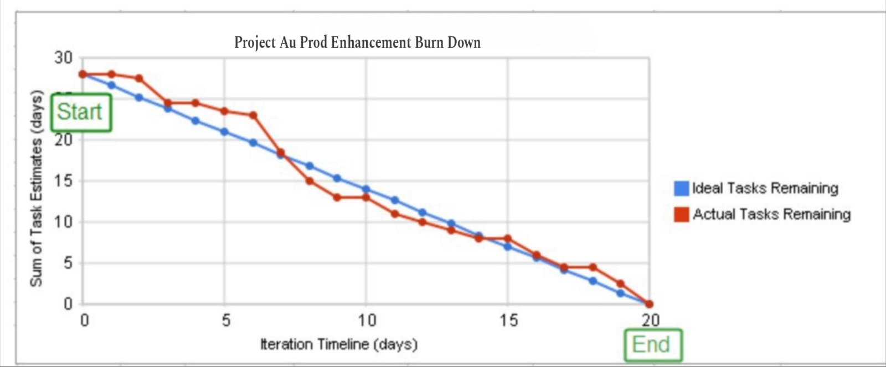

Sprint Burndown Chart – Sprint 3:
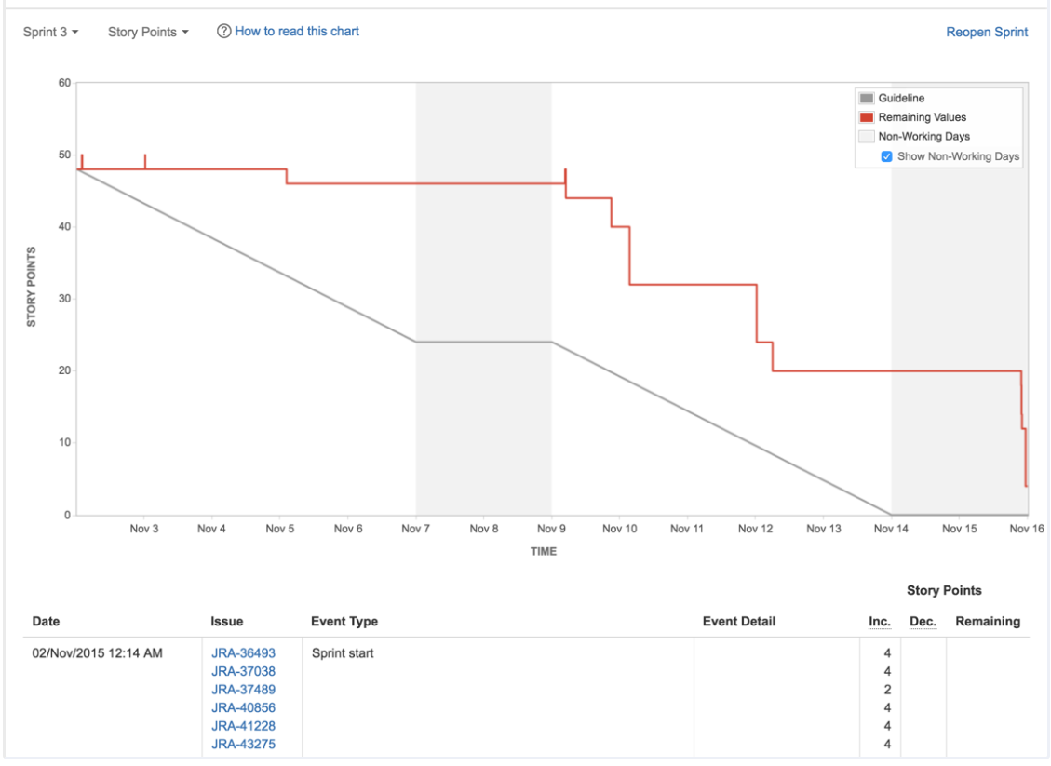

Document 6: Sprint Meetings-

Sprint meetings are essential ceremonies in the Scrum framework. As a Business Analyst (BA), My role in these meetings is to ensure clarity of requirements, represent stakeholder interests, and support team collaboration throughout the sprint.

Sprint Planning Meeting
- Date: 03-06-2025
- Time: 10:00 AM – 11:30 AM
- Location: Teams Call – AU Agile Room
- Prepared by: Kanika Jagtap
- Attendees: Scrum Team, Product Manager, QA
- Agenda Topics:
  - Sprint 1 planning – Login enhancements
  - Task estimation
  - Sprint goal definition
- Observers: QA Manager
- Special Notes: Prioritize biometric feature

Sprint Review Meeting
- Date: 12-06-2025
- Time: 3:00 PM
- Location: Ultratech Boardroom – Jaipur HQ
- Sprint Status: 80% completed
- Things to Demo: OTP Login, UI updates
- Quick Updates: Feedback from Head
- What’s Next: Biometric

Sprint Retrospective Meeting
- Date: 13-06-2025
- Time: 11:00 AM
- Location: Virtual Scrum Room
- Agenda: Review of Sprint 1
  - What went well: Fast development.
  - What didn’t go well: Biometric took more time
  - Questions: How to reduce dependency delays?

Daily Stand-up Meeting
Name/Role | Week “1” (03-06-2025 to 09-06-2025) | Mon | Tue | Wed | Thu | Fri | Sat | Sun
Developer 1 (Sneha) | Biometric dev | ✅ | ✅ | ❌ | ✅ | ✅ | ✅ | ❌
Developer 2 (Aayush) | OTP flow | ✅ | ✅ | ✅ | ✅ | ✅ | ❌ | ❌
Developer 3 (Mahesh) | API & Test | ✅ | ❌ | ✅ | ✅ | ✅ | ✅ | ❌
Questions Tracked:
- What did you do yesterday?
- What will you do today?
- Any blockers?

