CAPSTONE PREP 2 PROJECT
AGRICULTURAL ONLINE STORE
QUESTION NO 1 - Write Agile Manifesto

Agile – Agile is a methodology where scrum is the method used in

this methodology. In Agile the delivery time is high. It also handles

change request. In this Scrum No Middlemen are involved it is done

by the developers, No documentation, Low Cost, Quick Deliverables

CR is posted as a user story. Agile has 4 main values and 12

principles

The four main values of Agile are –

- Individuals and Interactions over the processes and tools

- Working software over comprehensive documentation.

- Customer Collaboration over contract Negotiation.

- Responding to change over following a plan

The 12 Main Values of Agile Manifesto are –

- Satisfy the customer through early and continuous delivery of

valuable software

- Welcoming change Requirements even late in development.

Agile processes harness change for the customer’s competitive

advantage.

- Delivering working software frequently from a couple of weeks

to couple of months with a preference to a shorter time scale

- Business people and developers must work together daily

throughout the project

- Build projects around motivated individuals. Give them support

and help them and trust them to get the job done.
- The most efficient and effective method of conveying

information to and within a development team is face to face

conversation

- Working software is the primary measure of progress

- Agile software promotes sustainable development. The

sponsors, developers, and users should be able to maintain a

constant pace indefinitely.

- Continuous attention to technical excellence and good design

enhances agility

10)Simplicity -The art of maximizing the amount of work not

done is essential.

11 The best architecture, designs, Requirements emerge from

self-organising teams.

12) At regular Intervals the team reflects on how to become more

effective, then tunes and adjusts its behaviour accordingly.

Question -2 User Stories- Acceptance Criteria-BV-CP

User Story – User story is a story which is written by the BA. It is commonly

used in Agile /Scrum methodology to capture the requirements in a way that

focuses on user needs rather than just system functions.

BA role in user story –

To start with the role once the project is kicked off, BA does the

requirement planning then conducts various requirements

gathering sessions and analysis the requirement.

Finally, the requirement is listed as a feature which is drafted by BA

And discussed with product owner. This feature list will have all the

existing features. From the features list BA identifies the epic and

breaks them as themes and then to the user stories.

Acceptance Criteria –

This area will have mandatory information that are needed in this

story.

The BA Briefs the story to the development team and regularly

supports the team for the development

BA also does the Integration Testing and the system Testing to

ensure that the system performs as desired.

BV- BV stands for business value.

Business Value - Business value includes all forms of value that

contribute to the health and success of a business over time. It’s not

just about profits—it’s about the full spectrum of benefits a business

delivers to its stakeholders.

CP- CP stands for Complexity Point.

Complexity Point – Complexity points are also known as story Points.

CP is the effort required by the Scrum Developers to develop this

feature (user story) using technology. Efforts include time taken to

solve the complexity and write the code. CP is estimated by the

Scrum Developers by using Poker cards.

Write minimum 40 User stories and their Acceptance Criteria

along with their BV and CP

User Story -1

User Story :1 | Tasks -2 |  | Priority: Highest
As a customer,

I want to browse restaurants

by cuisine, so that I can find food I like.

BV -9 |  | CP- 3
Acceptance Criteria
Cuisine filter available

Results update dynamically

Multiple cuisines selectable

USER STORY -2
User Story :2 | Tasks -2 |  | Priority: Highest
As a customer,

I want to view restaurant ratings,

so that I can choose quality options.

BV -8 |  | CP- 2
Acceptance Criteria
Star ratings visible

Based on verified reviews

Sort by rating

User Story -3

User Story :3 | Tasks -2 |  | Priority: Highest
As a customer,

I want to search for dishes by name,

so that I can quickly find my favourites.

BV -500 |  | CP- 2
Acceptance Criteria
-Search bar available

Autocomplete suggestions

Results match keywords

User Story -4
User Story :1 | Tasks -2 |  | Priority: Highest
As a customer,

I want to customize my order (e.g., spice level),

so that it suits my taste.

BV -8 |  | CP- 4
Customization options per dish

Saved in cart

Reflected in order summary

User Story -5
User Story :5 | Tasks -2 |  | Priority: Highest
AS A CUSTOMER

I WANT TO ADD THE ADDRESS

SO THAT I CAN GET THE ORDER TO MY ADDRESS

BV -500 |  | CP- 2
Acceptance Criteria
Text Box to enter.

Business Rules: Within the radius of 5 km

User Story -6
User Story :6 | Tasks -2 |  | Priority: Highest
AS A CUSTOMER

I WANT TO SELECT THE PAYMENT MODE

SO THAT I CAN MAKE PAYMENT OF MY CHOICE

BV -500 |  | CP- 3
Acceptance Criteria

Display payment modes, radio buttons to select payment modes, payments button.

Business Rule. Can select only one payment mode

User Story -7
User Story :7 | Tasks -2 |  | Priority: Highest
As a customer,

I want to apply promo codes,

so that I can save money.

BV -8 |  | CP- 3
Acceptance Criteria
Promo field in checkout

Validation logic

Discount reflected in total

User Story -8
User Story :8 | Tasks -2 |  | Priority: Highest
As a customer,

I want to track my order in real-time,

so that I know when it arrives.

BV -9 |  | CP- 6
Acceptance Criteria
Map view

Status updates (Preparing, Out for Delivery, Delivered

ETA visible

User Story -9
User Story :9 | Tasks -2 |  | Priority: Highest
As a customer,

I want to reorder past meals,

so that I save time.

BV -7 |  | CP- 3
Acceptance Criteria
Reorder” button

Past orders stored

Items added to cart

User Story -10
User Story :10 | Tasks -2 |  | Priority: Highest
As a customer,

I want to rate my delivery experience,

so that I can give feedback.

BV -6 |  | CP- 2
Acceptance Criteria
Rating form

Optional comments

Linked to delivery ID

User Story -11
User Story :11 | Tasks -2 |  | Priority: Medium
As a restaurant owner,

I want to add new dishes,

so that customers can order them.

BV -9 |  | CP- 4
Acceptance Criteria
Dish form

Image upload

Price and category fields

User Story -12
User Story :12 | Tasks -2 |  | Priority: Medium
AS A RESTAURANT OWNER

I WANT TO PROVIDE TIME SLOTS

SO THAT CUSTOMER CAN CHECK OPENING AND CLOSING HOURS

BV -9 |  | CP- 4
Acceptance Criteria

- Click on restaurant dashboard

- Add from time to time

3. Click on submit

4. Display updated successfully

User Story -13
User Story :13 | Tasks -2 |  | Priority: Medium
As a restaurant owner,

I want to disable unavailable items,

so that customers don’t order them.

BV -8 |  | CP- 3
Acceptance Criteria
checking the availability

Immediate effect

Notification to users

User Story -14
User Story :14 | Tasks -2 |  | Priority: Medium
As a restaurant owner,

I want to view daily orders,

so that I can manage kitchen operations.

BV -9 |  | CP- 5
Acceptance Criteria
Order dashboard

Filters by time/status

Export option

User Story -15
User Story :15 | Tasks -2 |  | Priority: Medium
As a restaurant owner,

I want to set delivery time estimates,

so that customers know when to expect food.

BV -7 |  | CP- 4
Acceptance Criteria
Time field per dish

Dynamic ETA calculation

Displayed on product page

User Story -16
User Story :16 | Tasks -2 |  | Priority: Medium
As a delivery partner,

I want to receive delivery assignments,

so that I can fulfil orders.

BV -10 |  | CP- 4
Acceptance Criteria
Push notification

Accept/reject option

Order details shown

User Story -17
User Story :17 | Tasks -2 |  | Priority: Medium
As a delivery partner,

I want to view optimized routes,

so that I save time.

BV -9 |  | CP- 6
Acceptance Criteria
-Map integration

Traffic-aware routing

ETA update

User Story -18
User Story :18 | Tasks -2 |  | Priority: Medium
As a delivery partner,

I want to mark orders as delivered,

so that the system updates status.

BV -8 |  | CP- 3
Acceptance Criteria
Delivered” button

Timestamp recorded

Customer notified

User Story -19
User Story :19 | Tasks -2 |  | Priority: Medium
As a delivery partner,

I want to view my earnings,

so that I track my income.

BV -7 |  | CP- 4
Acceptance Criteria
Daily/weekly summary

Breakdown by order

Export option

User Story -20
User Story :20 | Tasks -2 |  | Priority: Medium
As a delivery partner,

I want to report issues,

so that support can assist me.

BV -6 |  | CP- 3
Acceptance Criteria
Issue form

Linked to order

Response SLA

User Story -21
User Story :21 | Tasks -2 |  | Priority: Highest
As an admin,

I want to view top-selling dishes,

so that I optimize the menu.

BV -8 |  | CP- 4
Acceptance Criteria
Ranked list

Filters by time

Exportable data

User Story -22
User Story :22 | Tasks -2 |  | Priority: Highest
As an admin,

I want to track customer retention,

so that I improve loyalty.

BV -7 |  | CP- 5
Acceptance Criteria
Repeat order rate

Analysis

Segment by region

User Story -23
User Story :23 | Tasks -2 |  | Priority: Highest
As an admin,

I want to monitor delivery performance,

so that I ensure quality.

BV -8 |  | CP- 4
Acceptance Criteria
On-time rate

Average delivery time

Partner comparison

User Story -24

User Story :24 | Tasks -2 |  | Priority: Highest
As an admin,

I want to analyse promo code usage,

so that I assess marketing ROI.

BV -7 |  | CP- 3
Acceptance Criteria
Usage count

Conversion rate

Revenue impact

User Story -25

User Story :25 | Tasks -2 |  | Priority: Highest
As an admin,

I want to view app usage trends,

so that I improve UX.

BV -6 |  | CP- 4
Acceptance Criteria
Page views

Session duration

Drop-off points

User Story -26
User Story :26 | Tasks -2 |  | Priority: Highest
As a user,

I want my data to be encrypted,

so that my privacy is protected.

BV -10 |  | CP- 6
Acceptance Criteria
Encryption

HTTPS enforced

No plaintext storage

User Story -27
User Story :27 | Tasks -2 |  | Priority: Highest
As an admin,

I want to manage user roles,

so that access is controlled.

BV -9 |  | CP- 5
Acceptance Criteria
Role assignment

Permissions matrix

Audit logs

User Story -28
User Story :28 | Tasks -2 |  | Priority: Highest
As a user,

I want to delete my account,

so that I control my data.

BV -8 |  | CP- 4
Acceptance Criteria
Delete request

Confirmation prompt

Data delete

User Story -29
User Story :29 | Tasks -2 |  | Priority: Highest
As a user,

I want to enable 2FA,

so that my account is more secure.
BV -9 |  | CP- 5
Acceptance Criteria
OTP via SMS/email

Toggle in settings

Backup codes

User Story -30
User Story :30 | Tasks -2 |  | Priority: Highest
As an admin,

I want to monitor suspicious activity,

so that I prevent fraud.

BV -8 |  | CP- 6
Acceptance Criteria
Alerts

IP tracking

Login history

User Story -31
User Story :31 | Tasks -2 |  | Priority: low
As a business owner,

I want to view daily revenue reports,

so that I can monitor financial performance.

BV -10 |  | CP- 4
Acceptance Criteria
Dashboard with daily totals

Filters by restaurant, region

Export

User Story -32
User Story :32 | Tasks -2 |  | Priority: low
As a business owner,

I want to track customer acquisition trends,

so that I can evaluate marketing effectiveness.

BV -9 |  | CP- 5
Acceptance Criteria

Graph of new users over time

Source attribution (ads, referrals)

Segment by region

User Story -33
User Story :33 | Tasks -2 |  | Priority: low
As a business owner,

I want to compare restaurant performance,

so that I can identify top performers.

BV -9 |  | CP- 4
Acceptance Criteria

Metrics: orders, revenue, ratings

Sortable table

Monthly comparison

User Story -34
User Story :34 | Tasks -2 |  | Priority: Low
As a business owner,

I want to monitor delivery efficiency,

so that I can improve logistics.
BV -8 |  | CP- 5
Acceptance Criteria
Avg delivery time

On-time rate

Partner performance

User Story -35
User Story :35 | Tasks -2 |  | Priority: Low
As a business owner,

I want to manage commission rates per restaurant,

so that I control profitability.

BV -8 |  | CP- 4
Acceptance Criteria

Editable commission field

Tiered structure

Audit log

User Story -36
User Story :36 | Tasks -2 |  | Priority: Low
As a business owner,

I want to approve or reject restaurant onboarding requests,

so that I maintain quality.

BV -7 |  | CP- 3
Acceptance Criteria
Request queue

Profile preview

Approve/reject buttons

User Story -37
User Story :37 | Tasks -2 |  | Priority: low
As a business owner,

I want to set promotional budgets,

so that I control marketing spend.

BV -8 |  | CP- 4
Acceptance Criteria
Budget field

Campaign tracking

Alert on overspend

User Story -38
User Story :38 | Tasks -2 |  | Priority: low
As a business owner,

I want to view refund statistics,

so that I identify service issues.

BV -7 |  | CP- 3
Acceptance Criteria
Refund count and value

Reasons categorized

Linked to orders

User Story -39
User Story :39 | Tasks -2 |  | Priority: Highest
As a business owner,

I want to analyse peak order times,

so that I optimize staffing and delivery.

BV -8 |  | CP- 4
Acceptance Criteria
Heatmap by hour/day

Filters by region

Exportable

User Story -40
User Story :40 | Tasks -2 |  | Priority: Highest
As a business owner,

I want to track app usage metrics,

so that I improve user engagement.

BV -7 |  | CP- 5
Acceptance Criteria
Page views

Session duration

Drop-off points

Question -3 What is Epic? Write 2 Epics

Business Value and Complexity Points

Epic – An Epic is a set of related user stories. They are also considered really
big story.
BV- BV stands for business value.

Business Value - Business value includes all forms of value that

contribute to the health and success of a business over time. It’s not

just about profits—it’s about the full spectrum of benefits a business

delivers to its stakeholders.

CP- CP stands for Complexity Point.

Complexity Point – Complexity points are also known as story Points.

CP is the effort required by the Scrum Developers to develop this

feature (user story) using technology. Efforts include time taken to

solve the complexity and write the code. CP is estimated by the

Scrum Developers by using Poker cards.

Question 4 –What is the difference between BV and CP

The differences between BV and CP

Business Value | Complexity Points
Business Value is the benefit or the task that brings value to the business. | Complexity is the measurement of how difficult or effort-intensive a task is to complete
The main focus is on value creation, ROI | The main focus is Technical Challenges, Time Resources.
It is used for high Impacting tasks or features | It is used for Estimating work load or planning sprints or releases.
It is often measured by Stake Holders based on business Impact | It is measured by developers or teams based on complexity or efforts.
The Goal is to Maximize Return and customer satisfaction | The Goal is to Manage Capacity

Question 5 - Explain about Sprint

Sprint – Sprint is a period that the team decides to delivery their objective

Normally, the sprint period will be for 2 weeks and will extend till 4 weeks.

Scrum is the sub unit of the sprint. Generally, Scrum can be implemented at

the beginning of the project or when u sense that project is falling behind the

schedule. This model exercises full admin power.

Generally, scrum team are the project resources which comprises of BA’S

Developers, testers etc. Each Team size average is of 7-8 members.

PBI: Product Backlog Item

Task: Unit of Work done by 1 Developer in 1 Scrum WIP: Work in Progress

Sprint Backlog PBI | Tasks | WIP | Done

Roles Involved
Product Owner: Defines the product vision and prioritizes the backlog.

Scrum Master: Facilitates the process and removes obstacles.

Development Team: Executes the work and delivers the product incremen

Benefits of Sprint

Faster delivery of working software.

Improved adaptability to change.

Continuous feedback from stakeholders.

Greater transparency and team alignment.
Why Sprint Works?
Higher product quality through iterative refinement
Sprints break down complex projects into bite-sized, manageable
chunks, allowing teams to stay focused, adapt quickly, and deliver value
consistently. It’s like running a series of short races instead of one
exhausting marathon.

Question -6 Explain Product backlog and sprint back log

Product Backlog - Product Backlog as the master list of everything that

could be built for the product.

All stories -All Requirements.

The product backlog is owned by the product owner

The features and contents are Enhancements, Bug Fixing, Technical Tasks

The format is usually written as user stories or epics.

The Priority is Items are ranked by business value, urgency, and stakeholder needs

The Flexibility is Continuously updated as new ideas or changes arise.

Sprint Backlog - The Sprint Backlog is a subset of the Product Backlog—it

contains only the items the team commits to completing during a specific

Sprint.

The Sprint backlog is owned by the Development Team.

The contents are the Selected Product Backlog items + tasks to complete them

Its Scope is Selected items for the Sprint

The Flexibility is fixed during the sprint.

Sprint Planning Meeting – This happens at the beginning of each sprint and

the team decides what they will be delivering in the sprint All 8 Scrum

Developers will gather before the sprint starts and understand how many user
stories, they can develop in 1 sprint (2 weeks), and move them from the

product Backlog to the sprint Backlog. They take inputs from Sprint

Retrospective meeting.

Scrum Meeting – Daily Stand-up Meeting

End of every Scrum, Scrum Developers will participate in Scrum meeting. Here

they must answer 3 Questions.

- What task did you work in this scrum?

- What task will you work on next scrum?

- Any Challenges/impediments? When you will complete the user story?

Daily Stand up meeting -

This happens every day where the team will be answerable 3 questions –

- What did u do Today?

- What will you do tomorrow?

- Is there any Impediments that is slowing you or stopping you?

Sprint Review Meeting –

This happens at the end of each sprint where team will demo the

completed stories to product owner and get it cleared.

Sprint Retrospective Meeting -

This happens at each sprint where team will answer the 3 questions

- What went well in the sprint?
- What did not go well?

- What are the required areas of improvements in the next sprint?

Question -7 What is impediments log? write 2 impediments

Impediments Log-

An Impediments Log is a running list of obstacles or blockers that hinder a
Scrum team’s progress. These are issues that prevent the team from
completing their work efficiently during a Sprint.

write 2 impediments

Unresolved External Dependency
- Description: The team is waiting on an API integration from a third-party vendor,

which is delaying development.

- Impact: Blocks progress on a key user story

- Resolution Plan: Scrum Master escalates to vendor management and tracks

delivery timeline.

Lack of Access to Test Environment
- Description: QA team cannot access the staging server due to expired credentials.

- Impact: Testing is delayed, risking Sprint goals.

- Resolution Plan: IT support is contacted to restore access; flagged as high priority.

Question 8 – Explain Velocity of the Team
Velocity is the measure of the amount of work a team completes during a
Sprint. It’s typically expressed in story points, which represent the effort or
complexity of tasks (user stories). Velocity helps teams forecast future work,
plan sprints, and set realistic expectations.

The Velocity is calculated by the end of each Sprint, you calculate velocity by
adding up the story points of all the user stories that were fully completed.
Velocity = Total Story Points Completed in a Sprint

Why Is Velocity Useful?

- Sprint Planning: Helps teams decide how much work to commit to.

- Forecasting: Predicts how many sprints are needed to complete a

backlog.

- Performance Tracking: Reveals trends in team productivity.

- Stakeholder Communication: Sets realistic delivery timelines.

Velocity – How many CP is covered in this sprint

To determine how many CP (Committed Points or Story Points) were covered

in this Sprint, you'd typically look at the Sprint Backlog and count only the

items that were fully completed and met the Definition of Done.

Question- 9 Draw Sprint Burn Charts and Product Burn Down Charts
Sprint Burn Charts – A sprint Burn Charts is a graphical view of the

remaining work left versus the time in an iteration. A project backlog can

be expressed on the vertical axis, while time is indicated on the

horizontal axis.
A Sprint Burndown Chart plots:
- X-axis: Time (days of the Sprint)

- Y-axis: Remaining work (usually in story points or hours)

- On Track: Actual line closely follows the ideal line

- Ahead of Schedule: Actual line drops faster than ideal

- Behind Schedule: Actual line stays above the ideal line

- Sudden Drops: May indicate bulk updates or late completions

- Flat Line: No progress—possible impediments

Sprint Burn Down Chart.
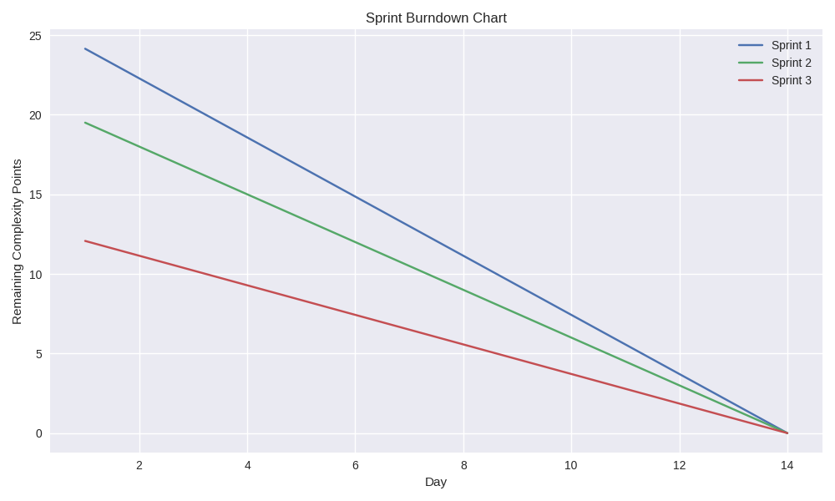

Product Burndown Chart

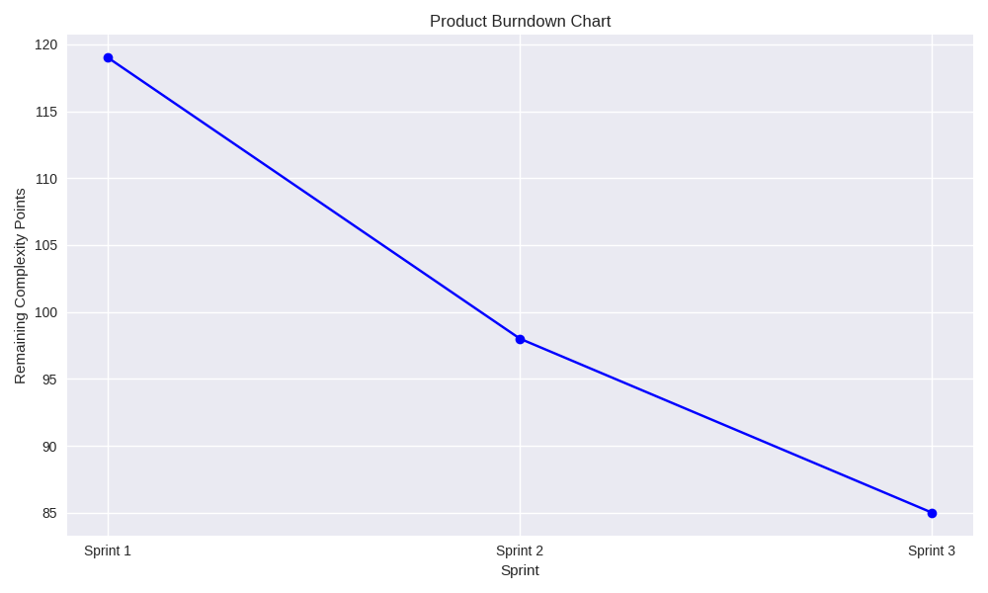

Question 10 – Explain about Product Grooming

Product Grooming – Product Grooming is the ongoing process of

reviewing, updating, and prioritizing items in the product backlog. The

people involved here -

• Product Owner / Manager – Leads the session, sets priorities
• Scrum Master – Facilitates the meeting
• Development Team – Provides technical insights and estimates
• Stakeholders – Occasionally invited for context or feedback

Product insights are actionable learnings derived from analysing how users interact with your product. They reveal:
- What users do (behavioural data)
- Why they do it (motivations, pain points)
- What they need (unmet expectations or desires)
These insights guide decisions on feature enhancements, UX design, pricing, positioning.

Question 11 – Explain the roles of Scrum Master and Product Owner

Scrum Master -
A Scrum Master is the agile team’s coach, facilitator, and protector of process.
Think of them as the guardian of the Scrum framework—ensuring that the
team follows agile principles while continuously improving how they work.
Roles of a Scrum Master –
  - He Will facilitate scrum by resolving issues.

  - Creating Environment for team self-organisation

  - Capturing Empirical data adjust the forecast

  - Guides the team through Scrum ceremonies (like stand-ups, sprint

planning, retrospectives)

  - Removes Obstacles that block the process.

Scrum Master will not have any management authority over the team.
Product Owner -
He will decide what needs to be in the product and will be

responsible for how the product has to be. He will regularly

interact with Customers and Business analyst. This role maybe

played by BA or any person who worked for end users for long

time or customer himself.

Roles of Product Owner -

- He is responsible for product Vision.
- He is also responsible for requirement questions.

- Product owners consider stake holders interests.

- Product Owner Decides whether to accept or reject the product

Increments.

- He is also responsible to continue or discontinue the

Development and whether to ship the project or not.

Question 12 – Explain all Meetings Conducted in Scrum Project

The meetings which are conducted in Scrum Project are –

- Scrum meeting or daily stand up meeting

- Sprint Planning Meeting

- Sprint Review Meeting

- Sprint Retrospective Meeting

- Scrum Meeting or Daily Stand up Meeting-

This happens each day where the team will just answer 3

questions.

- What did u do today?

- What will you do tomorrow?

- Is there any Impediments that is slowing or stopping you?

- Sprint Planning Meeting –

This happens at the beginning of each sprint and the team

decides what they will be delivering in the sprint.

- Sprint Review Meeting –

This happens at the end of each sprint where team will demo

the completed stories to product owner and get it clear.

- Sprint Retrospective Meeting –

This happens at the end of the sprint where team is answerable

for 3 questions -

- What went well in the sprint?

- What did not go well?

- What are the required areas of Improvement in the next?

Sprint?

Question 13 – Explain Sprint Size and Scrum Size

Sprint Size –

Sprint Size refers to the duration of a sprint—how long your team works on a

set of tasks before reviewing and resetting.

The Sprint Size is 2 to 4 weeks (2 Weeks is most Common)

The Influencing factors are stake holder’s availability and team maturity.

Scrum Size –

Scrum Size refers to the number of the people in a scrum Team, which Includes

- Scrum Master-1

- Product Owner-1

- Developers -8

A well-sized Scrum Team working within a well-sized Sprint ensures:

- Clear goals

- Predictable delivery

- Effective collaboration

- Continuous feedback and improvement.

Question 14 – Explain DOR and DOD

DOR defines Definition of Ready. It defines the criteria a user story or

backlog item must meet before the team can start working on it.

The purpose is to ensure that work entering a sprint is well understood

, feasible, actionable. The Criteria of DOR is –

- Acceptance Criteria is testable

- Estimation completed by the team.

- Stake holder approval required (if Required)

DOD – DOD Defines Definition of Done.

This outlines the criteria that must be met for a backlog item to be

considered complete. The purpose is to ensure that to maintain

consistent Quality and avoid ambiquity about what done really means.

The Criteria of DOD is –

- Unit and Integration test pass.

- Documentation Updated.

- Product Owner Approval Required.

DOD is the exit gate which ensures the work is done and meets its

quality standards and is truly deliverable.

Question-15 Explain Prioritization Techniques and MVP

MVP stands for Minimal Viable product

An MVP is the simplest version of a product that delivers core value to users
and allows you to:
- Validate assumptions

- Gather feedback

- Minimize time-to-market

- Avoid building unnecessary features

The core value is solving the primary user problem.
It Can released and tested by the real users.

Prioritization Techniques-
These techniques are used to rank backlog items based on the value, effort,
urgency and strategic fit and used for the development purpose.
Factors that influence are -Importance, risk, cost, benefits, time, strategy.
There are 3 main actors
- Customers

- Developers

- Business Owners

MOSCOW Technique- Must, Should, Could, Would

MOSCOW is a prioritization technique used in the business analysis and

software development to reach a common understanding with the stake

holders on the importance as they place the delivery on each requirement

also known as MOSCOW prioritization Technique.

M- Must have this requirement to meet the business needs.

S – Should have this requirement if possible, but the project success does

not rely on it.

C-Could have this requirement if it does not affect anything else in the

project.

W- Would like to have this requirement later, but it won’t be delivered at

this time.

Question 16 – Difference between Business Analyst n Product Owner

Business Analyst | Product Owner
The Primary Focus is  Understanding Business  needs and translating them to  requirements. | The Primary Focus is Maximizing the  product value and managing product  backlog.
The Responsibilities are Elicit the  requirements, model processes,  facilitate workshops. | Define user stories, prioritize  backlogs, Accept /Reject the work,  align them with vision
Acts as a bridge between business  and technical teams. | Represents customer and business  interests to the development team.
Advises on scope and feasibility,  but doesn’t own product decisions | Owns product decisions, roadmap,  and release priorities
BRDs, use cases, diagrams, requirement templates | Roadmaps, story maps, backlog tools (Jira, Azure DevOps)

Question -17 Prepare a sample Resume of 3yrs exp Product Owner

Name: Sameera
Location: Hyderabad, India
Email: Sameera@email.com
Phone: +91 7386844537
LinkedIn: linkedin.com/in/Sameera

Professional Summary-
Results-driven Product Owner with 3+ years of experience in agile product development, backlog management, and stakeholder alignment. Proven ability to translate business needs into actionable user stories, prioritize features based on value, and deliver customer-centric solutions. Skilled in cross-functional collaboration, sprint planning, and MVP scoping.

Core Competencies
• Agile & Scrum Methodologies
• Product Road mapping
• Backlog Grooming & Prioritization
• MVP Definition & Delivery
• Stakeholder Engagement
• User Story Writing & Acceptance Criteria
• Jira, Confluence

Professional Experience

Product Owner

HCA – Hyderabad Aug 2024 – Present

Defined and prioritized backlog items using Moscow
• Collaborated with UX designers and developers to deliver 6 major releases in 12 months
• Conducted sprint planning, reviews, and retrospectives with a cross-functional Scrum team
Associate Product Owner
E-Commerce – Bengaluru
Jul 2020 – Jul 2024
• Created user stories, acceptance criteria, and release notes for 50+ features
• Worked closely with Business Analysts to align product goals with user needs
• Facilitated stakeholder demos and roadmap presentations

Education
Bachelor of Technology
(B. Tech) – Computer Science
Osmania University, Hyderabad 2016 – 2020

Certifications
- Certified Scrum Product Owner (CSPO) – Scrum Alliance

- Agile Product Management –

- Jira Fundamentals –

