Capstone Project prep 2

Q.no 1:
Write Agile Manifesto?
Answers: -
Agile:
Agile is a flexible and iterative approach to project management and software development that focuses on delivering value quickly, adapting to change.
Agile value:
- Individuals and interactions over processes and tools.
- Working software over comprehensive documentation.
- Customer collaboration over contract negotiation.
- Responding to change over following a plan.
Agile principles:
These principles guide how Agile teams operate day-to-day:
- Satisfy the customer through early and continuous delivery of valuable software.
- Welcome change, even during later stages of development. Agile processes harness change for the customer’s competitive edge.
- Deliver working software frequently from a couple of weeks to a couple of months with a preference for a shorter time frame.
- Business teams and development teams must work together daily throughout the project.
- Working software is the measure of progress.
- The most effective and efficient method of conveying information to and within the development team is face-to-face conversation.
- Build projects around motivated individuals. Give them the environment and support they need and trust them to get the job done.
- Agile processes promote sustainable development. Sponsors, developers, and users must maintain a constant pace indefinitely.
- Continuous attention to technical excellence and good design increases agility.
- Simplicity the art of maximizing the amount of work not done is essential.
- The best architectures, requirements, and designs emerge from self-organizing teams.
- At regular intervals, the team reflects on how to become more effective, then tunes and adjusts its behavior accordingly.

Q.no 2
Write minimum 40 User stories and their Acceptance Criteria along with their BV and CP?
Answers: -
USER STORIES
SPRINT-1
User Story No: 1 | Tasks: 2 | Priority: HIGHEST
AS A DELIVERY BOY
I WANT TO REGISTER IN SCRUM FOODS
SO THAT I CAN DELIVER ORDERS
BV: 500 | CP: 02
ACCEPTANCE CRITERIA
Registration Screen
Text Boxes for User Name, Password, Nation ID, Mobile No, Email, Address,
Phone Number.
Click on Register Button.
Send Successful Notification to the user

User Story No: 02 | Tasks: 2 | Priority: HIGHEST
AS A RESTAURANT OWNER
I WANT TO VIEW ORDERS
SO THAT I CAN VIEW THE LIST OF ORDERS

BV: 500 | CP: 02
Acceptance Criteria:
View Order, Display List of orders in the tabular Form

User Story No: 3 | Tasks: 2 | Priority: HIGHEST
AS A CUSTOMER
I WANT TO ADD THE ADDRESS
SO THAT I CAN GET THE ORDER TO MY ADDRESS
BV: 500 | CP: 2
Acceptance Criteria:
Text Box to enter.
Business Rules: Within the radius of 5km

User Story No: 4 | Tasks: 2 | Priority: HIGHEST
AS A CUSTOMER
I WANT TO SELECT THE PAYMENT MODE
SO THAT I CAN MAKE PAYMENT OF MY CHOICE
BV: 500 | CP: 3
Acceptance Criteria:
Display payment modes, radio buttons to select payment modes, payments button.
Business Rule. Can select only one payment mode

User Story No: 5 | Tasks: 2 | Priority: HIGHEST
AS AN ADMIN
I WANT TO VIEW THE RESTAURANTS
SO THAT I CAN APPROVE THEIR REGISTRATION
BV: 500 | CP: 2
ACCEPTANCE CRITERIA
List of restaurants, select Restaurants, verify restaurant details, approve button, reject button, notification to the restaurant.

User Story No: 6 | Tasks: 2 | Priority: LOW
AS A CUSTOMER
I WANT TO VIEW THE PRICE
SO THAT I CAN ORDER THE FOOD
BV: 50 | CP: 1
Acceptance Criteria:
- Display price in the list of menu items

User Story No: 7 | Tasks: 2 | Priority: LOW
AS A CUSTOMER
I WANT TO VIEW THE CONTACT NUMBER OF DELIVERY BOY
SO THAT I CAN CONTACT DELIVERY BOY FOR THE STATUS
BV: 50 | CP: 1
Acceptance Criteria:
- Display delivery boy mobile number
- Display delivery boy name in tracking field
- Display delivery boy picture

User Story No: 8 | Tasks: 2 | Priority: MEDIUM
AS A RESTAURANT OWNER
I WANT TO PROVIDE TIME SLOTS
SO THAT CUSTOMER CAN CHECK OPENING AND CLOSING HOURS
BV: 100 | CP: 2
Acceptance Criteria:
- Click on restaurant dashboard
- Add from time to time
- Click on submit
- Display updated successfully

User Story No: 9 | Tasks: 2 | Priority: HIGH
AS A Business OWNER
I WANT TO VIEW RESTAURANT REVENUE REPORT
SO THAT I CAN VIEW THE RESTAURANT ‘S REVENUE
BV: 200 | CP: 3
Acceptance Criteria:
Select Reports
Select Revenue Reports
Select to and from date
Select Region (can select all)
Generate Report
Download Report in EXCEL

User Story No: 10 | Tasks: 3 | Priority: High
AS A REG ADMIN
I WANT TO MANAGE REGIONAL RESTAURANTS,
SO THAT, I CAN TRACK THE PERFORMANCE OF REGIONAL RESTAURANTS.
BV: 200 | CP: 03
Acceptance Criteria:
CLICK ON PERFORMANCE OF RESTAURANTS
SELECT FROM DATE TO DATE
CLICK ON GENERATE REPORT WHICH INCLUDES RESTAURANTS ID, NAME, REVENUE
CLICK ON DOWNLOAD REPORT SHOULD BE IN EXCEL

User Story No: 11 | Tasks: 02 | Priority: Medium
AS AN ADMIN
I WANT TO SEE THE REGIONAL REVENUE REPORTS,
SO THAT I CAN VIEW THE REGIONAL PERFORMANCE

BV: 100 | CP: 03
Acceptance Criteria:
Select regional dropdown
View performance of each rest of that region in tabular form which includes restaurants name, revenue generated
Download in excel or PDF

User Story No: 12 | Tasks: 02 | Priority: High
AS A CUSTOMER
I WANT TO CHAT WITH REG ADMIN
SO THAT I CAN REQUEST FOR REFUND
BV: 200 | CP: 02
Acceptance Criteria:
- BR-ALL MANDATORY
- TEXT BOX FIELDS
- DISPLAY ORDER ID
- TEXT BOX, FOR DESCRIPTION
- SUBMIT BUTTON
- GENERATE ISSUE ID
- DISPLAY SUCCESSFUL

User Story No: 13 | Tasks: 02 | Priority: High
AS A HUNGRY USER
I WANT TO BROWSE NEARBY RESTAURANTS
SO THAT I CAN ORDER THE FOOD
BV: 200 | CP: 02
Acceptance Criteria:
- Each restaurant entry displays its name, cuisine type, and rating.
- This list can be sorted by distance or rating

User Story No: 14 | Tasks: 02 | Priority: High
AS A CUSTOMER
I WANT TO BROWSE DIFFERENT RESTAURANTS AND MENUS
SO THAT I CAN FIND A PLACE TO ORDER FOOD
BV: 200 | CP: 02
Acceptance Criteria:
- The menu includes dishes, prices and descriptions
- Show the restaurant is open or closed

User Story No: 15 | Tasks: 01 | Priority: High
AS A CUSTOMER
I WANT TO BROWSE FOR SPECIFIC DISHES AND CUISINES
SO THAT I CAN FIND A PLACE TO ORDER FOOD
BV: 200 | CP: 02
Acceptance Criteria:
- App displays relevant restaurants and dishes matching the query

User Story No: 16 | Tasks: 01 | Priority: High
AS A CUSTOMER
I WANT TO FILTER RESTAURANTS
SO THAT I CAN FIND A PLACE TO ORDER FOOD
BV: 200 | CP: 02
Acceptance Criteria:
- Filter restaurants by cuisine type and dietary options (vegan, veg, non-veg, egg)

User Story No: 17 | Tasks: 02 | Priority: High
AS A CUSTOMER
I WANT TO TRACK MY ORDER
SO THAT I KNOW THE TIME OF DELIVERY
BV: 200 | CP: 02
Acceptance Criteria:
- App shows real time update on the order status.
- Display estimated delivery time.

User Story No: 18 | Tasks: 01 | Priority: High
AS A USER
I WANT TO RATE AND REVIEW RESTAURANTS SO THAT
I CAN RATE AND REVIEW THE RESTAURANTS I HAVE VISITED
BV: 200 | CP: 02
Acceptance Criteria:
- Can see reviews from other users to help me make dining decisions.

User Story No: 19 | Tasks: 01 | Priority: High
AS A USER
I WANT TO SAVE FAVOURITE RESTAURANTS AND DISHES
SO THAT I CAN ORDER FROM MY FAVOURITES
BV: 200 | CP: 02
Acceptance Criteria:
- Access my list of favorites easily for future orders.

User Story No: 20 | Tasks: 01 | Priority: High
AS A USER
I WANT TO VIEW PAST ORDER HISTORY
SO THAT I CAN ORDER AGAIN
BV: 200 | CP: 02
Acceptance Criteria:
- Can see the details such as order items, total cost and order date.

User Story No: 21 | Tasks: 03 | Priority: High
AS A USER
I WANT TO RECEIVE NOTIFICATIONS
SO THAT I CAN RECEIVE UPDATES
BV: 200 | CP: 02
Acceptance Criteria:
- Notifications for order confirmation.
- Notification for dispatch.
- Notification for delivery.

User Story No: 22 | Tasks: 01 | Priority: Medium
AS A CUSTOMER
I WANT TO CONTACT CUSTOMER SUPPORT
SO THAT I CAN SUBMIT QUERIES OR ISSUES
BV: 200 | CP: 02
Acceptance Criteria:
- Customer support section with contact information.

User Story No: 23 | Tasks: 02 | Priority: High
AS A RESTAURANT OWNER
I WANT TO RECEIVE AND MANAGE ORDERS
SO THAT I CAN UPDATE ORDER STATUS
BV: 200 | CP: 02
Acceptance Criteria:
- Manage order status
- Notify restaurants about incoming orders

User Story No: 24 | Tasks: 02 | Priority: High
AS A RESTAURANT OWNER
I WANT TO ACCESS TO CUSTOMER REVIEWS
SO THAT I CAN VIEW AND RESPOND TO CUSTOMER REVIEWS
BV: 200 | CP: 02
Acceptance Criteria:
- Owners can address feedback.
- Owners can improve their services.

User Story No: 25 | Tasks: 01 | Priority: Medium
AS A CUSTOMER
I WANT TO VIEW PROMOCODES AND DISCOUNTS
SO THAT I CAN ORDER AT LOWER PRICE
BV: 100 | CP: 04
Acceptance Criteria:
- Active promo codes.

User Story No: 26 | Tasks: 01 | Priority: Medium
AS A CUSTOMER
I WANT TO APPLY PROMOCODES AND DISCOUNTS
SO THAT I CAN ORDER AT LOWER PRICE
BV: 100 | CP: 04
Acceptance Criteria:
- Active promo codes.

User Story No: 27 | Tasks: 07 | Priority: High
AS A DELIVERY BOY
I WANT TO VIEW THE ORDERS
SO THAT I CAN ACCEPT THE ORDERS
BV: 200 | CP: 04
Acceptance Criteria:
- Order visibility.
- Real-time updates.
- Order details.
- Order filtering and sorting.
- Order map view
- Order navigation.
- Order completion and confirmation.

User Story No: 28 | Tasks: 05 | Priority: HIGH
AS A DELIVERY BOY
I WANT TO LOGIN
SO THAT I CAN ACCEPT THE ORDER
BV: 200 | CP: 04
Acceptance Criteria:
- User Authentication.
- Error Handling.
- Password security.
- Multi-factor Authentication.
- Compatibility and Usability.

User Story No: 29 | Tasks: 05 | Priority: MEDIUM
AS A DELIVERY BOY
I WANT TO VIEW FEEDBACK
SO THAT I CAN KNOW THE CUSTOMER FEEDBACK
BV: 200 | CP: 04
Acceptance Criteria:
- Access to feedback system.
- Feedback visibility.
- Feedback sorting and filtering.
- Response Mechanism.
- User Support.

User Story No: 30 | Tasks: 05 | Priority: MEDIUM
AS AN ADMIN
I WANT TO VIEW FEEDBACK
SO THAT I CAN KNOW THE CUSTOMERS FEEDBACK
BV: 200 | CP: 04
Acceptance Criteria:
- Access to feedback system.
- Feedback Visibility.
- Feedback sorting and filtering.
- Response Mechanism.
- User Support.

User Story No: 31 | Tasks: 05 | Priority: MEDIUM
AS A RESTAURANT OWNER
I WANT TO VIEW FEEDBACK
SO THAT I CAN KNOW THE CUSTOMERS FEEDBACK
BV: 200 | CP: 04
Acceptance Criteria:
- Access to feedback system.
- Feedback Visibility.
- Feedback sorting and filtering.
- Response Mechanism.
- User Support.

User Story No: 32 | Tasks: 03 | Priority: HIGH
AS AN ADMIN
I WANT TO KNOW THE ISSUES
SO THAT I CAN RESOLVE THEM
BV: 100 | CP: 03
Acceptance Criteria:
- Display issue section.
- Sorting and filtering of issues list.
- Editing and modifying the issues.

User Story No: 33 | Tasks: 03 | Priority: HIGH
AS A REGIONAL ADMIN
I WANT TO KNOW THE ISSUES
SO THAT I CAN RESOLVE THEM
BV: 200 | CP: 04
Acceptance Criteria:
- Display issue section.
- Sorting and filtering of issues list.
- Editing and modifying the issues.

User Story No: 34 | Tasks: 06 | Priority: HIGH
AS A RESTAURANT OWNER
I WANT TO VIEW REVENUE GENERATED
SO THAT I CAN VIEW RESTAURANTS REVENUE
BV: 200 | CP: 04
Acceptance Criteria:
- Select Reports
- Select Revenue Reports
- Select to and from date
- Select Region (can select all) Generate Report
- Download Report in EXCEL.

User Story No: 35 | Tasks: 05 | Priority: MEDIUM
AS A RESTAURANT OWNER
I WANT TO KNOW DELIVERY BOY
SO THAT I CAN VERIFY THE DELIVERY BOY
BV: 200 | CP: 04
Acceptance Criteria:
- ID proof.
- Punctuality and reliability.

User Story No: 36 | Tasks: 02 | Priority: Low
AS A CUSTOMER
I WANT TO VIEW THE CONTACT NUMBER OF DELIVERY BOY
SO THAT I CAN CONTACT DELIVERY BOY FOR THE STATUS
BV: 50 | CP: 01
Acceptance Criteria:
- Display delivery boy mobile number.
- Display delivery boy name in tracking field.
- Display delivery boy picture.

User Story No: 37 | Tasks: 02 | Priority: MEDIUM
AS A RESTAURANT OWNER
I WANT TO PROVIDE TIME SLOTS
SO THAT CUSTOMERS CAN CHECK OPENING AND CLOSING HOURS
BV: 100 | CP: 02
Acceptance Criteria:
- Click on restaurant dashboard.
- Add from time to time.
- Click on submit.
- Display updated successfully.

User Story No: 38 | Tasks: 03 | Priority: High
AS A USER
I WANT TO RECEIVE NOTIFICATIONS
SO THAT I CAN RECEIVE UPDATES
BV: 200 | CP: 02
Acceptance Criteria:
- Notifications for order confirmation.
- Notification for dispatch.
- Notification for delivery.

User Story No: 39 | Tasks: 01 | Priority: MEDIUM
AS A CUSTOMER
I WANT TO CONTACT CUSTOMER SUPPORT
SO THAT I CAN SUBMIT QUERIES OR ISSUES
BV: 200 | CP: 02
Acceptance Criteria:
- Customer support section with contact information.

User Story No: 40 | Tasks: 04 | Priority: MEDIUM
AS A CUSTOMER
I WANT TO VIEW THE ORDER
SO THAT I CAN CANCEL IT
BV: 100 | CP: 03
Acceptance Criteria:
- Order status.
- Method of cancellation.
- Refund policy.
- Time Frame.

Q. no 3:
What is epic? Write 2 epics
Answers: -
Epic:
An epic is a large, strategic piece of functionality or business goal that can be broken into multiple user stories or features.
Epic is a set of user stories or the big user story consisting the number of small user stories to complete the mile stone know as epic.
Epic can be said as the set of user stories completed to achieve one task. Epics help teams organize and prioritize work that contributes to strategic goals.
Key Features of an Epic:
- High Level Objective:
Focuses on a broader goal rather than granular functionality.
- Collection of user stories:
An epic contains multiple smaller user stories that contribute to achieving the goal.
- Cross- Sprint work:
Epics often span multiple sprints or iterations.

- Helps organize work:
Provides structure to manage related stories within a project.
Examples of Epics in General
- Build a secure e-commerce platform
- Implement a food delivery system

Epic 1: User Onboarding and Authentication System
Objective:
Ensure seamless user registration, login, and secure account management for all stakeholders (customers, admins, vendors).

Key Features:
- Registration for customers, vendors, and admins
- Role-based login functionality
- Password recovery and account settings
- User data management during registration
Epic 2: Order Management System
Objective:
Develop a complete workflow for placing, tracking, and managing orders.
Key Features:
- Item search and selection functionality
- Order placement with integrated payment options
- Real-time order tracking
- Support for order cancellations and refund processing

Q.no 4:
What is the difference between BV and CP?
Answers: -

Aspect | Business Value (BV) | Complexity Points (CP)
Definition | Measures the benefit or impact a feature brings to users or the business. | Measures the effort or difficulty required to implement a feature.
Evaluated By | Product Owners, Business Analysts, Stakeholders | Developers, Architects, Technical Leads.
Purpose | Prioritize feature that deliver maximum value | Estimate development effort for planning and capacity.
Factors Considered | ROI (Return on investment), customer satisfaction, strategic goals, compliance | Technical difficulty, integration, dependencies, risk
Scoring Nature | Subjective but business-driven | Relative and team-calibrated (e.g., using story points)
Used In | Value-based prioritization, roadmap planning | Sprint planning, velocity tracking, capacity estimation
Focus | Why a feature matter | How hard it is to build
examples | Helps farmers choose the best crop based on soil and weather → increases trust and app usage | OTP login improves security and user trust → requires SMS/email gateway integration, retry logic, and secure token handling → estimated 8 story points

Q.no 5:
Explain about Sprint?
Answers:
SPRINT:
A Sprint is a time-boxed, iterative development period used in Agile methodologies. It allows teams to focus on delivering a specific set of tasks and goals within a fixed timeframe. Sprints are central to Agile because they promote flexibility, collaboration, and continuous delivery of value to the customer.

Key Components of a Sprint:
- Time Frame:
A Sprint typically lasts between 1 to 4 weeks, with 2 weeks being most common. The duration remains consistent across all sprints to ensure predictability and rhythm in development.
- Goals and Objectives:
At the beginning of each Sprint, the development team collaborates with stakeholders to select a set of user stories, features, or tasks from the Product Backlog. These selected items form the Sprint Backlog.
- Planning:
During Sprint Planning, the team breaks down the selected items into smaller, manageable tasks. Each task is estimated for effort, and the team commits to completing them within the Sprint.
- Daily Stand-ups (Daily Scrum):
Throughout the sprint, the team holds daily stand-up meetings (also known as daily scrums) to discuss progress, obstacles, and plans. Each team member shares:
- What they’ve accomplished
- What they’re working on
- Any challenges they’re facing
These meetings foster communication and collaboration.
- Development:
The development team works on tasks from the sprint backlog using techniques like pair programming and frequent code reviews to ensure high-quality software.
- Continuous Integration:
Developers regularly integrate code changes into the main codebase to keep the software functional and stable throughout the sprint.
- Testing:
Testing is a core part of each sprint. Automated tests validate code changes, and manual testing ensures overall software quality.

- Review and Demo:
At the end of the sprint, the team conducts a sprint review and demo to showcase completed work to stakeholders, gather feedback, and validate alignment with expectations.
- Retrospective:
After the review, the team holds a sprint retrospective to reflect on successes, identify areas for improvement, and define action items for the next sprint—driving continuous improvement.

- Incremental Development:
Each sprint delivers a potentially shippable product increment, meaning a new version of the software with added features or enhancements is available.
- Adaptability:
Agile emphasizes flexibility and the ability to respond to changing requirements. New priorities or insights can be addressed in future sprints.
Why Sprints Matter:
Sprints enable development teams to deliver value to customers and stakeholders in a controlled and predictable manner. By breaking work into manageable chunks and continuously seeking feedback, Agile teams:
- Enhance collaboration
- Reduce risk
- Improve overall software quality
Q.no 6:
Explain Product backlog and sprint back log?
Answers:
Product backlog:
The Product Backlog is a master list of all desired features, enhancements, bug fixes, and technical tasks for the product. It’s owned by the Product Owner and evolves continuously.

- Characteristics:
- Scope: Entire product lifecycle.
- Content: Epics, user stories, technical spikes, bugs.
- Priority: Ordered by business value and stakeholder urgency.
- Flexibility: Continuously refined and reprioritized.
- Purpose: Strategic planning and product vision alignment.
Examples:
Feature ID | User story | Priority
PB01 | As a farmer, I want to search seeds by crop type | High
PB02 | As a user, I want to pay online using UPI | High
PB03 | As a store manager, I want to view monthly sales reports | Medium
PB04 | As a user, I want to get SMS alerts for discounts | Low
These are not yet being worked on, they’re just ideas or plans.
Sprint backlog:
The Scrum Backlog is a subset of the Product Backlog selected during the Sprint Planning Meeting. It contains the items the Scrum Team commits to completing during the current sprint.
- Characteristics:
- Scope: One sprint (typically 2 weeks).
- Content: Selected user stories + associated tasks.
- Ownership: Scrum Developers.
- Fixed: Remains stable during the sprint.
- Purpose: Tactical execution and delivery of increment.
Example:
Task ID | Linked Feature | Task Description | Assigned To
SB01 | PB01 | Design crop-type filter UI | UX Designer
SB02 | PB02 | Build crop-type filter logic | Frontend Dev
SB03 | PB03 | Connect filter to seed database | Backend Dev
SB04 | PB04 | Test crop-type filter | QA Engineer

Differences between Product backlog and Sprint backlog
Feature | Product backlog | Sprint backlog (Scrum backlog)
Owner | Product Owner | Scrum Developers
Scope | Entire product | Current sprint
Content | High-level items | Detailed tasks for sprint execution
Flexibility | Continuously updated | Fixed during sprint
Purpose | Strategic planning | Tactical execution
Time Horizon | Long-term | Short-term (1 sprint)
Refinement | Ongoing backlog grooming | Sprint planning only

Q.no 7:
What is impediments log? write 2 impediments.
Answers:
Impediments Log:
An Impediments Log is a document or tool used in Agile software development to track and manage obstacles, bottlenecks, or any factors that hinder the progress of a project or team. It helps ensure that issues are visible, prioritized, and resolved efficiently.
Examples of Impediments:
- Delivery partner shortage in a specific region
Description | Delivery partner shortage in specific region
Impact | Delays in order deliveries and increases customer dissatisfaction
Priority | High (due to its impact on customer experience)
Assigned to | Operations team and HR team
Status | Open
Action Taken | The operations team is actively recruiting new delivery partners in the region. The HR team is working on fast-tracking the onboarding process.
Resolution | Delivery partner recruitment efforts are ongoing and the HR team is streamlining the onboarding process to expedite new hires. Regular updates are being provided in team meetings.

- Technical issue causing intermittent order processing failure
Description | Technical issue causing intermittent order processing failures
Impact | Delays in order processing and potential revenue loss
Priority | High (due to its impact on revenue and customer experience)
Assigned to | Tech team and QA team
Status | In progress
Action Taken | The tech team has identified the root cause and is working on a fix. The QA team is conducting extensive testing to ensure the issue is resolved.
Resolution | The tech team has implemented a fix and conducted thorough testing. The issue has been resolved, and orders are now processing smoothly.

Q.no 8:
Explain Velocity of the Team?

Answers:
Velocity:
Velocity is a measure of how much work a Scrum team can complete during a sprint. It’s usually tracked in story points and helps teams understand their delivery capacity over time.
Example:
Let’s say your team completes the following in a 2-week sprint:
User Story | Story points
Browse seeds by crop type | 5
Add to cart feature | 3
SMS alert for new offers | 2
Total Velocity for Sprint = 5 + 3 + 2 = 10 story points.
If team consistently completes around 10 points per sprint, that becomes your average velocity.

Why Velocity Matters:
- Sprint Planning: Helps decide how many stories to commit to
- Forecasting: Predicts how many sprints are needed to finish the backlog
- Performance Tracking: Shows team progress over time
- Stakeholder Communication: Sets realistic expectations
Velocity Chart (Conceptual)
Imagine a chart where:
- X-axis = Sprint numbers (Sprint 1, Sprint 2, Sprint 3…)
- Y-axis = Story points completed
This chart helps visualize team consistency and identify trends (e.g., improving, stable, or declining velocity).
Summary:
Feature | Description
Unit of Measure | Story Points
Time Frame | Per Sprint (usually 2 weeks)
Purpose | Planning, forecasting, and performance tracking
Owner | Scrum Team
Ideal Use | After 3–5 sprints to get a stable average

Q.no 9:
Draw Sprint Burn Charts and Product Burn Down Charts?
Answers:
Sprint Burn Chart (Sprint Burndown Chart):
Tracks the completion of work during a single sprint (usually 1–4 weeks).

Burnup Report:

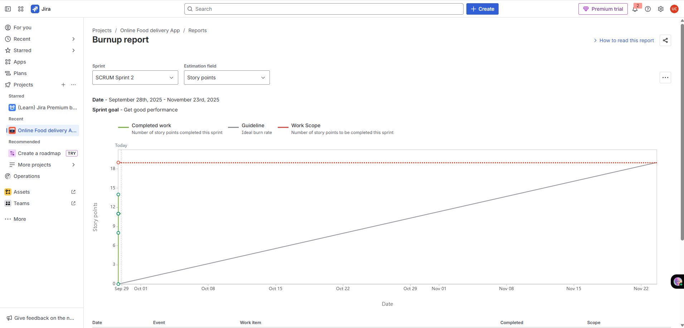

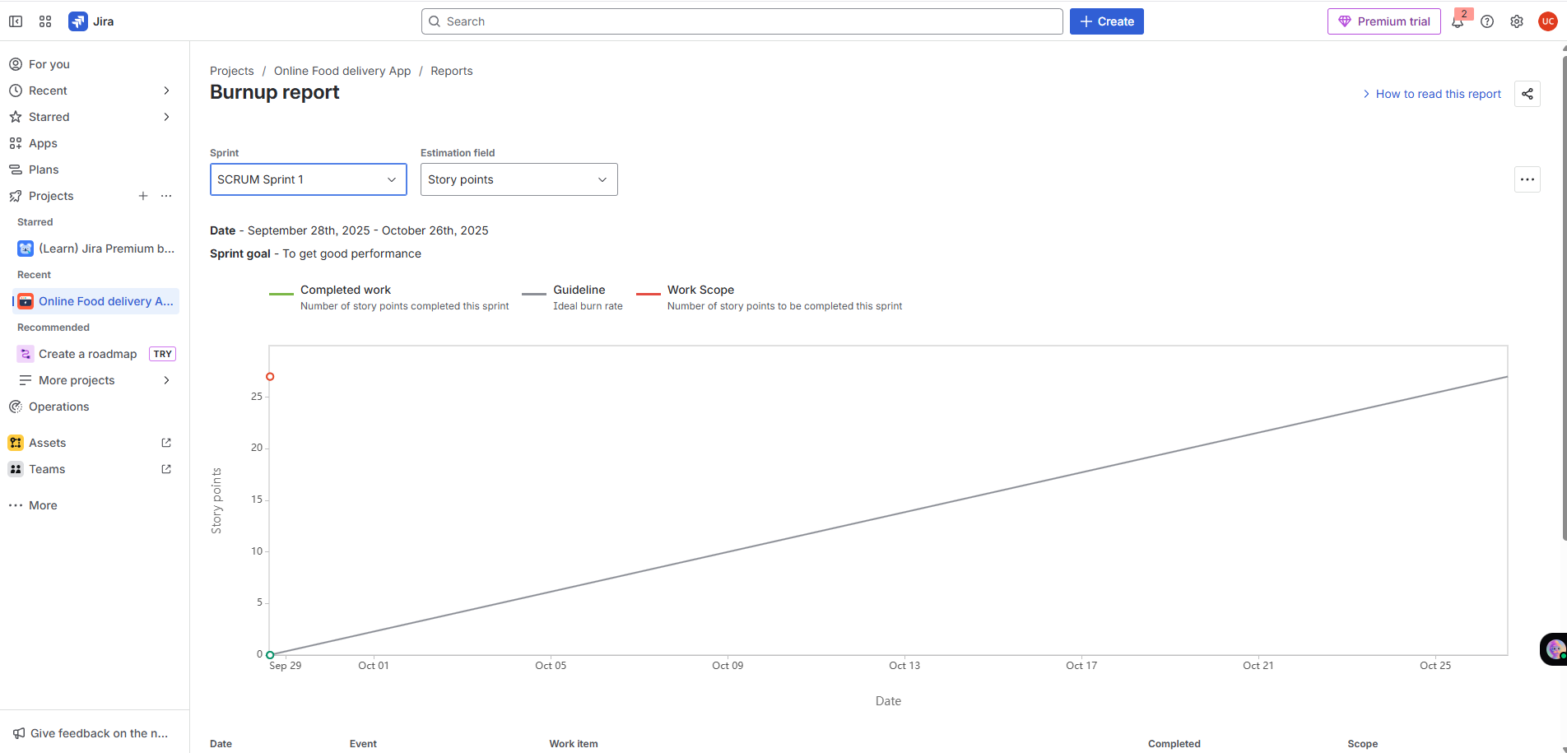

Sprint burndown chart:
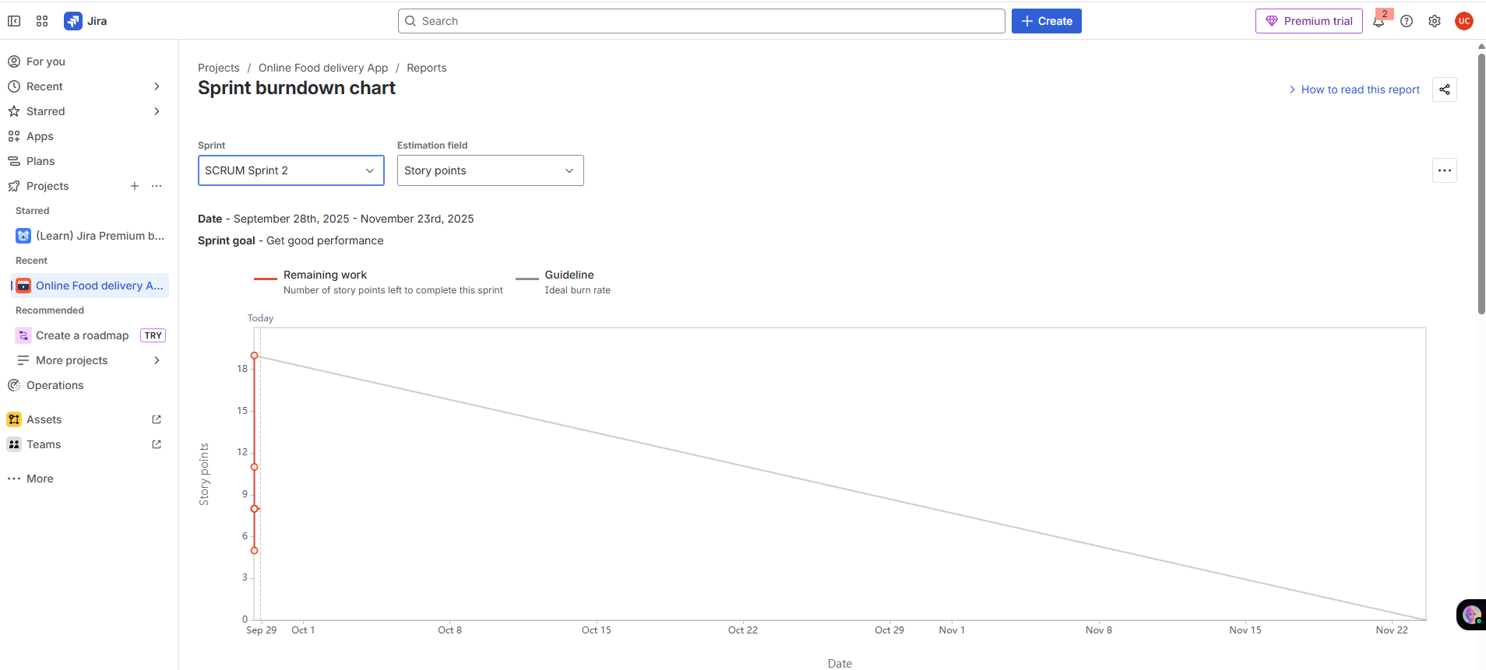

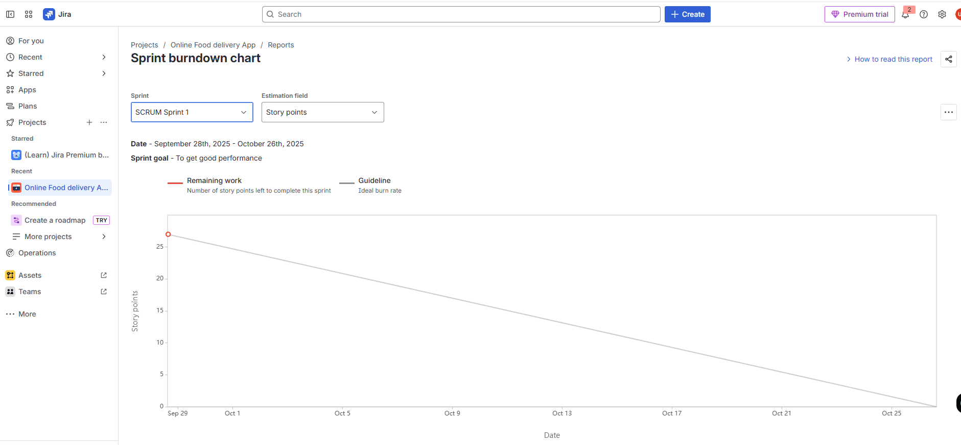

Product Burn Down Chart:
Tracks progress toward completing the entire product backlog across multiple sprints.

Q.no 10:
Explain about Product Grooming?

Answers:
Product Grooming:
Product grooming (also known as backlog refinement) is a collaborative process where the team prepares and refines items in the product backlog to ensure they are well-understood, prioritized, and ready for development.
1.Setting the Context
- The team and relevant stakeholders align on the overall goals and objectives of the project.
- This shared understanding sets the stage for meaningful backlog grooming.
2. Backlog Review
- The product owner and development team review existing backlog items.
- They assess user stories, tasks, and other entries for accuracy, relevance, and alignment with project goals.
3. Prioritization
- The team collaboratively prioritizes backlog items.
- Decisions are based on product value and customer/user needs.
- Ensures high-impact work is addressed first.
4.Refinement and Estimation
- Items are clarified with detailed descriptions.
- User stories are broken into smaller, manageable tasks.
- Technical requirements are reviewed.
- Estimation is done using story points or other effort metrics.

5.Dependency Analysis
- The team identifies dependencies between backlog items.
- Helps in sequencing work and managing bottlenecks.
6. Acceptance Criteria
- Clear acceptance criteria are defined for each item.
- Criteria outline what must be met for completion and delivery.
- Promotes shared understanding and prevents misalignment.
7.Backlog Grooming Meetings
- Regular sessions involving the product owner and development team.
- Activities include review, refinement, prioritization, and estimation.
- Typically held before sprint planning to ensure readiness.
Backlog grooming is an iterative process that keeps the backlog healthy and organized. It ensures the development team always has a prioritized list of items that are Clearly defined, Estimated, Ready to develop, Testable. This supports efficient sprint planning and execution, enabling the team to deliver value to customers in a predictable and effective manner.
Q.no 11:
Explain the roles of Scrum Master and Product Owner?
Answers:
Product Owner:
Defines what the team should build by managing the product backlog and ensuring it delivers value to users and stakeholders.
Scrum Master:
Scrum master is like a coach for an Agile team. They help the team stay organized, follow Scrum rules, and remove any obstacles so the team can work smoothly and deliver high-quality results.

Criteria | Product Owner | Scrum Master
Nature of Work | Collaborates with all the stakeholders and brings the vision of a product into the product backlog. | Acts as a team coach and is responsible for maintaining the quality of the product.
Responsibilities | Responsible for completing the project on time. Acts as an intermediary between development team and the customers. | Ensures the Scrum framework is followed and helps the development team create a quality product.
Accountability | Responsible for project backlog and the timely completion of the product by meeting the expectations of the clients and stakeholders. | Accountable for the quality of the entire project and for giving updates to the management about the completion of the product.
Reporting | Reports to top management and clients | Reports to top management about the efficiency of the team and the quality of the product.
Qualities | Requires strong communication, leadership, creativity, critical thinking, and strategic vision. | Needs deep understanding of Scrum theory, servant leadership, and the ability to guide without authority.
Q.no 12:
Explain all Meetings Conducted in Scrum Project?
Answer:
1. Sprint Planning
- Initiates each sprint (typically 2–4 weeks).
- Involves Product Owner, Scrum Master, and Development Team.
- Objective: Define the sprint goal and select backlog items (user stories, features).
- Team breaks items into tasks and estimates effort required.

2. Daily Stand-up (Daily Scrum)
- A brief daily meeting during the sprint.
- Each member answers:
- What did I accomplish since the last stand-up?
- What will I work on until the next stand-up?
- Are there any obstacles or impediments?
- Ensures alignment and early identification of blockers.
3. Sprint Review
- Held at the end of the sprint.
- Team presents completed work to stakeholders, customers, and Product Owner.
- Demonstrates the potentially shippable product increment.
- Feedback is collected to refine the product backlog.
4. Sprint Retrospective
- Conducted after the Sprint Review.
- Team reflects on collaboration and processes.
- Discusses:
- What went well?
- What could be improved?
- What changes can enhance future sprints?
5. Backlog Refinement (Grooming)
- Ongoing activity throughout the sprint.
- Team and Product Owner review and refine backlog items.
- Adds details, clarifications, and estimates.
- Prepares items for future sprint planning.

6. Product Backlog Refinement
- Focuses on improving clarity and readiness of backlog items.
- Team and Product Owner discuss requirements, priorities, and changes.
- Ensures backlog items are actionable and aligned with sprint goals.
7. Release Planning
- Occurs at the beginning of a project or major release.
- Participants: Product Owner, Development Team, and Stakeholders.
- Purpose:
- Define high-level scope.
- Set timelines and release goals.
- Align expectations across all parties.
8. Ad Hoc Meetings
- Scheduled as needed throughout the project lifecycle.
- Purpose:
- Resolve specific impediments.
- Address technical challenges.
- Conduct additional planning or collaboration sessions.
- Flexible and focused on immediate needs.
Q.no 13:
Explain Sprint Size and Scrum Size?
Answer:
Sprint Size:
A Sprint is a time-boxed iteration during which the development team works to deliver a potentially shippable product increment.

- Typical Duration: 1 to 4 weeks
- Factors Influencing Sprint Duration:
- Team velocity
- Project complexity
- Business needs
- Shorter Sprints:
- Enable frequent feedback.
- Allow faster adaptation.
- Longer Sprints:
- Provide more development time.
- May reduce overhead from frequent planning.
Scrum Team Size:
The Scrum Team consists of individuals who collectively contribute to product development.
- Key Roles:
- Product Owner
- Scrum Master
- Development Team
- Development Team Size Recommendation:
- Typically, 3 to 9 members
- Why Small Teams Work Best:
- Easier communication
- Better collaboration
- Faster decision-making

Q.no 14:
Explain DOR and DOD?
Answer:

Definition of Ready (DoR):
The Definition of Ready outlines the criteria that a product backlog item—such as a user story, feature, or task—must meet before it is considered ready to be taken into a sprint for development. It ensures that the item is:
- Well-defined
- Understood
- Prepared for efficient development
While the specific criteria may vary from team to team, common elements include:
- Clear Description and Acceptance Criteria
The item's requirements are clearly stated, and the conditions for its successful completion are well-defined.
- Dependencies Identified
Any dependencies on external factors, teams, or resources are identified and addressed.
- Estimable
The team has enough information to provide a reasonable estimate of the effort required.
- Testable
It's possible to determine whether the item has been successfully implemented through testing.
- Minimal Ambiguity
The item's details are clear, and any uncertainties are resolved.

Definition of Done (DoD):

The Definition of Done outlines the criteria that must be met for a product increment or backlog item to be considered complete and potentially shippable. It ensures consistency in quality and completeness across teams.
Common DoD elements include:

- Code Complete
All development work is finished, including coding, testing, and integration.
- Peer-Reviewed
Code has been reviewed by other team members for quality and adherence to coding standards.
- Automated Tests Passed
Automated tests (unit tests, integration tests, etc.) have been successfully executed and passed.
- Functional Requirements Met
The item meets all specified acceptance criteria and functional requirements.
- Document Updating
Any necessary documents, user guides, or technical documentation have been updated.

Q.no 15:
Explain Prioritization Techniques and MVP?
Answer:
Prioritization Techniques:
Prioritization techniques are methods used to determine the order in which tasks, features, or items should be addressed in a project. These techniques help teams allocate resources effectively and focus on delivering the most valuable work first. Some common prioritization techniques include:
- MOSCOW:
This technique categorizes items into Must have, should have, could have, and won’t have categories. It helps clarify essential features from those that are optional or lower priority.
- Weighted Shortest Job First (WSJF):
WSJF assigns a priority score to each item based on factors like business value, time sensitivity, and risk. Items with higher scores are considered more important to work on.

- Kano Model:
Categorizes features into Basic Needs, Performance Needs, and Delighters to prioritize based on user satisfaction.
- Value vs. Effort Matrix:
Plots feature on a matrix based on potential value and required effort to identify high-value, low-effort items.
- Relative Prioritization:
Compares items pairwise to determine importance, creating a relative ranking.
- Buy a Feature:
Gives stakeholders a budget to 'buy' features, helping prioritize based on perceived value.

Minimum Viable Product (MVP):
MVP is the smallest version of a product that includes just enough features to provide value and gather feedback.
- Core Functionality:
Focuses on core functionalities addressing primary needs or pain points.
- Essential Features:
Includes only non-essential features to avoid complexity.
- Testing Hypotheses:
Tests assumptions and hypotheses about user behavior, market demand, and product viability.
- Iterative Development:
Refines and expands the product based on user feedback.
- Early Value
The MVP allows the product to be released faster, gaining valuable insights and attracting early adopters.

Q.no 16:
Difference between Business Analyst and Product Owner?
Answers:

Aspect | Business Analysts (BA) | Product Owner (PO)
Goal | Understand business needs and translate them into clear, actionable requirements. | Maximize product value by  managing and prioritizing the product backlog.
Focus Area | Understand business needs. | Deliver product value.
Key Role | Gather and document requirements. | Prioritize and manage product backlog.
Decision Power | Suggests solutions. | Makes product decisions.
Stakeholder Work | Talks to users, teams, and departments. | Aligns stakeholders with product goals.
Agile Role | Supports Agile team with clear inputs. | Core Scrum role, owns backlog and sprint goals.
Deliverables | BRDs, user stories, flowcharts. | Backlog items, user stories, acceptance criteria.
Customer Voice | Translates customer needs. | Represents customer in the team.
Tools Used | Wireframes, diagrams, documentation tools. | Backlog tools, roadmaps, story maps.

Note: BA is requirement expert who ensures expert and PO is the product decision-maker who drives value.

Q.no 17:
Prepare a sample Resume of 3yrs exp Product Owner?

Answer:

Sample Resume: Product Owner (3 Years Experience)

Name: Priya
Location: Uppal, Telangana, India.
Email: priya.architha1999@gmail.com
Phone: +91-9381347448

Professional Summary:

Detail-oriented and outcome-driven Product Owner with 3 years of experience leading Agile teams across healthcare, logistics, and CSR-driven domains. Adept at translating business needs into actionable user stories, aligning stakeholders, and driving product roadmaps from ideation to delivery. Known for bridging technical and business gaps with clarity, empathy, and precision.

Core Competencies:

Agile &Scrum | Stakeholder Alignment | Product Road mapping
Backlog Grooming | User Story Writing | MVP Definition
Sprint Planning | Wireframing & Prototyping | UAT Coordination
BV/CP Scoring | Traceability Matrix | Data-Driven Prioritization

Professional Experience:

Product Owner – XYZ HealthTech Pvt Ltd
Hyderabad, India | Jan 2023 – Present
- Led Agile delivery of a patient engagement platform used by 10K+ users across 3 hospitals.
- Collaborated with cross-functional teams to define epics, user stories, and acceptance criteria.
- Conducted stakeholder workshops to align on MVP scope and quarterly roadmap.
- Implemented BV/CP scoring to prioritize backlog items, improving sprint velocity by 18%.
- Created wireframes and prototypes for appointment booking, dashboard, and feedback modules.
Associate Product Owner – Agri Store Logistics Solutions
Hyderabad, India | Jul 2021 – Dec 2022
- Owned the product backlog for a B2B agriculture inventory platform serving 500+ vendors.
- Facilitated sprint ceremonies and maintained traceability matrix for regulatory compliance.
- Translated business requirements into technical deliverables using user story mapping.
- Supported UAT and release planning, reducing post-deployment defects by 30%.
- Presented product demos to internal and external stakeholders for alignment and feedback.

Education:

Bachelor of Technology (B. Tech) – Computer Science
Jawaharlal Nehru Technological University, Hyderabad
Graduated: 2020

Certifications:

- Certified Scrum Product Owner (CSPO) – Scrum Alliance
- Agile Business Analysis – IIBA Endorsed

Projects & Highlights:

- CSR Donation Tracker: Designed and launched a donation tracking module for a CSR initiative, improving transparency and donor engagement by 40%.
- Agri Store Mobile App: Spearheaded mobile-first redesign with intuitive UX, resulting in 25% increase in vendor onboarding.

Tools & Technologies:

- Jira, Confluence, Trello
- Figma, Balsamiq, Lucid chart
- SQL, REST APIs (for integration understanding)
- Azure DevOps, GitHub

Achievements:

- Spearheaded launch of MVP in 10 weeks, ahead of schedule
- Recognized as “Agile Champion” for cross-team collaboration
- Increased user engagement by 30% through feature enhancements

Declarations:

I am passionate about building products that solve real-world problems and enhance user experience. I look forward to opportunities where I can collaborate with cross-functional teams and drive impactful outcomes.

