Question 1 – Audits - 5 Marks
As a Business Analyst (BA) in this project, quarterly audits (Q1, Q2, Q3, Q4) would involve the following responsibilities:
- Documentation Review: Ensuring all BA deliverables (requirements documents, use cases, diagrams) are complete, accurate, and up-to-date.
- Process Compliance: Verifying that all BA activities follow the organization's standards and methodologies.
- Traceability Check: Confirming that requirements are properly traced from business needs through to technical implementation.
- Stakeholder Validation: Ensuring requirements have been properly validated with stakeholders.
- Change Management: Reviewing any change requests and their impacts on requirements.
- Risk Assessment: Identifying any risks related to requirements or business analysis processes.
- Progress Reporting: Providing status updates on BA activities against the project timeline.
The BA would participate in audit meetings, provide necessary documentation, and address any findings related to business analysis.

Question 2 – BA Approach Strategy - 6 Marks
BA Approach Strategy:
- Elicitation Techniques: Apply a combination of techniques including interviews (with Mr. Henry, Peter, Kevin, Ben), document analysis (any existing materials), brainstorming sessions, and prototyping for UI validation.
- Stakeholder Analysis: Create a RACI matrix identifying:
  - Responsible: BA (me), Developers
  - Accountable: Mr. Vandanam (PM), Mr. Karthik
  - Consulted: Mr. Henry, Peter, Kevin, Ben
  - Informed: Other team members
- Documents to Write:
  - Business Requirements Document
  - Functional Requirements Specification
  - Use Case Diagrams and Specifications
  - Activity Diagrams
  - UI Mockups/Wireframes
  - Traceability Matrix
- Document Sign-off Process:
  - Draft documents circulated to stakeholders
  - Review meetings conducted
  - Feedback incorporated
  - Final version approved by Mr. Henry and Mr. Vandanam
- Approval Process:
  - Formal approval emails for major deliverables
  - Signed acceptance forms for key milestones
- Communication Channels:
  - Weekly status meetings
  - Email updates
  - Shared documentation repository
  - Dedicated Slack/Teams channel
- Change Request Handling:
  - Formal change request form
  - Impact analysis
  - Approval by change control board (Mr. Henry, Mr. Vandanam, Mr. Karthik)
- Progress Updates:
  - Weekly status reports
  - Dashboard showing requirements completion status
  - Risk/issue log updates
- UAT Sign-off:
  - Coordinate UAT with testers and stakeholders
  - Document test results
  - Obtain signed Project Acceptance Form from Mr. Henry

Question 3 – 3-Tier Architecture - 5 Marks
3-Tier Architecture Explanation:
The 3-tier architecture separates the application into three logical and physical computing tiers:
- Presentation Tier (UI Layer):
  - Web/mobile interface that users interact with
  - Displays product catalog, handles user input
  - Technologies: HTML, CSS, JavaScript, React/Angular
- Application Tier (Business Logic Layer):
  - Contains business rules and processes
  - Handles user authentication, product search, order processing
  - Technologies: Java (using Spring framework), application servers
- Data Tier (Database Layer):
  - Stores and manages data
  - Product information, user accounts, orders
  - Technologies: Relational database (MySQL/Oracle), DB admin tools

Benefits for this project:
- Clear separation of concerns
- Easier maintenance and scalability
- Security (database isn't directly exposed)
- Different teams can work on different tiers simultaneously

Question 4 – BA Approach Strategy for Framing Questions – 10 Marks
Before framing questions to stakeholders, a BA should consider:
- 5W1H Framework:
  - Who is the right stakeholder to ask?
  - What exactly needs to be known?
  - When does this requirement apply?
  - Where is this functionality needed?
  - Why is this requirement important?
  - How should this work?
- SMART Criteria:
  - Ensure questions will yield Specific, Measurable, Achievable, Relevant, Time-bound answers
- RACI Matrix:
  - Direct questions to the Responsible or Accountable parties
  - Be aware of who needs to be Consulted or Informed
- 3-Tier Architecture:
  - Frame questions to cover all layers:
    - UI: "How should the product search results be displayed?"
    - Business Logic: "What are the rules for product categorization?"
    - Data: "What product attributes need to be stored?"
- Use Case Approach:
  - Focus on user goals and system responses
  - "When a farmer searches for products, what filters should be available?"
- Models and Diagrams:
  - Ask questions that will feed into diagrams:
    - "What are the main user roles in the system?"
    - "What are the key steps in the order process?"
- Page Designs:
  - Gather UI requirements:
    - "What information should appear on the product detail page?"
    - "Where should the login button be positioned?"
- Non-functional Aspects:
  - Performance: "How many concurrent users do you expect?"
  - Security: "What authentication requirements are needed?"

Question 5 – Elicitation Techniques - 6 Marks
Elicitation techniques I'm aware of (BDRFOWJIPQU):
- Brainstorming: Group creativity technique to generate many ideas quickly
- Document Analysis: Reviewing existing documentation/systems
- Focus Groups: Guided discussion with representative users
- Interviews: One-on-one structured conversations
- Observation: Watching users perform tasks in their environment
- Workshops: Structured group meetings to gather requirements
- Surveys/Questionnaires: Collecting information from many stakeholders
- Interface Analysis: Examining existing systems' interfaces
- Prototyping: Creating mockups to validate requirements
- User Stories: Capturing requirements from user perspective

Question 6 – This project Elicitation Techniques - 5 Marks
For this project, the most appropriate elicitation techniques would be:
- Interviews:
  - With Mr. Henry (business objectives)
  - With Peter, Kevin, Ben (user needs)
  - Justification: Direct access to key stakeholders available
- Document Analysis:
  - Review any existing materials about current processes
  - Justification: Understand current challenges farmers face
- Prototyping:
  - Create UI mockups for validation
  - Justification: Important for user-friendly interface requirement
- Workshops:
  - Conduct requirement gathering sessions with multiple stakeholders
  - Justification: Efficient way to get consensus among diverse stakeholders
- Use Case Specifications:
  - Detail system interactions
  - Justification: Complex workflows need clear documentation
Less appropriate techniques like observation might not be feasible due to remote locations of farmers.
Question 7 – 10 Business Requirements- 10 Marks
- BR003 - User Registration: Farmers and manufacturers should be able to create accounts with email and secure password (Priority: 9)
- BR004 - Product Catalog: System must display categorized products (fertilizers, seeds, pesticides) with images and details (Priority: 10)
- BR005 - Search Functionality: Farmers should be able to search products by name, category, and filter by price/quantity (Priority: 9)
- BR006 - Shopping Cart: Users should be able to add products to cart and save for later (Priority: 8)
- BR007 - Payment Gateway: System must support COD, credit/debit cards, and UPI payments (Priority: 9)
- BR008 - Order Tracking: Farmers should receive email confirmations and be able to track order status (Priority: 7)
- BR009 - Manufacturer Dashboard: Manufacturers need interface to upload/edit product information (Priority: 8)
- BR010 - Inventory Management: System should show real-time product availability (Priority: 6)
- BR011 - Mobile Responsiveness: Application must work on mobile devices (Priority: 8)
- BR012 - Multilingual Support: Interface should support local languages (Priority: 5)
Question 8 –Assumptions- 5 Marks
- Farmers in remote areas have basic internet access via mobile devices
- Manufacturers have digital catalog of their products
- Delivery services are available to remote areas
- Payment gateway providers are available for integration
- Users are comfortable with basic digital interfaces
- System will support English and at least one local language
- Initial rollout will focus on specific region before expanding
- Training materials will be provided for first-time users
- Inventory updates from manufacturers will be near real-time
- Basic smartphone literacy among farmer users

Question 9 – This project Requirements Priority - 8 Marks
Updated Requirements Priority:
Req ID | Req Name | Req Description | Priority
BR001 | Farmer Search for Products | Farmers should be able to search for available products in fertilizers, seeds, pesticides | 9
BR002 | Manufacturers upload their Products | Manufacturers should be able to upload and display their products in the application | 9
BR003 | User Registration | Account creation for farmers and manufacturers | 9
BR004 | Product Catalog | Display categorized products with details | 10
BR005 | Search Functionality | Advanced search and filtering | 9
BR006 | Shopping Cart | Add products to cart/save for later | 8
BR007 | Payment Gateway | Multiple payment options | 9
BR008 | Order Tracking | Email confirmations and status tracking | 7
BR009 | Manufacturer Dashboard | Interface for product management | 8
BR010 | Inventory Management | Real-time availability | 6
BR011 | Mobile Responsiveness | Mobile-friendly interface | 8
BR012 | Multilingual Support | Local language options

Q 10 A Use Case Diagram is a visual representation in Unified Modeling Language (UML) that illustrates:
1. Purpose
- Shows how users (actors) interact with a system to achieve specific goals.
- Helps capture functional requirements from a user’s perspective.

2. Key Components
Component | Symbol | Description
Actor | 🧍 (Stick Figure) | A user, system, or external entity interacting with the system (e.g., Farmer).
Use Case | ⚪ (Oval) | A goal the system helps achieve (e.g., "Place Order").
System Boundary | 🟦 (Rectangle) | Defines the scope of the system (optional).
Relationships | ---→ (Arrows/Lines) | Shows interactions between actors and use cases.
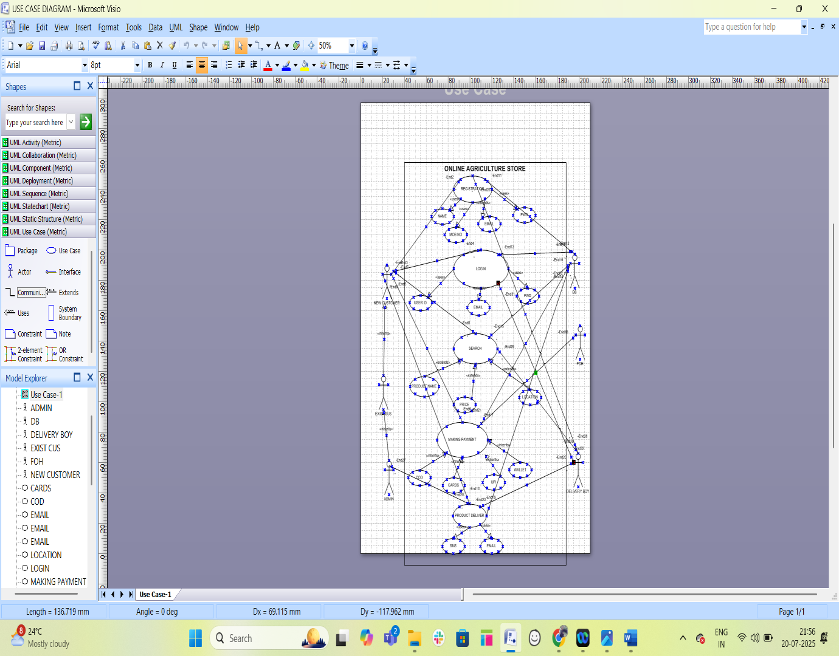

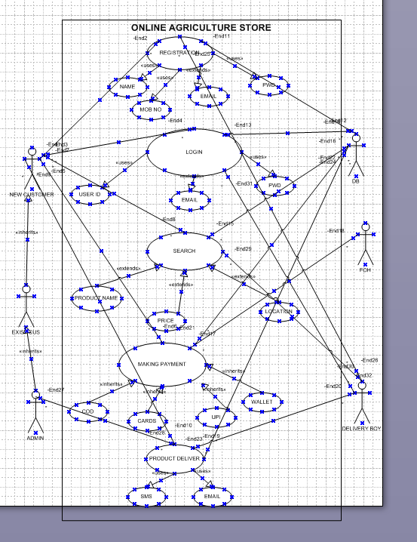

Question 11 – (minimum 5) Use Case Specs - 15 Marks
- Use Case: Search Products
  - Actor: Farmer
  - Description: Farmer searches for products
  - Precondition: Farmer is logged in
  - Basic Flow:
    - Farmer enters search term
    - System displays matching products
    - Farmer can apply filters
    - System updates results
  - Alternative Flows:
    - No results found
    - Invalid search term
- Use Case: Add to Cart
  - Actor: Farmer
  - Description: Add product to shopping cart
  - Precondition: Farmer is viewing product
  - Basic Flow:
    - Farmer selects quantity
    - Clicks "Add to Cart"
    - System confirms addition
  - Alternative Flows:
    - Insufficient inventory
    - Not logged in (prompt to login)
- Use Case: Upload Product
  - Actor: Manufacturer
  - Description: Add new product to catalog
  - Precondition: Manufacturer is logged in
  - Basic Flow:
    - Manufacturer selects "Add Product"
    - Enters product details (name, category, price, etc.)
    - Uploads images
    - Submits form
    - System validates and saves product
  - Alternative Flows:
    - Invalid data entered
    - Duplicate product
- Use Case: Make Payment
  - Actor: Farmer
  - Description: Complete purchase
  - Precondition: Items in cart
  - Basic Flow:
    - Farmer proceeds to checkout
    - Selects payment method
    - Enters payment details
    - Confirms order
    - System processes payment
    - Generates order confirmation
  - Alternative Flows:
    - Payment failure
    - COD selected
- Use Case: Track Order
  - Actor: Farmer
  - Description: View order status
  - Precondition: Order exists
  - Basic Flow:
    - Farmer views order history
    - Selects order to track
    - System displays current status
  - Alternative Flows:
    - Order not found
    - Delivery delayed

Q 12 An Activity Diagram is a UML (Unified Modeling Language) diagram that models the flow of activities, actions, and decisions in a system or process. It is similar to a flowchart but more powerful, as it can show parallel processes, swimlanes (for roles), and complex workflows.

1. Purpose of Activity Diagrams
- Visualize business workflows (e.g., order processing, user registration).
- Model system behavior (e.g., how a payment is processed).
- Identify bottlenecks, inefficiencies, or redundant steps in a process.
- Help developers and stakeholders understand complex workflows.
