Capstone Project- 3

Q.1) Draw a Use Case Diagram
Ans.
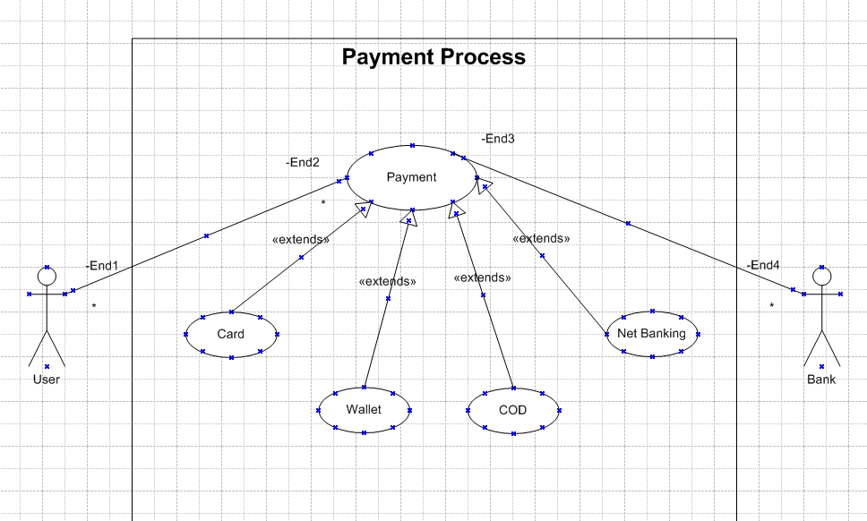

Q.2) Derive Boundary Classes, Controller classes, Entity Classes
Ans. Boundary Classes (User Interaction & External Communication)
Boundary classes represent the interaction between the user and the system — the interface or screen where input/output happens.
Classes:
- PaymentPageUI (Class) → The UI where the customer selects the payment method and enters payment details.
- PaymentGatewayAPI (Class) → Connects the system to external payment providers (e.g., PayPal, Stripe).
- NotificationService (Class) → Sends payment confirmation via email or SMS.
Analogy: Boundary Classes are like a hotel’s front desk. They take customer requests and pass them to the right department.
Controller Classes (Processing & decision making)
Controller classes handle the flow of data between boundary and entity classes, processing user actions. These are processing-related classes that coordinate actions.
Classes & Their Methods:
- PaymentController (Class) → Manages the overall payment flow.
  - initiatePayment(Order, Payment payment) → Starts the payment process.
  - handlePaymentResponse (Transaction) → Updates order status after payment is processed.
- Transaction Manager (Class) → Handles approval, money transfer, and settlement.
  - Authorize Payment(Payment) → Checks if payment details are valid.
  - process Payment(Payment) → Interacts with Payment Gateway API to complete payment.
  - record Transaction(Transaction) → Stores transaction details in the system.
- Fraud Detection Service (Class) → Monitors transactions for potential fraud.
  - Analyze Risk(Payment, Customer) → Checks for suspicious activities.
Analogy: Controller Classes are like hotel managers. They oversee the entire operation, ensuring everything runs smoothly.
Entity Classes (Data storage & Business information)
Entity classes represent the business data and logic.
Entity classes represent the core business objects that store and manage data. These are data-related classes that hold important information.
Classes & Their Attributes:
- Order (Class) → Stores details of customer purchases.
  - Attributes: orderID, items, totalAmount, status.
- Payment (Class) → Stores payment details.
  - Attributes: paymentID, amount, method (credit card, PayPal, etc.), status.
- Transaction (Class) → Records individual payment transactions.
  - Attributes: transactionID, date, status, referenceNumber.
- Customer (Class) → Stores customer details.
  - Attributes: customerID, name, email, paymentHistory.
Analogy: Entity Classes are like a hotel's record books, where they keep track of guest reservations, payments, and transactions.

Q.3) Place these classes on a three tier Architecture
Ans.
- Presentation Layer (User Interface & External Communication)
This layer is responsible for user interaction and communication with external services.
Contains Boundary Classes → These classes handle inputs from users or external systems.
Class (Code Component) | Role
PaymentPageUI | Displays the payment page where customers enter their details.
Payment Gateway API | Connects with external payment providers (e.g., PayPal, Stripe).
Notification Service | Sends payment confirmation via email/SMS.

- Business Logic Layer (Processing & Decision Making)
This layer processes user requests, applies business rules, and coordinates the workflow.
Contains Controller Classes → These classes define logic and control the payment process.
Class (Code Component) | Role
PaymentController | Manages the overall payment process.
TransactionManager | Handles payment authorization, processing, and transaction recording.
FraudDetectionService | Checks for fraudulent transactions before approving a payment.

- Data Layer (Database & Data Storage)
This layer is responsible for storing and retrieving all payment-related information.
Contains Entity Classes → These classes represent and store business data.
Class (Code Component) | Role
Order | Stores details of customer purchases (items, amount, status).
Payment | Stores payment details (amount, method, status).
Transaction | Records each payment transaction (date, status, transaction ID).
Customer | Stores customer details (name, email, payment history).

Q.4) Explain Domain Model for Customer making payment through Net Banking
Ans. A Domain Model shows the real-world concepts, their attributes, and relationships for a specific scenario—in this case, a customer making a payment through Net Banking.
Key Concepts (Entities)
- Customer
  - Attributes: customer Id, name, preferred Payment Method.
  - Associations: One-to-Many with Transaction (A customer can initiate multiple transactions).
- Payment
  - Attributes: paymen tId, amount, method (Net Banking), status.
  - Associations: One-to-One with Transaction (Each transaction corresponds to a payment).
- Transaction
  - Attributes: transaction Id, timestamp, payment Id, customer Id, status.
  - Associations: Linked to Customer and Payment.
- Net Banking Details (Optional Entity for Extended Modeling)
  - Attributes: bank name, account number, IFSC Code, transaction Reference.
Purpose and Uses
- Ensures Business Clarity – Defines how net banking payments work before technical design.
- Bridges the Gap – Helps both business and technical teams align on requirements.
- Prepares for Database Design – Serves as the foundation for ER diagrams and database schemas.
- Prevents Rework – Avoids misunderstandings and unnecessary changes during development.
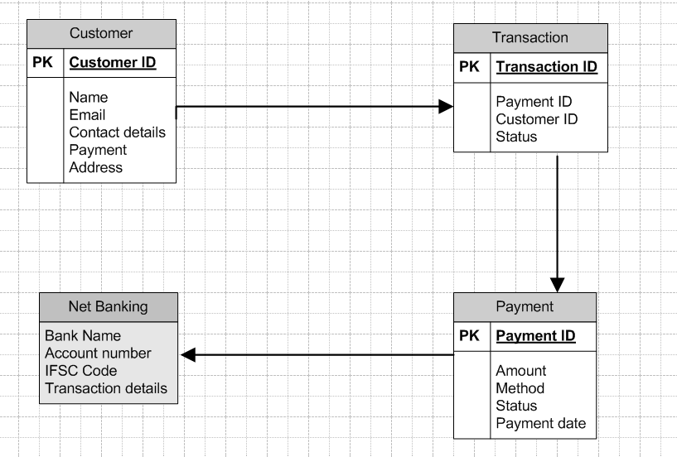

Q.5) Draw a sequence diagram for payment done by Customer Net Banking
Ans. A Sequence Diagram is a type of UML (Unified Modeling Language) diagram that shows how different parts of a system interact over time by exchanging messages.
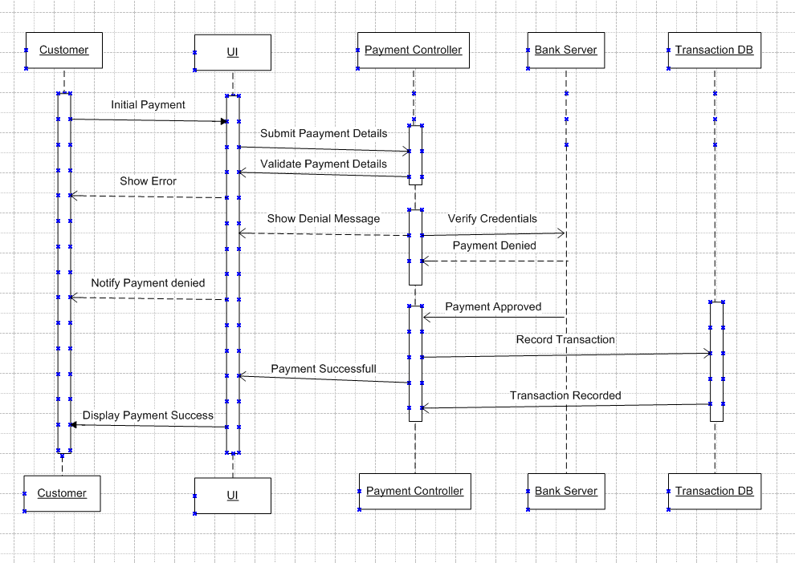

Q.6) Explain Conceptual Model for this Case
Ans. A conceptual model provides a high-level overview of the system’s key concepts and their relationships.
Key Concepts
- Customer:
  - Initiates payments.
  - Has attributes like customer Id, name, and contact Info.
- Payment:
  - Represents the payment instance.
  - Includes attributes like method, amount, and status.
- Transaction:
  - Logs each payment activity.
  - Tracks details like transaction Id, timestamp, and status.
- Net Banking Details (Optional in this case):
  - Captures specifics of the net banking process (e.g., account number, bank name)
Relationships:
- Customer ↔ Transaction:
  - A customer can initiate multiple transactions, but a transaction is tied to one customer.
- Transaction ↔ Payment:
  - A transaction corresponds to a single payment, defining its method and status.
Validation Rules:
- Valid Net Banking details:
  - Correct account number and IFSC.
  - Sufficient balance for the transaction.
- Unique transaction IDs.
- Secure handling of sensitive data.

Q.7) What is MVC architecture? Explain MVC rules to derive classes from use case diagram and guidelines to place classes in 3-tier architecture
Ans. MVC (Model–View–Controller) is a software architectural pattern that separates an application into three interconnected components:
- Model: Represents the application's data, business logic, and rules. It communicates with the database and performs operations such as retrieval, insertion, and modification.
- View: Handles the user interface and presentation logic. It displays data to the user and collects input from them.
- Controller: Acts as an intermediary between the Model and View. It processes user input, interacts with the Model, and updates the View accordingly.
MVC Rules to Derive Classes from a Use Case Diagram
To derive Model, View, and Controller classes from a use case diagram, follow these rules:
- Model Classes:
  - Identify entity classes from the use case diagram, especially nouns (e.g., "Customer," "Payment," "Transaction").
  - Ensure these classes handle data storage and business logic, typically corresponding to database entities.
- View Classes:
  - Focus on boundary classes identified in the use case diagram (e.g., "Login Page," "Payment Form").
  - These classes represent user interfaces and are responsible for displaying data and collecting user input.
- Controller Classes:
  - Identify control classes from the use case diagram (e.g., "Payment Controller," "Order Controller").
  - These classes implement use case behaviour by orchestrating interactions between the Model and View components.
Guidelines to Place Classes in 3-Tier Architecture
In a 3-tier architecture, the application is divided into three logical layers: Presentation, Business Logic, and Data Access.
- Presentation Layer:
  - Place View Classes here.
  - Responsible for user interfaces, displaying information, and handling user inputs.
  - Examples: Login pages, payment forms, dashboards.
- Business Logic Layer:
  - Place Controller Classes and any business logic classes here.
  - Handles processing, validations, and interaction between the presentation and data layers.
  - Examples: Payment controllers, transaction processors.
- Data Access Layer:
  - Place Model Classes here.
  - Responsible for interacting with the database, performing CRUD operations, and maintaining data consistency.
  - Examples: Customer entities, payment entities.

Q.8) Explain BA contributions in project (Waterfall Model – all Stages)
Ans.
1. Requirements Gathering / Feasibility Study Phase
BA’s Contributions:
- Interact with stakeholders (customers, users, management) to gather functional and non-functional requirements.
- Conduct feasibility analysis by identifying constraints like budget, technology, timelines, and resources.
- Document requirements clearly, avoiding ambiguity.
- Perform gap analysis between current state and desired state.
- Prioritize requirements based on business impact and technical feasibility.
Deliverables:
- Requirements Specification Document (SRS)
- Business case or feasibility report
- Initial risk assessment
2. System Design Phase
BA’s Contributions:
- Translate requirements into design inputs by working closely with system architects, designers, and developers.
- Ensure that design aligns with business goals and compliance needs.
- Review data models, process flows, and use case diagrams to confirm requirements are addressed.
- Clarify business logic to technical teams to avoid misinterpretations.
Deliverables:
- Functional design document
- Use case diagrams, workflows, and process maps
- Interface specifications
3. Implementation / Development Phase
BA’s Contributions:
- Support the development team by clarifying requirements and resolving queries.
- Ensure that development stays aligned with requirements through regular reviews and walkthroughs.
- Act as a liaison between developers and stakeholders, ensuring that changes or updates are evaluated for business impact.
- Help in setting up test scenarios by defining acceptance criteria and edge cases.
Deliverables:
- Clarification documents
- Updated requirements as needed
- Test scenarios and validation checklists
4. Testing Phase
BA’s Contributions:
- Work with QA teams to develop test cases based on user requirements and acceptance criteria.
- Support User Acceptance Testing (UAT) by coordinating with end users and explaining workflows.
- Identify and document defects related to unmet business needs or logic flaws.
- Ensure traceability between requirements and test cases, confirming that all functionality is covered.
Deliverables:
- Test plans and scripts
- Issue tracking reports
- UAT reports and sign-offs
5. Deployment / Implementation Phase
BA’s Contributions:
- Assist in training end users, ensuring that they understand how to use the system effectively.
- Prepare user manuals and documentation that reflect how the system meets business processes.
- Support rollout activities, ensuring smooth transition with minimal disruption.
- Gather feedback from early users to quickly address issues or concerns.
Deliverables:
- User guides and FAQs
- Training materials
- Implementation checklist
6. Maintenance / Support Phase
BA’s Contributions:
- Track and manage change requests, ensuring that any enhancements or bug fixes are aligned with business goals.
- Analyze system usage to suggest improvements or optimizations.
- Support ongoing communication between business and IT teams, ensuring that evolving requirements are properly documented and implemented.
- Help prioritize fixes or new features based on business needs.
Deliverables:
- Change request documents
- Enhancement proposals
- Support reports and usage analytics

Q.9) What is conflict management? Explain using Thomas – Kilmann technique
Ans. Conflict Management is the process of identifying, addressing, and resolving disagreements or differences between individuals or groups in a constructive way. Conflicts are natural in teams and projects due to differing opinions, goals, expectations, or communication styles.
The aim of conflict management is not to eliminate conflict entirely but to handle it in a way that reduces negative effects and promotes cooperation, productivity, and mutual understanding.
Thomas–Kilmann Conflict Mode Instrument (TKI)
The Thomas–Kilmann model helps understand how people respond to conflict based on two dimensions:
- Assertiveness – the extent to which you try to satisfy your own concerns.
- Cooperativeness – the extent to which you try to satisfy the other person's concerns.
Using these dimensions, the model defines five conflict-handling styles:
1. Competing (High Assertiveness, Low Cooperativeness)
- You pursue your own goals at the expense of others.
- Useful when quick, decisive action is needed or in emergencies.
Example: A project deadline is at risk, and the manager enforces strict rules without negotiation.
2. Accommodating (Low Assertiveness, High Cooperativeness)
- You prioritize others’ concerns over your own.
- Useful when the issue matters more to the other person, or to maintain harmony.
Example: A team member wants to implement a feature you don't agree with, but you let it pass to avoid conflict.
3. Avoiding (Low Assertiveness, Low Cooperativeness)
- You sidestep the issue without addressing it.
- Useful when the issue is trivial, emotions are high, or more information is needed.
Example: A disagreement about minor UI changes is postponed for a later discussion.
4. Collaborating (High Assertiveness, High Cooperativeness)
- You work together to find a win-win solution that satisfies both parties.
- Best when both viewpoints are important and a lasting solution is needed.
Example: Two departments have conflicting priorities; you facilitate a workshop to develop a joint roadmap.
5. Compromising (Moderate Assertiveness, Moderate Cooperativeness)
- You find a middle ground where each party gives up something.
- Useful when a temporary or quick solution is needed.
Example: Two teams share limited resources by dividing time equally, even though it's not ideal for either.

Q.10) List down the reasons for project failure
Ans.
1. Poor Planning
- Inadequate scope definition.
- Unclear objectives and deliverables.
- Unrealistic timelines and budgets.
- Ignoring risk assessment.
2. Lack of Clear Requirements
- Requirements not documented or poorly defined.
- Changing requirements without proper change control.
- Misunderstanding business needs or customer expectations.
3. Ineffective Communication
- Poor collaboration between stakeholders.
- Information silos across teams.
- Lack of regular status updates.
- Misinterpretation of requirements or expectations.
4. Weak Project Leadership
- Inexperienced or unavailable project manager.
- Lack of stakeholder engagement.
- No clear roles and responsibilities.
- Poor conflict management.
5. Inadequate Resource Management
- Insufficient team size or skillsets.
- Overloaded team members.
- Lack of training or knowledge transfer.
6. Budget Overruns
- Failure to estimate costs accurately.
- Ignoring hidden expenses.
- Frequent scope changes leading to increased costs.
7. Technology Challenges
- Choosing inappropriate or outdated tools.
- Poor integration with existing systems.
- Unexpected technical complexities or failures.
8. Ignoring Quality
- Lack of proper testing and validation.
- Not addressing defects early.
- Pressure to deliver on time causing rushed work.
9. Poor Risk Management
- Risks not identified or evaluated.
- No mitigation plans in place.
- Failure to adapt when risks materialize.
10. Stakeholder Issues
- Lack of stakeholder alignment.
- Conflicting priorities between departments.
- Absence of end-user feedback.
11. Resistance to Change
- Employees reluctant to adopt new systems.
- Inadequate change management or communication.
- Lack of training and support.
12. Governance and Compliance Failures
- Ignoring regulatory or legal requirements.
- Poor documentation and audit trails.
- Non-compliance leading to penalties or halts.
13. Overconfidence or Optimism Bias
- Underestimating the complexity of tasks.
- Overpromising deliverables.
- Ignoring warning signs early in the project.
14. Lack of Performance Monitoring
- No tracking of progress.
- KPIs and milestones not clearly defined.
- Failing to course-correct based on feedback.
15. Poor Vendor or Third-Party Management
- Unreliable external partners.
- Contractual ambiguities.
- Misaligned service expectations.

Q.11) List the Challenges faced in projects for BA
Ans. 1. Eliciting Clear Requirements
- Stakeholders may not fully understand or communicate their needs.
- Requirements may be incomplete, ambiguous, or contradictory.
- Customers may have hidden expectations not formally expressed.
2. Managing Changing Requirements (Scope Creep)
- Stakeholders frequently change priorities or add features.
- Pressure to deliver more within tight deadlines.
- Lack of a formal change management process.
3. Communication Gaps
- Poor collaboration between technical and non-technical teams.
- Information loss across different stakeholder groups.
- Misinterpretations due to jargon or assumptions.
4. Stakeholder Alignment
- Conflicting goals between departments (e.g., marketing vs engineering).
- Difficulties in getting stakeholder buy-in or consensus.
- Political influences affecting decisions.
5. Time Constraints
- Tight schedules that do not allow thorough requirement analysis.
- Pressure to deliver quickly leading to skipped documentation or reviews.
- Managing priorities between multiple simultaneous projects.
6. Handling Ambiguity
- Working in uncertain environments with incomplete data.
- Deciding on best practices when no precedent exists.
- Balancing risk and innovation without clear guidelines.
7. Technical Understanding
- Bridging the gap between business goals and technical feasibility.
- Understanding new technologies quickly to align solutions.
- Translating user-friendly requirements into technical specifications.
8. Managing Stakeholder Expectations
- Unrealistic expectations about timelines or features.
- Difficulty in explaining trade-offs and constraints.
- Handling dissatisfaction when goals are adjusted.
9. Documentation Challenges
- Keeping requirements updated with frequent changes.
- Maintaining version control and ensuring everyone accesses the latest documents.
- Creating user-friendly documents that are both detailed and understandable.
10. User Acceptance & Training
- Ensuring that end users understand how the solution works.
- Resistance from users who are uncomfortable with change.
- Supporting the transition from legacy systems.
11. Risk and Issue Management
- Identifying potential risks early enough to mitigate them.
- Dealing with unforeseen issues during implementation.
- Communicating risks without causing panic or resistance.
12. Decision-Making Support
- Providing recommendations based on incomplete data.
- Helping stakeholders make informed decisions without bias.
- Balancing business needs, technical constraints, and cost considerations.
13. Maintaining Objectivity
- Avoiding personal biases while gathering requirements.
- Staying neutral between competing stakeholder interests.
- Ensuring that solutions serve the business, not individual agendas.
14. Collaboration Across Geographies
- Coordinating with remote teams in different time zones.
- Managing communication barriers due to cultural differences.
- Ensuring consistency when stakeholders are spread globally.
15. Measuring Success
- Defining measurable outcomes that align with business goals.
- Tracking performance metrics post-implementation.
- Demonstrating the impact of BA work to management.

Q.12) Write about Document Naming Standards
Ans. Purpose: Naming standards ensure consistency, clarity, and traceability across all project documentation, making it easier to identify, track, and manage documents.
1. Standard Naming Convention:
- Document Type: Start with the document type to clarify the content (e.g., BRD for Business Requirements Document, FRD for Functional Requirements Document, SRS for Software Requirements Specification).
- Project/Module Name: Follow with the project or module name to provide context (e.g., "BRD Order Management" for a project related to order management).
- Separation: Use underscores (_) or dashes (-) to separate components for improved readability.
Example: BRD_Order Management
2. Version Control:
- Version Number: Include a version number to track updates (e.g., V1.0 for the initial version, V1.1 for minor updates, V2.0 for major revisions).
- Standard Format: Follow a consistent format like V1.0, V1.1, V2.0, etc.
Example: BRD_OrderManagement_V1.0
3. Author/Team Identifier (Optional):
- Optionally, include the initials of the document creator or team responsible for the document. This can be especially helpful for collaboration and tracking.
Example: BRD_OrderManagement_V1.0_JS
4. Date Inclusion:
- Add the creation or update date in YYYYMMDD format for chronological organization, making it easier to identify the most recent version.
Example: BRD_OrderManagement_20250107
5. Avoid Special Characters:
- Avoid using special characters like !, @, or spaces, which might cause issues in file systems or cloud storage.
- Stick to alphanumeric characters, underscores (_), or dashes (-) for consistency and compatibility.
6. Examples:
- BRD_InventoryManagement_V1.0_20250107.pdf
- FRD_CustomerPortal_V2.1_20250107.docx

Q.13) What are the Do’s and Don’ts of a Business analyst
Ans. Do’s of a Business Analyst
✔ Understand the Business Domain
Take time to learn the industry, business goals, and user needs before proposing solutions.
✔ Communicate Clearly and Effectively
Use simple language, avoid jargon, and ensure stakeholders understand the requirements and constraints.
✔ Actively Listen
Pay attention to what stakeholders say and what they don’t say—ask follow-up questions to uncover hidden needs.
✔ Document Requirements Accurately
Create detailed, structured, and traceable documentation (like SRS, BRD) that aligns with business objectives.
✔ Engage Stakeholders Regularly
Maintain frequent communication with all parties to gather feedback, align expectations, and resolve misunderstandings early.
✔ Manage Changes Thoughtfully
Track requirement changes and assess their impact on cost, time, and scope before approving them.
✔ Be Neutral and Objective
Remain unbiased when mediating between conflicting stakeholders and present solutions based on facts and business needs.
✔ Validate and Verify Solutions
Work with QA teams to ensure solutions meet requirements and support user acceptance testing.
✔ Stay Organized and Prioritize
Keep documentation and tasks structured, and prioritize requirements based on business impact and urgency.
✔ Be Adaptable and Open to Feedback
Accept suggestions, learn from mistakes, and continuously improve processes and interactions.

Don’ts of a Business Analyst
❌ Don’t Assume You Know Everything
Always ask questions and clarify requirements rather than making assumptions.
❌ Don’t Overcomplicate Documentation
Avoid creating unnecessarily detailed or complex documents that stakeholders may find hard to understand.
❌ Don’t Ignore Stakeholder Input
Every stakeholder’s viewpoint is important—even if it seems minor, it may highlight an important requirement.
❌ Don’t Skip Requirement Reviews
Always review documents with stakeholders to ensure nothing is missed before moving to design or development.
❌ Don’t Push Solutions Prematurely
Understand the problem thoroughly before offering solutions—premature answers may lead to wrong implementations.
❌ Don’t Overpromise or Commit Without Approval
Never commit to timelines, features, or scope changes without consulting the project manager or stakeholders.
❌ Don’t Let Personal Bias Influence Decisions
Stay neutral when prioritizing requirements or resolving conflicts.
❌ Don’t Avoid Conflict
Address disagreements early and constructively rather than ignoring them, which may lead to bigger issues later.
❌ Don’t Neglect User Training and Adoption
Ensure that end users are properly trained and supported when new systems are rolled out.
❌ Don’t Overlook Testing and Validation
Always ensure that the final solution meets the requirements before signing off, or risk delivering a subpar product.

Q.14) Write the difference between packages and sub-systems
Ans. Package (in UML)
A package is a logical grouping used to organize related UML elements like classes, interfaces, or use cases.
Key Points:
- No behavior of its own — it’s only used for organization.
- Helps manage large models by grouping similar components.
- Think of it like a folder that holds related files.
Example (from Payment Scenario):
A package named PaymentMethods can contain:
- Card Payment class
- Wallet Payment class
- Cash Payment class
- Net Banking Payment class
These classes inside the package perform actions like pay with Card(), pay with Wallet() — not the package itself.
Subsystem (in UML)
A subsystem is a self-contained, functional unit within a larger system. It encapsulates behavior and has its own interfaces and responsibilities.
Key Points:
- Represents a module that performs a specific job.
- Contains methods, classes, and interfaces that work together.
- Can communicate with other subsystems or components.
Example (from Payment Scenario):
A subsystem named Payment Processing may:
- Contain methods like process Payment(), validate Payment Method(), generate Receipt()
- Internally call the right class from Card Payment, Wallet Payment, etc., to complete the payment
The subsystem itself performs actions and coordinates between payment types.

Q.15) What is camel-casing and explain where it will be used
Ans. Camel-casing is a naming convention in which multiple words are joined together without spaces or underscores, and each word (except possibly the first one) starts with a capital letter. The result looks like the humps on a camel’s back—hence the name.
Types of Camel-Casing
- Lower Camel Case
  - The first letter of the first word is lowercase; subsequent words start with an uppercase letter.
  - Example: customerName, paymentAmount, orderStatus
- Upper Camel Case (Pascal Case)
  - The first letter of every word is capitalized.
  - Example: CustomerName, PaymentAmount, OrderStatus

Where Camel-Casing is Used
- Programming (Variable & Function Names) – Used in many programming languages to improve readability.
- Class and Object Naming – Typically used to name classes in object-oriented programming.
- API & JSON Naming Conventions – Frequently used in API responses and data exchange formats.
- Database & Column Naming – Sometimes used for naming database columns and tables.
Advantages of Camel Casing:
- Improves Readability – Makes variable and function names easier to understand.
- Removes the Need for Underscores or Spaces – Ensures cleaner and more professional naming conventions.
- Widely Accepted in Industry Standards – Used across various programming languages and
Q.16) Illustrate Development server and what are the accesses does business analyst has?
Ans. A Development Server is an environment where applications, websites, or software modules are built, tested, and iterated before they are moved to production. It replicates the actual system but allows developers, testers, and analysts to work without affecting live data or users.
Types of Servers (Common in IT & BA Work)
1️. Development Server – Used by developers to build, test, and modify applications before they are sent for testing.
- Who uses it? Developers, Testers, BAs (for review)
2️. UAT (User Acceptance Testing) Server – Used by clients and testers to validate if the system meets business requirements before going live.
- Who uses it? Clients, Testers, BAs (for UAT support)
3️. Production Server – The live system where real users interact with the application.
- Who uses it? End-users, Support Teams (BAs don’t usually access it directly)
A development server is an environment where application code is written, tested, debugged, and validated before being moved to higher environments like UAT or Production. It helps identify and resolve issues early by mimicking the production setup.
Access for a Business Analyst (BA)
1️. Read-Only Access
- Can review logs, application interfaces, and data to validate requirements or assist in troubleshooting.
- No modification permissions.
2️. Testing Access
- Can review test cases and results but usually does not execute tests directly.
- Involvement in UAT (User Acceptance Testing) happens in the UAT environment, not the development server.
3️. Documentation and Reporting
- Full access to requirement documents (BRD, SRS, FRS) and project-related reports.
- May use reporting tools integrated into the server.
4️. APIs and Endpoints (Limited Access)
- May be allowed to test APIs using tools like Postman for verification.
- Usually works with developers and testers for API validation.
5️. Data Review (Limited or Indirect Access)
- Can review test datasets, data mappings, workflows, and business logic for validation.
- No direct access to production-like sensitive data due to security reasons.
6️. Role Restrictions
- No write access to code or database.
- Cannot deploy or modify application settings.
Q.17) What is Data Mapping
Ans. Data Mapping is the process of matching fields from one data source to corresponding fields in another data source. It defines how data from a source is transformed, linked, or aligned to fit into a target structure.
Data mapping is essential in data migration, integration, reporting, and system implementation because it ensures that information is accurately transferred, understood, and used between systems.
Key Concepts in Data Mapping
✔ Source Data – The original dataset, fields, or database where information currently resides.
✔ Target Data – The destination where data needs to be moved, converted, or integrated.
✔ Mapping Rules – Instructions that describe how each field from the source corresponds to the target field (including data transformation, formats, validation rules, etc.).
✔ Transformation Logic – Any operations needed to convert or format data correctly (e.g., date formats, currency conversions).
✔ Validation Rules – Ensure that the data fits the required format and constraints in the target system.
- ETL (Extract, Transform, Load) Processes – Data extraction, cleansing, and transformation workflows.
- Compliance Reporting – Ensuring accurate, traceable data for audits and regulations.
Example of Data Mapping
A bank is migrating customer data from an old system to a new system. The fields need to be mapped correctly.
Old System (Source Field) | New System (Target Field) | Transformation Required?
Customer ID (Text) | Client ID (Integer) | Convert Text → Integer
Full Name (Text) | Customer Name (Text) | No change
Phone (Text) | Mobile Number (Text) | No change
DOB (MM/DD/YYYY) | Date of Birth (YYYY-MM-DD) | Date format conversion
Address (Text) | Residential Address (Text) | No change

Q.18) What is API. Explain how you would use API integration in the case of your application Date format is dd-mm-yyyy and it is accepting some data from Other Application from US whose Date Format is mm-dd-yyyy
Ans. API (Application Programming Interface) is a set of rules, protocols, and tools that allows different software applications to communicate with each other. It defines how requests and responses are exchanged between systems, enabling them to interact without needing to know the internal workings of each other.
API Integration in My Application (Handling Date Format Differences)
Scenario:
- My application stores dates in DD-MM-YYYY format.
- It receives data from a US-based application where dates are in MM-DD-YYYY format.
- To avoid incorrect date interpretation, the format must be converted before storing the data.
Steps for API Integration & Date Format Handling
- US Application Sends API Request
  - The order date is in MM-DD-YYYY format.
- API Middleware Applies Data Mapping Rules
  - Extracts the date field.
  - Identifies the format as MM-DD-YYYY.
  - Converts it to DD-MM-YYYY.
- API Sends the Transformed Data to My System
  - The date is now in the correct DD-MM-YYYY format.
- My Application Stores the Data Correctly
  - The format matches my system’s requirement, ensuring accurate processing and reporting.
BA’s Role in API Integration for This Scenario
- Define Data Mapping Rules: Ensure the API converts MM-DD-YYYY to DD-MM-YYYY.
- Collaborate with Developers: Validate API request/response formats.
- Test API Behavior: Verify if data is received and transformed correctly.
- Document API Specifications: Clearly outline how the API should handle data transformations.
Final Answer: API + Data Mapping
- API enables communication between systems.
- Data Mapping ensures format conversion.
- Together, they prevent data inconsistencies

