Nurturing Process - Capstone Project1 – Part -2/3 V2D2- August 2024 www.coepd.com
COEPD – Traditional Development Capstone Project1 – Part -2/3 – 100 Marks - Pass 60 %
12 Questions:
Question 1 – Audits - 5 Marks
4 Quarterly Audits are planned Q1, Q2, Q3, Q4 for this Project What is your knowledge on how these Audits will happen for a BA?
Answer:
Q1 Audit – Requirements & Planning Review
- Ensuring that all stakeholder requirements (from farmers, manufacturers, committee, etc.) are documented properly.
- Ensure validating use cases, business process flows, and requirement traceability matrix (RTM).
- Reviewing the functional and non-functional requirement documents.
- Confirming the alignment between business goals and scope.

Q2 Audit – Design & Initial Development Review
- Tracing the business requirements to technical design documents.
- Verifying if the UAT planning is initiated.
- Ensure gap analysis is done if any changes or new requests were introduced.
Q3 Audit – Development Progress & Testing Preparation
- Confirming that implemented features should meet the business needs through continuous BA-Dev sync.
- Ensuring RTM is updated till development stage.
- Supporting test case reviews with QA team to confirm coverage of business scenarios.
- Begin reviewing the user manuals or help documentation for usability.
Q4 Audit – UAT, Go-Live Readiness, and Closure
- Validating that UAT sign-offs are collected and all critical bugs are closed.
- Ensuring training materials, user guides, and FAQs are aligned with BA documentation.
- Participating in final go-live review to ensure business acceptance criteria is met.
- Preparing BA-specific contribution for project closure document – missed requirements, stakeholder satisfaction review.

Question 2 – BA Approach Strategy - 6 Marks
Before the Project is going to Kick Start, The Committee asked Mr Karthik to submit BA Approach Strategy Write BA Approach strategy (As a business analyst, what are the steps that you would need to follow to complete a project – What Elicitation Techniques to apply, how to do Stakeholder Analysis RACI/ILS, What Documents to Write, What process to follow to Sign off on the Documents, How to take Approvals from the Client, What Communication Channels to establish n implement, How to Handle Change Requests, How to update the progress of the project to the Stakeholders, How to take signoff on the UAT- Client Project Acceptance Form )
Your Team Project Manager - Mr Vandanam Senior Java Developer - Ms. Juhi Java Developers - Mr Teyson, Ms Lucie, Mr Tucker, Mr Bravo Network Admin - Mr Mike DB Admin - Mr John, Testers - Mr Jason and Ms Alekya BA - You Technical Team have assembled to discuss on the Project approach and have finalised to follow 3-tier architecture for this project
Answers:
As the Business Analyst on this project, my approach strategy will ensure all business needs are captured, validated, and translated into implementable requirements for the technical team, while keeping clear communication with stakeholders throughout.
Pre-Project Preparation
- Understanding Business Context: Analyze the background – farmers needing access to fertilizers, seeds, pesticides, and the CSR objective behind it.
- Identifing Stakeholders: Internal (Henry, Pandu, Dooku, Committee) and external (Peter, Kevin, Ben, farmers, manufacturers). Technical team is secondary but important.
- Prepareing Stakeholder Matrix (RACI / ILS):
RACI Sample for Requirements Gathering:
    - R: BA (Me)
    - A: Project Manager (Mr. Vandanam)
    - C: Committee, Farmers (Peter, Kevin, Ben)
    - I: Technical Team, Testers

Requirement Elicitation Techniques
- Workshops with Committee and Stakeholders
- Interviews with Farmers and Manufacturers
- Questionnaires for broader farmer base
- Prototyping early UI/UX to validate expectations
- Document Analysis (if similar systems exist or to analyze govt guidelines for agriculture commerce)

Requirement Documentation
- Business Requirement Document (BRD)
- System Requirement Specification (SRS)
- Use Case / User Stories
- Process Flow Diagrams / BPMN
- Requirement Traceability Matrix (RTM)
- Change Request Log
- UAT Plan & Scenarios

Sign-Off & Approvals Process
- All documents to be reviewed with Committee and Mr. Henry
- Internal walkthrough with Project Manager and Dev Team
- Collect Sign-off via email and signed approval form (PDF/doc-based)
- Store all signed docs in a central repository (shared drive or project portal)

Communication Plan
- Daily Standups with Dev Team (Scrum-style updates)
- Weekly Status Calls with PM, Delivery Head (Mr. Karthik), and Committee
- Progress Mails every Friday to stakeholders
- Change Request Meetings on-demand
- Communication Tools: Email + Zoom/Teams + shared Google Drive/SharePoint

Handling Change Requests (CRs)
- Maintain a Change Request Tracker
- Every CR goes through impact analysis: Cost, Time, Scope
- Present CR impact to Committee and PM
- Only proceed after written approval
- Update RTM, SRS, and Project Plan accordingly

Progress Updates to Stakeholders
- Use BRD and RTM to track coverage
- Highlight completed, in-progress, and pending items in weekly reviews
- Maintain a visual dashboard (Excel/PowerPoint/Tableau if needed)

UAT & Final Acceptance
- Prepareing UAT Plan with business scenarios derived from BRD
- Coordinate UAT execution with testers and Committee (especially Peter, Kevin, Ben)
- Log defects and get them resolved before sign-off
- After successful UAT, get a signed UAT Acceptance Form from the Committee and Mr. Henry

Architecture Note
Since the team has agreed to a 3-tier architecture (Presentation – Application – Database):
- I will ensure requirements clearly separate concerns:
  - UI/UX for farmers and companies (Presentation)
  - Business Logic for transactions, product listings, order flow (Application)
  - Data modeling for products, users, transactions (Database)

Question 3 – 3-Tier Architecture - 5 Marks
Explain and illustrate 3-tier architecture?
Answers:
3-Tier Architecture: It is a software design pattern that organizes applications into three logical layers:
Presentation Layer (Client Tier)
This is the front-end — the part users see and interact with.
- Farmers and manufacturers- use it.
- Via mobile app or web browser
- What it does:
  - Displays product listings (seeds, fertilizers, pesticides)
  - Captures user actions (search, add to cart, place order)
  - Handles login, registration, order tracking
Application Layer (Middle Tier / Business Logic Layer)
This is the brain of the system.
- Backend Java team (Juhi, Teyson, Lucie, etc.)- runs it.
- What it does:
  - Processes requests from the front-end
  - Applies business rules (e.g., only allow order if product is in stock)
  - Manages user sessions, payments, and order workflows
  - Acts as a bridge between UI and database
Data Layer (Database Tier)
This is the storage layer — it manages all data.
- DB Admin (John)- manages it.
- What it does:
  - Stores user profiles, product details, orders, inventory
  - Responds to queries from application layer (e.g., “get all available fertilizers under ₹500 or 1000” or more)
  - Ensures data consistency and integrity
Question 4 – BA Approach Strategy for Framing Questions – 10 Marks
Business Analyst should keep What points in his/her mind before he frames a Question to ask to the Stakeholder ( 5W 1H – SMART – RACI – 3 Tier Architecture – Use Cases, Use case Specs, Activity Diagrams, Models, Page designs)
Answers:
As a Business Analyst,Here’s my approach before framing any question for stakeholders:
5W1H
Before forming a question, I ask myself:
- What do I want to know? (e.g., What features are must-have for farmers?)
- Why is this information important? (Is it tied to scope, logic, or compliance?)
- Who is the right stakeholder to answer this?
- When is the right time to ask it? (Early phase, post-feedback, etc.)
- Where in the system/process will this info be used?
- How will the answer impact design or development?
SMART
Every question I ask should lead to information that is:
- Specific
- Measurable (quantifiable if possible)
- Achievable (within project limits)
- Relevant (to scope and stakeholder role)
- Time-bound (e.g., is this required in phase-1 or post-MVP?)

RACI
Before asking, I check:
- Am I asking the Responsible person?
- Am I copying or informing the Accountable or Consulted?
- Should the Informed be updated later?
Example: Asking farmers about usability → Consulted
Asking Committee about scope → Accountable
Asking PM about timelines → Responsible
This help in avoid asking the wrong person.
3-Tier Architecture
Questions should align with the layer they affect:
- Presentation Layer: Ask about UI/UX preferences, language support, ease of navigation.
- Application Layer: Ask about business rules, order validation, payment flows.
- Data Layer: Ask what data needs to be stored, tracked, or reported.
Like:
“Should expired products be auto-hidden?” → Business logic layer
Use Case-Driven Thinking
It help build or refine:
- Use Cases (e.g., “Buy Fertilizer”, “Track Order”)
- Use Case Specs – Inputs, actors, flows, alt flows
- Activity Diagrams – Workflow clarity
- Mockups/Page Designs – To validate what they see vs what they expect
So,I imagine:
Which use case will this answer shape? Will it change the flow, actors, or conditions?
Question 5 – Elicitation Techniques - 6 Marks
As a Business Analyst, What Elicitation Techniques you are aware of? ( BDRFOWJIPQU)
Answers:
As a Business Analyst, I use a mix of elicitation techniques depending on the stakeholder type, project phase, and clarity of requirements.
B – Brainstorming
- Used to generate a large number of ideas quickly.
When: Early phase, with stakeholders or technical team, to define features or solve problems.
D - Document Analysis
- Reviewing existing documents (manuals, reports, workflows).
When: To understand legacy systems or regulatory/compliance requirements.
R- Reverse Engineering
- Analyzing an existing system to extract requirements.
When: No documentation exists but the system is live and used.
F - Focus Groups
- Small, focused group discussions with representative users.
When: To gather feedback on early prototypes or specific features.
O-Observation
- Watching end users perform their tasks to discover real needs.
When: When users find it hard to articulate problems or needs.
W – Workshops
- Structured sessions with stakeholders to elicit, discuss, and validate requirements.
When: For high-collaboration, cross-functional requirement gathering.
J - Job Shadowing
- Following a user during their daily activities to understand processes.
When: For field-based or operational process analysis (e.g., farmer workflows).
I-Interface Analysis
- Studying existing or required interfaces between systems or modules.
When: For integration projects, or where data flow across systems is critical.
P- Protyping
- Building rough versions of screens/pages to get user feedback early.
When: When requirements are unclear or visual confirmation helps understanding.
Q – Questionnaires
- Surveys with fixed questions sent to a wide audience.
When: To collect data from a large user base (e.g., farmers across different regions).
U- Use Case/Scenario Analysis
- Defining how users will interact with the system, step by step.
When: To explore functional flows in detail and define happy/alternate paths.

Question 6 – This project Elicitation Techniques - 5 Marks
Which Elicitation Techniques can be used in this Project and Justify your selection of Elicitation Techniques? Prototyping Use case Specs Document Analysis Brainstorming Fertilizers, seeds, pesticides details from the manufacturers and should be able to display them to the Farmers. To gather the business requirements from the client, you went to SOONY and met Mr. Henry. When Mr. Henry was asked about the project and what are they expecting from the project, Mr. Henry stated that he is expecting to have a login for all its users (fertilizers, seeds, pesticides manufacturers and Farmers) , a product catalog of fertilizers, seeds, pesticides, a search option to search for products, payment process, and delivery tracking. After doing the stakeholder analysis, you have found out that Peter, Kevin, Ben are the key stakeholders and you have scheduled an appointment to meet them. After meeting with them and trying to gather the stakeholder requirements, Kevin said that, a Farmer should be able to browse through the products catalog once they visit the website and need to have a search option so that they can search for any product they need. Peter said that, if a farmer wants to buy any product or add them to buy-later list, they need to login first using their email id and password. If it is a new user, then they can create a new account by submitting their email ID and creating a secure password. Ben added saying that, Farmers needs to have an easy-to-use payment gateway which should include cash-on-delivery (COD), Credit/Debit card and UPI options so that the user’s experience should be better. Kevin mentioned that, a user gets an email confirmation regarding their order status. A delivery tracker to track the whereabouts of their order. Identify Business Requirements (which includes Stakeholder Requirements) BR001 – Farmers should be able to search for available products in fertilizers, seeds, pesticides BR002 – Manufacturers should be able to upload and display their products in the application.
Answers:
For this Online Agriculture Product, I would use a mix of the following elicitation techniques,to different stakeholders and requirement types:

Document Analysis
- Why: To understand any existing documentation related to CSR goals, previous procurement processes, or regulatory guidelines.
- Example: Reviewing internal project proposals from Mr. Henry’s SOONY Company or APT IT Solutions’ past e-commerce projects (if available).
Stakeholder Interviews
- Why: To gather business requirements directly from Mr. Henry and the committee.
- Example: Mr. Henry clearly mentioned login, catalog, search, payment, and delivery tracking.
Prototyping
- Why: To validate usability and expectations from non-technical users like farmers.
- Example: Show mock screens of the product catalog, search, and login flow to Peter, Kevin, and Ben.
Use Case & Use Case Specifications
- Why: To define step-by-step flows for core features like "Login", "Browse Catalog", "Search Product", "Place Order", "Track Delivery"
Brainstorming
- Why: To generate feature ideas and explore future enhancements (like regional language support or loyalty programs).
- Example: Brainstorming with committee and developers on what else could enhance farmer experience.
From the elicitation sessions, I documented:
- BR001 – Farmers should be able to search for available products in fertilizers, seeds, pesticides
- BR002 – Manufacturers should be able to upload and display their products in the application
Other potential BRs discovered through elicitation:
- BR003 – Farmers should be able to login/create accounts
- BR004 – A user should be able to track delivery status
- BR005 – Multiple payment modes should be supported including UPI, COD, Cards
- BR006 – Email confirmation should be sent on successful order

Question 7 – 10 Business Requirements- 10 Marks
- Make suitable Assumptions and identify at least 10 Business Requirements.
Answers:
BR001 – Farmers should be able to search for available products in fertilizers, seeds, and pesticides.
→ feature for product discovery.
BR002 – Manufacturers should be able to manage their product listings.
→ Including price, quantity, description, images.
BR003 – The system should allow users (farmers/manufacturers) to register and login using email and password.
→ Includes account creation and login flow.
BR004 – The system should provide role-based access: manufacturers can upload their products and farmers can only view and purchase.
→ Assumption: We need to secure actions per user type.
BR005 – Farmers should be able to add products to a cart and place an order with selected quantity and payment mode.
→ Basic e-commerce functionality.
BR006 – Farmers should be able to track the status of their order (Ordered, Packed, Shipped, Delivered).
→It improves user trust and experience.
BR007 – The application should support multiple payment options including UPI, Credit/Debit Card, and Cash on Delivery.
→ mentioned by Ben.
BR008 – Email notifications should be sent to users after successful order placement and on status updates.
→ Input based on Kevin’s.
BR009 – Admin/Manufacturers should be able to view analytics such as product views, orders, and inventory status.
→ Assumption: This helps manufacturers make informed decisions.
BR010 – Farmers should be able to provide product reviews or ratings after delivery is completed.
→ Assumption: Helps other farmers with trust and decision-making.
Question 8 –Assumptions- 5 Marks
- List your assumptions
Answer:
Here are the assumptions I’ve made while defining requirements and planning the BA work:
A1. Farmers and manufacturers both have access to internet-enabled devices (mobile or desktop) in order to use the web/mobile application.
A2. Users are comfortable using email for account creation, login, and receiving notifications (password resets, order updates).
A3. Product data (name, type, price, stock, description, image) will be provided by manufacturers in a standard format.
A4. There will be a logistics/delivery partner or in-house delivery setup that will fulfill orders and update delivery status.
A5. Payment gateway integration is within the project scope and budget, and supports UPI, credit/debit cards, and COD.
A6. The application will follow a 3-tier architecture as finalized by the technical team — meaning UI, logic, and database layers are all handled separately.
A7. Only registered users can place orders or access advanced features like "Buy Later" or tracking, while browsing is open to all.
A8. There will be an Admin or Super Admin (maybe from SOONY or APT IT) who can manage users, resolve disputes, and oversee transactions.
A9. Delivery tracking updates will be automated (through APIs) or manually updated by the logistics team/admin.
A10. Language support will initially be in English, with regional language support considered in future phases.

Question 9 – This project Requirements Priority - 8 Marks
Question 9 – This project Requirements Priority - 8 Marks Give Priority 1 to 10 numbers ( 1 being low priority – 10 being high priority) to these Requirements after discussions with the stakeholders Req ID Req Name Req Description Priority BR001 Farmer Search for Products Farmers should be able to search for available products in fertilizers, seeds, pesticides 8 BR002 Manufacturers upload their Products Manufacturers should be able to upload and display their products in the application 8 Once the requirements are finalized, as a business analyst, one of the major roles is to act as a liaison between the client and the project team. To gather the requirements correctly from the client side and then to deliver those requirements to the project team in a way they understand. To make the project team understand the requirements, you need to convert those requirements into UML diagrams and screen mock-ups.
Answers:
Here's a priority list based on your initial two (both at 8), plus realistic assumptions about what stakeholders (farmers, manufacturers, committee) would value most in Phase 1.
Req ID | Req Name | Req Description | Priority
BR001 | Farmer Search for Products | Farmers should be able to search for available products in fertilizers, seeds, pesticides | 8
BR002 | Manufacturers Upload Products | Manufacturers should be able to upload and display their products in the application | 8
BR003 | User Registration/Login | Farmers and Manufacturers should be able to register and log in | 10
BR004 | Place Order | Farmers should be able to add items to cart and complete purchase | 10
BR005 | Product Catalog Display | System should display all available products by category, price, and brand | 9
BR006 | Payment Integration | Support UPI, Cards, COD during checkout | 9
BR007 | Delivery Tracking | Farmers should be able to track their order status | 7
BR008 | Email Notifications | Users should get email confirmation for orders and delivery updates | 6
BR009 | Admin Panel | Admin should be able to manage users and oversee product listings | 5
BR010 | Product Review and Ratings | Farmers should be able to rate and review purchased products | 4
Prioritization is based on business value, technical dependency, and user need. For MVP, login, product upload, search, catalog display, and placing orders are non-negotiable.

Part 2: Convert Requirements for Project Team
Once requirements are finalized and approved by stakeholders, my role as a BA is to make them consumable for the project team (developers, testers, designers). Here’s how I’d do that:
UML Diagrams:
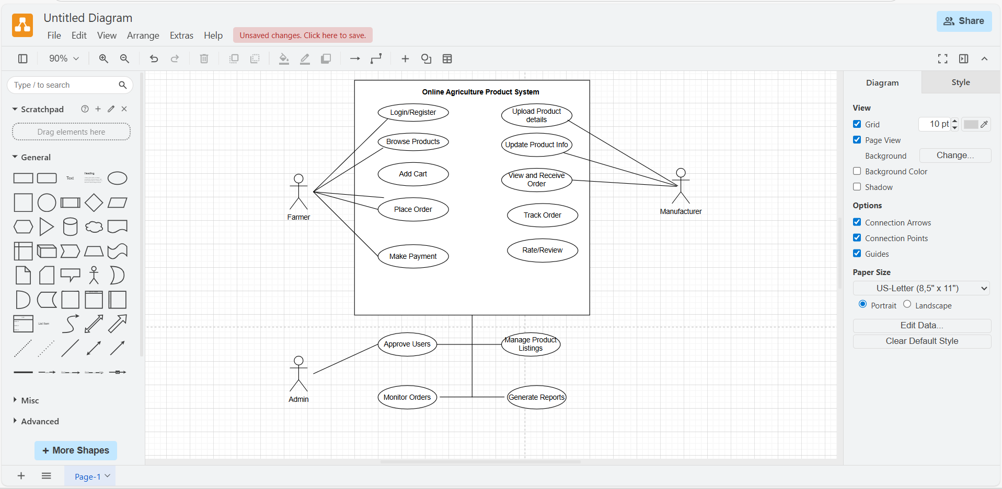
Screen Mock-ups / Wireframes:
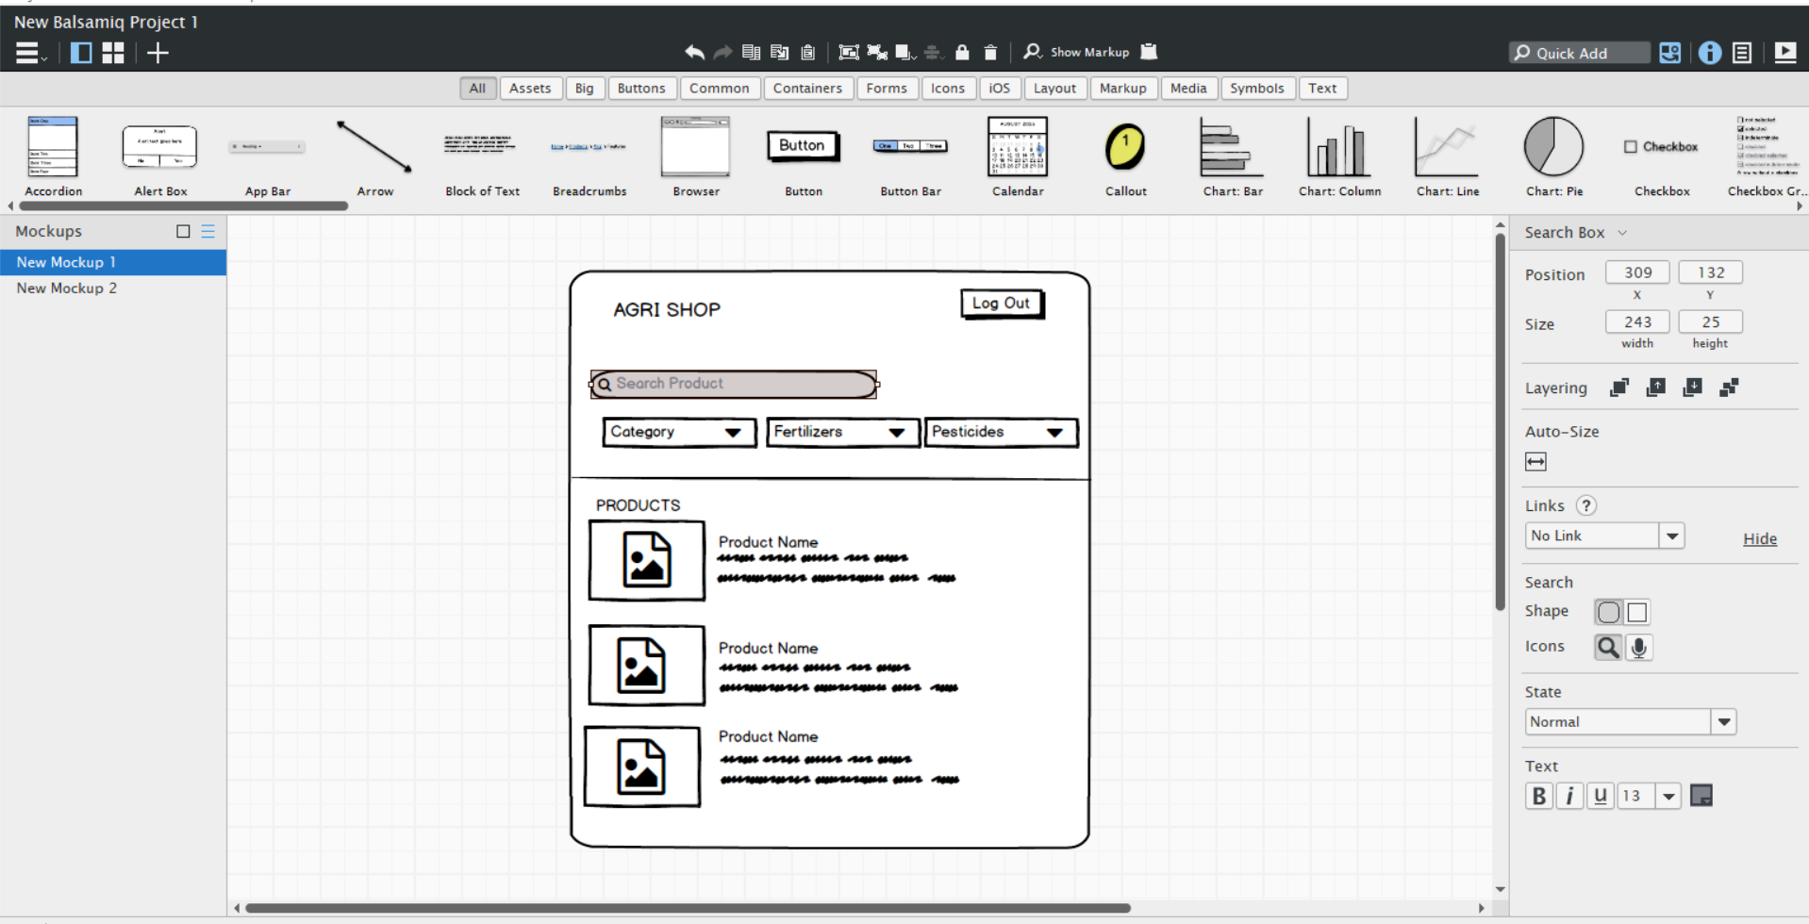

Question 10 – Use Case Diagram - 10 Marks
Draw use case diagram
Answers:
Actors
- Farmer (Primary user)
- Manufacturer (Product supplier)
- Admin (System overseer)
- System (Implicit system boundary)
Use Cases
For Farmer:
- Register/Login
- Browse Products
- Search Products
- Add to Cart
- Place Order
- Make Payment
- Track Order
- Rate/Review Product
- View Order History
For Manufacturer:
- Register/Login
- Upload Product Details
- Update Product Info
- View Orders Received
For Admin:
- Approve Users
- Manage Product Listings
- Monitor Orders
- Generate Reports
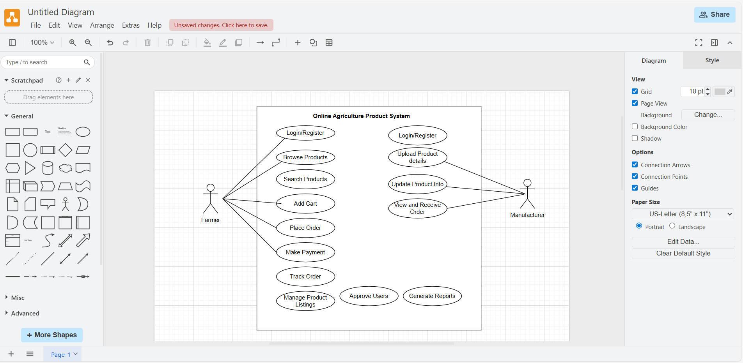

Question 11 – (minimum 5) Use Case Specs - 15 Marks
- Prepare use case specs for all use cases
Answer:
Use Case 1: UC001 – User Login
- Actor: Farmer, Manufacturer
- Description: Allows users to log into the system using email and password.
- Precondition: User must be registered.
- Postcondition: User is successfully logged in and redirected to dashboard.
Basic Flow:
- User opens login page
- Enters email and password
- System validates credentials
- If valid, user is logged in and redirected
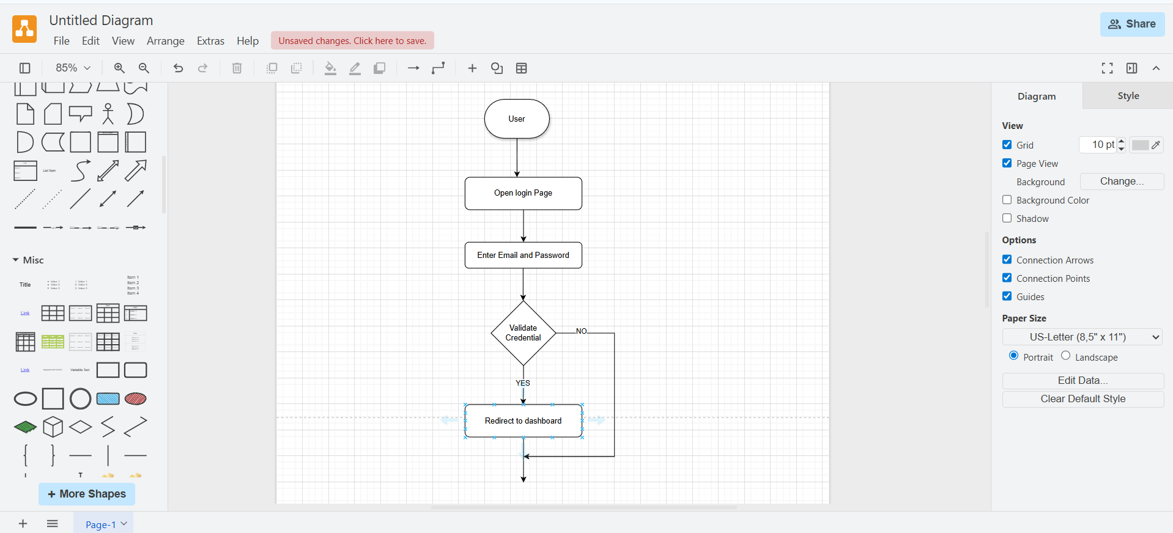
Use Case 2: UC002 – Browse Product Catalog
- Actor: Farmer
- Description: Allows farmers to view available products under seeds, fertilizers, pesticides.
- Precondition: User must be logged in.
- Postcondition: User can view product details and add to cart or buy later.
Basic Flow:
- User selects a category (e.g., Seeds)
- System fetches available products under that category
- Products are displayed with details (name, price, image, quantity)
- User clicks on a product to view full details
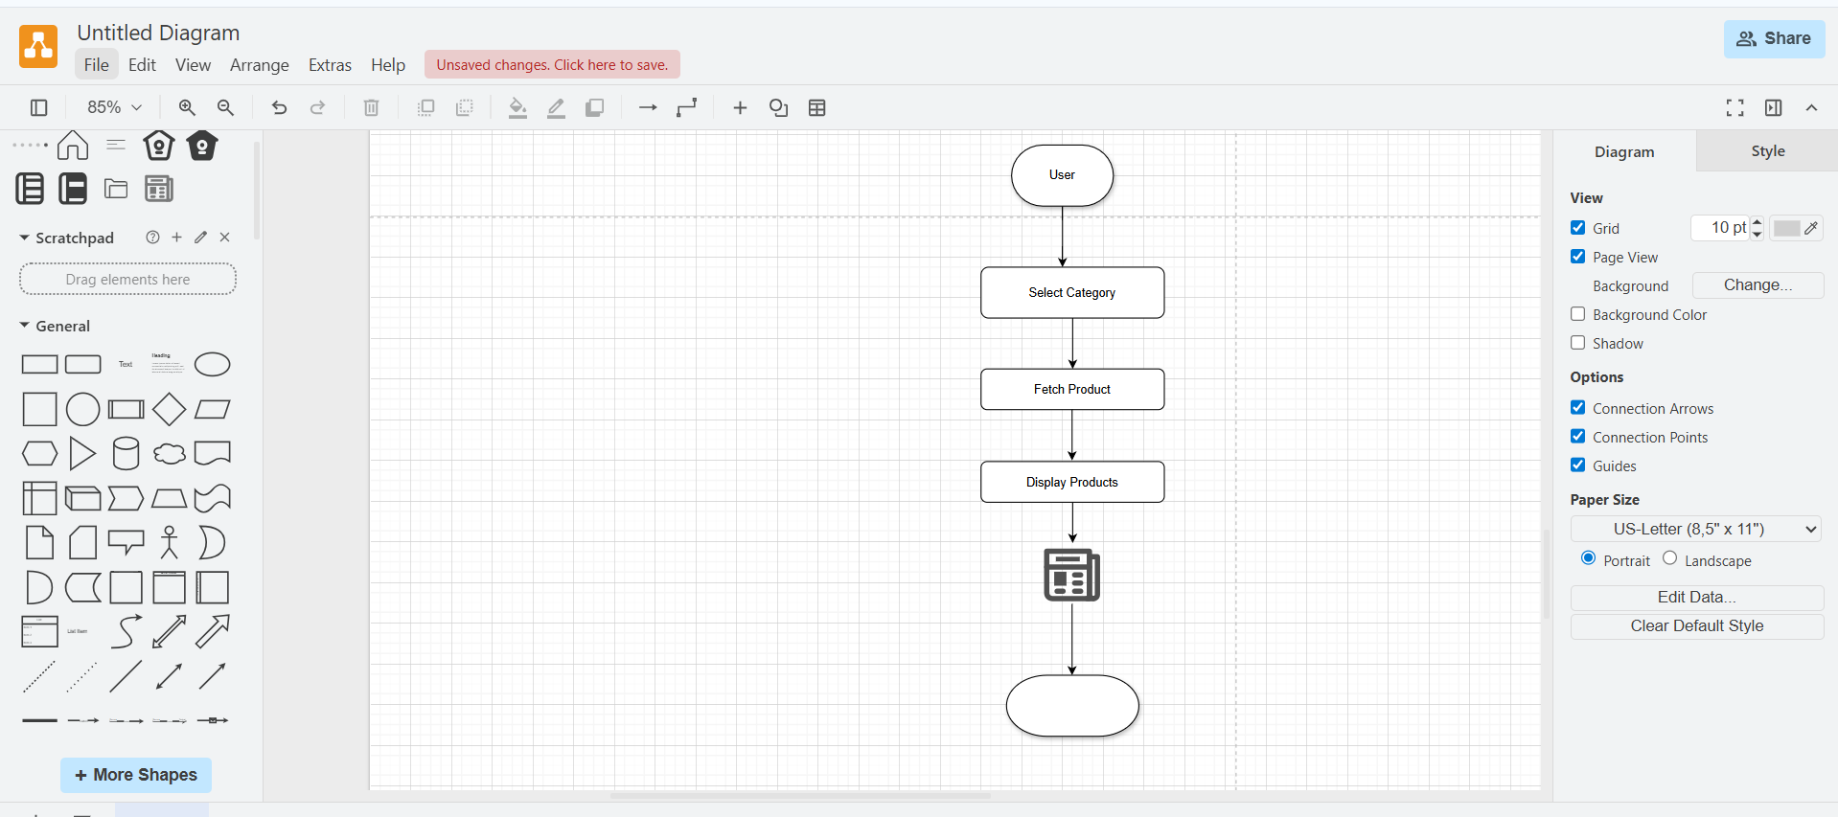
Use Case 3: UC003 – Upload Product (by Manufacturer)
- Actor: Manufacturer
- Description: Manufacturers can add new products to the system with full details.
- Precondition: Manufacturer must be logged in and verified.
- Postcondition: Product becomes visible in the catalog for farmers.
Basic Flow:
- Manufacturer clicks “Add Product”
- Fills form: name, type, price, stock, description, image
- Submits product
- System saves and displays product in catalog
Alternate Flow:
- A1: If required fields are missing → show validation error
- A2: If image upload fails → prompt retry or skip
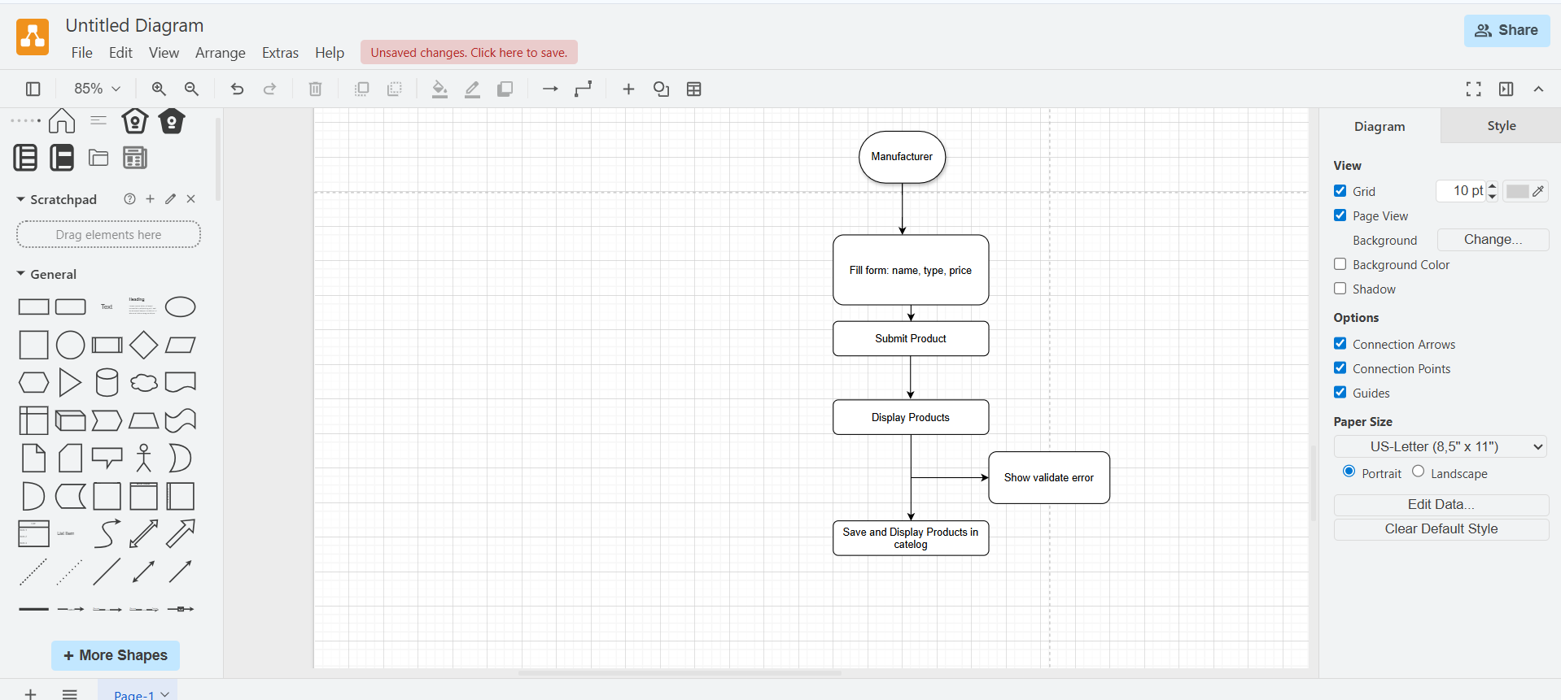
Use Case 4: UC004 – Place Order
- Actor: Farmer
- Description: Allows farmers to place orders for one or more products.
- Precondition: User must be logged in and have products in cart.
- Postcondition: Order is saved and confirmation is sent.
Basic Flow:
- User reviews cart
- Clicks on “Place Order”
- Selects address and payment method
- Confirms order
- System generates order ID and shows confirmation
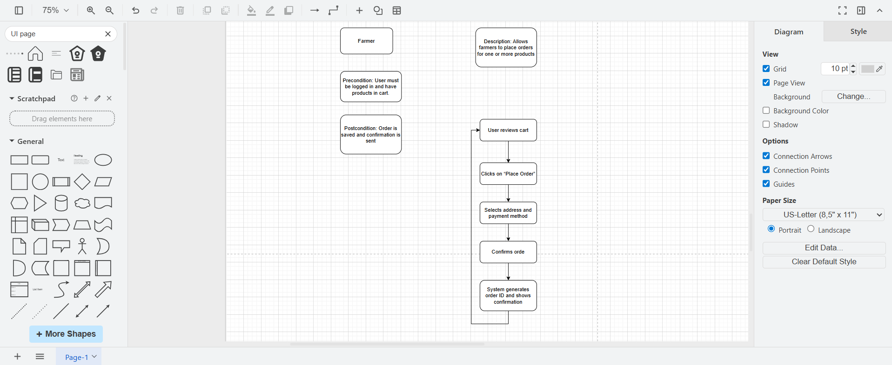
Use Case 5: UC005 – Track Order
- Actor: Farmer
- Description: Farmers can track the current status of their placed orders.
- Precondition: Order must be placed
- Postcondition: User sees real-time status (Ordered → Packed → Shipped → Delivered)
Basic Flow:
- User goes to “My Orders”
- Selects an order
- System fetches and displays latest delivery status with timestamps
Alternate Flow:
- A1: If tracking data is delayed → show “In Progress”
- A2: If order is cancelled → show cancellation status and reason
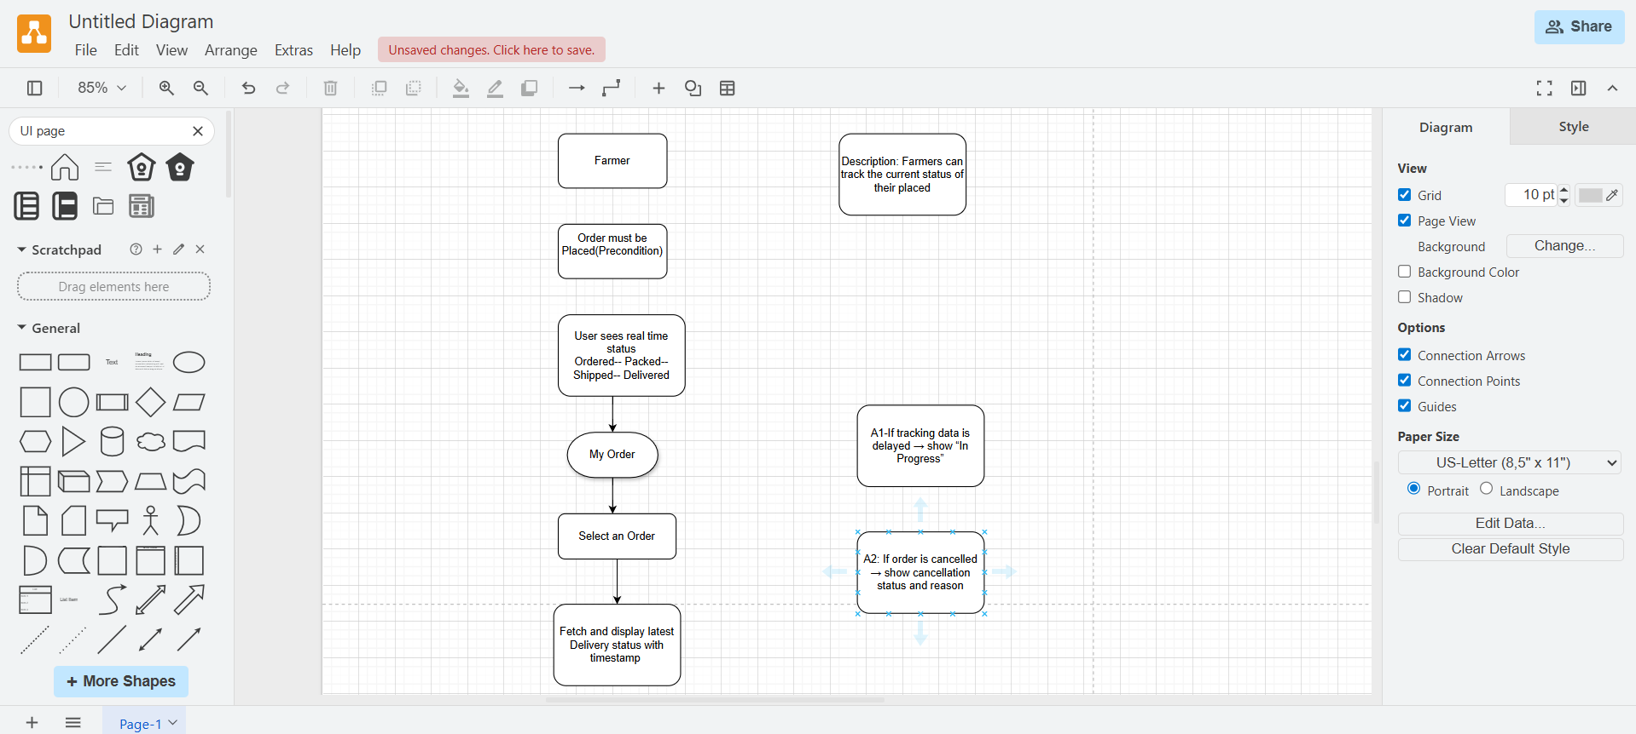

Question 12 – (minimum 5) Activity Diagrams - 15 Marks
Activity diagrams
Answer:
1. User Login
Showing how a user logs into the application.
2. Browse Product Catalog
Capturing the farmer's flow to search and view products.
3. Upload Product (by Manufacturer)
Illustrating how a manufacturer uploads new products.
4. Place Order
Covering the steps a farmer takes to place an order.
5. Track Order
Showing how a farmer checks the delivery status of their order.
