Capstone project 3 – part -1/2
Q1. Draw a use case diagram?
Answer
Use case diagram: a use case diagram is a visual representation that shows the functional requirements of a system by illustrating the interactions between external actors and the system’s use cases.
- Use case: A use case defines how a user or system interacts with the system to achieve a specific, valuable goal, outlining the steps and outcomes of that interaction.
- Actor: An actor is an external entity, such as a person or another system, that interacts with a system to perform a use case.

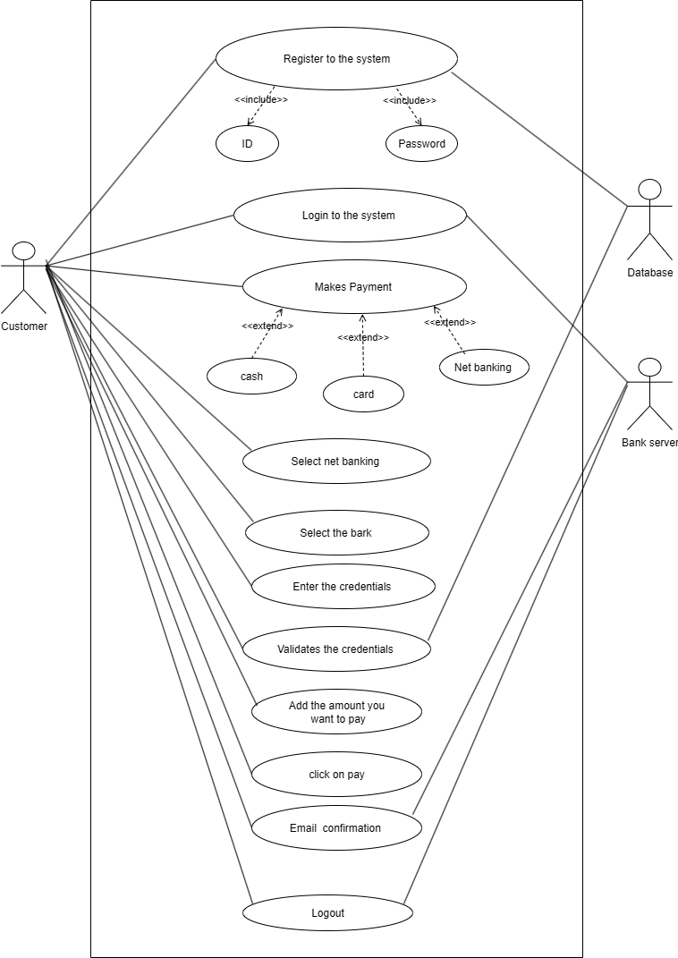

Q2. Derive boundary classes, controller classes, entity classes?
Answer
- Boundary classes: boundary classes are the interfaces between the system and the external actors, such as a user or another system. they handle input and output.
Example: Payment option boundary
Card payment boundary
- Controller classes: controller classes contain the business logic and coordinate the flow between boundary and entity classes. they are the brain of the application.
Example: payment-initiated controller
Card payment controller
- Entity classes: entity classes represent the core data or information that the system manages. They are passive and hold data, without a direct concern for how it’s presented or controlled.
Example: customer
Payment
Q3. Place these classes on a three-tier architecture?
Answer
- User layer: This tier is the user interface and handles all direct interaction with the customer. Its primary role is to display information and collect input.
- Boundary classes: these classes act as the interface to the system.
- Payment UI: This class is responsible for the visual elements, such as the web page or mobile screen where the user selects a payment method (card, wallet, etc.) and enters their payment details. It sends the user’s request to the business logic tier.
- Business logic tier: This layer contains the core business rules and logic. It proccesses the request from presentation tier, uses the data tier to manage data and orchestrates the application’s functionality.
- Controller class: These classes contain the business logic and coordinate the flow between the other two tiers
- Payment processor: This is the central controller teht receives the payment request from the payment UI. It validates the input, determines which payment method to use, and communicates with the paymentGatewayAPI to process the transaction. It is responsible for making decisions based on the bussiness rules.
- PaymentGatewayAPI: while a boundary class, it logically resides in this tier as it’s the interface used by the controllers to cinnect with external payment systems, which is part of the core business process.
- Data tier: this is the lowest tier and responsible fior data storage and retrieval. It manages the presentent data, such as a database, and is independent of the business logic.
- Entity classes: these classes represent the data structures and are managed by this tier.

- Payment: this entity stores all the data related to a single payment transaction, including the amount, data, method, and status.
- Customer: this entity holds all the data about the customer making payment.
- Order: this entity contains information about the order being paid for
Q4. Explain the domain model for customer making payment through net banking?
Answer
Domain model: it is a conceptual representation that defines the structure, relationship, and behaviour of entities within a specific problem domain.

In the below diagram,
- The customer table is connected to bank table, which is why the customer is able to make payment.
- Customer table is also connected to payment table, because he/she should make the payment
- Now the payment is done by netbanking, so payment table is connected to the net banking table.
- The account is in the bank, so the account table is connected to the bank.
- The authentication table is connected to both net banking table and bank table, because authentication is to performed there.
- Also, the authentication table is connected to transaction table, because authentication wiil be done while transaction.
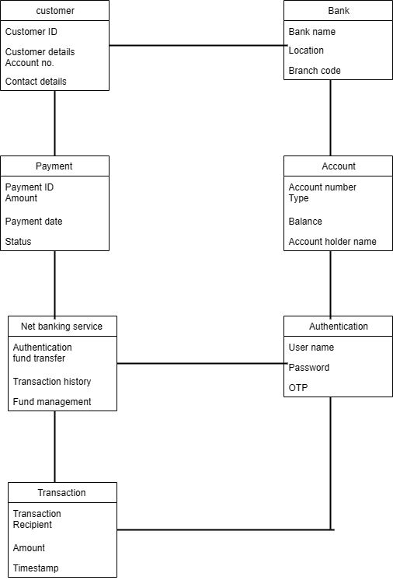
Q5. Draw a sequence diagram for payment done by customer net banking?
Answer
Sequence diagram: it is a type of interaction diagram used in software engineering and systems design to illustrate how processes operate with one another and in what order.
It is used to show the flow of messages, events or actions between the objects of the system.
This diagram helps to visualize the behavior of the system.
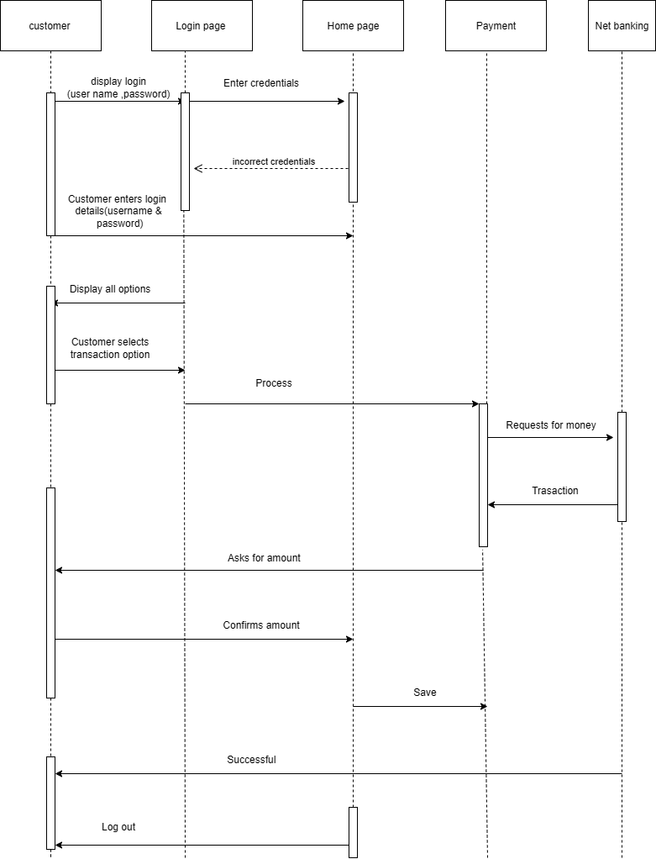
Q6. Explain Conceptual Model for this Case?
Answer
Conceptual model: A conceptual model is a high-level representation of a system thet helps in umderstanding visualizing, and communicating the essential aspects of a domain.
- It provides a clear and simplified view of the domain, making it easier to understand.
- Key elements of conceptual model:
Entities:
- Cutomer: the person initiating the transaction.
- Order: what is being bought that requires payment.
- Payment: the transaction record created to settle the order.
- Payment method: the mechanism used to complete the payment (net banking).
Attributes:
Each entity holds simple relavent data
- Customer: customer ID, name, email, phone number.
- Order: orderID, total amount, date placed.
- Payment: payment ID, amount paid, payment date, status.
Relationship:
The model defines how these concepts interact
- Customer place order: a customer place one or more orders (one- to- many relationships)
- Oreder requires payment: an oreder is fullfilled by one payment. (one-to-one relationship)
- Payment method used: the payment entity is the general concept, and the specific payment methods are specializations of it.
Q7. What is MVC architecture? Explain MVC rules to derive from use case diagram and guidelines to place classes in 3 -tier architecture.
Answer
- The Model-view- controller (MVC) framework is an architectural pattern that separates an application into three main logical components models, view and controller.
- View- represents the presentation layer of the application.
- Model- represents the data and the business logic of the application.
- Controller – acts as an intermediary between model and view.
MVC Architecture rules
- Combination of one actor and a use case result in one boundary class.
- Combination of two actors and a use case result in two boundary classes.
- Combination of three actors and use case results in three boundary classes and so on….
NOTE: only one primary actor is to be considered with a use case.
- Use case will result in a controller class.
- Each actor will result in one entity class.
Guidelines to place identified MVC classes in a 3-tier architecture
1.Place all entity classes in DB layer
- Place primary actor associated boundary class in application layer.
3.Place controller class in application layer
4. If governing body influence or reusability is there with any of remaining boundary classes, place them in business logic layer else place them in application layer.
Q8. Expain BA contributions in project (waterfall model-all stages?
Answer
The busines analyst plays a critical role across all stages of the waterfall model, ensuring that the final product aligns with the business needs and delivers value. Since the waterfall model is sequential, the BA’s primary and most intensive work is concentrated in the early stages (pre-project, initiated and requirements).
Stage | BA activities | Artifacts &Resources
Pre – project | Conduct feasibility study and current state analysis. Define the business problem and high-level objectieves to justify the projects. | Business case, feasibility report, market analysis
Project initiation | Define the project’s scope, key stakeholders, and measurable success metrics. Scure initial sign-off and budgeting for the discovery phase. | Project charter, high -level scope document.
Requirements gathering | Elicit, document, and categorize detailed functional and non-functional requirements using various techniques (interview, workshops, surveys). | BRD (business requirements document) stakeholders register, traceability matrix
Requirements analysis | Analyze, prioritize, and validate all gathered requirements to ensure they are complete, consistent and feasible.  Model the requirements using UML diagram (usecsae, activity, class) | FRD (fuctionality requirements document). Use case specifiactions, data flow diagrams (DFDs)
Design | Provide support and clarification to the design team (architects, UI/UX designers) to ensure the technical design and user interface faithfully reflect the documented quick checks on prototypes. | Review of technical design documents, wireframes and mockups(review/approval)
Development | Act as the primary liaison between the development team and the business stakeholders. manage change requests, resolve requirements-related ambiguities and conduct quick checks on prototypes. | Change request forms, requirements clarification log
Testing | Define and review test scenarios and test cases based on the requirements. Participate in system testing and often leads the UAT (user acceptance testing) preparation. | Test strategy /plan (input), test scenarios and cases (review)
UAT (user accepatance testing) | Crucial role: develop UAT test cases, train business users on the system, coordinate the testing effort, manage defects, and collect formal sign-off from the business to approve the solution for deployment. | UAT test plan/scripts, Defect log, fianl business sign-off document

Q9. What is conflict management? Explain using thomas -kilmann technique?
Answer
Conflict management is the process of resolving disagreements or disputes between individuals or groups in a constructive manner to reduce negative impact and achive a positive, working outcome. It focuses on handling defferences effectively rather than letting them escalate.
Thomas – kilmann conflict mode instrument (TKI)
The thomas – kilman conflict mode instrument (TKI) assesses and indiviodual’s approach to conflict by plotting it across two dimensions: assertiveness (focus on one’s own concerns) and cooperativeness (focus on the other party’s concern concerns). The chosen TKI style often guides the negotiation phase (step 5) of the conflict resolution phase
Five conflict resolution options (TKI Mode)
Style | Assertiveness(self) | Cooperativeness(other) | Goal/ key guideline
- Competing | high | low | To win; used when a quick decision is vital or on issues of hifh importance where you are certain you are correct.
- Accommodating | Low | high | To yield; used when the relationship is more important than the issues or when the issues is far more important to the other party.
- Avoiding | Low | low | To delay; used when the issue is trivial, when time is needed to cool down, or when you lack the necessary inforamtion.
- Collaborating | High | High | To find a win -win solution; used when both parties concern are too important to compromise and creative integration is required.
- Compromising | Medium | Medium | To find a middle ground; used when goals are moderately imporatant but quick, expendient resolution is necessary.

5 steps of conflict management
These five general steps outline the practical approach to resolving a conflict
- Identify the conflict: clearly define the objective disagreement by separating the core issue from personal emotions and assumptions.
- Discuss the details: allow all parties involved to fully express their perspectives, facts and feelings regarding the disagreement.
- Agree with the root problem: achieve consensus on the actual, underlying cause or need that must be addressed, rather than just treating the symptoms.
- Check for every possible solution for the conflict: brainstorming and evaluate multiple potential solutions, often leaning toward collaborating to find the optimal outcome.
- Negotiate the solution to avoid future conflicts: select the final solution (potentially using the compromising or competing mode if necessary) and establish clear commitments and processes to prevent the conflict from reoccurring.
Q10. List down the reason for project failure?
Answer
- Unclear Objectives and Requirements: This is argubly the most common cause. If the project’s goals scope, and success criteria aren’t clearly defined, agreed upon, and documented from the start, the team will deliver a product that doesn’t meet the business need.
- Poor planning and Estimation: Failure to accurately estimate the required time, resources, and budget leads to unrealistic deadlines and premature exhaustion of funds, causing the project to stall.
- Inadequate Risk management: Meglecting to proactively identify, assess, and plan mitigation strategies for potential risks (technical, market, financial) means the tema is caught off fuard when inevitavble problems occur.
- Poor Communication and Collaboration: Ineffective or infrequent communication among team members, stakeholders, and management leads to misunderstandings, duplicate work, and delayed identification of critical issues.
- Scope Creep (Uncontrolled Changes): Allowing frequent, undocumented, and unathorized additions of featues or requirements after the projects has started drastically consumes resources and time, derailing the schedule and budget.
- Lack of Stakeholder Engagement and Support: When key stakeholders (including end-users and senior management) are not actively involved in decision-making and do not endorse the project, it often lacks the necessary authority, funcign, and user adoprion to succeed.
- Resource Constraints: Having insufficient or unqualified human resources (staff), limited access to necessary tools or equipment, or major budjet cuts severely impedes the team’s ability to execute the plan.
- Technical Challenges and Poor Qulity: Using unproven technology, failing to perform thorough testing, or delivering a product with high defect rages leads to frustated users, costly rework and eventual product rejection.
Q11. List of the challenges faced in projects for BA?
Answer
Business analysts (BA) face a variety of challenges in project that can undermine their ability to gather, analyze and manage requirements effectively, especially given that they act as the crucial link between business stakeholders and the technical team.
Here are the key challenges faced by BAs in projects:
- Unclear or constantly changing requirements: stakeholders often provide vague, incomplete or conflicting needs and these requirements frequently change throughout the project lifecycle, making it difficult for the BA to establish a stable baseline.
- Managing stakeholder expectations and confllict: BAs must mediate conflicting priorities, goals and viewpoints among various stakeholders (user, management, tachnical team) often needing to manage unrealistic expectations about scope, time or cost.
- Scope creep and scope management: uncontrolled addictions or changes to the project’s features and boundaries after the initial agreement (scope creep) place immence pressure on the BA to rapidly assess the impact, document the changes, and gain formal approval.
- Time and resource constraints: BAs often have a limited time for thorough elicitation and analysis, and may lack access to key subject matter experts (SMEs), forcing them to make assumptions or rely on incomplete information.
- Quality assurance and testing alignment: ensuring that test cases and quality assurance efforts are fully aligned with the original and evolving business requirements is a consistent challenge, especially in complex system.
- Documentation and knowledge management: maintaining high quality, up-to-date documentation (like the BRD and FRD) throughout changes in time -consuming, and esuring that knowledge is effectively transferred to the development and testing teams can be difficult.
- Technology constraints and complexity: the BA must understand and translate business needs into requirements that are technically feasible within the current system arechitechture or chosen technology stack, which can be challenging when dealing with complex or legacy system.
Q12. Write about document naming standards?
Answer
Document naming standards
a document naming standard (or document numbering standards) is a systematic approach to assigning unique, meaningful identifiers to various documents created and used throughout the entire software development lifecycle. The primary goal is to ensure that documents are easy to locate, track and maintain consistency across a project or organization.
A good standard typically combines seversl key components into a specific, ordered format, allowing anyone to immediately understand the document’s context.
Standard components and example
Component | description | Example value
Project ID | A unique short code for the specific project. | PROJ123
Document type | A standardized acronym representing the content (e, g., requirements, test plan, design) | REQ (requirements)
Version | The current version number, indicating major/minor chnges. | 1.0
Date | The date the document was created or last formally approved/released | 2025-10-11

Example document identifier: PROJ123-REQ-1.0-2025-10-11
Imporatance and benefits
- Traceability: makes it easy to trace documents back to their respective project and versions.
- Consistency: ensure everyone uses the same format, reducing cinfusion and errors.
- Management: simplifies configuration management and version control.
- Searchability: allows the users to quickly search and filter documents based on specific criteria (e.g., “show all test plans for PROJ123”)
Q13. What are the Do’s and Don’ts of a business analyst?
Answer
s.no | BA Do’s | BA Don’ts
1 | Consult a subject matter expert (SME) for clarifications on requirements to ensure accuracy. | Never say NO to the client outright; instead, analyze the request and propose alternative or a justification for denial.
2 | Approach the client with a plain mind (no assumptions) when eliciting requirements. | Never use the word “by default”, all system behaviours and values must be explicitly defined and documented.
3 | Listen carefully and completely until the client is finished, and then ask clarifying questions. | Never imagine anything in terms of GUI (graphical user interface) during the initial requirements phase; focus on the business need.
4 | Concentrate on the important requirements (prioritization) that deliver the most value to the business | Don’t interrupt the client when they are giving you the problem or expressing their needs.
5 | Question the existence of current processes and challenge everything to ensure an optimal solution is built | Never try to give solutions to the client straight away based on previous experience or assumptions; first, understand the unique problem entirely.

Q14. Write difference between packages and sub-systems?
Answer
Features | Package | Subsystem
Definition | A simple grouping mechanism used to organize model elements (classes, interfaces). | A self- contained component that offers specific srevices via clearly defined interfaces.
Behaviour | No inherent behaviour; it’s a passive container used for namespacing. | Has behaviour; it acts like a single functional unit or module within the system.
Internal view | Its internal structure is exposed. it’s primarily a directory structure. | Its internal structure is hidden (a ‘BLACK BOX”); client only interact with public interfaces.
Reusability | Elements inside may or may not be reusable; often specific to a single application. | Designed to be highly reusable and plug-and-play across different applications or projects.
Eaxample | Grouping all boundary classes: com.app. payment.ui or a boundary -classes folder. | A payment gateways subsystem that takes a payment request and returns a status, hiding the complex logic of communicating with external banks.

Q15. What is camel- casing and explain where it will be used?
Answer
Camel- casing is a naming convention used in computer programming to write compound words or phrases without spaces. It is characterized by capitalizing the first letter of every word after the first word, which starts with a lowercase letter.
- The resulting name has alternating capital and lowercase letters that resemble the hump of a camel.
Example: camelcaseExample
Two primary forms of definations
Camel casing is used in two main forms, each applied to different elements in code
- Lower camel case(standard): the first word of the identifier starts with a lowercase letter, and the first letter of every subsequent word is capitalized.
Example: calculateTotalAmount, cutomerFirstName
- Upper camel case (pascal case): the first letter of every word is identifier is capitalized, including the vaery first word.
Eaxmple: PaymentProcessor, NetBankingService
Uses of camel casing
- Entity and data names:
- Use: naming the core business objects(entities), attributes, and database tables, ensuring direct mapping to development standards.
- Example: customerDetails, validateCustomerDetails
- Use cases and features:
- Use: naming high -level use cases, functional features, or system capabilities within a specification document
- Example: MakePayment, InitialRefund

- User stories and scenarios:
- Use: naming specific user stories, especially when referring to the system’s actions or system requirements.
- Example: “As a customer, I want the system to updateOrderHistory when a payment is successful”.
- Business rules and work flow:
- Use: namimg steps with in a business process or defining specific rules that the system must satisfy.
- Eaxmple: defining a rule as minimumOrderValueRule or a workflow step as validateShippingAddress.
- Requirement identifiers:
- Use: standardized requirement IDs sometimes incorporate camel -casing to make the identifier more descriptive and readable.
- Example: FR.01.updateStatus.
Q16. Illustrate development srver and what are the accesses does business analyst has?
Answer
A development server is a dedicated environment or server used during the software development process. It provides a plateform where developer and tester can build, integrate, test and debug application features before they are deployed to a production environment.
Its primary purpose is to provide a safe, isolated space for coding and experimentation without risking the stability of the live system.
The key accesses and permissions a BA typically has are:
- Read-only application access (front-end access):
- Purpose: to interact with the application interface (UI/UX) as an end user would.
- Detail: the BA uses this access to perform exploratory testing and valiadate initial prototyopes or early builds against the document requirements. This is crucial for verifying the look, feel and basic flow of a feature.

- User accepatnce testing (UAT) access:
- Purpose: to prepare the environment for UAT and often act as a power user during early testing phase.
- Details: the BA sets up and executes UAT scripts to ensure the system funtions meet the buisness needs, often using a dedicated UAT environment which is typically a clone of the dev/test environment.
- Read access to test data /database(limited):
- Purpose: to verify that the application is correctly saving and retrieving data according to business rules.
- Details: a BA might be granted limited, read-only access to a specific database schema or testing tool to confirm transaction outcomes without being able to modify or delete data.
- Access to logging /monitoring tools(limited) :
- Purpose: to help diagnose and replicate reported defects
- Details: the BA may need read access to logs or simple monitoring dashboard to gather information (error codes or timestamps0 that they can provide to the development teams when reporting a bug.
In summary, the BAs access is centered on observation, testing and validation, strictly avaiding any permission to write, deploy or modify code.
Q17. What is data mapping?
Answer
- Data mapping is the process of connecting data from one source to another.
- It’s like creating a guide or map that shows hoe data in one place corresponds to data in another place.
- This is especially important when you’re moving data between different systems or database to ensure that the data stays consistent and accurate.
- The main purpose of data mapping is to ensure that the data is accurately transferred or converted into different format.
Importance and uses of data mapping
- Data integration: while combining the data from different sources, it ensures that the data is properly matched.
- Data migration: while migrating the data from source to new system, the data elements are mapped accurately into the new system.
Required techniques are applied to convert the data into the format that is required by the new system.
- Data transformation: data transforamtion means converting the data from one format to other.
In data mapping, data transformation plays a very important role which ensures that the data of legacy system (source) is mapped correctly to the data in new system(destination)
Q18. What is API. Explain how you would use API integration in the case of your application Date format is dd-mm-yyyy and it is accepting some data from Other Application from US whose Date Format is mm-dd-yyyy
Answer
Application programming interface: an API is a set of rules, protocols and tools that allows different software applications to communicate with each other .it defines the methods and data formats that one application (the client) can use to request and exchange information or services from another application (the server). an API acts as a middleman, abstracting away the complexity of the internal system.
The steps for managing the date format conflict are:
- Define the interface specification: the BA defines the exact format that the internal system expects (dd-mm-yyyy) and the foramt from the external API (mm-dd-yyyy) in the integration specification document.
- Input/request transformation: when our internal application sends a date to the US system, the PaymentProcessor (controller) uses a utility function to convert the date from dd-mm-yyyy to mm-dd-yyyy before the BankGatewayAPI transmits the request
Eaxmple: sending “12-10-2025” must be converted to”10-12-2025”
- Output/ response transformation: when external US application sends a response back to us (e.g. a transaction confirmation date), the BankGatewayAPI receives the date in mm-dd-yyyy format.
- Business logic correction: the PaymentProcessor (or a dedicated datamapping service) must intercept the receive date and apply a transformation rule to covert it back to the internal standard of dd-mm-yyyy before it is saved in the payment entity (data tier)
Eaxmple: receiving “10-12-2025” must be converted to “12-10-2025”

