Capstone prep 2
Question 1: write Agile Manifesto
The Agile Manifesto focuses on delivering customer value, responding to change, and encouraging collaboration among teams. It is based on four core values and twelve principles.
The Agile Manifesto is a short document created by software experts to guide how teams should work smarter and faster when developing products or software.
It focuses on people, collaboration, and flexibility, instead of strict processes or heavy documentation.
The Agile Manifesto is a set of values and principles for agile software development:
- Deliver high-quality results quickly
- Adapt to changes easily
- Work closely with customers
- Focus on teamwork and continuous improvement
Fore core values of agile manifesto
- Individuals and interactions over processes and tools
→ People and teamwork are more important than rigid tools or processes.
- Working software over comprehensive documentation
→ Delivering a functional product is more valuable than producing lengthy documents.
- Customer collaboration over contract negotiation
→ Constant discussion with customers is better than just following fixed agreements.
- Responding to change over following a plan
→ Being flexible and adapting to change is more valuable than strictly following an old plan.
12 principles of agile manifesto:
- Customer satisfaction through early and continuous delivery of valuable software.
- Welcome changing requirements, even late in development. Agile processes harness change for the customer's competitive advantage.
- Deliver working software frequently, from a couple of weeks to a couple of months. with a preference to the shorter timescale.
- Business people and developers must work together daily throughout the project.
- Build projects around motivated individuals. Give them the environment and support they need, and trust them to get the job done.
- The most efficient and effective method of conveying information to and within a development team is face-to-face conversation.
- Working software is the primary measure of progress.
- Agile processes promote sustainable development. The sponsors, developers, and users should be able to maintain a constant pace indefinitely.
- Continuous attention to technical excellence and good design enhances agility.
- Simplicity--the art of maximizing the amount of work not done--is essential. It mean simplicity focus only on what’s necessary.
- Self-organizing teams produce the best architectures and designs. I mean The best architectures, requirements, and designs emerge from self-organizing teams.
- Regular reflection and adjustment — the team reviews and improves its performance. It means At regular intervals, the team reflects on how to become more effective, then tunes and adjusts its behaviour accordingly.
Application to Scrum Foods Project:
In the Scrum Foods (Food Delivery Application) project,
- The Scrum team collaborates daily to deliver working product increments.
- We welcome changes from clients or stakeholders anytime (e.g., new features like “Chat with Admin” or “Track Delivery”).
- Every Sprint (2 weeks) ensures working features such as registration, order tracking, and payment are delivered early and frequently.
- Regular sprint reviews and retrospectives help us inspect and adapt to continuously improve customer satisfaction.
Question 2 – User Stories- Acceptance Criteria-BV-CP
Write minimum 40 User stories and their Acceptance Criteria along with their and CP
Scrum Foods Project – User Stories, Acceptance Criteria, BV & CP
User Story No: 1 | Tasks: 2 | Priority: HIGH
As a Delivery Boy, I want to register in Scrum Foods so that I can deliver orders.
BV: 1000 | CP: 3
ACCEPTANCE CRITERIA
Registration Screen with Name, Password, ID, Email, Address. Register button sends success message.

User Story No: 2 | Tasks: 2 | Priority: HIGH
As a Customer, I want to register so that I can order food online.
BV: 1000 | CP: 4
ACCEPTANCE CRITERIA

Registration form for customer with validation; confirmation email sent.

User Story No: 3 | Tasks: 2 | Priority: HIGH

As a Customer, I want to login using username and password.

BV: 500 | CP: 2
ACCEPTANCE CRITERIA
Login page with correct credentials login success; wrong credentials show error.

User Story No: 4 | Tasks: 2 | Priority: HIGH
As an Admin, I want to manage all user accounts.
BV: 100 | CP: 7
ACCEPTANCE CRITERIA
Admin can view, edit, delete users.

User Story No: 5 | Tasks: 2 | Priority: HIGH

As a Delivery Boy, I want to login to check my assigned orders.

BV: 500 | CP: 4
ACCEPTANCE CRITERIA
Successful login redirects to delivery dashboard.

User Story No: 6 | Tasks: 2 | Priority: HIGH

As a Customer, I want to reset password if forgotten.

BV: 100 | CP: 2
ACCEPTANCE CRITERIA
Forgot password link sends reset email.

User Story No: 7 | Tasks: 2 | Priority: HIGH

As an Admin, I want to deactivate inactive users.

BV: 500 | CP: 6
ACCEPTANCE CRITERIA
Admin dashboard allows marking users inactive.

User Story No: 8 | Tasks: 2 | Priority: HIGH
As a Customer, I want OTP verification for registration.
BV:500 | CP: 3
ACCEPTANCE CRITERIA

OTP sent and verified before successful registration.

User Story No: 9 | Tasks: 2 | Priority: HIGH
As a System, I want to display error messages for invalid inputs.
BV: 200 | CP: 1
ACCEPTANCE CRITERIA
Validation on all registration fields.

User Story No: 10 | Tasks: 2 | Priority: HIGH
As an Admin, I want to view total number of users registered.
BV: 300 | CP: 2
ACCEPTANCE CRITERIA
Admin dashboard displays user count.

User Story No: 11 | Tasks: 2 | Priority: HIGH
As a Restaurant Owner, I want to register my restaurant in Scrum Foods.
BV: 500 | CP: 4
ACCEPTANCE CRITERIA
Form with restaurant details, verified by admin.

User Story No: 12 | Tasks: 2 | Priority: HIGH
As a Restaurant Owner, I want to upload my menu items.
BV: 800 | CP: 4
ACCEPTANCE CRITERIA
Upload form for dishes with name, price, image.

User Story No: 13 | Tasks: 2 | Priority: HIGH
As a Customer, I want to browse restaurants near me.
BV: 500 | CP: 3
ACCEPTANCE CRITERIA
Location-based restaurant listing.

User Story No: 14 | Tasks: 2 | Priority: HIGH

As a Customer, I want to filter food items by category.

BV: 500 | CP: 3
ACCEPTANCE CRITERIA

Filter options like veg/non-veg, price range.

User Story No: 15 | Tasks: 2 | Priority: HIGH

As a Customer, I want to view restaurant ratings.

BV: 400 | CP: 2
ACCEPTANCE CRITERIA

Rating visible on restaurant profile.

User Story No: 16 | Tasks: 2 | Priority: HIGH
As a Restaurant Owner, I want to edit my menu.
BV: 500 | CP: 3
ACCEPTANCE CRITERIA
Update or delete existing dishes.

User Story No: 17 | Tasks: 2 | Priority: HIGH
As an Admin, I want to approve restaurant listings.
BV: 50 | CP: 4
ACCEPTANCE CRITERIA

Admin dashboard shows pending approval requests.

User Story No: 18 | Tasks: 2 | Priority: HIGH
As a Customer, I want to view food item details.
BV: 400 | CP: 2
ACCEPTANCE CRITERIA
Click food item → opens detailed view.

User Story No: 19 | Tasks: 2 | Priority: HIGH
As a Customer, I want to see discounts/offers.
BV: 300 | CP: 3
ACCEPTANCE CRITERIA
Offers visible during checkout.

User Story No: 20 | Tasks: 2 | Priority: HIGH

As a System, I want to display “No restaurant found” if none available.

BV: 200 | CP: 1
ACCEPTANCE CRITERIA
Message displayed when no restaurants nearby.

User Story No: 21 | Tasks: 2 | Priority: HIGH

As a Customer, I want to add food items to my cart.

BV: 500 | CP: 3
ACCEPTANCE CRITERIA

Add to cart button adds items with quantity.

User Story No: 22 | Tasks: 2 | Priority: HIGH

As a Customer, I want to update or remove items from my cart.

BV: 500 | CP: 3
ACCEPTANCE CRITERIA
Quantity editable, items removable.

User Story No: 23 | Tasks: 2 | Priority: HIGH

As a Customer, I want to view total order amount.

BV: 400 | CP: 2
ACCEPTANCE CRITERIA
Cart total updates automatically.

User Story No: 24 | Tasks: 2 | Priority: HIGH
As a Customer, I want to proceed to checkout.

BV: 500 | CP: 3
ACCEPTANCE CRITERIA

Checkout page lists items and delivery address.

User Story No: 25 | Tasks: 2 | Priority: HIGH

As a Customer, I want to make payment via multiple options.

BV: 1000 | CP: 4
ACCEPTANCE CRITERIA
Options: Card, UPI, Wallet, COD.

User Story No: 26 | Tasks: 2 | Priority: HIGH
As a System, I want to confirm payment success/failure.
BV: 500 | CP: 3
ACCEPTANCE CRITERIA
Payment gateway integration with status update.

User Story No: 27 | Tasks: 2 | Priority: HIGH
As a Customer, I want to get an order confirmation email.
BV: 200 | CP: 2
ACCEPTANCE CRITERIA
Email with order ID sent after payment success.

User Story No: 28 | Tasks: 2 | Priority: HIGH

As a Delivery Boy, I want to view my assigned orders.

BV: 500 | CP: 3
ACCEPTANCE CRITERIA

Delivery dashboard lists pending orders.

User Story No: 29 | Tasks: 2 | Priority: HIGH
As a Customer, I want to cancel order before dispatch.
BV: 100 | CP: 2
ACCEPTANCE CRITERIA
Cancel button available before order accepted.

User Story No: 30 | Tasks: 2 | Priority: HIGH

As an Admin, I want to monitor total revenue generated.

BV: 1000 | CP: 8
ACCEPTANCE CRITERIA

Admin dashboard shows revenue analytics.

User Story No: 31 | Tasks: 2 | Priority: HIGH

As a Delivery Boy, I want to update order delivery status.

BV: 500 | CP: 3
ACCEPTANCE CRITERIA
Change status: Picked Up → Out for Delivery → Delivered.

User Story No: 32 | Tasks: 2 | Priority: HIGH

As a Customer, I want to track my order live.

BV: 1000 | CP: 4
ACCEPTANCE CRITERIA

Real-time tracking map available.

User Story No: 33 | Tasks: 2 | Priority: HIGH
As a Customer, I want to rate the restaurant after delivery.
BV: 100 | CP: 3
ACCEPTANCE CRITERIA

Star rating and comments submitted successfully.

User Story No: 34 | Tasks: 2 | Priority: HIGH

As a Delivery Boy, I want to view delivery history.

BV: 100 | CP: 2
ACCEPTANCE CRITERIA
Past deliveries visible in dashboard.

User Story No: 35 | Tasks: 2 | Priority: HIGH

As a Customer, I want to download my invoice.

BV: 500 | CP: 3
ACCEPTANCE CRITERIA

PDF invoice downloadable after order completion.

User Story No: 36 | Tasks: 2 | Priority: HIGH

As an Admin, I want to monitor delivery performance.

BV: 700 | CP: 4
ACCEPTANCE CRITERIA
Reports for delivery time, satisfaction

User Story No: 37 | Tasks: 2 | Priority: HIGH

As a System, I want to send notifications for delivery updates.

BV: 500 | CP: 3
ACCEPTANCE CRITERIA

Push/email notifications for each stage.

User Story No: 38 | Tasks: 2 | Priority: HIGH
As a Customer, I want to contact customer support.
BV: 400 | CP: 2
ACCEPTANCE CRITERIA

Chat or call button available.

User Story No: 39 | Tasks: 2 | Priority: HIGH

As a Customer, I want to reorder from past orders.

BV: 500 | CP: 3
ACCEPTANCE CRITERIA

Reorder button replicates previous order.

User Story No: 40 | Tasks: 2 | Priority: HIGH

As an Admin, I want to view overall system analytics.

BV: 1000 | CP: 5
ACCEPTANCE CRITERIA
Dashboard with graphs for sales, ratings, and delivery stats.

Question 3– What is epic? Write 2 epics
Epic: An Epic is a major business requirement or large user story in Agile/Scrum that represents a big feature or functionality of the project.
It is too large to complete in a single sprint, so it is divided into smaller user stories for easy development and delivery.
Examples Epics for Scrum Foods (Food Delivery Application)
- Epic 1: User Registration and Login
  - As a user, I want to create an account and log in securely so that I can access my profile and orders.
- Epic 2: Restaurant Management
  - As a restaurant owner, I want to manage my restaurant profile, menu, and orders so that I can serve customers effectively.
- Epic 3: Online Food Ordering and Payment
  - As a customer, I want to browse restaurants, select food items, and make online payments so that I can easily place my food order.
- Epic 4: Real-Time Order Tracking
  - As a customer, I want to track my food delivery in real-time so that I know when my food will arrive.
- Epic 5: Feedback and Rating System
  - As a customer, I want to give feedback and rate my delivery experience so that the service can be improved.

Question 4 –What is the difference between BV and CP
What is Business Value:
Business Value (BV) means the importance or benefit that a feature, product, or project gives to the business.
It shows how much the business will gain — like more profit, customer satisfaction, or time savings.
How is BV decided
During Backlog Grooming or Prioritization, the Product Owner (you) and Stakeholders (clients, managers) assign BV to each user story based on its importance.
You usually use fixed denominations (like Scrum currency notes):
₹1000, ₹500, ₹100, ₹50, ₹20, ₹10
or simply: 1000, 500, 300, 100, 50
Example:
1. Customer Value

How much the feature helps the customer

“Payment feature” = High BV
2. Revenue Impact

Does it bring money or business?

“Subscription upgrade” = High BV
3. Urgency / Priority

Needed soon or can wait?

“Login security update” = High BV
4.Brand / Reputation Impact
Improves trust, user satisfaction
Customer Feedback System = Moderate BV

Purpose of Business Value:
- To identify which features are most valuable to the business.
- To prioritize work that gives the highest benefit to customers and the organization.
- To help teams make better decisions on where to spend time and resources.
What is Complexity Point?
Complexity Point (CP) means how difficult or complicated a task or feature is to develop in a project.
It measures the amount of effort, time, and skill needed by the team to complete that work.
How CP is decided:
CP is decided by the development team (not the Product Owner) during Sprint Planning or Estimation Meetings using the Planning Poker technique.
They assign points like:
1, 2, 3, 5, 8, 13, 21 (Fibonacci series)
EXAMPLE:
CP = 1

Very simple, 1–2 hours work

Change button color, minor UI fix
CP = 2
User Story =
“As a user, I want to log in with my email”
Reason =

Simple logic and small UI
CP = 8
User Story = As admin, I want to see analytics reports
Reason = Heavy logic, data queries, charts

Purpose of Complexity Point:
- To estimate the effort required to build a feature.
- To plan work properly during sprints.
- To help teams understand which tasks are easy or hard.
- To make sure resources and time are used effectively.
Feature
  BV (Business Value)
  BV (Business Value)
Defination |  | It shows how difficult or complex it is to develop a feature.
  It shows how important or valuable a feature is to the business.
Primary Use
  Used to prioritize features that give more value to customers or business.
  Used to estimate the effort or time needed to complete the work.
Who Estimates | Product Owner, business stakeholders, and other business-focused roles.
  Development Team / Technical Team
Type of Measure | Measures benefit or impact | Measures effort or difficulty
Example | A payment feature has high BV because it directly affects revenue. | A real-time tracking system has high CP because it is technically complex.

Question 5: Explain about Sprint
Sprint Understanding:
In agile model a big project divided into modules, then each module further divided into smaller components called sprints.
Then the software will be implemented sprint by sprint.
A Sprint is a short, fixed period of time in which a Scrum team works to complete a set of tasks or goals.
Each Sprint delivers a usable and working product increment (a small part of the final product).
It helps the team work in small, manageable steps and show progress regularly.
Sprint Duration:
- Duration: 2 Weeks
- Purpose: To plan, develop, test, and deliver small features within a short time frame.
Scrum:
Scrum is a agile development method. Where developers and testers work together as team and focus on their tasks.
- Scrum is a daily meeting (subunit of a Sprint) where the team discusses progress, issues, and next steps.
- Duration: 1 Day (Daily Scrum or Stand-up Meeting)
- Purpose: To track daily work progress and remove any blockers.
Term | Meaning
PBI (Product Backlog Item) | A feature or requirement that needs to be developed.  A list of requirement and functionality’s planned to implement in a product called
Task | A small piece of work done by one developer in one day (within the Scrum).  A planned work item is called task.
WIP (Work In Progress)
  Tasks currently being worked on by the team.
Sprint Backlog | The list of all PBIs and tasks the team plans to complete in that Sprint.
DONE | Tasks that are fully completed and tested in the Sprint.

Question 6 – Explain Product Backlog and Sprint Backlog
Product Backlog:
Product Backlog = All features and requirements for the entire project.
A list of requirement and functionality’s planned to implement in a product is called product backlog.
- The Product Backlog is a list of all features, requirements, and ideas that need to be developed in the project.
- It is created and managed by the Product Owner.
- The items in the backlog are called PBIs (Product Backlog Items).
- The Product Backlog keeps changing as new requirements or ideas come up.
Example:
- User registration
- Login
- Online payment
- Order tracking
Purpose:
To keep track of everything that must be built in the product.
Sprint Backlog:
Sprint Backlog = Selected features and tasks planned for the current Sprint.
- The Sprint Backlog is a subset of the Product Backlog that the team selects to complete in the current Sprint (2 weeks).
- It contains specific tasks to be done in that Sprint.
- The Sprint Backlog is owned by the Scrum Team and updated daily.
Example:
If the Product Backlog has 10 items, the Sprint Backlog may contain 3–4 items chosen for the 2-week Sprint.
Purpose:
To focus the team’s work on a clear set of goals for the Sprint.

Question 7 – What is impediments log? write 2 impediments
An Impediments Log is a list of problems or obstacles that stop or slow down the Scrum team’s work during a Sprint.
It helps the Scrum Master and team to track, manage, and fix these issues quickly so the project can move forward smoothly.
An Impediments Log is a document or list used in Scrum to record and track all obstacles or issues that block or slow down the Scrum team’s work during a Sprint.
It helps the Scrum Master to identify, prioritize, and remove these impediments quickly so that the team can stay productive and meet Sprint goals.
It’s a record of all blockers that need to be solved to keep the team’s work going without delay. An Impediments Log helps track all problems that block or slow down progress in a Sprint so the team can resolve them and maintain efficiency.
Purpose of Impediments log:
- To identify and record blockers or challenges faced by the team.
- To monitor the status of each impediment until it is resolved.
- To help the Scrum Master and management take action for quick removal.
- To ensure smooth progress of the Sprint without unnecessary delays.
Examples:
- Server Downtime:
The testing or production server is not accessible, stopping deployment.
- Pending Approvals:
The client has not yet approved the UI design, delaying development.
- Dependency Delay:
Another team has not delivered the API required for integration.
- Technical Issue:
A developer’s laptop crashed, and tools need to be reinstalled.
- Lack of Clarity in Requirements:
The user story is not well-defined, and the team needs more details from the Product Owner.
In Summry:
An Impediments Log helps track all problems that block or slow down progress in a Sprint so the team can resolve them and maintain efficiency.
Question 8 – Explain Velocity of the Team
Velocity – How many CP is covered in this sprint
Velocity means how much work the team completes in one Sprint.
It is measured by counting the total Complexity Points (CP) or Story Points finished during that Sprint.
Velocity:
Velocity means how many Complexity Points (CP) or Story Points the Scrum team has completed in one Sprint.
It helps measure the team’s performance and speed in finishing work.
Velocity means Total CP completed by the team in one Sprint. Velocity shows the speed or capacity of the team to complete work in each Sprint.
Question 9 – Draw Sprint Burn Charts and Product Burn Down Charts
Sprint Burn Down Chart
• Sprint Burn Down Chart = progress within one sprint
Tracks how much work (story points or tasks) remains in the current sprint.
Covers 1 sprint (usually 2 weeks).
Scrum team (daily) to monitor sprint progress.
X-axis (Horizontal) = Days in a sprint (e.g., Day 1–10).
Y-axis (Vertical) = Remaining work in story points or hours for the sprint.
Goal is to ensure all sprint tasks are completed by the end of the sprint.

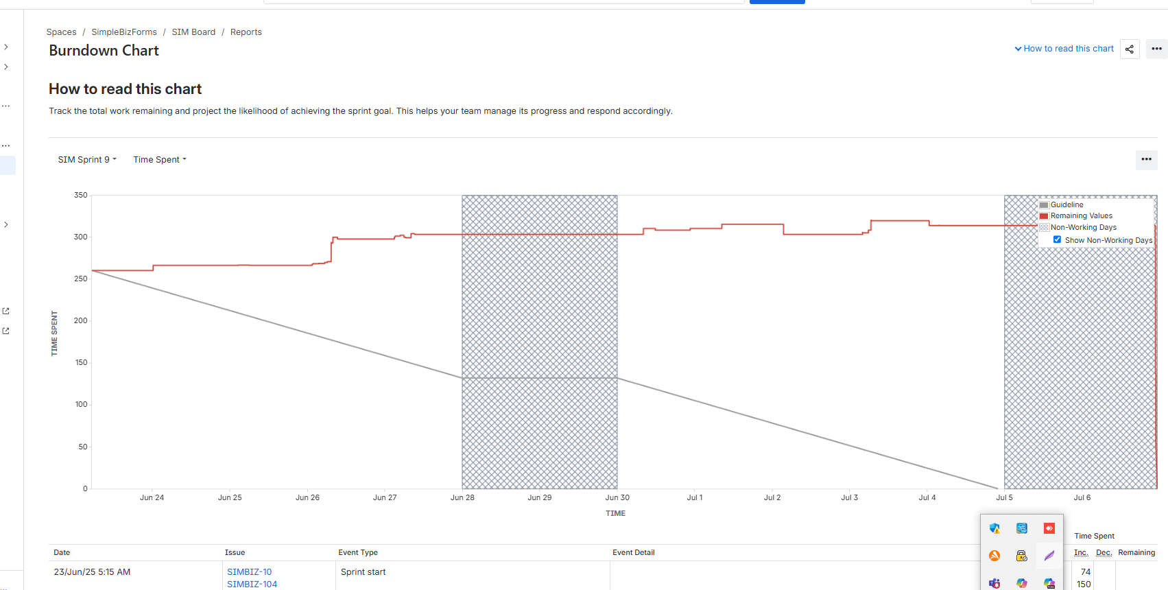
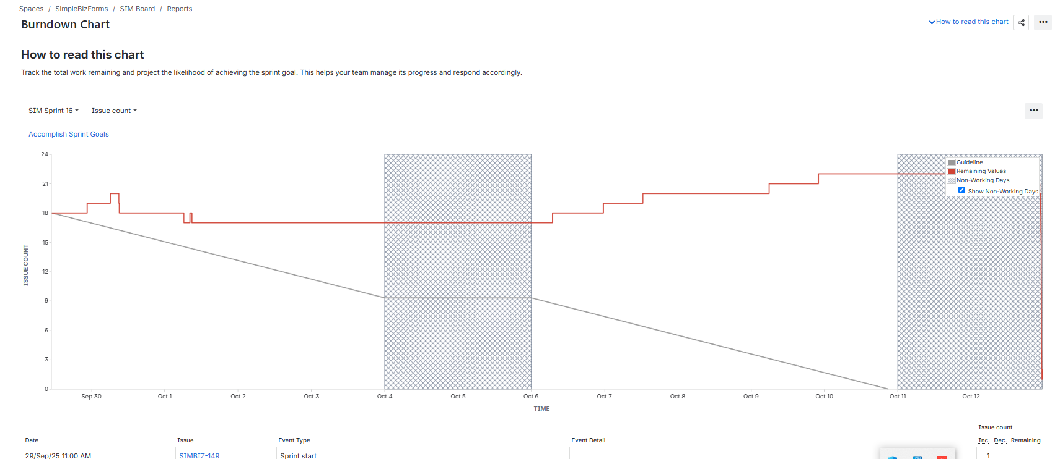

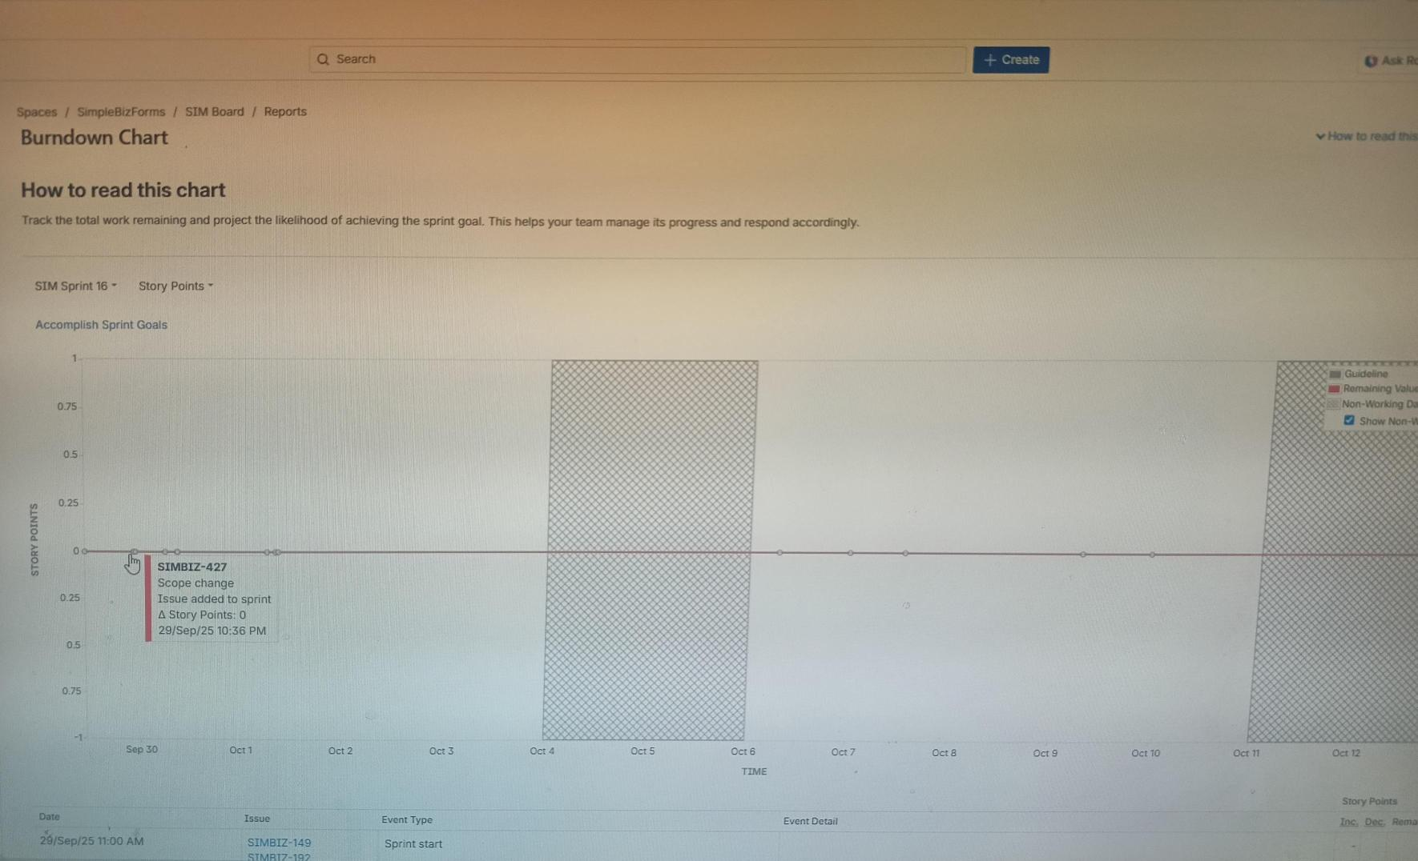

Product Burn Down Chart
• Product Burn Down Chart = progress across all sprints
Tracks how much work remains in the entire project or product.
Covers the whole product lifecycle (many sprints).
Product Owner and management to track release progress.
Sprints in the project (e.g., Sprint 1–Sprint 8).
X-axis (Horizontal) = Sprints in the project (e.g., Sprint 1–Sprint 8).
Y-axis (Vertical) = Total product backlog story points remaining.
Goal is to see if the team is on track to deliver the full product or release.

Question 10 – Explain about Product Grooming –
Product insights for improvement
Used for product grooming

Product Grooming:
Product Grooming (also called Backlog Refinement) is a regular meeting where the Product Owner and Scrum Team review and update the Product Backlog.
They check user stories, add new ones, remove unnecessary items, and set priorities to make sure everything is clear and ready for upcoming Sprints.

Or
Product Grooming, officially known as Product Backlog Refinement, is an ongoing activity in Agile and Scrum to review, update, and manage the Product Backlog.
It is essential because it ensures the Product Backlog remains a clear, prioritized, and manageable list of items that the development team can pull from to start work in the next Sprint.

Purpose:
The primary goal is to ensure the Product Backlog is "ready" for upcoming Sprints, meaning the top-priority items meet the DEEP criteria:
- Detailed Appropriately: High-priority items are clear and fully defined; low-priority items are intentionally vague.
- To get product insights for improvement.
- To keep the Product Backlog organized, updated, and clear for future development.
- Estimated: Items have an effort estimate (e.g., Story Points) from the Development Team.
- Emergent: The backlog continuously evolves based on new product insights, market changes, and customer feedback.
- Prioritized: Items are ordered based on their business value and urgency.
Product Grooming helps the team refine and prioritize tasks to improve the product continuously.
Question 11 – Explain the roles of Scrum Master and Product Owner
Team Experiences with Sprint 1
Scrum Master:
Product Owner
You acted as Product Owner.

Scrum Master:
The Scrum Master is responsible for guiding the Scrum Team and ensuring that the Scrum process is followed correctly.
They help remove impediments or blockers, conduct Scrum meetings, and make sure the team works smoothly and efficiently during the Sprint.
Key Role: Supports the team, removes challenges, and ensures proper Scrum practices.
Product Owner:
The Product Owner is responsible for managing the Product Backlog and deciding what features should be developed.
They communicate with stakeholders and customers to understand business needs and set priorities for the team.
In this project, you acted as the Product Owner — defining user stories and deciding their priority for each Sprint.
Key Role: Represents customer needs and ensures the team builds the right product with maximum business value.
Scrum Master ensures the team works effectively.
Product Owner ensures the team builds what the customer needs.
Question 12 – Explain all Meetings Conducted in Scrum Project

The Scrum Framework defines specific formal events, known as the Scrum Events, which are time-boxed meetings used to create regularity and minimize the need for other unplanned meetings.
All these events occur within the primary container—The Sprint.
Meetings Conducted in a Scrum Project
In a Scrum project, several key meetings are conducted to plan, track, and review progress.
1.Sprint Planning Meeting
- Conducted at the start of every Sprint (2 weeks).
- Purpose: To plan what work will be done in the upcoming sprint.
- The team selects User Stories from the Product Backlog and moves them to the Sprint Backlog.
- The team discusses how the work will be completed.
2. Daily Scrum (Stand-Up-Meeting)
- Conducted every day (15 minutes) during the sprint.
- Purpose: To track daily progress and identify any challenges (impediments).
- Each team member answers three questions:
  - What did I do yesterday?
  - What will I do today?
  - Are there any impediments blocking me?
3. Sprint Review Meeting
- Conducted at the end of the sprint.
- Purpose: To demonstrate the completed work (potentially shippable product) to stakeholders.
- The Product Owner collects feedback for improvement or future sprints.
4. Sprint Retrospective Meeting
- Conducted after the Sprint Review and before the next Sprint Planning.
- Purpose: To discuss what went well, what didn’t, and how to improve in the next sprint.
- Helps the team in continuous improvement.

Meeting Name | Purpose | When Conducted
Sprint Planing | Plan what to do in the sprint | Beginning of Sprint
Daily Scrum | Track progress and remove blockers | Every Day
Sprint Review | Show completed work and get feedback | End of Sprint
Sprint Retrospective |  | After Sprint Review
  Improve process for next sprint
Beyond the Events: Backlog Refinement
In addition to the formal events, a critical, ongoing activity that involves recurring meetings is Product Backlog Refinement (often called Grooming):
- Goal: To add detail, estimates, and order to the items in the Product Backlog. Its purpose is to ensure the backlog items are clear, estimated, and sized appropriately (DEEP), making them "ready" to be pulled into a future Sprint.
- Time: This is an ongoing activity that typically consumes no more than $10\%$ of the Development Team's capacity.
- Participants: Product Owner and Developers (Scrum Master ensures the process is followed).

Question 13 – Explain Sprint Size and Scrum Size
Sprint Size:
Sprint Size means the duration of one Sprint — the time period in which the Scrum Team completes a set of user stories.
Usually, a Sprint lasts for 2 weeks, but it can be 1–4 weeks depending on the project.
Sprint Size = Total duration of Sprint (e.g., 2 weeks)
Example:
If the team decides to work for 2 weeks to complete selected user stories, then the Sprint Size = 2 weeks
Scrum Size:
Scrum Size means the duration of one Scrum meeting or cycle within the Sprint.
Each Scrum (Daily Stand-up Meeting) usually lasts for 1 day, where the team reviews progress and plans the next tasks.
Scrum Size = Duration of one daily Scrum (1 day)
Example:
If the team has daily stand-ups, then the Scrum Size = 1 day.

Question 14 – Explain DOR and DOD

DOR (Definition of Ready):
Definition of Ready means that a user story is fully prepared and clear enough for the development team to start working on it.
It ensures that all requirements, designs, and acceptance criteria are properly defined before development begins.
Example:
User story has complete details, acceptance criteria, and approvals — then it is Ready to start.

DOR = Ready to Start
DOD (Definition of Done):
Definition of Done means that the user story is fully completed, tested, and meets all acceptance criteria.
It ensures the work is finished, reviewed, and ready for delivery or release.
Example:
Code developed → tested → reviewed → accepted by Product Owner = Done DOD = Fully Completed
Question 15 – Explain Prioritization Techniques and MVP
Prioritization Techniques:
Prioritization techniques are methods used by the Product Owner to decide which user stories or features should be developed first based on their value, urgency, or impact.
These techniques help the team focus on high-value items and deliver important features early.
Prioritization Techniques help decide what to build first.`
It means the level of importance or urgency assigned to a task, requirement, issue or defect.
It helps teams decide what should be done first, what can wait and what is least critical.
Example: Fixing a payment failure bug = High Priority
Common Prioritization Techniques:
MoSCoW is a method used to set priorities — especially in projects or requirements gathering.
It helps decide what’s most important and what can wait.
Each letter stands for a level of priority
Letter | Meaning
M – Must have | These are essential. Without them, the project will fail.
S – Should have | These are important, but not critical. If needed, they can wait for later.
C – Could have | These are nice-to-have features — only if time and resources allow.
W – Won’t have (this time) | These will not be done now, but may be considered in the future.
Example:
If you’re building an online store:
- Must have: Add to cart, payment system
- Should have: Product reviews
- Could have: Wishlist
- Won’t have: Augmented reality preview
MVP (Minimum Viable Product):
MVP is the first working version of a product with only the most important features.
It allows the team to test the idea quickly, collect feedback from users, and then improve the product in later versions.

MVP helps launch a basic version quickly to test and improve the product.
Example:
In a food delivery app, an MVP may include only registration, restaurant listing, and order placement — advanced features like chat or offers can come later.
Question 16 – Difference between Business Analyst n Product Owner
Business Analyst
The Business Analyst finds out what the business needs, A Business Analyst is a professional who acts as a bridge between business stakeholders and the technical team.
The Business Analyst (BA) focuses on understanding and defining what the business needs.
Their main job is to understand business problems, gather requirements, and translate them into clear, detailed documents that the development team can follow.
The BA ensures that the final product meets the business goals and user needs.
They analyze processes, identify gaps, suggest improvements, and make sure all requirements are well-understood and testable before development starts.
  - Goal to ensure the right requirements are delivered correctly to achieve business success.
Key Points
- Requirement Gathering – Collecting business and user needs through interviews, meetings, and workshops.
- Documentation – Creating Business Requirement Documents (BRD), Functional Specifications, and Use Cases.
- Analysis – Studying current business processes and identifying areas for improvement.
- Communication – Acting as a link between business users and the technical team.
- Validation – Ensuring the developed solution meets the original business needs.
Product Owner:
Product Owner (PO) focuses on deciding priorities and ensuring those needs are delivered effectively. Decides which needs to build first to create the most valuable product.
A Product Owner is a key role in Agile/Scrum projects, responsible for defining the product vision and prioritizing features to deliver maximum business value.
The PO represents the voice of the customer and ensures the Scrum Team is building the most valuable features first.
They manage the Product Backlog, write User Stories, and work closely with the development team to clarify requirements.
The Product Owner also decides what to build, in what order, and when to release new features.
  - Goal is to ensure the product delivers maximum value to both the business and customers.
Key Points:
- Define Product Vision – Setting the long-term goal and purpose of the product.
- Backlog Management – Creating, updating, and prioritizing user stories in the Product Backlog.
- Stakeholder Communication – Understanding customer and business needs and turning them into actionable items.
- Decision Making – Making final decisions on feature priorities and release planning.
- Feedback & Improvement – Reviewing progress and incorporating customer feedback to improve the product.
Aspect | Business Analyst | Product Owner
Role |  | Acts as the voice of the customer and owns the product vision.
  Acts as a bridge between business and technical teams.
Focus and Goal | Understanding and documenting business requirements  To make sure requirements are clear and feasible | Prioritizing and managing product development.  To ensure the team builds high-value features aligned with business goals
Responcibilitys | - Gather and analyze business needs.  - Prepare documents like BRD and use cases.  - Ensure clarity of requirements. | - Create and manage Product Backlog.  - Define product vision and goals.  - Prioritize user stories for each Sprint.
Decision On | Usually suggests solutions, but final decisions are taken by stakeholders or PO. | Has decision-making authority on what to build and when.
Involvement Stage | Involved mostly in requirement gathering and analysis phases. | Involved throughout the product lifecycle — planning, development, and delivery.
Goal |  | To ensure the product delivers maximum value to the customer and business.
  To ensure requirements are correct and complete.

Question 17 – Prepare a sample Resume of 3yrs exp Product Owner

NAVEEN KUMAR
Hyderabad, India | +91-98765-43210 | naveen.k@example.com | linkedin.com/in/Naveen po

PROFESSIONAL SUMMARY
Results-driven Product Owner with 3 years of experience in Agile and Scrum environments. Skilled in translating business needs into actionable user stories, managing product backlogs, and
collaborating with cross-functional teams to deliver high-quality digital products.
KEY SKILLS
Agile & Scrum Methodologies | Product Backlog Management | User Story Writing & Acceptance Criteria
Sprint Planning & Review | Stakeholder Communication | Prioritization (MoSCoW, 100-Point Method)
JIRA, Confluence, Trello | Business Value & ROI Analysis | Roadmap Planning

PROFESSIONAL EXPERIENCE
Product Owner – Scrum Foods Pvt. Ltd. | Hyderabad | June 2022 – Present
• Managed end-to-end product lifecycle for an online food delivery app.
• Defined product vision, goals, and roadmap aligned with business strategy.
• Collaborated with 8-member Scrum team for 2-week sprints.
• Ensured stories met Definition of Ready (DOR) and Definition of Done (DOD).
• Increased user satisfaction by 25% through feature improvements.
Associate Product Owner – TechVision Solutions | Bangalore | Jan 2021 – May 2022
• Assisted in backlog management and sprint planning.
• Supported MVP releases and tracked delivery timelines.
• Collaborated with QA and dev teams to ensure timely sprint completion.
• Helped improve sprint velocity by 30% through better prioritization.
EDUCATION
B.Tech in Computer Science – Osmania University, Hyderabad – 2020
CERTIFICATIONS
• Certified Scrum Product Owner (CSPO) – Scrum Alliance
• Agile Fundamentals – IIBA
ACHIEVEMENTS
• Launched 2 MVPs in record time.
• Improved sprint velocity by 30%.
• Recognized as “Top Performer” for team collaboration.
PERSONAL DETAILS
Languages: English, Telugu, Hindi
Notice Period: Immediate
DECLARATION
I hereby declare that all the information provided above is true to the best of my knowledge and belief.

NAVEEN KUMAR
Product Owner | Certified Scrum Product Owner (CSPO)
(555) 123-4567 | jay.smith@email.com | LinkedIn Profile URL | City, State
PROFESSIONAL SUMMARY
Highly motivated and results-driven Product Owner with 3 years of experience in Agile/Scrum environments, specializing in B2C SaaS product development. Proven ability to translate user needs and business strategy into a clear, prioritized product backlog, driving significant improvements in user engagement and revenue growth. Seeking to leverage product discovery and execution skills to deliver maximum business value.
PROFESSIONAL EXPERIENCE
Product Owner
Tech Innovation Corp, City, State | 2022 – Present
- Product Strategy & Vision: Owned the roadmap and feature delivery for the flagship customer-facing analytics dashboard (used by 50K+ users). Defined and communicated the Product Goal to align stakeholders and the development team.
- Value Delivery: Led the successful launch of 5 major features and 12 minor updates. Resulted in a 25% increase in weekly active users (WAU) and 15% growth in feature adoption within 6 months.
- Backlog Management: Managed and prioritized a 300+ item Product Backlog. Conducted weekly Product Backlog Refinement (Grooming) sessions to ensure the top 2-3 Sprints of work were "Ready" (clarified, estimated, and sized).
- Agile Execution: Worked directly with a dedicated Scrum Team (5 Developers, 1 Scrum Master). Improved Team Velocity by 12% by reducing scope creep and providing clear Acceptance Criteria.
- User Research & Discovery: Collaborated with UX/UI to run A/B tests and collect user feedback, using insights to validate hypotheses and inform a data-driven product roadmap.
Junior Business Analyst / Scrum Team Member
Digital Solutions Ltd., City, State | 2021 – 2022
- Supported the Senior Product Owner in managing user stories, capturing requirements, and conducting market research.
- Assisted in Sprint Planning and Sprint Review meetings, documenting stakeholder feedback and action items.
- Reduced bug report frequency by 10% by improving quality assurance criteria in early-stage user stories.

KEY SKILLS
- Product Management: Product Roadmapping, Backlog Refinement, User Stories, Acceptance Criteria, Release Planning, Value Maximization.
- Agile & Scrum: Scrum Framework, JIRA, Confluence, Sprint Management, Stakeholder Management, Requirements Elicitation.
- Data & Analytics: Google Analytics, User Behavior Analysis, A/B Testing, Hypothesis Testing, Metric Definition (KPIs).
EDUCATION
Master of Business Administration (M.B.A.) Major University Name, City, State | 2019
Bachelor of Science in Computer Science State University Name, City, State | 2017
CERTIFICATIONS
- Certified Scrum Product Owner (CSPO) – Scrum Alliance
- Professional Scrum Product Owner I (PSPO I) – Scrum.org

