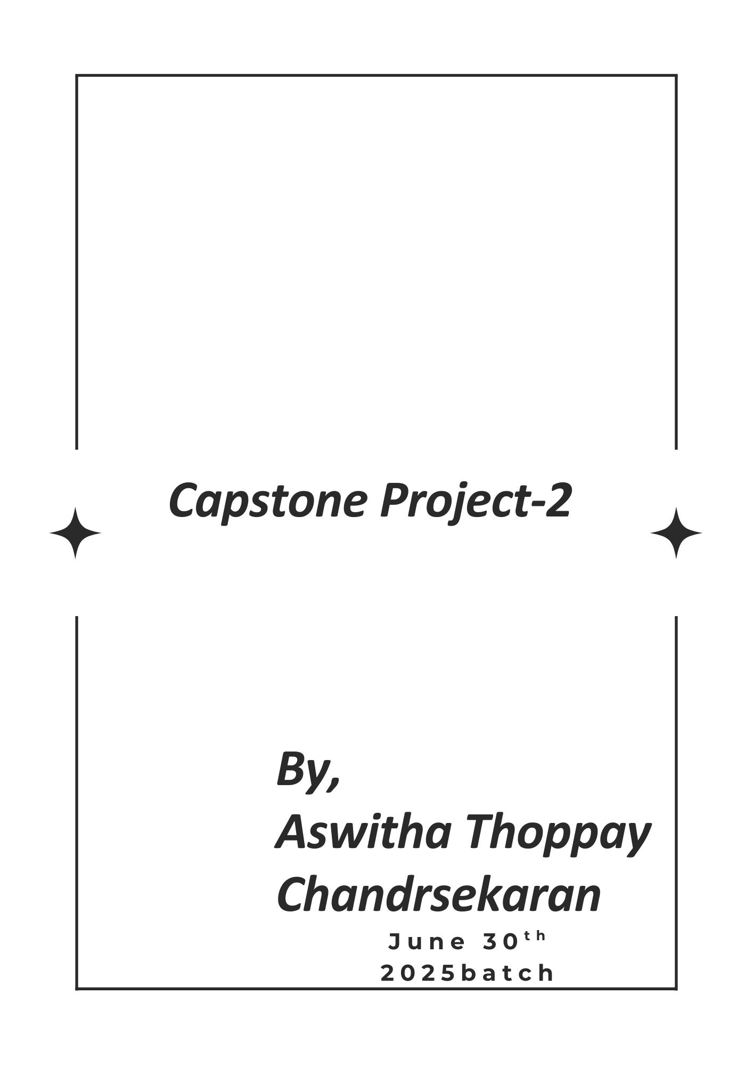
Online Agriculture product store
Mr. Henry, after being successful as a businessman and has become one of the wealthiest persons in the city. Now, Mr. Henry wants to help others to fulfil their dreams. One day, Mr. Henry went to meet his childhood friends Peter, Kevin and Ben. They live in a remote village and do farming. Mr. Henry asked his friends if they are facing any difficulties in their day-to-day work. Peter told Mr. Henry that he is facing difficulties in procuring fertilizers which are very important for farm. Kevin said that he is also facing the same problem in-case of buying seeds for farming certain crops. Ben raised his concern on lack of pesticides which could help in greatly reducing pests in crops. After listening to all his friends’ problems, Mr. Henry thought that this is a crucial problem faced not only by his friends but also by so many other farmers. So, Mr. Henry decided to make an online agriculture product store to facilitate remote area farmers to buy agriculture products. Through this Online Web / mobile Application, Farmers and Companies (Fertilizers, seeds and pesticides manufacturing Companies) can communicate directly with each other. The main purpose to build this online store is to facilitate farmers to buy seeds, pesticides, and fertilizers from anywhere through internet connectivity. Since new users are involved, Application should be user friendly.
This new application should be able to accept the product (fertilizers, seeds, pesticides) details from the manufacturers and should be able to display them to the Farmers. Farmers will browse through these products and select the products what they need and request to buy them and deliver them to farmers location.

Mr. Henry has given this project through his Company SOONY. In SOONY Company, Mr Pandu is Financial Head and Mr Dooku is Project Coordinator. Mr. Henry , Mr Pandu , and Mr Dooku formed one Committee and gave this project to APT IT SOLUTIONS company for Budget 2 Crores INR and 18 months Duration under CSR initiative. Peter, Kevin and Ben are helping the Committee and can be considered as Stakeholders share requirements for the Project.

Mr Karthik is the Delivery Head in APT IT SOLUTIONS company and he reached out to Mr Henry through his connects and Bagged this project. APT IT SOLUTIONS company have Talent pool Available for this Project. Mr Vandanam is project Manager, Ms. Juhi is Senior Java Developer, Mr Teyson, Ms Lucie, Mr Tucker, Mr Bravo are Java Developers. Network Admin is Mr Mike and DB Admin is John. Mr Jason and Ms Alekya are the Tester. And you joined this team as a BA.

Question 1 – Audits - 5 Marks
4 Quarterly Audits are planned Q1, Q2, Q3, Q4, for this Project. What is your knowledge on how these Audits will happen for a BA?
An audit is a review to ensure the project is following the plan, utilizing the correct documents, staying within budget, and delivering what was promised.
There will be internal as well as external Audits conducted during the project progress as a part of the Quality Assurance procedure that may belong to any Standards that the IT Company may follow.
As a Business Analyst, I would play a supportive role in the quarterly audits for the Online
Agriculture Products Store project. In these audits, my main responsibility would be to supply
necessary documentation and details related to various project stages, including requirements
gathering, design, development, testing, and deployment. The goal of these audits is to evaluate the
project's progress, confirm that it's aligning with the set objectives and timeline, and identify any risks
or problems that may need attention.
The Project Manager will be overall responsible for audit coordination, responses, and implementing corrective actions based on audit findings

Stage | Quarter 1 – Audit Report (Requirement gathering phase)
Completed | Months 1–3
Check list | - BRD template finalized  - Elicitation results and stakeholder sign-off  - Initial risk assessment and mitigation plan  - RTM draft (Requirements Traceability Matrix)  - Stakeholder map and communication plan  - Project charter approved
Stage | Quarter 2 – Audit Report (Requirement analysis phase)
Completed | Months 4–6
Check list | - Functional/non-functional requirements detail  - Architecture concepts (high-level)  - Data model preliminaries (ER diagrams, data dictionary)  - RTM updated and baseline approved  - Stakeholder sign-off on requirements  - Initial UML diagrams or user stories
Stage | Quarter 3 Audit Report (Design phase)
Completed | Completed Months 7–9
Check list | - Low-level design (LLD) and system architecture  - Data model finalized; schema definitions  - Integration plan with external services (payments, notifications)  - Test strategy and initial test plans  - UI/UX design proofs and approvals
Stage | Quarter 4 – Audit Report (Implementation/Validation phase)
Completed | Months 10–12
Check list | - Core modules implemented  - Data model implemented in staging  - Integration adapters connected (payment, mail/SMS, logistics)  - Initial test plans updated with test cases  - Code reviews and security checks
Stage | Quarter 5( Validation, UAT, Data Migration Prep
Completed | 3 months
Check list | - User Acceptance Testing (UAT) executed and sign-off  - Data migration plan validated; migration scripts prepared  - Security/compliance review completed  - Performance/load testing plan defined  - Deployment readiness checklist
Stage | Quarter 6( Deployment, Closeout, and Post-Implementation Review)
Completed | Months 16–18
Check list | - Production rollout plan and cutover executed  - Post-implementation review conducted  - Final audit/report delivered  - Knowledge transfer and handover completed  - Final risk register update and lessons learned

Question 2 – BA Approach Strategy - 6 Marks
Before the Project is going to Kick Start, The Committee asked Mr Karthik to submit BA Approach Strategy Write BA Approach strategy (As a business analyst, what are the steps that you would need to follow to complete a project – What Elicitation Techniques to apply, how to do Stakeholder Analysis RACI/ILS, What Documents to Write, What process to follow to Sign off on the Documents, How to take Approvals from the Client, What Communication Channels to establish n implement, How to Handle Change Requests, How to update the progress of the project to the Stakeholders, How to take signoff on the UAT- Client Project Acceptance Form )
Your Team
Project Manager | Mr Vandanam
Senior Java Developer | Ms. Juhi Java Developers - Mr Teyson, Ms Lucie, Mr Tucker, Mr Bravo
Network Admin | Mr Mike
DB Admin | Mr John
Testers | Mr Jason and Ms Alekya
BA | You

Technical Team have assembled to discuss on the Project approach and have finalized to follow 3-tier architecture for this project.
BA Approach Strategy
As a BA here I am going to discuss about the BA strategy involved in this Online Agriculture product store project.
- Elicitation Technique:
There are various Elicitation Techniques are there like (BDRFOWJIPQ)
- Brainstorming
- Document Analysis
- Reverse Engineering
- Focus Groups
- Observation
- Workshop
- JAD(Joint Application Development) -Requirements Workshop
- Interview
- Prototyping
- Questionnaire
The details of all the above elicitation techniques are described in Question 5(Elicitation Techniques)
Here, I am going to explain what elicitation techniques can be followed from the BA strategy:
Technique | Who involved | How we use it | Sample questions | Type of questions
Interviews | CSR committee, PM, Developer, QA, Mike, John | Short, structured talks to capture goals, scope, constraints | What are the top goals for this store?  What must be in the first release?  Which product categories are must-have?  What approvals are needed before go-live?  What risks worry you most?  What reports do you need?  What budget/timeline limits do we have? | Open-ended and probing (exploratory, to uncover goals and constraints)
Joint workshops (JAD) | CSR, PM, BA, Devs, QA | Agree on features, flows, and acceptance criteria | Who are the user roles?- Walk us through browse → cart → pay → deliver.- What makes “checkout” done?  How do we handle out-of-stock/refunds?  What is MVP vs later? What performance do we expect? | Collaborative, scenario-based (interactive, brainstorming)
Document analysis | BA with CSR/PM docs | Read CSR policies, budgets, past decisions | Which CSR rules affect pricing/discounts?  Any data retention or privacy rules?  Any fixed deadlines? Any approved vendors/tools?  Any language or accessibility standards? | Factual, compliance-focused (yes/no, confirmation)
Business Process Modeling (As-Is/To-Be) | BA; CSR reps; PM (Mr Vandanam); Senior Dev (Ms Juhi); QA (Mr Jason, Ms Alekya) | Map current agriculture business processes vs future online store processes | How do farmers currently order products?  What steps are in current billing process? Where are the delays in current system?  How should online ordering flow work? What approval steps are needed? | Process-focused, workflow validation (step-by-step confirmation)
Quick surveys/polls | Selected farmers/customers via CSR | Short feedback to validate priorities | Which device do you use?  Preferred language?  Preferred payment?  Expected delivery time?  Top 3 pain points? | Closed/multiple-choice (quantitative validation)

- Stakeholder Analysis RACI/ILS:
Stakeholder Analysis involves identifying the stakeholder who will be directly or indirectly impacted by the change and analyzing the information once collected.
There are various stakeholder analyses
      - Identify Stakeholders
      - Stakeholders Listing Document
      - Stakeholders Summary
      - RASCI Matrix - Responsible, Accountable, Supporting, Consulted, Informed

Identifying the Stakeholder
Internal Stakeholder:
Stakeholder | Role
Mr. Vandanam | Project Manager
You | Business Analyst
Ms. Juhi | Senior Java Developer
Mr. Teyson | Java Developer
Ms. Lucie | Java Developer
Mr. Tucker | Java Developer
Mr. Bravo | Java Developer
Mr. Mike | Network Administrator
Mr. John | Database Administrator
Mr. Jason | Tester
Ms. Alekya | Tester

External Stakeholder:
Stakeholder | Role
Mr. Henry | Project Owner/Sponsor
Mr. Pandu | Financial Head
Mr. Dooku | Project Coordinator
Peter | Subject Matter Expert
Kevin | Subject Matter Expert
Ben | Subject Matter Expert

Stakeholders Listing Document: A table of all stakeholders with name, role, organization, contact, influence/interest, approvals needed, and preferred communication.
Stakeholders Summary: A short note per key group (CSR Committee, PM, BA, Devs, QA, DB, Network, End Users) describing what they decide/provide and what they need from the project.

We have already discussed the Stakeholder analysis(RACI Matrix) in our previous Capstone project now let’s prioritize the stakeholders
Interest Legitimacy Support (ILS)
The Interest Legitimacy Support (ILS) concept ensures that the project aligns with the legitimate interests and concerns of all stakeholders involved. It helps to validate that the project objectives and deliverables truly address the needs and priorities of the stakeholders. By incorporating ILS, the project can gain stronger support and buy-in from all parties, leading to a more successful implementation

Stakeholder | Role | R (Responsible) | A (Accountable) | C (Consulted) | I (Informed)
Mr. Henry | Project Initiator & Sponsor |  | A | C | I
Mr. Pandu | Financial Head |  | A | C | I
Mr. Dooku | Project Coordinator | R | A | C | I
Peter, Kevin, Ben | Stakeholders (Farmers) |  |  | C | I
Mr. Karthik | Delivery Head (APT IT Solutions) | R | A | C | I
Mr. Vandanam | Project Manager | R | A | C | I
Ms. Juhi | Senior Java Developer | R |  | C | I
Mr. Teyson, Ms. Lucie, Mr. Tucker, Mr. Bravo | Java Developers | R |  | C | I
Mr. Jason & Ms. Alekya | Testers | R |  | C | I
Mr. John | Database Admin | R |  | C | I
Mr. Mike | Network Admin | R |  | C | I
Business Analyst (BA) | Requirement Elicitation & Traceability | R | A | C | I

- What Documents to Write
- Business Case Document-Shows why the project is worth doing, including benefits, costs, and risks.
- Business Process Document- Talks about the why the project has initiated, budget, timeline, stakeholders and vision of the project
- Business Requirements Document (BRD) - Captures high-level business needs and objectives for the agriculture store
- Functional Requirements Specification (FRS) - Details what the system should do (features, functions, behaviors)
- NFRS(Non-Functional Requirements)-Describes how the system should perform (speed, security, reliability, usability, etc.).
- BPPM(Business Process & Project Management)- Outlines how the project will run—scope, schedule, resources, roles, and governance.
- Project Closure Document- Summarizes what was delivered, final acceptance, lessons learned, and sign-off.

- What process to follow to Sign off on the Documents,How to take Approvals from the Client, What Communication Channels to establish n implement

As a BA, I will be drafting the document. Once the document is completed, I will be sending it to the client for Review with the PM's acknowledgement. The client will review and sign off on the requirements for the above documents, such as the Business Process Document and BRD, through official communication channels like email, Skype, or Teams, to ensure they receive final approval before project progression.

- How to Handle Change Requests
A change request is when someone, like a stakeholder (e.g., a farmer or CSR committee member), wants to modify something in the project, such as adding a new feature to the agriculture store. As a BA, I ensure changes are handled carefully to avoid delays or extra costs, while aligning with our SMART goals.
Here's a step-by-step process I recommend:
- Receive and Document the Change Request: Start by logging the request in a central system. For example, if a stakeholder wants to add a new payment option, note all details like why it's needed and who requested it.
- Conduct a Feasibility Study: Assess if the change is practical by checking resources, time, and technology. In your project, I'd evaluate if adding the feature is doable with our current budget and tools, ensuring it's achievable and relevant.
- Perform an Impact Analysis: Analyze how the change affects the project, such as its impact on timeline, costs, or other features. For instance, in the agriculture supply chain project, I might find that the new payment option could delay deployment by 2 weeks and increase the budget by 10%—this helps keep things measurable and specific.
- Review with the Change Control Board (CCB): Present the findings to the CCB, a group of key team members (e.g., project manager, developers, and stakeholders), who decide if the change should proceed. As a BA, I'd prepare a summary report for discussion to ensure the board's decision is based on facts.
- Get Client Approval: Once the CCB approves, submit the proposal to the client for final sign-off through official channels like email or Teams. I'd send a clear message, such as, "Based on our analysis, we recommend this change—please approve via email," and wait for their confirmation to move forward.
- Implement and Update: If approved, update all relevant documents (e.g., BRD or FRS), communicate the changes to the team, and track the progress to ensure everything stays on schedule.
This process helps maintain project control and prevents scope creep, keeping your agriculture project efficient and aligned with business goals

- How to update the progress of the project to the Stakeholders
As a BA, I ensure that progress updates are clear, timely, and tailored to stakeholders (e.g., farmers, manufacturers, CSR committees, and admins) to build trust, manage expectations, and support decision-making. This helps keep the project on track, especially when dealing with aspects like requirement changes or timelines.
Here's a step-by-step process :
- Establish a regular cadence for progress updates (e.g., weekly or monthly) and communicate it to all stakeholders.
- In each progress update, cover key elements such as project milestones and deliverables, key accomplishments and challenges, upcoming activities and risks, and any action items or decisions requiring stakeholder input.
- Utilize a mix of communication channels, including email, virtual meetings, and project management tools, to share information and foster interactive discussions.
- Maintain a comprehensive stakeholder contact list and tailor the content and communication style to meet the needs and preferences of each stakeholder group.

- How to take signoff on the UAT- Client Project Acceptance Form
Field | Details
Version Date
Project Name | Online Agriculture Products Store
Project Goals | 1. Provide farmers with an online platform (web & mobile) to browse and purchase seeds, fertilizers, and pesticides.  2. Enable manufacturers to submit product details (type, stock, price, usage) for approval and listing.  3. Integrate payments and delivery tracking for seamless order management.  4. Ensure compliance with CSR guidelines, budget constraints, and security standards.
Project Details
Attribute | Detail
Project Manager | Mr. Vandanam
Sponsor | Mr. Henry
Business Analyst | Aswitha
Start Date
Planned Completion Date
Planned Budget | INR 2 Crores
Actual Completion Date
Actual Budget
Variance
Duration | 18 Months
Days Past Planned Completion Date
Project Deliverables
By Signing this document, I acknowledge that I have delivered all the stated deliverables at the agreed quality levels.  Project Manager Signature  Date: **/**/**** | By Signing this document, I acknowledge that I received all the stated deliverables at the agreed quality levels.  Sponsor Signature:  Date: **/**/****

Question 3 – 3-Tier Architecture - 5 Marks
Explain and illustrate 3-tier architecture?
The three tier architecture explains about the
Presentation Layer
Business Logic layer/Application and
Data Layer

Presentation Layer` Business Logic Layer/Application Layer Data Layer
Request
Application Server
- Catalog
- Orders
- Payment
- Delivery
Data
- Products
- Orders
- payments


Processing
Response
Farmers Admin
Middleware
Web/mobile App Processing
Presentation Layer
The Farmers access store website Admin manages the product
Sample Scenarioe: A farmer opens agriculture store website ,browses fertilizer catalog
Business Logic/Application Layer
Order processing rules Payment collections
Sample: Processes requests, enforces business rules, orchestrates workflows, integrates with external services,System checks inventory, applies discounts, calculates delivery charges
Data Layer
Product database Customer Information
Sample : Stores and serves data (schemas, queries, transactions, backups, reporting),Retrieves fertilizer data, updates inventory, saves order information

Question 4 – BA Approach Strategy for Framing Questions – 10 Marks
A Business Analyst should keep What points in his/her mind before he frames a Question to ask to the Stakeholder
( 5W 1H – SMART – RACI – 3 Tier Architecture – Use Cases, Use case Specs, Activity Diagrams,Models, Page designs)
- 5W1H

What | Who | When | Where | Why | How
What agriculture products will be sold (fertilizers, seeds, tools)? | Who are the target farmers for this agriculture store? | When the project has to be delivered? | Where the farmers access the store(online/web/mobile)? | Why the project has been initiated? | How the farmers should search for the product
What payment methods should farmers use? | Who can approve farmer registrations on the platform? | When the application can be used? | Where the products should be showcased | Why choose online platform? | How the payment method should be done using OTP or just give the product?
What information to collect during farmer registration? | Who handles customer support for farmers? | When the payment should happen immediately or later | Where the OTP has to be sent(Mobile or email or both) | Why to integrate the payment gateways as we have COD option | How to handle refunds and out of stock?
what tabs has to be displayed in the login user page? | Who decides product pricing and discounts? |  | Where the order tracking should be displayed ? |  | How the timeline has to be tracked?
What rules has to be followed in order to purchase the agriculture products? | Who will be benefitted from this project

- SMART
SMART goals (Specific, Measurable, Achievable, Relevant, Time-bound).SMART is a key framework that is used to define and track project objectives, ensuring they align with business needs
- Specific: The goals and objectives are clearly defined and focused.
As a BA, I start by making specific and detailed goals, like "Improve the online store's order processing for farmers by reducing delivery times," to provide a clear focus for the project team and stakeholders
- Measurable: The goals have quantifiable metrics or criteria to track progress.
I incorporate metrics to track progress, such as "Achieve a 20% reduction in delivery times within 3 months using current resources," helping to assess feasibility and adjust plans based on real data
- Achievable: The goals are realistic and within the team's capabilities to accomplish.
- Relevant: The goals are aligned with the overall business objectives and priorities.
I evaluate how goals tie to broader project objectives, for example, ensuring the agriculture supply chain enhancements support CSR committee priorities, making sure they're meaningful and linked to stakeholder interests
- Time-bound: The goals have well-defined timelines and deadlines for completion.
I establish realistic timelines, like "Complete UAT for the new features by the end of Quarter-4," to keep the project on schedule and enable regular reviews for better decision-making and success tracking

- RACI
- Responsibility: Identify who is responsible for the task, decision, or information you are seeking.
The product manager is responsible for defining the requirements for the new payment feature.
The development team is responsible for implementing the technical solution.
- Accountability: Determine who is ultimately accountable for the outcome and who has the authority to make decisions.
Mr. Henry is the main person accountable for this agriculture store project's overall success or failure
- Consulted: Recognize which stakeholders should be consulted for their expertise or input before a decision is made.

The finance team should be consulted to ensure the payment feature aligns with the company's financial policies and procedures.
The customer service team should be consulted to understand the customer pain points and preferences related to payment methods
- Informed: Identify the stakeholders who need to be kept informed about the progress, changes, or decisions made.

The IT security team should be informed to ensure the feature meets the organization's data privacy and security standards
By considering the RACI framework, the Business Analyst can ensure that the questions asked are targeted, relevant, and address the appropriate stakeholders, leading to more effective communication and better-informed decisions. give me a scenario for this project
- 3 Tier Architecture
Presentation Layer
- Which screen/page is this on? What should the user see and do?
- What fields, labels, defaults, and messages are needed?
- What validations happen on the page (format, required, ranges)?
- What happens on success/error (messages, next page)?
- Any usability needs (mobile, accessibility, language)?
Application/Business Logic Layer
- What business rules apply (pricing, discounts, stock, returns)?
- What is the step-by-step workflow, including exceptions?
- Which external services are called (payment, notifications) and when?
- What authorization is needed (who can do what)?
- Any performance/throughput targets for the process?
Data Layer
- What entities and fields are required (product, inventory, order, customer)?
- What is the source of truth and required data quality/constraints?
- How long do we keep the data; any masking or privacy needs?
- What reports/queries must be supported?
- What data changes on each step (create, update, status), and who owns it?
- Use Cases
Goal (one line): What outcome does the user want? (e.g., place an order)
Primary actor and roles: Who does it? (customer, CSR admin)
System boundary: What our store does vs. external services (payment, delivery)
Trigger: What starts it? (click “Add to Cart”, nightly job)
Preconditions: What must be true before it starts? (user logged in, product in stock)
Postconditions: What must be true after success? (order created, email sent)
Main flow (happy path): Key steps from start to success
Alternate flows: Valid variants (apply coupon, guest checkout)
Exception flows: Errors/failures (payment failed, stock changed)
Business rules: Pricing, tax, discounts, stock reservations, return rules
Data needs: Inputs/outputs and mandatory fields (quantity, address)
UI touchpoints: Screens, messages, validations; link to simple wireframe
Integrations: Which external calls, when, and what happens on timeout/retry
Security/roles: Who is allowed to do this; any approvals
Non-functional: Response time, peak load, audit/logging needs
Dependencies: Other use cases it relies on (e.g., “Maintain Product Catalog”)
Acceptance criteria: What proves it’s done for each flow
Assumptions/out of scope: What we are not covering; open questions to confirm
- Use case Specs
- Name and ID: Be clear which use case .
- Goal: What outcome the user wants (place order).
- Primary actor: Who does it (customer or CSR admin).
- Scope/boundary: What our system does vs external (payment, delivery).
- Trigger: What starts it (click “Buy Now”).
- Preconditions: What must be true first (logged in, item in stock).
- Success result: What must be true after (order created, email sent).
- Main flow: Straight steps from start to success (number them).
- Alternate flows: Valid variations (apply coupon, guest checkout).
- Exceptions: Errors and messages (payment failed, out of stock).
- Business rules: Pricing, tax, discounts, stock reservation.
- Data: Required inputs/outputs and validations (qty, address).
- UI touchpoints: Pages, fields, messages; link to wireframe if any.
- Integrations: Which external calls, when, and retry/timeout behavior.
- Permissions/audit: Who is allowed; what to log.
- Non-functional: Response time, volumes, peak load for this use case.
- State changes: What records change and statuses (cart→order).
- Notifications: Who gets emails/SMS and when.
- Acceptance criteria: How we will verify it works.
- Dependencies/priority: What it depends on and target release.
- Open questions/assumptions: What needs stakeholder decisions

- Activity Diagrams
- Define the start and end: what event starts the flow and what is the success end.
- Identify lanes/actors: Customer, CSR Admin, Application, Payment Gateway, Inventory/DB.
- Stay at one detail level: each activity is a clear, single task by one lane.
- Map the happy path first: core steps (e.g., select product → add to cart → checkout → payment → confirmation).
- Decisions with clear conditions: where does it branch (in stock? valid coupon? payment approved?).
- Parallel vs sequential: what happens together (send email and update inventory) and what must wait.
- Inputs/outputs per step: key data used/produced (quantity, price, order ID).
- Preconditions/postconditions: what must be true before/after the flow or a key step.
- Exceptions and retries: how we handle failures (payment timeout, out of stock, address invalid).
- Timers/events: any timeouts, SLAs, scheduled jobs (e.g., hold stock for 15 minutes).
- Handoffs/integrations: where the app calls external services and who initiates it.
- State changes: how entities move (cart → order → paid → shipped; stock reserved → deducted).
- UI touchpoints: which screen/action maps to each user activity and messages shown.
- Business rules at the right step: pricing, discounts, taxes, stock reservation, return eligibility.
- Naming consistency: use the same terms as use cases and data dictionary to avoid confusion

- Models
Data Model (products, inventory, orders, customers)
- What entities and fields are needed? Which are mandatory and formats?
- How are entities related (order → order items → product; product ↔ inventory)?
- Who owns/updates each field (CRUD) and what is the source of truth?
- Any codes/lists (units, categories, tax rates), privacy, and retention rules?
Process Model (end-to-end flows like checkout, returns)
- What triggers the process and what is the success end?
- What are the main steps, decisions, and exceptions?
- Who does each step (customer, CSR admin, system)?
- Any SLAs/timers (e.g., reserve stock for 15 minutes)?
State Model (e.g., order, payment, shipment)
- What are the valid statuses and their meanings?
- What transitions are allowed and who/what triggers them?
- What rules/timers apply at each status (cancellation window, refund)?
- What must be logged/audited on each change?

- Page Designs
Define the page’s purpose, primary user, key actions, required fields, validations, and messages; sketch a simple wireframe for layout, navigation, and states (loading/success/error). Confirm roles/permissions, needed integrations, and performance targets; write clear acceptance criteria so the page is unambiguous and testable
Here is the list
PRIMARY ACTORS (Direct System Users):
1. FARMER
- Role: End customer/buyer
- Actions: Register, browse products, place orders, make payments, track orders
- Goal: Buy agriculture products easily
2. Manufacturer
- Role: System administrator
- Actions: Manage products, approve farmers, view reports, handle customer support
- Goal: Manage agriculture store operations
SECONDARY ACTORS (External Systems/Support):
4. PAYMENT GATEWAY
- Role: External payment processor
- Actions: Process payments, send confirmations, handle payment failures
- Goal: Secure payment processing
5. SMS/EMAIL SYSTEM
- Role: Notification service
- Actions: Send OTPs, order confirmations, delivery updates
- Goal: Keep farmers informed
6. DELIVERY PARTNER
- Role: Product delivery service
- Actions: Pick up orders, deliver to farmers, update delivery status
- Goal: Timely product delivery

Question 5 – Elicitation Techniques - 6 Marks
As a Business Analyst, What Elicitation Techniques you are aware of? ( BDRFOWJIPQU)

Elicitation Technique | Abbreviation
Brainstorming | Brainstorming can be an effective way to generate lots of ideas on a specific issue and then determine which idea - or ideas - is the best solution. Brainstorming is most effective with groups of 8-12 people and should be performed in a relaxed environment.  Develop a clear and concise definition of the area of interest.  Determine a time limit for the group to generate ideas, the larger the group, the more time required
Document Analysis | Document Analysis is an important gathering technique. Evaluating the documentation of a present system can assist when making AS-IS  process documents and also when driving the gap analysis for scoping of the migration projects.  Evaluate which existing system and business documentation are relevant and appropriate to be studied
Reverse Engineering: | Reverse engineering is the process of analyzing a system to understand its components, architecture, and behavior, often to recreate or improve it without access to original source code or design documents.  It typically involves collecting data from the system (documentation, binaries, specifications) and inferring the design decisions and implementation details that produced its behavior.  Two common types  - Static reverse engineering: examining a system without executing it (e.g., analyzing binaries, binaries’ code, assembly, decompilation, and file formats) to infer structure and behavior.  - Dynamic reverse engineering: observing a system in operation (e.g., runtime analysis, debugging, monitoring inputs/outputs and system calls) to understand how it behaves during execution  .
Focus Groups | A focus group is a means to elicit ideas and attitudes about a specific product, service or opportunity in an interactive group environment. The participants share their impressions, preferences and needs, guided by a moderator.  A focus group typically has 6-12 attendees.  - Homogeneous - individuals with similar characteristics. Caution: Differing perspectives will not be shared. Possible solution: conduct separate sessions for different homogeneous groups.  Heterogeneous - individuals with diverse backgrounds, perspectives. Caution: Individuals may self-censor if not comfortable with others' background resulting in lower quality of data collected
Observation | Observing, shadowing users or even doing part of their job, can provide information of existing processes, inputs and outputs.In this approach, the business analyst observes the subject matter expert working through the business routine but does not ask questions. The business analyst writes notes about what he/she sees, but otherwise stays out of the way, as if  he/she was invisible.  - Passive / invisible. In this approach, the business analyst observes the subject matter expert working through the business routine but does not ask questions. The business analyst writes notes about what he/she sees, but otherwise stays out of the way, as if he/she was invisible. The business analyst waits until the entire process has been completed before asking any questions. The business analyst should observe the business process multiple times to ensure he/she understands how the process works today and why it works the way it does.  Active / visible. In this approach, while the business analyst observes the current process and takes notes he/she may dialog with the worker. When the business analyst has questions as to why something is being done as it is, he/she asks the questions right away, even if it breaks the routine of the person being observed. In this approach, the business analyst might even participate in the work to gain an immediate appreciation for how the current process works
Workshop | Workshops can comprise 6-10 or more users/ stakeholders, working together to identify requirements. Workshops tend to be of a defined duration, rather than outcome and may need to be briefly repeated in order to clarify or obtain further details. A Requirements Workshop is a structured way to capture requirements. A workshop may be used to scope, discover, define, prioritize and reach closure on requirements for the target system
JAD(Joint Application Development) | The Joint Application Development (JAD) technique is an extended, facilitated workshop. It involves collaboration between stakeholders and systems analysts to identify needs or requirements in a concentrated and focused effort.This technique allows for the simultaneous gathering and consolidating of large amounts of information. This technique  produces relatively large amounts of high­ quality information in a short period of time. Discrepancies are resolved immediately with the aid of the facilitator. This technique provides a forum to explore multiple points of view regarding a topic.
Interview | An interview is a systematic approach to elicit information from a person or group of people in an informal or formal setting by talking to the person - the interviewee, asking relevant questions and documenting the responses.  {This section considers the business analyst in the role of interviewer.
Prototyping | Screen mockups can support the requirements gathering process when introduced at the right time, but if introduced too early they can become problematic.Mockups are nice because they help the business representatives or clients visualize the functionality of the system. This can be a big advantage to help analysts and stakeholders identify problems early on. However, if introduced too soon in the process the natural tendency is for the business reps/clients to try and be screen designers. Instead of stating that the system shall support "x", they are beginning saying that they need a dropdown to capture "y" and a button to do "z". The client is not a UI designer; in fact few business analysts truly are, so this can lead to a screen design which does not have an appropriate emphasis on usability. Similarly, specifying the controls needed on a screen detracts from the true requirements of the system and often results in an inadequate level of discussion around why a system must support certain functionality
Questionnaire (Survey) | Questionnaires can be useful for obtaining limited system requirements details from users / stakeholders, who have a minor input or are geographically remote. The design of the questionnaire  {whether off line or web based) and types of questions are important and can influence the answers, so care is needed.
Use Case Modelling | Developing scenarios to elicit actor interactions and system behaviors.

Question 6 – This project Elicitation Techniques - 5 Marks
Which Elicitation Techniques can be used in this Project and Justify your selection of Elicitation Techniques?
Prototyping
Use case Specs
Document Analysis
Brainstorming
Fertilizers, seeds, pesticides details from the manufacturers and should be able to display them to the Farmers.
To gather the business requirements from the client, you went to SOONY and met Mr. Henry. When Mr. Henry was asked about the project and what are they expecting from the project, Mr. Henry stated that he is expecting to have a login for all its users (fertilizers, seeds, pesticides manufacturers and Farmers) , a product catalog of fertilizers, seeds, pesticides, a search option to search for products, payment process, and delivery tracking.
After doing the stakeholder analysis, you have found out that Peter, Kevin, Ben are the key stakeholders and you have scheduled an appointment to meet them. After meeting with them and trying to gather the stakeholder requirements, Kevin said that, a Farmer should be able to browse through the products catalog once they visit the website and need to have a search option so that they can search for any product they need. Peter said that, if a farmer wants to buy any product or add them to buy-later list, they need to login first using their email id and password. If it is a new user, then they can create a new account by submitting their email ID and creating a secure password. Ben added saying that, Farmers needs to have an easy-to-use payment gateway which should include cash-on-delivery (COD), Credit/Debit card and UPI options so that the user’s experience should be better. Kevin mentioned that, a user gets an email confirmation regarding their order status. A delivery tracker to track the whereabouts of their order.

Identify Business Requirements (which includes Stakeholder Requirements)
BR001 – Farmers should be able to search for available products in fertilizers, seeds, pesticides
BR002 – Manufacturers should be able to upload and display their products in the application
Answer
Document Analysis:
Review manufacturer product sheets, existing catalogs, regulations/labels for agro-chemicals, payment gateway and logistics API docs. Ensures we capture the right product attributes, compliance fields, and integration constraints before we design.
- Manufacturers might have existing product catalogs, technical specifications, pricing documents
- Analyze manufacturer product brochures, price lists, technical datasheets to understand product attributes needed in system
Prototyping:
This is ideal for visualizing and eliciting feedback on UI elements like page designs for product catalogs, search options, login screens, payment gateways, and delivery trackers. In the narrative, stakeholders emphasized user experience (e.g., easy browsing and payments for farmers); prototypes can be created quickly and iteratively to refine these, reducing rework within our budget and timeline. For example, I'd prototype the search and checkout pages to validate with farmers.
- Rural farmers may have difficulty expressing UI preferences verbally
- Create mobile app prototype showing product catalog, search interface, payment options (COD, Card, UPI)
Use Case Specs:
While more of an artifact, this technique involves detailing scenarios to elicit structured requirements on user interactions (e.g., login, browsing, purchasing). The stakeholder inputs describe specific flows (e.g., registration, order confirmation, delivery tracking), making it perfect for capturing actor roles (farmers, manufacturers) and exceptions (e.g., invalid login). It ensures traceability to business needs like product uploads and searches, integrating with our use case modeling for the 3-tier system.
- Clear functional requirements exist (login process, search functionality, payment options)
- Create detailed use case specifications for farmer login, product search, order placement, payment processing
Business Requirements (which includes Stakeholder Requirements)
BR001 – Farmers should be able to search for available products in fertilizers, seeds, pesticides (From Kevin: Search option for products; aligns with browsing the catalog upon visiting the website)
BR002 – Manufacturers should be able to upload and display their products in the application (From project details: Manufacturers provide and display fertilizers, seeds, pesticides details to farmers; ties to Mr. Henry's product catalog expectation).
BR003 – All users (manufacturers and farmers) should have a secure login using email ID and password (From Mr. Henry: Login for all users; Peter: Login required for buying or adding to buy-later list)
BR004 – New users should be able to register by submitting an email ID and creating a secure password (From Peter: New users create accounts for login)
BR005 – Farmers should be able to browse the product catalog without logging in (From Kevin: Farmers browse products once visiting the website)
BR006 – Farmers should be able to add products to a buy-later list or purchase them after logging in (From Peter: Login required for buying or adding to buy-later)
BR007 – The system should provide an easy-to-use payment gateway with options for COD, Credit/Debit card, and UPI (From Ben: Payment options to enhance user experience; Mr. Henry: Payment process)
BR008 – Users should receive email confirmations for order status (From Kevin: Email confirmation regarding order status)
BR009 – The system should include a delivery tracker for users to monitor order whereabouts (From Kevin: Delivery tracker; Mr. Henry: Delivery tracking)

Question 7 – 10 Business Requirements- 10 Marks
Make suitable Assumptions and identify at least 10 Business Requirements.
Assumptions
As the Business Analyst for the Online Agriculture Products Store project at APT IT SOLUTIONS, I've made the following reasonable assumptions based on the project context (e.g., CSR focus on farmers, online platform for fertilizers, seeds, and pesticides, stakeholder inputs from Mr. Henry, Peter, Kevin, and Ben.
BR010 – The system should allow manufacturers to update inventory levels and notify users of out-of-stock items (Assumption: Inventory management; Ties to BR002 for product display and preventing order failures).
BR011 – Users should be able to view and manage their order history, including cancellations and refunds (Assumption: Order management; Extends BR008 and BR009 for post-purchase support)
BR012 – The platform should support multilingual interfaces (e.g., English and Hindi) for better accessibility in rural areas (Assumption: User diversity; Aligns with CSR goals for farmers)
BR013 – Farmers should have access to educational content or usage guides for products like fertilizers and pesticides (Assumption: CSR features; Enhances value for farmers beyond purchasing)
BR014 – The system should include user reviews and ratings for products to build trust (Assumption: Feedback mechanisms; Supports product catalog browsing in BR005)
BR015 – Admins should generate reports on sales, user activity, and inventory to support business decisions (Assumption: Analytics and reporting; Aligns with overall project goals for sustainability)

Question 8 –Assumptions- 5 Marks
List your assumptions

- User Diversity and Accessibility: Farmers in rural areas may have limited tech literacy and use mobile devices primarily, so the system should support multilingual interfaces (e.g., English, Hindi) and offline browsing where feasible.
- Security and Compliance: As an e-commerce platform handling payments and personal data, the system must include basic security features like password recovery and data encryption, complying with Indian regulations (e.g., data protection laws).
- Inventory and Product Management: Manufacturers will need tools to update stock levels, and the system should handle out-of-stock notifications to prevent failed orders.
- Order Management and Support: Post-purchase features like order history, cancellations, and customer support (e.g., chat or helpline) are essential for user satisfaction and CSR goals.
- Analytics and Reporting: Admins (e.g., store managers) require reports on sales, user activity, and popular products to optimize inventory and marketing.
- Integration Needs: The platform will integrate with third-party services for payments (e.g., Razorpay for UPI), email notifications (e.g., SMTP), and logistics (e.g., India Post or private couriers for rural delivery).
- Promotions and CSR Features: To support farmers, include discounts, subsidies, or educational content on product usage, aligning with CSR objectives.
- Scalability: The system should handle peak seasons (e.g., planting times) with features like cart persistence and guest checkout options.
- Feedback Mechanisms: Users can provide reviews/ratings on products to build trust and improve offerings.
- Budget and Timeline Constraints: All features must be prioritized for MVP (Minimum Viable Product) to fit within the budget, focusing on core e-commerce flows first.
These assumptions help bridge any unspecified details in the requirements elicitation.

Question 9 – This project Requirements Priority - 8 Marks
Give Priority 1 to 10 numbers ( 1 being low priority – 10 being high priority) to these Requirements after discussions with the stakeholders
Req ID | Req Name | Req Description | Priority
BR001 | Secure User Login | All users (manufacturers and farmers) should have a secure login using email ID and password (From Mr. Henry: Login for all users; Peter: Login required for buying or adding to buy-later list) | 10
BR002 | New User Registration | New users should be able to register by submitting an email ID and creating a secure password (From Peter: New users create accounts for login) | 10
BR003 | Payment Gateway Options | The system should provide an easy-to-use payment gateway with options for COD, Credit/Debit card, and UPI (From Ben: Payment options to enhance user experience; Mr. Henry: Payment process) | 10
BR004 | Farmer Search for Products | Farmers should be able to search for available products in fertilizers, seeds, pesticides | 10
BR005 | Manufacturers upload their Products | Manufacturers should be able to upload and display their products in the application | 10
BR006 | Email Order Confirmations | Users should receive email confirmations for order status (From Kevin: Email confirmation regarding order status) | 9
BR007 | Delivery Tracker | The system should include a delivery tracker for users to monitor order whereabouts (From Kevin: Delivery tracker; Mr. Henry: Delivery tracking) | 8
BR008 | Inventory Updates and Notifications | The system should allow manufacturers to update inventory levels and notify users of out-of-stock items (Assumption: Inventory management; Ties to BR002 for product display and preventing order failures) | 7
BR009 | Order History Management | Users should be able to view and manage their order history, including cancellations and refunds (Assumption: Order management; Extends BR008 and BR009 for post-purchase support) | 6
BR010 | Catalog Browsing Without Login | Farmers should be able to browse the product catalog without logging in (From Kevin: Farmers browse products once visiting the website) | 6
BR011 | Add to Buy-Later or Purchase | Farmers should be able to add products to a buy-later list or purchase them after logging in (From Peter: Login required for buying or adding to buy-later) | 6
BR012 | Multilingual Interfaces | The platform should support multilingual interfaces (e.g., English and Hindi) for better accessibility in rural areas (Assumption: User diversity; Aligns with CSR goals for farmers) | 5
BR013 | Educational Product Content | Farmers should have access to educational content or usage guides for products like fertilizers and pesticides (Assumption: CSR features; Enhances value for farmers beyond purchasing) | 4
BR014 | User Reviews and Ratings | The system should include user reviews and ratings for products to build trust (Assumption: Feedback mechanisms; Supports product catalog browsing in BR005) | 4
BR015 | Admin Reports Generation | Admins should generate reports on sales, user activity, and inventory to support business decisions (Assumption: Analytics and reporting;Aligns with the overall project goals for sustanibility | 6

Once the requirements are finalized, as a business analyst, one of the major roles is to act as a liaison between the client and the project team. To gather the requirements correctly from the client side and then to deliver those requirements to the project team in a way they understand. To make the project team understand the requirements, you need to convert those requirements into UML diagrams and screen mock-ups.

Question 10 – Use Case Diagram - 10 Marks
Draw use case diagram 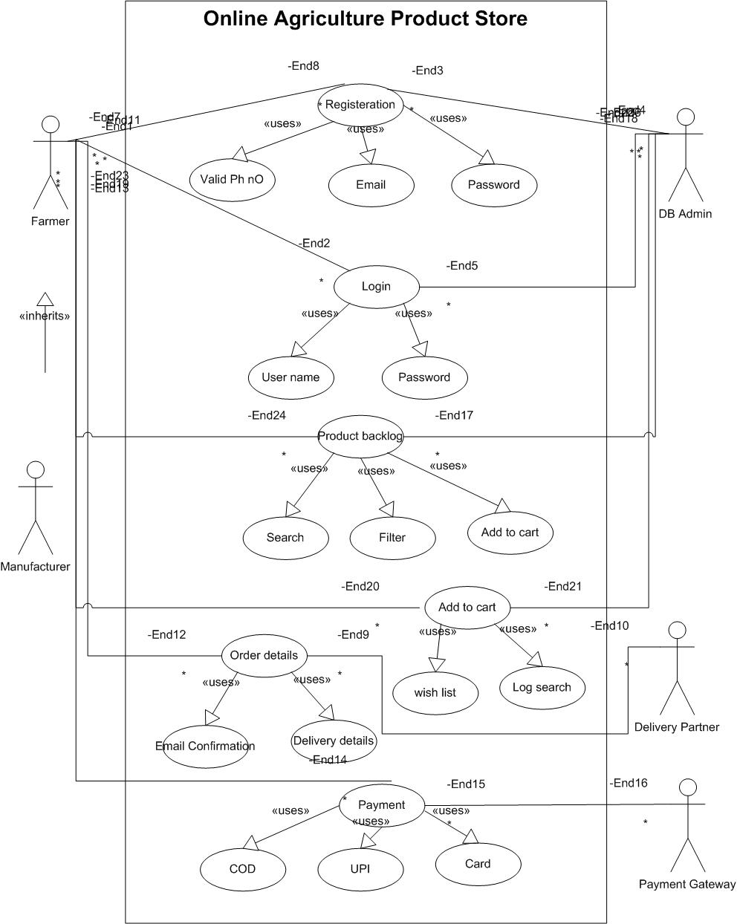

Question 11 – (minimum 5) Use Case Specs - 15 Marks
Prepare use case specs for all use cases
We create use cases to clearly show how users will interact with the system.They connect business requirements to real user actions step by step.Use cases help testers design test cases and avoid missing scenarios.They also let clients validate early that the system will meet their needs.

Use case spec 1 – New User Registration (BR004)
Actor(s)
Primary: New User (Farmer or Manufacturer)
Supporting/External: SMS/Email Service (for OTP)
Preconditions
User is not logged in.
Internet connection available.
Registration page is accessible.
Basic Flow (Happy Path)
User opens app/website and selects Create Account → Register.
System shows Registration form.
User enters First Name, Last Name, Mobile Number, Email, Password.
System validates the data (mandatory fields, formats, email uniqueness, password policy).
System sends OTP/verification link to the provided channel (SMS/Email).
User enters OTP / clicks verification link.
System verifies the OTP, creates the account, assigns role (Farmer/Manufacturer), and confirms “Account Created”.
Alternate / Exception Flows
A1 – Invalid Form Data (missing/invalid fields, weak password)
System shows error and highlights fields → user returns to Enter Details and resubmits.
A2 – Duplicate Email
System shows “Email already exists – login or reset password” → user may go to Login or change email and retry.
A3 – OTP Not Received / Expired / Incorrect
System shows OTP error → allow Resend OTP (rate-limited) or re-enter OTP → then continue to verification.
A4 – SMS/Email Service Unavailable
System shows friendly message; queue retry or ask user to try again later; form data is preserved.
Postconditions
Success: A verified user account is created; user can proceed to Login.
Failure: No account is created; user remains unauthenticated (errors logged).
Supplemental Requirements (Non-Functional & Rules)
Security: Hash & salt passwords; HTTPS only; OWASP validation; audit registration & verification events.
Password Policy: Minimum length/complexity; reject common passwords.
OTP Policy: Deliver within ~60s; TTL 2–5 minutes; max resend attempts with cooldown; single-use.
Performance/UX: Form submit/validate <2s; accessible labels/help text; clear error messages; preserve entered data on errors.
Compliance: Store consent for communications; protect PII; follow CSR governance.

Use case spec 2 – Secure Login (BR003)
Actor(s):
Primary: User (Farmer / Manufacturer / Admin / Store Manager)
Supporting/External: SMS/Email Notification Service (for OTP delivery)
Preconditions:
User is not currently logged in.
Internet connection is available.
For Email+Password: a verified account exists.
For Mobile+OTP: mobile number is linked to the account and OTP service is reachable.
Basic Flow (Happy Path)
User opens the Login page.
User selects a login method: Email+Password or Mobile+OTP.
If Email+Password:
3.1 Enter email ID and password.
3.2 System validates credentials.
If Mobile+OTP:
4.1 Enter mobile number.
4.2 System sends OTP to the number.
4.3 User enters the received OTP.
4.4 System validates OTP.
On successful validation (either method), the system creates an authenticated session.
System shows “Login successful” and redirects to the user’s landing page.
Alternate / Exception Flows
A1 – Incorrect Password
System shows “Incorrect password”; allow retry.
After N failed attempts, temporarily lock account; offer password reset.
A2 – Unregistered Email
System shows “Email not found”; suggest Register or Forgot Password.
A3 – OTP Not Delivered
System shows “OTP not received”; allow Resend OTP with rate limit.
A4 – Invalid/Expired OTP
System shows “Invalid/expired OTP”; allow re-entry or Resend (respect resend limits).
A5 – System/Network Error
Show friendly error; keep user data safe; allow retry.
Supplemental Requirements (Non-Functional & Rules)
Security:
Passwords hashed & salted; OWASP controls; HTTPS only.
Rate-limit login and OTP requests; CAPTCHA after repeated failures.
Account lockout after N failed attempts; audit trail for all auth events.
OTP Policy:
OTP TTL (e.g., 2–5 minutes); max resend attempts & cooldown; one-time use.
Session Management:
Secure cookies, HttpOnly/SameSite; idle timeout; explicit logout.
Performance & UX:
Login response under ~2 seconds under normal load; accessible (WCAG AA).
Clear error messages without exposing sensitive details.

Use case spec 3 – Browse & Search Catalog (BR005 + BR001)
Brief Description
A Farmer browses categories and searches for products (seeds, fertilizers, pesticides). Browsing does not require login.
Actors
- Primary: Farmer
- Supporting: System Catalog / Search Service (index), Analytics/Logging service
Preconditions
- Internet connection available.
- Products are approved/published in the catalog and indexed for search.
Basic Flow (Happy Path)
- Farmer opens app/website.
- System displays categories and featured products.
- Farmer enters a search term (and/or selects a category).
- System performs in parallel (fork):
  - 4a) Fetch results from catalog/index.
  - 4b) Log search (analytics, recent searches).
(join)
- System displays results (list/grid with price, rating, stock).
- Farmer may open Product Details (flow continues in “View Product Details”).
- Use case ends successfully.
Alternate / Exception Flows
- A1 – No Results: Show “No results found”, suggest similar keywords/categories, allow clear filters.
- A2 – Filter Conflict: Inform user that filters conflict; offer to reset or relax filters.
- A3 – Catalog Unavailable: Show friendly error and retry; log incident.
Postconditions
- Farmer has viewed product options and/or navigated to Product Details.
- Search query and interaction are logged (for analytics/relevance).
Business Rules & Notes
- Only approved/published products are visible.
- Sorting: relevance (default), price, rating; filters: price range, brand, rating, stock status, category.
- Respect language/locale for labels and units.
Supplemental Requirements (NFRs)
- First contentful paint ≤ 2.5 s on 3G/rural bandwidth.
- Search results: ≤ 2 s (cached) / ≤ 3 s (filtered).

Use case spec 4 – Manage Cart & Buy-Later (BR006)
BRIEF DESCRIPTION
This use case explains how a logged-in Farmer adds items to cart or to a buy-later list and manages quantities.
ACTORS
Farmer
Inventory subsystem (stock check)
Pre-Conditions
Farmer is logged in for purchase/buy-later persistence.
Products are available and approved.
Basic Flow
Use case begins when the Farmer clicks Add to Cart or Add to Buy-Later on a product.
System validates stock and selected quantity.
Cart is updated; totals (price, tax, shipping estimate) are recalculated.
Farmer can Update Qty / Remove / Move to Buy-Later.
Use case ends successfully.
Alternate Flow
Out of Stock – System displays: “Out of stock. Try lower quantity or similar products.”
Price/Stock Changed During Session – System prompts to accept updated price/qty before proceeding.
Guest User Adds to Cart – Cart is temporary; prompt to login to persist.
Post Conditions
Cart/buy-later lists reflect current selections and totals.
SUPPLEMENTAL REQUIREMENTS
Cart operations complete < 500 ms.
Do not reserve stock until order placement.
Tax/shipping estimates must follow configured rules by location.

Use case spec 5 – Place Order & Payment with Notifications (BR007 + BR008)
BRIEF DESCRIPTION
This use case explains how a Farmer checks out the cart, pays via COD/Card/UPI, and receives order confirmation emails/SMS.
ACTORS
Farmer
Payment Gateway (external)
SMS/Email System (external)
Delivery Partner (for later tracking linkage)
Pre-Conditions
Farmer is logged in with a non-empty cart.
Shipping address and serviceability validated.
Internet connection is available.
Basic Flow
Use case begins when the Farmer clicks Checkout.
System confirms address, delivery option/ETA, re-validates stock.
System calculates order total (items, taxes, shipping, discounts).
Farmer selects payment method (COD/Card/UPI).
System initiates payment with the Payment Gateway; receives success status/webhook.
System creates the Order, generates Order ID, and associates payment reference.
System sends notifications (email/SMS) with order confirmation and summary.
Use case ends successfully.
Alternate Flow
Payment Failure/Timeout – System shows error; Farmer can retry or choose another method. No order is created.
Stock Conflict at Checkout – System proposes adjusted quantity/substitutes; Farmer confirms or cancels.
Address Not Serviceable for COD – Hide COD; prompt to choose online payment.
Post Conditions
Successful – Order created with status “Confirmed/Processing”; notifications delivered.
Failure – No order created; cart remains; reason shown to Farmer.
SUPPLEMENTAL REQUIREMENTS
Checkout flow typically ≤ 60 s; idempotent order submission.
PCI-DSS scope minimised (no card storage; tokenization).
Email/SMS delivery target: ≥95% within 2 minutes; retries with backoff.
Full audit trail (who/when, payment reference, totals).

Question 12 – (minimum 5) Activity Diagrams - 15 Marks
Activity diagrams
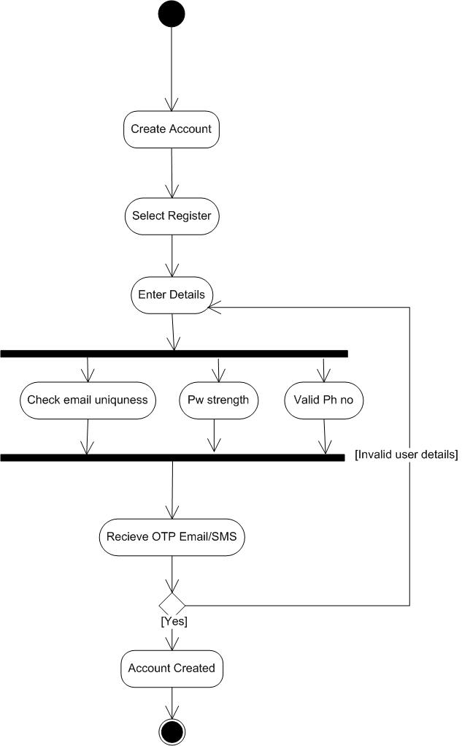

Figure 1-New Registration

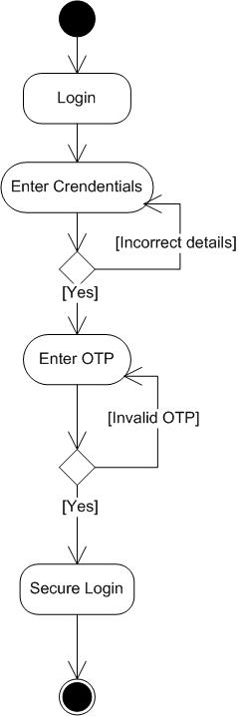

Figure 2-Secure Login

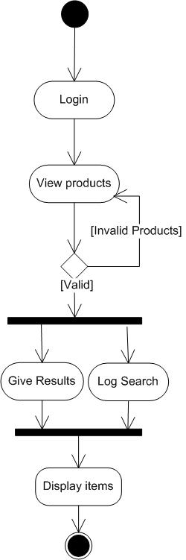

Figure 3-Browse & search

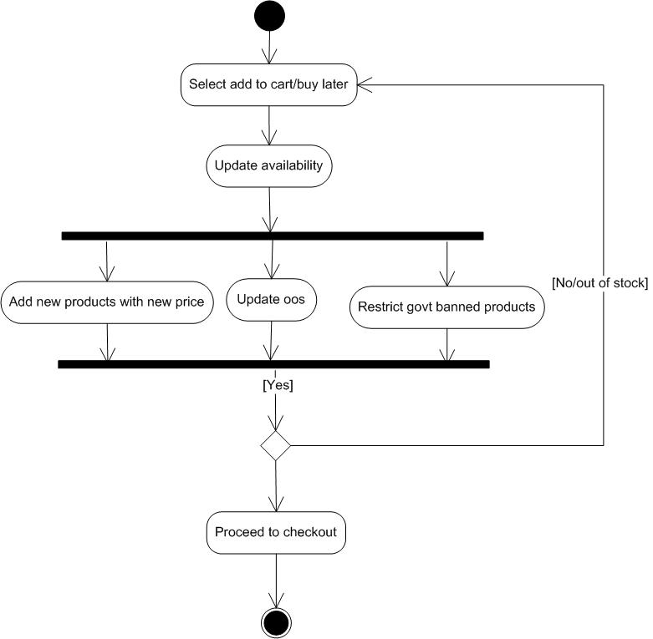

Figure 4- Add to cart

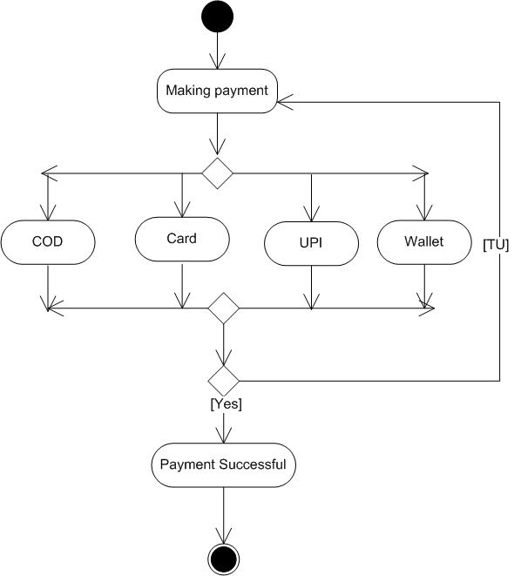

Figure 5-Payment

