PROJECT BESCOM
Author: Venkatesh Dhanana Date: 23-06-2025

Document 1: Definition of Done.
Project: BESCOM – Disconnection & Dismantling (D&D) Module
Partner: Fluentgrid Ltd.
Framework: Agile (Scrum)
Version: 1.0
Date: 23-06-2025
Prepared By: Venkatesh D.
1. Purpose
The purpose of this document is to define the Definition of Done (DoD) checklist agreed upon by the entire Agile team (developers, testers, architects, product owner and other stakeholders) to ensure the quality, completeness and readiness of all backlog items (user stories, sprints and releases) for the BESCOM D&D project.
This ensures that each completed backlog item is:
- Fully developed
- Properly tested
- Documented
- Reviewed
- Ready for deployment and stakeholder acceptance

2. DoD Checklist for a User Story
Criteria Type | Checklist Item
Functional Code | Produced working code for all expected functionalities
Business Validation | Assumptions and acceptance criteria of the user story are fully met
Build Verification | Code builds successfully without errors
Testing | Unit tests written and passing with coverage as per standards
Testing | Feature tested on all applicable devices/browsers (as per BESCOM assumptions)
Testing | QA testing completed and all critical/major bugs resolved
Testing | Feature verified against acceptance criteria
Testing | Regression testing done for impacted areas
UX & Design | UX review performed and approved by UX designer
Code Quality | Peer Code Review completed, feedback addressed
Code Quality | Refactoring completed (where applicable)
Environment Readiness | Deployed on staging/test environment identical to production
Documentation | Feature documentation (functional + technical) updated
Documentation | Any configuration or build-related changes documented
Stakeholder Approval | Product Owner has signed off

3. DoD for Sprint Completion
- All user stories in the sprint backlog meet the DoD checklist above.
- Sprint goals achieved as planned.
- Sprint Review conducted with stakeholders.
- Sprint Retrospective completed with improvement points captured.
- Sprint Burndown chart reflects work completion trend.
- No major unresolved defects in the sprint increment.
- Potentially shippable product increment is delivered.

4. DoD for Release
- All planned stories/features across sprints are accepted by Product Owner.
- Full system integration testing and UAT completed.
- All known critical and major bugs are fixed.
- Deployment scripts/configurations verified.
- Release documentation prepared and reviewed (User manual, deployment guide, etc.)
- Training materials shared with BESCOM users (if applicable).
- Release approved by BESCOM stakeholders for go-live.

5. Agreed By (Sign-Off Section)
Role | Name | Signature | Date
Product Owner (BESCOM)
Scrum Master
Project Manager
QA Lead
Development Lead
Business Analyst

Document 2: Product Vision.
Project Name: BESCOM – Disconnection & Dismantling (D&D) Module
Client: Bangalore Electricity Supply Company Limited (BESCOM)
Technology Partner: Fluentgrid Ltd.
Version: 1.0
Date: 23-06-2025
Prepared By: Venkatesh Dhanana

1. Vision Statement
To build a robust, user-friendly and scalable Java-based Disconnection & Dismantling (D&D) Module for BESCOM that automates and streamlines the process of identifying defaulting consumers, issuing notices, disconnecting and reconnecting services, dismantling inactive connections, and ensuring arrear recovery—while providing accurate reporting and complete transparency for decision-making and compliance.
2. Business Need
BESCOM currently uses an outdated SAP system which is not capable of supporting modern operational challenges. With increasing consumer demand, high default rates, and complex manual workflows, BESCOM faces delays, errors, and revenue loss. There is a critical need to upgrade the system to a more stable, flexible, and functional solution tailored to the Disconnection & Dismantling process.
3. Product Objectives
- Automate the identification of defaulting consumers using configurable rules.
- Generate and track payment notices efficiently.
- Enable seamless execution of disconnection, reconnection and dismantling processes.
- Ensure all arrears are recovered or appropriately transferred.
- Deliver detailed reports and dashboards for operational and financial insights.
- Support future scalability across all BESCOM zones.
- Reduce manual intervention, paperwork, and delays.
4. Target Users
- Field Officers – To perform disconnection, reconnection, and dismantling actions.
- Billing & Recovery Teams – To track notices, payments, and dues.
- BESCOM Management – To monitor defaulter trends, revenue leakage, and process efficiency.
- IT Admins – For managing infrastructure, configurations, and integrations.

5. Key Features
Feature | Description
Defaulter List Generation | Automated list creation based on payment history and rules.
Notice Issuance & Tracking | Generation of notices (SMS, email, print), with status tracking.
Disconnection Workflow | Initiation and completion of power disconnection activities.
Reconnection Workflow | Service restoration after payment confirmation.
Dismantling Process | Final service removal after prolonged non-payment.
Arrear Recovery & Transfer | Record management and dues transfer to linked accounts.
Reporting & Dashboards | Real-time reports for consumers, field activity, and revenue

6. Technical Scope
- Platform: Java (Spring Boot)
- Database: Oracle/PostgreSQL
- Architecture: Microservices-based (optional, if Fluentgrid supports)
- Integrations: Billing system, payment gateways, mobile app/field devices
- Deployment: Staging, UAT, and Production environments
7. Success Criteria
- 100% automation of D&D workflows in Bangalore Urban area.
- Accurate and timely generation of defaulter notices.
- At least 40–50% reduction in manual effort for BESCOM staff.
- No critical defects during UAT and Production.
- On-time delivery within 12 months.
- High adoption rate among field users and staff.
8. Assumptions
- Fluentgrid’s utility software base can be customized for BESCOM’s needs.
- Data access and legacy system support will be provided by BESCOM.
- Regulatory guidelines will remain stable throughout the project period.
9. Constraints
- Project must adhere to BESCOM's internal budget and timelines.
- Data migration from SAP may have limitations.
- Field staff may require training for new system adoption.
10. Dependencies
- Timely availability of BESCOM business users for UAT and feedback.
- Infrastructure setup by BESCOM or Fluentgrid.
- Integration support with existing billing/payment systems.
Product Vision – Scrum Format
Scrum Project:
Name: BESCOM – Disconnection & Dismantling (D&D) Module Implementation
Venue: Fluentgrid Ltd. – Project Collaboration Center / BESCOM Office / Hybrid (as per schedule)
Date:
Start Time: 20-6-2025
End Time: 19-6-2026
Duration: 12 Months
Client: Bangalore Electricity Supply Company Limited (BESCOM)
Stakeholder List:
- Mr. Kalyan, Chief Engineer – BESCOM Operations
- Mr. Venkat, IT Head – BESCOM
- Mr. Lokesh, Billing Head – BESCOM
- Mr. Prakash, Field Operations Supervisor – BESCOM
- Mr. Kishore, Product Manager – Fluentgrid Ltd.
- Mr. Naidu, Technical Architect – Fluentgrid Ltd.
Scrum Team
Scrum Master: Satya Rathnakar (Fluentgrid Ltd.)
Product Owner: Mr. [Name], Senior Business Analyst (representing BESCOM)
Scrum Developer 1: Ramesh P. – Java Developer
Scrum Developer 2: Anjali K. – Java Developer
Scrum Developer 3: Suresh T. – Backend Developer
Scrum Developer 4: Priya M. – Frontend Developer
Scrum Developer 5: Vinod R. – QA Engineer

Document 3: User stories
Epic 1: Defaulter Management
User Story 1.1: Generate Defaulter List
Priority: High
Value Statement:
As a billing officer,
I want to automatically generate a list of consumers who have pending dues beyond the due date,
So that I can initiate the disconnection notice process promptly.
BV: 1000 CP: 8
Acceptance Criteria:
- System filters consumers with outstanding bills.
- Defaulter list is exportable and saved in the system.
- List can be filtered by zone, sub-division, date or amount.

User Story 1.2: Update Defaulter Status
Priority: Medium
Value Statement:
BV: 100 CP: 2
As a recovery agent,
I want to update the status of a consumer in the defaulter list after payment is made,
So that disconnection is avoided for paying customers.
Acceptance Criteria:
- Manual and automatic status update options available.
- Audit trail maintained for updates.
- Confirmation alert shown upon update.

Epic 2: Notice Management
User Story 2.1: Generate Payment Notice
Priority: Medium
Value Statement:
As a BESCOM officer,
I want to auto-generate and send payment notices to defaulters,
So that consumers are officially informed and given time before disconnection.
BV: 50 CP: 8
Acceptance Criteria:
- Notices can be sent via SMS, email or print.
- Notice format is configurable.
- Delivery status is trackable.

User Story 2.2: Track Notice Acknowledgement
Priority: Low
Value Statement:
As a field officer,
I want to view which consumers have acknowledged the notice,
So that I can prioritize visits to non-responsive consumers.
BV: 10 CP: 5
Acceptance Criteria:
- Acknowledgement status is tracked per consumer.
- Dashboard view shows summary per zone.

Epic 3: Disconnection & Reconnection Workflow
User Story 3.1: Perform Service Disconnection
Priority: High
Value Statement:
As a field technician,
I want to receive a daily disconnection list on my mobile device / or hard copy from DISCOM,
So that I can efficiently perform disconnections as per the schedule.
BV: 1000 CP: 8
Acceptance Criteria:
- Technician view is filtered by assigned area.
- System logs disconnection date, readings, time and remarks.

User Story 3.2: Reconnect Service after Payment
Priority: High
Value Statement:
As a recovery officer,
I want to trigger a reconnection request once payment is received,
So that service can be restored quickly.
BV: 500 CP: 5
Acceptance Criteria:
- Payment verification is mandatory.
- Reconnection action is logged.
- Notification sent to consumer and technician.

Epic 4: Dismantling Process
User Story 4.1: Initiate Dismantling for Non-Payment
Priority: High
Value Statement:
As a supervisor,
I want to initiate a dismantling order after multiple failed recovery attempts,
So that the account can be closed and physical connection removed.
BV: 500 CP: 5
Acceptance Criteria:
- Consumer history is shown before dismantling.
- Final Bill is calculated and locked.
- Approval required before final dismantling.

Epic 5: Arrear Transfer
User Story 5.1 – Transfer Arrears to Live Service
Priority: Medium
Value Statement:
As a billing clerk,
I want to transfer unpaid arrears from a dismantled connection to a linked active account,
So that BESCOM can recover dues even if the original connection is removed.
BV: 100 CP: 2
Acceptance Criteria:
- System validates linked account.
- Transfer transaction recorded with remarks.
- Updated bill reflects arrear addition.

Epic 6: Reporting and Audit
User Story 6.1: Generate Disconnection Summary Report
Priority: Medium
Value Statement:
As a BESCOM manager,
I want to generate daily/weekly reports of disconnection and recovery activities,
So that I can review performance and plan actions.
BV: 100 CP: 2
Acceptance Criteria:
- Report exportable to Excel/PDF.
- Filters available by zone/date/user.
- Charts/visuals included for high-level review.

Document 4: Agile PO Experience
Agile Product Owner Experience Summary
As an Agile Product Owner with hands-on experience across domain-specific software solutions, I have successfully represented the voice of the customer and stakeholders, collaborated with cross-functional Scrum Teams, and ensured the delivery of high-value product increments. My role involved end-to-end responsibility for translating business needs into actionable user stories and prioritizing product backlogs to align with business goals and technical feasibility.
1. Key Responsibilities & Contributions:
- Market Analysis
- Conducted thorough market research to understand current demand trends, customer pain points, and emerging opportunities.
- Benchmarked similar industry products to identify differentiators and competitive advantages for positioning our solutions.
- Evaluated feasibility and impact of launching new modules such as Disconnection & Dismantling (D&D) for BESCOM and online food delivery for the Scrum Foods project.

- Enterprise Analysis
- Assessed market opportunities and business potential to justify investment in new feature development.
- Partnered with stakeholders to align product ideas with enterprise strategy and CSR objectives (e.g., BESCOM government collaboration, SOONY CSR initiative).
- Performed SWOT analysis and risk assessment to support product development viability.

- Product Vision & Roadmap
- Defined and articulated a clear, long-term Product Vision aligned with stakeholder goals, domain expertise, and market demand.
- Developed a Product Roadmap detailing high-level features and timelines for iterative delivery.
- Regularly communicated vision and roadmap updates to both internal teams and external stakeholders for alignment.

- Managing Product Features
- Collaborated with stakeholders to gather feature requests and prioritize them based on business value, technical feasibility, and ROI.
- Translated stakeholder needs into well-defined epics, capabilities, and user stories.
- Used prioritization techniques like MoSCoW, Kano Analysis, and Weighted Shortest Job First (WSJF).
- Managing Product Backlog
- Owned the product backlog, ensuring it was prioritized, refined, and ready for development.
- Broke down epics into actionable user stories with clear acceptance criteria.
- Reprioritized backlog items during grooming sessions based on feedback from end users, business changes, or development constraints.
- Coordinated with BAs and developers to ensure stories followed the INVEST principles.

- Managing Iteration Progress
- Actively participated in Sprint Planning, Daily Stand-ups, Sprint Reviews, and Retrospectives.
- Reviewed sprint progress regularly and realigned priorities as needed to ensure consistent delivery of value.
- Collaborated with Business Analysts to analyze sprint retrospectives and drive continuous improvement across sprints.

2. Sprint Ceremonies and My Involvement
- Sprint Planning Meeting
- Defined sprint goals and finalized high-priority backlog items for development.
- Collaborated with the Scrum Master and development team to break stories into tasks and estimate effort.
- Ensured clarity of acceptance criteria before sprint commitment.

- Daily Scrum Meeting
- Participated in daily stand-ups to track progress, unblock impediments, and synchronize efforts.
- Used updates to reassess priorities and manage scope changes in real time.

- Sprint Review Meeting
- Demonstrated completed features to stakeholders for feedback.
- Captured improvement suggestions and incorporated them into the product backlog.
- Evaluated sprint outcomes against defined objectives and metrics.

- Sprint Retrospective Meeting
- Reflected on sprint performance with the Scrum team to identify what went well and what could improve.
- Proposed actionable changes to improve the team’s productivity and collaboration in future sprints.

- Backlog Refinement (Grooming) Meeting
- Regularly reviewed and refined the product backlog to ensure stories were INVEST-compliant (Independent, Negotiable, Valuable, Estimable, Small, Testable).
- Adjusted priorities based on stakeholder feedback, sprint outcomes, and new business insights.

3. User Story Creation – Key Components
Each user story I created was structured to be clear, concise, testable and valuable. The format I followed included:
- Story Number:
- Unique identifier for each user story (e.g., US-101, US-102, etc.) to enable easy tracking and traceability.
- Tasks:
- Break-down of the story into manageable development or testing tasks.
- Tasks helped the team estimate effort and assign responsibility during sprint planning.
- Priority:
- Categorized as High, Medium, or Low based on urgency, business value, or stakeholder dependency.
- Prioritization was done collaboratively with stakeholders and based on ROI.
- Acceptance Criteria:
- Clear and testable conditions that defined when a story was considered complete.
- Used the Given–When–Then format to ensure understanding across BA, Dev, QA, and stakeholders.
- Business Value (BV):
- Numerical value assigned to the story based on the expected impact on business.
- Helped in decision-making when choosing stories for sprints with limited capacity.
- Complexity Points (CP):
- Story Points estimated by the development team using Planning Poker or similar technique.
- Helped in sprint planning to match total complexity with team velocity.

4. Vision & Market Understanding
- Developed a clear product vision rooted in my domain expertise and analysis of current market needs.
- Ensured the product addressed real-world problems and created tangible value for end-users and stakeholders.

5. Liaison between Stakeholders and Scrum Team
- Acted as the primary point of contact for business stakeholders, gathering evolving requirements and translating them into actionable insights for the Scrum team.
- Participated in regular stakeholder meetings to communicate product progress and gather continuous feedback.

6. Backlog Management & Feature Definition
- Defined product features based on stakeholder expectations and business goals.
- Broke down high-level features into well-structured Product Backlog Items (PBIs) such as epics and user stories.
- Maintained a prioritized backlog, balancing technical constraints, business urgency, and customer value.

7. Collaboration within Scrum
- Worked closely with Scrum team members (Scrum Master and Developers) in:
- Sprint Planning: Ensuring the team had a clear understanding of what needed to be built.
- Daily Scrums: Addressing any blockers or clarifications needed.
- Sprint Reviews: Reviewing completed work and gathering stakeholder feedback.
- Sprint Retrospectives: Helping identify improvement opportunities for future sprints.
- Backlog Refinement: Continuously refining and reprioritizing stories based on feedback and sprint progress.

Document 5: Product and sprint backlog and product and sprint burndown charts.
1. Product Backlog:
The Product Backlog is a dynamic, prioritized list of features, enhancements, fixes, and technical requirements that the product may need. It is maintained by the Product Owner.
Characteristics:
- Evolving and flexible (not static)
- Prioritized based on Business Value (BV), urgency, risk, and dependencies
- Each item is usually a User Story, Epic, or Task
- Items include Acceptance Criteria, Estimates, and Priority
Product Backlog Sample:
Story No. | User Story | Priority | BV | CP | Status
US01 | As an Admin, I want to generate a list of defaulting consumers | High | 500 | 8 | Ready
US02 | As a User, I want to issue notice to defaulters via system notifications | High | 50 | 5 | Ready
US03 | As a Field Agent, I want to update disconnection status from field | Medium | 100 | 5 | In Refinement
US04 | As a Supervisor, I want to verify reconnection requests | Medium | 100 | 3 | Not Started
US05 | As an Admin, I want to dismantle connection data and close accounts | High | 500 | 8 | Ready
US06 | As a Finance Officer, I want to transfer arrears to linked active services | Medium | 100 | 5 | Ready
US07 | As a Manager, I want detailed reports of disconnections and arrear recoveries | Medium | 20 | 3 | In Refinement

2. Sprint Backlog
The Sprint Backlog is a subset of the Product Backlog. It includes all items selected for a specific sprint plus the plan for delivering them. Owned by Scrum Team.
Characteristics:
- Created during the Sprint Planning Meeting
- Contains user stories, tasks, and estimated effort
- Can be updated daily
- Shows the team’s commitment for the sprint
Sprint Backlog Sample (Sprint 1 - 2 Weeks):
Story No. | User Story | Task(s) | Status
US01 | Generate list of defaulters | Design UI, Build logic, Validate inputs | In Progress
US02 | Issue notice to consumers | Backend API, Notification template, Integration | To Do
US05 | Dismantle connection & close account | DB update, UI validation, Trigger final notice | To Do

3. Sprint Burndown Chart
The Sprint Burndown Chart shows the daily progress of the team during a sprint, tracking how much work remains to be completed.
Tracks:
- X-axis: Days in the sprint
- Y-axis: Remaining effort (e.g., hours or story points)
Usefulness:
- Helps monitor team progress
- Shows if the team is on track to complete sprint goals
- Early warning of risks or impediments

Here is the Sprint Burndown Chart for a 1-week sprint (5 working days) with 5 story points. It visualizes the team's daily progress:

Sprint Burndown Char derived from Jira:
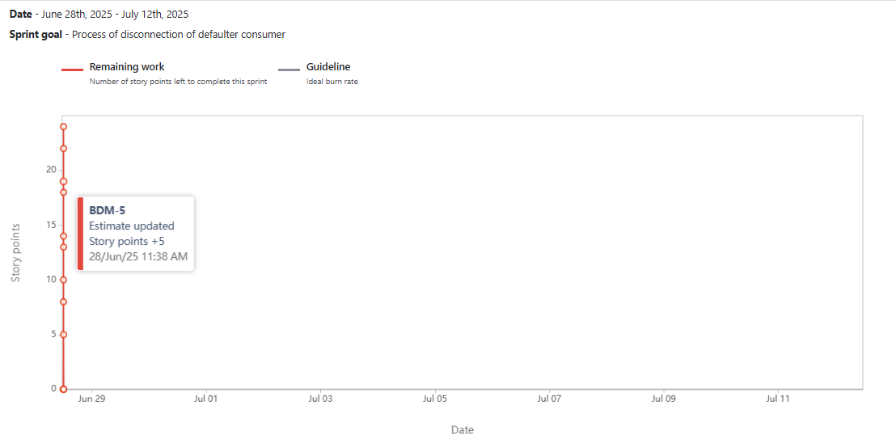

4. Product Burndown Chart
The Product Burndown Chart visually shows progress toward completing the entire Product Backlog.
Tracks:
- X-axis: Sprints or Time
- Y-axis: Remaining effort (e.g., Story Points)
Usefulness:
- Tracks overall product progress
- Helps to know project completion
- Highlights scope creep or work completion trends
Below is the Product Burndown Chart showing the ideal vs. actual progress of story points across 10 sprints. The ideal burndown line represents how work should progress in theory, while the actual burndown line shows real sprint completion. This helps track whether the team is ahead, on track or behind schedule.
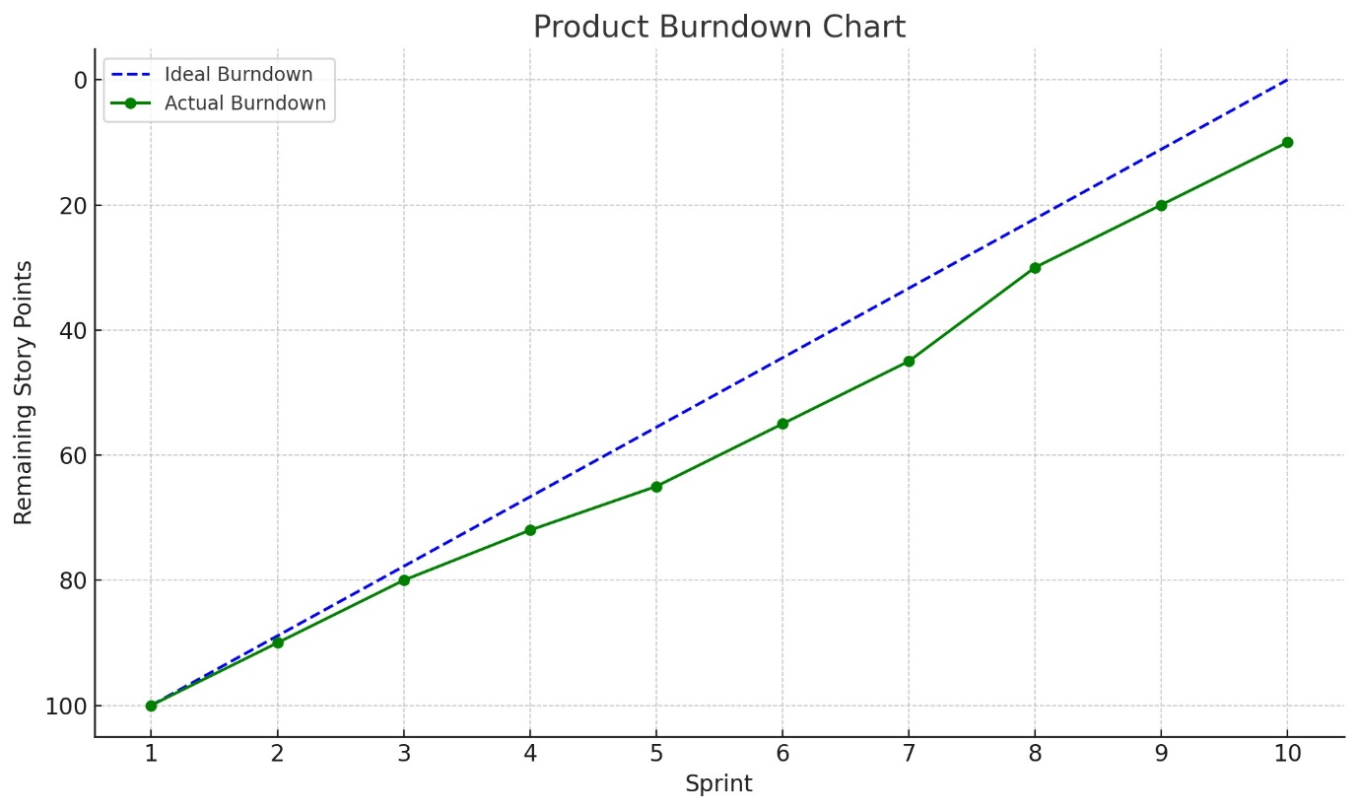

Document 6: Sprint meetings
Meeting Type 1: Sprint planning meeting - Overview
The Sprint Planning Meeting is the first ceremony in the Scrum framework that marks the beginning of a new sprint. It sets the tone, direction and expectations for the work to be done in the upcoming sprint (typically 1 to 4 weeks).
Purpose of Sprint Planning
- Define the Sprint Goal
- Select and commit to user stories from the Product Backlog
- Break down selected stories into tasks
- Estimate the effort and assign responsibilities
Sprint planning meeting
Meeting Type | Sprint Planning Meeting
Date | 24-June-2025
Time | 10:00 AM – 11:30 AM IST
Location | Fluentgrid-BESCOM Project Conference Room / MS Teams
Prepared By | Venkatesh D (Product Owner)
Attendees | Product Owner, Scrum Master, Development Team, QA Team, Solution Architects

Agenda Topics
Topic | Presenter | Time Allotted
Project and Sprint Goals | Product Owner | 10 mins
Review of Product Backlog | Scrum Master | 15 mins
Selection of User Stories for Sprint | Entire Scrum Team | 30 mins
Task Breakdown for Selected Stories | Developers, QA | 20 mins
Capacity Planning & Estimation | Scrum Master, Dev Team | 10 mins
Definition of Done (DOD) Confirmation | Product Owner, QA Lead | 5 mins

Observers
- Mr. Rajesh (BESCOM IT)
- Ms. Meena (Fluentgrid PMO)
Resources
- JIRA board with prioritized product backlog
- Definition of Done checklist
- Team availability sheet
- Historical velocity chart
- Sprint goal reference document
Special Note
- Ensure each team member commits to the Sprint Goal.
- Add buffer for unplanned backlog refinement if needed.
- Update JIRA immediately after the meeting.

Meeting Type 2: Sprint review meeting
The Sprint Review Meeting is a crucial event in the Scrum framework held at the end of each Sprint. Its primary purpose is to inspect the increment, gather feedback, and adapt the product backlog based on the delivered work.
Purpose of Sprint Review
- Demonstrate what was done during the sprint
- Get feedback from stakeholders
- Discuss what went well, what problems occurred, and how they were resolved
- Review the current state of the product and update the product backlog accordingly

Sprint Review Meeting – Template
Field | Details (Fill As Applicable)
Date | [Insert Date]
Time | [Insert Time]
Location | [Insert Location or "Virtual"]
Prepared By | [Your Name or Scrum Master]
Attendees | Product Owner, Scrum Master, Scrum Team, Stakeholders

Sprint Status
- Sprint Goal: [State the original goal of the sprint]
- Planned vs. Delivered:
  - Planned User Stories: [X]
  - Delivered User Stories: [Y]
  - Velocity Achieved: [Z Story Points]

Things to Demo
- [Feature 1 Name] – [Short Description]
- [Feature 2 Name] – [Short Description]
- [Bug Fixes / Enhancements] – [If any]
- [Screenshots or links, if remote]

Quick Updates
- Any blockers faced and how they were resolved
- Feedback from QA or Stakeholders during the sprint
- Any technical innovations, code optimizations, or refactors done

What’s Next
- Items to be carried over to the next sprint (if any)
- Stakeholder feedback to be incorporated
- Grooming sessions to refine upcoming backlog items
- Preparing for next Sprint Planning

Meeting Type 3: Sprint retrospective meeting
A Sprint Retrospective is the final ceremony in a Scrum sprint, conducted after the Sprint Review and before the next Sprint Planning. The goal is to reflect on the sprint, identify improvements, and plan actionable changes for the next iteration.
Purpose:
To continuously improve team performance by discussing:
- What went well during the sprint
- What didn’t go well
- What could be improved
- What actionable steps can be taken to enhance the next sprint

Date: 23-June-2025
Time: 4:00 PM – 5:00 PM IST
Location: Conference Room B / Zoom (if virtual)
Prepared By: Product Owner
Attendees:
- Scrum Master: Satya Rathnakar
- Product Owner: Venkatesh D
- Scrum Developers: Linesh Vegad, Yogender, Gowri, A. Lakshmikala, Madhuri, Varun, Rakesh, Rajesh
Agenda:
- Introduction & Objective of Meeting.
- Review Sprint Goal and Outcome
- Discuss:
  - What went well
  - What didn’t go well
  - What can be improved
- Action Items for Next Sprint
- Close Meeting
What Went Well:
- Completed 100% of committed user stories
- Minimal defects raised during QA
- Collaboration between developers and testers was smooth
- Daily Scrum was punctual and effective
What Didn’t Go Well:
- User story acceptance criteria were not clear in one case
- Delay in environment setup impacted early testing
- Two developers were overloaded due to task imbalance
Questions Raised:
- Can we schedule backlog grooming earlier in the sprint?
- How can we improve clarity in acceptance criteria?
- Should we assign a backup developer for each critical module?
References:
- Sprint Board on JIRA Links
- Previous Retrospective Notes

Meeting Type 4: Daily Stand-up meeting
The Daily Stand-up Meeting is a 15-minute time-boxed event held every day of the Sprint, where the Scrum Team synchronizes and plans for the next 24 hours. Its main goal is to inspect progress, identify blockers and ensure transparency.
Participants:
- Scrum Master (Facilitator)
- Scrum Developers (Primary speakers)
- Product Owner (Optional attendance)
- Observers (e.g., stakeholders – only observe, not speak)
When and Where:
- Frequency: Daily
- Duration: 15 minutes max
- Timing: Usually held at the same time and place every day
- Mode: In-person, remote, or hybrid (based on team setup)
Key Questions Asked:
Each team member answers these three questions:
- What did I do yesterday that helped the development team meet the sprint goal?
- What will I do today to help the development team meet the sprint goal?
- Do I see any impediments that prevent me or the team from achieving the sprint goal?
Benefits:
- Promotes team alignment and communication
- Enables early detection of issues or blockers
- Encourages collaboration and accountability
- Keeps the Sprint Goal visible to all
- Helps the Scrum Master identify and remove impediments quickly

Daily Stand-up Tracker
Week 1 (from DD-MM-YYYY to DD-MM-YYYY)
Scrum Team: Project Name
Facilitated By: Scrum Master
Time: Daily (15 minutes max)
Location: Online/Office (specify)
Name / Role | Day | Q1: What did you do yesterday? | Q2: What will you do today? | Q3: Any blockers?
Developer 1 | Monday
Developer 2 | Monday
Developer 3 | Monday
Developer 1 | Tuesday
Developer 2 | Tuesday
Developer 3 | Tuesday
Developer 1 | Wednesday
Developer 2 | Wednesday
Developer 3 | Wednesday
-------- | ---------
-------- | ---------

