Document 6 – Use Case Diagram, Activity Diagram & Use Case Specification
Project/Domain: ICS Global Proxy Services (Broadridge)
Internal Tool: MOCHA MAINFRAME (Screens 400 & 10)
Primary Use Case: Update Meeting Information (as per client request)
Context & Scope
Problem Statement: Client requests changes to corporate meeting data (e.g., Meeting Date, Record Date, Meeting Type, Location, Meeting Time, Event ID). Operations/BA team updates the details using MOCHA MAINFRAME, with validations, audit logging, and notifications.
In Scope: Editing and saving meeting attributes on MOCHA screens; validation; audit trail; submission for approval (if applicable); notifications.
Out of Scope: Upstream data ingestion, downstream vote processing, external issuer communications.
Use Case Diagram

Activity Diagram
Use Case Specification
1. Use Case Name
Update Meeting Information
2. Use Case Description
This use case describes how a Business Analyst (BA) updates meeting-related information (e.g., Meeting Date, Record Date, Meeting Type, Location, Meeting Time, and Event ID) in the MOCHA Mainframe system based on client requirements.
3. Actors
- Primary Actor: Business Analyst (BA)
- Secondary Actors: MOCHA Mainframe System (internal product), Client (requestor of changes)
4. Basic Flow
- Client sends a request to update meeting details.
- BA logs into the MOCHA Mainframe system (Screen 400 / Screen 10).
- BA navigates to the meeting information section.
- BA updates the required meeting fields (e.g., Meeting Date, Record Date, Event ID).
- System validates the entered data (format, mandatory fields).
- BA saves the changes.
- System updates the database and confirms success.
- BA notifies the client of the update completion.
5. Alternate Flow
- Partial Update: If the client requests changes to only selected fields (e.g., only Location), BA updates those specific fields while keeping others unchanged.
- Client Cancels Request: If the client cancels before BA updates, the request is closed without any changes
6. Exceptional Flows
- Invalid Data: If the BA enters an invalid format (e.g., incorrect date), the system rejects the input and prompts for correction.
- System Unavailable: If MOCHA Mainframe is down, the BA cannot proceed, and the request is deferred.
- Missing Mandatory Fields: If Event ID or Meeting Date is missing, the system prevents saving.
7. Pre-Conditions
- BA must have valid login credentials to access MOCHA Mainframe.
- Client request for changes must be documented and approved.
8. Post-Conditions
- Meeting details are successfully updated in MOCHA Mainframe.
- Audit logs are maintained for tracking changes.
- Client is informed of update status.
9. Assumptions
- Client provides accurate and complete meeting details.
- BA has the necessary permissions to update meeting information.
10. Constraints
- Updates must follow regulatory and compliance guidelines.
- Changes are allowed only during the deadline dates.
11. Dependencies
- Availability of MOCHA Mainframe system.
- Dependency on client-provided data (Meeting Date, Record Date, etc.).
- Database connectivity for saving changes.
12. Inputs and Outputs
- Inputs: Meeting Date, Record Date, Meeting Type, Location, Meeting Time, Event ID.
- Outputs: Updated meeting record in MOCHA Mainframe and confirmation notification.
13. Business Rules
- Meeting Date cannot be earlier than Record Date.
- Event ID must be unique and mandatory.
- Location must follow predefined formats (e.g., city/country or virtual mode).
- All updates must be logged for audit and compliance.
14. Miscellaneous Information
- This use case applies to internal BA activities within Broadridge.
- Security policies (password protection, access rights) must be enforced.
- Training may be provided to new BAs for handling MOCHA Mainframe updates.
Document 7- Screens and pages
using balsamic
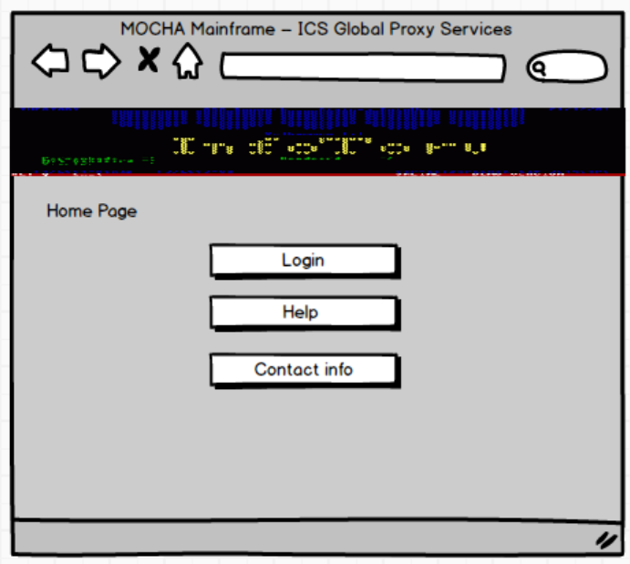
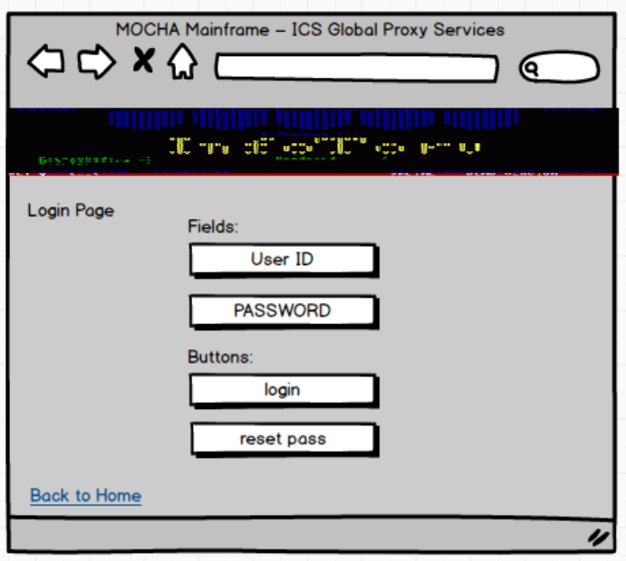
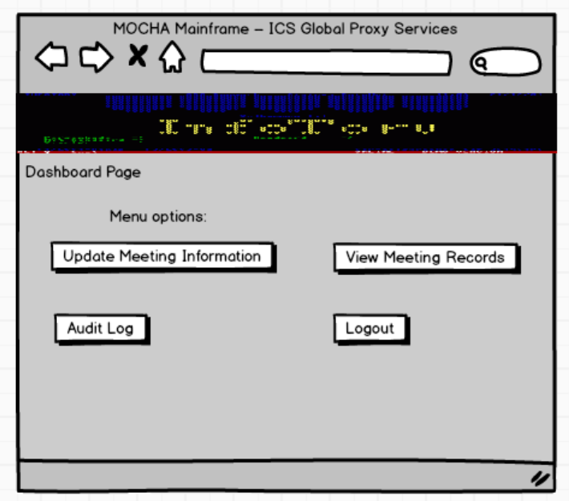
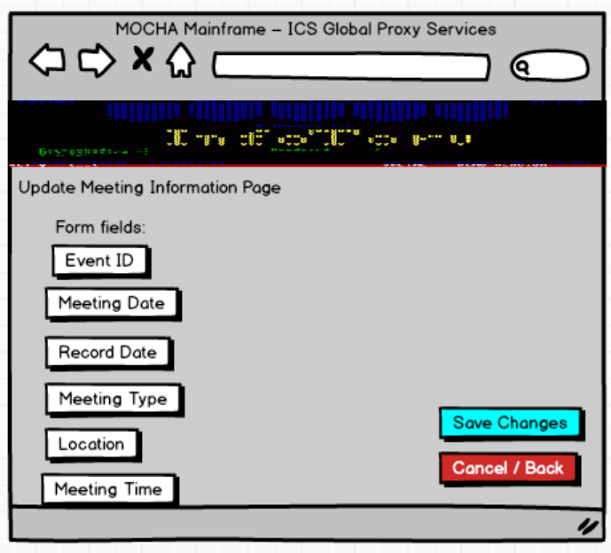
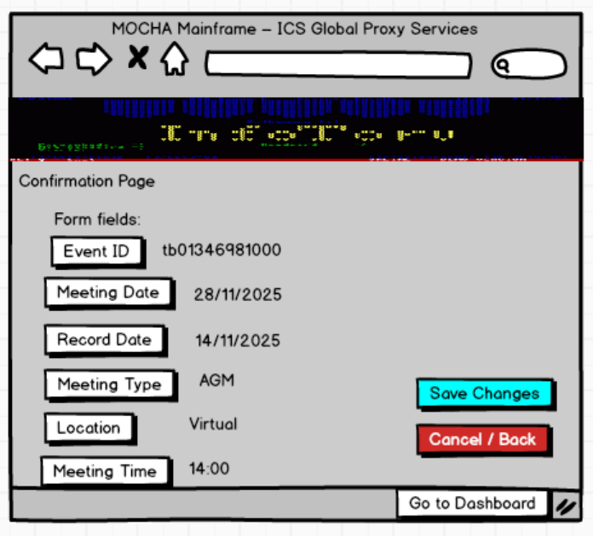
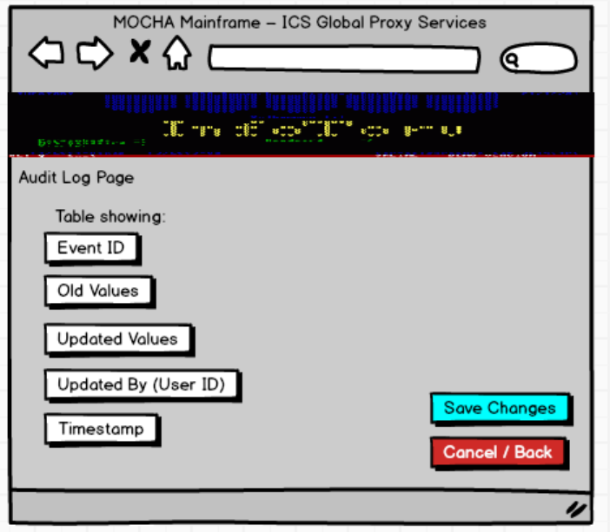
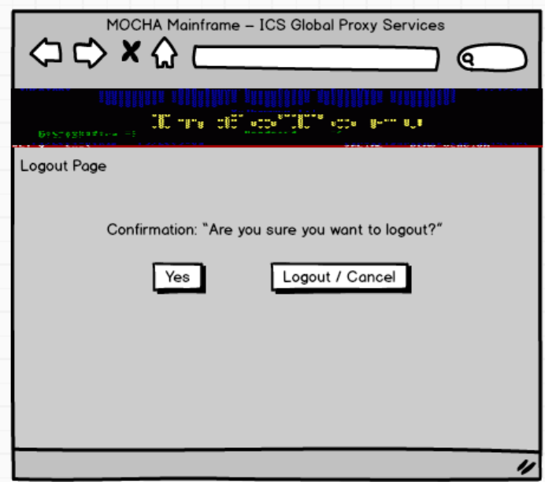
Document 8- Tools-Visio and Axure
As part of the ICS Global Proxy Services project, I utilized Microsoft Visio and Axure RP to support different aspects of requirements gathering and design. Visio was primarily used to create process flow diagrams, activity diagrams, and use case diagrams, which helped in visualizing the “as-is” and “to-be” workflows in MOCHA Mainframe. These diagrams made it easier to communicate complex processes with stakeholders and ensure alignment before moving to the development stage. On the other hand, Axure RP was used to design interactive mock-ups and wireframes of the MOCHA Mainframe screens such as login, dashboard, and meeting information update forms. Axure allowed me to simulate user interactions and demonstrate how different meeting fields (Meeting Date, Record Date, Event ID, etc.) would be updated in the system. This combination of tools improved clarity, reduced misunderstandings, and accelerated stakeholder approvals during the project lifecycle
Document 9- BA experience
My experience as BA in following phases:
1. Requirement Gathering Phase
- As a Business Analyst in the ICS Global Proxy Services project, my primary responsibility was to elicit and validate requirements effectively
- For prioritization, we followed the MoSCoW technique (Must have, Should have, Could have, Won’t have), which ensured that critical requirements were captured first
- During this phase, the client was unavailable for certain periods, so I proactively identified and coordinated with alternate points of contact from the client’s side to avoid delays
- Once requirements were collected, I validated them using the FURPS technique (Functionality, Usability, Reliability, Performance, and Supportability) to ensure quality and completeness
- I also identified duplicate or repeated requirements and removed them promptly to maintain a clean and accurate backlog
- To help stakeholders visualize requirements more clearly, I used prototyping techniques, creating mock-ups of MOCHA Mainframe screens (e.g., Meeting Date, Record Date, Event ID fields).
- This gave the client a better understanding of the system behaviour and helped refine requirements before moving to the design stage
2. Requirement Analysis:
- Created UML diagrams (Use Case, Class Diagrams) to visually describe requirements
- Designed Activity Diagrams to capture the end-to-end process flow for meeting information updates
- Communicated diagrams with the development and QA teams for validation and clarity
- Collected feedback from team members; if there were disagreements or suggestions, considered them and updated diagrams accordingly
- Prepared Business Requirements Specification (BRS) to capture high-level business needs
- Prepared System Requirements Specification (SRS) to define detailed functional and non-functional requirements
- Ensured all requirements were clear, unambiguous, and aligned with the business goals
3. Design:
- Derived test cases from use case diagrams to ensure coverage of all functional requirements
- Actively communicated with the client to review design and solution documents for validation
- Prepared both positive and negative test cases to capture all possible system behaviours
- Ensured that no test case was missed, as even a small gap could have a major impact on later stages of development
- Created test data sets to be used during the testing phase
- Maintained and updated the Requirements Traceability Matrix (RTM) to confirm that all requirements were mapped to corresponding test cases and fully covered
4. Development:
- Conducted Joint Application Development (JAD) sessions with the technical team and stakeholders
- Clarified queries raised by the technical team during the coding phase to avoid blockers
- Managed conflicts by addressing non-cooperative team members through one-on-one discussions, explaining the project impact, and maintaining a healthy working environment
- Referred to UML and activity diagrams to guide developers in coding specific units
- Organized regular meetings with the technical team and client to ensure alignment
- Handled challenges such as team members missing meetings by recording sessions and conducting follow-up discussions with the missed participants
5. Testing:
- Prepared test cases based on use case scenarios to ensure full functional coverage
- Performed high-level testing to validate end-to-end business workflows
- Collected or requested test data from the client to simulate real scenarios
- Updated the Requirements Traceability Matrix (RTM) to confirm that all requirements were tested
- Obtained formal sign-off from the client once testing results were validated
- Prepared the client team for User Acceptance Testing (UAT) by explaining processes, test data, and expected outcomes
6. Deployment:
- Forwarded the Requirements Traceability Matrix (RTM) to the client, which was attached to the Project Closure Document
- Coordinated with the team to complete and share End-User Manuals for smooth system adoption
- Planned and organized training sessions for end users to ensure they understood the new system
- Ensured all participants attended training sessions by sending reminders and following up with absentees

