Dairy Lite

BRD
  - Business Requirement Document

DAIRY LITE
DLT1025
V1.0
Business Analyst – Chetan Ambadkar

Contents
1. Document Revision …………………………………………………………………………………………….……………..…….4
2. Approvals…………………………………………………………………………………………………………………………..……..4
3. RASCI Chart for this document………………………………………………………………………………………………..…5
Code used in RASCI Chart…………………………………………………………………………………………..………….….5
RASCI Chart……………………………………………………………………………………………………………….…..………….5
4. Introduction………………………………………………………………………………………………………………….………..….6
4.1. Business Goals……………………………………………………………………………………………………………………….7
4.2. Business Objectives……………………………………………………………………………………………………………….7
4.3. Business Rules……………………………………………………………………………………………………………………….8
4.4. Background…………………………………………………………………………..……………………………………………….6
4.5. Project Objective…………………………………………………………………..……………………………………………….6
4.6. Project Scope………………………………………………………………………..……………………………………………….6
4.6.1 In Scope Functionality…………….……………………………………..……………………………………………….6
4.6.2 Out Scope Functionality …………………….………………………..…….……………………….…………………6
5. Assumptions………………………………………………………………………………………………………….……………………8
6. Constraints……………………………………………………………………………………………………………….………..………8
7. Risks………………………………………………………………………………………………………………………….……….………8
Technological Risks………………….…………………………………………………………………………………….……………..9
Skills Risks………………………………………………….………………………………………………………………….……………...9
Political Risks…………………………………………………………..…………………………………………………….………………9
Business Risks…………………………………………………………………….………………………………………….……………...9
Requirements Risks………………………………………………………………………………………………………….……………9
Other Risks………………………………………………………………………………………………………………………….…………9
8. Business Process Overview…………………………………………………………………………………………….…………10
8.1. Business Process Overview………………………………………….………………………………………….………10
8.2. Business Process Overview………………………….…………………………………………………………………10

9. Business Requirements………………………………………………………………………..………………………………….11
10. Appendices…………………………………………………………………………………..………..…………………………….…11
10.1 List of Acronyms…………………………………………..……………………………………………..……………….…11
10.1 Glossary of Terms………………………………………………………………………………………..……………….…11
10.1 Related Documents……………………………………………………………………………………..……………….…11

1. Document Revision

Date | Version Number | Document Changes
06/10/2025 | 1.0 | Initial Draft
08/10/2025 | 1.1 | Update Project Scope and Business Objectives

2. Approvals

Role | Name | Title | Signature | Date
Project Sponsor | Mr. Mike | Project Sponsor |  | 07/10/2025
Business Owner | Mr. Salton | Business Owner |  | 07/10/2025
Project Manager | Mrs. Vedika | Project Manager |  | 07/10/2025
System Architecture | Mrs. Sanvi | System Architecture |  | 07/10/2025
Development Lead | Mr. Rushikhesh | Development Lead |  | 07/10/2025
User Experience Lead | Mr. Sanket | User Experience Lead |  | 07/10/2025
Quality Lead | Mr. Brok | Quality Lead |  | 07/10/2025
Content Lead | Mrs. Neharika | Content Lead |  | 07/10/2025

3. RACI Chart for This Document

Name | Position | * | R | A | S | C | I
Mrs. Vedika | Project Manager |  | R | A |  | C | I
Mr. Chetan | Business Analyst |  | R |  |  | C | I
Mr. Rushikesh | Senior Developer |  | R |  | S | C | I
Mr. Surya | Developer |  | R |  | S | C | I
Mrs. Dahika | Developer |  | R |  | S | C | I
Mr. Dhiraj | Tester |  | R |  | S | C | I
Mr. Suraj | Network Admin |  | R |  | S | C | I
Mr. Pratik | DB Admin |  | R |  | S | C | I
Mr. Piyush | Warehouse Manager |  | R |  |  | C | I
Mrs. Pooja | Inventory Supervisor |  | R |  |  | C | I
Mr. Roshan | Delivery Coordinator |  |  |  |  | C | I
Mr. Saurabh | Operations Head |  |  | A |  | C | I
Mr. Mike | Senior Management | * |  | A |  |  | I

4. Introduction

4.1. Business Goals

The goal of the Dairy Lite project is to build a centralized digital system that automates the management of ice-cream and milk products across all manufacturing plants and warehouses. Currently, the company faces issues like stock mismatch, delayed deliveries, and manual tracking of inventory. The new system will simplify daily operations by tracking stock levels, monitoring product expiry, and managing warehouse distribution digitally. It will help ensure that every order is fulfilled quickly from the nearest location, reducing time and cost. This transformation will improve efficiency, reduce wastage, and enhance customer satisfaction with timely delivered product.

Need:
- Replace manual stock registers with digital inventory management.
- Track product batches, expiry, and movement across warehouses.
- Ensure faster delivery through nearest warehouse mapping.
- Maintain real-time stock visibility for all plants and warehouses.
- Reduce wastage and improve supply chain efficiency.
- Increase customer satisfaction through timely and accurate deliveries.

4.2. Business Objectives

- To create a digital system for managing ice-cream and milk product inventory across all warehouses.
- To reduce manual work by automating stock updates, product tracking, and order processing.
- To maintain real-time visibility of available products, batches, and expiry dates.
- To ensure fastest delivery by assigning orders to the nearest warehouse automatically.
- To provide managers with dashboards for monitoring sales, stock, and delivery performance.
- To improve coordination between production, warehouse, and delivery teams using a single platform.
- To increase overall customer satisfaction by delivering fresh products quickly and accurately.

4.3. Business Rules

Policies:
- All inventory data (milk, cream, and ice-cream stock) must be recorded and updated in the system daily.
- Each warehouse must maintain accurate records of production, stock movement, and product expiry.
- Customer and vendor information must be stored securely and used only for official business purposes.
- Only authorized staff can approve stock dispatch, delivery schedules, or returns.
- All operations must follow company hygiene and food safety standards like fessai.
Procedures:
- Products will be tracked using batch numbers and expiry dates for effective stock rotation.
- Reorder alerts must be generated automatically when stock reaches minimum level.
- Delivery assignments will be auto-suggested based on warehouse proximity to customer.
- Daily reports will be generated for management review showing stock levels and dispatch details.
- All damaged or expired items must be recorded before disposal and approved by the manager.
Rules & Regulations:
- Access to the system will be role-based (Admin, Inventory Staff, Delivery Manager, etc.).
- All transactions (stock in/out, delivery updates) must be logged for audit tracking.
- Reports must be reviewed weekly to ensure data accuracy.
- The system must comply with government guidelines for dairy and frozen product handling.

4.4. Background
- The company produces ice-cream and milk products and manages multiple manufacturing plants and warehouses across the country.
- Currently, inventory and delivery tracking are handled manually using Excel sheets and registers, causing frequent errors and stock mismatches.
- Manual monitoring of expiry dates and product movement leads to wastage and late deliveries.
- Managers face difficulty in getting real-time updates on stock availability and warehouse performance.
- Customers experience delivery delays due to lack of coordination between production and logistics teams.
- To solve these issues, the company initiated the Dairy Lite project to automate inventory and delivery operations.

4.5. Project Objective
- To develop a centralized system that manages inventory, production, and delivery of ice-cream and milk products digitally.
- To replace manual stock tracking with automated tools for real-time visibility across all plants and warehouses.
- To ensure timely replenishment and reduce wastage by monitoring product batches and expiry dates.
- To speed up customer deliveries by assigning orders to the nearest warehouse automatically.
- To provide managers with dashboards for tracking daily production, stock movement, and delivery status.
- To enhance coordination between production, warehouse, and delivery teams through a single integrated platform.
- To increase efficiency, reduce errors, and achieve higher customer satisfaction through faster and accurate service.

4.6. Project Scope
- To develop a centralized digital system to manage ice-cream and milk product inventory efficiently.
- To replace manual tracking with automated tools for production, stock, and warehouse management.
- To ensure faster customer delivery through automatic warehouse selection based on location.
- To maintain real-time visibility of stock, batch, and expiry details across all plants.
- To generate reports and dashboards for management to monitor sales, wastage, and productivity.
- To reduce manual errors, improve coordination, and achieve faster decision-making through digital transformation.

4.6.1 In Scope Functionality
- Digital entry of daily stock for milk, ice-cream, and other dairy products in all warehouses.
- Batch and expiry date tracking system for quality and freshness control of all products.
- Automatic reorder alert when stock quantity reaches the minimum limit in any warehouse.
- Centralized dashboard showing total production, available stock, and pending deliveries in real time.
- Delivery module for assigning customer orders to the nearest warehouse automatically.
- Role-based user access for admin, warehouse staff, and delivery managers for secure operation.
- Daily and monthly reports generation for production, wastage, and delivery performance review.
- Return and wastage management module for handling expired or damaged products properly.

4.6.2. Out Scope Functionality
- Online order booking or payment processing by customers is not part of this project phase.
- Integration with third-party ERP or logistics tracking systems will not be implemented currently.
- AI-based demand forecasting or automatic delivery route optimization features are excluded for now.
- Mobile application for customers or delivery staff will not be developed in this version.
- Automatic SMS or email alerts for delivery updates are not included in this project phase.
- Multi-language interface support will not be part of the current software version.
- Billing, invoice generation, and accounting modules are not included in the present implementation.

5. Assumptions
- All plants and warehouses will have stable internet connections to access the Dairy Lite system smoothly.
- Required hardware and software will be available before implementation starts in all project locations.
- Employees will attend training sessions and adapt quickly to the new digital inventory system.
- Stock data entered by warehouse staff will be accurate and updated regularly in the system.
- Management will provide continuous support and timely approvals during each project phase.
- System requirements and scope will remain stable without major changes during the development process.
- Sufficient budget and skilled team members will be available throughout the entire project timeline.
- Delivery staff will follow digital instructions generated by the system for route and warehouse selection.

6. Constraints
- The project must be completed within six months, including design, development, and testing phases.
- The total project budget is limited to ₹15,00,000, covering software, training, and basic infrastructure.
- Only a limited number of developers and testers are available, which may affect task speed.
- The system will run only on approved technologies defined by the company’s IT policy.
- Integration with external systems or third-party software will not be possible in this version.
- Any delay in training sessions may affect staff readiness and system adoption timeline.
- Data migration from old Excel files and registers may take additional manual effort.
- System performance depends on server capacity and network stability across all warehouse locations.

7. Risks
7.1. Technological Risk
Compatibility with Current Systems
- Likelihood: Medium
- Impact: High – If Dairy Lite software doesn’t work well with existing warehouse devices, delay and extra cost may occur.
- Plan: Mitigate – Test all hardware and software setup early to ensure full compatibility before deployment.
Data Migration Issues
- Likelihood: High
- Impact: Medium – Transferring old stock data from Excel and registers may cause missing or incorrect information.
- Plan: Mitigate – Move data in small batches and verify accuracy against original files.
Performance and Speed Problems
- Likelihood: Medium
- Impact: High – Slow system response during order processing can delay deliveries and reduce customer satisfaction.
- Plan: Avoid/Mitigate – Test system load capacity and optimize design for faster performance.
Cyber Security Threats
- Likelihood: Medium
- Impact: Very High – Unauthorized access could expose customer and stock data.
- Plan: Mitigate/Transfer – Use secure login, encryption, and regular system audits.
7.2. Skills Risk
Lack of Technical Knowledge
- Likelihood: Medium
- Impact: High – Warehouse staff unfamiliar with software may make data-entry errors.
- Plan: Mitigate – Provide hands-on training and user manuals before go-live.
User Adoption Delay
- Likelihood: High
- Impact: Medium – Staff may take longer to fully adapt to the new system.
- Plan: Accept/Mitigate – Offer continuous support and refresh training sessions.

7.3. Political Risk
Change in Food Safety Regulations
- Likelihood: Medium
- Impact: High – New dairy standards may require system updates for compliance.
- Plan: Mitigate – Stay updated on government policies and design flexible reports.
Data Privacy Law Changes
- Likelihood: Low to Medium
- Impact: High – New data-protection rules may affect how customer data is stored.
- Plan: Mitigate – Follow current IT security guidelines and prepare for future updates.
7.4. Business Risk
Project Delay
- Likelihood: Medium
- Impact: High – Late delivery will keep manual work on going and reduce productivity.
- Plan: Mitigate – Monitor progress through weekly status reports and review meetings.
Customer Dissatisfaction
- Likelihood: Medium
- Impact: High – If orders are delayed or data is wrong, customer trust may fall.
- Plan: Mitigate – Ensure strong testing and proper order tracking before launch.
Budget Overrun
- Likelihood: Medium
- Impact: High – Extra hardware or license costs could exceed allocated funds.
- Plan: Mitigate/Transfer – Keep contingency funds and get early approval for changes.
7.5. Requirements Risk
Incomplete Requirement Understanding
- Likelihood: Medium
- Impact: High – Missed details in warehouse or order process can cause rework.
- Plan: Mitigate – Conduct stakeholder workshops and validate every requirement.
Changing Client Expectations
- Likelihood: High
- Impact: High – Frequent change requests can delay project completion.
- Plan: Avoid/Mitigate – Freeze requirements after sign-off and move extras to future phases.
Dashboard Reporting Gaps
- Likelihood: Medium
- Impact: Medium – Missing key performance metrics may affect management decisions.
- Plan: Mitigate – Validate dashboard fields with managers before final design.
7.6. Other Risk
Power or Network Failure
- Likelihood: Medium
- Impact: Medium – Outages may stop real-time stock updates temporarily.
- Plan: Mitigate – Arrange backup power and internet connections.
Resistance to Change
- Likelihood: Medium
- Impact: High – Some employees may prefer old manual methods.
- Plan: Mitigate – Conduct awareness sessions and show system benefits.
Delay in Training
- Likelihood: Medium
- Impact: Medium – Lack of timely training can delay full software adoption.
- Plan: Mitigate – Schedule multiple training batches and monitor attendance.
Seasonal Demand Fluctuations
- Likelihood: Medium
- Impact: Medium – Sudden demand rise in summer may affect delivery timelines.
- Plan: Mitigate – Maintain buffer stock and plan production based on demand forecasts.

8. Business Process Overview
8.1. Legacy System (AS-IS)
- All stock details of milk and ice-cream are recorded manually using registers and Excel sheets.
- Warehouse staff updates stock entries at the end of the day, often causing mismatched or missing records.
- Delivery orders are received manually through phone calls or paper requests from retail outlets.
- There is no centralized system to track product batches, expiry dates, or warehouse-wise stock levels.
- Managers prepare stock and delivery reports manually, which consumes extra time and effort daily.
- Communication between production, warehouse, and delivery teams happens through calls or handwritten notes.
- Customer orders are not tracked digitally, and there is no system to check delivery progress in real time.
- Due to manual work, stock wastage, delayed deliveries, and data inaccuracy occur frequently.

8.2. Proposed Recommendations (TO-BE)

- Implement a centralized digital system (Dairy Lite) to record, track, and manage all stock and delivery data.
- Customers will log in to the Dairy Lite app, browse products, and place orders online easily.
- Orders will automatically be assigned to the nearest warehouse based on the customer’s delivery location.
- Warehouse staff will update stock, packaging, and dispatch details digitally in real time.
- The system will track batch numbers, expiry dates, and product movements automatically across all warehouses.
- Managers will use dashboards and reports to monitor sales, deliveries, and stock levels anytime.
- Customers will get real-time updates on order confirmation, dispatch, and delivery through the app.
- The new process will reduce manual errors, improve speed, and increase customer satisfaction with timely delivery.

Process Flow Diagram
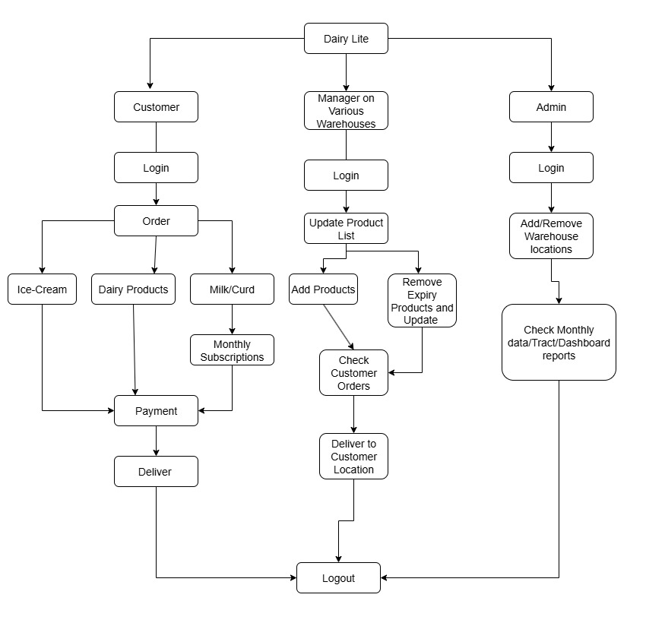

9. Business Requirements
- The system must allow customers to create accounts and securely log in through the Dairy Lite application.
- Customers should be able to browse available ice-cream and milk products with details like price, quantity, and expiry date.
- The system must allow customers to place new orders and confirm them instantly through the online application.
- It should automatically assign the nearest warehouse for order fulfilment based on customer location.
- Warehouse staff must receive real-time notifications for new orders and prepare items for dispatch immediately.
- The system should update order status at every stage — confirmed, packed, dispatched, and delivered.
- Customers should be able to view their past orders, invoices, and delivery details in their profile.
- The system must send order and delivery updates through app notifications or messages for customer convenience.
- The application should maintain a secure centralized database for all customer profiles, orders, and delivery records.

10.0 Appendices
10.1. List of Acronyms
Acronyms | Description
DMS | Dairy Management System
DB | Database
DBA | Database Administrator
UI | User Interface
QA | Quality Assurance
ROI | Return On Investment
ERP | Enterprise Resource Planning
SKU | Stock Keeping Unit
PDF | Portable Document Format

10.2. Glossary of Terms

Term | Definition
Batch Number | Unique identification number assigned to each production batch for tracking and quality control.
Expiry Date | The last date a dairy product can be sold or consumed safely.
Warehouse | Storage location where finished milk and ice-cream products are kept before dispatch.
Recorder Alert | System notification that triggers when stock quantity drops below the defined minimum level
Dashboard | Centralized screen displaying real-time data about stock, orders, and deliveries.
Delivery Module | Part of the system that handles assignment, tracking, and confirmation of product deliveries.

10.3. Related Documents

Document Name | Description | Reference Link
Business Requirement Document (BRD) | Captures overall business needs and objectives | BRD Documents
Functional Specification Document (FSD) | Define Functional Documents | FSD Documents
Requirement Traceability Matrix (RTM) | Map business requirements to functional and non-functional specification | RTM Documents
Process Flow Diagram | Illustrate AS-IS and TO-BE workflow for MTS enhancements. | Process Diagram
Security & Compliance Guidelines | Details security policies. | Security Documents

Assignment – 2

  - Write an introduction letter to a client introducing yourself as a business analyst in charge of working with the client and his team to start the business understanding process.

Subject: Introduction as Your Business Analyst for Business Understanding
Dear Sir/Madam,
I hope this message finds you well. My name is Chetan Ambadkar, and I am assigned as the Business Analyst for your project. My role involves collaborating closely with you and your team to understand your business processes, gather requirements, and ensure that we accurately capture your needs to support a successful project outcome.
I will be coordinating meetings, workshops, and discussions with your team to gain a thorough understanding of your operations and objectives. Your insights will be invaluable in helping us document clear and precise business requirements.
Please feel free to reach out to me at any time for any queries or clarifications. I am looking forward to working with you and your team and contributing to the success of this project.

Best regards,
Chetan Ambadkar
Business Analyst
Chetaanambadkar@15gmail.com
7066660659

Daily Horoscope

BRD

Daily Horoscope
DH1025
V1.0
Business Analyst – Chetan Ambadkar

Contents
1. Document Revision …………………………………………………………………………………………….……………..…….4
2. Approvals…………………………………………………………………………………………………………………………..……..4
3. RASCI Chart for this document………………………………………………………………………………………………..…5
Code used in RASCI Chart…………………………………………………………………………………………..………….….5
RASCI Chart……………………………………………………………………………………………………………….…..………….5
4. Introduction………………………………………………………………………………………………………………….………..….6
4.1. Business Goals……………………………………………………………………………………………………………………….7
4.2. Business Objectives……………………………………………………………………………………………………………….7
4.3. Business Rules……………………………………………………………………………………………………………………….8
4.4. Background…………………………………………………………………………..……………………………………………….6
4.5. Project Objective…………………………………………………………………..……………………………………………….6
4.6. Project Scope………………………………………………………………………..……………………………………………….6
4.6.1 In Scope Functionality…………….……………………………………..……………………………………………….6
4.6.2 Out Scope Functionality …………………….………………………..…….……………………….…………………6
5. Assumptions………………………………………………………………………………………………………….……………………8
6. Constraints……………………………………………………………………………………………………………….………..………8
7. Risks………………………………………………………………………………………………………………………….……….………8
Technological Risks………………….…………………………………………………………………………………….……………..9
Skills Risks………………………………………………….………………………………………………………………….……………...9
Political Risks…………………………………………………………..…………………………………………………….………………9
Business Risks…………………………………………………………………….………………………………………….……………...9
Requirements Risks………………………………………………………………………………………………………….……………9
Other Risks………………………………………………………………………………………………………………………….…………9
8. Business Process Overview…………………………………………………………………………………………….…………10
8.1. Business Process Overview………………………………………….………………………………………….………10
8.2. Business Process Overview………………………….…………………………………………………………………10

9. Business Requirements………………………………………………………………………..………………………………….11
10. Appendices…………………………………………………………………………………..………..…………………………….…11
10.1 List of Acronyms…………………………………………..……………………………………………..……………….…11
10.1 Glossary of Terms………………………………………………………………………………………..……………….…11
10.1 Related Documents……………………………………………………………………………………..……………….…11

1. Document Revision

Date | Version Number | Document Changes
07/10/2025 | 1.0 | Initial Draft

2.0. Approvals

Role | Name | Title | Signature | Date
Project Sponsor | Mr. Shehar | Project Sponsor |  | 08/10/2025
Business Owner | Mr. Pandit | Business Owner |  | 08/10/2025
Project Manager | Mrs. Vedika | Project Manager |  | 08/10/2025
System Architecture | Mrs. Sanvi | System Architecture |  | 08/10/2025
Development Lead | Mr. Rushikhesh | Development Lead |  | 08/10/2025
User Experience Lead | Mr. Sanket | User Experience Lead |  | 08/10/2025
Quality Lead | Mr. Brok | Quality Lead |  | 08/10/2025
Content Lead | Mrs. Neharika | Content Lead |  | 08/10/2025

3.0. RACI Chart for This Document

Name | Position | * | R | A | S | C | I
Mrs. Vedika | Project Manager |  | R | A |  | C | I
Mr. Chetan | Business Analyst |  | R |  |  | C | I
Mr. Rushikesh | Senior Developer |  | R |  | S | C | I
Mr. Surya | Developer |  | R |  | S | C | I
Mrs. Dahika | Developer |  | R |  | S | C | I
Mr. Dhiraj | Tester |  | R |  | S | C | I
Mr. Suraj | Network Admin |  | R |  | S | C | I
Mr. Pratik | DB Admin |  | R |  | S | C | I
Mr. Dehati | Astrologer (20 Yr. Exp.) |  |  |  | S | C | I
Mrs. Pooja | Astrologer (Content Lead) |  | R |  |  | C | I
Mr. Aditya | Astrologer Lead |  |  |  |  | C | I
Mrs. Priya | Customer Support Executive |  |  | A |  | C | I
Mr. Pandit | Senior Management | * |  | A |  |  | I

4.0. Introduction
4.1. Business Goals
The primary business goal of the Horoscope application is to provide users with a personalized and interactive astrology experience. Clients can register and log in to create their profiles, allowing them to access daily, weekly, and monthly horoscope predictions based on their zodiac signs. The platform aims to enhance user engagement by offering personalized remedies and mantras to address individual life challenges. Users who book a kundali will receive a soft copy directly via their registered email, ensuring convenient access to detailed astrological information. Additionally, the application enables users to consult professional astrologers via chat or video calls to discuss their problems and receive personalized guidance. Overall, the platform seeks to deliver meaningful insights, increase user retention, provide premium astrology services, and generate revenue through paid features and consultations.
Needs:
- Users need a secure and easy registration/login system to create and manage profiles.
- Users need accurate horoscope predictions tailored to their zodiac sign.
- Users need access to personalized remedies and mantras for guidance.
- Users need a way to generate their kundali and avail premium astrology services.
- Users need direct interaction with astrologers via chat or video call for personalized advice.

4.2. Business Objectives
- Provide users with accurate daily, weekly, and monthly horoscope predictions personalized according to their zodiac signs and birth details.
- Enable clients to register, create profiles, and securely manage personal information for a customized astrology experience.
- Offer personalized remedies and mantras to help users address life challenges and improve well-being based on horoscope insights.
- Facilitate premium services where users can generate their kundali by paying a fee and receive the soft copy via email.
- Allow users to interact with professional astrologers via chat or video calls for personalized advice and solutions.
- Engage users through notifications, daily tips, and regular horoscope updates to maintain continuous user retention.
- Ensure a user-friendly interface across web and mobile platforms to provide seamless access to all horoscope features.
- Generate revenue through paid kundali services, premium astrologer consultations, and value-added astrology features within the application.

4.3. Business Rules

Policies
- All users must register with valid personal information before accessing horoscope services.
- Paid services, including kundali generation and premium consultations, must be completed before service delivery.
- User data, including birth details and profiles, must be securely stored and handled according to privacy standards.

Procedures
- Users create an account by registering through email or social media and verifying their details.
- Horoscope predictions are generated daily, weekly, and monthly based on verified astrology sources.
- Premium services, such as kundali generation, are processed after payment, and the digital copy is emailed to the user.
- Users can schedule and conduct consultations with verified astrologers via chat or video call according to available time slots.

Rules & Regulations
- Only certified astrologers are allowed to provide consultations on the platform.
- Users must maintain professional conduct during interactions; abusive behavior may result in suspension.
- Notifications, messages, and promotional content can be sent only after user consent.

4.4. Background
The Horoscope Application project was proposed to address the increasing demand for accessible and personalized astrology services in the digital space. Traditional methods of consulting astrologers or accessing horoscopes through newspapers and books were time-consuming and lacked personalization. The client identified a business opportunity to create a comprehensive platform that allows users to register, manage their profiles, and receive daily, weekly, and monthly horoscope predictions based on their zodiac signs. Additionally, the platform would provide personalized remedies and mantras to help users improve their well-being. Users can also generate their kundali by paying a fee and receive a soft copy directly via email, ensuring convenience and accessibility. To further enhance the service, the application will allow users to interact with professional astrologers via chat or video calls to discuss their problems and receive tailored guidance. Implementing this project is expected to increase user engagement, provide premium astrology services, generate revenue, and build a loyal user base through a trusted and interactive platform.

4.5. Project Objective
- Enable users to securely register, create profiles, and manage personal information for a personalized astrology experience.
- Provide accurate daily, weekly, and monthly horoscope predictions based on user zodiac signs and birth details.
- Deliver personalized remedies and mantras aligned with horoscope insights to address user-specific life challenges.
- Allow users to generate a paid kundali and receive the digital copy conveniently via email.
- Facilitate professional astrologer consultations through chat or video calls for personalized guidance and advice.
- Engage users through notifications, daily tips, and regular horoscope updates to maintain continuous interaction.
- Ensure a user-friendly interface across web and mobile platforms for seamless access to all services.
- Integrate horoscope content from verified sources to maintain accuracy, authenticity, and reliability for all predictions.
- Align premium features and services with business objectives to maximize revenue and user satisfaction.
- Implement secure data storage, privacy policies, and encryption standards to protect sensitive user information.

4.6. Project Scope
The Horoscope Application aims to provide users with personalized astrology services, including horoscope predictions, remedies, kundali generation, and astrologer consultations through chat or video call. The project focuses on delivering accurate, accessible, and user-friendly astrology features through both web and mobile platforms to enhance user satisfaction and engagement.

4.6.1. In Scope Functionality
- Users can register and log in securely using their email, mobile number, or social media accounts to access personalized horoscope services.
- The system will display daily, weekly, and monthly horoscope predictions based on each user’s zodiac sign and birth information.
- Users can generate their kundali by paying a fixed fee and receive a soft copy directly through their registered email address.
- The platform will provide customized remedies and mantras according to the user’s horoscope and planetary positions.
- Users can book chat or video consultations with professional astrologers for personal advice and problem-solving.
- An admin dashboard will manage users, astrologers, and horoscope content to ensure accurate and updated predictions.
- Push notifications and alerts will remind users about their daily horoscope, lucky numbers, and astrology tips.
- The system will store user details and kundali reports securely using data encryption for privacy and safety.
- The application will include a payment gateway for processing kundali and astrologer consultation payments safely.
- The app will support both Android and iOS platforms, ensuring accessibility for a wide range of users.

4.6.2. Out Scope Functionality
- Prediction of financial outcomes, health diagnoses, or legal issues using astrology data will not be part of this project.
- Offline access to horoscope data without an internet connection will not be supported, except for recently viewed horoscopes.
- Integration with third-party astrology APIs or external horoscope sources is excluded from this project phase.
- AI-based chatbot astrologers or automatic response systems are not included in the current version.
- Automatic refund or dispute management for paid consultations is out of scope and will be handled manually.
- Multi-language support other than English and Hindi is not part of the current implementation plan.
- User-to-user chat or community discussion forums are not included in the present system design.
- Astrologer recruitment, verification, and payroll management will be handled outside the application system.
- Offline payment options like cash or cheque are excluded; only online digital payments will be supported.
- Integration with external platforms like Google Calendar or social media horoscope sharing will not be implemented in this phase.

5.0. Assumptions
- Users will have a stable internet connection to access horoscope predictions, remedies, and online consultations.
- All horoscope data and predictions will be provided by verified astrologers or reliable astrology sources.
- Users will enter accurate birth details (date, time, and place) to generate correct kundali and horoscope results.
- Payments for premium services like kundali and consultations will be made securely through integrated online payment gateways.
- Users will consent to share personal details like date of birth and email for horoscope personalization.
- The system will send the kundali soft copy automatically to the user’s registered email after successful payment.
- Astrologers will be available online at scheduled times for chat or video consultations.
- The mobile application and website will use the same centralized database to ensure consistent and real-time updates.
- Notifications and daily horoscope updates will be delivered automatically without manual input each day.
- Users will use modern devices that support the latest Android and iOS versions for a smooth app experience.

6.0. Constraint
- The total project budget is fixed at ₹1 Crore, covering design, development, testing, deployment, marketing, and maintenance, with no additional financial extension allowed.
- The project must be completed within 2 years, including all phases — requirement gathering, design, development, testing, and final implementation.
- Only approved technologies and tools will be used for development; no third-party or unlicensed software can be integrated without management approval.
- Limited availability of skilled astrologers and technical staff may delay horoscope content updates or consultation-related module development.
- The system must strictly comply with data privacy and security regulations, limiting flexibility in storing or sharing user information.
- Project success depends on continuous internet connectivity and hosting performance; any downtime may temporarily affect user access and app reliability.
- Any major scope changes or feature additions after approval will be considered for future phases, not during the current 2-year schedule.
- All horoscope predictions and remedies must come from verified astrologers or authentic sources, restricting use of automated or AI-generated astrology data.
- The testing and deployment phases must align with platform policies (Play Store, App Store), which may delay the final app releases if not approved.

7.0. Risk
Technological Risk
The Horoscope Application depends on reliable technology, so a few technical risks may occur:
System Compatibility
- Likelihood: Medium
- Impact: High – If the app does not work smoothly across all Android and iOS devices, users may face installation or performance issues.
- Plan: Mitigate – Conduct compatibility testing across devices before launch and optimize performance.
Server or Hosting Downtime
- Likelihood: Medium
- Impact: High – If hosting servers fail, users cannot access horoscope predictions or consultations.
- Plan: Mitigate – Use reliable cloud hosting with regular backups and 24×7 monitoring.
Data Security Breach
- Likelihood: Low to Medium
- Impact: Very High – Unauthorized access may expose user birth details and payment data.
- Plan: Mitigate – Use strong encryption, secure APIs, and role-based authentication.

Skills Risk
The project’s success depends on skilled astrologers, developers, and testers.
Lack of Skilled Astrologers
- Likelihood: Medium
- Impact: High – Inexperienced astrologers may provide incorrect horoscope content, reducing credibility.
- Plan: Mitigate – Hire verified astrologers and maintain quality checks on content.
Limited Technical Knowledge
- Likelihood: Medium
- Impact: Medium – Developers may face challenges integrating astrology APIs or features.
- Plan: Mitigate – Conduct training sessions and ensure documentation support.
Training Time for Astrologers/Staff
- Likelihood: High
- Impact: Medium – Team may take extra time to learn new digital tools.
- Plan: Accept/Mitigate – Provide proper onboarding, manuals, and demo sessions.

Political Risk
External policies and government rules may affect online astrology operations.
Change in Digital Service Regulations
- Likelihood: Low
- Impact: Medium – New policies may require updates to online astrology service compliance.
- Plan: Mitigate – Stay updated with regulations and modify policies accordingly.
Data Privacy Law Updates
- Likelihood: Medium
- Impact: High – Stricter data laws could require new encryption or consent features.
- Plan: Mitigate – Follow global data protection guidelines and update systems as required.

Business Risk
If the Horoscope Application fails to attract users or generate revenue, several business issues may arise.
Low User Adoption
- Likelihood: Medium
- Impact: High – Users may not install or use the app regularly.
- Plan: Mitigate – Use marketing campaigns and promotional offers to increase engagement.
Customer Dissatisfaction
- Likelihood: Medium
- Impact: High – Incorrect horoscope predictions or app bugs could reduce trust.
- Plan: Mitigate – Ensure continuous testing and validate horoscope data accuracy.
Revenue Loss
- Likelihood: High
- Impact: High – If paid features like kundali services are not used, revenue may drop.
- Plan: Mitigate – Add attractive packages and regular offers to boost premium usage.

Requirements Risk
Changes or unclear requirements may cause delays or rework.
Unclear Feature Definition
- Likelihood: Medium
- Impact: High – Misunderstood requirements for kundali or chat features may cause rework.
- Plan: Mitigate – Conduct detailed requirement workshops and client confirmations.
Frequent Changes During Development
- Likelihood: High
- Impact: High – Late changes in horoscope or payment modules can delay release.
- Plan: Avoid/Mitigate – Freeze scope with client approval and move extra requests to later phases.
Missed Functional Details
- Likelihood: Medium
- Impact: Medium – Small overlooked requirements may affect user satisfaction.
- Plan: Mitigate – Use a requirement checklist and RTM to track coverage.

Other Risks
Additional operational and external risks that may impact project success:
Server or Network Failure
- Likelihood: Medium
- Impact: Medium – Users may not access horoscopes or consultations temporarily.
- Plan: Mitigate – Maintain backup servers and ensure 24×7 monitoring.
Resistance to Change
- Likelihood: Medium
- Impact: Medium – Some astrologers or staff may hesitate to adapt to digital platforms.
- Plan: Mitigate – Provide motivation, proper training, and highlight benefits of the new system.
Budget Overruns
- Likelihood: Medium
- Impact: High – Unplanned costs for hosting, tools, or licenses may exceed budget.
- Plan: Mitigate/Transfer – Maintain a contingency fund and approve additional expenses only when justified.

8.0 Business Process Overview
8.1. Legacy System (AS-IS)
- Users currently depend on multiple online websites or newspapers for horoscope readings, which provide generic and non-personalized predictions.
- No single platform exists that offers daily, weekly, and monthly horoscope predictions in one place with personalized remedies.
- Users cannot directly communicate with professional astrologers through chat or video calls for personalized consultation.
- There is no option for users to create a profile and store their birth details for customized horoscope generation.
- Kundali generation is handled manually by astrologers, making the process time-consuming and prone to calculation errors.
- Users do not receive any digital or soft copy of their kundali through email after booking or payment.
- Horoscope services are scattered across different websites with no consistency, making it difficult for users to trust predictions.
- Payments for astrology services are often made offline, leading to lack of transparency and record tracking.
- Users do not receive personalized remedies or mantras according to their horoscope, reducing engagement and spiritual connection.
- No system currently exists for automated horoscope notifications or updates to keep users informed daily.
- Traditional astrology processes lack digital efficiency, customer engagement, and secure record-keeping for horoscope data.

8.2. Proposed Recommendations (TO-BE)
- A single digital platform will provide users with personalized daily, weekly, and monthly horoscope predictions based on their zodiac sign and birth details.
- Users can register, log in, and create personal profiles to save birth information for accurate horoscope generation.
- The application will automatically deliver customized remedies and mantras according to the user’s horoscope and planetary alignment.
- Kundali generation will be automated and users will receive a soft copy of their kundali directly through email after successful payment.
- The platform will allow users to chat or video call with certified astrologers for personalized consultations and remedies.
- All data, including horoscope content and user profiles, will be securely stored in a centralized database with encryption.
- Admins will manage astrologers, users, and content updates through a secure backend control panel.
- A digital payment gateway will be integrated to handle kundali bookings and paid consultations smoothly.
- Users will receive daily notifications and alerts about horoscope updates, remedies, and upcoming astrological events.
- The system will provide a seamless experience across mobile and web platforms for easy access anywhere.
- Overall, the application will make astrology services faster, accurate, interactive, and fully digital to enhance user trust and satisfaction.

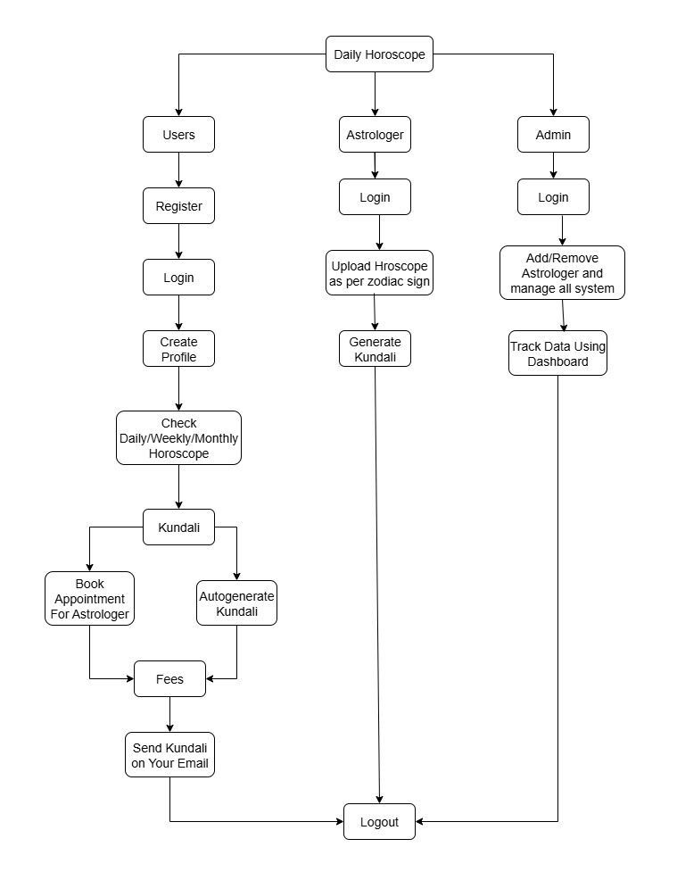
Process Flow Diagram (TO-BE)

9.0. Business Requirements
- The system must allow users to register and log in securely using their email or mobile number to create a personalized astrology profile.
- Users should be able to enter their birth details, including date, time, and place, to generate accurate horoscope predictions and kundali reports.
- The application must display daily, weekly, and monthly horoscope predictions personalized according to the user’s zodiac sign and planetary positions.
- Users should receive personalized remedies, mantras, and tips based on their horoscope to improve well-being and spiritual balance.
- The system must allow users to generate a paid kundali and automatically send its soft copy to the registered email after payment confirmation.
- Users should be able to book chat or video call consultations with professional astrologers for personal discussions and guidance.
- The admin must have access to add, update, and manage astrologers, horoscope content, remedies, and user feedback through a secure admin panel.
- The application should include a secure online payment gateway for processing kundali and astrologer consultation fees safely and quickly.
- The system must store all user profiles, horoscope data, and kundali reports in a secure centralized database with data encryption.
- Users should receive push notifications for daily horoscope updates, reminders for consultations, and astrology-related announcements.
- The system must provide a user-friendly interface for both mobile and web platforms to ensure smooth access and consistent user experience.
- The application should generate analytical reports for the admin, showing user activity, consultation bookings, and revenue performance to track growth.

10.0 Appendices
10.1. List of Acronyms
Acronyms | Description
DB | Database
DBA | Database Administrator
API | Application Programming Interface
QA | Quality Assurance
ROI | Return On Investment
UAT | User Acceptance Testing
UI | User Interface
PDF | Portable Document Format
OTP | One-Time Password

10.2. Glossary of Terms
Term | Definition
Horoscope | A forecast of a person’s future based on the position of stars and planets at the time of birth.
Zodiac Sign | One of twelve divisions of the celestial belt, used to determine personality traits and horoscope predictions.
Kundali | A personalized birth chart created using date, time, and place of birth to predict life events
Remedies | Astrological solutions such as mantras, gemstones, or rituals suggested to overcome challenges indicated in the horoscope.
Mantra | A spiritual sound or phrase used to attract positive energy and balance planetary influences.
User Profile | Personal information stored in the system including name, birth details, and zodiac sign for personalized predictions.

10.3. Related Documents

Document Name | Description | Reference Link
Business Requirement Document (BRD) | Captures overall business needs and objectives | BRD Documents
Functional Specification Document (FSD) | Define Functional Documents | FSD Documents
Requirement Traceability Matrix (RTM) | Map business requirements to functional and non-functional specification | RTM Documents
Process Flow Diagram | Illustrate AS-IS and TO-BE workflow for MTS enhancements. | Process Diagram
Security & Compliance Guidelines | Details security policies. | Security Documents

Mr. Pandit
Daily Horoscope
Software Requirement Specification
(07/10/2025)

Acceptance:

____________________________________________
Client Authorized Representative

Record of Revisions

Version | Date of Release / Revision | Prepared / Revised By | Reviewed By |  | Approved By |  | Reasons for revisions
Version | Date of Release / Revision | Prepared / Revised By | Name | Date | Name | Date | Reasons for revisions
1.0 | 8/10/2025 | Chetan Ambadkar | Project Manager | 09/10/2025

Table of Contents

1.0 Introduction……………………………………………………………………………………………………………………..5
1.1 Overview………………………………………………………………………………………………………………………..….5
1.1 Acronyms and Definition ………………………………………………………………………………………………..….5
1.1 Operational Requirements.……………………………………………………………………………………………..….5
1.1 References ……………………………………………………………………………………………………………………..….5
1.1 Design and Implementation Constraint ……….………………………………….……………………………..….5
1.1 Assume factors that could affect the requirement stated in the SRS…………………………….…....5
1.1 Acronyms and Definition ………………………………………………………………………………………………..….5
2.0 System Overview
2.1 Current System……………………………………………………………………………………………………………………7
2.1 Proposed System…………………………………………………………………………………………………………………7
2.1 Benefits of the proposed System…………………………………..…………………………………….………………7
3.0 UI Requirements……………………………………………………………………………………………………………….8
3.1 2.1 Project Content……………………………………………………………………………………………………………8
4.0 Other Parameters………………………………………………………………………………………………………………9
4.1 Acceptance……………………………………………………………………………………………………….…………………7

1.0 Introduction
1.1 Overview
The Daily Horoscope Application is a digital astrology platform designed to provide personalized horoscope predictions and astrological services to users based on their zodiac signs and birth details. The system enables users to register, create profiles, and access daily, weekly, and monthly horoscope predictions, along with personalized remedies, mantras, and kundali generation features.
It also facilitates chat and video consultations with certified astrologers for personalized advice and solutions. The goal of the application is to deliver accurate, convenient, and engaging astrology services through a secure and user-friendly web and mobile platform.
This project will help increase user engagement, promote digital astrology adoption, and generate revenue through premium services and consultation bookings.

1.2 Acronyms and Definition
Term | Description
DB | Database
DBA | Database Administrator
API | Application Programming Interface
QA | Quality Assurance
ROI | Return on Investment
UAT | User Acceptance Technique
OTP | One Time Password
PDF | Portable Document Format
UI | User Interface

1.3 Operational Requirements
1.3.1 Software Requirements
- Operating System: Windows / Android / iOS
- Front-End: ReactJS / Flutter (for mobile)
- Back-End: Node.js / Python Django
- Database: MySQL or MongoDB
- Web Server: Apache / Nginx
- IDE/Tools: Visual Studio Code, Postman, Figma (for UI design)
- Browser Compatibility: Chrome, Edge, Firefox, Safari (latest versions)

1.3.2 Hardware Requirements
Server Configuration:
- Processor: Intel Xeon or equivalent
- RAM: Minimum 8 GB
- Storage: 250 GB SSD
- Internet: Stable broadband with 99% uptime
Client System (User):
- Mobile Device (Android/iOS) or Desktop/Laptop
- Minimum 4 GB RAM, 64-bit processor
- Active Internet Connection

1.4 References
- Business Requirement Document (BRD): Daily Horoscope v1.0 (Prepared by Chetan Ambadkar)
- Proposal Document: Project charter and client requirement summary
- User Requirement Document (URD): Captures all functional and non-functional user needs
- Security & Compliance Guidelines: Data protection and privacy policies for user information

1.5 Design and Implementation Constraints
- The project must be developed within the approved technology stack (ReactJS, Node.js, MySQL).
- No third-party or unlicensed tools may be integrated without management approval.
- Must comply with data security standards such as encryption of user data and secure payment gateways.
- The system must support both Android and iOS platforms within performance limits.
- Development should follow agile methodology and coding standards set by the project team.
- Project budget is fixed at ₹1 Crore and must be completed within 2 years.

1.6 Assumed Factors That Could Affect the Requirements Stated in the SRS
- Users must have stable internet connectivity for horoscope access and online consultations.
- Horoscope content will be created and verified by certified astrologers only.
- Users will input accurate birth details (date, time, and place) to ensure correct horoscope results.
- The system depends on cloud hosting and server uptime for availability.
- Mobile and web platforms will share a centralized database to maintain data consistency.
- Users will grant consent for storing personal data in compliance with privacy laws.

2.0 System Overview
2.1 Current System
The current astrology service environment is highly fragmented and largely manual. Users depend on multiple online websites, newspapers, or astrologers for generic horoscope readings that lack personalization. There is no centralized digital platform that offers daily, weekly, and monthly horoscope predictions combined with personalized remedies and consultations.
Existing methods require users to contact astrologers offline or through social media, which is time-consuming and lacks privacy. Kundali generation is mostly manual, prone to calculation errors, and users rarely receive digital reports. There is no automated reminder or notification system for horoscope updates, nor a consistent way to manage user profiles, payments, or consultations securely.
Overall, the current system is inconsistent, time-consuming, and fails to deliver accurate, personalized, and interactive astrology experiences to modern users.

2.2 Proposed System
The proposed Daily Horoscope Application aims to deliver a modern, digital, and personalized astrology platform that resolves the issues of the traditional system. The system will enable users to:
- Register and log in using email, mobile number, or social media accounts.
- Access personalized daily, weekly, and monthly horoscope predictions based on zodiac sign and birth details.
- Generate their kundali online by paying a fixed fee and receive the soft copy via email automatically.
- Get personalized remedies and mantras according to their horoscope and planetary positions.
- Book chat or video consultations with certified astrologers for one-on-one discussions.
- Receive daily horoscope notifications, lucky numbers, and astrology tips automatically.
- Ensure data privacy using encryption and secure cloud storage.
- Allow admins to manage astrologers, users, and content via a secure backend dashboard.
- Provide a seamless experience across web and mobile platforms.
This proposed system combines astrology, technology, and user personalization to create a complete, interactive astrology experience that ensures trust, convenience, and engagement.

2.3 Benefit of the Proposed System
- The system provides personalized horoscope predictions based on each user’s zodiac sign and birth details, ensuring higher accuracy and user satisfaction.
- It offers one-stop access to all astrology services such as horoscope, kundali generation, remedies, and astrologer consultations.
- The entire process is automated, including kundali generation and email delivery, which reduces manual work and errors.
- Users receive daily notifications and astrology tips to keep them continuously engaged with the application.
- The system maintains data security and privacy through encrypted storage and secure login authentication.
- Verified astrologers ensure reliability, quality, and professional horoscope consultations for users.
- The platform provides revenue opportunities through paid kundali generation, premium consultations, and subscription features.
- An admin dashboard allows easy management of astrologers, users, and horoscope content with full control over system operations.
- The application supports Android, iOS, and web versions, giving users flexibility to access services anytime and anywhere.
- The project helps in building customer trust and long-term engagement through accurate predictions and transparent service delivery.
- It is designed to be scalable, allowing future expansion with new technologies like AI-based astrology insights or multilingual support.
- The proposed system reduces the dependence on manual astrology services and promotes digital transformation in the astrology domain.

3.0 UI Requirements
3.1 Project Contents

1. User Module
- Allows users to register and log in using email, mobile number, or social media credentials.
- Users can create and update personal profiles including name, birth details, and zodiac information.
- Provides access to daily, weekly, and monthly horoscope predictions.
- Allows users to generate paid kundali and automatically receive the report via email.
- Displays personalized remedies, mantras, and tips according to planetary positions.
- Enables users to book chat or video consultations with astrologers.
- Sends notifications about horoscope updates, lucky numbers, and consultation reminders.
- Provides secure payment options for premium features.
- Allows users to rate or provide feedback after consultations.

2. Astrologer Module
- Astrologers can register and log in through a verified account approved by admin.
- Enables astrologers to view and manage consultation bookings (chat/video).
- Allows astrologers to provide horoscope content, remedies, and mantras through the admin panel.
- Provides a dedicated dashboard to view customer details and consultation history.
- Supports availability scheduling for astrologers to manage appointment timings.
- Allows astrologers to upload or edit daily horoscope updates as assigned.

3. Admin Module
- Admin can manage all user and astrologer profiles through a secure backend dashboard.
- Controls content updates for horoscopes, remedies, and mantras.
- Monitors payment transactions, kundali bookings, and consultation activities.
- Can approve, reject, or modify astrologer details and service listings.
- Generates analytics and reports showing user growth, app usage, and revenue data.
- Manages system configurations, notifications, and promotional content.
- Ensures data privacy compliance and role-based access for internal users.

4. Kundali Generation Module
- Allows users to enter birth details (date, time, place).
- System automatically calculates and generates a kundali report.
- Enables payment gateway integration before report generation.
- Automatically delivers the kundali soft copy via email after payment.
- Stores the kundali securely in the user’s account for future access.

5. Consultation Module
- Provides real-time chat and video call options for users to consult astrologers.
- Displays available astrologers and their expertise with ratings.
- Allows users to book appointments by choosing date and time.
- Integrates secure payment for consultation booking.
- Maintains complete consultation history for both users and astrologers.

6. Notification Module
- Sends daily horoscope alerts, reminders, and astrology tips automatically.
- Sends booking confirmations, payment receipts, and upcoming consultation reminders.
- Supports push notifications for Android and iOS users.
- Allows admin to schedule or customize message templates.

7. Payment Module
- Supports secure online payments through debit/credit cards, UPI, and wallets.
- Integrates with popular gateways like Razorpay or Paytm.
- Ensures transaction logs, receipts, and invoice generation for each user.
- Handles payment confirmation before premium service delivery.

8. Report & Analytics Module
- Generates admin-side reports for user activity, consultation bookings, and revenue trends.
- Provides real-time dashboards for monitoring system performance.
- Tracks user retention, session duration, and active astrologer statistics.

9. Security Module
- Provides role-based authentication for users, astrologers, and admin.
- Encrypts sensitive data (personal and payment details).
- Includes OTP verification for registration and login.
- Ensures secure API connections between front-end and back-end systems.

UI Design Principles
- Clean, minimal layout with smooth navigation.
- Consistent colour theme representing astrology and spirituality.
- Icons and fonts optimized for readability on both mobile and web.
- Responsive design ensuring proper display on all screen sizes.
- Accessibility features for visually impaired users.

4.0 Other Parameters
The Daily Horoscope Application will be reviewed, tested, and accepted by the client only after fulfilling all the functional, technical, and quality requirements mentioned in the SRS document.
The following deliverables and conditions must be met before final client acceptance:
4.1 Acceptance
Working Prototype:
A functional prototype of the horoscope application demonstrating major modules such as user registration, horoscope display, kundali generation, and consultation booking.
Complete Application:
Final deployment of the Daily Horoscope Application on both web and mobile platforms (Android and iOS), integrated with a secure database and payment gateway.
Documentation Set:
  - Software Requirements Specification (SRS)
  - User Manual / Installation Guide
  - Test Plan and Test Cases
  - User Acceptance Testing (UAT) Report
  - Maintenance and Support Document
Admin Dashboard Access:
Fully functional admin panel for managing astrologers, content, users, and payments.
Security and Performance Testing Reports:
Evidence of data encryption, secure login, and successful performance load testing results.
Training and Handover:
A brief demonstration and knowledge transfer session for the client’s operational team to manage application content and users.

Acceptance Criteria
- The system must meet all the functional and non-functional requirements as outlined in the SRS.
- All critical defects or bugs identified during UAT must be resolved before final approval.
- Application performance should be stable, responsive, and secure across web and mobile platforms.
- Payment transactions and kundali generation features must work without data loss or errors.
- The application interface should match the approved UI/UX design prototypes.
- The client will perform final verification of system functionalities prior to sign-off.
- All deliverables should be submitted within the approved project timeline and budget.

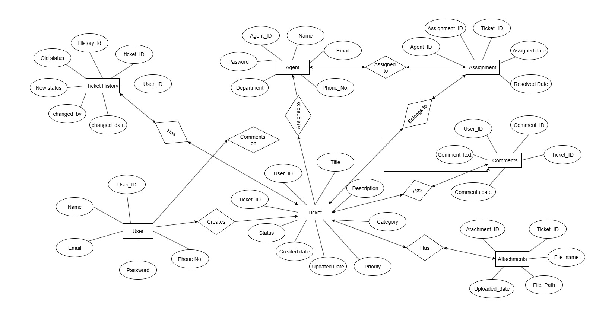
03. Make an ERD of creating a Ticketing life cycle.
04. User story of shopping from ecommerce.
User Story No.: 01 | Tasks: 3 |  | Priority: High
Value Statement:
As a Customer,
I want to register and create an account
so that I can shop securely and track my orders.
BV: 500 |  | CP: 2
Acceptance Criteria:
Account must be created successfully with valid email, phone, and password; user should receive confirmation and be able to log in.

User Story No.: 02 | Tasks: 1 |  | Priority: High
Value Statement:
As a Customer,
I want to log in to my account easily
so that I can access my saved details and order history.
BV: 200 |  | CP: 2
Acceptance Criteria:
User must log in with valid credentials; incorrect details should show an error message.

User Story No.: 03 | Tasks: 1 |  | Priority: High
Value Statement:
As a Shopper,
I want to browse products by category
so that I can easily find what I need.
BV: 200 |  | CP: 4
Acceptance Criteria:
System should display products based on selected category with correct details and images.

User Story No.: 04 | Tasks: 1 |  | Priority: Medium
Value Statement:
As a Shopper,
I want to search for a product by name
so that I can find specific items quickly.
BV: 100 |  | CP: 3
Acceptance Criteria:
Search should return accurate product results matching the entered keyword.

User Story No.: 05 | Tasks: 1 |  | Priority: High
Value Statement:
As a Shopper,
I want to view detailed information about a product
so that I can make the right purchase decision.
BV: 500 |  | CP: 2
Acceptance Criteria:
Product page must show name, price, image, description, and availability.

User Story No.: 06 | Tasks: 1 |  | Priority: High
Value Statement:
As a Customer,
I want to add products to my shopping cart
so that I can buy multiple items at once
BV: 500 |  | CP: 4
Acceptance Criteria:
Selected product must appear in cart with correct name, quantity, and price.

User Story No.: 07 | Tasks: 1 |  | Priority: Medium
Value Statement:
As a Shopper,
I want to update or remove items from my cart
so that I can control what I purchase.
BV: 50 |  | CP: 2
Acceptance Criteria:
User must be able to change quantity or remove any item; total price updates automatically.

User Story No.: 08 | Tasks: 1 |  | Priority: High
Value Statement:
As a Customer,
I want to see the total price before checkout
so that I can confirm my order cost.
BV: 200 |  | CP: 3
Acceptance Criteria:
System should display subtotal, taxes, and final total before proceeding to payment.

User Story No.: 09 | Tasks: 1 |  | Priority: High
Value Statement:
As a Customer,
I want to save multiple delivery addresses
so that I can select where to receive my orders.
BV: 200 |  | CP: 2
Acceptance Criteria:
User can add, edit, and delete delivery addresses easily.

User Story No.: 10 | Tasks: 1 |  | Priority: Medium
Value Statement:
As a Shopper,
I want to apply discount coupons
so that I can get reduced prices.
BV: 50 |  | CP: 2
Acceptance Criteria:
System must validate coupon and apply discount to total amount.

User Story No.: 11 | Tasks: 1 |  | Priority: High
Value Statement:
As a Customer,
I want to choose my payment method
so that I can pay using my preferred option.
BV: 500 |  | CP: 5
Acceptance Criteria:
System must allow card, UPI, and cash on delivery; payment confirmation message must be shown.

User Story No.: 12 | Tasks: 2 |  | Priority: High
Value Statement:
As a Shopper,
I want to receive order confirmation after payment
so that I know my purchase is successful.
BV: 200 |  | CP: 5
Acceptance Criteria:
User should get order confirmation message and email with details.

User Story No.: 13 | Tasks: 2 |  | Priority: Medium
Value Statement:
As a Customer,
I want to track my order status
so that I can know when it will arrive.
BV: 100 |  | CP: 3
Acceptance Criteria:
System should show order status such as “Packed,” “Shipped,” and “Delivered.”

User Story No.: 14 | Tasks: 2 |  | Priority: Medium
Value Statement:
As a Customer,
I want to cancel my order before shipping
so that I can correct any mistake.
BV: 100 |  | CP: 2
Acceptance Criteria:
System must allow cancellation for orders not yet shipped and update stock.

User Story No.: 15 | Tasks: 2 |  | Priority: Medium
Value Statement:
As a Shopper,
I want to return or replace a damaged product
so that I can get the right item or refund.
BV: 100 |  | CP: 3
Acceptance Criteria:
User must be able to request return within allowed days; system tracks status.

User Story No.: 16 | Tasks: 2 |  | Priority: Medium
Value Statement:
As a Customer,
I want to view my past orders
so that I can reorder easily in future.
BV: 100 |  | CP: 2
Acceptance Criteria:
System should show complete order history with date, product, and amount.

User Story No.: 17 | Tasks: 2 |  | Priority: Medium
Value Statement:
As a Shopper,
I want to rate and review products
so that I can share my experience.
BV: 50 |  | CP: 2
Acceptance Criteria:
User can submit review with rating and comment; review should display publicly.

User Story No.: 18 | Tasks: 2 |  | Priority: Low
Value Statement:
As a Shopper,
I want to add items to wishlist
so that I can buy them later.
BV: 20 |  | CP: 2
Acceptance Criteria:
System must let users add/remove wishlist items and view them anytime.

User Story No.: 19 | Tasks: 2 |  | Priority: Medium
Value Statement:
As a Customer,
I want to receive notifications about offers
so that I can save money while shopping.
BV: 100 |  | CP: 2
Acceptance Criteria:
System must send email or app notifications for discounts and promotions.

User Story No.: 20 | Tasks: 2 |  | Priority: Medium
Value Statement:
As an Admin,
I want to manage product inventory
so that stock levels remain updated.
BV: 50 |  | CP: 2
Acceptance Criteria:
Admin can add, edit, or remove products; quantity updates automatically after each sale.

User Story No.: 21 | Tasks: 2 |  | Priority: Medium
Value Statement:
As an Admin,
I want to view daily sales reports
so that I can track business performance.
BV: 100 |  | CP: 2
Acceptance Criteria:
System must generate accurate reports showing total sales, returns, and revenue.

User Story No.: 22 | Tasks: 2 |  | Priority: High
Value Statement:
As a System Admin,
I want to manage users and roles
so that I can control system access.
BV: 500 |  | CP: 3
Acceptance Criteria:
Admin can add, block, or delete users; permissions should apply correctly.

