AGILE-
Question 1 – write Agile Manifesto – 8 Marks
Answer.
The Agile approach to software development is defined by its commitment to creating software incrementally or in regular increases and stages. The approach offers users new versions, or releases, of software following brief periods of work. Those brief periods of work are often called sprints.
This Agile process contrasts with the traditional waterfall approach to software development, where developers typically compile the needs and requirements of the users and then build the software all at once. With these traditional methodologies, the completed project is released at the very end of the project cycle.
The Agile Alliance was seeking an alternative to waterfall model, which it described as “ documentation driven, heavy weight software development processes”

The 4 core values of agile software development process are stated in the Agile Manifesto, as follows:
1.Individuals and interactions over processes and tools;
2.working software over comprehensive documentation;
3.Customer collaboration over contract negotiation;
4.Responding to change over following a plan.
12 Principles of agile-
Below are the 12 principles of Agile-
1. Our highest priority is to satisfy the customer through early and continuous delivery of valuable software.
2. Welcome changing requirements, even late in development. Agile processes harness change for the
customer’s competitive advantage.
3. Deliver working software frequently, from a couple of weeks to a couple of months, with a preference to the shorter timescale.
4. Business people and developers must work together daily throughout the project.
5. Build projects around motivated individuals. Give them the environment and support they need, and trust them to get the job done.
6. The most efficient and effective method of conveying information to and within a development team is face-to-face conversation.
7. Working software is the primary measure of progress.
8. Agile processes promote sustainable development. The sponsors, developers, and users should be able to maintain a constant pace indefinitely.
9. Continuous attention to technical excellence and good design enhances agility.
10. Simplicity–the art of maximizing the amount of work not done–is essential.
11. The best architectures, requirements, and designs emerge from self-organizing teams.
12. At regular intervals, the team reflects on how to become more effective, then tunes and adjusts its
behaviour accordingly.
Question 2 – User Stories- Acceptance Criteria-BV-CP – 40 Marks Write minimum 40 User stories and their Acceptance Criteria along with their BV and CP
User story No:1 | Task 1 |  | Priority : Medium
AS A DELIVERY BOY
I WANT TO LOGG IN TO THE PORTAL
SO THAT I CAN MANAGE MY PROFILE
BV:500 |  | CP: 02
ACCEPTANCE CRITERIA :
REGISTRATION SCREEN
TEXT BOX OF USER NAME , GENDER , EMAIL ID
CONTACT NUMBER
CLICK ON LOG IN BUTTON
SEND SUCCESSFUL MESSAGE TO THE USER

User story No:2 | Task 2 |  | Priority : Medium
AS A DELIVERY BOY
I WANT TO ENABLE MY LOCATION IN THE PORTAL
SO THAT I CAN GET ODERES FROM SAME LOCATION
BV:500 |  | CP: 02
ACCEPTANCE CRITERIA :
ENBLE CURRENT LOCATION , GPS
TEXT BOX OF LOCATION ,AREA ,

User story No:3 | Task 3 |  | Priority : Medium
AS A DELIVERY BOY
I WANT TO VIEW CUSTOMERS ADDRESS IN THE PORTAL
SO THAT I CAN DELIVER FOOD
BV:50 |  | CP: 02
ACCEPTANCE CRITERIA :
CLICK ON VIEW CUSTOMER ADDRESS OPTION IN THE PORTAL

User story No:4 | Task 4 |  | Priority : Medium
AS A DELIVERY BOY
I WANT TO ACCESS CUSTOMERS CONTACT NUMBER
SO THAT I CAN CALL FOR DELIVERY
BV:50 |  | CP: 02
ACCEPTANCE CRITERIA :
CLICK ON CALL TO THE CUSTOMER

User story No:5 | Task 5 |  | Priority : Medium
AS A DELIVERY BOY
I WANT TO VIEW RESTURANT ADDRESS
SO THAT I CAN PICK UP FOOD
BV:50 |  | CP: 02
ACCEPTANCE CRITERIA :
ENABLE THE ADDRESS OF RESTURANT

User story No:6 | Task 6 |  | Priority : Medium
AS A DELIVERY BOY
I WANT TO UPDATE THE WAITING TIME IN RESTURANT
SO THAT I CAN UPDATE TO SCRUM FOOD
BV:50 |  | CP: 02
ACCEPTANCE CRITERIA :
ENABLE THE GPS IN THE LOG IN

User story No:7 | Task 7 |  | Priority : Medium
AS A DELIVERY BOY
I WANT TO UPDATE THE WBS IN LOG IN
SO THAT MY PAYROLL GETS MONITORED
BV:50 |  | CP: 02
ACCEPTANCE CRITERIA :
ENABLE THE TIME SHEET AND ATTENDANCE IN LOG IN

User story No:8 | Task 8 |  | Priority : Medium
AS A DELIVERY BOY
I WANT TO UPDATE THE DELIVERY STATUS
SO THAT IT CAN UPDATE TO SCRUM FOOD
BV:100 |  | CP: 02
ACCEPTANCE CRITERIA :
ENABLE THE COMMENT AND PHOTO UPLOAD ACCESS IN LOG IN

User story No:9 | Task 9 |  | Priority : Medium
AS A DELIVERY BOY
I WANT TO UPDATE THE RAITING AND FEEDBACK TO THE CUSTOMER
SO THAT I CAN BE UPDATE TO SCRUM FOOD
BV:50 |  | CP: 02
ACCEPTANCE CRITERIA :
ENABLE THE FEEDBACK OPTION IN LOG IN

User story No:10 | Task 10 |  | Priority : Medium
AS A DELIVERY BOY
I WANT TO UPDATE THE WAITING TIME IN RESTURANT
SO THAT I CAN UPDATE TO SCRUM FOOD
BV:50 |  | CP: 02
ACCEPTANCE CRITERIA :
ENABLE THE GPS IN THE LOG IN

User story No:11 | Task 11 |  | Priority : HIGHEST
AS A DELIVERY BOY
I WANT TO UPDATE/VERIFY THE AMOUNT PAID IF IT IS COD
SO THAT I CAN UPDATE TO SCRUM FOOD
BV:500 |  | CP: 02
ACCEPTANCE CRITERIA :
ENABLE THE PAYMENT GET WAY , ACCESS TO THE POOLING ACCOUNT TO CHECK PAYENT RECEIVED

User story No:12 | Task 12 |  | Priority : Medium
AS A RESTURANT
I WANT TO REGISTER IN THE PORTAL
SO THAT I CAN SELL FOOD THROUGH SCRUM FOOD
BV:500 |  | CP: 05
ACCEPTANCE CRITERIA :
NAME , KYC , TRADE LICENCE , EMAIL ID , NO OF EMPLOYEES , ESTABLISHED ON , COUSINE TYPE ,

User story No:13 | Task 13 |  | Priority :HIGHEST
AS A RESTURANT
I WANT TO LOGG IN TO THE PORTAL
SO THAT I CAN ACCESS MY PROFILE
BV:100 |  | CP: 05
ACCEPTANCE CRITERIA :
LOGG IN WITH USER ID AND PASSWORD

User story No:14 | Task 14 |  | Priority : Medium
AS A RESTURANT
I WANT TO DISPLAY THE MENU
SO THAT CUSTOMERS CAN CHOOSE FROM THAT
BV:100 |  | CP: 02
ACCEPTANCE CRITERIA :
DISPLAY MENUS WITH CHOOSE / ADD BUTTON

User story No:15 | Task 15 |  | Priority : Medium
AS A RESTURANT
I WANT TO VERIFY THE DELIVERY BOY IDENTITY
SO THAT I CAN HANDOVER THE CORRECT PACKAGE TO THE ASSIGNED DELIVERY BOY
BV:100 |  | CP: 10
ACCEPTANCE CRITERIA :
ENABLE THE UNIQUE ORDER ID AND DELIVERY BOYS ORDER ID

User story No:16 | Task 16 |  | Priority : Medium
AS A RESTURANT
I WANT TO VIEW THE ORDERS PLACED BY THE CUSTOMER
SO THAT I CAN CONFIRM THE AVAILABILITY
BV:100 |  | CP: 05
ACCEPTANCE CRITERIA :
ACCEPT / DECLINE THE ORDER BASED ON AVAILABILITY

User story No:17 | Task 17 |  | Priority : Medium
AS A RESTURANT
I WANT TO UPDATE THE TIMINGS
SO THAT I CAN SERVE WITHIN THAT TIME
BV:50 |  | CP: 02
ACCEPTANCE CRITERIA :
ENABLE THE OPEN AND CLOSURE TIMING

User story No:18 | Task 18 |  | Priority : Medium
AS A RESTURANT
I WANT TO UPDATE THE AVAILABILITY OF THE DISH
SO THAT I CAN DELIVER THE CORRECT ONE
BV:50 |  | CP: 02
ACCEPTANCE CRITERIA :
ENABLE THE UPDATION OF AVAILABLE DISH

User story No:19 | Task 19 |  | Priority : Medium
AS A RESTURANT
I WANT TO VIEW THE CUSTOMER CONTACT NUMBER
SO THAT I CAN CONTACT FOR ANY ALTERNATIVES IN CASE OF UNAVAILABILITY
BV:50 |  | CP: 02
ACCEPTANCE CRITERIA :
ENABLE THE CUSTOMERS CONTACT NUMBER ALONG WITH THE ORDER

User story No:20 | Task 20 |  | Priority : Medium
AS A RESTURANT
I WANT TO VIEW FEQUENTLY ORDERED DISH
SO THAT I CAN WORK ON THAT
BV:50 |  | CP: 02
ACCEPTANCE CRITERIA :
ENABLE THE REPORT OF FREQUENTLY ORDERED DISH

User story No:21 | Task 21 |  | Priority : Medium
AS A RESTURANT
I WANT TO UPDATE TODAY SPECIAL DISH
SO THAT THE CUSTOMERS CAN ORDER FOOD
BV:100 |  | CP: 02
ACCEPTANCE CRITERIA :
ENABLE THE EDIT AND UPDATION IN MENU OPTION

User story No:22 | Task 22 |  | Priority : Medium
AS A RESTURANT
I WANT TO UPDATE THE MENU
SO THAT I CAN UPDATE IT TIME TO TIME
BV:50 |  | CP: 02
ACCEPTANCE CRITERIA :
ENABLE THE UPDATE OPTION IN MENU

User story No:23 | Task 23 |  | Priority : Medium
AS A REGIONAL ADMINISTATOR
I WANT TO INITIATE THE POLICE VERIFICATION AND BGC OF EMPLOYEES
SO THAT VALID EMPLOYEES GET ENROLLED TO SCRUM FOOD
BV:500 |  | CP: 100
ACCEPTANCE CRITERIA :
ENABLE THE KYC VALIDATION PROCESS OF EMPLOYEES
User story No:24 | Task 24 |  | Priority : Medium
AS A REGIONAL ADMINISTATOR
I WANT TO ACCESS THE TIME SHEET OF THE EMPLOYEES
SO THAT I CAN APPROVE ON TIME
BV:500 |  | CP: 05
ACCEPTANCE CRITERIA :
ENABLE THE ACCESS TO THE TIMESHEET UPDATE

User story No:25 | Task 25 |  | Priority : Medium
AS A REGIONAL ADMINISTATOR
I WANT TO VALIDATE THE PAYROLL AND INCENTIVES OF THE EMPLOYEES
SO THAT I CAN DISBURSE ONTIME
BV:500 |  | CP: 100
ACCEPTANCE CRITERIA :
ENABLE PAYROLL AND TIMESHEET OF EMPLOYEES

User story No:26 | Task 26 |  | Priority : Medium
AS A ADMINISTATOR
I WANT TO VIEW CUSTOMER FEEDBACK
SO THAT I CAN WORK ONTHAT
BV:500 |  | CP: 100
ACCEPTANCE CRITERIA :
ENABLE PAYROLL AND TIMESHEET OF EMPLOYEES

User story No:27 | Task 27 |  | Priority : Medium
AS A ADMINISTATOR
I WANT TO SET UP CUSTOMER SERVICE CENTER
SO THAT I CAN RESOLVE QUERRIES ONTIME
BV:500 |  | CP: 100
ACCEPTANCE CRITERIA :
ENABLE EMPLOYEES QUERIES , CUSTOMER QUERIES , EMPLOYEES QUERIES

User story No:28 | Task 28 |  | Priority : Medium
AS A ADMINISTATOR
I WANT TO VALIDATE THE PAYMENT DONE BY THE CUSTOMER
SO THAT I CAN VERIFY THE SAME
BV:500 |  | CP: 100
ACCEPTANCE CRITERIA :
REPORT GENERATION OF PAYMENTS

User story No:29 | Task 29 |  | Priority : Medium
AS A ADMINISTATOR
I WANT TO EDIT THE PAYMENT METHOD
SO THAT CUSTOMER CAN MAKE PAYMENT SEAMLESSLY
BV:500 |  | CP: 100
ACCEPTANCE CRITERIA :
ENABLE AND EDIT PAYMENT METHODS

User story No:30 | Task 30 |  | Priority : Medium
AS A ADMINISTATOR
I WANT TO MANAGE THE DATABASE
SO THAT I CAN MONITOR THEM PROPERLY
BV:500 |  | CP: 100
ACCEPTANCE CRITERIA :
ENABLE DATABASE OF EMPLOYEES ,CUSTOMERS , RESTURANTS
EDITING AND MODIFICATION

User story No:31 | Task 31 |  | Priority : Medium
AS A REGIONAL ADMINISTATOR
I WANT TO PUBLISH ADD FOR EMPLYEMENTS
SO THAT I CAN RECRUIT NEW EMPLOYEES
BV:100 |  | CP: 02
ACCEPTANCE CRITERIA :
1.PUBLISH ADVIRTIZATION,
2 ACCEPT APPLICATIONS ,
3.ROUTE THEM TO THE RECRUITEMENT TEAM

User story No:32 | Task 32 |  | Priority : Medium
AS A REGIONAL ADMINISTATOR
I WANT TO MONITOR THE REGIONAL REVENUE
SO THAT I CAN MONITOR THAT
BV:500 |  | CP: 100
ACCEPTANCE CRITERIA :
1 .REPORT GENERATION
2.TOTAL COST
3.TOTAL PROFIT GAINED

User story No:33 | Task 33 |  | Priority : Medium
AS A REGIONAL ADMINISTATOR
I WANT TO ACCESS TO EMPLOYEES RESIGNATION
SO THAT I CAN APPROVE
BV:100 |  | CP: 02
ACCEPTANCE CRITERIA :
1.RESIGNATION REQUEST
2. APPROVAL
3.FOREWARD THAT TO THE NEXT AUTHORITY

User story No:34 | Task 34 |  | Priority : Medium
AS A REGIONAL ADMINISTATOR
I WANT TO LOGG OUT FROM PORTAL
SO THAT I CAN LOGG OUT
BV:100 |  | CP: 02
ACCEPTANCE CRITERIA :
1.LOG OUT RADIO BUTTON

User story No:35 | Task 35 |  | Priority : Medium
AS A CUSTOMER
I WANT TO REGISTER IN THE APP
SO THAT I CAN ACCESS THE PORTAL
BV:500 |  | CP: 100
ACCEPTANCE CRITERIA :
- NAME
- GENDER
- CONTACT NUMBER
- EMAIL ID
- VALIDATION BY OTP
- ADDRESS
- REGISTER

User story No:36 | Task 36 |  | Priority : Medium
AS A CUSTOMER
I WANT TO EDIT ADDRESS
SO THAT I CAN UPDATE THE ADDRESS
BV:500 |  | CP: 100
ACCEPTANCE CRITERIA :
1.ADD ADDRESS MANUALLY
2.ENABLE CURRENT LOCATION

User story No:37 | Task 37 |  | Priority : HIGHEST
AS A CUSTOMER
I WANT TO VIEW OFFERS
SO THAT I CAN CHOOSE
BV:500 |  | CP: 500
ACCEPTANCE CRITERIA :
1.OFFERS IN SPECIFIC RESTURANT
2.OFFERS FOR THE DAY

User story No:38 | Task 38 |  | Priority : Medium
AS A CUSTOMER
I WANT TO VIEW PICTURES OF MENUS WITH PRICE
SO THAT I CAN CHOOSE

BV:500 |  | CP: 100
ACCEPTANCE CRITERIA :
1.ITEM NAME
2.PRICE

User story No:39 | Task 39 |  | Priority :HIGHEST
AS A CUSTOMER
I WANT MANAGE THE CART
SO THAT I CAN ADD AND ORDER
BV:500 |  | CP: 100
ACCEPTANCE CRITERIA
1.ADD TO CART
2.EDIT
3.CHECK OUT
4.DELETE

User story No:40 | Task 40 |  | Priority : Medium
AS A CUSTOMER
I WANT TO VIEW TOTAL AMOUNT PAYBLE
SO THAT I CAN KNOW THE PRICE BREAK UP AND TAX
BV:500 |  | CP: 100
ACCEPTANCE CRITERIA :
1.BILL GENERATION
2.TOTAL AMOUNT PAYBLE
3.SERVICE TAX

Question 3– What is epic? Write 2 epics – 5 Marks Business Value and Complexity Points
EPIC-
Epic is a large body of work that can be broken down into specific tasks or user stories. These are based on the needs and requests of the customers or the end users. Epics are an important part of Agile software development methodology. ?
One or more epics can form the basis for the business case that justifies and initiates a project.
Epics are often used as place holders for new ideas that have not been thought out fully, or whose full elaboration has been deferred until actually needed. Epics are split into multiple user stories that help Agile development teams effectively manage and groom their product backlog.
2. EPIC
3. User Stories

1. Theme

In simple terms, Scrum Epic in Agile Methodology is a big chunk of work, which can be divided into smaller user stories. An Epic can be spread across sprints and even across agile teams. An Epic can be a high-level description of what the client wants, and accordingly, it has some value attached to it.

Business value:
The value of a specific set of requirements, capability, feature, or user story for a product. Business value has tangible and intangible benefits a business can get from the capabilities of a product. Business Value indicates User Story importance from the customer's point of view. The most valuable User Stories should be implemented as early as possible in the development process.
Revenue. One of the main indicators for measuring business value is revenue. Revenue acts as a raw number that shows the total income generated by your organization, including all costs. When the total revenue for your organization rises, it's often perceived as a Positive sign. On the other hand, the business value is the most important concept that sets the direction of team's work on the product. Therefore it's worth putting in the effort to define the business value, and understand what needs or problems are behind it, and how it can change during the project.

COMPLEXITY POINT:
Complexity points are units of measure, based on relative sizing, used to estimate development work in terms of complexity and or size instead of traditional time-based methods that attempt to measure the duration of time required to complete some unit of work.
Complexity = Amount of Work + Degree of Risk + Level of Uncertainty.
This Complexity being the benchmark for estimating story points.

Below are two Epic scenarios:
USER STORY-1
AS A CUSTOMER I W
USER STORY-2
AS A CUSTOMER I WANT TO CHOOSE OFF LINE MODE SO THAT I CAN PAY OFF LINE
Business Value: 500; Complexity Points: 100

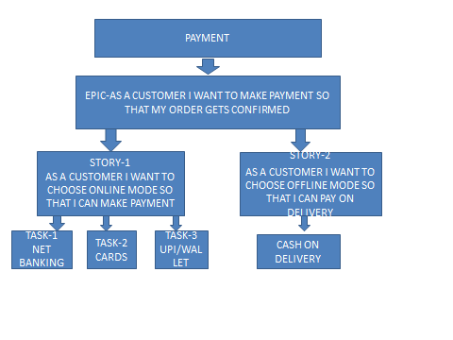
Business Value: 200; Complexity Points: 50
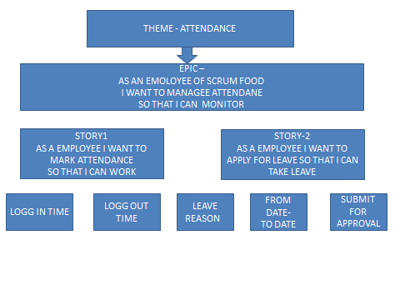
Question 4 –What is the difference between BV and CP – 2 Marks Product Backlog Your User stories will go into Product Back log
BUSINESS VALUE BV | COMPLEXITY POINTS CP
BV is Units of measure | CP is sum of points of all planned developments
Based on relevant sizing | Based on developments
Used to estimate development work in terms of complexity and/or size instead of traditional time-based methods that attempt to measure the duration of time required to complete some unit of work. | All efforts (tasks, user stories, planned work) planned to be developed as part of the product are evaluated individually using business value points.

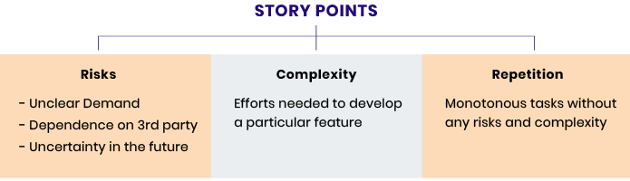
Complexity points are units of measure, based on relative sizing, used to estimate development work in terms of complexity and/or size instead of traditional time-based methods that attempt to measure the duration of time required to complete some unit of work.

Question 5 –Explain about Sprint– 5 Marks Sprint Understanding What is sprint Duration: 2 Weeks - Your sprint Value Scrum is a subunit of Sprint. What is scrum Duration: 1 day – Your scrum Value ? PBI: Product Backlog Item Task: Unit of Work done by 1 Developer in 1 Scrum WIP: Work In Progress Sprint Backlog
Sprint:
Sprints are time-boxed periods of one week to one month, during which a product owner, scrum master, and scrum team work to complete a specific product addition. During a sprint, work is done to create new features based on the user stories and backlog. A new sprint starts immediately after the current sprint ends.
In Agile product development, a sprint is a set period of time during which specific work has to be completed and made ready for review.
Each sprint begins with a planning meeting. During the meeting, the product owner (the person requesting the work) and the development team agree upon exactly what work will be accomplished during the sprint. The development team has the final say when it comes to determining how much work can realistically be accomplished during the sprint, and the product owner has the final say on what criteria need to be met for the work to be approved and accepted.
The duration of a sprint is determined by the scrum master, the team's facilitator and manager of the Scrum framework. Once the team reaches a consensus for how many days a sprint should last, all future sprints should be the same. Traditionally, a sprint lasts 30 days.
After a sprint begins, the product owner must step back and let the team do their work. During the sprint, the team holds daily stand-up meetings to discuss progress and brainstorm solutions to challenges. The project owner may attend these meetings as an observer but is not allowed to participate unless it is to answer questions. (See pigs and chickens). The project owner may not make requests for changes during a sprint and only the scrum master or project manager has the power to interrupt or stop the sprint.
At the end of the sprint, the team presents its completed work to the project owner and the project owner uses the criteria established at the sprint planning meeting to either accept or reject the work.
What is sprint Duration: 2 Weeks - Your sprint Value is 500 points
What is scrum Duration: 1 day – Your scrum Value: 50 points

PBI | TASKS | WIP | DONE
PAYMENT | 1.PAYMENT THROUGH CARD  2.PAYMENT THROUGH NET BANKING  3.PAYMENT THROUGH UPI  4. COD OPTION | PAYMENT THROUGH CARD | ACCEPTANCE CRITERIA  1.CHOOSE CARD (DEBIT/CREDIT )  2.TYPE OF DEBIT CARD (VISA / MASTER)  3.PUT CARD NO ,EXPIRY DTAE(CALENDER) ,CVV , OTP  SUBMIT BUTTON

Sprint roles, artifacts and ceremonies
A variety of roles are involved in a sprint, with each working on different parts of the process. These roles include:
- Product owner: This person represents the business or user community and is a liaison between the development team and customers. The product owner is in charge of working with the user group to define, prioritize and adjust what features will be in the product release. They also accept or reject work results and keep customers upraised of the project’s status.
- Scrum master: This person is the main facilitator for the project’s development team. They manage the process for how information is exchanged during the sprint, including leading stand-up meetings and helping the team stay on track by mediating problems and removing obstacles. Their main focuses are transparency, observation and organization.
- Scrum team: This group of people is responsible for executing the work. In addition to developers, the scrum team can contain testers, architects, designers and IT operations while the scrum master is charged with protecting the team and keeping focus, the team itself is self-managed and ultimately responsible for collectively determining how to reach their goals.
Artifacts provide the information that a scrum team needs to understand the product under development, as well as completed and planned activities for the project. Artifacts include:
- Backlog
- Burn down charts
- User stories
Ceremonies are meetings that are held for every sprint. Ceremonies include:
- Sprint planning meeting
- Daily scrum or daily stand-up meeting
- Sprint review
- Sprint or Agile retrospective

Sprint workflow and process
The sprint workflow is intended to help team members evaluate their work and communicate with each other throughout the entire process. The workflow is followed for each sprint. The process includes:
- Backlog - A list of set tasks that must be completed before the product is released. The backlog is built by the product owner. The product owner gives a backlog of prioritized items to the scrum master and scrum team. The backlog is based on user stories, which focus on features that consider the type of end user, what they want and why.
- Sprint planning - The team discusses top priority user stories and decides what can be delivered in the sprint.
- Sprint backlog - Agreed upon by the entire team, this list finalizes and defines what the development team will complete during the sprint.
- Sprint – The time frame in which the work must be completed – often 30 days.
- Daily scrum – Lead by the scrum master, the team comes together for short daily meetings, in which they discuss what they have completed, what they are working on and any issues that are blocking the work.
- Outcome - The outcome of a sprint is a hypothetically usable product. The product owner can decide if the product is ready or if additional features are needed.
- Sprint end - At the end of a sprint, two meetings are held:
  - Sprint review – The team shows their work to the product owner.
  - Sprint retrospective – The team discusses what they can do to improve processes. An important goal is continuous improvement.

Scrum vs. sprint
Scrum is the specific, framework used under the Agile umbrella to develop complex products. The term scrum is also used to describe the daily, standup meetings that occur during a sprint.
Sprints are time-boxed periods of one week to one month, during which a product owner, scrum master, and scrum team work to complete a specific product addition. During a sprint, work is done to create new features based on the user stories and backlog. A new sprint starts immediately after the current sprint ends.

Scrum productivity tools
Today's marketplace offers a multitude of scrum productivity tools. Each is designed to help product development teams follow the scrum/sprint methodology efficiently and accurately.
Popular scrum tools include:
- Jira
- nTask
- QuickScrum
- ScrumDo
- Scrumwise
- Vivify Scrum

Benefits of scrum sprints over traditional development
While there are many software development methodologies, such as rapid application development (RAD) and DevOps, most of today’s development teams use either Agile or the Waterfall model.
The waterfall model is a software development methodology that originated in the 1950s and is often referred to as ‘traditional’ software development. The waterfall model tackles projects in a linear, sequential manner based on distinct phases:
- Requirements
- Analysis
- Design
- Coding/implementation
- Testing
- Operation/Deployment
- Maintenance
These phases are siloed, each dependent on the completion of the phase before it, and include little or no user feedback until the final phase. Some Agile advocates claim that the waterfall model leaves few opportunities for design adjustments mid-process, which can disrupt the development workflow and delay product delivery.
Scrum sprints are more collaborative and adaptive than waterfall phases because sprints break software features and requirements into iterations to be tackled during short time periods. With frequent testing, immediate feedback, daily meetings and ongoing input and consideration of end-user stories and needs, sprints result in products with extremely relevant features.
Agile proponents also report that sprints offer improved time to market, faster ROI, greater customer satisfaction, improved team morale and better project control.
Question 6 – Explain Product backlog and sprint back log– 5 Marks Sprint Planning Meeting: All 8 Scrum Developers will gather before the sprint starts and understand how many user stories, they can develop in 1 sprint (2 weeks), and move them from the product Backlog to the sprint Backlog. They take inputs from Sprint Retrospective meeting. Scrum Meeting – Daily Stand-up Meeting End of every Scrum, Scrum Developers will participate in Scrum meeting. Here they must answer 3 Questions. a. What task did you work in this scrum? b. What task will you work on next scrum? c. Any Challenges/impediments? When you will complete the user story?

What is a Product Backlog?

A product backlog is a prioritized list of work for the development team that is derived from the roadmap and its requirements. The most important items are shown at the top of the product backlog so the team knows what to deliver first. The development team doesn't work through the backlog at the product owners pace and the product owner isn't pushing work to the development team. Instead, the development team pulls work from the product backlog as there is capacity for it, either continually (Kanban) or by iteration (Scrum)

A well-prioritized agile backlog not only makes release and iteration planning easier, it broadcasts all the things your team intends to spend time on—including internal work that the customer will never notice. This helps set expectations with stakeholders and other teams.

Once the product backlog is built, it's important to regularly maintain it to keep pace with the program. Product owners should review the backlog before each iteration planning meeting to ensure prioritization is correct and feedback from the last iteration has been incorporated. Regular review of the backlog is often called "backlog grooming" in agile circles (some use the term backlog refinement).

Once the backlog gets larger, product owners need to group the backlog into near-term and long-term items. Near-term items need to be fully fleshed out before they are labeled as such. This means complete user stories have been drawn up, collaboration with design and development has been sorted out, and estimates from development have been made. Longer term items can remain a bit vague, though it's a good idea to get a rough estimate from the development team to help prioritize them. The key word here is "rough": estimates will change once the team fully understands and begins work on those longer term items.

The backlog serves as the connection between the product owner and the development team. The product owner is free to re-prioritize work in the backlog at any time due to customer feedback, refining estimates, and new requirements. Once work is in progress, though, keep changes to a minimum as they disrupt the development team and affect focus, flow, and morale.

Sprint back log:

A sprint backlog is a list of work items your team plans to complete during a project sprint. These items are usually pulled from the product backlog during the sprint planning session. A clear sprint backlog prevents scope creep by clarifying exactly what your team will be doing—and not doing—during each sprint. From creating one source of information to defining work items, a sprint backlog has many positive effects on team productivity

As the Scrum master or product owner, it’s your responsibility to create the sprint backlog and distribute it to all project stakeholders. With the help of the product owner, you will choose backlog items based on priority. Then, document each task’s needs in the form of user stories. These are software features written from the perspective of the end user within a workflow.

PRODUCT BACKLOG | SPRINT BACKLOG
A product backlog tracks what the product team works on. Depending on the size of your organization, you may have one central product backlog or multiple product backlogs for different teams. The product owner will refine the product backlog periodically to make sure the most important initiatives are at the top and each initiative has all of the information needed to execute against it. | A sprint backlog is a subset of the product backlog and lists the work items to complete in one specific sprint. The purpose of the sprint backlog is to identify items from the product backlog that the team will work on during the sprint. This occurs during the sprint planning process. These items move from the product backlog into the sprint backlog and shouldn’t change once the sprint begins.
Before a project begins, the Product Owner creates a list of features to add to the project. Software development teams call this list the Product Backlog. The Product Backlog should break down the tasks necessary for each item on the list. The Product Backlog should also give teams a place to document how much time the tasks on the Backlog might take.
The Product Backlog gives teams a place to understand the dimensions of the entire project. It helps them visualize how they will tackle the tasks ahead of them. It helps the Product Owner to organize and prioritize their thoughts and wishes. The team uses the dynamic Product Backlog to keep track of problems to fix in future Sprints.
The Product Backlog, as an element of Agile, is not set. Flexibility and change must play a key role in any Product Backlog. Bugs or errors might add items to the Backlog. Software development teams will drop completed items from the Product Backlog. The Product Backlog is a living document. The Product Backlog likely grows during certain parts of the software development project. It should begin to shrink as the project nears completion.
- What did you do yesterday?
- What will you do today?
- Are there any impediments in your way?
By focusing on what each person accomplished yesterday and will accomplish today, the team gains an excellent understanding of what work has been done and what work remains. The daily scrum meeting is not a status update meeting in which a boss is collecting information about who is behind schedule. Rather, it is a meeting in which team members make commitments to each other.
If a programmer stands up and says, "Today, I will finish the data storage module," everyone knows that in tomorrow's meeting, he will say whether or not he finished. This has the wonderful effect of helping a team realize the significance of these commitments, and that their commitments are to one another, not to some far-off customer or salesman.
Any impediments that are raised in the scrum meeting become the Scrum Master’s responsibility to resolve as quickly as possible. Typical impediments are:
- My ____ broke and I need a new one today.
- I still haven't got the software I ordered a month ago.
- I need help debugging a problem with ______.
- I'm struggling to learn ______ and would like to pair with someone on it.
- I can't get the vendor's tech support group to call me back.
- Our new contractor can't start because no one is here to sign her contract.
- I can't get the ____ group to give me any time and I need to meet with them.
- The department VP has asked me to work on something else "for a day or two."

The Product Backlog usually contains at least some of the following items:
- Bugs – Problems testers or team members have flagged.
- User stories – features needed in the software development project. User stories should be explained in plain language from the end user’s perspective.
- Tasks – general work the Scrum team needs to complete.
The Product Backlog contains all the items in the software development project. The Sprint Backlog contains only the items of the Backlog specific to the current Sprint. Sprint Backlogs are the songs. The complete Product Backlog is the album.

What is a Sprint Backlog?
Sprint Backlogs give software development teams a way to chip away a long list of items. Teams use the Sprint Backlog in a very distinct way. They do not make changes to the Sprint Backlog. They set each Sprint Backlog at the Sprint Planning Meeting. Once they set the Sprint Backlog it is set. If new issues come up during the Sprint the team adds them to the Product Backlog. They work on these issues in a later Sprint.
A Sprint Backlog proves simpler, smaller and easier to understand than the Product Backlog. Teams still need to strategize and coordinate with the Project Owner and Scrum Master to make the Sprint run smoothly. They need to understand the limits of their resources.
A well-groomed Sprint Backlog will allow the teams the right amount of time to complete their work. They should not have to rush or work crazy hours to deliver. Before a Scrum Master moves a task from the Product Backlog to the Sprint Backlog, they should plan with the development team (and possibly the Product Owner) to ensure they have capacity. Scrum Masters, however, do not own decision-making. Scrum Masters facilitate and help the team.
Break down the differences and similarities between Product Backlog and Sprint Backlog:
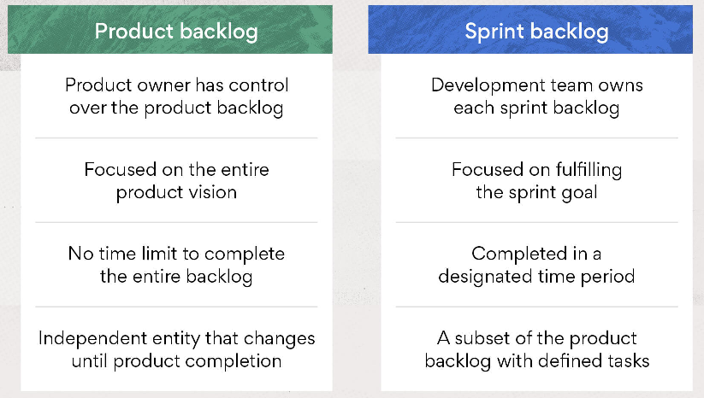
Product Backlog | Sprint Backlog
Contains all tasks for the development project | Contains only the items to complete in the current Sprint
Created by the Product Owner | The development team and Scrum Master create the list
Flexible, a living document that will change over time | Once set in the Sprint planning meeting it does not change
Independent parent list | Dependent on the Product Backlog
Specific to the project goal | Specific to the Sprint
Remains until the project is complete | Ends when the Sprint ends
Product Owner manages | Scrum team manages

Question 7 – What is impediments log? write 2 impediments – 5 Marks

Impediments log

Impediments are barricades, hurdles or obstacles. In terms of Scrum, they are “blockers” that prevent the Scrum Team from completing work, which in return impacts velocity. Anything that prohibits the team from doing work is considered an impediment. Examples of Scrum impediments are listed in Table 1.
Table 1. Scrum Impediments
The Scrum Master is responsible for tracking, monitoring and ensuring that impediments are removed. All Scrum Team members are responsible for continually identifying impediments for discussion during the Daily Standup Meeting. If for some reason an impediment does not disappear in a timely manner, this would indicate that the root causes have not been identified. The Sprint Retrospective is another place for impediments that reoccur. It is important to understand that the Scrum Master is not solely responsible for the removal of impediments. The team should work together to remove impediments that can be easily resolved and provide assistance with any additional support that may be required.
A few things to note:
- Impediments that are identified daily are generally very small and can be quickly resolved. This may include sending a simplifying email and/or getting assistance from a Scrum Team member.
- The bigger impediments are most likely to be identified during the Retrospective meetings and require a level of dedication to be removed. These types of impediments are added to the Sprints for resolution.
- Impediments that are identified by the team are added to the Product Backlog for prioritization and processing. Large items that are not able to be addressed quickly are addressed in later Sprints.
- Organizational impediments added to the Impediments Log are prioritized and addressed on an ongoing basis. Both team and organizational impediments are reviewed after each Sprint in the Retrospective meeting.
There are two main types of impediments, organizational and team related and they need different types of handling.
- Team Impediments – issues that the team can solve without needing external assistance. However, the team may need internal assistance from management. These types of impediments would include but are not limited to:
  - Changes to the way that the team works
  - Reminders for when a specific problem re-occurs
  - The need for tools or workflows that can make team’s work easier
  - Internal measures put in place for the team to avoid repeating a prior error
- Organizational Impediments – issues that are dependent on others to solve. These issues include but are not limited to:
  - Slow internet
  - Issues with obtaining input from other teams or divisions
  - Lack of training
The expectation is that the team can learn to remove its own impediments without the Scrum Master’s intervention. This also means that impediments in the log should not be delegated to the team because many of them may be very difficult to resolve. On the other hand, the Scrum Master is not expected to resolve all impediments alone either. The entire Scrum Team needs to work together to determine which impediments it can resolve and what support may be needed. Over time, the team should become capable of removing more and more impediments on its own.
Impediment Logs
There should only be a single Impediment Log for a Scrum Master to manage. Table 2. outlines the process that is typically used to create, monitor and maintain the Impediments Log.
Process | Description
- Record | The Daily Standup Meeting is the best time to document impediments in the Impediments Log as each team member reveals them. After the brief meeting, the Scrum Master will gather additional information so that the impediments can be prioritized.
- Prioritize | Impediments should be prioritized based on their levels of importance and in relation to those on that are already on the log.
- Publish | The Impediments Log should be made visible to everyone and posted for all to view.
- Address | The Scrum Master should address the highest priority impediments from the log and ensure that it is removed so that the team can continue to reach the Sprint’s objective.
- Communicate | When the impediment is removed, this information should be communicated to the involved parties and the Impediments Log is updated.
Table 2. Impediments Process in Scrum
Table 3. Identifies a description of each of the field on the Log. Figure 1. is an illustration of an Impediments Log. Let’s examine the data input fields to gain the proper understanding of their usage.
Impediments Log Field | Description
- Impediment Description | - Identifies what the impediment is
- Importance of Impediment Resolution | - (Blocker, Critical, Major, Minor), Describes the priority level
- Action suggested to be taken | - Recommended action to be taken to resolve the impediment
- Owner | - The person assigned to remove the impediment
- Due date of when it must be resolved | - Deadline date for resolution
- Release that impediment was identified in | - Release number

Impediment -1
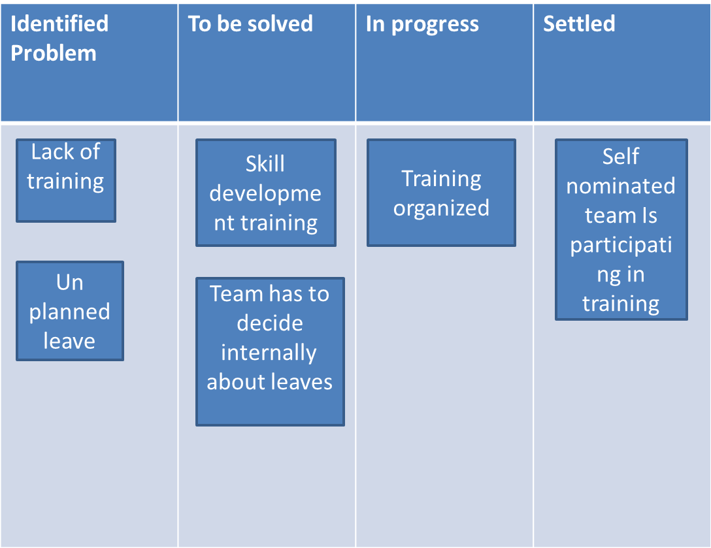
Sprint 1

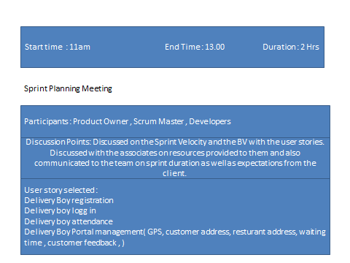

Prepare Tasks from PBI:

1. Delivery boy Portal registration
2. Delivery boy log in
3. Delivery boy attendance in the portal
4. GPS access
5. Access to restaurant address
6. Access to customers address
7. Customer calling access
8. Updation of restaurant waiting time
9. Delivery update with photograph
10. Validation of payment, customer feedback, COD, bill generation, log out

How many Scrums, we will have in this sprint?
We will have 5 scrums in this sprint
  - Scrum planning Meeting
  - Daily Scrum Meeting
  - Sprint Review meeting
  - Sprint Retrospective meeting
  - Back log refinement meeting

Allocate Tasks to Developers:

Delivery Boy Portal registration / Log in, attendance / Log out
Scrum Developer 1: Linesh Vegad
Scrum Developer 2: Yogender

Order receiving in the portal / address of restaurant and customer / customer calling access / waiting time updation in portal
Scrum Developer 3: Gowri
Scrum Developer 4: A.Lakshmikala
Scrum Developer 8: Rajesh

Payment validation / bill generation / customer feedback /
Scrum Developer 5: Madhuri
Scrum Developer 6: Varun
Scrum Developer 7: Rakesh

End of every Scrum, Scrum Developers will participate in Scrum meeting. Here they must answer 3
Questions.
a. What task did you work in this scrum?
Answer: The page of delivery boy and payment validation
b. What task will you work on next scrum?
Answer: The page for Administrator
c. Any Challenges/impediments? When you will complete the user story?
Answer: some of the developers have to be enable with specific skills

From the Done state of the sprint Backlog, we will product Increment and we can deliver it to the client
What is the Product Increment we made now?

As a team we have developed the registration page for the delivery boy and also tested it.

Sprint Retrospective meeting: Only the Scrum Developers will participate and will discuss about
Challenges faced and come up with lessons learnt. We can use these lessons learnt in Sprint Planning
Meeting to select user stories for the next sprint.

Answer: The unplanned leave taken by the developers was a main impediment that the team faced and now the team has decided that the team will have a proper dissuasion for the leave and The team will not depend on a specific resource for some specific functionality.Team has agreed to mutual programming.
Sprint Review meeting: All Stakeholders like Scrum Developers, Product owner, Scrum master, Client,
third party reviewers will participate. What they discuss is
We as team, we have coded, developed and tested the delivery boy log in page and its functionality.
Question 8 – Explain Velocity of the Team – 1 Marks Velocity – How many CP is covered in this sprint

Velocity ​​in agile terms means the average amount of work a team can complete in one “delivery cycle” – typically a sprint or a release for Scrum teams or a time period such as a Week or a month for Kanban teams. (It is also referred to by many as the Throughput, especially by Kanban teams).Knowing velocity, the team can compute (or revise) an estimate of how long the project will take to complete, based on the estimates associated with remaining user stories and assuming that velocity over the remaining iterations will remain approximately the same. This is generally an accurate prediction, even though rarely a precise one.
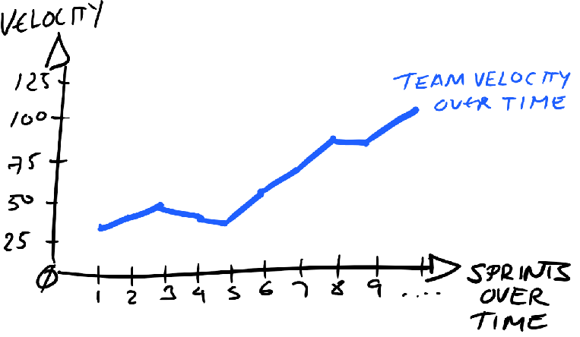
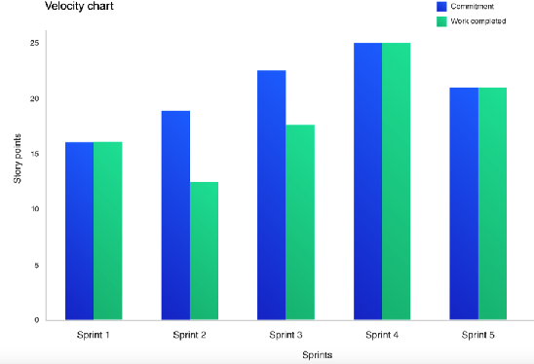

What is velocity in Agile?
The rate at which your team can deliver is a key Agile metric, called velocity. Accurately calculating your Agile team’s velocity will allow you to determine the dates you can reach product milestones or, if you need to deliver a product in completion, what date you should be able to achieve completion. Velocity will also help you avoid overpromising on deliverables for a client.
Agile velocity is a useful tool for teams to use internally, not necessarily to use for external determinations. The team can use it to track estimates and completions over several sprints—giving them an accurate understanding of how fast they can move through a backlog. It helps a team look at their progress and strengths and learn how to improve their metrics.

How is Agile velocity calculated?
Before you begin to calculate your team’s velocity, you will want to complete at least three to five sprints. This allows for a team that is new to Agile project management to get used to the workflow and for any changes the team is going through to normalize. Your velocity will fluctuate during these initial sprints but will stabilize after three or more have been completed.
To work through the formula, you will need to know how many points each user story is worth. Story point measurement is relative. It can be calculated in different ways for different organizations.
The rule of thumb in determining a story point is to find the simplest story, assign it one point, and then use it to assess the rest. You can use two scales to determine your story points: a linear scale or Fibonacci sequence.

Agile velocity formula.
To calculate the velocity of a sprint, you need to know how many user stories the team needs to complete. You also need to know the number of points that a user story is worth. Then, look at the number of stories completed and add up the points.
Let’s look at an example of velocity in Agile:
- In sprint one, your team has committed to eight user stories, and each story equals three story points. Let’s say the team only completes four stories. You would achieve 12 story points in total.
- In sprint two, your team has committed to 10 user stories, and each story equals five story points. Let’s say your team completes seven stories. You would end up with 35 story points.
- In sprint three, your team commits to nine user stories, and each story equals four story points. Let’s say your team completes seven stories. You’d have 28 story points.
Now that you have the individual sprint velocities, you can average them together.
Average sprint velocity = (12+35+28)/3 = 56

Velocity chart in Agile.
Once you have found the velocity of each sprint, you might want to enter that information into a velocity chart. A velocity chart can help in a few ways:
- It can be used to track the status of a project.
- It can be used to track volatility, which is a measure of predictability. If you are finding hills and valleys in your chart, the project is an unpredictable one. That can be for several reasons, including the size and difficulty of the project and team changes.
- A velocity chart will also help you identify patterns in your team's velocity — including on projects where there may not be story points, but instead, the team is working out bugs.
Question 9 – Draw Sprint Burn Charts n Product Burn Down Charts– 3 Marks

Sprint Burndown Chart

The Sprint Burn down Chart makes the work of the Team visible. It is a graphic representation of the rate at which work is completed and how much work remains to be done. The Sprint Burndown Chart is a visual measurement tool that shows the completed work per day against the projected rate of completion for the current sprint. It provides transparency about the current performance (burndown rate) and allows easy estimation if the Sprint Goal can be reached in time or if the team has to find additional measures to speed-up completion of the remaining activities. The rate of progress of a Scrum Team is called “velocityy”. It expresses the amount of work in story points completed per sprint. An import rule for calculating the velocity is that only stories that are completed at the end of the sprint are counted. Counting partially finished work (e.g. coding only – test missing) is strictly forbidden.
It helps the user to understand how quickly your team has completed tasks, and predict when your team will achieve the goal or goals of the sprint.

What does a Burndown chart show?

Total Estimate
It is the sum of efforts in hours of all the user-stories, tickets, and issues, basically, it’s the total number of works in hours to which the team is committed to.

Amount of work Remaining or Effort Remaining
This is what burn down shows and this is how this graph gets its name, in literal meaning, it is the “effort burndown chart”. The Team will burn down some effort each day so that on last day of sprint or release there is no work effort remains.

Working Days
Since the team need to calculate and carefully work on the commit item each day, so that is the reason total days of commitment of work are shown in a graph. This is the total working days in a sprint (excluding holidays, weekend, etc.). This is actually your sprint duration.

Ideal Effort
The ideal effort is drawn as a guide for a team, its drawn by calculating the exact amount of effort remaining which team need to burn down. That is the reason you see a very straight line from the top of the Y-axis to X-axis, which is the last day of your sprint.

Real Effort
Effort remaining line varies from team to team and day to day. It depends on how much effort remaining is added or reduced each day. If more items (user stories and issues) are added after the sprint started, this show as an upward spike.
The chart can help in answering the following questions:

  - How good is this team with the planning?
  - How well is this team executing against the planned stories in a Sprint?
  - Is this team self-organized and are they working in unison as a “team”?
  - What improvements can this team make?
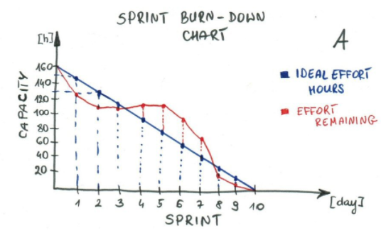
Product Burn down Charts

The product burndown chart is the chart that is plotted with the story points of all the user stories in the y-axis and the sprint numbers on the x-axis. It provides the product backlog visualization of completed requirements over time.

A Product-Burndown-Chart depicts story points of all user stories in the so called product backlog, where the product backlog is a simple ranked list of all functional and non-functional requirements described as user stories. The chart displays story points for each completed sprint, so it depicts the completion of requirements over time. Backlog and Product-Burndown-Chart is usually updated at the end of each sprint. New user stories can be added and/or removed before each sprint planning meeting.
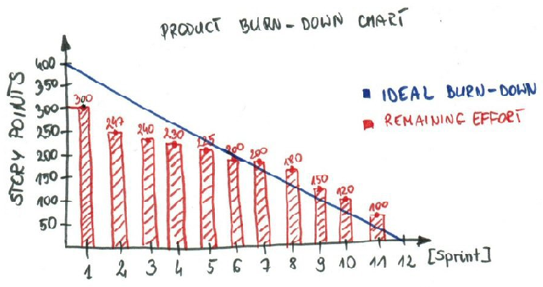
Question 10 – Explain about Product Grooming – 2 Marks
Product Grooming
Backlog refinement (formerly known as backlog grooming) is when the product owner and some, or all, of the rest of the team review items on the backlog to ensure the backlog contains the appropriate items, that they are prioritized, and that the items at the top of the backlog are ready for delivery. This activity occurs on a regular basis and may be an officially scheduled meeting or an ongoing activity. Some of the activities that occur during this refinement of the backlog include:
- removing user stories that no longer appear relevant
- creating new user stories in response to newly discovered needs
- re-assessing the relative priority of stories
- assigning estimates to stories which have yet to receive one
- correcting estimates in light of newly discovered information
- splitting user stories which are high priority but too coarse grained to fit in an upcoming iteration

Product Backlog Grooming
A Scrum product backlog is simply a list of things to do for the project. The Product Owner creates, maintains, and regularly re-orders a list of feature to be implemented for a product for adapting to emerging requirements, customer feedback, and market changes.
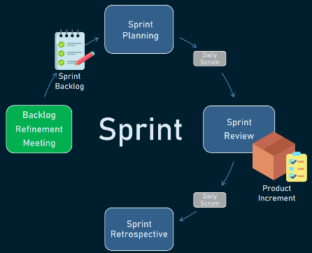
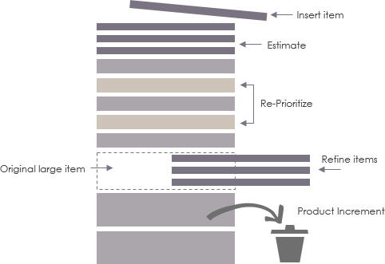Product Backlog
– The Value of the Product Backlog: Grooming
Groundwork of Product Backlog for Sprint Planning
Product Backlog items at the top of the Product Backlog should be refined and likely to be included soon in next sprint planning. Items further down the backlog need less concrete and can reflect bigger ore more complex ideas. These larger chunks will need to be broken down into smaller pieces as they approach the top of the Product Backlog as shown in the Figure below as suggested by Gunther Verheyen’s article

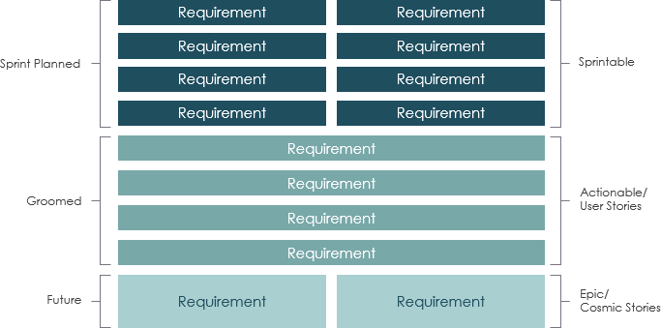Groundwork of Product Backlog for Sprint Planning
In the product backlog above, product backlog items (PBIs) are classified as three different categories readily for the sprint planning:
Sprinted Planned: Sprintable
Groomed: Actionable / user stories
Future: Epic / Cosmic Stories
By maintaining a well categorized product backlog like the structure above, your team should be more readily to proceed to the sprint planning process.

Backlog grooming is a regular session where backlog items are discussed, reviewed, and prioritized by product managers, product owners, and the rest of the team. The primary goal of backlog grooming is to keep the backlog up-to-date and ensure that backlog items are prepared for upcoming sprints.

Question 11 – Explain the roles of Scrum Master and Product Owner – 3 Marks

- ROLE OF A SRUM MASTER-
The scrum master helps to facilitate scrum to the larger team by ensuring the scrum framework is followed. He/she is committed to the scrum values and practices, but should also remain flexible and open to opportunities for the team to improve their workflow. SCRUM master split the work between developers. Take notes in meetings and sending the meeting minutes to everyone.
b) ROLE OF PRODUCT OWNER-
The Product Owner (PO) is a member of the Agile Team responsible for defining Stories and prioritizing the Team Backlog to streamline the execution of program priorities while maintaining the conceptual and technical integrity of the Features or components for the team.
MAJOR RESPONSIBILITIES OF PO-

-Managing and prioritizing the product backlog. ...
-Translating product managers' strategies to tasks for development. ...
-Learning the market and customers' needs. ...
-Serving as a liaison between product and development. ...
-Staying accessible to development to answer questions.

Question 12 – Explain all Meetings Conducted in Scrum Project – 8 Marks

Purpose of Sprint meeting-
Sprint planning sets up the entire team for success throughout the sprint. Coming into the meeting, the product owner will have a prioritized product backlog. They discuss each item with the development team, and the group collectively estimates the effort involved.
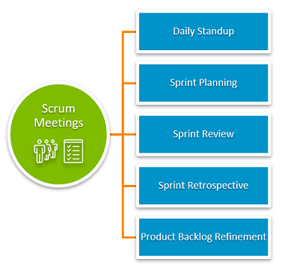
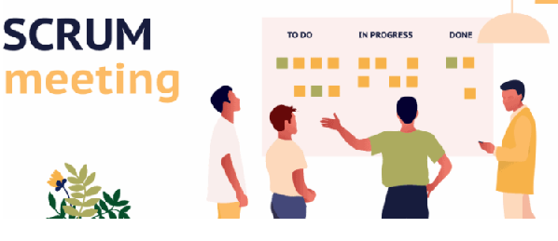
Below mentioned are types of scrum meetings-
- Sprint Planning- this meeting begins with product owner on daily basis.
A sprint planning meeting is when the team (including the Scrum Master, Scrum Product Manager, and Scrum Team) meets to determine which backlog items will be handled in the next sprint. The sprint planning Scrum ceremony is a collaborative process that allows team members to have a say in when work happens.
This meeting begins with the Product Owner. In this meeting the PO explains their vision and how the team should go about completing this step of the project. During this meeting, team members decide the amount of work they can complete within the sprint. This is also when the team moves work from the Product Backlog to the Sprint Backlog. This step requires a lot of planning and can take several hours for the group to decide on a finalized Sprint.

- Daily Scrum-From the planning meeting, we move into the daily scrum meetings. Every single day for 15 minutes, the team gathers together to report any issues or progress on their tasks. Though brief, this meeting is an essential part of the scrum process. It is designed to keep all group members on track in a cohesive manner. Normally the Product Owner is present during all daily scrum meetings to assist in any way.

- Sprint Review- The sprint review is an informal meeting where the team gives a demo of the product and will determine what is finished and what isn't, in other words, is a meeting to demonstrate and determine the usability of a piece of software

This meeting is used to showcase a live demonstration of the work completed. During this meeting the Product Owner, Scrum Master and stakeholders are present to review the product and suggest changes or improvements.

- Sprint Retrospective- The sprint retrospective is a recurring meeting held at the end of a sprint used to discuss what went well during the previous sprint cycle and what can be improved for the next sprint. This meeting is held to facilitate a team’s reflection on their progress. The team speaks openly about their organizational concerns and teamwork. During this meeting, dialogue should remain friendly, non-judgmental and impartial. This review session is a key part of team building and development and it’s also very important for future scrum projects.

5. Backlog Refinement Meeting:
- Last, is the backlog refinement meeting. In this meeting, team members focus on the quality and skill of the work involved during the sprints. This meeting is necessary for the business owners to connect with the development team and is used to assess the quality of the final product. This meeting involves important reflection on the team backlogs. These backlogs are often written in user story form and specify what makes the product useful to the consumer. Scrum meetings involve so much more than these brief descriptions. There are many additional pieces of the scrum process including things like burndown charts and scaling, but the point of this post is to provide an overview of different kinds of scrum meetings. Regardless of the type, all scrum meetings encourage organization, progress and resolutions. With this incremental and cyclical software development process, all members have the ability to communicate openly and honestly. With the process of scrum and the sprint timeline, projects are now efficiently completed with the help of a capable and cooperative team and Product Owner led by a skillful Scrum Master.

Question 13 – Explain Sprint Size and Scrum Size– 2 Marks
The size of a Scrum team-
A Scrum team should consist of less than 9 people. For large enterprise projects, the ideal Scrum team size is 7 people (product owner, scrum master, and 5 developers). Smaller projects typically consist of four team members (product owner, scrum master, and 2 developers).
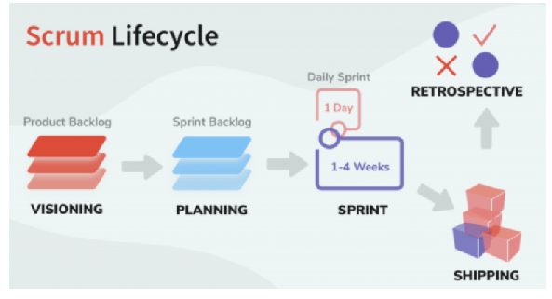
Size of sprint-
An Agile sprint is a concept in scrum that represents a time box - a short amount of time the team has committed to complete the work. Sprints in Scrum can be as long as you want - however, it's most common for sprints to be between 1 and 4 weeks. Teams running Scrum sprints need to decide what makes sense for them.
A good rule of thumb is that no user story should take longer to complete than half the duration of the Sprint. That is in a 2 weeks Sprint for example, no user story should take longer than 1 week to complete
The distinction between Sprint and Scrum is that they are two linked but different terms. Scrum is a framework often used in Agile methodology, and a Sprint is part of Scrum's framework structure. Scrum gives meetings, tools, and roles, while a Sprint is a defined period for creating a feature
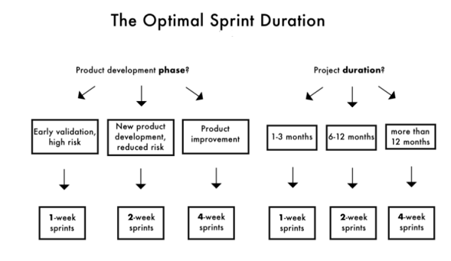
Question 14 – Explain DOR and DOD – 2 Marks
DOR AND DOD-
The concepts of Definition of Ready (DoR) and Definition of Done (DoD) are terms used to reinforce Transparency, assure Built-In Quality, and set the right expectations for the work items to be planned, developed, and completed during an Agile product development.
Definition of DOR (Definition of READY)-
It is a checklist of what needs to be done to a product backlog item before the team can start implementing it in the next sprint. You can view the definition of ready as the “DoD” the Product Owner has to fulfill so that the Development Team accepts the story in the Sprint Planning meeting.
Definition of DOD (Definition of DONE)
DOD is when all conditions, or acceptance criteria, that a software product must satisfy are met and ready to be accepted by a user, customer, team, or consuming system,”
DIFFERENCE BETWEEN DOR AND DOD-
DOR | DOD
a story ready to be pulled into a sprint to work on without further refinement | is a story that work has been completed and is ready to deploy into production without further adieu
Checklist of what needs to done | Checklist about what all are accepted by user
DOR comprises of multiple things hence a bit long | DOD is short
DoR specifies the requirements which need to be met to start an activity. | DoD specifies the requirements which need to be met to consider an activity.

Question 15 – Explain Prioritization Techniques and MVP – 3 Marks
- PRIOTIZATION TECHNIQUES-
Impact–effort matrix- all about what things needs to be prioritized

Feasibility, desirability, and viability scorecard.
RICE method.
MoSCoW analysis- MoSCoW prioritization, also known as the MoSCoW method or MoSCoW analysis, is a popular prioritization technique for managing requirements.
The acronym MoSCoW represents four categories of initiatives: must-have, should-have, could-have, and won't-have, or will not have right now.
7 Best Prioritization Models in Agile Product Development
- Kano Model. The Kano agile product development prioritization technique takes into consideration actionable product feedback from users in development. ...
- Opportunity Scoring. ...
- Stack Ranking. ...
- Priority Poker. ...
- MoSCoW Model. ...
- Cost of Delay. ...
- 100 Dollar Test.

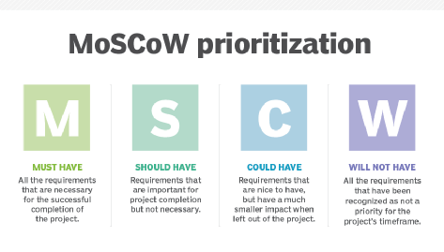

- MVP-
MVP is an abbreviation for the
Minimum Viable Product or MVP is a development technique in which a new product is introduced in the market with basic features, but enough to get the attention of the consumers. The final product is released in the market only after getting sufficient feedback from the product's initial users.
MVP (Minimum Viable Product), the Core of the Agile Methodology. An MVP is a concept from agile scrum that refers to a product that has just enough features to satisfy the needs of early customers and, more importantly, give them something to provide feedback on to shape the future of the product.

MVP product development
An MVP is a finished product and should be treated as such. This means that customers should get a functional, reliable, usable, and attractive solution. That said, every advanced function should be excluded from an MVP. Only the functions that are necessary to fulfill the actual purpose of the product are included. This saves a lot of time, work, and money.
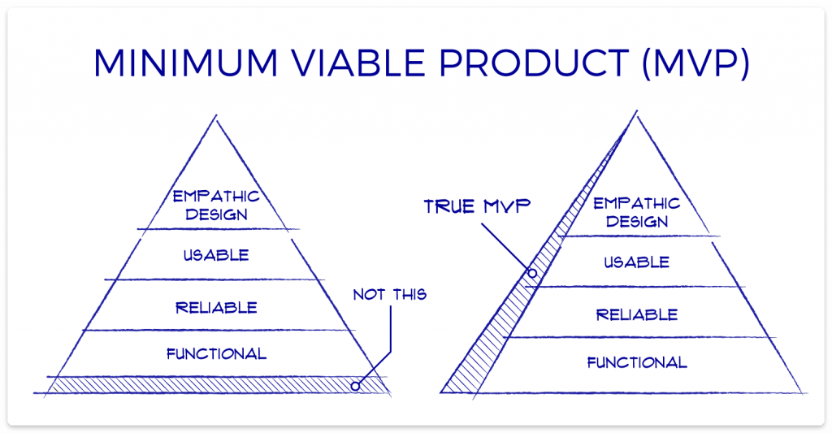
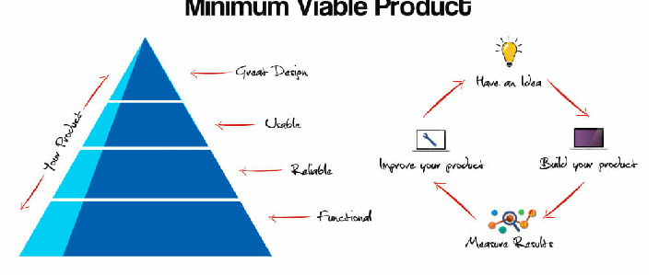
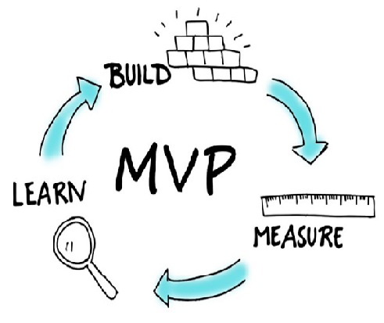
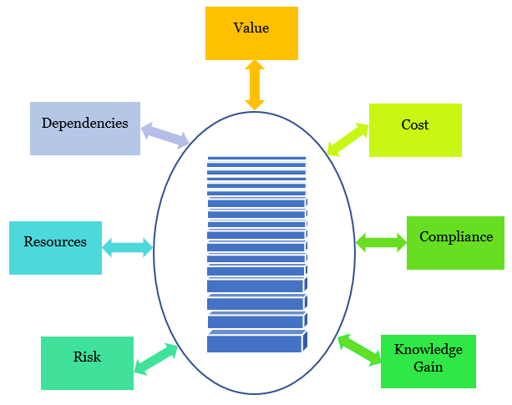
Question 16 – Difference between Business Analyst n Product Owner – 3 Marks
ANS.16

- Business Analyst:-
A business analyst in general does the following job. The need to understand this is important to know how an agile BA differs from the traditional one.

BA is the owner who makes all decisions concerning the business. They master the system and the product they work upon. This is possible due to the analytical skills they possess.
The business requirements get drilled down by the BA before it is accepted to be worked upon.
They map the process flow, the interaction diagram, etc.
The communication with the customer and other stakeholders back and forth by the BA will lead to a final decision of product development.
The business analyst, or BA, on the other hand, is the person responsible for aligning what the customer wants with what the team is producing. The BA works as a bridge between the business and the technical team, looking for gaps and analysing impact.
- Product Owner:-
1. Managing and prioritizing the product backlog
We list this first not because it’s necessarily the most critical product owners’ task, but because it is typically where they’ll spend a lot of their time.

The product backlog is an essential document for agile organizations because it captures and prioritizes the development team’s user stories to work on in upcoming sprints.

But whether or not an organization follows the agile sprint framework, its product owners will spend much of their time and focus reviewing the backlog of development tasks and prioritizing what the developers should take on next. This helps make sure that the team executes according to the product management team’s strategic goals and priorities.

2. Translating product managers’ strategies to tasks for development
When we stated above that product owners manage the backlog, we did not mean they simply moved existing user stories and other task-level details around the backlog. Product owners must be more proactive than that. In many cases, they are responsible for drafting (or at least refining) these stories into tasks that the development team can execute on.

Here is how Selina M., a product owner for Quest Software, describes her role:

“Product owners take initiatives from the product manager, break them down into stories or actionable chunks of value, and work with the engineering team to implement them.”

3. Learning the market and customers’ needs
To be useful in translating their company’s strategic plan into the right execution steps, product owners must understand their market and customer needs.

This often involves working with product managers to learn about what problems they are aiming to solve with the product, what customer needs or desires have informed their product strategy, and what the team will view as product success.

Gaining this high-level knowledge of the market, customer persona, and product strategy helps product owners more effectively perform several of their day-to-day tactical functions, including:

Breaking product management’s epics into user stories
Arranging and prioritizing sprints
Evaluating progress at each stage of development
Answering dev questions about the reasoning for user stories or tasks
4. Serving as a liaison between product and development
Product managers set the big-picture goals and strategy for their product’s success. The engineering or development teams build the physical (or digital) product. But between these two ends of the product development spectrum, there is a lot of room for interpretation—and misinterpretation.

Product owners act as a bridge to connect the product and development teams. They translate their understanding of the product manager’s vision and what each product’s area is designed to do for its users. This enables them to explain to the dev team the how and the why behind all user stories and other tasks they’re prioritizing.

5. staying accessible to development to answer questions
When they’re working stories and other tasks during a sprint, the development team might be unclear about a particular job assigned to them. They might not understand, for example, why a user story calls to design the product functionality in a particular way. They might also believe they have a faster, more efficient way to build the functionality but aren’t sure if doing so could undermine product management’s strategic goal in some way.

In these instances, the development team should ask the product owner for answers and guidance. Because the company’s development sprints are time-boxed—usually two weeks, or a month at the longest—the team will need these answers quickly.

For these reasons, the product owner should be accessible to the development team and prepare to respond to their questions immediately.

The product owner, or PO, as most of us say, is pivotal to the overall success of the project. This role works directly with the business to gain project-related knowledge and provide the business justification of why certain features are developed. The PO serves as a voice from business side.
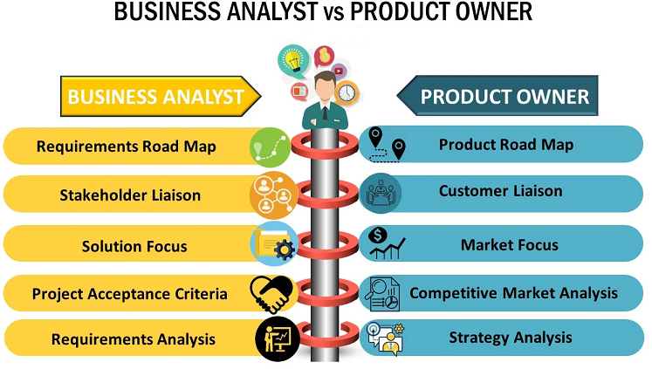
- Difference between BA and PO-
Sr no. | Business Analyst | Product Owner
1. | Understand and define stakeholder’s needs | A single point of contact to get alignment
2. | Act as an facilitator between business and IT | Define the business strategy
3. | Analyse the technical and business impacts | Keeps focus on customer needs
4. | Identify and the gaps between the customer and the development team | Manage the product backlog

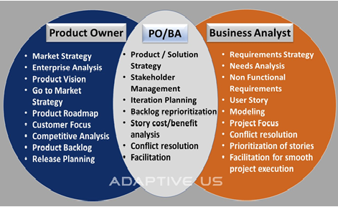

Question 17 – Prepare a sample Resume of 3yrs exp Product Owner – 3 Marks

Agile Product Owner
Rekha Rawat
2017–
Acted as liaison between business, sales and IT teams to refine the product and incorporate features based on market demands.
Partnered with IT and product leadership to drive and manage the solution development process and ensure the product team understands the direction and vision.
Collaborated with teams to discover and deliver the best solution to the market presented by the product team lead and the business.
Created and maintained the solution vision, roadmap, and backlog of work through the project's life cycle.
Translated features into user stories within the team’s backlog while managing, ranking, and prioritizing this backlog to reflect stakeholder’s requirements.
Key achievement:
Effectively negotiated sprint goals with the team, which resulted in slashing delivery time by 20% in a single quarter.
Scrum Product Owner
Morgan Stanley, Bangalore, PSM
2017–2021
Collaborated with stakeholders to understand business problem statements and convert them into user stories.
Articulated product vision and user stories in a way clearly understandable to development teams.

