Capstone Project 2 – Agile-Scrum: “Scrum Foods”

Question 1 – Write Agile Manifesto
Answer: Agile Manifesto —
Four Core Values:
1. Individuals and interactions over processes and tools
2. Working software over comprehensive documentation
3. Customer collaboration over contract negotiation
4. Responding to change over following a plan.
Twelve Agile Principles :
1. Our highest priority is to satisfy the customer through early and continuous delivery of valuable software.
2. Welcome changing requirements, even late in development. Agile processes harness change for the customer’s competitive advantage.
3. Deliver working software frequently, from a couple of weeks to a couple of months, with a preference to the shorter timescale.
4. Business people and developers must work together daily throughout the project.
5. Build projects around motivated individuals. Give them the environment and support they need, and trust them to get the job done.
6. The most efficient and effective method of conveying information is face-to-face conversation.
7. Working software is the primary measure of progress.
8. Agile processes promote sustainable development. Sponsors, developers, and users should be able to maintain a constant pace indefinitely.
9. Continuous attention to technical excellence and good design enhances agility.
10. Simplicity — the art of maximizing the amount of work not done — is essential.
11. The best architectures, requirements, and designs emerge from self-organizing teams.
12. At regular intervals, the team reflects on how to become more effective, then tunes and adjusts its behavior accordingly.

Question: Write minimum 40 user stories and their Acceptance Criteria along with their Business Value (BV) and Complexity Points (CP).
Answer:
Note on notation: BV uses stakeholder-assigned denominations (e.g., Rs 1000, 500, 200, 100, 50, 20 — higher means more business impact). CP uses story points / poker values (1,2,3,5,8,13,20…).

User Stories (1–40)
The Priority will be assigned based on BV and CP using this logic:
- High → BV ≥ 500 or critical business impact
- Medium → BV between 200–499
- Low → BV ≤ 100

User Story No. | User Story | Business Value (BV) | Complexity Points (CP) | Acceptance Criteria | Priority
1 | As a Delivery Boy, I want to register in Scrum Foods so that I can deliver orders. | 500 | 2 | Registration form with name, password, ID, mobile, email, address; register button; confirmation email/SMS. | Highest
2 | As a Restaurant Owner, I want to view incoming orders so that I can prepare food on time. | 500 | 2 | Restaurant dashboard lists orders with details, ability to accept/reject. | Highest
3 | As a Customer, I want to add delivery addresses so that orders are delivered to my preferred location. | 500 | 2 | Form with validation, save multiple addresses, set default, within 5 km radius. | Highest
4 | As a Customer, I want to select payment mode so that I can pay using my preferred method. | 500 | 3 | Payment modes displayed, single selection, proceed to payment. | Highest
5 | As an Admin, I want to view restaurants awaiting approval so that I can verify and approve. | 500 | 2 | Admin dashboard with pending list, approve/reject, notify restaurant. | Highest
6 | As a Customer, I want to view price of menu items so that I can decide what to order. | 50 | 1 | Menu lists items with prices shown in cart/order summary. | Low
7 | As a Customer, I want to view delivery boy contact details so that I can contact them if needed. | 50 | 1 | Tracking screen shows delivery boy details, privacy rules apply. | Low
8 | As a Restaurant Owner, I want to provide opening/closing times so that customers know operating hours. | 100 | 2 | Time slot input, multiple slots, visible on listing. | Medium
9 | As a Business Owner, I want to view revenue reports so that I can monitor performance. | 200 | 3 | Reports page with filters, downloadable Excel/PDF. | High
10 | As a Regional Admin, I want to manage regional restaurants so that I can track performance. | 200 | 3 | List of regional restaurants, metrics, messaging, region-level reports. | High
11 | As an Admin, I want to view regional revenue reports so that I can compare regions. | 100 | 3 | Region dropdown, date filter, exportable report. | Medium
12 | As a Customer, I want to chat with admin for refund requests so that I can resolve issues. | 200 | 2 | Chat UI with order ID, text box, issue ID generation, confirmation. | High
13 | As a Customer, I want to search restaurants by cuisine or name so that I can find food quickly. | 200 | 2 | Search bar with auto-suggestions, filter by cuisine, sort results. | High
14 | As a Customer, I want to filter restaurants by rating/delivery time so that I can choose easily. | 100 | 1 | Filters available, results update instantly, combinable. | Medium
15 | As a Customer, I want to view item details including allergens so that I can avoid risks. | 200 | 2 | Details page with ingredients, allergens, calories, spice level. | High
16 | As a Customer, I want to schedule an order so that food arrives at my preferred time. | 200 | 3 | Option to set date/time, validated, confirmation displayed. | High
17 | As a Customer, I want to apply promo codes so that I get discounts. | 100 | 2 | Promo code input, validate, apply discount or show error. | Medium
18 | As a Customer, I want to rate/review restaurants so that others get feedback. | 200 | 2 | Rating & review available post-delivery, moderation flagging, avg rating updates. | High
19 | As a Customer, I want to track my order on a map so that I know ETA. | 500 | 3 | Map view shows driver location & ETA, order status updates. | Highest
20 | As a Delivery Boy, I want to accept/decline delivery requests so that I manage workload. | 200 | 1 | Notification of new job, accept/decline, auto-reassign if declined. | High
21 | As a Delivery Boy, I want to update order status so that stakeholders stay informed. | 200 | 2 | Status toggles, auto notifications, proof of delivery (photo/signature). | High
22 | As a Restaurant, I want to update order status so that customers/delivery boy know progress. | 200 | 1 | Status updates saved, visible, option to set prep time. | High
23 | As a System Admin, I want to integrate a secure payment gateway so that payments are safe. | 1000 | 8 | Gateway integrated, PCI compliance, transaction records, error handling. | Highest
24 | As a Finance Admin, I want to support COD reconciliation so that payouts are correct. | 500 | 3 | COD flag, collection record, reconciliation dashboard. | High
25 | As a Customer, I want an in-app wallet so that I can pay quickly. | 200 | 3 | Wallet top-up, balance display, payment option, history. | High
26 | As an Admin, I want to manage refunds/chargebacks so that complaints are resolved. | 300 | 3 | Refund form, approval workflow, auto refund, notifications. | High
27 | As a Restaurant Owner, I want a dashboard for performance so that I can optimize. | 300 | 3 | Dashboard with revenue, best items, cancellations, reports. | High
28 | As a Regional Admin, I want to assign delivery zones so that efficiency is ensured. | 200 | 2 | Zone map, assign/unassign drivers, rebalancing options. | High
29 | As an Admin, I want to manage promotions so that we acquire and retain customers. | 200 | 2 | Promotion creation, rules, validity dates, applicable items. | High
30 | As a Customer, I want notifications for order events so that I stay informed. | 200 | 2 | Notifications for placed, accepted, out for delivery, delivered. | High
31 | As a Customer, I want multi-language support so that I can use the app comfortably. | 100 | 3 | Language selector, core screens translated, fallback to default. | Medium
32 | As a Visually Impaired Customer, I want accessibility features so that I can use easily. | 50 | 3 | Accessibility toggle, large fonts, ARIA labels, screen reader support. | Low
33 | As a Customer, I want to chat with delivery boy so that I can share directions. | 200 | 3 | Chat opens after delivery assigned, message timestamps, block/report option. | High
34 | As a Delivery Boy, I want to view my earnings so that I can track income. | 200 | 2 | Earnings dashboard, filters by date, payout request, pending/paid status. | High
35 | As an Admin, I want to verify restaurant documents so that only verified restaurants operate. | 300 | 3 | Document upload UI, verification workflow, status on profile. | High
36 | As an Admin, I want RBAC so that permissions are controlled. | 200 | 2 | Roles matrix, assign roles, secure endpoints respect RBAC. | High
37 | As a Customer, I want to see nearby restaurants so that I can order locally. | 300 | 3 | Geolocation prompt, list sorted by distance, permission handling. | High
38 | As Finance/Admin, I want GST invoices so that records are legal. | 200 | 3 | Invoice generation with GST, download/print, unique number. | High
39 | As a Customer, I want order history/reorder so that I can repeat orders easily. | 200 | 2 | Order history with reorder button, editable before confirm. | High
40 | As a System Admin, I want to detect and flag fraudulent orders so that we reduce losses. | 200 | 5 | Rules for fraud detection (high-value orders, failed payments), alerts, hold/cancel flow. | High

Question: What is epic? Write 2 epics and provide Business Value and Complexity Points.
Answer:
Definition: The concept of an epic in agile is introduced as a large body of work that can be broken down into smaller user stories when it cannot be completed in a single sprint
Epic 1: Ordering & Delivery Flow
- Description: End-to-end flow from customer placing an order to restaurant preparing it and delivery boy completing the delivery, including payment, notifications, tracking and proofs.
- Representative BV : 3,500 (sum of related stories; high business impact)
- Representative CP : 40 (high complexity — many integrations and real-time components)
- Contains user stories: 3,4,16,19,20,21,22,30,33,39.
Epic 2: Onboarding & Verification
- Description: All functionality to onboard restaurants and delivery partners securely: registration, document upload, verification, role assignment, and approval workflows.
- Representative BV : 1,500
- Representative CP : 18
- Contains user stories: 1,2,5,28,35.

Question: What is the difference between Business Value (BV) and Complexity Points (CP)?
Answer:
- Business Value (BV): BV measures the business impact or benefit of a feature and is assigned by business stakeholders or product owners.
- Complexity Points (CP): Measures the effort or complexity to complete the feature and is estimated by the development team using story points or the poker code system. Higher CP means more development effort or complexity.
In short: BV = value/priority (business perspective); CP = effort/complexity (development perspective).

Question: Explain sprint.
Answer:
- Sprint : A sprint is a fixed time-boxed iteration (in this project: 2 weeks) during which the Scrum Team delivers a potentially releasable product. It is set by the product owner or team to complete specific work.
A Sprint consists of several Scrum events (Sprint Planning, Daily Scrums, Sprint Review, and Sprint Retrospective). The work to be performed is selected from the Product Backlog during Sprint Planning and moved into the Sprint Backlog.
Scrum is a shorter cycle within a Sprint. It represents one day of development work.

Question: Explain Product backlog and sprint backlog.
Answer:
Aspect | Product Backlog | Sprint Backlog
Definition | Ordered list of all desired features, bugs, enhancements | Subset of Product Backlog items selected for current sprint
Owner | Product Owner | Development Team
Timeframe | Long-term scope of product | Short-term
Purpose | Vision & prioritization | Sprint commitment & execution

Question: What is impediments log? Write 2 impediments.
Answer:
- Impediments Log:
An impediment log is a tool used by the scrum team to track and manage obstacles or issues that are hiding the hiding the team progress during the sprint. It records the problems or challenges that block the team from the from achieving the sprint goal. These challenges are known as impediment. Impediment is handled by the scrum master. The scrum master is responsible for identifying and addressing and removing these impediments.
Two example impediments:
- A key developer is unexpectedly on sick leave for three days, delaying a critical task with high dependencies.
- The team is blocked because the third-party payment gateway API for testing is down, and the vendor's support has not provided a resolution ETA.

Question: Explain velocity.
Answer:
It measures the amount of work a team complete during a sprint. It is calculated by adding up the story points of all task or user stories completed in a sprint. Sum of story points by sprint.

Question: Draw Sprint Burndown Charts and Product Burndown Charts.
Sprint Burndown Charts - It tracks the amount of work remaining in the sprint and tracks the progress towards the sprint goal over the sprint duration. It is a daily graph maintained by the scrum master.
Product Burndown Charts - Product burndown chart tracks the progress of entire product backlog over multiple sprints.
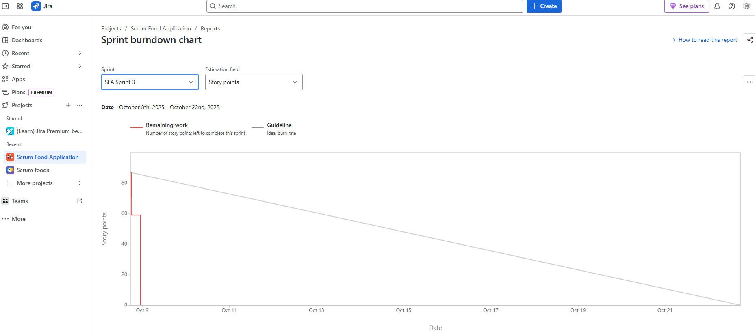
Sprint Burndown Chart:

Product Burndown Chart :
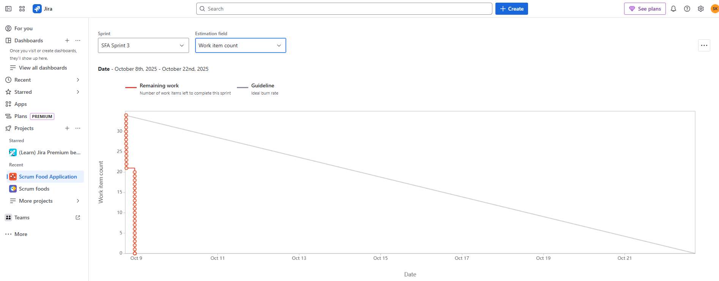

Question: Explain product grooming.
Answer:
- Product Grooming - It involves regular reviewing and refining the product backlog to ensure it is up to date, well prioritized, contain items that are well understood and ready for the future sprint or not. The main purpose of product grooming is to ensure the product backlog is well organized, prioritized and ready for the sprint planning.

Question: Explain the roles of Scrum Master and Product Owner.
Answer:
Scrum Master (SM) - Scrum master is responsible for facilitating the scrum process to the team. He will facilitate the scrum events, remove the impediments and coach the team. He will conduct meetings like product grooming, sprint planning, daily standup, sprint review and sprint retrospectives.
Product Owner (PO) - Product owner defines the future of the product. PO prioritize the future according to the business value and communicate the product vision. PO can make the quick decisions and product owner can accept or reject the workflow.
Collaboration: PO focuses on “what” and “why” (value), SM focuses on “how” (process and productivity), and Developers focus on “doing” (building increment).

Question: Explain all meetings conducted in Scrum Project.
Answer:

- Sprint Planning (Start of Sprint)
- Here team will discuss what should be delivered in the particular sprint.
- Daily Scrum (Daily Standup)
  - Here Development team will discuss like what did they do yesterday and what they are going to do today. Duration is 15 min of time
  - They will check is there any impediment on their way.
- Sprint Review (End of Sprint)
  - Development team will give work demo to the team or stakeholder and gather the feedback from the stakeholder. It will be conducted at the end of the sprint.

- Sprint Retrospective (End of Sprint)
  - Scrum team will discuss about what went well in the sprint, what didn't go well in the sprint, is there any improvements we have to make for the upcoming sprint

- Product Grooming
  - It involves regular reviewing and refining the product backlog to ensure it is up to date, well prioritized, contain items that are well understood and ready for the future sprint or not. The main purpose of product grooming is to ensure the product backlog is well organized, prioritized and ready for the sprint planning.

Question: Explain Sprint Size and Scrum Size.
Answer:
- Sprint Size typically refers to duration of a sprint. It is a time box iteration in scrum. For Scrum Foods: 2 weeks (recommended).
- Scrum (Daily) Size refers to number of members in the team based on project. Team members will be like product owner, scrum master, development team & QA Team.

Question: Explain Definition of Ready (DoR) and Definition of Done (DoD).
Answer:
- Definition of Ready (DoR):
- It ensures that a user story or task is sufficiently prepared and understood before work begins. Here clear acceptance criteria is checked. There should be no blocker and BV Value should be assigned properly and team understood before going to begin the work.
- Product owner is responsible for ensuring the story is meeting the DOR.
- The development team help by providing the feedback during the backlog refinement.
- Scrum Master will facilitate the process.
- Definition of Done (DoD):
It is also a kind of checklist. It ensures that a user story or task meet all necessary criterias and quality standards before it should be considered as complete.
Criteria for DOD –
- Code for the feature completion is checked
- Unit test is passed or not
- Documentation is updated or not
- Acceptance criteria is met or not

Question: Explain prioritization techniques and MVP.
Answer:
Prioritization Techniques: - It helps team decide which task or future to focus on based on various criteria. Commonly used technique called MoSCoW.
- MoSCoW: Categorizes requirements into Must have, should have, could have, and won’t have (this time).

MVP (Minimum Viable Product): It includes just enough future to satisfy early customer and provide feedback for the future product development. It includes just enough features so that a piece of software is delivered to the market. Feedback is gathered from the customer for the future product development. It is designed to test about what customer need and what they want. The main purpose of MVP is to gather the customer feedback and it will reduce the risk. And we can deliver the software and we get early in the market.

Question: Difference between BA and Product Owner.
Answer:
- Product Owner (PO):
Product owner owns the product vision and the product backlog.
Product owner focuses on the product priorities, business values.
Responsibilities of product owner is he/she will prioritize the future and deliver maximum values.
- Business Analyst (BA):
Business analyst gathers the requirements, analyze the requirements and document the requirements.
Focus on the requirement analysis and documentation.
The business analyst act as a bridge between stakeholder and the technical team.

Question: Prepare a sample resume for a Product Owner with 3 years experience.
Answer:
Swapnil S. Khobragade - Email: swapnil.93@outlook.com Phone: +91-8437195731 - LinkedIn: linkedin.com/in/swapnil
Professional Summary Product Owner with 3 years of experience delivering customer-centric digital products in agile environments. Proven track record in backlog management, stakeholder engagement, and driving product roadmap and MVP delivery. Strong communicator with experience across fintech and e‑commerce platforms.
Experience Product Owner — Scrum Foods (Capstone / COEPD project) May 2024 – Present (project-based) - Owned product backlog for Scrum Foods — food delivery app; wrote and prioritized 40+ user stories and epics. - Collaborated with stakeholders (business owner, regional admin, restaurants) to define vision and prioritize MVP features. - Led grooming, sprint planning, and sprint reviews; maintained product burn down and velocity metrics. - Defined acceptance criteria, improved DoR and DoD, and reduced rework by 20% through clearer stories.
Associate Product Owner — XYZ Digital (Intern / 1 year) Jan 2023 – Apr 2024 - Assisted PO in defining feature scope, documented user journeys, and coordinated UAT. - Prepared market research reports and competitor analysis to inform prioritization.
Business Analyst — ABC Solutions (1 year) Jan 2022 – Dec 2022 - Elicited requirements, created use cases, and maintained traceability between requirements and test cases. - Facilitated stakeholder workshops and supported release planning.
Education - Bachelor of Engineering — Computer Science (2015)
Skills - Agile & Scrum, Backlog Management, JIRA/Confluence, User Story Writing, Stakeholder Management, Wireframing, Data-driven decision making, MS Excel/PowerPoint.

