12 Questions .
Instructions to follow:
1. Copy paste (either image, diagram or text) is not entertained. If done, the document will not be
evaluated.
2. After submission of the answers of this prep exam, You should be prepared to attend viva and justify
your answers in the prep exams. If in Viva, participant is NOT justifying the answers, Viva will be
repeated until Candidates justify 60% correctness.
3. Mentor calls are scheduled only if the participant have submitted their task at least for one time.
(should apply their knowledge in this task first)
4. For attempting prep exams participant should be thorough on the topics using their references.
5.Please format the document properly (Always have a question no., question and answer).
6. Have a consistent format (Font name: Arial/ Calibri -Font size 12, Font Color: Black ).
7. Few Questions are related to the case study, if check Questions thoroughly before you answer.
8.Answers should be elaborated in detail(*not as per the allotted marks).
9. Please focus on learning and applying the knowledge as this knowledge will be helpful in
contributing at your BA job.
10.In the evaluation, students must answer all questions and should be able to justify at least
60% content and correctness of each answer.

0-
Question 1 – Audits - 5 Marks
4 Quarterly Audits are planned Q1 , Q2, Q3, Q4 for this Project What is your
knowledge on how these Audits will happen for a BA ? 0
Ans -1)
As a Business Analyst (BA) on the Online Agriculture Products Store project, your role during quarterly audits (Q1, Q2, Q3, and Q4) will involve supporting the evaluation of the project’s progress, ensuring alignment with requirements, and facilitating communication between stakeholders and the project team. Below is an overview of how these audits typically happen and your involvement as a BA:

1. Purpose of Quarterly Audits
Quarterly audits are periodic reviews to assess the project’s health, ensuring it stays on track in terms of scope, budget, timeline, quality, and stakeholder expectations. For this 18-month project under SOONY’s CSR initiative with a 2 Crore INR budget, audits help:
- Verify progress against the project plan.
- Identify risks, issues, or deviations.
- Ensure compliance with CSR goals and user needs (e.g., user-friendly platform for farmers).
- Confirm deliverables meet quality standards.

2. How Quarterly Audits Happen
Audits are typically conducted by a designated audit team or committee (e.g., Mr. Henry, Mr. Pandu, and Mr. Dooku from SOONY, possibly with external auditors). The process generally includes:
- Preparation: Gathering documents, reports, and data before each quarter ends (e.g., Q1: J.an-Mar, Q2: Apr-Jun, etc.).
- Review: Assessing project metrics, deliverables, and processes.
- Meetings: Discussions with key team members (e.g., project manager Mr. Vandanam, delivery head Mr. Karthik, and stakeholders like Peter, Kevin, and Ben).
- Reporting: Documenting findings, issues, and recommendations.
- Follow-Up: Addressing action items from the audit.

3. Your Role as a BA in Quarterly Audits
As a BA, I will bridge the gap between stakeholders (farmers, manufacturers, SOONY committee) and the technical team (developers, testers, admins). Here’s how I will contribute during each audit:

a. Pre-Audit Preparation
- Documentation: Ensure all BA-related documents are updated and ready for review, including:
- Requirements Specification Document (e.g., features for farmers to browse seeds, fertilizers, pesticides, and place orders).
- Use Cases or User Stories (e.g., how farmers select products, how manufacturers upload details).
- Process Flows (e.g., order placement, delivery to remote locations).
- Traceability Matrix (mapping requirements to deliverables).
- Data Collection: Gather feedback from stakeholders (Peter, Kevin, Ben) on usability, functionality, and issues faced.
- Progress Tracking: Collaborate with Mr. Vandanam (PM) to confirm which requirements have been implemented, tested, or are in progress.

b. During the Audit
- Present Requirements: Explain how the platform meets stakeholder needs (e.g., user-friendly interface for farmers, direct communication with manufacturers).
- Clarify Issues: Address questions from the committee about gaps, delays, or changes in scope. For example, if farmers find the app hard to navigate, you’d explain plans to simplify it.
- Support Metrics Review: Provide insights on:
- Completion of requirements (e.g., Q1 goal: finalize product catalog feature).
- User feedback alignment (e.g., Peter’s need for fertilizers, Kevin’s for seeds, Ben’s for pesticides).
- Risks (e.g., delays in integrating delivery logistics due to remote areas).
- Facilitate Communication: Act as a liaison between the SOONY committee and APT IT SOLUTIONS team to clarify expectations or resolve misunderstandings if any.

c. Post-Audit Actions.
- Analyze Findings: Review the audit report to understand issues (e.g., budget overruns, timeline delays, or quality concerns).
- Update Requirements: If the audit identifies new needs (e.g., better mobile app support for rural internet), refine documents and share with Ms. Juhi, Mr. Teyson, and the development team.
- Action Items: Work with Mr. Vandanam to address audit recommendations, such as improving user training or fixing a feature.
- Stakeholder Update: Inform Peter, Kevin, and Ben about progress and gather their input for the next phase.

4. Timeline and Focus for Each Quarter
Assuming the project starts in August 2024 (per the document) and runs for 18 months:
- Q1 (Oct-Dec 2024): Early phase—focus on requirement gathering, initial design, and prototype. My role is to present finalized requirements, get stakeholder approval.
- Q2 (Jan-Mar 2025): Development begins (e.g., product catalog, user login). My role is to ensure delays align with specs, collect early feedback.
- Q3 (Apr-Jun 2025): Mid-phase—features like order placement and delivery tracking roll out. My role is to validate functionality with Mr. Jason and Ms. Alekya (testers), report .progress.
- Q4 (Jul-Sep 2025): Testing and refinement—ensure platform is user-friendly. My role is support testing, address usability gaps, prepare for launch.

5. Key Tips for a BA
- Stay Organized: Keep documents clear, concise, and accessible for audits.
- Collaborate: Work closely with Mr. Vandanam, Mr. Karthik, and stakeholders to align expectations.
- Focus on Users: Prioritize Peter, Kevin, and Ben’s needs—ease of use, access to products, and delivery to remote areas.
- Be Proactive: Flag risks early (e.g., poor internet in villages affecting app use) and suggest solutions.

6. Tools and Support
- Use tools like JIRA to track progress.
- Coordinate with Mr. Mike (Network Admin) for connectivity issues and Mr. John (DB Admin) for product data storage.
- Lean on Ms. Juhi and the dev team to ensure technical solutions match requirements.
Question 2 – BA Approach Strategy - 6 Marks
Before the Project is going to Kick Start, The Committee asked Mr Karthik to submit BA Approach Strategy
Write BA Approach strategy (As a business analyst, what are the steps that you would need to
follow to complete a project – What Elicitation Techniques to apply, how to do Stakeholder Analysis
RACI/ILS, What Documents to Write, What process to follow to Sign off on the Documents, How to
take Approvals from the Client, What Communication Channels to establish n implement, How to
Handle Change Requests, How to update the progress of the project to the Stakeholders, How to
take signoff on the UAT- Client Project Acceptance Form )
Your Team
Project Manager - Mr Vandanam Senior
Java Developer - Ms. Juhi
Java Developers - Mr Teyson, Ms Lucie, Mr Tucker, Mr Bravo
Network Admin - Mr Mike
DB Admin - Mr John.
www.coepd.com
nurtureba@coepd.com
CONFIDENTIAL
Page 2 of 5
Nurturing Process - Capstone Project1 – Part -2/3 V2D2- August 2024
Testers - Mr Jason and Ms Alekya
BA - You
Technical Team have assembled to discuss on the Project approach and have finalised to follow 3-tier
architecture for this project.

Ans 2 -
Business Analyst Approach Strategy for Online Agriculture Products Store
1. Objective
As the Business Analyst (BA) for the Online Agriculture Products Store project, the goal is to ensure the platform meets the needs of farmers (e.g., Peter, Kevin, Ben) and manufacturers, aligns with SOONY’s CSR initiative, and delivers a user-friendly solution within 18 months and a 2 Crore INR budget. This strategy outlines steps, techniques, and processes to achieve a successful project kickoff and completion.
2. Stakeholder Analysis
Objective
Identify and understand stakeholders to ensure effective collaboration and requirement alignment.
Steps
- Identify Stakeholders: List key players (e.g., Mr. Henry, Mr. Pandu, Mr. Dooku from SOONY; Peter, Kevin, Ben as farmer representatives; manufacturers; APT IT SOLUTIONS team: Mr. Vandanam, Ms. Juhi, Mr. Teyson, Ms. Lucie, Mr. Tucker, Mr. Bravo, Mr. Mike, Mr. John, Mr. Jason, Ms. Alekya).
- Analyze Roles & Influence: Assess interests, influence, and impact on the project.
- RACI/ILS Matrix:
  - RACI (Responsible, Accountable, Consulted, Informed):
    - Responsible: Who performs tasks (e.g., I as BA for requirements, Ms. Juhi for development).
    - Accountable: Who owns outcomes (e.g., Mr. Vandanam for project delivery, Mr. Karthik for oversight).
    - Consulted: Who provides input (e.g., Peter, Kevin, Ben for farmer needs).
    - Informed: Who needs updates (e.g., Mr. Henry, Mr. Pandu, Mr. Dooku).
  - ILS (Interest, Legitimacy, Support):
    - Interest: High for farmers (need products) and SOONY (CSR goal).
    - Legitimacy: Stakeholders with authority (e.g., SOONY committee) vs. end users.
    - Support: Gauge willingness to back the project (e.g., farmers eager, manufacturers may need onboarding help).
- Output: Create a Stakeholder Register and RACI/ILS Matrix.
3. Elicitation Techniques
Objective
Gather clear, complete requirements for a user-friendly platform supporting product uploads, browsing, ordering, and delivery.
Techniques
- Interviews: One-on-one with Peter, Kevin, and Ben to understand farmer needs (e.g., fertilizers, seeds, pesticides); with manufacturers for product upload needs.
- Workshops: Group sessions with SOONY committee (Mr. Henry, Mr. Pandu, Mr. Dooku) and farmers to align on goals.
- Surveys: Distribute to other remote farmers for broader input on usability and access.
- Observation: Shadow farmers to see challenges (e.g., internet issues in villages).
- Brainstorming: With Mr. Vandanam and technical team (Ms. Juhi, Mr. Teyson, etc.) to create features for 3-tier architecture.
- Document Analysis: Review existing processes or vendor catalogs for baseline data.
- Output: Raw requirements data, prioritized needs (e.g., simple UI, delivery to remote areas).
4. Documentation
Objective
Create clear, traceable documents to guide development and ensure alignment.
Documents to Write
- Business Requirements Document (BRD): High-level goals (e.g., facilitate farmer-manufacturer interaction, user-friendly platform).
- Software Requirements Specification (SRS): Detailed functional (e.g., product catalog, order placement) and non-functional (e.g., performance, mobile compatibility) requirements.
- Use Cases/User Stories: Scenarios like “Farmer browses seeds and orders” or “Manufacturer uploads pesticide details.”
- Process Flows: Diagrams for order placement, delivery, and payment processes.
- Requirements Traceability Matrix (RTM): Map requirements to design, code, and test cases.
- Change Request Log: Track scope changes during the project.
- UAT Plan: Outline user acceptance testing process for client signoff.

5. Document Signoff Process
Objective
Ensure stakeholders review and approve requirements.
Steps
- Draft Documents: Prepare BRD, SRS, and related artifacts.
- Internal Review: Share with Mr. Vandanam (PM) and Mr. Karthik (Delivery Head) for feedback.
- Stakeholder Review: Present to SOONY committee (Mr. Henry, Mr. Pandu, Mr. Dooku) and farmers (Peter, Kevin, Ben) via email or meeting.
- Incorporate Feedback: Update documents based on comments.
- Final Approval: Request formal signoff via email or a signoff form, confirming agreement on scope and requirements.
- Storage: Save signed documents in a shared repository (e.g., shared drive or project tool like JIRA).
6. Approvals from Client
Objective
Secure formal client buy-in for milestones and deliverables.
Steps
- Prepare Deliverables: Finalize documents (e.g., BRD, SRS) or prototypes.
- Present to Client: Schedule a meeting with SOONY committee to walk through content.
- Address Concerns: Clarify questions (e.g., how 3-tier architecture supports scalability).
- Approval Request: Provide a signoff form or email template for Mr. Henry, Mr. Pandu, and Mr. Dooku to confirm acceptance.
- Document Approval: Store signed forms in project repository for audit trail.
7. Communication Channels
Objective
Establish clear, effective channels for collaboration and updates.
Steps
- Identify Channels:
  - Emails: Formal updates, document sharing (e.g., nurtureba@coepd.com for SOONY).
  - Meetings: Weekly status calls with Mr. Vandanam, SOONY committee, and team; monthly stakeholder reviews.
  - Tools: Use JIRA or Trello for task tracking, Slack/Teams for quick team chats (Mr. Mike to set up network access).
  - Reports: Weekly progress summaries, quarterly audit reports.
- Implement:
  - Set up tools with Mr. Mike (Network Admin) and Mr. John (DB Admin) for access.
  - Define cadence: Weekly team syncs, biweekly stakeholder updates.
- Ensure Clarity: Share communication plan with all (e.g., who to contact for issues—PM for delays, BA for requirements).

8. Handling Change Requests
Objective
Manage scope changes efficiently to avoid delays or budget overruns.
Steps
- Log Requests: Capture change requests (e.g., new feature for payment options) from stakeholders via email or form.
- Analyze Impact: Assess effects on scope, timeline, budget, and 3-tier architecture with Mr. Vandanam, Ms. Juhi, and team.
- Document: Record in Change Request Log (requestor, description, impact, priority).
- Review: Discuss with SOONY committee and Mr. Karthik for approval.
- Approve/Reject: Get client signoff for approved changes.
- Update Plans: Adjust SRS, RTM, and project plan; inform Ms. Juhi, Mr. Teyson, testers, etc.
- Track: Monitor implementation and report in progress updates.
9. Progress Updates to Stakeholders
Objective
Keep stakeholders informed of project status.
Steps
- Prepare Updates: Compile progress (e.g., % of requirements completed, features built by Ms. Juhi, Mr. Teyson, etc.).
- Format: Weekly email reports, monthly presentations with visuals (e.g., progress charts).
- Content: Milestones achieved, risks, issues, next steps.
- Delivery: Share via email to SOONY committee, Peter, Kevin, Ben; present in meetings.
- Feedback: Collect input from stakeholders to address concerns.
- Tools: Use JIRA for real-time tracking, share access with Mr. Henry, Mr. Pandu, Mr. Dooku.
10. UAT and Client Project Acceptance
Objective
Secure client signoff on User Acceptance Testing (UAT) and project completion.
Steps
- Plan UAT: Draft UAT Plan with test scenarios (e.g., farmer orders seeds, delivery confirmed) with Mr. Jason and Ms. Alekya.
- Engage Stakeholders: Train Peter, Kevin, Ben, and manufacturers to test the platform.
- Execute UAT: Facilitate testing, log issues (e.g., UI not user-friendly), coordinate fixes with Ms. Juhi, Mr. Teyson, etc.
- Review Results: Validate all requirements met via RTM.
- Client Signoff: Present UAT results to SOONY committee; provide Client Project Acceptance Form.
- Form Content: Include project summary, UAT outcome, acceptance statement, signature fields for Mr. Henry, Mr. Pandu, Mr. Dooku.
- Secure Signoff: Obtain signatures via meeting or email, store in repository.
- Handover: Deliver final platform, documentation to SOONY.

11. Conclusion
This BA approach leverages elicitation, stakeholder analysis, and structured processes to deliver a user-friendly online agriculture store. Collaboration with Mr. Vandanam, Ms. Juhi, Mr. Teyson, Ms. Lucie, Mr. Tucker, Mr. Bravo, Mr. Mike, Mr. John, Mr. Jason, and Ms. Alekya ensures alignment with the 3-tier architecture and stakeholder needs, driving success within 18 months.
Question 3 – 3-Tier Architecture - 5 Marks
Explain and illustrate 3-tier architecture?
Ans 3 –
3-tier architecture is a software design pattern that separates the system into three distinct layers, each responsible for a specific function. These are:
- Presentation Layer (Client Tier)
- Application Layer (Business Logic Tier)
- Data Layer (Database Tier)

Illustration –
..
Benefits of 3-Tier Architecture
- Security: Business logic and data are hidden from the client
- Scalability: Each layer can be scaled independently
- Maintainability: Easier to fix bugs or update components without affecting the whole system
- Reusability: Code in the business logic tier can be reused across platforms (web/mobile)

Question 4 – BA Approach Strategy for Framing Questions – 10 Marks
Business Analyst should keep What points in his/her mind before he frames a Question to ask to the Stakeholder ( 5W 1H – SMART – 6 – 3 Tier Architecture – Use Cases, Use case Specs, Activity Diagrams,Models, Page designs)
Ans – 4
5W 1H Technique
Element | Purpose | Questions Like
What | Identify the exact need | What product details should be visible to the farmer?
Why | Understand the business value | Why is direct communication between farmer and manufacturer important?
Who | Know the user/stakeholder roles | Who will be responsible for uploading product info?
Where | Understand physical or digital location | Where will the products be delivered?
When | Understand timing/frequency | When will new product updates happen in the system?
How | Get into the process/implementation | How should the farmer track his order?

SMART Framework
Ensure the requirements being discussed or asked :
- Specific → Is the feature clearly defined?
- Measurable → Can it be tracked (e.g., number of users, deliveries)?
- Achievable → Is it technically and financially feasible?
- Relevant → Does it support the business goal (e.g., ease of access for farmers)?
- Time-bound → Can we set clear deadlines/milestones?
RACI Matrix
Clarify roles and responsibilities when framing stakeholder-based questions:
- R – Responsible (Who is doing the task?)
- A – Accountable (Who makes the final decision?)
- C – Consulted (Whose opinions are needed?)
- I – Informed (Who should be kept in the loop?)

3-Tier Architecture Awareness
Frame questions aligned to where a feature sits in the system:
Tier | What to Ask
Presentation Layer | What should the user interface look like for farmers? Any local language support?
Business Layer | What rules apply when a farmer places a bulk order?
Data Layer | What product details need to be stored? How often should inventory data be updated?

Use Cases and Supporting Models
Use visual thinking and modeling to guide
questions.
- Use Cases – Helps ask about interactions (e.g., How does a farmer register? Place an order?)
- Use Case Specifications – Drives questions into fields, validations, pre/post conditions
- Activity Diagrams – Guide process flow questions (e.g., What happens after order confirmation?)
- Wireframes/Page Designs – Useful for asking about interface layout, navigation, and user experience expectations

Question 5 – Elicitation Techniques - 6 Marks
As a Business Analyst, What Elicitation Techniques you are aware of? ( BDRFOWJIPQU)
Ans 5
Technique | Description | When to Use
B – Brainstorming | Generating ideas or solutions through team discussions | When exploring features or solving complex problems
D – Document Analysis | Reviewing existing docs (SOPs, reports, manuals) | For understanding current system, legacy processes
R – Requirement Workshops | Structured meetings with stakeholders to gather & prioritize requirements | When many stakeholders must agree on scope quickly
F – Focus Groups | Targeted discussion with a selected group of users | For understanding user needs or feedback on existing products
O – Observation | Watching how users perform tasks in real environment | Useful for understanding real-life workflows and pain points
W – Workshops (JAD) | Collaborative sessions with users, developers, testers | Ideal for gathering requirements in agile or complex setups
J – Job Shadowing | Following a user through their day-to-day tasks | Best when detailed process understanding is needed
I – Interviews | One-on-one or group Q&A with stakeholders | For in-depth insight on goals, issues, expectations
P – Prototyping | Creating wireframes or mockups to visualize system features | To get early feedback or validate ideas visually
Q – Questionnaires/Surveys | Sending structured questions to a large audience | When input is needed from many users in short time
U – User Stories / Use Cases | Capturing functional requirements in user-centric way | For Agile or when user scenarios are key to solution design

Question 6 – This project Elicitation Techniques - 5 Marks
Which Elicitation Techniques can be used in this Project and Justify your selection of Elicitation Techniques?
Prototyping
Use case Specs
Document Analysis
Brainstorming
Fertilizers, seeds, pesticides details from the manufacturers and should be able to display them to the
Farmers.
To gather the business requirements from the client, you went to SOONY and met Mr. Henry. When Mr.
Henry was asked about the project and what are they expecting from the project, Mr. Henry stated that he is
expecting to have a login for all its users (fertilizers, seeds, pesticides manufacturers and Farmers) , a product
catalog of fertilizers, seeds, pesticides, a search option to search for products, payment process, and delivery
tracking.
After doing the stakeholder analysis, you have found out that Peter, Kevin, Ben are the key stakeholders and
you have scheduled an appointment to meet them. After meeting with them and trying to gather the
stakeholder requirements, Kevin said that, a Farmer should be able to browse through the products catalog
once they visit the website and need to have a search option so that they can search for any product they
need. Peter said that, if a farmer wants to buy any product or add them to buy-later list, they need to login first using their email id and password. If it is a new user, then they can create a new account by submitting
their email ID and creating a secure password. Ben added saying that, Farmers needs to have an easy-to-use
payment gateway which should include cash-on-delivery (COD), Credit/Debit card and UPI options so that the
user’s experience should be better. Kevin mentioned that, a user gets an email confirmation regarding their
order status. A delivery tracker to track the whereabouts of their order.
Identify Business Requirements (which includes Stakeholder Requirements)
BR001 – Farmers should be able to search for available products in fertilizers, seeds, pesticides
BR002 – Manufacturers should be able to upload and display their products in the application
Ans 6 -
Elicitation Technique | Justification | Applied Requirement
Document Analysis | Understand existing vision and scope | SOONY CSR docs, initial briefs
Interviews | Directly capture stakeholder expectations | Login, Catalog, Payment needs
Prototyping | Validate UI/UX with non-technical users | Product catalog, registration, order tracker
Use Case Specs | Functional detailing of system behavior | BR001: Search ProductsBR002: Upload Products
Brainstorming | Explore enhancements and usability features | Buy Later, Payment options, Delivery status
Business Requirements Identified
- BR001 – Farmers should be able to search for available products in fertilizers, seeds, pesticides
- BR002 – Manufacturers should be able to upload and display their products in the application
- Additional Stakeholder Requirements (Implied):
  - SR001 – Farmers should be able to create accounts using email/password
  - SR002 – The platform should support multiple payment options
  - SR003 – Order confirmation and tracking should be sent via email and tracker

Question 7 – 10 Business Requirements- 10 Marks
Make suitable Assumptions and identify at least 10 Business Requirements.
Ans 7 -
Identified Business Requirements (BR)
ID | Business Requirement Description
BR001 | Farmers should be able to search and filter available products in fertilizers, seeds, and pesticides using keywords, category, and brand.
BR002 | Manufacturers should be able to upload, update, and manage their product listings (name, description, price, image, quantity).
BR003 | All users (farmers and manufacturers) should be able to register and log in securely using email and password.
BR004 | The platform should allow role-based access (Farmers: browse/buy, Manufacturers: upload/manage, Admin: moderate/control).
BR005 | Farmers should be able to add products to a wishlist or Buy-Later list for future purchases.
BR006 | The system should support multiple payment methods: Credit/Debit Cards, UPI, and Cash on Delivery (COD).
BR007 | Upon placing an order, farmers should receive email confirmation and SMS notification with estimated delivery date.
BR008 | A delivery tracking feature should be available for farmers to check the current status and location of their orders.
BR009 | The application should support regional languages and simple navigation for ease of use by rural users.
BR010 | The system should allow the Admin to review, approve, or reject products listed by manufacturers to ensure quality and compliance.

Question 8 –Assumptions- 5 Marks
List your assumptions
Ans 8-
Assumptions Made:
- The application will be web and mobile-friendly.
- Farmers and manufacturers will access the system via the internet.
- Manufacturers are responsible for uploading and managing their product listings.
- Payments will be processed via a secure payment gateway.
- Delivery partners or logistics systems will integrate with the platform.
- Notifications will be sent via email/SMS.
- User roles will have different access rights.
- All prices will be displayed in INR.
- User registration must include basic identity verification.
- A dashboard will be provided for both manufacturers and farmers.

Question 9 – This project Requirements Priority - 8 Marks
Give Priority 1 to 10 numbers ( 1 being low priority – 10 being high priority) to these Requirements
after discussions with the stakeholders Req ID Req Name Req Description BR001 Farmer Search for Products Priority Farmers should be able to search for available products in fertilizers, seeds, pesticides 8 BR002 Manufacturers upload their ProductsManufacturers should be able to upload and display their products in the application8 Once the requirements are finalized, as a business analyst, one of the major roles is to act as a
liaison between the client and the project team. To gather the requirements correctly from the client side and then to deliver those requirements to the project team in a way they understand. To make the project team understand the requirements, you need to convert those requirements into UML diagrams and screen mock-ups.
Ans 9-
Req ID | Req Name | Description | Priority | Justification
BR001 | Farmer Search for Products | Farmers should be able to search for available products in fertilizers, seeds, pesticides | 8 | Core functional feature; must be usable and intuitive
BR002 | Manufacturers Upload Products | Manufacturers can upload and manage product listings | 8 | Key supply-side requirement; needed for platform to have content
BR003 | User Registration & Login | Secure registration/login for all users (farmers and manufacturers) | 10 | Foundational requirement for any interaction or personalization
BR004 | Role-Based Access | Different access levels for Farmers, Manufacturers, Admins | 7 | Important for security and data segregation
BR005 | Wishlist / Buy-Later | Farmers can save products for future purchase | 4 | Useful but not critical for MVP; can be in Phase 2
BR006 | Multiple Payment Options | COD, Credit/Debit Cards, UPI | 9 | Directly affects conversion, trust, and usability
BR007 | Order Confirmation Notifications | Email/SMS confirmation of order | 6 | Supports user experience; moderately urgent
BR008 | Delivery Tracking | Track order status/location post-purchase | 7 | Useful for customer confidence; slightly post-MVP
BR009 | Regional Language & UX Simplicity | Multi-language support and farmer-friendly navigation | 8 | Critical for rural user adoption and inclusivity
BR010 | Admin Review/Approval of Products | Admin panel to approve/reject listings | 5 | Important for quality control but internal-facing

Question 10 – Use Case Diagram - 10 Marks
Draw use case diagram
Ans 10 -
Online Agriculture Product Store

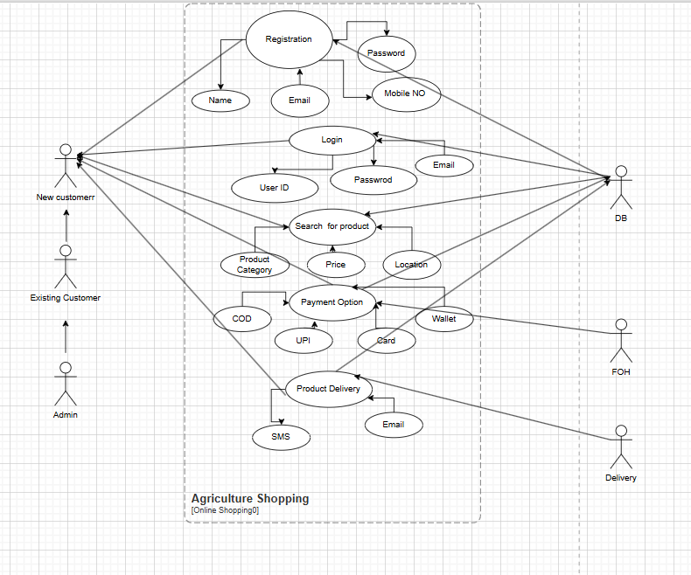
Question 11 – (minimum 5) Use Case Specs - 15 Marks
Prepare use case specs for all use cases
Ans 11 -
Here is a detailed Use Case Specification document for the main use cases identified in the Online Agriculture Products Store project.

✅ USE CASE SPECIFICATIONS

Use Case 1: User Registration
- Use Case ID: UC001
- Actor: Farmer, Manufacturer
- Description: Allows new users to create an account on the platform.
- Preconditions: User is not registered.
- Postconditions: A user account is created.
- Basic Flow:
  - User selects “Register”
  - Enters name, email, mobile number, and password
  - Selects role: Farmer or Manufacturer
  - Clicks “Submit”
  - System validates and creates account
  - Confirmation email is sent
- Alternate Flows:
  - A1: Email already exists → Show error
  - A2: Weak password → Prompt for stronger one

Use Case 2: User Login
- Use Case ID: UC002
- Actor: Farmer, Manufacturer, Admin
- Description: Authenticates users to access the system
- Preconditions: User must be registered
- Postconditions: User is logged in and redirected to dashboard
- Basic Flow:
  - User enters email and password
  - Clicks login
  - System verifies credentials
  - User is redirected to their role-specific dashboard
- Alternate Flows:
  - A1: Incorrect credentials → Show error message

Use Case 3: Upload Product
- Use Case ID: UC003
- Actor: Manufacturer
- Description: Enables product listing in catalog
- Preconditions: Manufacturer is logged in
- Postconditions: Product is saved and submitted for admin approval
- Basic Flow:
  - Manufacturer clicks “Upload Product”
  - Enters product name, description, category, price, quantity, image
  - Clicks “Submit”
  - Product goes to Admin for approval
- Alternate Flows:
  - A1: Missing mandatory fields → Error shown
  - A2: Image upload fails → Prompt to retry

Use Case 4: Search Products
- Use Case ID: UC004
- Actor: Farmer
- Description: Farmers search for products by keyword, category, or manufacturer
- Preconditions: Products exist in the system
- Postconditions: Relevant product results are shown
- Basic Flow:
  - Farmer enters keyword or filter
  - Clicks “Search”
  - System displays matching results

Use Case 5: Place Order
- Use Case ID: UC006
- Actor: Farmer
- Description: Completes purchase of selected products
- Preconditions: User must be logged in; cart must have items
- Postconditions: Order is placed and confirmation is sent
- Basic Flow:
  - Farmer reviews cart
  - Selects payment option (COD, UPI, Card)
  - Enters delivery address
  - Clicks “Place Order”
  - System processes and confirms order
- Alternate Flows:
  - A1: Payment fails → Retry
  - A2: Address incomplete → Prompt user

Use Case 6 : Track Order
- Use Case ID: UC007
- Actor: Farmer
- Description: Farmer can track the status of delivery
- Preconditions: Order has been placed
- Postconditions: Tracking details are shown
- Basic Flow:
  - Farmer clicks “Track Order”
  - System displays current delivery status

.Question 12 – (minimum 5) Activity Diagrams - 15 Marks
Activity diagrams
Ans 12 –
On Boarding of Client
. 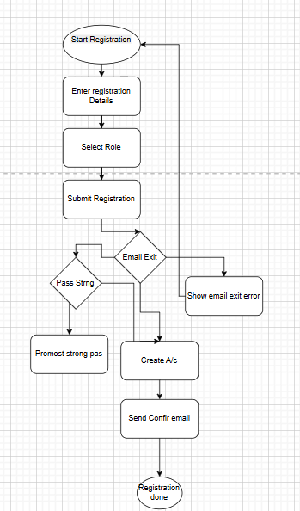

User Login 2

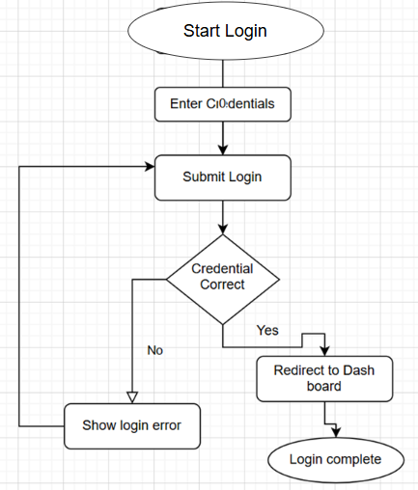

Manufacturer Product Management 3
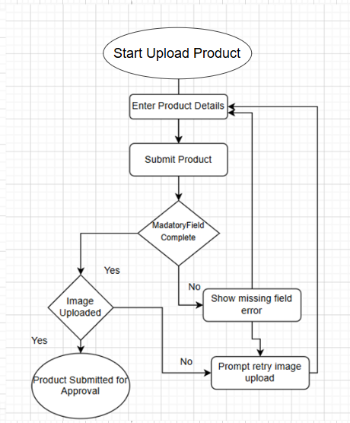

Farmer Product Search 4

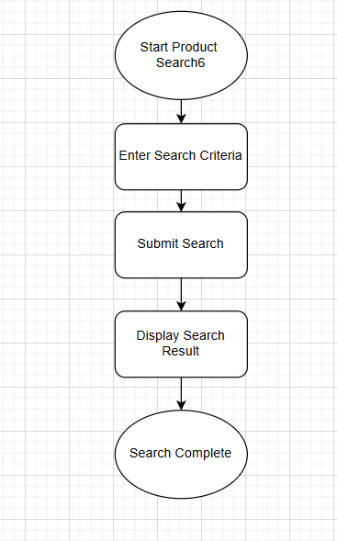

Farmer Order Placement 5

