Nurturing Process - Capstone Project3– Part -1/2 V2D2 August 2024

A customer can make a payment either by Card or by Wallet or by Cash or by Net banking. Q1. Draw a Use Case Diagram

Q2. Derive Boundary Classes, Controller classes, Entity Classes

View (boundary class)
It represents the presentation layer of application. It is used to visualize the data that the model
contains.
Model (entity class)
It represents the business layer of application. It is an object to carry the data that can also contain the logic to update controller if data is changed.
Controller (controller class)
It works on both the model and view. It is used to manage the flow of application, data flow in the model object and to update the view whenever data is changed.

Boundary Classes | Paymentoptionboundary  Cardpaymentboundary  Walletpaymentboundary  Cashpaymentboundary  Netbankingpaymentboundary
Controller Classes | Paymentinitiationcontroller  Cardpaymentcontroller  Walletpaymentcontroller  Cashpaymentcontroller  netbankingpaymentcontroller
Entity Classes | Customer  Payment  Card  Wallet  Bank Server

Q3. Place these classes on a three tier Architecture.
Application Layer | Paymentoptionboundary  Cardpaymentboundary  Walletpaymentboundary  Cashpaymentboundary  Netbankingpaymentboundary
Business Layer | Paymentinitiationcontroller  Cardpaymentcontroller  Walletpaymentcontroller  Cashpaymentcontroller  netbankingpaymentcontroller
Database Layer | Customer (Entity Class)  Payment (Entity Class)  Card (Entity Class)  Wallet (Entity Class)  Bank Server (Entity Class)

Q4. Explain Domain Model for Customer making payment through Net Banking

Q5. Draw a sequence diagram for payment done by Customer Net Banking

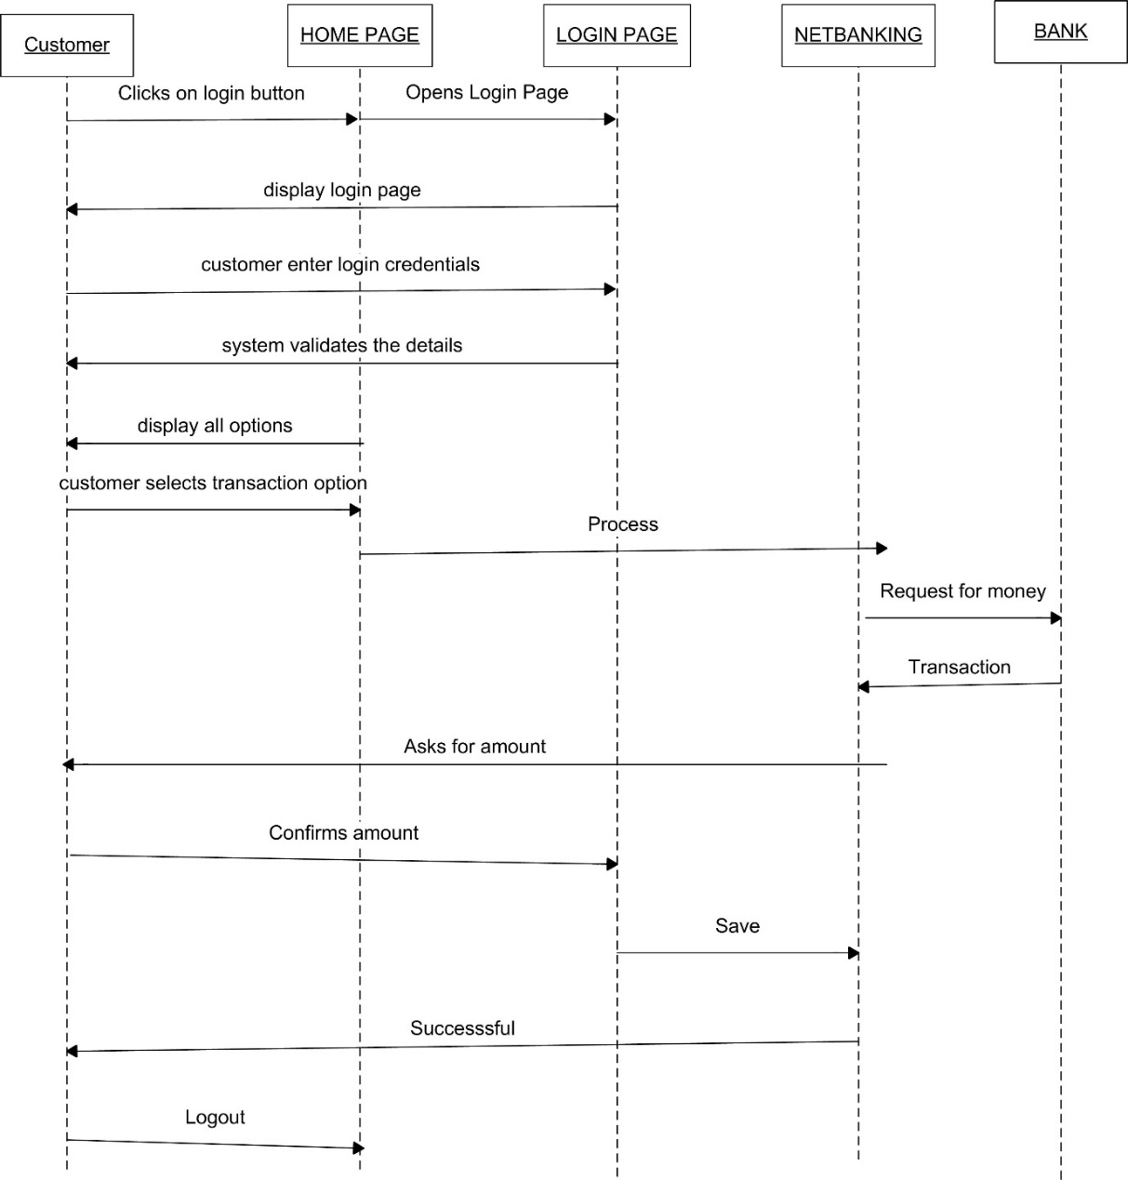
Q6. Explain Conceptual Model for this Case
The conceptual model is the model of an application that designers want users to understand. By using the software and perhaps reading its documentation, users build a model in their minds of how it works. Its primary objective is to convey the fundamental principles and basic functionality of the system which it represents. It is an abstract, psychological representation of how tasks should be carried out

Q7. What is MVC architecture? Explain MVC rules to derive classes from use case diagram and guidelines to place classes in 3-tier architecture
Ans
The Model-View-Controller (MVC) framework is an architectural/design pattern that separates an application into three main logical components Model, View, and Controller. Each architectural component is built to handle specific development aspects of an application. It isolates the business logic and presentation layer from each other
Features of MVC
It provides a clear separation of business logic, Ul logic, and input logic.
It offers full control over your HTML and URLs which makes it easy to design web application
architecture.
It is a powerful URL-mapping component using which we can build applications that have
comprehensible and searchable URLs.
It supports Test Driven Development (TDD).
Components of MVC
The MVC framework includes the following 3 components:
Controller
Model
View
MVC Architecture Design
Controller:
The controller is the component that enables the interconnection between the views and the model so it acts as an intermediary. The controller doesn’t have to worry about handling data logic, it just tells the model what to do. It processes all the business logic and incoming requests, manipulate data using the model component and interact with the View to render the final output.
View:
The View component is used for all the UI logic of the application. It generates a user interface for the user. Views are created by the data which is collected by the model component but these data aren’t taken directly but through the controller. It only interacts with the controller
Model:
The Model component corresponds to all the data-related logic that the user works with. This can represent either the data that is being transferred between the View and Controller components or any other business logic-related data. It can add or retrieve data from the database. It responds to the controller’s request because the controller can’t interact with the database by itself. The model interacts with the database and gives the required data back to the controller.
MVC Rules in identifying classes:
1. Combination of one actor and a use case result in one boundary class
2. Combination of two actor and a use case result in two boundary class
3. Combination of three actor and a use case result in three boundary class
Note: only one primary actor is to be considered with a use case
4. Use case will result in a controller class
5. Each actor will result in one entity class
Guidelines to place identified MVC classes in 3 tier architecture:
1. Place all entity classes in DB layer.
2. Place Primary Actor associated boundary class in application layer
3. Place controller class in application layer.
4. If governing body influence or reusability is there with any of the remaining boundary classes, place them in business layer

Q8 BA contribution to project waterfall
Ans
Requirement gathering analysis- This is initial stage of the project where BA is involved. BA is mainly responsible for preparing BRD (Business Requirement Document)
Design- A BA communicates with clients on the design and solution documents to make them
understand how the solution would look. A BA prepares prototypes and mock-ups along with
the design teams for helping the client understand about the final product and also take
feedback on the same for any changes and improvements.
Coding- BA organizes JAD sessions, clarifies queries of technical team during coding. A
developer refers to the diagrams and documents prepared by a BA to code their unit. Regular
status meetings are conducted to update the client on the progress.
Testing- A BA prepares test cases from the use cases or assist testing team to do so. A BA
performs high level testing and prepares client for UAT, updates end user manuals, updates RTM
and takes sign off on UAT.
Deployment and Implementation- BA forwards the RTM to the client or PM to be attached to
the project closure document, coordinates to complete and share end user manuals, plans and
organizes training sessions for end users. BA prepares lessons learned from this project to take
precautions for upcoming project.
Maintenance- Once the implementation is done team has to provide support for installation, handling change request and providing support. This will be mainly handled by support team by coordinating with BA

Q9 What is conflict management and explain the technique?
Ans
Conflict management
Conflict management is the practice of being able to identify and handle conflicts sensibly, fairly, and efficiently. It is the process of dealing with disagreements arising from, for example, diverging opinions, objectives, and needs.
The aim of conflict management is to enhance learning and group outcomes, including effectiveness or performance in an organizational setting.
Thomas - Kilmann technique
Researchers Kenneth Thomas and Ralph Kilmann developed a model for resolving conflicts. This model is known as the Thomas-Kilman model
Conflict occurs whenever people disagree. The disagreement could be over their perceptions, ideas, values, motivations, or desires. This model is based on two dimensions of conflict management: assertiveness and empathy.
Based on these two dimensions, there are five conflict resolution strategies: Competing, Avoiding, Accommodating, Collaborating, and Compromising

1.Competing
we have high assertiveness and low empathy. We use competing as a conflict resolution strategy
whenever we resort to being aggressive. In addition, we also get uncooperative with the opponent.
The first strategy for dealing with conflict is competing. This strategy works well when you are in a commanding position and have limited time and resources to resolve the conflict.
2. Avoiding
We see low assertiveness and low empathy. That means you neither asset your position nor do you consider or emphasize the other party's point of view.
The second strategy for dealing with conflict involves avoiding it.
People use this conflict management strategy when they know that they don't have any authority over the other person. Instead, they avoid confrontation by ignoring or avoiding the conflict entirely
3.Accommodating
we find low assertiveness and high empathy.
Accommodating is a third strategy for dealing with conflict.
The idea behind this approach is to make concessions. For example, if one person makes a request, you agree to do what the first person requested instead of arguing about the matter.
It's an effective way to manage conflict when you lack power
4. Collaboration
we see high assertiveness and high empathy.
When you collaborate, you take a moderate approach to solving problems. You attempt to balance power between yourself and another person. You also try to find common ground and work together towards achieving a shared goal.
It's an ideal choice if both parties are committed to reaching a mutual agreement. The goal here is to reach an agreement with each other. It also needs two people who trust each other and value working together
5. Compromising
which is compromising. This is the middle of the assertiveness and empathy scale
If you compromise, you take the middle road between opposing views. This means agreeing to specific terms and giving up on certain other items. And since you're trying to resolve a disagreement, it's important that you show flexibility.

Q 10. List down the reasons for project failure?
Ans
Reasons for project failure
Wrong Business Requirements: - A thorough analysis of requirements is essential at the initiation phase to avoid future complications. Proper requirements analysis will only lead to delivering correct product.
Poor planning: - Planning is the first and foremost and the most important step in the journey of the project. It lays the foundation of a project. If planning is improper, the desired outcome will not fall into place.
Continuous change in requirements: - Especially if the project is dynamic in nature, this becomes very true. Any change request in business needs can lead to the business case becoming outdated before a project has been completed leading to total failure.
Unrealistic expectations: - It is important that the right people are assigned to perform tasks based on their skills and performance metrics. The concerned person should have awareness and in-depth knowledge of he/she will be doing in the project. Expectations should be realistic.
Lack of user involvement: - It is essential to engage user during the project lifecycle as their suggestions and feedbacks play an important role. Failure in user involvement in the project leads to an improper end result and the product fails to meet the user expectations.
Lack of executive support: - Project may also fail if there’s no proper guidance or support from the executives. This is because, without effective leadership, team members will not be able to work together effectively.

Q 11. List the Challenges faced in projects for BA?
Ans
Challenges that are faced by a business analyst in real time are as follow: -
Lack of training-
it includes all those areas which are directly or indirectly related to the project by efficient training to the people involved in project we can definitely produce a good and efficient result for the organisation.
Obtaining sign off on requirements-
This is one of the major areas where a business analyst struggles for while taking sign off on requirement it is necessary for him/her to convince them to the best that all the requirements will be satisfied for taking sign off they have to keep on approaching the clients and be in touch, book an appointment to have the sign off on requirements as well.
Changing business needs and requirement -
Business analyst has to come up with all the changes that comes in a management while completion of the Project, he/she has to put on the whole process by being involved in the process and managing the changes in the organisation.
Coordination between developers and testers-
In any project if the coordination between developers and tester is not well managed then the project success could not be assumed.in any project it is must to create a coordination between both these teams in an efficient way.
Conducting meetings-
Conducting meeting is very important and necessary, which is managed by the business analyst as it creates a very great impact in the view of stakeholders. one must note down one thing is to create an effective meeting and minutes and agenda should be prepared well in advance.
Making sure status reporting is effective-
The report status is the key factor of the meeting and the one who is responsible must take care of it in such way by maintaining secrecy of the report.
Driving clients for UAT completion-
The UAT completion must by the clients and this will be the main part of the project which must be looked up by business analyst.
People management-
People management is the main quality that a business analyst must have, this helps the business analyst to control all the fields in a proper way by which they may create a well and healthy atmosphere with a productive result as well.

Q12. Write about Document Naming Standards?
Ans
1. Keep file names short but meaningful.
2. Include any unique identifiers, e.g. case number, project title.
3. Be consistent.
4. Indicate version number where appropriate.
Ensure the purpose of the document is quickly and easily identifiable and all Documents will be named using some standards like
[Project ID][Document Type]VD[Y].ext.
Example: PQ298BRDV1D1.docx
PQ298BRDV1D1.2.docx
PQ536BRDV1D1docx

Q13. What are the Do’s and Don’ts of a Business analyst?
Ans
Business analysts are responsible for working with management to improve operating procedures, reduce costs and inefficiencies, and achieve better performance Business Analyst will be independent of domain and technology.

DO’S of a Business Analyst:
- Confirm understanding with client
- Always have a client interaction so that project will be on track
- Always open to work on any domain and technology
- Reach office at least 15 min prior to shift timing
- Solve the client problem only with IT solution
- Be like a lotus in a mud
- Never take Tensions but pass on the tensions
- Requirement hurried – Project buried
- Always appreciate stakeholder even they contributed even small efforts for a project
- Never say “NO” to client
- There is no word called as “By Default”
- Never imagine anything in terms of GUI
- Consult an SME for clarifications in requirement
- Need to conduct daily meetings with team to take updates on project
- Always need to follow up to Email in a call and update model
- Need to maintain individual contribution work sheet (Time Sheet)
- Ensure the users involvement
- Important mails are followed up by a phone call
- All mails should be acknowledged
- All project mails should be copied to Project Manager
- BA should follow the decisions taken by Project Manager
- Need to handle Conflict Management
- Need to communicate client requirement into UML to Developers and Testers
- Need to clarify doubts related to functional and non-functional requirements to tester and developers
- BA should check the change request and accordingly need to handle change requirement
- BA should identify stakeholder and need to be documented
- BA need to prepares BRD by interacting with client
- Prototyping can be used by BA to make the client to give more specific requirements
- A need to sort the gathered requirements
- BA need to prioritize requirements
- BA need to validate requirements
- A organizes JAD Sessions
DONT’S of a Business Analyst:
- Criticizing stake holder
- Improper requirement gathering from client
- Arrogant with team
- Hurried in Requirement gathering from client
- Imaging / guessing of requirements
- As working in a similar project and expecting that all projects will be similar model only and working in a monotonous way
- Delaying for updating information to client as well as to PM
- Delaying in communicating reply to emails
- Do not leave Emails without follow up to respective team
- Do not hide the tensions and last-minute updates need to be avoided
- Do not do improper planning
- Improper coordinating with team members
- Not having complete information about the functional and non-functional requirement
- Expressing individual opinion without doing pre project homework
- Very rude attitude and not holding updates of the projects

Q 14. Write the difference between packages and sub-systems
Ans
Packages:
A package is a grouping and organizing element in which other elements reside, which must be uniquely named. In the UML, packages are used in a manner similar to the way directories and folders in an operating system group and organize files. It is a collection of components which are not reusable in nature.
Subsystems:
Collection of components which are reusable in nature. system is an organized collection of elements that may be decomposed into smaller subsystems and eventually into non decomposable primitive elements. For example, the project management system
may be decomposed into the following:
- A user interface subsystem responsible for providing a user interface through which users may interact with the system.
- A business processing subsystem responsible for implementing business functionality
- A data subsystem responsible for implementing data storage functionality. while a package simply groups elements, a subsystem groups elements that together provide services such that other elements may access only those services and none of the elements themselves E.g. Tally software is one of the examples of subsystem

Q15. What is camel-casing and explain where it will be used?
Ans
Camel casing
CamelCase is a way to separate the words in a phrase by making the first letter of each word capitalized and not using spaces. It is commonly used in web URLs, programming and computer naming conventions. It is named after camels because the capital letters resemble the humps on a camel's back. Entire first word will be in lowercase and subsequent word’s first letter should be in Upper Case. There will be no gap in between words.
Example: GoThere(), CompleteTheProject(), GetEmpId(), TurnLeftAndSlowDown
Entire first word will be in lowercase and subsequent words first letter should be in Upper Case. There will be no gap in between words.

Q16. Illustrate Development server and what are the accesses does business analyst has?
Ans
Development server
It is a type of server that is designed to facilitate the development and testing of programs, websites, software or applications for software programs. It provides a run-time environment, as well as hardware, software utilities that are essential to perform debugging and development.BA has visualizing access in development server. BA get access to all functional server so that it would identify the user trends.

Q17. What is Data Mapping?
Data mapping is the process through which we take one set of data known as the source and assign or map its destination known as the target. The goal is to make organization’s data more structured, cohesive, and accessible to team or customers

Q18. What is API. Explain how you would use API integration in the case of your application Date format is dd-mm-yyyy and it is accepting some data from Other Application from US whose Date Format is mm-dd-yyyy?
Ans
API stands for application programming interface. An API are mechanism that enables two software components to communicate with each other using a set of definition and protocol. Developers use APIs to make their jobs more efficient by reusing code from before and only changing the part that is relevant to the process they want to improve. A good API makes it easier to create a program API stands for Application programming interface. Interface can be thought of as a contract of service between two applications.
API is a way for two or more computer programs to communicate with each other. API is a software interface that allows two applications to interact with each other let’s understand via one example, you want to book your flight ticket using amazon/paytm of Indigo flight for Mumbai to Goa destination but the amazon/paytm have not excess of Indigo company, in this case via API the application shows the require details like available date/seat etc. API is the intermediate of two applications. using API we can go for the booking. an API used to integrate new applications with existing software system. It serves as the connection between two applications, letting them exchange data. This increase development speed because each functionality doesn't have to be written from scratch

