Document 6- Please prepare a use case diagram,
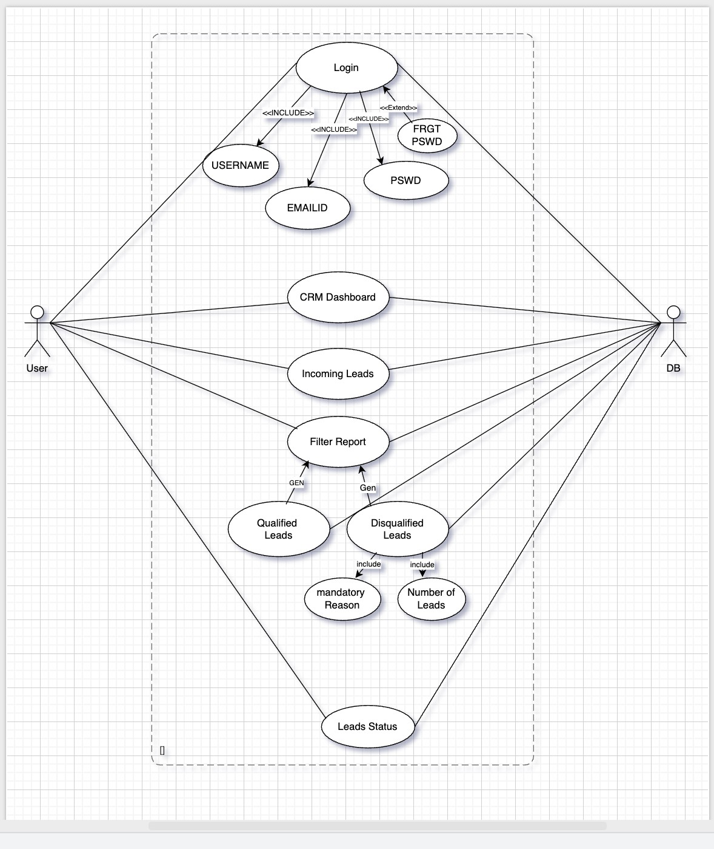

Activity diagram :

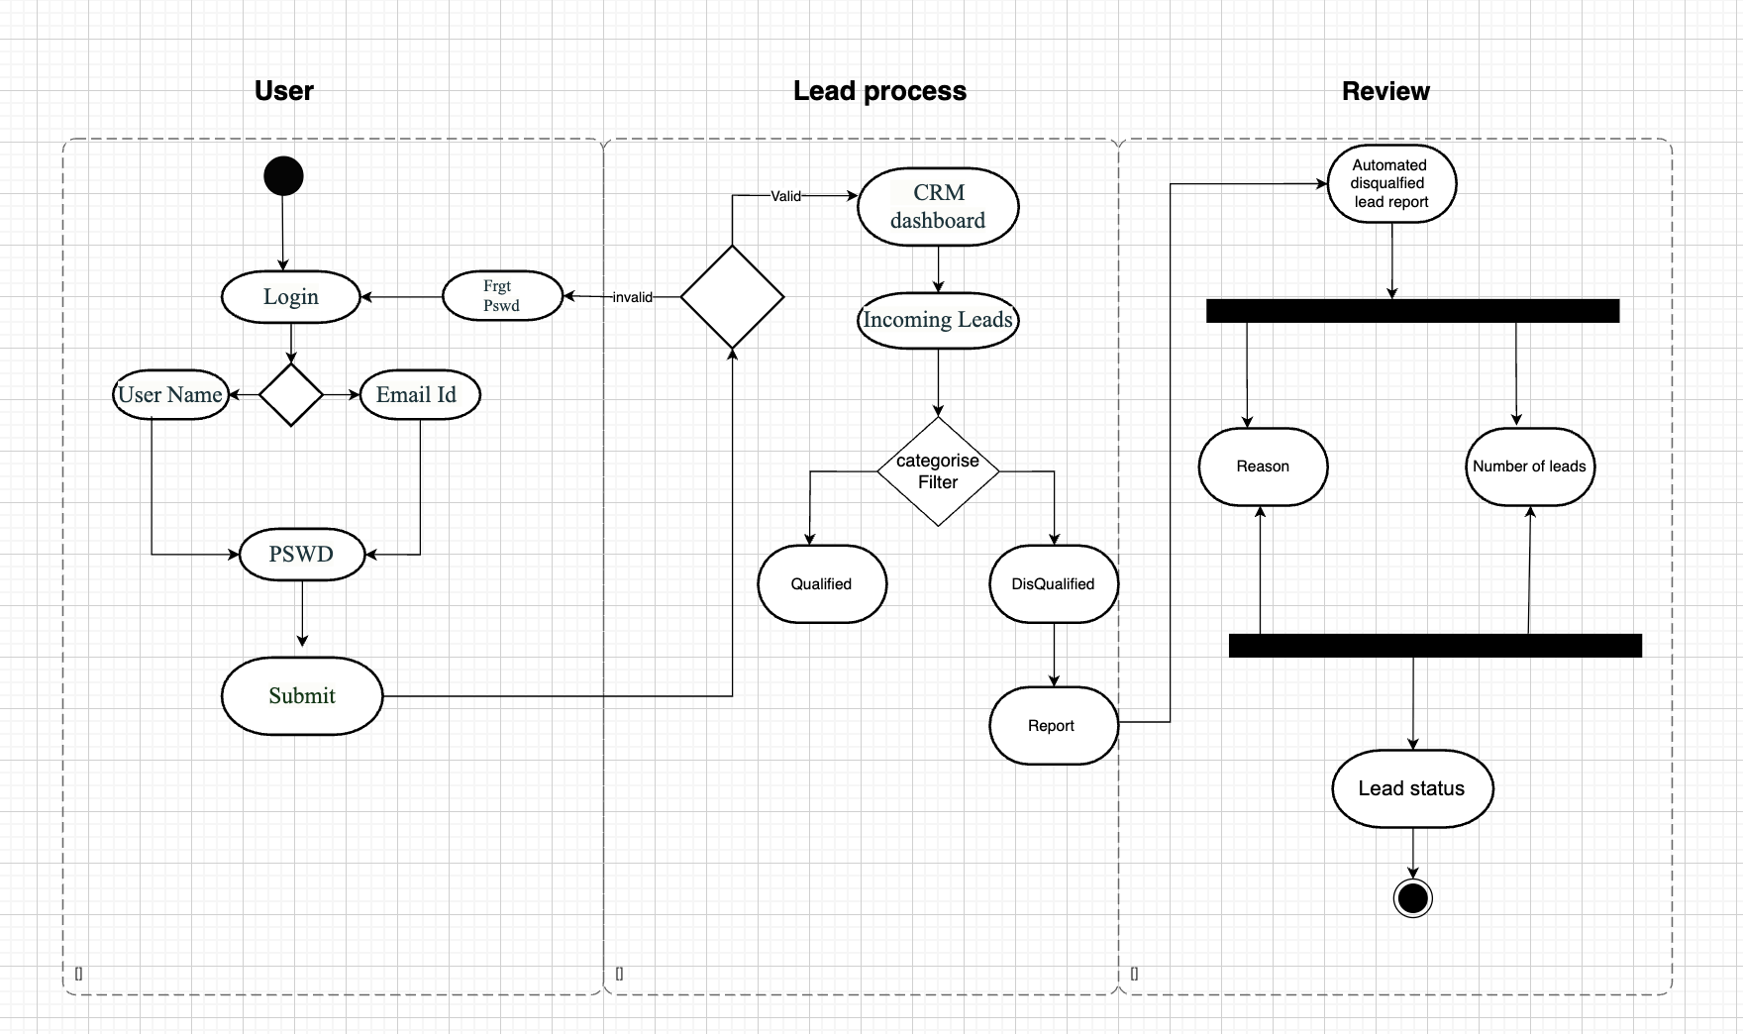

Use case specification document

Use Case : Login
- Use Case Name: Login
- Use Case Description: users to authenticate themselves into the CRM system.
- Actors: Primary: User (Sales/Marketing/Admin) Secondary: CRM Database
- Basic Flow:
User navigates to the login page.
User enters credentials (username and password). System validates credentials.

If valid, user is granted access to the CRM dashboard.
- Alternate Flow: User selects "Forgot Password" to reset their password.
- Exceptional Flows:
  - Invalid credentials entered more than 3 times lead to account temporarily locked.
  - Server down , Login fails.
- Pre-Conditions: User must have registered credentials.
- Post-Conditions: User is authenticated and redirected to the CRM dashboard.
- Assumptions:
  - User has active internet connection.
  - Authentication API is functional.
- Constraints: System must enforce password security policy.
- Dependencies: Authentication & Authorization services.
- Inputs: Username, Password
Outputs: Session Token, Access to Dashboard
- Business Rules:
3 failed attempts temporarily lock the account. Passwords must meet complexity rules.
- Miscellaneous Information: N/A

Use Case 2: CRM Dashboard
- Use Case Name: CRM Dashboard Access
- Use Case Description: Displays a centralized view of lead performance, incoming leads, conversions, and reports.
- Actors:
Primary: Logged-in User Secondary: CRM Database
- Basic Flow:
User logs into the system. User lands on the dashboard.
System displays stats: lead counts, recent activity, disqualified leads, insights.
- Alternate Flow: User customizes dashboard widgets or layout.
- Exceptional Flows: No data to display . System shows "No records found". Reporting API failure.

- Pre-Conditions:
Valid user session.
Dashboard modules configured.
- Post-Conditions: User views up-to-date CRM data on dashboard.
- Assumptions: Required permissions exist for modules.
- Constraints: Limited access for non-admin roles.
- Dependencies: Data warehouse, Reporting Service
- Inputs: CRM data
Outputs: Graphical dashboard UI
- Business Rules:
Dashboard refreshes every X minutes. Data filters apply to widget content.
- Miscellaneous Information: Supports both mobile and desktop layouts.

Use Case 3: Incoming Leads
- Use Case Name: Incoming Leads Capture
- Use Case Description: Captures new leads submitted via web forms, integrations, or manual entries.
- Actors:
Primary: Sales/Marketing Team Secondary: CRM Database
- Basic Flow:
Lead data entered manually or received via integration. CRM validates lead fields.
Lead is added to the system and marked “New.”
- Alternate Flow: Leads bulk uploaded via CSV import.
- Exceptional Flows:
Data validation fails then lead rejected. Duplicate lead detected then flag for review.
- Pre-Conditions:
CRM integration enabled. Required fields defined.
- Post-Conditions: Lead is recorded and visible in pipeline.
- Assumptions: Lead source provides reliable data.

- Constraints: Max lead size or field limits.
- Dependencies: Manual input.
- Inputs: Lead data (name, email, source) Outputs: Lead entry in CRM
- Business Rules:
Mandatory fields must be filled. Leads must be unique by email.
- Miscellaneous Information: Lead source is tagged for attribution.
Use Case 4: Filter Report
- Use Case Name: Filter Report
- Use Case Description: Allows users to apply filters (e.g., date, region, reason) to generate customized reports.
- Actors:
Primary: Sales Head, Marketing Analyst Secondary: CRM Database
- Basic Flow:
User navigates to Reports section. Selects filters (date, status, region). Clicks "Generate".
System displays filtered data in chart/table format.
- Alternate Flow: Export filtered report as CSV or PDF.
- Exceptional Flows:
No data matches → Show "No results message."
Invalid filter combination.
- Pre-Conditions: User must have reporting access.
- Post-Conditions: User views/downloads a report.
- Assumptions: Data is updated in real time.
- Constraints: Filters limited to 6/month by basic users.
- Dependencies: Data indexer, Reporting engine.
- Inputs: Filter options Outputs: Custom lead report
- Business Rules: User roles determine level of report access.
- Miscellaneous Information: Supports drill-down by lead source or campaign.

Use Case 5: Disqualified Leads (Reason & Number of Leads)
- Use Case Name:Track Disqualified Leads and Reasons
- Use Case Description: Logs disqualified leads and captures standardized reasons for analytics and reports.
- Actors:
Primary: Sales Executive, Marketing Analyst Secondary: CRM Database
- Basic Flow:
User disqualifies a lead.
System prompts to select a reason. Reason is recorded against the lead.
Lead data updates report of disqualified leads.
- Alternate Flow: User adds optional notes for context.
- Exceptional Flows: User skips reason selection → Prevent save, show validation
error.
- Pre-Conditions: Lead is in active/pending state.
- Post-Conditions: Lead is marked disqualified with reason linked.
- Assumptions: Drop-down reasons are predefined and maintained.
- Constraints: Reason field is mandatory to mark as disqualified.
- Dependencies: User interface, Reporting module
- Inputs: Lead ID, Disqualification reason Outputs: Updated lead record, report data
- Business Rules: Reasons are not editable by users. All disqualifications are logged with a timestamp.
- Miscellaneous Information: Used in weekly lead drop-off analysis.

Use Case 6: Leads status
- Use Case Name: Lead Insight Dashboard
- Use Case Description: Analyzes lead trends, sources, and disqualification patterns for decision-making.
- Actors:
Primary: Marketing Manager, Sales Manager

Secondary: CRM Database
- Basic Flow:
User opens Lead Insight module. Filters by time period, region, campaign.
Visual charts display trends (top sources, drop reasons, conversion rates).
- Alternate Flow: Export insights as PowerPoint or PDF summary.
- Exceptional Flows: Data not loading → Prompt user to retry or refresh.
- Pre-Conditions: Leads and interaction data available in CRM.
- Post-Conditions: User views data-backed insights and shares them.
- Assumptions: All lead actions logged properly.
- Constraints: Insights available for last 12 months only.
- Dependencies: CRM DB, BI visualization tools
- Inputs: Filter criteria
Outputs: Insight dashboard (charts, graphs, tables)
- Business Rules: Data shown depends on user role. Insights update daily at 2 AM server time.
- Miscellaneous Information: Also shown on executive summary dashboard.

Document 7- Screens and pages Please follow the following steps to create the mock-ups
Login

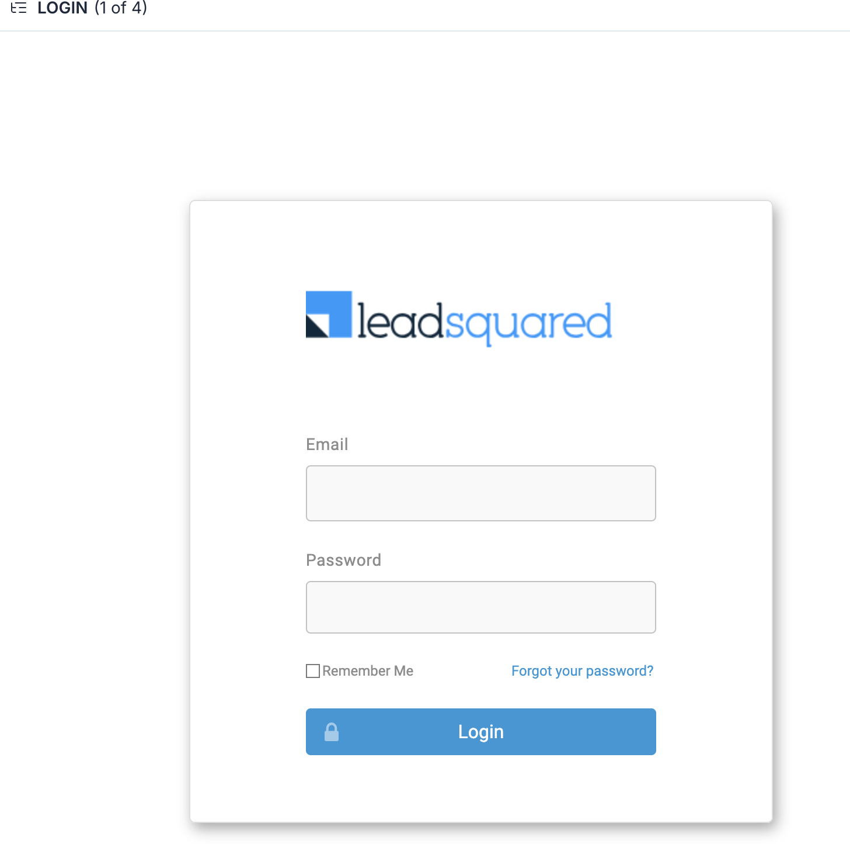

CRM DASHBOARD

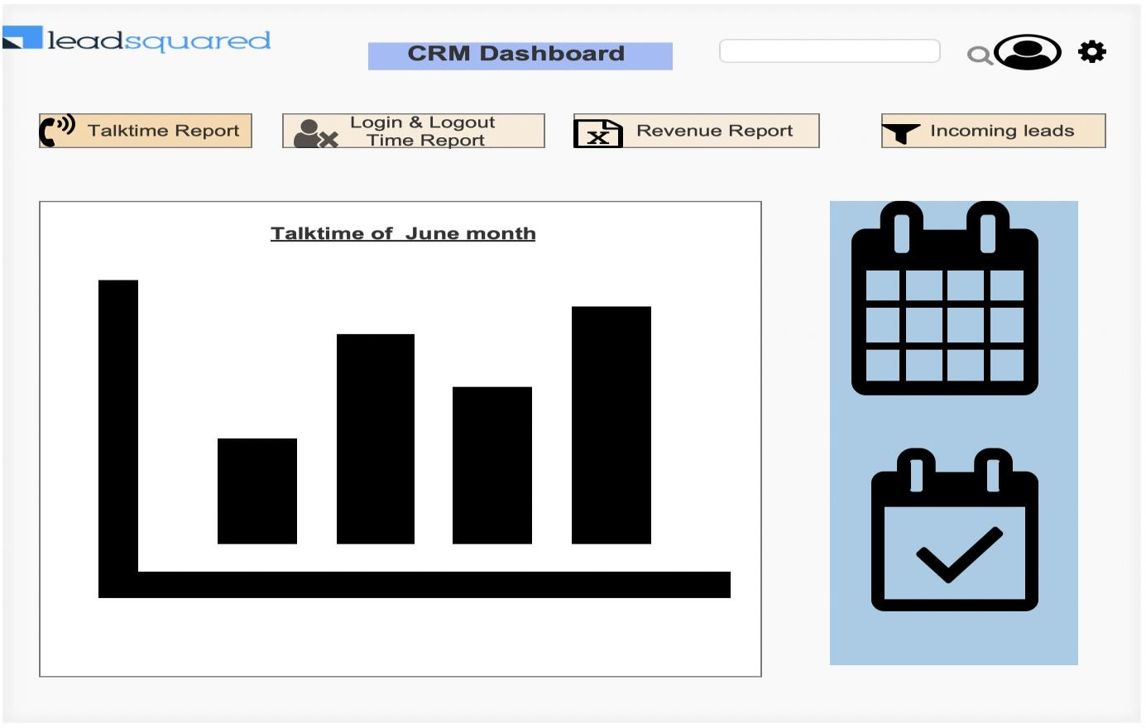

INCOMMING LEADS

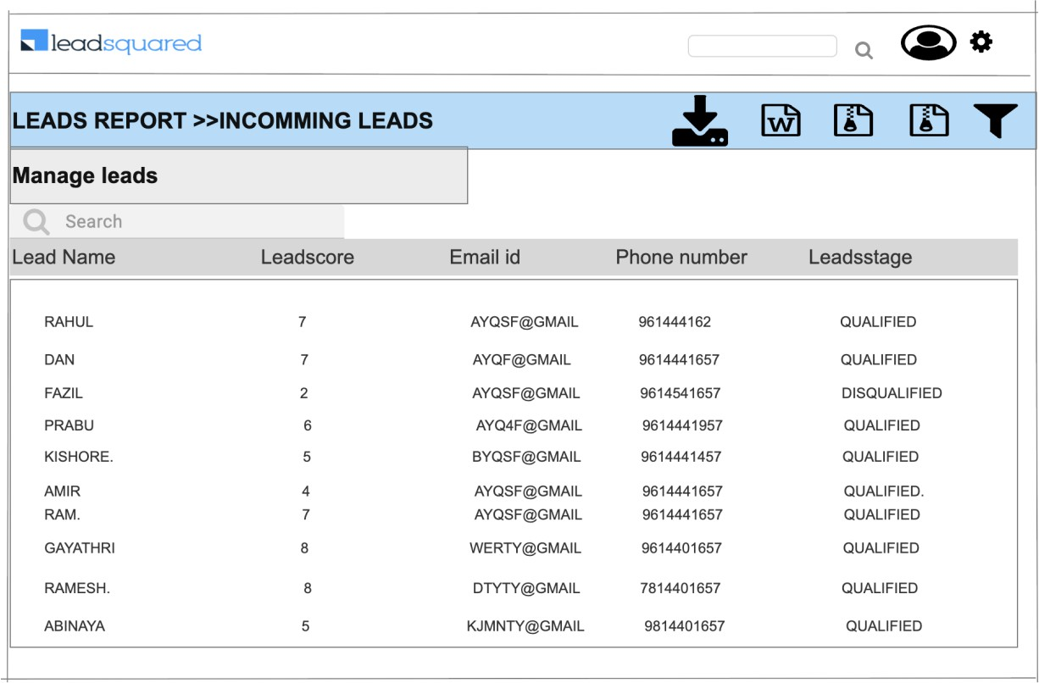

LEADS FILTER REPORT
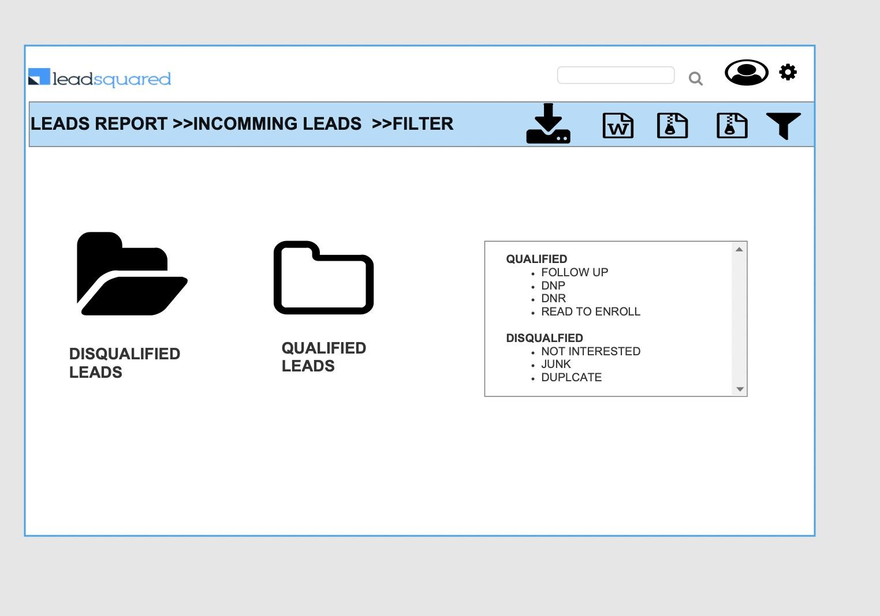

LOGOUT

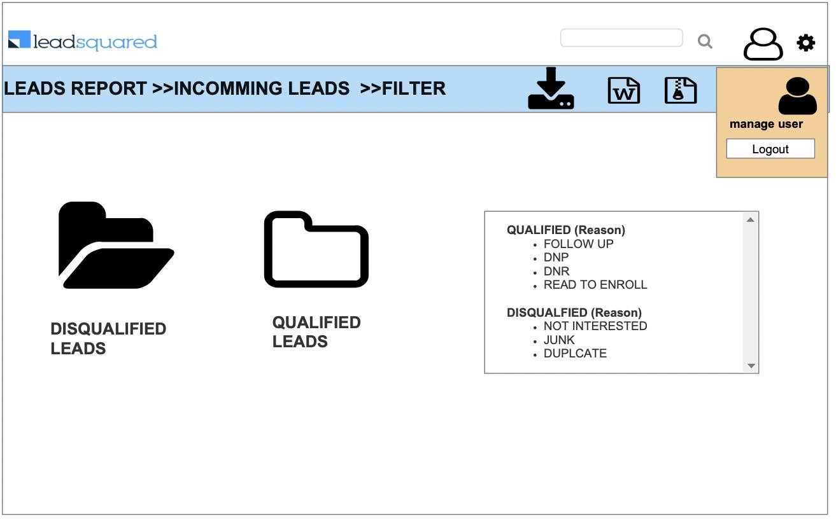

Document 8- Tools-Visio and Axure Write a paragraph on your experience using Visio and Axure for the project.
Microsoft Visio was very helpful for creating clear and organized diagrams like process flows and system designs. It was easy to use with its drag-and-drop tools, and it helped us show how different parts of the system work together. The diagrams made it easier to explain ideas to the team and stakeholders.

We also used Axure RP to design and build interactive screen mockups and advance Wireframe. This allowed us to create clickable wireframes that looked and worked like the real CRM system before it was built. It helped us understand how users would use the system and make improvements early, saving time later. Axure also made it simple to share the designs with others for feedback.

Document 9- BA experience
My experience as BA in following phases:
- Requirement gathering:

  - To gather requirements, we used MOSCOW technique.
  - Client is not available for some period of time during this phase. So as a BA i need to
source out point of contacts from his side and get the information ASAP.
  - I validate the requirements using FURPS technique
  - There are many requirements which are duplicated or repeated. We need to remove
them immediately
  - Prototyping is used to give more specific requirements
- Requirement Analysis:
  - We need to draw UML diagrams to visually describe the requirements
  - Activity diagrams also used to describe the process flow
  - Communicate the diagrams to team. Some team members might not agree with them and might make changes. As a BA we need to consider the points and make modifications
  - Prepare BRD and SRS

- Design:
  - From the use case diagrams, we prepare test cases
  - Communicate with client on design and solution documents
  - Write negative test cases as well along with positive test cases.
  - Do not miss a single test case. It might have huge impact on project development in
later stages
  - Prepare test data for testing
  - Update RTM just as we need to make sure that all the requirements are met
- Development:
  - Organized JAD sessions
  - Clarifying queries of tech team during coding
  - There might be some team members who doesn't agree with the concept or who doesn’t cooperate during JAD sessions. As a BA i handle the situation gently and had one on one discussion with them. Explained how their actions are going to affect the project. Setup healthy environment within the team.

  - Referred diagrams to code the Unit
  - Conduct regular meetings with technical team and client which is challenging. Some team members might not be available for the meeting. Recording the session and providing that to missed one and having one to one discussion later with that missed person is all i need to do .

- Testing:
  - Prepare test cases from use cases
  - Perform high level testing
  - Test data is requested by BA from client
  - Updated RTM
  - Take signoff from client
  - Prepare client for UAT

- Deployment:
  - Forwarded RTM to client which should be attached to project closure document
  - Coordinates to complete and share end user manuals
  - Plans and organizes training sessions
  - Make sure all the candidates attend the meeting

