Document 6
Use Case Diagram, Activity Diagram and Use Case Specification
Document

Use Case Diagram

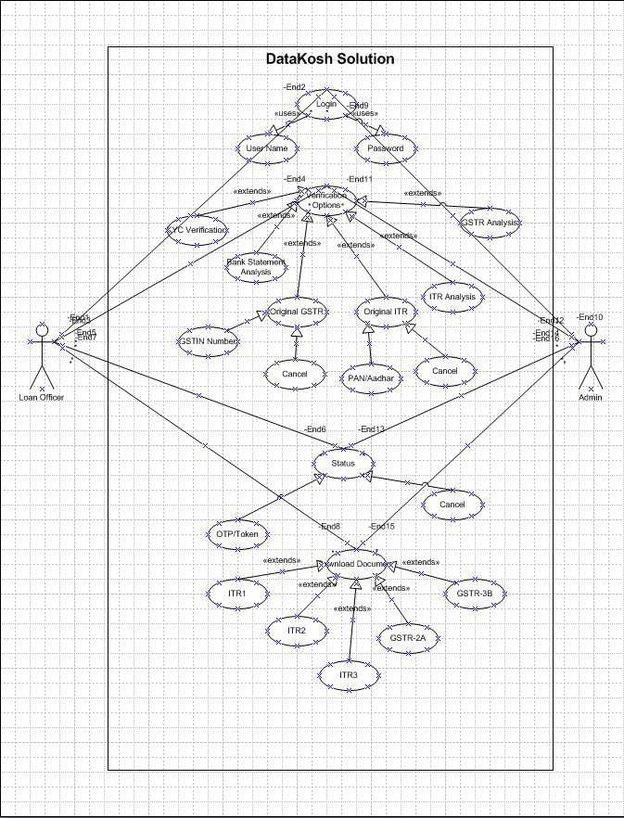

Activity Diagram

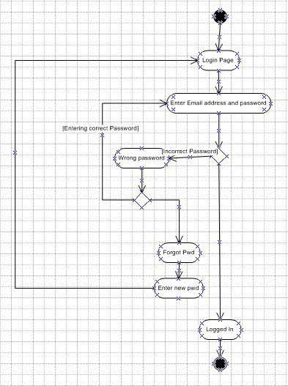

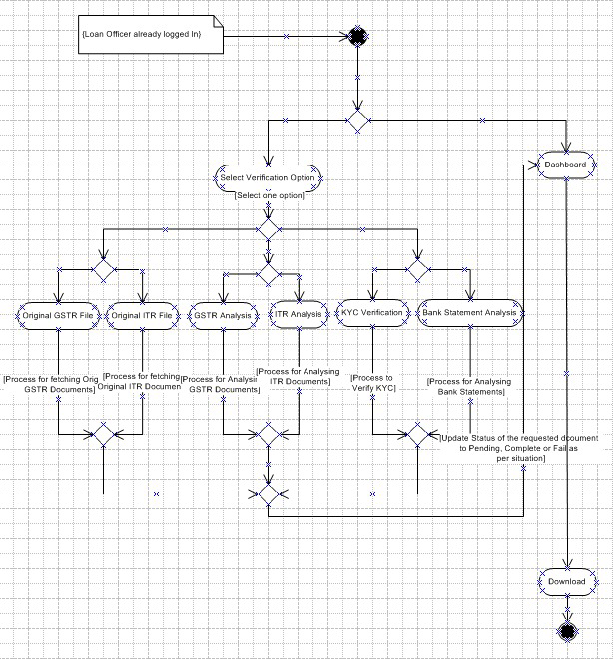

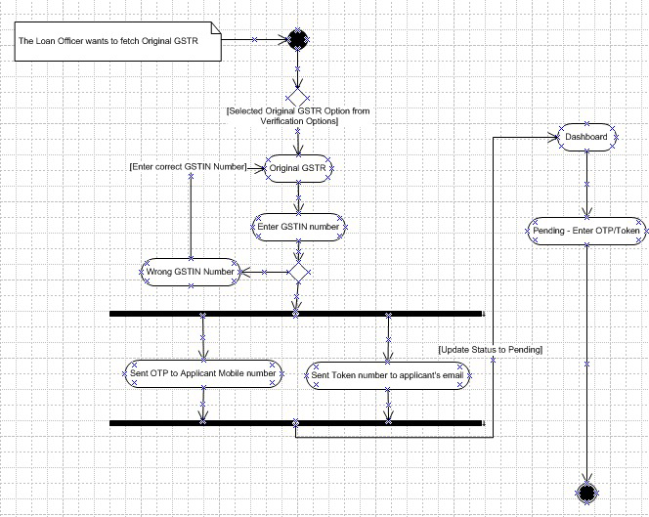

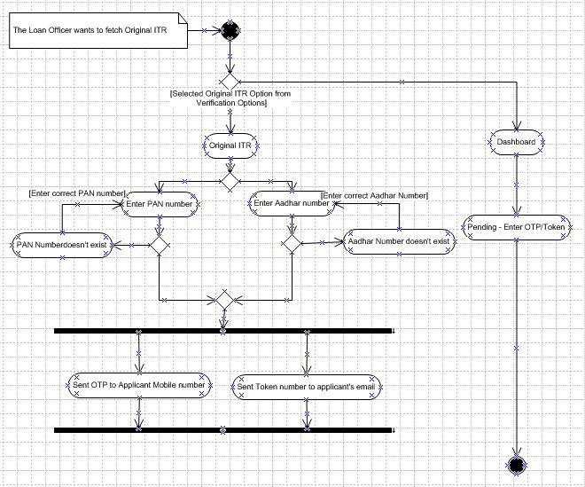

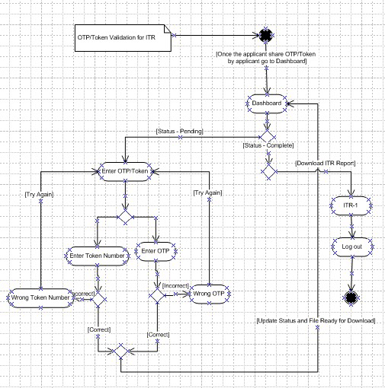

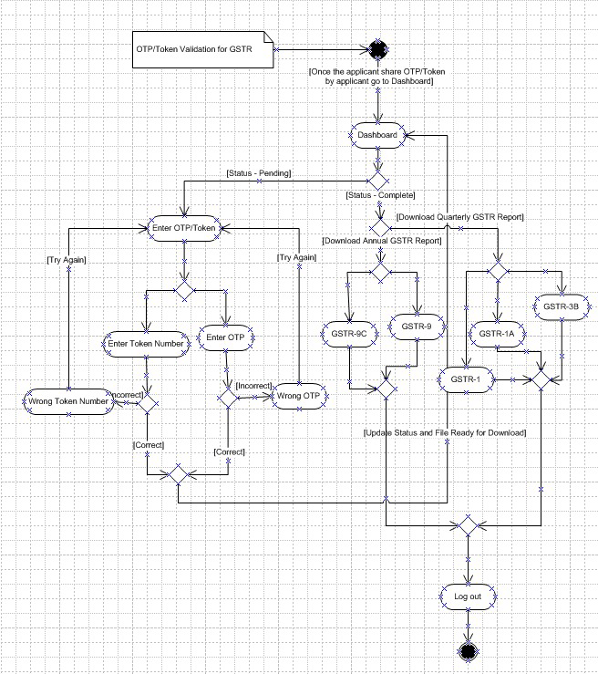

Use Case Specification Document

Use Case Specs - Original ITR Option
Description | Allows the loan officer to initiate the process of retrieving original ITR PDFs by selecting the Original ITR from the Verification options.
Actor | Loan Officer
Pre-Condition | - The loan officer is logged into the Datakosh Solution software.  - The system displays the ITR input page.
Post-Condition | The system sends an OTP and email token to the applicant and updates the dashboard status to "Pending."
Basic Flow | - The loan officer selects the "Original ITR" option from the dashboard.  - The system navigates to the ITR input page, prompting for the applicant’s PAN or Aadhar number.  - The loan officer enters the applicant’s PAN or Aadhar number on the ITR input page.  - The system validates the input format.  - The system sends an OTP to the applicant’s registered phone and an email token to their registered email.  - The system displays a message: "OTP and Token Sent to Applicant."  - The system updates the dashboard status to "Pending" for the ITR request.  - The system returns the loan officer to the dashboard.
Alternative Flow | The PAN/Aadhar number is invalid, the system displays an error message "Invalid PAN/Aadhar Number" and prompts re-entry.
Exceptional Flow | - If the Verification option fails to respond, the system displays an error message System Error. “Try Again”  - If the system fails to send OTP/token (e.g., network issue), it displays an error message "Failed to Send OTP/Token. Try Again."  - The loan officer is prompted to retry or contact support.
Assumption | - The loan officer knows which applicant’s PAN/Aadhar number.  - The applicant’s PAN/Aadhar is linked to a valid phone number and email.
Constraints | - PAN must be 10 alphanumeric characters; Aadhar must be 12 digits.  - OTP/token sending must complete within 10 seconds.
Dependencies | Requires integration with KDK Solution APIs for fetching the documents
Input-Output | - Input: PAN or Aadhar number  - Output: OTP/token sent, dashboard status updated to "Pending," confirmation message
Business Rules | - The system does not store PAN/Aadhar numbers after validation.  - OTP/token is valid for 24 hours.
Misc. Info | Audit trail created.

Use Case Specs - Original GSTR Option
Description | Allows the loan officer to initiate the process of retrieving original GSTR PDFs by selecting the Original GSTR from the Verification options.
Actor | Loan Officer
Pre-Condition | - The loan officer is logged into the Datakosh Solution software.  - The system displays the GSTIN input page.
Post-Condition | The system sends an OTP and email token to the applicant and updates the dashboard status to "Pending."
Basic Flow | - The loan officer selects the "Original GSTR" option from the dashboard.  - The system navigates to the GSTR input page, prompting for the applicant’s GSTIN number.  - The loan officer enters the applicant’s GSTIN number on the GSTR input page.  - The system validates the input format.  - The system sends an OTP to the applicant’s registered phone and an email token to their registered email.  - The system displays a message: "OTP and Token Sent to Applicant."  - The system updates the dashboard status to "Pending" for the GSTR request.  - The system returns the loan officer to the dashboard.
Alternative Flow | The GSTIN number is invalid, the system displays an error message "Invalid GSTIN Number" and prompts re-entry.
Exceptional Flow | - If the Verification option fails to respond, the system displays an error message System Error. “Try Again”  - If the system fails to send OTP/token (e.g., network issue), it displays an error message "Failed to Send OTP/Token. Try Again."  - The loan officer is prompted to retry or contact support.
Assumption | - The loan officer knows which applicant’s GSTIN number.  - The applicant’s GSTIN is linked to a valid phone number and email.
Constraints | - GSTIN must be 15 alphanumeric characters.  - OTP/token sending must complete within 10 seconds.
Dependencies | Requires integration with KDK Solution APIs for fetching the documents
Input-Output | - Input: GSTIN number  - Output: OTP/token sent, dashboard status updated to "Pending," confirmation message
Business Rules | - Only GSTR documents associated with the verified GSTIN should be displayed.  - All available past GSTR filings should be presented.
Misc. Info | Tracks API call count.

Use Case Specs - OTP/Token for ITR/GSTR Retrieval
Description | Allows the loan officer to enter the OTP or email token shared by the applicant to retrieve ITR PDFs
Actor | Loan Officer, Loan Applicant
Pre-Condition | - The loan officer has initiated a ITR/GSTR request, and the dashboard shows "Pending" status.  - The applicant has shared the OTP or token with the loan officer.
Post-Condition | The system retrieves and displays GSTR PDFs with download options, and the dashboard status is updated to "Completed."
Basic Flow | - The loan officer clicks the "Pending" status for the ITR/GSTR request on the dashboard.  - The system displays a page to enter the OTP or email token.  - The loan officer enters the OTP or token.  - The system validates the OTP/token with the government portal.  - The system retrieves all ITR/GSTR documents filed by the applicant.  - The system displays the ITR/GSTR documents with download options.  - The system updates the dashboard status to "Completed."
Alternative Flow | The OTP/token is invalid, the system displays an error message "Invalid OTP/Token" and prompts re-entry.
Exceptional Flow | If the government portal is down or KDK API fails to connect portal, the system displays an error message "Connection to Portal Failed. Try Again or Contact Support."
Assumption | - The applicant shares the correct OTP/token promptly.  - The government portal is available and responsive.
Constraints | OTP/token must be entered within 24 hours of issuance.
Dependencies | Requires API integration with the KDK solution to access government portal.
Input-Output | - Input: OTP or email token  - Output: GSTR PDFs with download options, dashboard status updated to "Completed"
Business Rules | - Only one of OTP or Token is required for validation.  - OTP/token is single-use and expires after 10 minutes.
Misc. Info | Logs each attempt for audit purposes.

Use Case Specs - Download ITR/GSTR PDFs
Description | Allows the loan officer to download retrieved ITR/GSTR PDFs for cross-verification.
Actor | Loan Officer
Pre-Condition | - The ITR/GSTR PDFs have been retrieved, and the dashboard status is "Completed".  - The loan officer is on the ITR/GSTR document display page.
Post-Condition | The selected ITR/GSTR PDFs are downloaded to the loan officer’s local system.
Basic Flow | - The loan officer views the list of retrieved ITR/GSTR PDFs on the document display page.  - The loan officer selects one or more PDFs to download.  - The system initiates the download of the selected PDFs.  - The system logs the download activity for audit purposes.  - The PDFs are saved to the loan officer’s local system.
Alternative Flow | At step 2, the loan officer selects an option to download all available GSTR PDFs.
Exceptional Flow | If the download fails (e.g., due to network issues), the system displays an error message "Download Failed. Try Again."
Assumption | - The Third-Party API System can successfully fetch the ITR PDFs from Government Portals.  - The PDFs are accessible and not corrupted.
Constraints | Download functionality must adhere to security protocols (e.g., no malicious content).
Dependencies | - Third-Party API System.  - Government Portals.  - Local file system access for download.
Input-Output | - Input: Selection of PDFs to download  - Output: Downloaded PDFs, audit log entry
Business Rules | - All available past ITR filings should be presented.  - PDFs are available for download for 30 days, after which they are deleted from the system.  - Audit every download.
Misc. Info | Download logs retained.

Use Case Specs – Error Handling
Description | Manages error scenarios across all interactions, providing appropriate messages and recovery options.
Actor | System Administrator
Pre-Condition | An error occurs during any use case (e.g., invalid input, connection failure).
Post-Condition | The system displays an error message and provides recovery options (e.g., retry, contact support).
Basic Flow | - An error occurs during a system operation (e.g., invalid PAN/Aadhar/GSTIN, failed OTP sending).  - System displays an error message: "Network connection error. Please check your internet connection and try again."  - The system provides recovery options (e.g., re-enter input, retry, contact support).  - The system logs the error for audit and debugging purposes.
Alternative Flow | If the loan officer selects "Retry," the system returns to the relevant input step (e.g., re-enter PAN/Aadhar).
Exceptional Flow | If the error is critical (e.g., database failure), the system notifies the system administrator and displays "System Unavailable. Contact Support."
Assumption | - The authentication service is operational and accessible.  - The system has robust error logging capabilities.
Constraints | - Error messages must be displayed within 2 seconds of the error occurring.  - Error logs must be retained for 7 years for compliance.
Dependencies | - Network connectivity.  - Requires a logging system and support contact database.
Input-Output | - Input: Error condition (e.g., invalid input, network failure)  - Output: Error message, recovery options, error log entry
Business Rules | - All errors are logged with timestamp, user ID, and error type.  - Critical errors trigger immediate admin notification.
Misc. Info | Error handling uses a centralized module to ensure consistency across the system.

Document 7
Screens and Pages

Create the mock-ups

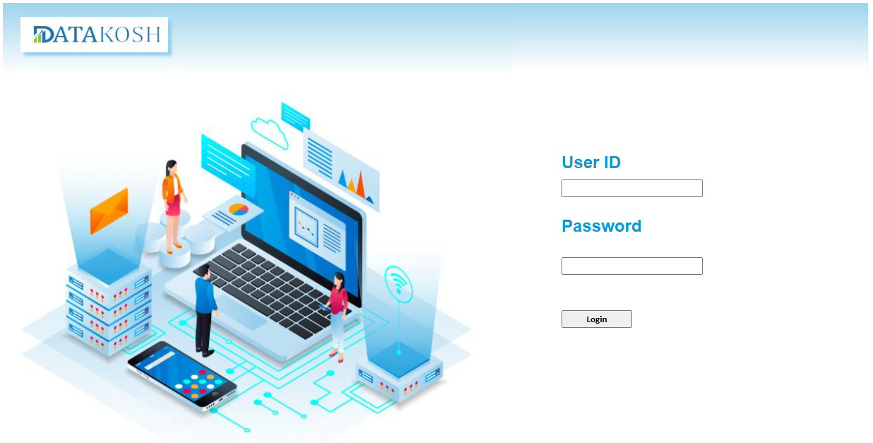

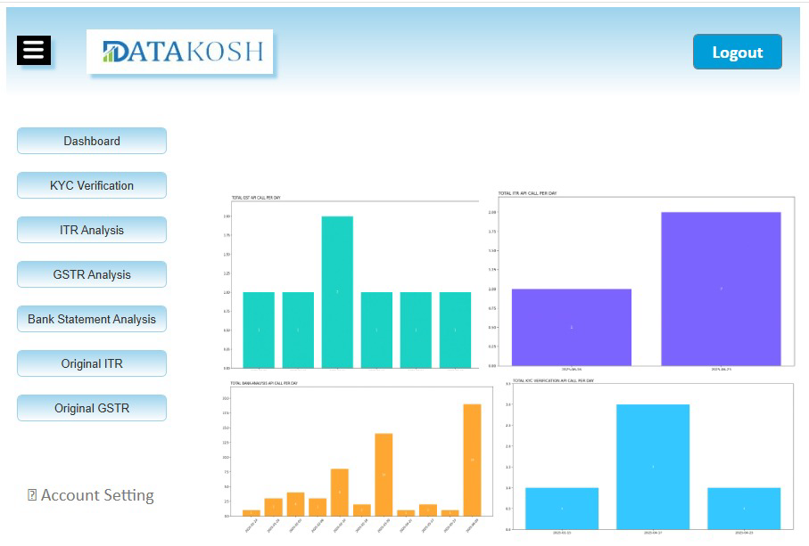

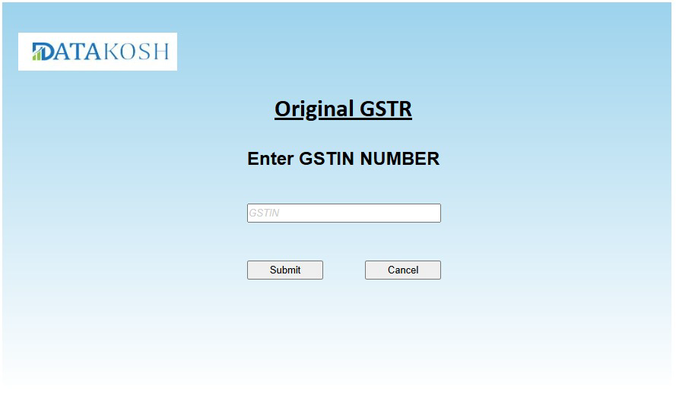

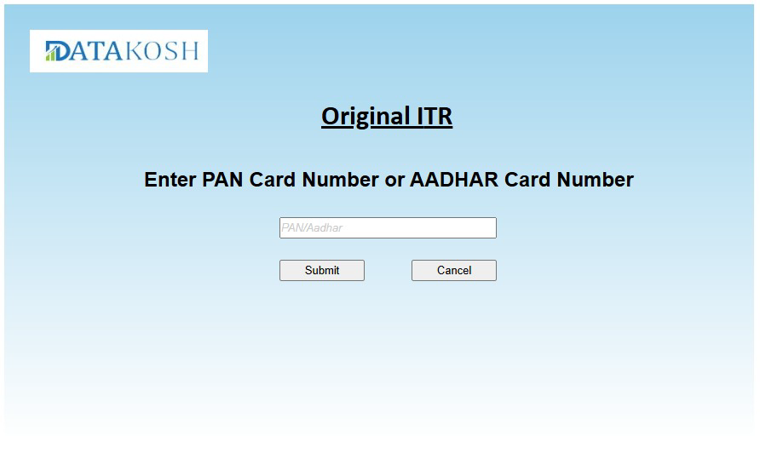

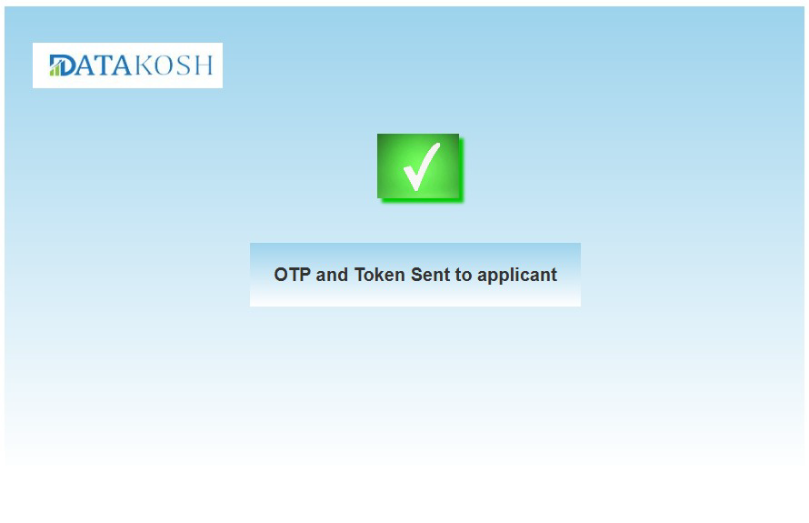

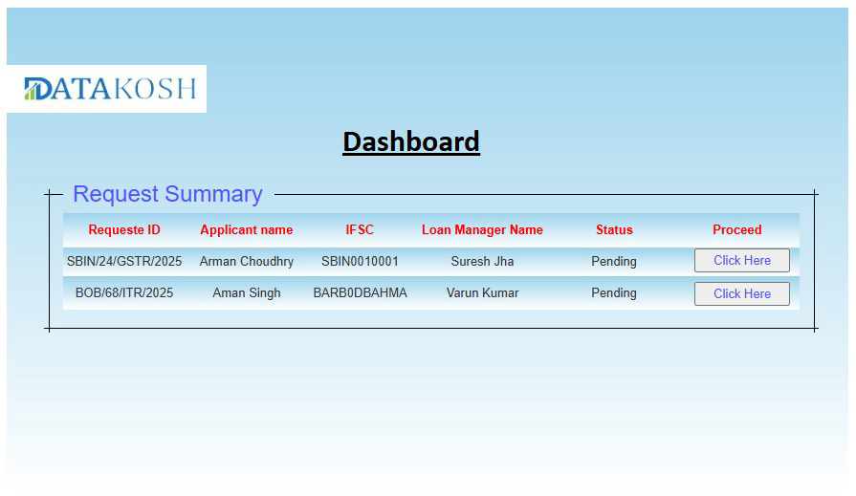

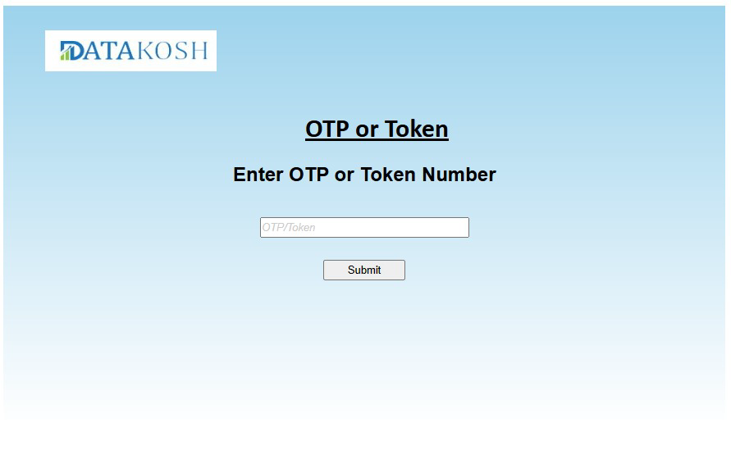

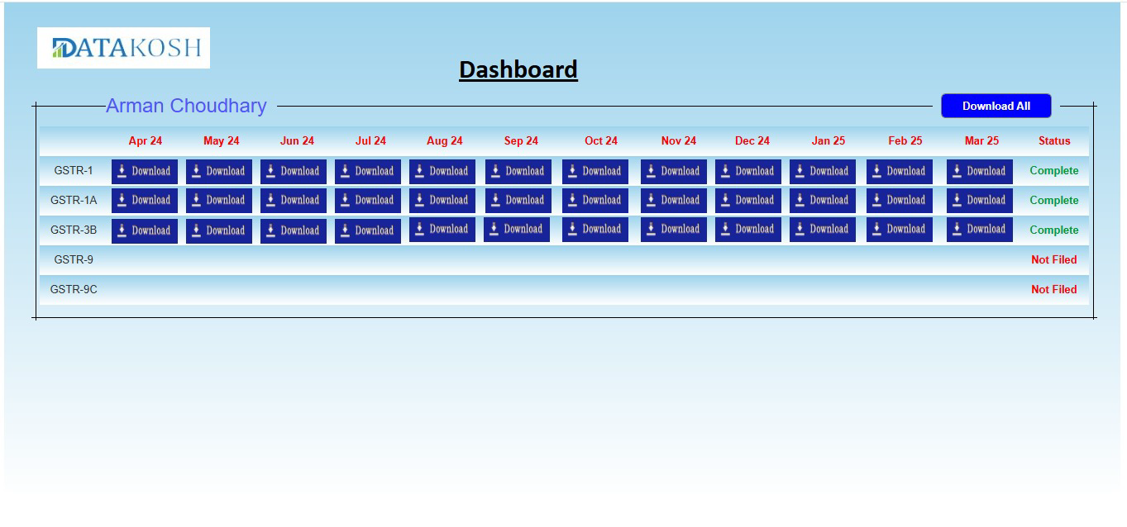

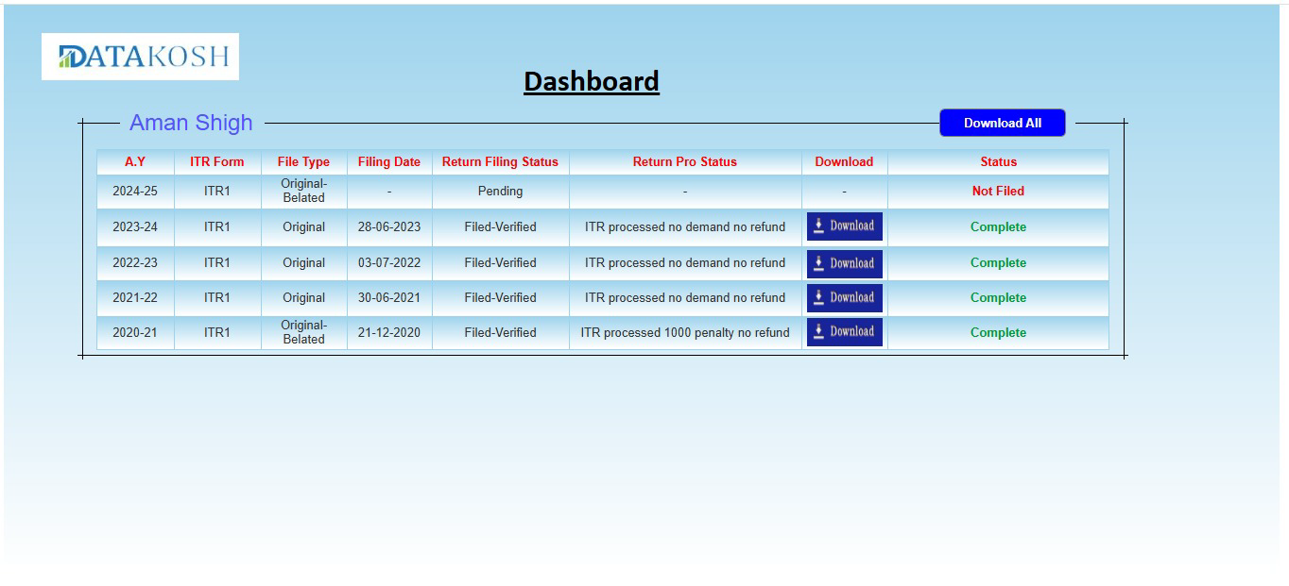

Document 8
Tools-Visio and Axure

Write a paragraph on your experience using Visio and Axure for the project.
For this project, I made effective use of Axure and Visio to help streamline the design and development process. Specifically, Visio played a key for visualizing both the AS-IS and TO-BE workflows helped establishing a simple and clear understanding of the complicated architecture and workflows of the project. The comprehensive Use Case Diagram, the high-level process flow Model, and the detailed Activity Diagrams for login, ITR, and GSTR retrieval were all created using it extensively. Visio’s robust diagramming capabilities allowed me to design detailed activity diagrams with clear branch and merge points, such as validating PAN/Aadhar or GSTIN inputs, and fork and join constructs for parallel tasks like sending OTPs and email tokens. Its drag-and-drop interface and extensive UML template library ensured that complex workflows, like the OTP/token validation process, were represented accurately and aligned with the waterfall methodology’s structured approach. By visually mapping out process flows, decision points, and system interactions, I was able to identify possible issues, ensure logical consistency, and gain collective agreement on the project's functional scope before a single line of code was written, significantly reducing uncertainty and potential rework.
In parallel, Axure RP 7.0 was an effective tool for creating detailed wireframes and interactive mock-ups of the new user screens — from the dashboard modules to the OTP/token entry pages. It proved invaluable for prototyping the user interface of the enhanced Datakosh Solution, particularly for the new dashboard options and PDF retrieval pages. Its interactive prototyping features allowed me to create high-fidelity mockups of the dashboard, ITR/GSTR input screens, and OTP/token entry pages, complete with dynamic elements like status updates (e.g., “Pending” to “Completed”). The tool’s widget library and conditional logic features enable the ability to create clickable prototypes allowed us to conduct early usability testing. This gave a tangible preview of how the proposed features would function before development began. This helps in minimized design changes during the development phase, ensuring that the final product was not only functional but also intuitive and highly user-friendly, directly contributing to a smoother and more efficient development cycle.

Document 9
BA experience

My experience as BA

Requirement gathering: For this project, I applied my business analysis skills to collect detailed requirements utilizing. interviews, workshops, and document analysis to ensure comprehensive coverage of the client’s needs. To get a clear client perspective I utilized following techniques:
- Held one-on-one interviews with loan officers, underwriters, and IT heads from client banks and NBFCs to understand their needs.
- Facilitated requirements workshops to map workflows and identify problem areas, ensuring clarity on client expectations.
- Identified key expectations related to data authenticity, security, and user-friendliness.
- Analysed bank loan processing manuals and compliance guidelines (e.g., RBI, DPDP Act) to align the solution with regulations.
- Captured both functional (e.g., PDF retrieval, dashboard updates) and non-functional (e.g., security, performance) requirements.
- Conducted discussions with CEO, CTO, Founders, and technical teams to come up with idea about API integration instead of direct government portal access.
- Identified a government-registered third-party API to securely access ITR and GSTR PDFs without storing sensitive credentials.
- Used Requirement Traceability Matrix (RTM) to eliminate overlaps and ensure full requirement coverage.
- Created interactive mock-ups using Axure RP 7.0 to demonstrate new dashboard enhancements and ITR/GSTR document fetching flows.
- Demonstrated prototypes to stakeholders and developers to gather early feedback and uncovered usability issues and unstated requirements through this session.

Requirement Analysis: As a Business Analyst for this project this phase was crucial for translating high-level business needs into actionable technical specifications. I used following methods to make the analysis clear and concise:
- Developed UML diagrams such as Use Case Diagrams to provide a high-level overview of system boundaries, actors, and core functionalities, and Activity Diagrams to show step-by-step process flows, decisions, branching, and merging.
- Organized regular review sessions to communicate diagrams using presentations and collaborative tools like email and Ms Teams.
- Acted as a facilitator and mediator, addressing stakeholder concerns (e.g., developer-noted technical complexities, tester-identified edge cases).
- Guided discussions to evaluate proposed modifications, assessing impacts on scope, timeline, and requirements.
- Documented all agreed modifications and updated diagrams accordingly.
- Ensured team buy-in, leading to clearer diagrams for developers and comprehensive test scenarios for QA.
- Prepared supporting documents, including BRD, SRS and detailed Use Case Specifications.
- Created Requirement Traceability Matrix (RTM), and Test Scenarios.
- Developed User Manual and API Documentation for new third-party integration.

Design: During the Design Phase, I played a key role in ensuring that the solution design was testable and traceable to all gathered requirements. The key activity during the this phase were:
- Prepared test cases rigorously based on Use Case Diagrams and their detailed specifications.
- Created test cases for the "Request Original ITR/GSTR PDF" use case, including successful OTP delivery, invalid PAN/Aadhar, network errors, and API system errors.
- Ensured system could handle invalid inputs, timeouts, and real-world issues gracefully through test cases.
- Considered each step in the basic, alternative, and exceptional flows of the use cases as potential test scenarios.
- Communicated design and solution documents, including updated process flows, wireframes, API details, and security workflows to all stakeholders.
- Conducted walkthrough meetings and shared documentation on a platform for stakeholders, including the Executive Management Team, CTO, developers, security experts, and external API vendors.
- Collaborated with the QA team to prepare comprehensive test data, including valid/invalid PAN/Aadhar/GSTIN, dummy OTPs, simulated API responses, and edge cases.
- Considered edge cases like old ITR filings, multiple GSTINs, expired OTPs, and slow network conditions (e.g., 1 Mbps) in test data.
- Ensured test data supported thorough testing of negative and exceptional flows.
- Updated the Requirements Traceability Matrix (RTM) diligently throughout the design phase. Ensured clear visibility to stakeholders, reducing risks of gaps and costly changes in later stages.
Development: As the Business Analyst during the Development phase, my primary focus shifted from defining what to build to ensuring how it was being built aligned with the requirements and design. This phase was all about active support, clarification, and continuous communication. Following action has been taken in this phase:
- Facilitated JAD sessions to align business requirements with technical implementation for features like OTP/token validation and third-party API integration.
- Ensured Use Case Diagrams, Activity Diagrams, and Process Flow Charts were available for developer reference.
- Used Microsoft Visio for diagrams and Axure RP 7.0 for prototypes to streamline coding and reduce misinterpretations.
- Conducted private conversations to address disengagement and explain impacts on project success.
- Developers used UML diagrams, especially Activity Diagrams and Use Case Specifications, to guide coding.
- Conducted regular meetings with both the technical team and stakeholders to maintain alignment.
- Recorded meetings and shared promptly, achieving 95% attendance with follow-ups for absentees.

Testing: As the Business Analyst during the Testing phase, my role was pivotal in ensuring that the developed solution not only met the requirements but was also robust, reliable, and truly ready for our clients. This phase was about meticulous verification and validation. Following steps have been followed:
- I collaborated with development and QA teams for high-level Unit Testing on modules like OTP/token generation and ITR/GSTR request/response handling with KDK Solutions.
- Ensured data formats exchanged between systems were consistent and accurate.
- Integration Testing covered scenarios like failed API calls, correct request sending by Datakosh, response processing by KDK, and interpretation by Datakosh.
- Validated the entire system as a cohesive unit, testing end-to-end functionality, performance, and security.
- Identified delays in retrieving multiple ITR/GSTR documents for applicants with extensive filing histories.
- Facilitated discussions with the dev team and Third-Party API provider to identify the limits and solution were optimized using asynchronous calls, parallel processing, or incremental document display.
- Regression Testing was done to ensure new features didn’t break existing functionalities like KYC, GSTR Analysis, ITR Analysis, and Bank Statement Analysis.
- Facilitated UAT with client loan department representatives to validate real-life scenarios.
- Managed tight client schedules by offering flexible slots and detailed test scripts for independent testing.
- The RTM was updated to track requirement validation, bug fixes, and test case results to ensure full coverage.
- After fixing all 8 bugs, a second UAT was conducted with client support representatives for confirmation.
- Formal signoff was obtained from CEO Ms. Monica post UAT confirmation and defect resolution.

Deployment: As the Business Analyst during the Deployment phase, my role was focused on ensuring a seamless and successful transition of the enhanced Datakosh Solution into the production environment and facilitating its adoption by our users. This phase was a culmination of all prior efforts. Following things are done:
- Coordinated with IT, KDK Solutions’ technical team, and stakeholders to plan the Datakosh Solution rollout, minimizing downtime and disruptions.
- Managed dependencies to minimize downtime, though the website was briefly disrupted.
- Shared the updated Requirement Traceability Matrix (RTM) with stakeholders, attaching it to project closure documentation for compliance.
- Conducted structured training for Sales, Support, and end-users, especially loan officers, on new features. Offered flexible training slots and clear agendas to ensure all targeted users attended.
- Addressed resistance from employees by providing practical demonstrations, one-on-one follow-ups, and user-friendly manuals.
- Conducted a Post-Implementation Review (PIR) to evaluate project success and gather formal and informal feedback from loan officers on system benefits and improvement areas.
- Documented lessons learned and identified areas for future enhancements to ensure the solution evolves with client and regulatory needs.

