Document 1: Definition of Done
The following checklist defines the Definition of Done (DoD) for each user story in the SMART MIS Reporting Framework project:
▪ Produced code for presumed functionalities
▪ Assumptions of User Story met
▪ Project builds without errors
▪ Unit tests written and passing
▪ Project deployed on the test environment identical to production platform
▪ Tests on devices/browsers listed in the project assumptions passed
▪ Feature ok-ed by UX designer
▪ QA performed & issues resolved
▪ Feature is tested against acceptance criteria
▪ Feature ok-ed by Product Owner
▪ Refactoring completed
▪ Any configuration or build changes documented
▪ Documentation updated
▪ Peer Code Review performed

Document 2: Product Vision
Scrum Project Name: SMART MIS Reporting Framework
Venue: Online (Broadridge Financial Solution)
Date: [07/08/2025, Start time: [5:00 PM], End time: [7:00 PM], Duration: 2 hours
Client: [NTT Finance]
Stakeholder list:
- Mr. Shamsher
- Mr. Zoraawar
- Mr. Prabhjot
- Business Analysts
- Technical Leads
Scrum Team:
Scrum Master: Mr.Karim Lala
Product Owner: Amandeep Singh
Scrum Developers: Dev 1 to Dev 5

Vision
To create a centralized, SMART-based MIS reporting framework that provides real-time, accurate, and actionable reports to executive and department stakeholders.

Target Group
Market Segment: Enterprises and growing SMEs with scattered data systems.
Target Users: Business heads, finance managers, HR, and operations leaders.

Needs
Problem: Current MIS systems are inefficient and manual.
Benefit: Reduce turnaround time and provide real-time insights for strategic decisions.

Product
Product: Web-based MIS Dashboard & Reporting System.
Special: Customizable templates, role-based access, KPI tracking.
Feasibility: Technically feasible using BI tools like Power BI/Tableau.

Value
Benefit: Enables faster decisions and standardizes reporting.
Business Goal: Enhance operational transparency and agility.
Business Model: Project-based implementation with optional support service subscription.

Document 3: User Stories
User story No: US001
Tasks: Gather MIS report requirements from Finance and HR departments
Priority: High
Value statement:
As a finance manager, I want to access daily cash flow and budget variance reports so that I can track financial performance effectively.
BV: 20 CP: 5
Acceptance criteria:
- The report loads within 5 seconds
- Data matches ERP system
- Accessible via role-based login
- Exportable to Excel/PDF
User story No: US002
Tasks: Build dashboard to display HR attrition trends
Priority: Medium
Value statement:
As an HR manager, I want to view attrition rate trends so that I can plan better retention strategies.
BV: 100 CP: 13
Acceptance criteria:
- Monthly trend for 12 months visible
- Filter by department and location
- HR login secured by role

User story No: US001
Tasks: Gather MIS report requirements from Finance and HR departments
Priority: High
Value statement:
As a finance manager, I want to access daily cash flow and budget variance reports so that I can track financial performance effectively.
BV: 500 CP: 20
Acceptance criteria:
- The report loads within 5 seconds
- Data matches ERP system
- Accessible via role-based login
- Exportable to Excel/PDF

User story No: US002
Tasks: Build dashboard to display HR attrition trends
Priority: Medium
Value statement:
As an HR manager, I want to view attrition rate trends so that I can plan better retention strategies.
BV: 100 CP: 13
Acceptance criteria:
- Monthly trend for 12 months visible
- Filter by department and location
- HR login secured by role

User story No: US003
Tasks: Integrate MIS with ERP for Sales Data
Priority: High
Value statement:
As a sales manager, I want MIS to pull daily sales from ERP so that I can track revenue trends in real time.
BV: 1000 CP: 60
Acceptance criteria:
- Data sync every 24 hrs
- KPI trend visible
- Accessible via sales role

User story No: US004
Tasks: Create Inventory Level Dashboard
Priority: Medium
Value statement:
As an inventory controller, I want a real-time stock dashboard so that I can avoid stockouts and overstocking.
BV: 500 CP: 40
Acceptance criteria:
- Alerts for low stock
- Search by SKU
- Exportable to Excel

User story No: US005
Tasks: Build Supplier Performance Report
Priority: Medium
Value statement:
As a procurement officer, I want to see supplier delivery times so that I can manage vendor relationships better.
BV: 500 CP: 100
Acceptance criteria:
- Delivery delay report
- Supplier ranking
- PDF export

User story No: US006
Tasks: HR Leave Balance Report
Priority: Low
Value statement:
As an HR associate, I want to see leave balances by department so that I can ensure compliance with leave policies.
BV: 20 CP: 5
Acceptance criteria:
- Department filter
- Accurate as per HRMS
- Printable view

User story No: US007
Tasks: Finance Year-End Consolidated Report
Priority: High
Value statement:
As a CFO, I want a year-end consolidated report so that I can present financial performance to the board.
BV: 100 CP: 13
Acceptance criteria:
- Consolidated across units
- Matches audited data
- Secure CFO-only access

User story No: US008
Tasks: Create Customer Feedback Analysis Dashboard
Priority: Medium
Value statement:
As a marketing manager, I want to analyze customer survey feedback so that I can improve customer experience.
BV: 50 CP: 21
Acceptance criteria:
- Sentiment analysis
- Filter by region
- Chart and table views

User story No: US009
Tasks: MIS Mobile App Interface
Priority: High
Value statement:
As a senior executive, I want to access MIS dashboards on my mobile so that I can review KPIs on the go.
BV: 100 CP: 13
Acceptance criteria:
- Mobile responsive
- Key KPIs accessible
- Login secured

User story No: US010
Tasks: Departmental Comparative Analysis
Priority: Medium
Value statement:
As a COO, I want a comparative analysis of departmental KPIs so that I can identify high and low performers.
BV: 50 CP: 34
Acceptance criteria:
- Compare KPIs
- Graphical view
- Export to PPT

User story No: US011
Tasks: Real-Time Expense Tracker
Priority: High
Value statement:
As a finance analyst, I want to track expenses as they occur so that I can control budget overruns.
BV: 10 CP: 8
Acceptance criteria:
- Live data feed
- Category filter
- Alerts for overspend

User story No: US012
Tasks: MIS Audit Log Reporting
Priority: Low
Value statement:
As an IT auditor, I want an audit log of all MIS user actions so that I can maintain compliance records.
BV: 50 CP: 5
Acceptance criteria:
- Records all logins
- Tracks data changes
- Filterable by date/user

Document 4: Agile Product Owner Experience
As the Product Owner for the SMART MIS Reporting Framework, I was responsible for defining the product vision based on market and enterprise analysis. I analyzed reporting gaps in the client's business and identified key user groups across departments.
I created epics and decomposed them into user stories aligned with ROI and urgency. I conducted stakeholder interviews, prioritized backlog items, participated in sprint planning and reviews, and ensured continuous delivery of business value.
I regularly reviewed sprint progress, reprioritized as needed, and worked with the Scrum Master and team to remove blockers. My active involvement in sprint retrospectives and backlog refinement ensured alignment with the evolving client needs.
This project strengthened my understanding of Agile PO responsibilities like stakeholder management, roadmap planning, and iterative delivery of high-value features.

Document 5: Product and Sprint Backlog

Product Backlog
User Story ID | User Story | Tasks | Priority | BV | CP | Sprint
US001 | Finance Report Dashboard | Requirement Gathering | High | 8 | 5 | 1
US002 | HR Attrition Trends | Dashboard Creation | Medium | 7 | 4 | 2

Sprint Backlog
User Story ID | User Story | Tasks | Owner | Status | Effort
US001 | Finance Report Dashboard | Data Collection,UI Design | Dev 1 | In Progress | 8 Hrs
US002 | HR Attrition Trends | Graph Setup, Filter Logiv | Dev 2 | To Do | 6 hrs

Product Burndown

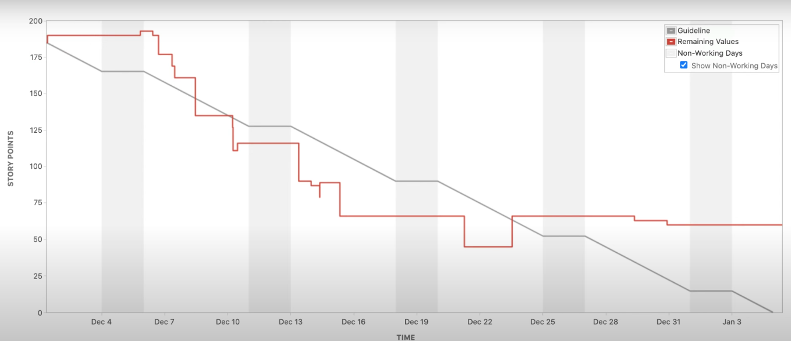

Sprint Burndown (Sprint 3)

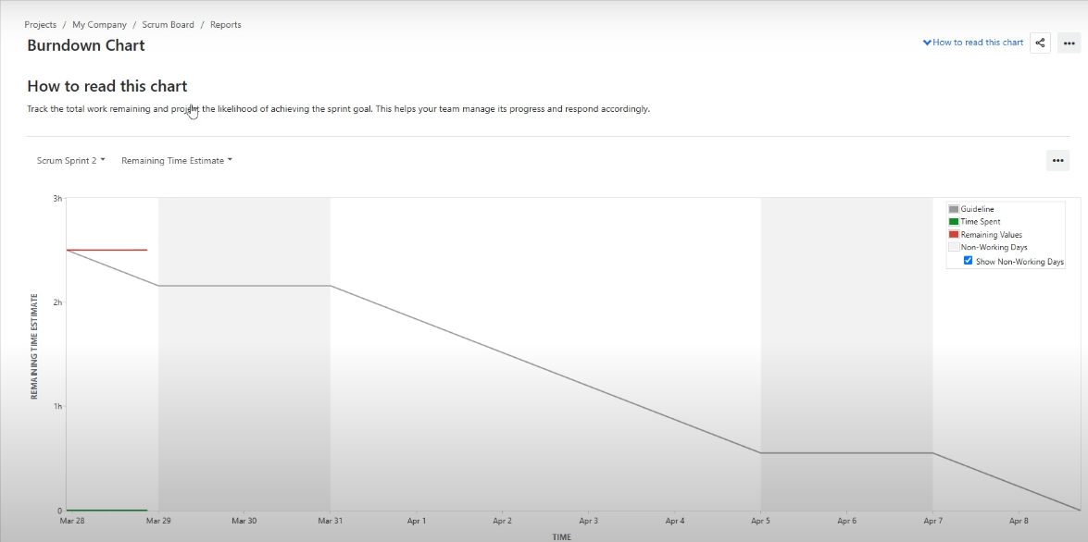

Document 6: Sprint Meetings

Meeting Type 1: Sprint Planning
Date: [09/08/2025] Time: 10:00 AM
Location: Online
Prepared By: PO
Attendees: Scrum Team, Stakeholders
Agenda Topics:
- Backlog prioritization
- Capacity planning
- Sprint goals
Observers: Client Reps
Resources: JIRA, Confluence
Special Notes: Emphasize SMART goals

Meeting Type 2: Sprint Review
Date: [22/08/2025] Time: 3:00 PM
Location: Zoom
Prepared By: Scrum Master
Attendees: Team + Client
Sprint Status: Completed
Things to Demo: Finance dashboard
Quick Updates: Minor UI fixes
What’s Next: HR reports

Meeting Type 3: Sprint Retrospective
Date: [23/08/2025] Time: 4:00 PM
Location: Teams
Prepared By: Scrum Master
Attendees: Scrum Team
What went well: Stakeholder feedback was positive
What didn’t go well: Delayed data access
Questions: How to pre-load next sprint data?

Meeting Type 4: Daily Stand-Up
Week: 1 (01-08-2025 to 07-08-2025)
Sample Table Format:
Developer 1:
- Yesterday: UI wireframes
- Today: Start API integration
- Blocker: None

