Business Requirements Document (BRD)
Project: Inventory & Quick Delivery System for Ice-Cream and Milk Products
Company: Ice-cream Factory
Prepared by: Nikhil H. Mali
Date: October 28, 2025
Version: 1.0

Table of Contents
Executive Summary 3
Background 3
Scope 3
Business Requirements 4
Business Use Cases 5
System Use Cases 5
Process Flow Diagram 6
RACI 8
Risk Analysis 9
Business Case & High-Level Cost/Benefit 9
Development & Resource Plan 9
Timetable & Milestones (High Level) 9
Testing Strategy 10
Nonfunctional Requirements (Summary) 10
Assumptions & Dependencies 10
Approvals / Sign-Off 10

Executive Summary
Overview:
This BRD defines the business requirements for an Inventory & Quick Delivery System to support the company's manufacturing plants and warehouses across the country. The solution aims to provide a centralized, real-time inventory management capability and an optimized order-to-delivery process to achieve fastest possible deliveries to customers.
Objectives:
1. Provide accurate, real-time inventory visibility across plants and warehouses.
2. Automate inventory controls (reorder points, stock transfers, batch/lot tracking, expiry management).
3. Prioritize and route orders for quickest delivery using nearest-warehouse logic and delivery slot optimization.
4. Integrate with existing ERP/finance, manufacturing execution systems (MES), and third-party logistics (3PL).
5. Provide dashboards and reports for operations, sales, and supply chain stakeholders.

Background
The company operates multiple manufacturing plants and warehousing facilities producing perishable dairy products and ice-cream. Current systems are fragmented, leading to stock inaccuracies, overstock/stockouts, and delays in fulfillment. This project addresses these operational gaps to reduce waste, improve fill-rates, and shorten delivery times.

Scope
Included in Scope
- Centralized inventory management (stock levels, SKU master, batch & expiry tracking).
- Order management and fulfillment routing (nearest-warehouse, inventory reservation, picking & packing instructions).
- Warehouse management features: receiving, put-away, picking, packing, stock transfer, cycle counts.
- Integration points: ERP (finance + master data), MES, 3PL carriers, POS (for retail customers), and mobile apps for warehouse staff.
- Dashboards and reporting for inventory, orders, deliveries, and exceptions.
Excluded from Scope
- Core ERP financial ledgers (only integration for posting financial entries).
- Manufacturing production scheduling logic (MES remains source of truth for production plan).
- Customer loyalty/CRM beyond basic customer and order data synchronization.
Constraints
- Must comply with food safety traceability and regulatory record-keeping for perishable goods.
- Operations run 24/7 in some facilities; deployment windows may be limited.
- Existing ERP and MES are legacy systems with limited modern APIs; some integrations may require middleware.

Business Requirements
BR-01 - Centralized SKU Master: Maintain SKU attributes, packaging sizes, temperature profile, weight, and shelf-life.
BR-02 - Real-Time Stock Levels: System shall provide near real-time stock levels per location, per batch/lot.
BR-03 - Batch & Expiry Tracking: Track manufacture date, batch number, and expiry for all perishable SKUs.
BR-04 - Reorder & Safety Stock: Support configurable reorder points and safety stock per SKU/location.
BR-05 - Reservation & Allocation: Reserve stock for confirmed orders and allow allocation strategies (FIFO, FEFO).
BR-06 - Warehouse Workflows: Support receiving, put-away, cycle counts, picking, packing, and shipping.
BR-07 - Nearest-Warehouse Fulfillment: Route orders to the warehouse that provides fastest delivery while honoring inventory constraints.
BR-08 - Delivery Slot Management: Allow customers to select delivery windows; system will optimize routes to meet slots.
BR-09 - Mobile App for Warehouse Staff: Barcode scanning, pick lists, and confirmation of handling steps.
BR-10 - Integration APIs: Standard REST APIs for ERP, MES, 3PL and POS integrations.
BR-11 - Dashboards & Alerts: Dashboards for stock health, expiring inventory, fill rates, and exceptions with automated alerts.
BR-12 - Reporting & Audit Trail: Maintain audit logs for stock movement for compliance and traceability.

Business Use Cases
Use Case 1: Receive Inventory at Warehouse
Brief: Warehouse receives shipment from a plant; items are checked, batch numbers captured, and stock is updated.
Primary Actors: Warehouse Operator, Warehouse Manager, MES
Triggers: Goods arrival; ASN (Advance Ship Notice) from plant.
Success Postcondition: Inventory increased and available for allocation based on quality checks.
Use Case 2: Customer Order Fulfillment for Quickest Delivery
Brief: Customer places order; system identifies nearest eligible warehouse with inventory, reserves stock, and schedules delivery to meet earliest delivery slot.
Primary Actors: Customer (web/app), Order Manager, Warehouse Picker, Carrier
Triggers: New order placed or bulk order received.
Success Postcondition: Order reserved, dispatched and delivered within customer-selected or earliest possible slot.
Use Case 3: Transfer Stock Between Warehouses
Brief: When stock imbalance occurs, system recommends transfers to meet regional demand and reduce expiry loss.
Primary Actors: Inventory Planner, Warehouse Manager
Triggers: Low stock alerts or overstock alerts.
Success Postcondition: Stock moved and levels updated at both locations.

System Use Cases
- Inventory Inquiry (User searches SKU across locations).
- Order Routing Engine (automated evaluation of warehouses & carriers based on delivery time, cost, and inventory).
- Warehouse Mobile Operations (scan, pick, pack, confirm).
- Integration Middleware (API orchestration and message queue for reliable delivery).

Process Flow Diagram
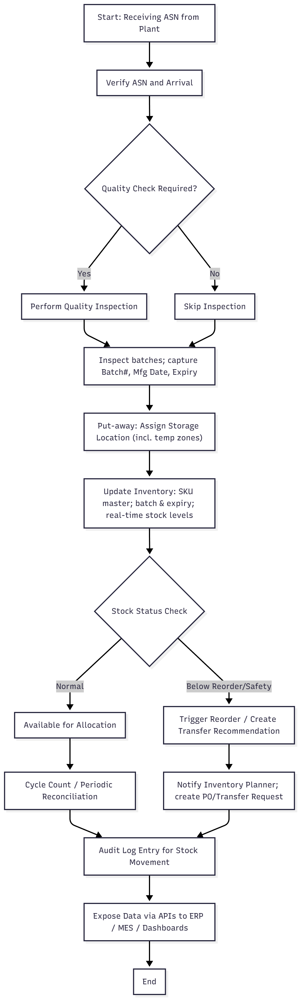
The following diagram shows the Quickest Delivery to Customer Process Flow Diagram.

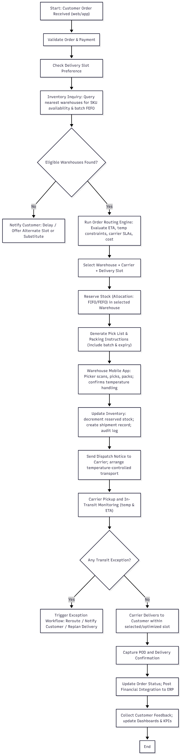
The following diagram shows the Quickest Delivery to Customer Process Flow Diagram.

RACI
Role | Responsibility | Accountable | Consulted/Informed
Sponsor (COO) | Project approval, priority | Yes | Executive Team
Project Manager | Project delivery | Yes | All Stakeholders
Business Analyst | Requirements, UAT | No | PM, Users
Solution Architect | Technical design | No | Dev Team
Dev Team Lead | Development & integration | No | QA
QA Lead | Testing & acceptance | No | Users
Warehouse Ops Lead | Process sign-off, UAT | No | Local Managers
3PL / Carrier | Integration & SLAs | No | Logistics Team

Risk Analysis
- Integration complexity with legacy ERP/MES (Likelihood: High; Impact: High) - Mitigation: Middleware and phased integration.
- Data quality and SKU master inconsistencies (Likelihood: High; Impact: Medium) - Mitigation: Data cleansing & pilot locations.
- Regulatory compliance for traceability (Likelihood: Medium; Impact: High) - Mitigation: Design audit trails and batch tracking.
- Perishable goods spoilage during transit (Likelihood: Medium; Impact: High) - Mitigation: Temperature-profile based routing and carrier SLAs.

Business Case & High-Level Cost/Benefit
Costs (Estimate):
- Software Development & Integration: ₹2.22 crore to ₹3.55 crore
- Hardware (scanners, printers, network upgrades): ₹0.44 crore to ₹0.89 crore
- Implementation, Training & Change Management: ₹0.35 crore to ₹0.71 crore
Benefits (Annual Estimate):
- Reduced waste/expiry: ₹8,862,870 - ₹22,157,175
- Lower stock holding & improved turns: ₹10,635,444 - ₹26,588,610
- Improved customer satisfaction & sales uplift: qualitative + potential ₹8,862,870 + uplift
Return: Payback expected within 18-30 months depending on scale and adherence to process improvements.

Development & Resource Plan
Suggested Delivery Approach: Agile (Scrum) with 2-week sprints. Total estimated delivery: 5 - 7 months (MVP) + 2-3 months for stabilization & integrations.
Core Team (estimated):
Role | Estimate (FTE) | Responsibility
Product Owner / Ops Lead | 0.3 - 0.5 | Define priorities, acceptance
Business Analyst | 1.0 | Requirements, UAT
Solution Architect | 0.5 | Integration design
Backend Developers | 2.0 | APIs, services
Frontend Developers | 1.0 | Dashboards, portals
Mobile Developers | 1.0 | Warehouse app
QA Engineers | 1.0 | Testing
DevOps/Infra | 0.5 | CI/CD, hosting
Data Engineer | 0.5 | Data migration & pipelines
Change Manager/Trainer | 0.5 | Training & rollout
Estimated Effort (MVP): ~800 - 1200 person-days across roles. Exact estimates to be refined after detailed analysis and design workshops.

Timetable & Milestones (High Level)
- Discovery & Detailed Requirements: 4 weeks
- Design & Architecture: 4 weeks
- Development (MVP features): 10-14 weeks (sprints)
- Integration & Testing: 4-6 weeks
- Pilot Rollout (1-2 warehouses): 2-4 weeks
- Full Rollout & Stabilization: 4-8 weeks

Testing Strategy
Phases: Unit Testing (Dev), Integration Testing, System Testing (including stress & performance), User Acceptance Testing (UAT) with warehouse operations, and Pilot validation. Regression test suite and automated tests for critical flows.
Implementation & Rollout
Rollout Strategy: Phased rollout by geography or warehouse cluster. Start with 1-2 pilot warehouses and iterate. Provide hands-on training, run parallel operations for a defined cutover period, and then switch to live.
Training: Train-the-trainer model. Provide quick reference guides, SOPs, and mobile job aids for warehouse staff.
Data Conversion: Migrate SKU master, opening balances, and pending orders. Clean master data during discovery.

Nonfunctional Requirements (Summary)
- Performance: System shall respond to inventory queries within 2 seconds for typical queries.
- Throughput: Support up to 200 concurrent warehouse operators during peak shifts.
- Availability: 99.5% uptime for core inventory services.
- Security: Role-based access control, encrypted data in transit and at rest, audit logging.
- Scalability: Design for multi-region expansion and ability to add new warehouses without downtime.

Assumptions & Dependencies
- Client will provide access to ERP and MES test environments and necessary API documentation.
- Key stakeholders (warehouse ops, inventory planners) will participate in workshops and UAT.
- 3PL partners will support API/webhook integration or provide agreed data exchange formats.

Approvals / Sign-Off
Prepared by: Nikhil Mali
Business Sponsor: Raju Dalvi
Date: 28/10/2025

End of document

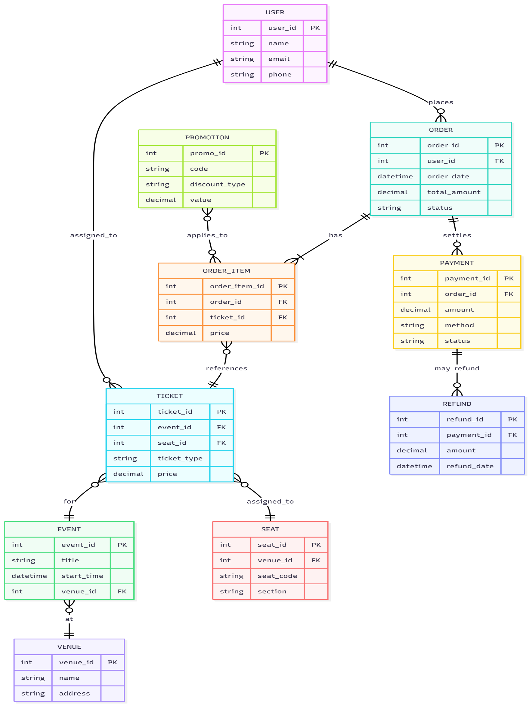

Ticketing System — Business Requirements Document (BRD)

1. Document Control
Project Name: Ticketing System
Version: 1.0
Date: 29 October 2025
Author: Nikhil Mali (Business Analyst)

Table of Contents
Ticketing System — Business Requirements Document (BRD) 1
1. Document Control 1
2. Executive Summary 3
3. Scope 3
4. Stakeholders 3
5. Business Requirements (High-level) 3
6. Success Criteria / Acceptance 4
7. Assumptions & Constraints 4
8. Risks 4
Ticketing System — Software Requirements Specification (SRS) 4
1. Record of Revisions 4
2. Introduction 4
2.1 Overview 4
2.2 Acronyms & Definitions 4
3. Operational Requirements 4
3.1 Software Requirements 4
3.2 Hardware Requirements 5
4. References 5
5. Design & Implementation Constraints 5
6. Assumed Factors That Could Affect Requirements 5
7. System Overview 5
7.1 Current System 5
7.2 Proposed System 5
7.3 Benefits 5
8. Functional Requirements (Detailed) 5
9. UI Requirements 6
10. Non-Functional Requirements 6
11. Interfaces 6
12. Data Model (High-level) 6
13. Acceptance Criteria 6
14. Other Parameters 7

2. Executive Summary
Problem Statement / Business Need: Current support/work-order tasks are managed across email and spreadsheets, causing slow response times, lost tickets, inconsistent prioritization and poor SLA tracking.
Objective: Deliver a centralized web-based Ticketing System to capture, triage, assign and track incidents and service requests with SLA enforcement, reporting and integrations to authentication and e-mail.
Audience: Stakeholders include service desk agents, team leads, IT operations, support managers, end-users, and external vendors.

3. Scope
In scope (MVP): - Ticket creation (web form, email-to-ticket, API) - Ticket lifecycle (open, in-progress, on-hold, resolved, closed) - Assignment and queues - SLA policies and automated escalations - Search and basic reporting (volume, SLA breaches, agent workload) - Notifications (email, in-app) - Role-based access (end-user, agent, manager, admin)
Out of scope (Phase 1): - Advanced analytics / ML-based routing - Multi-tenant billing - Live chat integration

4. Stakeholders
- Product Owner / Sponsor
- Service Desk Manager
- Service Desk Agents
- IT Operations
- Developers / Integrations Team
- End Users
- Compliance / Security Team

5. Business Requirements (High-level)
- BR-01: System shall allow users to create tickets via web form, email and REST API.
- BR-02: System shall support categorization (category, sub-category) and priority levels.
- BR-03: System shall provide role-based views and permissions for agents, managers and admins.
- BR-04: System shall enforce SLA targets per priority and auto-escalate on breach.
- BR-05: System shall provide audit trail and ticket history for compliance.
- BR-06: System shall provide scheduled and ad-hoc reports (SLA, volume, resolution times).
- BR-07: System shall integrate with corporate SSO (SAML/OAuth) and e-mail systems.
- BR-08: System shall support attachments and embedded screenshots.

6. Success Criteria / Acceptance
- 90% of tickets created are captured in the system (vs email backlog) within 30 days of go-live.
- SLA (service level agreement) breach rate reduced by 40% within 3 months.
- Positive user satisfaction score >= 80% from internal survey.

7. Assumptions & Constraints
Assumptions: - Corporate SSO (single sign-on) will be available for integration. - Agents have internet access and modern browsers.
Constraints: - Use existing corporate identity provider. - Data must remain within corporate cloud region for compliance.

8. Risks
- Delay in SSO integration may affect timelines.
- Insufficient training adoption by agents.

Ticketing System — Software Requirements Specification (SRS)

1. Record of Revisions
Version 1.0 — 29 Oct 2025 — Initial release

2. Introduction

2.1 Overview
This SRS describes functional and non-functional requirements for the Ticketing System. It is intended for developers, testers, and stakeholders.

2.2 Acronyms & Definitions
- SLA: Service Level Agreement
- SSO: Single Sign‑On
- API: Application Programming Interface

3. Operational Requirements

3.1 Software Requirements
- Browser support: Latest stable Chrome, Edge, Firefox
- Backend: Java 17 / Node.js 18 (to be finalized)
- Database: SQL
- Authentication: SAML 2.0 / OAuth2

3.2 Hardware Requirements
- Cloud hosted; minimum 2 vCPU / 4GB RAM for app node (scalable)
- Database cluster with high availability

4. References
- BRD (Ticketing System) — this document.
- Corporate security standards.

5. Design & Implementation Constraints
- Must integrate with corporate SSO.
- Data residency in corporate cloud region.
- Use of SMTP for notifications.

6. Assumed Factors That Could Affect Requirements
- Availability of SSO metadata and credentials.
- Third‑party e-mail provider SLA.

7. System Overview

7.1 Current System
Ad-hoc email + spreadsheets; no unified tracking or SLAs.

7.2 Proposed System
A centralized web application with REST API for ticket intake, role-based dashboards, SLA engine, reporting, and integrations.

7.3 Benefits
- Centralized tracking
- Improved SLA compliance
- Better reporting for continuous improvement

8. Functional Requirements (Detailed)
FR-1: Ticket Creation - FR-1.1: System shall allow authenticated end-users to create tickets via a web form with fields: Title, Description, Category, Priority, Attachments, Contact. - FR-1.2: System shall convert incoming emails to tickets, parsing sender and subject. - FR-1.3: System shall accept ticket creation via REST API (token-based auth).
FR-2: Ticket Lifecycle & Assignment - FR-2.1: System shall support statuses: New, Assigned, In Progress, On Hold, Resolved, Closed. - FR-2.2: System shall allow manual and auto-assignment to agents or queues. - FR-2.3: System shall record timestamps for each status change and actor.
FR-3: SLA & Escalation - FR-3.1: System shall allow SLA definitions per priority (e.g., Critical: 4 hours, High: 24 hours). - FR-3.2: System shall compute SLA remaining time and flag tickets nearing breach. - FR-3.3: System shall auto-escalate to next-level owner after configurable breach threshold and notify stakeholders.
FR-4: Notifications - FR-4.1: System shall send email notifications for ticket creation, assignment, status change and SLA escalation. - FR-4.2: System shall support in-app notifications for agents.
FR-5: Reporting & Search - FR-5.1: System shall provide pre-built reports: Ticket volume, SLA breaches, Mean Time to Resolution (MTTR), agent workload. - FR-5.2: System shall provide search/filter by ticket id, status, assignee, date range, and keywords.
FR-6: Security & Access Control - FR-6.1: System shall integrate with SSO and map user roles to permissions. - FR-6.2: System shall log all user actions (audit trail).
FR-7: Attachments - FR-7.1: System shall store attachments up to 25MB and scan for malware (integration point).

9. UI Requirements
- Responsive web UI with role-aware dashboards.
- Ticket form with validation and rich-text description support.
- Agent queue view with sorting and quick actions (assign, escalate, add note).

10. Non-Functional Requirements
- NFR-1 (Availability): 99.9% uptime (excluding scheduled maintenance).
- NFR-2 (Performance): Page load for dashboards under 3 seconds for typical datasets; API responses < 500 ms for common endpoints.
- NFR-3 (Scalability): System must handle 1,000 concurrent users and scale horizontally.
- NFR-4 (Security): Data encrypted at rest and in transit; role-based access and periodic penetration testing.
- NFR-5 (Backup & Recovery): Daily backups; RTO 4 hours; RPO 24 hours.

11. Interfaces
- REST API for ticket creation and query.
- SMTP for e-mail notifications and e-mail-to-ticket.
- SAML/OIDC for SSO.
- Optional: Webhooks for external integrations.

12. Data Model (High-level)
- Ticket (ticket_id, title, description, status, priority, category, created_by, assigned_to, created_at, updated_at)
- User (user_id, name, email, role)
- Attachment (id, ticket_id, filename, size, storage_path)
- SLA (priority, target_hours)

13. Acceptance Criteria
- End-to-end ticket creation via web, email and API is demonstrated.
- SLA rules trigger correctly and escalate as configured.
- Role-based permissions enforced and audit logs visible.
- Performance and availability meet non-functional targets in staging tests.

14. Other Parameters
- Deployment pipeline: staging and production with automated tests.
- Documentation: Installation guide and user manual to be delivered.

End of document

Date: 29/10/25
Dear ABC Corp,
My name is Nikhil Mali, and I am the Business Analyst assigned to work with you and your team to begin the business understanding phase of our engagement for Online Ticketing. I am looking forward to partnering closely with you to understand the current state, capture real business needs, and shape a clear, actionable scope that will drive the project’s success.
To get us started smoothly, my primary objectives for the initial phase are:
- Understand your business goals, success criteria, and pain points.
- Map current processes and identify gaps and opportunities.
- Identify and engage the right stakeholders and subject-matter experts.
- Capture high-level requirements, constraints, and key data sources.
- Produce a clear, prioritized set of deliverables (e.g., stakeholder map, process maps, initial requirement backlog, and assumptions/risks).
I propose we hold a 60-minute kickoff meeting to align on objectives and next steps. A suggested agenda:
- Introductions and roles.
- Project goals and success criteria.
- Current-state overview (processes, systems, data).
- Key stakeholders, timelines, and constraints.
- Immediate next steps and information/ access needed.
To prepare for the kickoff, it would be helpful if you can share any of the following (if available): existing BRDs or SOWs, current process diagrams, organizational chart, key KPIs or reports, sample data extracts, and a list of primary stakeholders. Please also confirm the best point(s) of contact and any non-working days or blackout periods we should be aware of.
I am generally available Monday–Friday between 09:00–17:00 IST. Please reply with a few time slots that suit you, or tell me who on your team I should coordinate with to schedule the meeting. If you prefer, I can propose 2–3 specific time options once you confirm availability windows.
If you have any immediate questions or specific concerns, you would like me to address before the kickoff, feel free to email me at nikhilhm1@gmail.com or call/text at +91-9833522474. I look forward to working with you and building a strong foundation for this project.
Warm regards,
Nikhil Mali
Business Analyst
[XYZ]
nikhilhm1@gmail.com| +91-9833522474
User story No: US-001 | Tasks:  - Create customer registration UI  - Validate email and phone  - Store profile data securely | Priority: High
Value statement:
As a Guest Shopper I want to register an account so that I can save addresses and view order history.
BV: High | CP: 3
Acceptance criteria:
1. Registration validates required fields
2. Confirmation email sent and account activated
3. Profile saved and retrievable

User story No: US-002 | Tasks:  - Create login UI / SSO integration  - Implement password reset  - Audit login attempts | Priority: High
Value statement:
As a Registered User I want to authenticate securely so that I can access my saved cart and purchase history.
BV: High | CP: 3
Acceptance criteria:
1. User can login with email/password
2. Password reset link is delivered and works
3. Failed logins logged and rate-limited

User story No: US-003 | Tasks:  - Implement product listing page  - Add pagination  - Show basic product info | Priority: High
Value statement:
As a Shopper I want to browse product categories so that I can discover items to buy.
BV: High | CP: 5
Acceptance criteria:
1. Category page shows products with image, title, price
2. Pagination works
3. Products link to details page

User story No: US-004 | Tasks:  - Add search bar with autocomplete  - Integrate search backend  - Support typo tolerance | Priority: High
Value statement:
As a Shopper I want to search products by keywords so that I can quickly find specific items.
BV: High | CP: 8
Acceptance criteria:
1. Search returns relevant results
2. Autocomplete suggests terms
3. Search supports misspellings

User story No: US-005 | Tasks:  - Create product detail page  - Show availability and  specifications  - Display high-res images | Priority: High
Value statement:
As a Shopper I want to view product details so that I can make an informed purchase decision.
BV: High | CP: 5
Acceptance criteria:
1. Product shows price, description, specs, stock status
2. Image gallery viewable
3. Related products suggested

User story No: US-006 | Tasks:  - Implement Add to Cart button  - Maintain cart state server-side  - Show mini-cart preview | Priority: High
Value statement:
As a Shopper I want to add items to my cart so that I can purchase multiple products together.
BV: High | CP: 5
Acceptance criteria:
1. Item can be added from product and listing pages
2. Cart updates quantity and subtotal
3. Mini-cart displays accurate count

User story No: US-007 | Tasks:  - Create wishlist UI  - Allow moving items between wishlist and cart  - Persist wishlist for logged-in users | Priority: Medium
Value statement:
As a Shopper I want to save items to a wishlist so that I can buy them later.
BV: High | CP: 3
Acceptance criteria:
1. User can add/remove items from wishlist
2. Wishlist persists for logged-in users
3. Items movable to cart

User story No: US-008 | Tasks:  - Implement coupon code entry  - Validate against promotion rules  - Apply discounts to order totals | Priority: High
Value statement:
As a Shopper I want to apply promo codes so that I can receive discounts on my purchases.
BV: High | CP: 5
Acceptance criteria:
1. Valid promo codes reduce totals
2. Invalid/expired codes show error
3. Discount reflected in order summary

User story No: US-009 | Tasks:  - Build checkout page  - Collect shipping and billing info  - Show order summary and taxes | Priority: High
Value statement:
As a Shopper I want to checkout securely so that I can complete my purchase.
BV: High | CP: 8
Acceptance criteria:
1. Checkout shows items, prices, taxes, shipping
2. Fields validate and persist
3. User can select saved addresses/payment methods

User story No: US-0010 | Tasks:  - Integrate payment gateway(s)  - Support card and wallet payments  - Handle payment failures | Priority: High
Value statement:
As a Shopper I want to pay with my preferred method so that my order is completed successfully.
BV: High | CP: 13
Acceptance criteria:
1. Payment authorized and captured
2. Failures return clear messages
3. PCI/tokenization used

User story No: US-0011 | Tasks:  - Generate order confirmation page and email  - Show order details and estimated delivery  - Include tracking link | Priority: High
Value statement:
As a Shopper I want confirmation of my purchase so that I know my order was received and processed.
BV: High | CP: 3
Acceptance criteria:
1. Confirmation page shows order id and summary
2. Confirmation email sent
3. Order status set to 'Confirmed'

User story No: US-0012 | Tasks:  - Create Order History page  - Allow filtering by date/status  - Show order details and invoices | Priority: Medium
Value statement:
As a Registered User I want to view my past orders so that I can track purchases and invoices.
BV: High | CP: 5
Acceptance criteria:
1. Order list shows recent orders with statuses
2. User can view order details
3. Invoice available to download

User story No: US-0013 | Tasks:  - Implement order cancellation workflow  - Validate cancellation window  - Restock inventory and issue refund if applicable | Priority: Medium
Value statement:
As a Shopper I want to cancel an order within allowed time so that I can stop unwanted purchases.
BV: High | CP: 8
Acceptance criteria:
1. User can cancel within timeframe
2. Order state changes to 'Cancelled'
3. Refund initiated if payment captured

User story No: US-0014 | Tasks:  - Create returns & refund request form  - Track RMA numbers  - Integrate refund processing | Priority: Medium
Value statement:
As a Shopper I want to return items and request refunds so that I can get money back on eligible returns
BV: High | CP: 8
Acceptance criteria:
1. User can submit return request with reason
2. RMA generated and trackable
3. Refund processed when accepted

User story No: US-0015 | Tasks:  - Enable product ratings & reviews  - Moderation tools for admin  - Display average ratings | Priority: Low
Value statement:
As a Shopper I want to read and write reviews so that I can share experiences and learn from others.
BV: High | CP: 3
Acceptance criteria:
1. Reviews submitted by verified purchasers
2. Average rating displayed
3. Admin can flag reviews

User story No: US-0016 | Tasks:  - Show stock levels on product and cart  - Prevent checkout of out-of-stock items  - Notify users of low stock | Priority: High
Value statement:
As a Shopper I want to see real-time stock so that I do not attempt to buy items that are unavailable.
BV: High | CP: 5
Acceptance criteria:
1. Stock reflected on product pages
2. Checkout prevents purchase beyond stock
3. Low stock alerts generated

User story No: US-0017 | Tasks:  - Implement address management UI  - Validate address formats  - Save multiple addresses | Priority: Medium
Value statement:
As a Shopper I want to save multiple shipping addresses so that I can choose one at checkout.
BV: High | CP: 3
Acceptance criteria:
1. User can add/edit/delete addresses
2. Address validation provides suggestions
3. Saved addresses selectable at checkout

User story No: US-0018 | Tasks:  - Support saved payment methods (tokenization)  - Allow adding/removing cards  - Use tokens for payments | Priority: Medium
Value statement:
As a Shopper I want to save payment methods securely so that future checkouts are faster.
BV: High | CP: 8
Acceptance criteria:
1. User can save/manage payment tokens
2. Tokenized payments complete securely
3. User can remove saved methods

User story No: US-0019 | Tasks:  - Send transactional notifications (email/SMS)  - Configurable templates  - Delivery tracking for notifications | Priority: Medium
Value statement:
As a Shopper I want to receive notifications about my orders so that I stay informed about status changes.
BV: High | CP: 3
Acceptance criteria:
1. Order status changes trigger notifications
2. Emails/SMS delivered
3. Templates include order details

User story No: US-0020 | Tasks:  - Support multi-currency display and conversion  - Show localized prices  - Handle currency at checkout | Priority: Low
Value statement:
As an International Shopper I want prices shown in my currency so that I understand cost before purchase.
BV: High | CP: 8
Acceptance criteria:
1. User can view prices in selected currency
2. Conversion rates applied at checkout
3. Currency selection persists

