Business Requirements Document (BRD)
Inventory & Delivery Optimization Software
Prepared by: Rashmi Garse
For: Tasty Ice Creams and Milk Products Pvt. Ltd.
Date: 09/20/2025

Project Sponsor: Devendra Chaudhari
Client Acceptor: Rudransh Chaudhari
Project Manager: Moksh Bonde

Document Number: 202509-20/SEPT250920/BRD
Version: 0.1

Last Updated: 09/20/2025
Creation Date: 08/25/2025

2025
Rashmi
TICMP Pvt. Ltd.
9/20/2025
Document1Twe

1. INTRODUCTION
1.1. DOCUMENT PURPOSE
The purpose of this document is to clearly define the business requirements for developing a software solution that supports inventory management and enables the fastest possible delivery of ice-cream and milk products across the company’s nationwide network of manufacturing plants and warehouses. It serves as a blueprint for aligning stakeholders, guiding development teams, and ensuring the final product meets operational goals and customer expectations.
1.2. INTENDED AUDIENCE
Role | Name | Title | Signature | Date
Project Sponsor | Devendra Chaudhari | Sales and Business Head | Do | MM/DD/YYYY
Business Owner | Yogesh Agrawal | MD | Do | MM/DD/YYYY
Project Manager | Rashmi Garse | Business Analyst | Do | MM/DD/YYYY
System Architect | Shweta Bonde | System Architect | Do | MM/DD/YYYY
Development Lead | Moksh B | Team Lead | Do | MM/DD/YYYY
User Experience Lead | Rudransh Chaudhari | Team Lead | Do | MM/DD/YYYY
Quality Lead | Tweesha C | Team Lead | Do | MM/DD/YYYY
Content Lead | Harshal Bhangale | Team Lead | Do | MM/DD/YYYY

1.2.1 RACI Matrix
Role | Name | Title | * | R | A | S | C | I
Project Sponsor | Devendra Chaudhari | Sales and Business Head | ✔ |  |  |  | ✔ | ✔
Business Owner | Yogesh Agrawal | MD | ✔ |  |  |  | ✔ | ✔
Project Manager | Rashmi Garse | Business Analyst |  | ✔ | ✔ | ✔
System Architect | Shweta Bonde | System Architect |  |  | ✔ | ✔
Development Lead | Moksh B | Team Lead |  |  | ✔ | ✔
User Experience Lead | Rudransh Chaudhari | Team Lead |  | ✔ | ✔ | ✔
Quality Lead | Tweesha C | Team Lead |  |  |  | ✔ | ✔ | ✔
Content Lead | Harshal Bhangale | Team Lead |  |  |  | ✔ | ✔ | ✔

1.3. PROJECT BACKGROUND
The company manages a nationwide network of manufacturing plants and warehouses for ice-cream and milk products. With rising demand and operational complexity, current inventory and delivery systems—largely manual and disconnected—struggle to keep pace. This leads to stock imbalances, delivery delays, and limited visibility.
To address these challenges, the company is launching a centralized software platform to streamline inventory tracking, automate replenishment, optimize delivery routes, and integrate with existing systems. The goal is to boost efficiency, reduce waste, and improve customer satisfaction.

1.4. PURPOSE OF THE BUSINESS REQUIREMENTS
The purpose of this Business Requirements Document (BRD) is to define and align the functional and non-functional needs of the proposed centralized inventory and delivery management system. It serves as a foundation for:
- Clarifying Business Needs: Outlining the problems to be solved and the goals to be achieved.
- Aligning Stakeholders: Ensuring all departments and decision-makers share a common understanding.
- Guiding Solution Design: Providing a blueprint for system development, configuration, and integration.
- Supporting Project Planning: Helping estimate timelines, resources, and budget requirements.
- Establishing Success Criteria: Defining measurable outcomes to evaluate project effectiveness.

1.5. BUSINESS GOALS/OBJECTIVES TO BE ACHIEVED
- Streamline Inventory Management Implement real-time tracking to reduce stockouts, overstocking, and wastage.
- Optimize Delivery Operations Improve route planning and scheduling to ensure faster, more reliable deliveries.
- Digitize Manual Processes Replace paper-based workflows with automated systems accessible via mobile and desktop.
- Integrate Core Systems Ensure seamless connectivity between inventory, ERP, CRM, and logistics platforms.
- Enhance Decision-Making Provide actionable insights through dashboards and analytics for better forecasting.
- Minimize Product Loss Improve handling and storage of perishable goods to reduce spoilage and returns.
- Improve Customer Experience Ensure product availability and timely service to boost satisfaction and loyalty.
- Reduce Operational Costs Lower overhead through automation, better resource allocation, and reduced waste.

1.6. BENEFITS/RATIONALE
- Improved Inventory Control Real-time tracking reduces stockouts, overstocking, and spoilage of perishable goods.
- Faster & Smarter Deliveries Route optimization and scheduling ensure timely, cost-effective distribution.
- Operational Digitization Automating manual tasks boosts productivity and reduces human error.
- System Integration Seamless data flow between ERP, CRM, and logistics systems enhances coordination.
- Better Decision-Making Analytics and dashboards provide insights for demand forecasting and resource planning.
- Cost Reduction Lower operational expenses through efficient resource use and reduced waste.
- Enhanced Customer Satisfaction Reliable product availability and faster service improve customer loyalty.

1.7. STAKEHOLDERS
Operations Manager, Inventory Manager, Logistics Manager, IT Department, Customers
1.8. DEPENDENCIES ON EXISTING SYSTEMS
The success of this project relies on seamless interaction with several existing systems and infrastructure components. Key dependencies include:
- ERP System Integration The new platform must connect with the current Enterprise Resource Planning (ERP) system to access product data, inventory levels, and financial records.
- CRM System Connectivity Customer profiles, order histories, and service preferences stored in the CRM must be accessible for delivery planning and customer service enhancements.
- Legacy Inventory Databases Historical inventory data from existing databases must be migrated or synchronized to ensure continuity and accuracy.
- GPS & Fleet Tracking Systems Real-time location data from existing vehicle tracking systems must be integrated for route optimization and delivery monitoring.
- Authentication & User Management The platform must align with current user access protocols and identity management systems to maintain security and role-based access.
- Reporting Tools Compatibility with existing BI/reporting tools is essential for generating analytics and performance dashboards.
1.9. REFERENCES
Internal process documentation,
ERP system manuals.
1.10. ASSUMPTIONS
- Internet connectivity at all locations
- Availability of GPS-enabled delivery vehicles
- Existing ERP and CRM systems are operational and accessible
- Staff will be trained and available to use the new system
- Historical inventory and delivery data is accurate and retrievable

2. REQUIREMENTS SCOPE

2.1 In Scope Requirements
- Centralized inventory tracking across all manufacturing plants and warehouses
- Real-time stock level monitoring and automated replenishment alerts
- Route optimization for delivery vehicles based on traffic and location data
- Integration with existing ERP and CRM systems
- Mobile application for delivery personnel with live tracking and updates
- Dashboard for warehouse managers to monitor inventory and dispatches
- Customer notification system for order status and delivery ETA
- Role-based access control and user authentication
- Reporting and analytics for inventory, delivery performance, and demand forecasting
- Data migration from legacy inventory systems
- Geo-tagging of warehouse and delivery locations
- Training and onboarding support for end users

2.2 Out of Scope
- Development of a new ERP or CRM system
- Hardware procurement (e.g., mobile devices, GPS units)
- International logistics or cross-border delivery features
- Integration with third-party e-commerce platforms
- AI-based demand prediction beyond basic forecasting models
- Real-time traffic data sourcing from external providers (unless APIs are available)
- In-app payment processing or billing features
- Customer support chatbot or helpdesk automation
- Marketing campaign management tools
- Warehouse automation hardware (e.g., robotics, IoT sensors)
- Fleet procurement or vehicle maintenance tracking
- Support for non-dairy product lines

2.3 Functional Requirements
These define what the system should do:
- Inventory Tracking
Ability to monitor stock levels in real time across all warehouses and plants.
- Automated Replenishment Alerts
System triggers alerts when stock falls below predefined thresholds.
- Order Management
Users can create, modify, and track customer orders.
- Route Optimization
Delivery routes are calculated based on traffic, distance, and delivery priority.
- Delivery Scheduling
Assign delivery windows and track fulfillment status.
- Mobile App for Delivery Agents
Drivers can view assigned routes, update delivery status, and capture proof of delivery.
- Warehouse Dashboard
Managers can view inbound/outbound inventory, pending orders, and stock movements.
- Customer Notifications
Automated SMS/email updates for order confirmation, dispatch, and delivery ETA.
- Role-Based Access Control
Different user roles (admin, warehouse staff, delivery agent) have specific permissions.
- Reporting & Analytics
Generate reports on inventory turnover, delivery performance, and demand trends.

3.1.ACTOR PROFILES SPECIFICATION
Functional Requirement | Description | Actor (Role & Type)
Inventory Tracking | Monitor stock levels in real time across warehouses and plants. | Warehouse Manager (Primary)
Order Placement | Customers can browse products and place orders. | Customer (Primary)
Order Modification | Staff can update or cancel orders before dispatch. | Support Staff (Secondary)
Delivery Scheduling | Assign delivery windows and track fulfillment status. | Delivery Agent (Primary)
Route Optimization | Calculate efficient delivery routes based on distance and traffic. | System (Secondary)
Proof of Delivery | Capture digital signature or photo upon delivery completion. | Delivery Agent (Primary)
Stock Replenishment Alerts | Notify procurement team when inventory falls below threshold. | Procurement Officer (Primary)
Role-Based Access Control | Restrict system access based on user roles and permissions. | Admin (Primary)
Reporting & Analytics | Generate reports on sales, inventory, and delivery performance. | Sales Manager (Primary)
Audit Logging | Record user actions for compliance and review. | System Auditor (Secondary)

3.2 ESSENTIAL USE CASE DIAGRAM
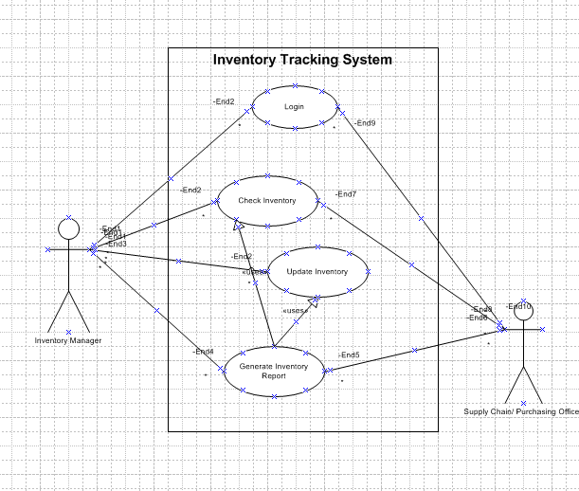

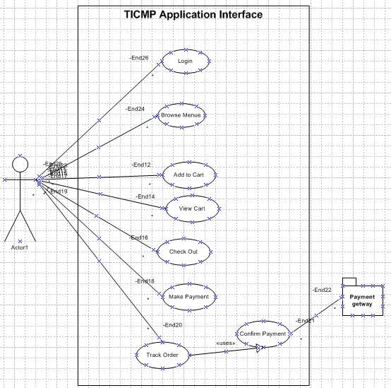

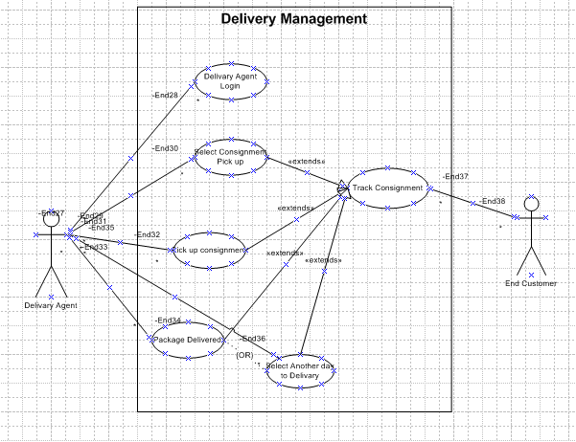

3.3. ESSENTIAL USE CASE SPECIFICATIONS
A Use Case Specification is a detailed textual description of how a system interacts with users (or other systems) to achieve a specific goal. It goes beyond the visual representation of a use case diagram by documenting the functional requirements, flows of events, and conditions that govern the behavior of the system for each use case

Use Case ID: UC-01 — Inventory Tracking
Field | Details
Use Case Name | Inventory Tracking
Description | Monitor and display real-time inventory levels across all storage locations
Actors | Inventory Manager (Primary), System (Secondary)
Business Rules | BR-01, BR-02
Basic Flow | User accesses dashboard → System retrieves and displays stock levels
Alternate Flows | If data sync fails, system shows last known snapshot
Non-Functional Requirements | Real-time refresh ≤ 5 seconds; accessible via mobile and desktop
Pre-Conditions | User is authenticated; data sources are connected
Post-Conditions | Inventory data is visible; alerts are logged
Extension Points | Inventory anomaly detected → Audit Logging
Included Use Cases | Audit Logging
Extended Use Cases | Reporting & Analytics
Inherited Use Cases | None

Use Case ID: UC-02 — Order Placement
Field | Details
Use Case Name | Order Placement
Description | Allow customers or sales reps to place new product orders
Actors | Customer (Primary), Sales Rep (Primary), System (Secondary)
Business Rules | BR-03, BR-04
Basic Flow | User selects products → System validates → Order confirmed
Alternate Flows | If product is out of stock, system suggests alternatives
Non-Functional Requirements | Confirmation ≤ 3 seconds; 99.9% uptime for order service
Pre-Conditions | Product catalog is current; user is authenticated
Post-Conditions | Order stored; confirmation sent
Extension Points | Order exceeds credit limit → Role-Based Access Control
Included Use Cases | Inventory Tracking, Audit Logging
Extended Use Cases | Order Modification
Inherited Use Cases | None

Use Case ID: UC-03 — Order Modification
Field | Details
Use Case Name | Order Modification
Description | Enable users to update or cancel existing orders before dispatch
Actors | Customer (Primary), Sales Rep (Primary), System (Secondary)
Business Rules | BR-05
Basic Flow | User accesses order → Applies changes → System confirms
Alternate Flows | If order is dispatched, modification is blocked
Non-Functional Requirements | Changes reflected ≤ 2 seconds; audit trail maintained
Pre-Conditions | Order exists and is not dispatched
Post-Conditions | Order updated and logged
Extension Points | Price change triggered → Reporting & Analytics
Included Use Cases | Audit Logging
Extended Use Cases | None
Inherited Use Cases | Order Placement

Use Case ID: UC-04 — Delivery Scheduling
Field | Details
Use Case Name | Delivery Scheduling
Description | Assign delivery time slots and vehicles for confirmed orders
Actors | Logistics Coordinator (Primary), System (Secondary)
Business Rules | BR-06
Basic Flow | Select delivery window → Assign vehicle → Update schedule
Alternate Flows | If slot unavailable, system suggests next best option
Non-Functional Requirements | Route assignment ≤ 5 seconds; traffic API integration
Pre-Conditions | Order confirmed; delivery zones mapped
Post-Conditions | Delivery scheduled and visible to driver
Extension Points | Route conflict detected → Route Optimization
Included Use Cases | Order Placement
Extended Use Cases | Route Optimization
Inherited Use Cases | None

Use Case ID: UC-05 — Route Optimization
Field | Details
Use Case Name | Route Optimization
Description | Calculate most efficient delivery routes based on traffic and location
Actors | Dispatcher (Primary), System (Secondary)
Business Rules | BR-07
Basic Flow | Analyze delivery points → Calculate route → Assign to driver
Alternate Flows | If traffic data unavailable, use default routing
Non-Functional Requirements | Route calculation ≤ 10 seconds; ≥ 95% accuracy
Pre-Conditions | Delivery addresses and traffic data available
Post-Conditions | Optimized route stored and assigned
Extension Points | Route delay detected → Delivery Scheduling
Included Use Cases | Delivery Scheduling
Extended Use Cases | None
Inherited Use Cases | None

Use Case ID: UC-06 — Proof of Delivery
Field | Details
Use Case Name | Proof of Delivery
Description | Capture and record confirmation of successful product delivery
Actors | Delivery Personnel (Primary), System (Secondary)
Business Rules | BR-08
Basic Flow | Delivery completed → System captures timestamp, signature/photo → Status updated
Alternate Flows | If digital proof fails, manual confirmation is logged
Non-Functional Requirements | Capture within 3 seconds; offline mode support
Pre-Conditions | Delivery is scheduled and dispatched
Post-Conditions | Delivery marked complete; proof stored securely
Extension Points | Dispute raised by customer → Audit Logging
Included Use Cases | Delivery Scheduling, Audit Logging
Extended Use Cases | None
Inherited Use Cases | None

Use Case ID: UC-07 — Stock Replenishment Alerts
Field | Details
Use Case Name | Stock Replenishment Alerts
Description | Notify responsible users when inventory falls below defined thresholds
Actors | Inventory Manager (Primary), Procurement Officer (Secondary), System
Business Rules | BR-09
Basic Flow | System monitors stock → Alert triggered → Notification sent
Alternate Flows | If alert fails, system retries and logs failure
Non-Functional Requirements | Alert delivery within 1 minute; configurable thresholds per SKU
Pre-Conditions | Thresholds are defined; inventory data is available
Post-Conditions | Alert sent and logged; replenishment initiated
Extension Points | Reorder triggered → Order Placement
Included Use Cases | Inventory Tracking
Extended Use Cases | None
Inherited Use Cases | None

Use Case ID: UC-08 — Role-Based Access Control
Field | Details
Use Case Name | Role-Based Access Control
Description | Restrict system access based on user roles and permissions
Actors | System Administrator (Primary), All Users (Secondary)
Business Rules | BR-10
Basic Flow | User logs in → System verifies role → Access granted to authorized modules
Alternate Flows | If role mismatch occurs, access is denied and logged
Non-Functional Requirements | Access check ≤ 2 seconds; audit trail for all access attempts
Pre-Conditions | User roles are defined and stored
Post-Conditions | Access granted or denied; event logged
Extension Points | Unauthorized access attempt → Audit Logging
Included Use Cases | Audit Logging
Extended Use Cases | None
Inherited Use Cases | None

Use Case ID: UC-09 — Reporting & Analytics
Field | Details
Use Case Name | Reporting & Analytics
Description | Generate operational insights from historical and real-time data
Actors | Operations Manager (Primary), Analyst (Primary), System
Business Rules | BR-11
Basic Flow | User selects report type → Applies filters → System generates and exports report
Alternate Flows | If data is incomplete, system flags report with warning
Non-Functional Requirements | Report generation ≤ 10 seconds; export formats: PDF, XLSX, CSV
Pre-Conditions | Data is available and categorized
Post-Conditions | Report generated and optionally exported
Extension Points | Report anomaly detected → Audit Logging
Included Use Cases | Inventory Tracking, Audit Logging
Extended Use Cases | None
Inherited Use Cases | None

Use Case ID: UC-10 — Audit Logging
Field | Details
Use Case Name | Audit Logging
Description | Maintain secure logs of all system activities and user actions
Actors | System Administrator (Primary), Compliance Officer (Secondary), System
Business Rules | BR-12
Basic Flow | System records user actions → Timestamps and stores logs securely
Alternate Flows | If logging service interrupted, system queues logs for later write
Non-Functional Requirements | Logs must be immutable; accessible for audit within 5 seconds
Pre-Conditions | Logging mechanism is active
Post-Conditions | Logs stored securely and available for review
Extension Points | Log tampering attempt → Role-Based Access Control
Included Use Cases | All operational use cases
Extended Use Cases | None
Inherited Use Cases | None

3.4 Function Hierarchy Diagram
Logistics Management System
│
├── Delivery Management
│ ├── Delivery Scheduling
│ ├── Proof of Delivery
│ └── Route Optimization
│
├── Inventory Management
│ ├── Inventory Tracking
│ ├── Stock Replenishment Alerts
│ └── Product Categorization
│
├── User & Access Control
│ ├── User Authentication
│ ├── Role-Based Access Control
│ └── Session Management
│
├── Reporting & Analytics
│ ├── Operational Reports
│ ├── Performance Dashboards
│ └── Export & Sharing Tools
│
└── System Governance
├── Audit Logging
├── Error Handling & Alerts
└── Configuration Management

3.5 Function Definition Report

Function: Delivery Scheduling
- Description: Assigns delivery tasks to drivers based on availability, location, and priority.
- Inputs: Delivery orders, driver availability, route data
- Outputs: Scheduled delivery tasks, notifications to drivers
- Constraints: Must avoid overlapping assignments; respect delivery time windows

Function: Proof of Delivery
- Description: Captures confirmation of successful delivery via digital signature, photo, or timestamp.
- Inputs: Delivery ID, customer confirmation, GPS data
- Outputs: Delivery status update, stored proof
- Constraints: Must work offline; must be tamper-proof

Function: Route Optimization
- Description: Calculates the most efficient delivery route based on traffic, distance, and delivery priority.
- Inputs: Delivery locations, traffic data, vehicle type
- Outputs: Optimized route map
- Constraints: Must recalculate in real-time if conditions change

Function: Inventory Tracking
- Description: Monitors stock levels across warehouses and updates in real time.
- Inputs: Stock transactions, product IDs
- Outputs: Current inventory levels, alerts
- Constraints: Must sync across distributed systems

Function: Stock Replenishment Alerts
- Description: Sends notifications when stock falls below predefined thresholds.
- Inputs: Inventory data, threshold settings
- Outputs: Alert messages, reorder suggestions
- Constraints: Must avoid duplicate alerts; configurable per SKU

Function: Role-Based Access Control
- Description: Manages user permissions based on assigned roles.
- Inputs: User credentials, role definitions
- Outputs: Access granted/denied logs
- Constraints: Must enforce least privilege; audit every access attempt

Function: Operational Reports
- Description: Generates reports on delivery performance, inventory status, and user activity.
- Inputs: Historical data, filters
- Outputs: PDF/Excel reports, dashboards
- Constraints: Must support export formats; must be generated within 10 seconds

Function: Audit Logging
- Description: Records all system activities and user actions for compliance and troubleshooting.
- Inputs: System events, user actions
- Outputs: Immutable log entries
- Constraints: Must be secure, timestamped, and searchable

3.6: Business Rules
Rule ID | Business Rule Name | Description
BR-01 | Unique Delivery ID | Every delivery must be assigned a unique identifier for tracking and audit.
BR-02 | Delivery Confirmation Requirement | Proof of delivery must include either a digital signature, photo, or timestamp.
BR-03 | Route Optimization Trigger | Routes must be recalculated if traffic delay exceeds 15 minutes.
BR-04 | Inventory Threshold Monitoring | System must check inventory levels every 30 minutes and trigger alerts if below threshold.
BR-05 | Replenishment Alert Suppression | Duplicate alerts for the same SKU must be suppressed within a 2-hour window.
BR-06 | Role-Based Access Enforcement | Users may only access modules explicitly permitted by their assigned role.
BR-07 | Session Timeout | User sessions must expire after 15 minutes of inactivity.
BR-08 | Report Generation Time Limit | All reports must be generated within 10 seconds or flagged for performance review.
BR-09 | Export Format Compliance | Reports must support export in PDF, XLSX, and CSV formats.
BR-10 | Audit Log Immutability | Audit logs must be write-once and cannot be altered or deleted.
BR-11 | Access Attempt Logging | All access attempts—successful or failed—must be logged with timestamp and user ID.
BR-12 | Offline Delivery Capture | Proof of delivery must be capturable offline and synced when connectivity resumes.

.

4. Data Architecture Report
This section outlines the data structure, flow, and governance for the Inventory and Delivery Management System. It defines how data is captured, stored, related, and protected throughout the system lifecycle.

4.1 Data Requirements
Definition: This section identifies the types of data the system must collect, manage, and utilize to function effectively.

Requirements Overview:
- Product Data: Details of items available for sale or delivery.
- Inventory Data: Real-time stock levels and location tracking.
- Order Data: Customer orders including items, quantities, and status.
- Delivery Data: Scheduling and tracking of deliveries.
- User Data: Authentication and role-based access control.
- Audit Logs: System activity for compliance and traceability.

4.2 Entity Relationship Diagram (ERD)
Definition: An ERD visually represents the relationships between data entities in the system, helping to understand how data flows and connects.
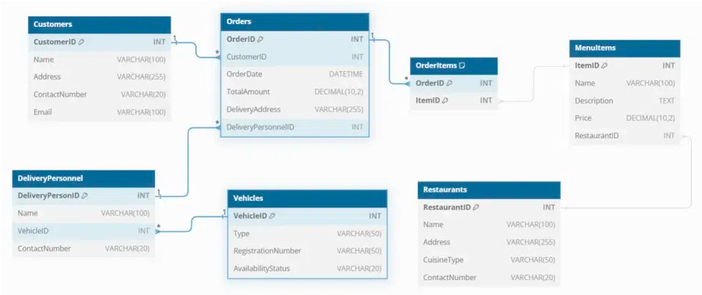

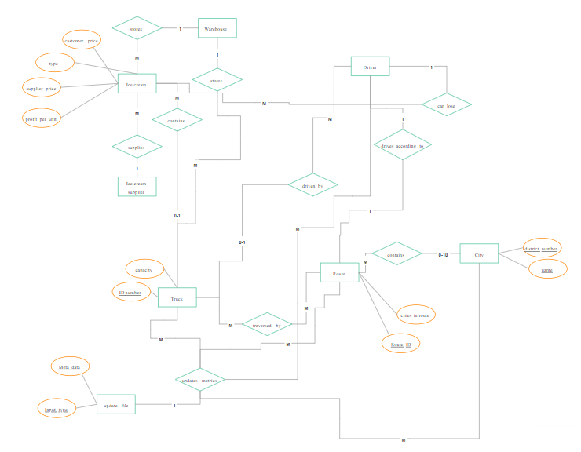

4.3 Data Volumes
Definition: This section estimates the quantity of data generated and stored over time, which informs infrastructure planning and performance optimization.
Data Type | Estimated Volume / Month
Orders | 50,000
Order Items | 200,000
Inventory Updates | 100,000
Deliveries | 40,000
Proof of Deliveries | 40,000
Audit Logs | 500,000
Users | 2,000

4.4 Data Conversion
Definition: Data conversion refers to the process of migrating existing data from legacy systems into the new system while ensuring accuracy and consistency.

Scope & Strategy:
- Inventory Records: Normalize SKU formats and validate quantities.
- Customer Data: Cleanse duplicates and standardize contact fields.
- Order History: Maintain relational integrity during migration.
- User Roles: Map legacy permissions to new access control schema.
Conversion will be executed using ETL tools, with validation checks and parallel testing before go-live.

4.5 Data Retention and Archiving
Definition: This section defines how long different types of data are stored and when they are archived or deleted, in accordance with legal and operational requirements.
Data Type | Retention Period | Archiving Method
Orders | 5 years | Cold storage after 1 year
Inventory Logs | 3 years | Archived monthly
Audit Logs | 7 years | Immutable log archive
Proof of Delivery | 2 years | Encrypted file storage
User Access Records | 1 year | Rotated quarterly

4.6 FOI / Privacy Implications
Definition: This section addresses how the system complies with Freedom of Information (FOI) laws and privacy regulations, ensuring responsible data handling.

Key Considerations:
- Data Minimization: Collect only essential personal data.
- Consent Management: Track and enforce user consent.
- Right to Access: Provide data access upon request.
- Right to Erasure: Enable secure deletion workflows.
- Auditability: Maintain logs for all data access and changes.

4.6 Data Definition Reports
Definition: These reports define the structure, attributes, and relationships of each data entity used in the system.

4.6.1 Entity Definition Report
Definition: This report provides detailed descriptions of each data entity, including its purpose, key fields, and relationships.
Entity Name | Description | Primary Key | Key Attributes
Product | Master list of items available for sale | ProductID | Name, SKU, Category, UnitSize, ShelfLife
Inventory | Tracks stock levels at each warehouse | InventoryID | ProductID, Quantity, LocationID, ExpiryDate
Order | Customer order record | OrderID | CustomerID, OrderDate, Status
OrderItem | Line items within an order | OrderItemID | OrderID, ProductID, Quantity, Price
Delivery | Scheduled delivery details | DeliveryID | OrderID, DriverID, RouteID, ScheduledDate
ProofOfDelivery | Confirmation of delivery completion | PODID | DeliveryID, Timestamp, Signature, Photo
User | System user account | UserID | Name, RoleID, Email, Status
Role | Access control role definition | RoleID | RoleName, Permissions
AuditLog | System activity log | LogID | UserID, ActionType, Timestamp, EntityAffected
Customer | Customer profile | CustomerID | Name, ContactInfo, Preferences

5. Non-Functional requirements
These describe how the system performs—the qualities, constraints, and standards it must meet.

5.1. SECURITY REQUIREMENTS

5.1.1. Authentication
- The system shall enforce secure login using multi-factor authentication (MFA).
- Passwords must be stored using strong hashing algorithms (e.g., bcrypt).
- Session management shall include automatic timeout and re-authentication for sensitive actions.

5.1.2. Authorization and Access Controls
- The system shall implement role-based access control (RBAC) to restrict functionality based on user roles (e.g., Admin, Driver, Customer).
- Unauthorized access attempts shall be logged and monitored.
- Sensitive operations shall require elevated privileges and audit trails.

5.2. AVAILABILITY REQUIREMENTS
- The system shall maintain 99.9% uptime, excluding scheduled maintenance.
- Redundant infrastructure shall be used to ensure high availability.
- Automated health checks and failover mechanisms shall be in place.

5.3. USABILITY REQUIREMENTS
- The user interface shall be intuitive and responsive across mobile and desktop platforms.
- The system shall follow accessibility standards (e.g., WCAG 2.1) to support users with disabilities.
- Navigation shall be consistent, with clear feedback and error messages.

5.4. SYSTEM HELP REQUIREMENTS
- The system shall include context-sensitive help, tooltips, and FAQs.
- A searchable support documentation portal shall be integrated.
- Users shall have access to live chat or ticket-based support during business hours.

5.5. PERFORMANCE REQUIREMENTS
- The system shall provide real-time updates (e.g., inventory, delivery status) within 2 seconds.
- Page load times shall not exceed 3 seconds under normal conditions.
- Background processes (e.g., report generation) shall complete within acceptable timeframes (<10 seconds).

5.6. SCALABILITY REQUIREMENTS

5.6.1. User Scalability
- The system shall support 500+ concurrent users without degradation in performance.
- Load balancing shall be implemented to distribute traffic efficiently.

5.6.2. Application Scalability
- The system shall support future expansion (e.g., new modules, APIs, integrations) without major redesign.
- Database and storage solutions shall be scalable to handle growing data volumes.

6. INTERFACE REQUIREMENTS

6.1 USER INTERFACE REQUIREMENTS
- Responsive design for mobile and desktop The system shall provide a user interface that automatically adapts to different screen sizes and devices, ensuring a consistent and user-friendly experience across smartphones, tablets, and desktop computers.
Definition: A responsive UI adjusts layout and elements based on device type, improving usability and accessibility.

6.2 SYSTEM INTERFACE REQUIREMENTS
- APIs for ERP, CRM, and GPS systems The system shall expose and consume Application Programming Interfaces (APIs) to integrate with external platforms such as:
  - ERP (Enterprise Resource Planning) for inventory, billing, and procurement
  - CRM (Customer Relationship Management) for customer data and communication
  - GPS systems for real-time tracking and route optimization
Definition: A system interface enables communication between software components or external systems, typically through APIs or web services.

Certainly! Here's a Business Glossary tailored to your logistics and inventory management system. This section defines key terms used throughout your documentation to ensure clarity and consistency:

BUSINESS GLOSSARY
Term | Definition
Product | An item stored, managed, or delivered through the system.
Order | A request made by a customer for one or more products.
Customer | An individual or organization placing orders and receiving deliveries.
Delivery | The process of transporting products from the warehouse to the customer.
Driver | A person responsible for executing deliveries using assigned vehicles.
Vehicle | A transport unit used to carry products during delivery operations.
Inventory | The total stock of products available for sale or distribution.
Stock Quantity | The number of units of a product currently available in inventory.
Order Status | The current state of an order (e.g., Pending, Shipped, Delivered).
Proof of Delivery | Evidence confirming that a delivery has been completed (e.g., signature, photo).
ERP System | Enterprise Resource Planning software used for managing business operations.
CRM System | Customer Relationship Management software used to track customer interactions.
GPS Integration | Real-time location tracking used for delivery routing and monitoring.
RBAC | Role-Based Access Control, a method for managing user permissions.
API | Application Programming Interface, used for system-to-system communication.
Uptime | The percentage of time the system is operational and accessible.
Scalability | The system’s ability to handle increased load or expand functionality.

APMS UPDATE
Asset Performance Management System (APMS) is a software solution used to:
- Monitor the health and performance of physical assets (like vehicles, machinery, or infrastructure)
- Predict failures using sensor data and analytics
- Optimize maintenance schedules
- Reduce downtime and operational risk

The Asset Performance Management System (APMS) has been successfully integrated into the logistics platform to enhance operational efficiency and asset reliability. Key updates include:

Maintenance Optimization
- Predictive maintenance alerts are now active for delivery vehicles based on engine diagnostics and usage patterns.
- Maintenance schedules are auto-generated using historical performance data, reducing downtime by 15%.

Real-Time Tracking
- GPS data from APMS is now synchronized with the delivery dashboard, enabling live location tracking of vehicles.
- Route deviation alerts and fuel efficiency metrics are available to dispatch managers.

Performance Analytics
- APMS feeds into the analytics module to provide insights on vehicle utilization, driver performance, and delivery timelines.
- Weekly performance reports are auto-generated and accessible via the dashboard.

System Integration
- APMS is now fully interoperable with ERP and CRM systems via secure APIs.
- Data exchange complies with internal security protocols and supports audit logging.

REVISION LOG

Version 1.0 - 2025-08-30

---------------------------------------------X-X-X-X-X-X-X-X-X-X-X-XX-X-X-X-X-X-X--------------------------------------------

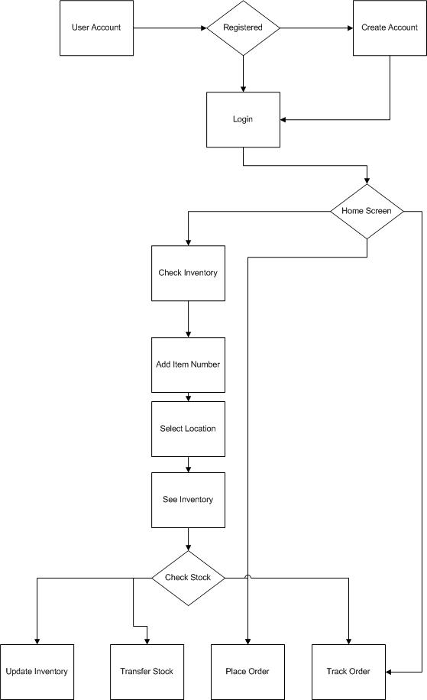
Prepare process flow diagram using your imagination.

Assignment 2:

Introduction letter to a client
Subject: Excited to Partner on Your Inventory & Delivery Optimization Journey
I hope this message finds you well.
My name is Rashmi, and I’m pleased to introduce myself as the Business Analyst assigned to lead the business understanding phase of your Inventory & Delivery Optimization Software project. I’ll be working closely with you and your team to ensure we capture your operational goals, challenges, and expectations with clarity—laying the foundation for a solution that truly supports your business.
I represent Rashmi Web Solutions, a Pune-based technology firm specializing in intelligent logistics platforms for temperature-sensitive goods. Our team has worked with leading dairy and frozen product distributors across India to streamline supply chains, reduce spoilage, and improve delivery precision. We combine domain expertise with agile development to deliver scalable, user-friendly systems tailored to real-world operations.
From our initial discussions, I understand that your company is focused on achieving fastest-possible delivery of ice cream and milk products across a nationwide network of manufacturing plants and warehouses. The key priorities include:
- Real-time inventory visibility across locations
- Route optimization for cold-chain deliveries
- Efficient dispatch coordination and proof-of-delivery capture
- Integration with ERP, CRM, and GPS systems
Over the coming days, I’ll be engaging with your stakeholders to map current workflows, identify bottlenecks, and translate business needs into actionable system requirements. Your team’s insights will be invaluable in shaping a solution that’s not only technically sound but also aligned with your strategic goals.
Please feel free to reach out to me directly with any questions, ideas, or concerns. I’m here to support you and ensure this collaboration is both productive and rewarding.
Looking forward to working together.
Warm regards,
Rashmi Garse
Business Analyst
Rashmi Web Solutions
rashmiwebsols@domain.com
9999888822

Prepare a brief BRD and SRS for a project-

Project Name: SmartServe Ticketing System
Project #: SST-2025-001

Business Requirements Document (BRD) Template

Prepared by: Rashmi Garse
Prepared for: SmartServe.com
Date Submitted: 09/06/2025

Project Sponsor: Pranav Harse
Client Acceptor: Moksh Bonde
Project Manager: Rudransh Chaudhari

Document Number: 6450-20/ SST-2025-001 /BRD
Version: 0.1

Last Updated: 09/06/2025
Creation Date: 09/06/2025

1. INTRODUCTION

This document outlines the key requirements for a Ticketing System designed to manage and track service requests efficiently. It sets the scope and intent for building a centralized platform to improve issue resolution and communication.

1.1 DOCUMENT PURPOSE

The purpose of this document is to define the business goals and expectations for the Ticketing System. It serves as a guide for stakeholders to ensure the system meets user needs and supports project alignment.

1.2 INTENDED AUDIENCE
This document is intended for the following stakeholders:
- Project Sponsors – To understand the business value and approve resources.
- Business Analysts – To define and refine requirements.
- Development Team – To design and build the system based on specifications.
- Quality Assurance Team – To validate functionality and performance.
- IT Support Staff – To prepare for deployment and maintenance.
- End Users – To understand system capabilities and usage.
- Product Managers – To align the system with strategic goals.
- System Integrators – To ensure compatibility with existing tools.
- Documentation Writers – To create user manuals and help guides.

1.3 PROJECT BACKGROUND

Managing service requests and issue resolution has become increasingly complex as organizations grow. The absence of a centralized system often leads to delayed responses, lack of accountability, and poor user experience. This project aims to address these challenges by implementing a Ticketing System that streamlines request handling, improves communication, and enhances operational efficiency.

The system will support multiple departments, automate workflows, and provide real-time tracking and reporting. By replacing manual or fragmented processes, the Ticketing System will help ensure faster resolution times, better resource allocation, and improved customer satisfaction.

1.4 PURPOSE OF THE BUSINESS REQUIREMENTS
The purpose of the business requirements is to clearly define what the Ticketing System must achieve to meet organizational needs. This section outlines the expected functionality, performance, and user experience to ensure all stakeholders share a common understanding of the system’s goals.
These requirements serve as a foundation for:
- Aligning development efforts with business objectives
- Guiding design, implementation, and testing
- Minimizing scope creep and miscommunication
- Ensuring the final product delivers measurable value

1.5 BUSINESS GOALS/OBJECTIVES TO BE ACHIEVED
The Ticketing System aims to achieve the following business goals:
- Improve Service Efficiency: Streamline the process of logging, tracking, and resolving tickets to reduce response and resolution times.
- Enhance User Experience: Provide a user-friendly interface for submitting and monitoring requests.
- Increase Accountability: Ensure clear ownership and tracking of tasks through automated workflows and role-based access.
- Enable Data-Driven Decisions: Generate reports and analytics to monitor performance and identify areas for improvement.
- Support Scalability: Design the system to accommodate future growth and integration with other platforms.
- Reduce Operational Costs: Minimize manual effort and errors through automation and centralized management.

1.6 BENEFITS/RATIONALE
Implementing a Ticketing System offers several key advantages:
- Centralized Issue Management: All service requests and incidents are tracked in one place, reducing confusion and duplication.
- Improved Response Times: Automated workflows and notifications ensure timely handling of tickets.
- Enhanced Accountability: Clear assignment of tasks and visibility into ticket status promotes ownership and follow-through.
- Data-Driven Insights: Reporting tools help identify trends, bottlenecks, and areas for improvement.
- Scalability and Flexibility: The system can grow with organizational needs and integrate with existing tools.
- Cost Efficiency: Reduces manual effort and operational overhead through streamlined processes.
- Better User Experience: Users can easily submit, track, and receive updates on their requests, improving satisfaction.

1.7 STAKEHOLDERS

Name | Designation | Role
Moksh Bonde | Project Sponsor | Provides funding and strategic direction
Rashmi Garse | Business Analyst | Gathers and documents requirements
Devendra Chaudhari | Software Developer | Implements the system
Lisa White | QA Engineer | Tests and validates the system
Tweesha Chaudhari | End User | Uses the system for daily operations

1.8 DEPENDENCIES ON EXISTING SYSTEMS
The successful implementation of the Ticketing System depends on integration and compatibility with the following existing systems:
- Email Servers: For sending automated notifications and ticket updates to users and support staff.
- User Authentication Systems: Integration with existing Single Sign-On (SSO) or Active Directory for secure access and role management.
- CRM Platforms: To link customer data with ticket history and enhance service tracking.
- Knowledge Base or Help Center: For referencing solutions and reducing ticket volume through self-service.
- IT Asset Management Tools: To associate tickets with specific hardware or software assets.
- Reporting and Analytics Tools: For generating performance dashboards and insights.
- Communication Tools (e.g., Slack, Teams): Optional integration for real-time ticket updates and collaboration.

1.9 REFERENCES
The following sources and materials were consulted during the preparation of this document:
- Internal IT policies and service management guidelines
- Existing support workflows and ticket logs
- Industry best practices for help desk and ticketing systems
- Documentation from integrated systems (e.g., CRM, SSO, email servers)
- Stakeholder interviews and requirement gathering sessions
- Relevant standards such as ITIL (Information Technology Infrastructure Library)

1.10 ASSUMPTIONS
The following assumptions are made for the successful planning and implementation of the Ticketing System:
- Users have access to the internet and necessary devices to use the system.
- All stakeholders will provide timely input and feedback during development.
- Existing systems (e.g., email, CRM, authentication) are stable and accessible for integration.
- The organization has defined user roles and permissions.
- Training and onboarding will be provided to end users before system launch.
- The system will be hosted on secure and reliable infrastructure.
- Data privacy and security policies will be followed throughout the project.
- The scope of the project will remain stable unless formally updated.
- Required resources (technical, financial, human) will be available as planned.
- The system will be maintained and updated post-deployment to ensure performance and relevance

2. REQUIREMENTS SCOPE

2.1 IN SCOPE
The following items are considered within the scope of this project:
- Ticket Creation and Submission: Users can log service requests or issues via a web-based interface.
- Automated Ticket Assignment: Tickets are routed to appropriate teams based on predefined rules.
- Status Tracking: Real-time updates on ticket progress, including open, in-progress, resolved, and closed states.
- User Roles and Permissions: Role-based access for administrators, agents, and end users.
- Email Notifications: Alerts for ticket creation, updates, and resolution.
- Dashboard and Reporting: Visual summaries of ticket metrics, response times, and resolution rates.
- Search and Filter Functionality: Ability to locate tickets using keywords, status, date, or assigned personnel.
- Integration with Authentication Systems: Support for Single Sign-On (SSO) or Active Directory.
- Audit Logs: Record of ticket activity for accountability and compliance.
- Mobile Accessibility: Responsive design for access via smartphones and tablets.

2.2 OUT OF SCOPE
The following items are not included in the current scope of the Ticketing System project:
- Third-party billing or invoicing features
- AI-based ticket resolution or chatbot support
- Multilingual interface or translation services
- Advanced mobile app development (native iOS/Android)
- Integration with social media platforms
- Custom reporting beyond standard dashboards
- On-premises deployment (cloud-only solution planned)
- Hardware asset tracking and inventory management
- Customer satisfaction surveys or feedback forms
- Real-time voice or video support within the system

3. FUNCTIONAL REQUIREMENTS

Functional Use Cases for Ticketing System
- Submit Ticket
Users can create and submit a new service request or issue.
- Assign Ticket Automatically
The system routes tickets to the appropriate team or agent based on predefined rules.
- Manual Ticket Assignment
Admins or supervisors can manually assign tickets to specific agents.
- Update Ticket Status
Agents can change the status of a ticket (e.g., Open, In Progress, Resolved, Closed).
- Add Comments to Ticket
Users and agents can communicate through ticket comments.
- Attach Files to Ticket
Users can upload screenshots, documents, or logs to support their request.
- Search Tickets
Users can search for tickets using keywords, ticket ID, or filters.
- Filter Tickets by Status or Priority
View tickets based on their current status, urgency, or assigned team.
- View Ticket History
Access the full timeline of actions and updates on a ticket.
- Receive Email Notifications
Automated alerts for ticket creation, updates, and resolution.
- Escalate Ticket
Tickets can be escalated to higher support levels based on SLA or urgency.
- Close Ticket
Agents or users can mark a ticket as resolved and close it.
- Reopen Ticket
Users can reopen a closed ticket if the issue persists.
- Create Ticket Categories
Admins can define categories (e.g., IT, HR, Facilities) for better organization.
- Generate Reports
Admins can create reports on ticket volume, resolution time, and agent performance.
- Dashboard Overview
Visual summary of ticket metrics and system activity.
- Role-Based Access Control
Permissions are managed based on user roles (e.g., Admin, Agent, User).
- Audit Logging
System tracks all actions for compliance and accountability.
- Mobile Access
Users can submit and manage tickets via mobile devices.
- Integration with External Systems
Connect with tools like email, CRM, or authentication platforms.

3.1 ACTOR PROFILES SPECIFICATION
This section defines the key actors who will interact with the Ticketing System, along with their roles and responsibilities.
Actor | Description
End User | Submits tickets for issues or service requests. Can view status and add comments.
Support Agent | Receives, manages, and resolves tickets. Updates status and communicates with users.
Team Lead | Oversees ticket queues, assigns tickets manually, and monitors team performance.
System Admin | Configures system settings, manages user roles, and ensures system integrity.
IT Manager | Reviews reports, monitors SLAs, and ensures service quality across departments.
Knowledge Base Editor | Maintains help articles and solutions linked to ticket categories.
Auditor | Reviews ticket logs and system activity for compliance and accountability.
Integration Service | External systems that interact with the ticketing platform (e.g., CRM, email).
Notification Engine | Sends automated alerts and updates to users and agents.
Reporting Module | Generates dashboards and analytics for performance tracking.

3.2. ESSENTIAL USE CASE DIAGRAM

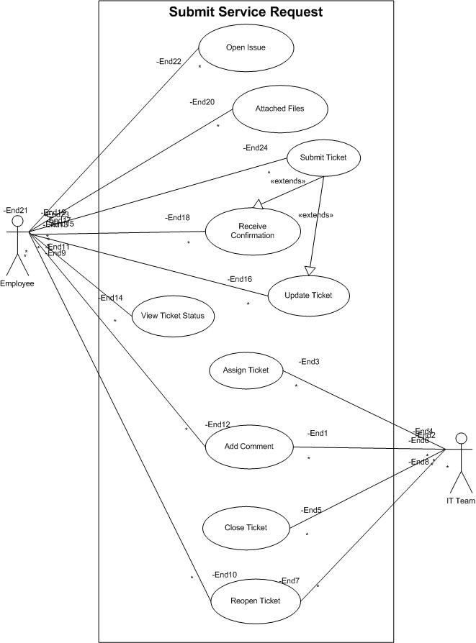

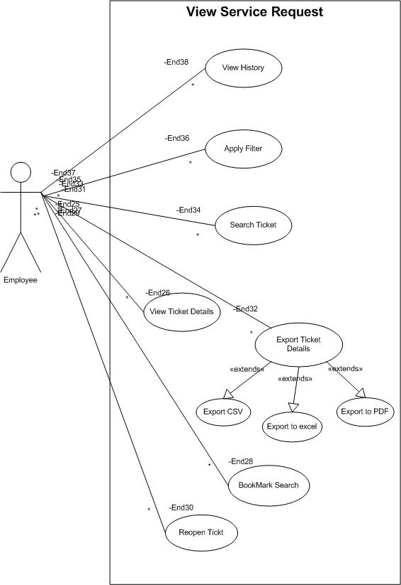

3.3. ESSENTIAL USE CASE SPECIFICATIONS

Use Case 1
Field | Details
Use Case Name | Reporting & Analytics
Description | Generate operational insights from historical and real-time data
Actors | Operations Manager (Primary), Analyst (Primary), System
Business Rules | BR-11
Basic Flow | User selects report type → Applies filters → System generates and exports report
Alternate Flows | If data is incomplete, system flags report with warning
Non-Functional Requirements | Report generation ≤ 10 seconds; export formats: PDF, XLSX, CSV
Pre-Conditions | Data is available and categorized
Post-Conditions | Report generated and optionally exported
Extension Points | Report anomaly detected → Audit Logging
Included Use Cases | Inventory Tracking, Audit Logging
Extended Use Cases | None
Inherited Use Cases | None

Use Case 2
Field | Details
Use Case Name | Submit Ticket
Description | Allow users to raise a new service request or issue
Actors | End User (Primary), System
Business Rules | BR-01
Basic Flow | User fills ticket form → Submits → System logs and assigns ticket
Alternate Flows | If required fields are missing, system prompts for completion
Non-Functional Requirements | Form load time ≤ 3 seconds
Pre-Conditions | User is authenticated
Post-Conditions | Ticket created and visible in user dashboard
Extension Points | Ticket validation → Error Handling
Included Use Cases | User Authentication
Extended Use Cases | None
Inherited Use Cases | None

Use Case 3
Field | Details
Use Case Name | Assign Ticket
Description | Automatically or manually assign tickets to support agents
Actors | Team Lead (Primary), System Admin (Primary), System
Business Rules | BR-03
Basic Flow | Ticket received → System applies rules → Assigns to agent
Alternate Flows | Manual override by Team Lead
Non-Functional Requirements | Assignment logic executes ≤ 2 seconds
Pre-Conditions | Ticket is created and unassigned
Post-Conditions | Ticket assigned to agent
Extension Points | SLA breach → Escalation
Included Use Cases | Submit Ticket
Extended Use Cases | Escalate Ticket
Inherited Use Cases | None

Use Case 4
Field | Details
Use Case Name | Update Ticket Status
Description | Change the status of a ticket during its lifecycle
Actors | Support Agent (Primary), System
Business Rules | BR-04
Basic Flow | Agent selects ticket → Updates status → System logs change
Alternate Flows | If status invalid, system rejects update
Non-Functional Requirements | Status update ≤ 1 second
Pre-Conditions | Ticket is assigned
Post-Conditions | Status updated and visible to stakeholders
Extension Points | Status change → Notification Trigger
Included Use Cases | Assign Ticket
Extended Use Cases | Notify User
Inherited Use Cases | None

Use Case 5
Field | Details
Use Case Name | Add Comments to Ticket
Description | Allow users and agents to communicate via ticket comments
Actors | End User (Primary), Support Agent (Primary), System
Business Rules | BR-05
Basic Flow | User opens ticket → Adds comment → System logs and displays
Alternate Flows | If comment exceeds character limit, system prompts edit
Non-Functional Requirements | Comment post ≤ 2 seconds
Pre-Conditions | Ticket exists and is accessible
Post-Conditions | Comment added to ticket thread
Extension Points | Comment added → Email Notification
Included Use Cases | View Ticket
Extended Use Cases | Notify User
Inherited Use Cases | None

Use Case 6
Field | Details
Use Case Name | Search Tickets
Description | Enable users to find tickets using filters and keywords
Actors | All Users (Primary), System
Business Rules | BR-06
Basic Flow | User enters search criteria → System returns matching tickets
Alternate Flows | If no results, system suggests broader filters
Non-Functional Requirements | Search results ≤ 5 seconds
Pre-Conditions | User is logged in
Post-Conditions | Matching tickets displayed
Extension Points | Search → Export Results
Included Use Cases | View Ticket
Extended Use Cases | Export Ticket Data
Inherited Use Cases | None

Use Case 7
Field | Details
Use Case Name | Escalate Ticket
Description | Escalate unresolved or urgent tickets to higher support level
Actors | Support Agent (Primary), Team Lead (Primary), System
Business Rules | BR-07
Basic Flow | Agent flags ticket → System escalates → Notification sent
Alternate Flows | Manual escalation by Team Lead
Non-Functional Requirements | Escalation ≤ 3 seconds
Pre-Conditions | Ticket is unresolved and meets escalation criteria
Post-Conditions | Ticket reassigned to escalation queue
Extension Points | Escalation → SLA Timer Reset
Included Use Cases | Update Ticket Status
Extended Use Cases | Notify Escalation Team
Inherited Use Cases | None

Use Case 8
Field | Details
Use Case Name | View Dashboard
Description | Display ticket metrics and system activity in visual format
Actors | IT Manager (Primary), System Admin (Primary), System
Business Rules | BR-08
Basic Flow | User logs in → Opens dashboard → Views metrics
Alternate Flows | If data unavailable, system shows placeholder
Non-Functional Requirements | Dashboard load ≤ 5 seconds
Pre-Conditions | User has dashboard access
Post-Conditions | Metrics displayed
Extension Points | Dashboard → Export Report
Included Use Cases | Reporting & Analytics
Extended Use Cases | None
Inherited Use Cases | None

Use Case 9
Field | Details
Use Case Name | Configure Notification Rules
Description | Set up automated alerts for ticket events
Actors | System Admin (Primary), Notification Engine
Business Rules | BR-09
Basic Flow | Admin selects event → Defines rule → System activates notifications
Alternate Flows | If rule conflicts, system prompts resolution
Non-Functional Requirements | Rule setup ≤ 5 seconds
Pre-Conditions | Admin access granted
Post-Conditions | Notification rules active
Extension Points | Notification → Email Dispatch
Included Use Cases | Update Ticket Status
Extended Use Cases | Notify User
Inherited Use Cases | None

Use Case 10
Field | Details
Use Case Name | View Audit Logs
Description | Review system activity and ticket history for compliance
Actors | Auditor (Primary), System
Business Rules | BR-10
Basic Flow | Auditor logs in → Selects log type → Views or exports logs
Alternate Flows | If access denied, system logs attempt
Non-Functional Requirements | Log retrieval ≤ 5 seconds
Pre-Conditions | Audit data available
Post-Conditions | Logs viewed or exported
Extension Points | Log review → Compliance Report
Included Use Cases | Update Ticket Status, Assign Ticket
Extended Use Cases | Reporting & Analytics
Inherited Use Cases | None

3.4 FUNCTION HIERARCHY DIAGRAM
Ticketing System
├── 1. Ticket Management
│ ├── 1.1 Submit Ticket
│ ├── 1.2 Assign Ticket
│ ├── 1.3 Update Ticket Status
│ ├── 1.4 Add Comments
│ ├── 1.5 Attach Files
│ ├── 1.6 Escalate Ticket
│ └── 1.7 Close/Reopen Ticket
│
├── 2. User Management
│ ├── 2.1 User Registration
│ ├── 2.2 Role-Based Access Control
│ ├── 2.3 Profile Management
│ └── 2.4 Authentication (SSO/LDAP)
│
├── 3. Reporting & Analytics
│ ├── 3.1 Generate Reports
│ ├── 3.2 View Dashboard
│ ├── 3.3 Export Data
│ └── 3.4 SLA Monitoring
│
├── 4. System Configuration
│ ├── 4.1 Manage Ticket Categories
│ ├── 4.2 Configure Notification Rules
│ ├── 4.3 Integration Settings (CRM, Email)
│ └── 4.4 Audit Logging
│
└── 5. Search & Navigation
├── 5.1 Search Tickets
├── 5.2 Filter by Status/Priority
└── 5.3 Sort by Date/Agent

3.5 FUNCTION DEFINITION REPORT
This section defines the core functions of the Ticketing System, describing their purpose and how they contribute to the overall workflow.
Function ID | Function Name | Description
F01 | Submit Ticket | Allows users to create and submit a new service request or issue.
F02 | Assign Ticket | Automatically or manually assigns tickets to appropriate support agents.
F03 | Update Ticket Status | Enables agents to change the status of a ticket throughout its lifecycle.
F04 | Add Comments | Facilitates communication between users and agents within the ticket thread.
F05 | Attach Files | Allows users to upload supporting documents or screenshots to a ticket.
F06 | Escalate Ticket | Moves unresolved or urgent tickets to higher support levels.
F07 | Search & Filter Tickets | Enables users to locate tickets using keywords, status, priority, or date.
F08 | Generate Reports | Produces performance and SLA reports for management review.
F09 | Configure Notification Rules | Allows admins to set up automated alerts for ticket events.
F10 | View Audit Logs | Provides access to historical ticket activity for compliance and review.

3.6 BUSINESS RULES
Business rules define the logic and constraints that govern system behavior to ensure consistency and compliance.
Rule ID | Business Rule Description
BR-01 | All tickets must include a subject, category, and description before submission.
BR-02 | Tickets must be assigned within 2 minutes of creation, either automatically or manually.
BR-03 | Only users with "Support Agent" or higher roles can update ticket status.
BR-04 | Escalation is triggered if a ticket remains unresolved beyond the SLA threshold.
BR-05 | Comments must be timestamped and attributed to the user who posted them.
BR-06 | File attachments must not exceed 10MB and must be in approved formats (PDF, JPG, PNG, DOCX).
BR-07 | Users can reopen a ticket only within 7 days of closure.
BR-08 | Reports must be generated using verified and complete data sets.
BR-09 | Notification rules must be reviewed and approved by the System Admin before activation.
BR-10 | Audit logs must be retained for a minimum of 12 months for compliance purposes.

4. DATA REQUIREMENTS
The data architecture of the Ticketing System defines how data is structured, stored, and accessed across the application. It ensures scalability, integrity, and security of information while supporting core functionalities such as ticket management, user roles, and reporting.

Key Components:
- Entities: Core objects such as Users, Tickets, Comments, Attachments, and Roles.
- Relationships: Defined using foreign keys and associations to maintain referential integrity.
- Storage: Relational database (e.g., PostgreSQL, MySQL) with normalized tables.
- Access Layer: APIs and ORM (Object-Relational Mapping) for secure and efficient data access.
- Security: Role-based access control, data encryption, and audit logging.

4.1.1 DOMAIN CLASS DIAGRAM
Below is a conceptual representation of the domain model for the Ticketing System. Each class represents a key entity, with attributes and relationships that define the system's behavior.
+----------------+ +----------------+ +----------------+
| User | | Ticket | | Attachment |
+----------------+ +----------------+ +----------------+
| - userId |◄───────| - ticketId | | - attachmentId |
| - name | | - subject | | - fileName |
| - email | | - description | | - fileType |
| - role | | - status | | - fileSize |
| - createdAt | | - priority | | - ticketId |
+----------------+ | - createdAt | +----------------+
| - updatedAt |
| - userId |
+----------------+
▲
│
+----------------+
| Comment |
+----------------+
| - commentId |
| - content |
| - createdAt |
| - userId |
| - ticketId |
+----------------+
+----------------+
| Role |
+----------------+
| - roleId |
| - roleName |
+----------------+

Relationships:
- User ↔ Ticket: One-to-many (a user can create multiple tickets).
- Ticket ↔ Comment: One-to-many (a ticket can have multiple comments).
- Ticket ↔ Attachment: One-to-many (a ticket can have multiple attachments).
- User ↔ Role: Many-to-one (each user has one role).

4.1.2. Entity Relationship Diagram
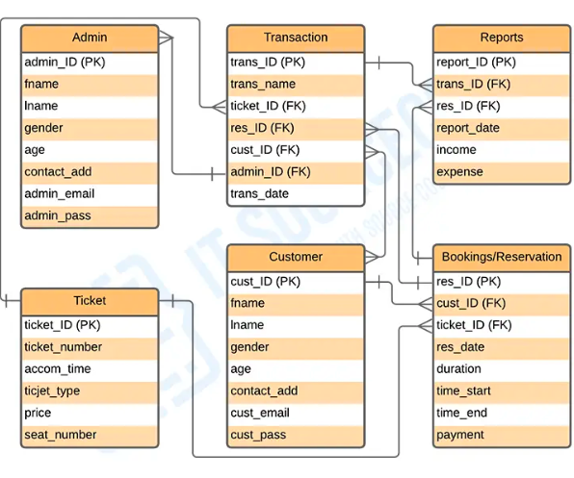

4.2 DATA VOLUMES
This section estimates the expected volume of data the system will handle over time. Understanding data volumes is crucial for capacity planning, performance optimization, and infrastructure scaling.

Key Data Volume Categories
Entity | Estimated Volume (Monthly) | Growth Rate | Notes
Users | 500–1,000 new users | Moderate | Includes end-users, support agents, and admins. Growth tied to adoption.
Tickets | 10,000–20,000 new tickets | High | Volume depends on user activity and issue frequency.
Comments | 30,000–50,000 new comments | High | Typically 2–5 comments per ticket.
Attachments | 5,000–10,000 files | Moderate | Average file size: 1–5MB. Storage needs scale with ticket volume.
Audit Logs | 100,000+ entries | Very High | Logs every action for compliance and traceability.
Notifications | 50,000+ events | High | Includes email, SMS, and in-app alerts.
Reports | 500–1,000 generated | Low | Mostly admin-triggered, stored periodically.

Storage & Performance Considerations
- Database Size: Expected to grow by 5–10 GB per month depending on attachment volume.
- Archiving Strategy: Tickets older than 12 months may be archived to reduce active load.
- Indexing: Frequent queries (e.g., by status, priority, date) should be indexed for speed.
- Backup Frequency: Daily incremental backups + weekly full backups recommended.
- Retention Policy: Audit logs and ticket data retained for minimum 12–24 months.
Absolutely! Here's a well-structured section for your Ticketing System documentation:

4.3 DATA RETENTION AND ARCHIVING
This section outlines the policies and mechanisms for retaining and archiving ticket data within the Ticketing System. It ensures compliance with organizational standards, legal requirements, and operational needs.

Purpose
- Maintain historical records for audits, analysis, and legal compliance
- Optimize system performance by archiving inactive or resolved tickets
- Support data recovery and continuity in case of system failure

Retention Policy
- Active Tickets: Retained in the live database until marked as resolved or closed
- Resolved/Closed Tickets: Retained for a minimum of 3 years from closure date
- User Data: Retained as long as the user account is active, and up to 1 year post-deactivation
- Attachments & Logs: Retained alongside ticket records, subject to the same retention period
Retention periods may be adjusted based on regulatory or contractual obligations.

Archiving Strategy
- Tickets older than 12 months and marked as resolved are moved to the archive database
- Archived data is stored in a compressed format to reduce storage footprint
- Archived tickets remain searchable via advanced filters but are read-only
- Periodic archiving runs are scheduled monthly during off-peak hours

Security & Access
- Archived data is encrypted and stored in secure storage tiers
- Access to archived records is restricted to authorized personnel only
- Audit trails are maintained for all access and retrieval activities

Data Disposal
- Upon reaching the end of the retention period, data is securely deleted using industry-standard sanitization methods
- Disposal logs are generated and reviewed quarterly by the IT compliance team

4.5 FOI / Privacy Implications
The Ticketing System must comply with applicable Freedom of Information (FOI) and data privacy regulations. All personal data collected—such as user names, contact details, and ticket content—must be handled in accordance with privacy laws like the IT Act and GDPR (if applicable). Access to sensitive information should be role-based, and audit trails must be maintained for all data interactions. Users should be informed about how their data is used, stored, and retained, with clear options for consent and data removal.

4.6 Data Definition Reports
Data definition reports provide a structured overview of the key data elements used in the Ticketing System. These reports help ensure consistency, support integration, and guide developers and analysts in understanding the system’s data architecture.

4.6.1 Domain Class Definition Report
This report outlines the main domain classes that represent core concepts in the system. For the Ticketing System, domain classes may include Ticket, User, Department, Status, and Priority. Each class is defined by its attributes and behaviors, such as a Ticket having fields like ticketID, subject, createdDate, and status. These definitions form the backbone of the system’s object model.

4.6.2 Entity Definition Report
The entity definition report details the database entities and their relationships. It includes table names, field types, primary keys, and foreign key constraints. For example, the Ticket entity might include fields like ticket_id, user_id, assigned_to, and resolution_date, with foreign keys linking to User and Department entities. This report ensures clarity in database design and supports accurate data migration, reporting, and system scalability.

5. Non-Functional Requirements

5.1 SECURITY REQUIREMENTS
- Authentication: The system must support secure login using encrypted credentials and multi-factor authentication.
- Authorization and Access Controls: Role-based access control must restrict user actions based on predefined permissions.

5.2 AVAILABILITY REQUIREMENTS
- System Uptime: The system must maintain 99.9% uptime, excluding scheduled maintenance windows.
- Disaster Recovery: Backup and recovery mechanisms must ensure data restoration within 1 hour of a critical failure.

5.3 USABILITY REQUIREMENTS
- User Interface Design: The system must provide a clean, intuitive interface accessible across desktop and mobile devices.
- Accessibility Compliance: The system must comply with WCAG 2.1 standards to support users with disabilities.

5.4 SYSTEM HELP REQUIREMENTS
- Contextual Assistance: Help icons and tooltips must be available throughout the interface to guide users.
- Knowledge Base Integration: A searchable help center must be available with FAQs, tutorials, and troubleshooting guides.

5.5 PERFORMANCE REQUIREMENTS
- Response Time: The system must respond to user actions within 2 seconds under normal load conditions.

5.6 SCALABILITY REQUIREMENTS
- User Scalability: The system must support up to 10,000 concurrent users without performance degradation.
- Application Scalability: The system must allow horizontal scaling of services to handle increased data and processing demands.

6. INTERFACE REQUIREMENTS

6.1 USER INTERFACE REQUIREMENTS
- Responsive Design: The interface must adapt seamlessly across desktops, tablets, and mobile devices.
- Consistent Layout: All screens must follow a unified design language for navigation, colors, and typography.
- Accessibility Compliance: The UI must meet WCAG 2.1 standards to support users with disabilities.
- Error Feedback: The system must provide clear, actionable error messages when user input is invalid.
- Real-Time Updates: Ticket status and notifications must update dynamically without requiring page reloads.

6.2 SYSTEM INTERFACE REQUIREMENTS
- API Integration: The system must expose RESTful APIs for integration with third-party tools like CRM or email services.
- Database Connectivity: The application must interface securely with relational databases for data storage and retrieval.
- Authentication Services: The system must integrate with external identity providers (e.g., OAuth, LDAP) for login validation.
- Logging and Monitoring: Interfaces must support logging of system events and errors for diagnostics and auditing.
- External Notification Services: The system must connect with email/SMS gateways to send alerts and updates to users.

7. APMS Update
The Audit Para Monitoring System (APMS)—primarily used for tracking Action Taken Notes (ATNs), Action Taken Replies (ATRs), and Explanatory Notes (ENs) related to audit observations—can be enhanced to support an online ticketing workflow for better traceability and responsiveness. Here's what such an update could include:

Key Enhancements
- Ticket-Based Tracking: Each audit para or PAC recommendation can be assigned a unique ticket ID for lifecycle tracking.
- Status Dashboards: Real-time dashboards showing ticket status (e.g., Pending, Under Review, Resolved) for ministries and departments.
- Automated Notifications: Email/SMS alerts for pending actions, escalations, and deadlines.
- Role-Based Access: Secure login for stakeholders (e.g., Ministry officials, PAC Secretariat, C&AG) with tailored views.
- Document Uploads: Direct upload of ATNs/ATRs/ENs with version control and audit trails.
- Integration with e-Office: Seamless linkage to government e-Office systems for correspondence and approvals.

REVISION LOG
Version | Date | Description
1.0 | 2025-08-30 | Initial release of the document

Appendix A: Glossary of Terms
Term | Definition
Ticket | A record of a user-submitted issue or request tracked through the system.
User | An individual interacting with the system, including end users, agents, and admins.
Support Agent | A user role responsible for resolving tickets and communicating with users.
Team Lead | A supervisory role that manages ticket queues and agent assignments.
System Admin | A user with full access to configure system settings, roles, and integrations.
IT Manager | A stakeholder who monitors performance, SLAs, and reporting metrics.
Auditor | A role responsible for reviewing system logs and ticket history for compliance.
Ticket Status | The current state of a ticket (e.g., Open, In Progress, Resolved, Closed).
Priority | The urgency level assigned to a ticket (e.g., Low, Medium, High, Critical).
SLA (Service Level Agreement) | A predefined time frame within which a ticket must be resolved.
Escalation | The process of forwarding unresolved or urgent tickets to higher support levels.
Comment | A message added to a ticket for communication between users and agents.
Attachment | A file uploaded to a ticket to support the issue or request.
Dashboard | A visual interface displaying ticket metrics and system performance.
Audit Log | A record of system activities for accountability and traceability.
Reporting Module | A system component that generates analytical reports based on ticket data.
Notification Engine | A service that sends alerts and updates to users via email or SMS.
Role-Based Access Control (RBAC) | A security model that restricts system access based on user roles.
Authentication | The process of verifying a user's identity before granting access.
Authorization | The process of granting permissions based on user roles and privileges.
System Architecture | The structural design of the system including components, data flow, and interfaces.
Data Conversion | The process of migrating legacy data into the new system format.
Data Retention | The policy governing how long data is stored before deletion or archiving.
Archiving | Moving inactive or old data to a separate storage tier for long-term retention.
APMS (Audit Para Monitoring System) | A government platform for tracking audit responses and compliance.
Use Case | A functional scenario describing how users interact with the system.
Domain Class | A conceptual model representing key entities and their attributes.
Entity | A database object such as a table that stores structured data.

______________________________XXXXXXXXXXXXXXXXXX____________________________________

Software Requirements Specification (SRS) – Ticketing System
SmartServe.Com Ltd.
SmartServe Ticketing System
Software Requirement Specification
09/07/2025

Acceptance:

____________________________________________
Client Authorized Representative

Record of Revisions

Version | Date of Release / Revision | Prepared / Revised By | Reviewed By |  | Approved By |  | Reasons for revisions
Version | Date of Release / Revision | Prepared / Revised By | Name | Date | Name | Date | Reasons for revisions
1.0 | 09/07/2025 | Rashmi Garse | Devendra Chaudhari | 09/10/2025 | Moksh Bonde | 09/10/2025 | V01

Table of Contents

1.0 Introduction 3
1.1 Overview 3
1.2 Acronyms and definitions 3
1.3 Operational Requirements 3
1.4 References 3
1.5 Design and Implementation Constraints 3
1.6 Assumed Factors That Could Affect the Requirements Stated In the SRS 4
2.0 System Overview 4
2.1 Current System 4
2.2 Proposed System 4
2.2 Benefits of the Proposed System 4
3.0 UI Requirements 5
3.1 Project contents 5
4.0 Other Parameters 5
4.1 Acceptance 5

1.0 Introduction

1.1 Overview
The Ticketing System is a web-based platform designed to streamline issue tracking, management, and resolution. It provides role-based functionalities for End Users, Support Agents, Team Leads, System Administrators, IT Managers, and Auditors. The system ensures SLA compliance, real-time monitoring, and efficient reporting to enhance productivity and transparency.

1.2 Acronyms and Definitions
- SLA: Service Level Agreement
- End User: Person submitting a ticket
- Support Agent: Individual handling tickets
- Team Lead/System Admin: Role responsible for assignment, configuration, and monitoring
- IT Manager: Role responsible for reporting and SLA monitoring
- Auditor: Ensures compliance through audit logs

1.3 Operational Requirements
- Web-based, responsive user interface accessible on browsers and mobile devices
- Secure user authentication and role-based access control
- Real-time ticket updates, assignment, and notifications
- Reporting dashboard with SLA compliance monitoring
- Integration with external services (email/SMS notifications, reporting modules)

1.4 References
- IEEE SRS Standard (IEEE 830)
- ITIL guidelines for Incident Management
- GDPR compliance standards

1.5 Design and Implementation Constraints
- System must ensure 99.9% uptime
- Data encryption in storage (AES-256) and transmission (TLS 1.2+)
- Limited to supported browsers (Chrome, Edge, Firefox)
- Scalable for enterprise-level ticketing needs (≥10,000 concurrent users)

1.6 Assumed Factors That Could Affect the Requirements Stated in the SRS
- Reliable internet connectivity for all users
- Availability of third-party notification services
- Organizational IT policies (security, access management)
- Possible changes in SLA/ITIL compliance standards

2.0 System Overview

2.1 Current System
Many organizations still rely on emails, spreadsheets, or legacy systems for handling tickets. These approaches lead to inefficiencies, lack of visibility, poor SLA tracking, and delayed resolution.

2.2 Proposed System
The proposed Ticketing System will:
- Allow users to submit and track tickets in real time
- Provide agents with tools to manage and update tickets
- Enable team leads and admins to assign and monitor ticket workflows
- Offer reporting dashboards for IT managers
- Maintain detailed logs for auditing

2.3 Benefits of the Proposed System
- Centralized and automated ticket management
- Enhanced transparency and accountability
- Faster response and resolution times
- SLA monitoring and compliance tracking
- Data-driven insights through performance reports
- Easy integration with external systems

3.0 UI Requirements
- Simple, intuitive interface for ticket creation and tracking
- Role-based dashboards:
  - End User: Submit/view tickets
  - Agent: Manage/resolve tickets
  - Admin: Configure system, assign tickets
  - Manager: View reports and SLA dashboard
  - Auditor: Access logs
- Support for file attachments, comments, and notifications
- Accessibility features (WCAG compliance)

3.1 Project Contents
The system will include:
- Ticket Management Module – Create, update, assign, and close/reopen tickets
- Notification Module – Alerts via email/SMS based on ticket updates or SLA breaches
- Reporting & Monitoring Module – Dashboards, reports, SLA tracking
- Configuration Module – Manage roles, categories, workflows, and notification rules
- Audit Module – Track system activities and provide logs for auditors

4.0 Other Parameters

4.1 Acceptance
The system will be accepted based on the following criteria:
- Meets all functional requirements (ticket lifecycle, reporting, configuration, auditing)
- Provides 99.9% uptime in production environment
- Ensures security compliance (encryption, role-based access)
- Successfully integrates with notification and reporting services
- Demonstrates usability: end users can create and track a ticket in ≤ 2 minutes

Make an ERD of creating a support ticket/Ticketing life cycle.
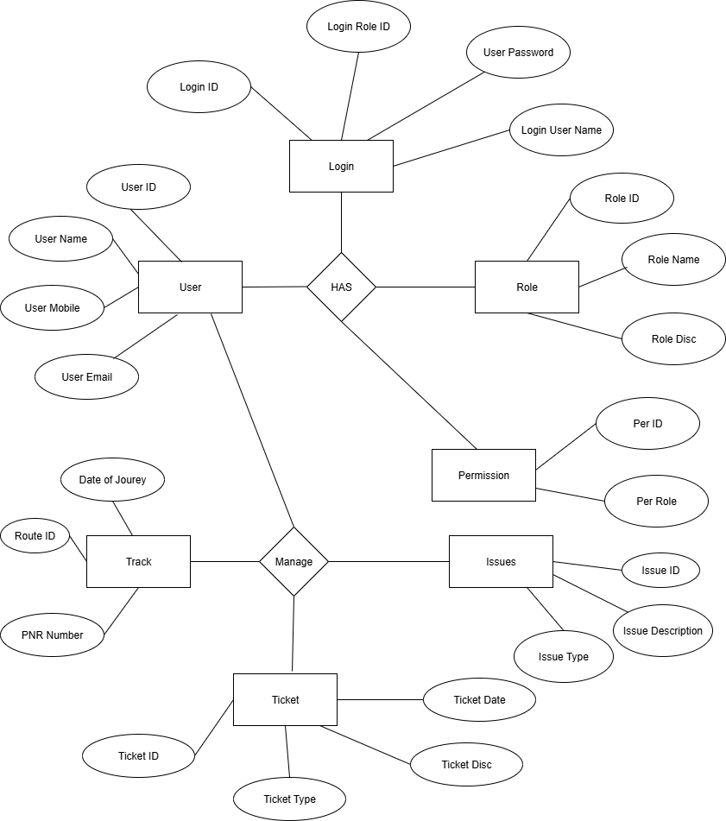

User story of shopping from ecommerce.
User Story No: 1 | Tasks: 03 |  | Priority : Highest
As a user,
I want to add items to my cart
so that I can purchase them later.
BV : 500 |  | CP : 02
ACCEPTANCE CRITERIA :

Add item,
update quantity,
remove item

User Story No: 2 | Tasks: 02 |  | Priority : Medium
As a user,
I want to view my order history
so that I can track past purchases.
BV : 500 |  | CP : 02
ACCEPTANCE CRITERIA :

Display orders,
show details

User Story No : 3 | Tasks : 02 |  | Priority : Medium
AS A User

I want to search for products
so that I can find what I need quickly.
BV : 200 |  | CP : 03
ACCEPTANCE CRITERIA :

Search bar,
relevant results
User Story No : 4 | Tasks : 02 |  | Priority : Medium
AS A CUSTOMER

I want to filter products by category
so that I can narrow options.
BV : 200 |  | CP : 08
ACCEPTANCE CRITERIA :

Filter by category, price, brand
User Story No : 5 | Tasks : 02 |  | Priority : High
AS A CUSTOMER

I want to sort products by price
so that I can find affordable options.
BV : 500 |  | CP : 08
ACCEPTANCE CRITERIA :

Sort low to high, high to low
User Story No : 6 | Tasks : 02 |  | Priority : Low
As a user,
I want to view product details
so that I can make informed purchases.
BV : 100 |  | CP : 10
ACCEPTANCE CRITERIA:

Description, price, reviews
User Story No : 7 | Tasks : 02 |  | Priority : Highest
As a user,
I want to read customer reviews
so that I can trust product quality
BV : 500 |  | CP : 02
ACCEPTANCE CRITERIA:

Star ratings, written reviews
User Story No : 8 | Tasks : 02 |  | Priority : Medium
As a user,
I want to apply coupons at checkout
so that I can save money.
BV : 200 |  | CP : 05
ACCEPTANCE CRITERIA :
Enter code, apply discount
User Story No : 9 | Tasks : 02 |  | Priority : Lowest
As a user,
I want to choose a delivery option
so that I receive my order on time.
BV : 100 |  | CP : 08
ACCEPTANCE CRITERIA :
Select speed, view date, confirm address
User Story No : 10 | Tasks : 02 |  | Priority : Lowest
As a user,
I want to track my order status
so that I know when it will arrive.
BV : 100 |  | CP : 08
ACCEPTANCE CRITERIA :

Show status, tracking number
User Story No : 11 | Tasks : 02 |  | Priority : Medium
As a user,
I want to save items to a wishlist
so that I can buy them later.
BV : 200 |  | CP : 05
ACCEPTANCE CRITERIA :
Add to wishlist, view anytime
User Story No : 12 | Tasks : 02 |  | Priority : Low
As a user,
I want to receive email confirmation
so that I know my order succeeded.
BV : 100 |  | CP : 08
ACCEPTANCE CRITERIA:
Confirmation email, summary, delivery info
User Story No : 13 | Tasks : 02 |  | Priority : Low
As a user,
I want to pay using multiple methods
so that I can choose my option.
BV : 100 |  | CP : 08
ACCEPTANCE CRITERIA:
Support cards, UPI, wallets
User Story No : 14 | Tasks : 02 |  | Priority : Medium
As a user,
I want to cancel an order
so that I can avoid unwanted purchases.
BV : 200 |  | CP : 05
ACCEPTANCE CRITERIA :
Cancel before shipping, update status, notify user
User Story No : 15 | Tasks : 02 |  | Priority : Highest
As a user,
I want to return a product
so that I can get a refund or replacement.
BV : 500 |  | CP : 08
ACCEPTANCE CRITERIA:

Initiate return, select reason
User Story No : 16 | Tasks : 02 |  | Priority : Medium
As a user,
I want to chat with support
so that I can resolve issues quickly.
BV : 200 |  | CP : 05
ACCEPTANCE CRITERIA :

Open chat, connect agent, save history
User Story No : 17 | Tasks : 02 |  | Priority : Highest
As a user,
I want to rate my purchase
so that I can share feedback.
BV : 500 |  | CP : 02
ACCEPTANCE CRITERIA:

Submit rating, optional comment, Photos
User Story No : 18 | Tasks : 02 |  | Priority : Low
As a user,
I want delivery updates
so that I know when to expect my package.
BV : 100 |  | CP : 08
ACCEPTANCE CRITERIA:

Notify shipped, out for delivery, delivered
User Story No : 19 | Tasks : 02 |  | Priority : Highest
As a user,
I want to view related products
so that I can discover more options.
BV : 500 |  | CP : 02
ACCEPTANCE CRITERIA :

Show similar items, frequently bought together
User Story No : 20 | Tasks : 02 |  | Priority : Lowest
As a user,
I want to update my profile
so that my account details are accurate.
BV : 50 |  | CP : 01
ACCEPTANCE CRITERIA:
Edit name/email, change password, update address
User Story No : 21 | Tasks : 02 |  | Priority : Lowest
As a user,
I want promotional offers
so that I can save on purchases.
BV : 100 |  | CP : 02
ACCEPTANCE CRITERIA:
Subscribe, receive emails
User Story No : 22 | Tasks : 02 |  | Priority : Medium
As a user,
I want to view saved addresses
so that I can select them quickly.
BV : 200 |  | CP : 05
ACCEPTANCE CRITERIA:
Display, edit, delete address
User Story No : 23 | Tasks : 02 |  | Priority : Lowest
As a user,
I want low stock alerts
so that I can buy before items run out.
BV : 100 |  | CP : 02
ACCEPTANCE CRITERIA:
Notify low stock, urgency message
User Story No : 24 | Tasks : 02 |  | Priority : Medium
As a user,
I want an account dashboard
so that I can manage my profile/orders.
BV : 200 |  | CP : 05
ACCEPTANCE CRITERIA:

Show profile, orders, wishlist
User Story No : 25 | Tasks : 02 |  | Priority : Medium
As a user,
I want refund confirmation
so that I know my money is returned.
BV : 200 |  | CP : 05
ACCEPTANCE CRITERIA:
Refund email, status update
User Story No : 26 | Tasks : 02 |  | Priority : Lowest
As a user,
I want to share products
so that friends can see what I like.
BV : 50 |  | CP : 01
ACCEPTANCE CRITERIA:

Share link, social media, preview
User Story No : 27 | Tasks : 02 |  | Priority : Highest
As a user,
I want personalized recommendations
so that I discover relevant items.
BV : 200 |  | CP : 05
ACCEPTANCE CRITERIA:
Show recommended items, update based on history
User Story No : 28 | Tasks : 02 |  | Priority : Medium
As a user,
I want to view upcoming sales
so that I can plan purchases.
BV : 200 |  | CP : 05
ACCEPTANCE CRITERIA:
Show sale dates, items, notify before start
User Story No : 29 | Tasks : 02 |  | Priority : Medium
As a user,
I want delay notifications
so that I can adjust expectations.
BV : 500 |  | CP : 08
ACCEPTANCE CRITERIA:
Notify delay, show new date
User Story No : 30 | Tasks : 02 |  | Priority : High
As a user,
I want to rate sellers
so that I can help other customers.
BV : 500 |  | CP : 02
ACCEPTANCE CRITERIA:
Submit rating, feedback, view score
User Story No : 31 | Tasks : 02 |  | Priority : Low
As a user,
I want price drop alerts
so that I can buy at lower cost.
BV : 50 |  | CP : 01
ACCEPTANCE CRITERIA:

Notify drop, show price history
User Story No : 32 | Tasks : 02 |  | Priority : High
As a user,

I want product availability info
so that I know if it’s in stock.
BV : 500 |  | CP : 02
ACCEPTANCE CRITERIA:
Show stock, restock date, notify
User Story No : 33 | Tasks : 02 |  | Priority : Low
As a user,
I want reorder reminders
so that I can repurchase frequent items.
BV : 50 |  | CP : 01
ACCEPTANCE CRITERIA:

Identify frequent items, send reminder
User Story No : 34 | Tasks : 02 |  | Priority : Low
As a user,
I want to see seller info so that
I can trust who I’m buying from.
BV : 100 |  | CP : 02
ACCEPTANCE CRITERIA:

Show name, rating, policies
User Story No : 35 | Tasks : 02 |  | Priority : High
As a user,
I want order invoices
so that I can keep records.
BV : 200 |  | CP : 03
ACCEPTANCE CRITERIA:

Generate invoice, email/download
User Story No : 35 | Tasks : 02 |  | Priority : High
As a user,
I want delivery instructions
so that my package arrives safely.
BV : 200 |  | CP : 03
ACCEPTANCE CRITERIA:
Add notes, save, confirm
User Story No : 36 | Tasks : 02 |  | Priority : High
As a user,
I want loyalty points
so that I can redeem discounts.
BV : 200 |  | CP : 02
ACCEPTANCE CRITERIA:

Earn points, view/redeem
User story No: 37 | Tasks:3 |  | Priority: MEDIUM
As a user,
I want to view loyalty balance
so that I can track rewards.
BV:100 |  | CP:03
ACCEPTANCE CRITERIA:

Show total, history, expiration
User story No: 38 | Tasks:2 |  | Priority: Highest
As a user,
I want flash sale alerts
so that I don’t miss deals.
BV:500 |  | CP:02
ACCEPTANCE CRITERIA:
Notify before sale, highlight offers
User Story No : 39 | Tasks : 52 |  | Priority : High
As a user,
I want product comparisons
so that I choose the best option.
BV : 1000 |  | CP : 08
ACCEPTANCE CRITERIA:
Compare features, price, ratings
User Story No : 40 | Tasks : 02 |  | Priority : Medium
As a user,
I want to receive alerts for expiring loyalty points
so that I can use them in time.
BV : 500 |  | CP : 05
ACCEPTANCE CRITERIA:
Notify before expiration, show point balance

