QUESTION PAPER PROJECT 3 PART 1

A customer can make payment by card ,debit card or net banking.
Q1)Draw a use case diagram.
Q2)Derive boundary class,controller class and entity classes.
Q3)Place these classes on a 3 tier archtiecture.
A netbanking payment use case diagram shows the primary actors involved, such as the Customer and the Bank, and the key functionalities, or use cases, they interact with within the system, including Login, View Accounts, Make Payment, and Receive Payment Confirmation. Actors are represented by stick figures, the system boundary by a rectangle, and the use cases by ovals, with lines connecting them to indicate their relationships.
Components of the Diagram
- Actors: These are the users or external entities that interact with the system.
  - Customer: The person making the payment.
  - Bank/Payment Gateway: The system or entity that processes the transaction and handles authentication.
- System Boundary: A rectangular box that represents the scope of the netbanking system.
- Use Cases: These are the specific functions or services the system provides, represented by ovals.
  - Login: The customer logs into their netbanking account.
  - View Accounts: The customer views their account details before making a payment.
  - Make Payment: The customer initiates a payment from their account.
  - Verify Payment Details: The system validates the payment information.
  - Process Payment: The bank or gateway processes the payment.
  - Receive Payment Confirmation: The customer receives confirmation that the payment was successful.
Relationships
- Association:
A solid line connecting an actor to a use case, showing the actor's interaction with that function.
- Include/Extend (Optional):
These can show relationships where one use case is a part of another (include) or a variation of another (extend), though they might not be necessary for a simple diagram.
Example Scenario
- The Customer actor interacts with the Login use case to access their account.
- The Customer then interacts with View Accounts to see their balance.
- The Customer initiates a payment by interacting with the Make Payment use case.
- The Bank/Payment Gateway interacts with Verify Payment Details, Process Payment, and Receive Payment Confirmation to complete the transaction.

- A Customer is required to create an account to avail services offered by Bank. Bank verifies detail and creates new account for each new customer. Each customer is an actor for the Use-Case Diagram and the functionality offered by Online Banking System to Add Account is Use-Case.
- Each customer can check the balance in bank account and initiate request to transfer an account across distinct branches of Bank. Cashier is an employee at bank who supports service to the customer.
- A customer can execute cash transactions where the customer must either add cash value to bank account or withdraw cash from account. Either of two or both that is credit as well as debit cash, might be executed to successfully execute one or multiple transactions.
- After each successful transaction customer might or might not want to get details for action. Manager can check interest value for each account corresponding to transaction to ensure and authenticate details.
- A customer can also request loan from bank where customer must add request for loan with the appropriate details.
- The type of loan in accordance with purpose or the need for loan and term or duration to pay back the loan must be provided by customer.
- The manager of each branch of bank has choice to either accept or approve loan to initiate process further or just reject request for loan based on terms and conditions.
- The record for each employee of bank is maintained by bank and bank manages all employees of each branch of bank. The manager of each branch has choice to offer bonus to employees. Note here that each employee is paid as part of management of staff but promotion or bonus might or might not be offered certainly to each employee.
This is the complete design and description for Use-Case of an Online Banking System specifying the use of <<include>> and <<extend>> for certain specific Use-Cases.

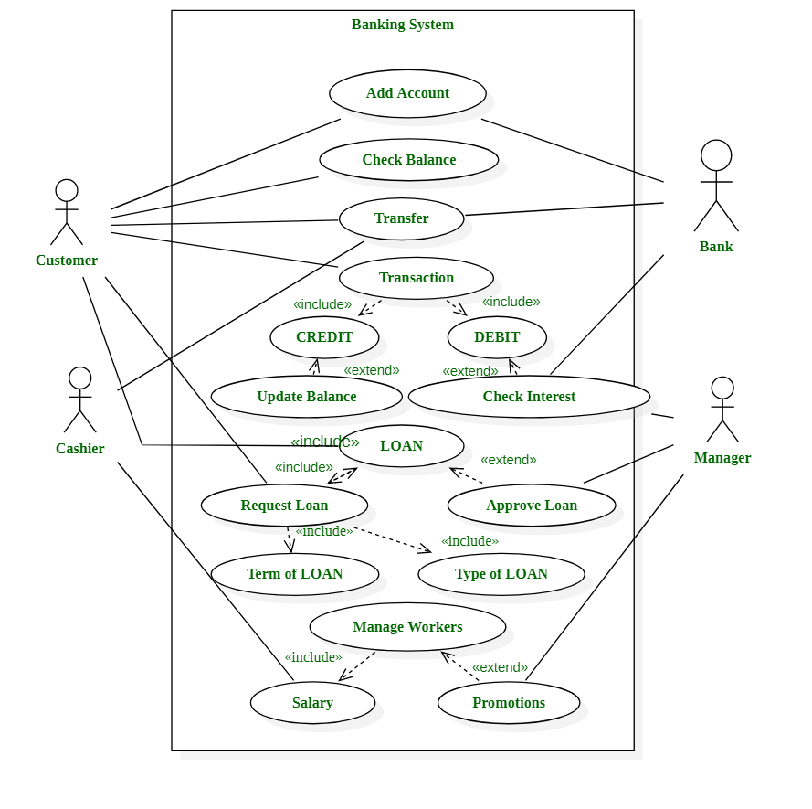
Q2) Derive boundary class,controller class and entity classes.
1. Analyze Use Cases:
- Use Case Diagram: This is your starting point.
- Flow of Events: Read the detailed steps of each use case narrative to understand the system's behavior and identify what needs to be done.
2. Derive Entity Classes:
- What they are: These represent data that the system needs to store and manage over time.
- How to identify them: Look for all the nouns in your use case description that represent core concepts or data, such as a Customer, Product, Order, or Payment.
- Example: In a banking system, nouns like "Account," "Customer," and "Transaction" would become entity classes.
3. Derive Boundary Classes:
- What they are: These classes model interactions between the system and its external environment, including actors and other systems.
- How to identify them:
  - Each actor that directly interacts with the system usually results in one boundary class, representing the user interface or communication interface.
  - Consider the sources of external events, like GUI inputs, data from existing systems, or responses from the system's surroundings.
- Example: For a website, you might have a ProductListingScreen or a LoginScreen.
4. Derive Controller Classes:
- What they are:
These classes act as the "glue". They implement business logic, coordinate activities, and direct the flow of events between boundary classes and entity classes.
- How to identify them:
  - Each use case typically results in one or more controller classes.
  - They handle the detailed steps of the use case, orchestrating the interaction with other classes.
  - They do not perform business functions themselves but redirect to the appropriate business logic classes.
- Example:
A ProductPurchaseController would handle the sequence of actions for a customer buying a product.

Q3)Place these classes on a 3 tier archtiecture.

In a three-tier architecture, Boundary, Controller, and Entity classes are placed within specific layers to enforce separation of concerns and promote maintainability.
1. Presentation Layer (or Application Layer):
- Boundary Classes: These classes are responsible for interacting with external actors (users or other systems) and presenting information. They handle user interface elements, input validation, and display data. Examples include user interface forms, web pages, or API endpoints.
2. Business Logic Layer (or Application Layer):
- Controller Classes: These classes orchestrate the flow of control within the system. They receive requests from Boundary classes, coordinate with Entity classes to perform business logic, and determine the appropriate response. They encapsulate the application's specific business rules and operations.
3. Data Access Layer (or Database Layer):
- Entity Classes: These classes represent the core data and business objects of the application. They encapsulate data and the operations that directly manipulate that data, often corresponding to tables in a database. Entity classes typically do not contain business logic specific to a particular use case but rather represent the fundamental domain concepts.

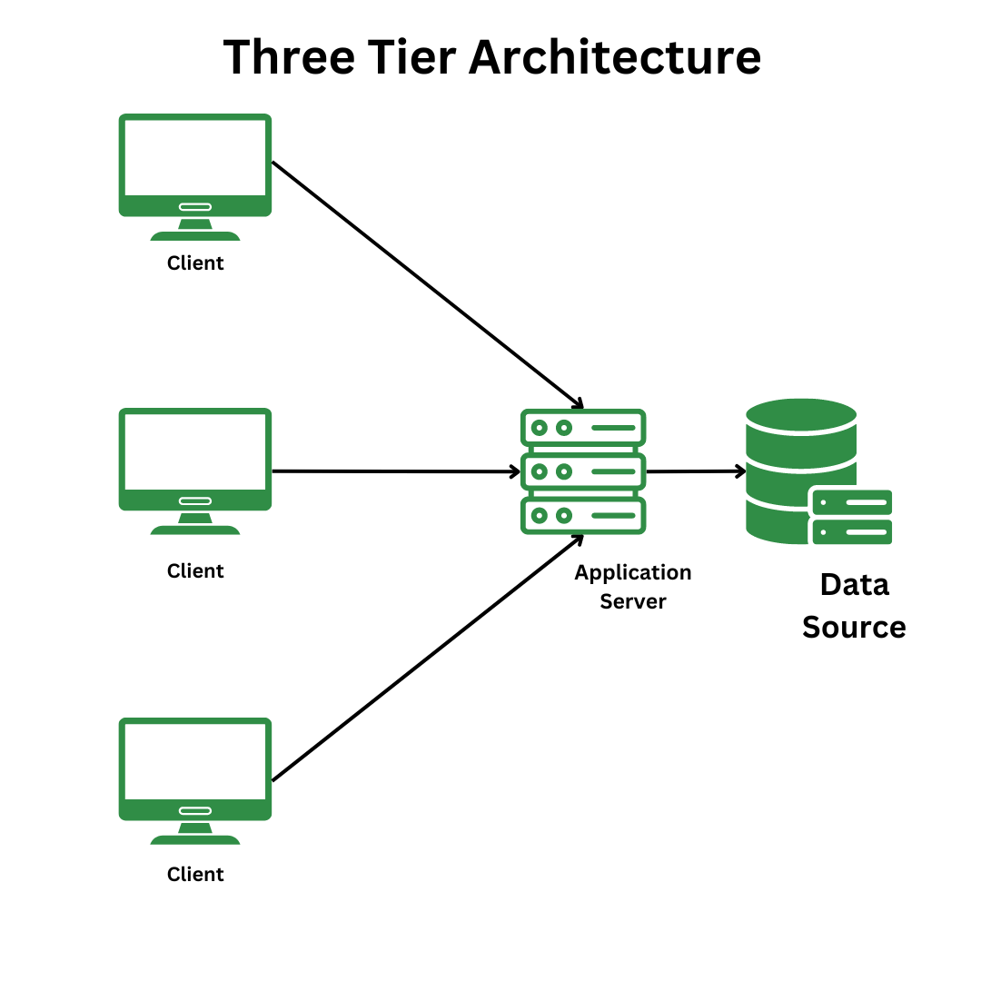

Q4)Explain Domain Model for customer making payment through net banking.

A domain model for a customer paying via net banking defines the core entities—like the Customer, Payment, BankAccount, NetBanking, and Authentication—along with their attributes (e.g., customer name, account number, transaction amount, authentication credentials) and relationships (e.g., a Customer has many BankAccounts, a Payment uses a NetBanking method). This conceptual model serves as a blueprint for software design, representing real-world banking concepts to understand and build the system's core functionality for secure, online transactions.
Key Entities and Their Attributes
Here are the essential entities you'd find in such a model:
- Customer:
Represents the individual making the payment.
  - Attributes: CustomerID, FullName, Email, Password.
- BankAccount:
Represents the customer's account within a bank.
  - Attributes: AccountNumber, Balance, BankID.
- Bank:
Represents the financial institution where the account is held.
  - Attributes: BankID, BankName.
- Payment:
Represents the actual transaction.
  - Attributes: PaymentID, Amount, Timestamp, Status (e.g., pending, success).
- NetBanking:
Specific details about the net banking method used.
  - Attributes: NetBankingID, Provider, UserCredentials (or link to Authentication).
- Authentication:
Details of the security process.
  - Attributes: AuthID, OTP, PasswordHash (linked to user).
Relationships Between Entities
The entities are connected by various relationships:
- Customer - BankAccount: A customer can have one or more bank accounts.
- BankAccount - Bank: A bank account belongs to a specific bank.
- Payment - Customer: A customer initiates a payment.
- Payment - NetBanking: A payment is processed using the net banking method.
- NetBanking - Authentication: The net banking process requires authentication.
- Payment - Authentication: Authentication occurs during the payment transaction.
How It Works (Simplified Example)
- A Customer initiates a Payment request.
- The system identifies the BankAccount the payment will come from.
- The Payment uses the NetBanking method.
- The system requires an Authentication process for the NetBanking method.
- Upon successful Authentication, the Payment is processed.

Q5)Draw a sequence diagram for payment by customer net banking.
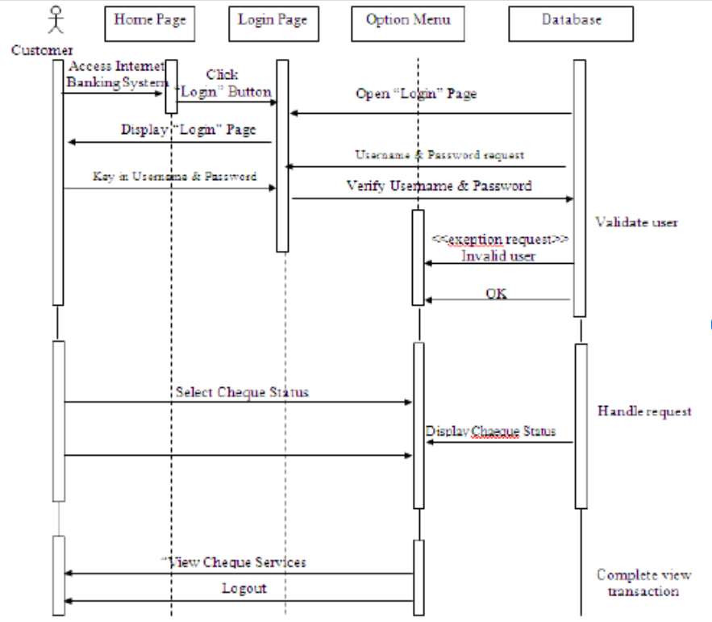
Q6)Explain conceptual model for this use case..

A conceptual model for net banking represents the structure and function of online banking systems, outlining core components like the user, bank, security protocols, and network infrastructure, and how they interact to enable services such as fund transfers, bill payments, and account management. Key aspects include the user's interface, backend systems for transaction processing, and the security layers like authentication and encryption that ensure data confidentiality and integrity. Conceptual models also consider factors influencing user adoption, including perceived usefulness, ease of use, security, and trust.
Core Components of a Net Banking Conceptual Model
- User/Customer:
The individual accessing the banking system through various devices like computers or mobile phones.
- Bank:
The financial institution providing the banking services, with its backend systems and data processing infrastructure.
- Network Infrastructure:
The internet and other network connections that enable communication between the user and the bank.
- User Interface:
The graphical front-end the customer uses to interact with the banking system, providing access to account balances, transaction history, and various services.
- Backend System:
The bank's internal systems that process transactions, manage accounts, and store customer data securely.
- Security Layer:
This includes essential security components such as:
  - Authentication: Verifying user identity (e.g., passwords, multi-factor authentication).
  - Authorization: Ensuring users can only access authorized data and functionalities.
  - Confidentiality: Protecting sensitive financial and personal data through encryption.
  - Integrity: Maintaining the accuracy and completeness of transactions and data.
  - Non-repudiation: Providing proof that a transaction occurred, preventing users from denying their actions.
Key Interactions in the Model
- User Action:
The user initiates a banking action (e.g., fund transfer) via the user interface.
- Request to Bank:
The user's request travels through the network to the bank's backend system.
- Security Checks:
The system performs authentication and other security checks to verify the user and the request.
- Transaction Processing:
If authenticated, the backend system processes the request, such as transferring funds or paying a bill.
- Confirmation and Feedback:
The user receives a confirmation and feedback, which helps build a sense of control and trust.
Factors Influencing Adoption and Use
A conceptual model also incorporates user-centric aspects like:
- Perceived Usefulness: The belief that net banking provides benefits and improves efficiency.
- Perceived Ease of Use: The belief that the system is easy to learn and use.
- Trust and Perceived Risk: Factors like the security of personal and financial information directly influence trust and the likelihood of adoption.

Q7)What is MVC architecture?Explain MVC rules to derive classes from use case diagram and guidelines to place classes in 3Tier architecture.

MVC architecture (Model-View-Controller) is a software design pattern that divides an application into three interconnected components: the Model, which handles data and business logic; the View, which is the user interface; and the Controller, which acts as an intermediary to process user input, interact with the Model, and update the View. This separation of concerns makes applications more organized, scalable, and easier to maintain.

Example of the MVC Design Pattern
- Model (Student class) Represents the data (student's name and roll number) and provides methods to access and modify this data. ...
- View (StudentView class) Represents how the data (student details) should be displayed to the user. ...
- Controller (StudentController class)
- MVC (Model-View-Controller) is a pattern in software design commonly used to implement user interfaces, data, and controlling logic. It emphasizes a separation between the software's business logic and display. This "separation of concerns" provides for a better division of labor and improved maintenance.

Q8)Explain BA contributions in Project Waterfall model.
In a Waterfall project, the Business Analyst (BA) plays a key role across all phases, though their primary involvement is in the early stages. They identify business needs, create the business case, elicit, analyze, and document detailed requirements. As the project progresses, the BA manages these requirements, acts as a liaison between stakeholders and the development team, provides clarification, and often leads acceptance testing to ensure the final product meets user expectations.
Waterfall Model Stages and BA Contributions
- Requirements/Analysis Phase:
  - BA Role: This is the BA's most critical phase. They work with stakeholders to understand the problem and identify potential solutions.
  - Contributions:
    - Business Case Creation: BAs help develop the business case to determine if a project makes sense for the organization.
    - Requirements Elicitation: They gather detailed requirements from business users through interviews and analysis.
    - Requirements Documentation: BAs document these requirements in a comprehensive way, such as User Stories or Functional Specifications, to guide the project.
- Design Phase:
  - BA Role: The BA defines how the system will meet the requirements identified in the previous phase.
  - Contributions:
    - Solution Definition: They ensure that the system design aligns with the requirements and meets user needs.
    - Requirements Traceability: BAs trace requirements through process and data models to ensure nothing is missed.
- Implementation (Development) Phase:
  - BA Role: The BA supports the development team and ensures the product being built aligns with the documented requirements.
  - Contributions:
    - Clarification: They answer questions and provide clarifications to developers regarding requirements and design specifications.
    - Change Management: As changes are inevitably requested, the BA reviews them and helps the team respond, ensuring the change is aligned with project goals.
- Testing (Verification) Phase:
  - BA Role: While testing is primarily a QA function, the BA often takes on the responsibility of managing the testing process and verifying user acceptance.
  - Contributions:
    - Acceptance Testing Leadership: BAs often lead the user acceptance testing (UAT) to ensure the developed solution satisfies business and user needs.
    - User Satisfaction Reviews: They facilitate reviews to ensure the product meets customer expectations.
- Maintenance Phase:
  - BA Role: The BA continues to support the product post-launch.
  - Contributions:
    - Troubleshooting & Enhancements: BAs help identify and address any issues that arise, and can provide input on minor modifications or enhancements for future versions

.
Q9)What is conflict management?explain Thomas killman technique.
Conflict management is a strategic approach to dealing with disagreements, and the Thomas-Kilmann Technique identifies five styles for doing so: Avoiding (unassertive, uncooperative), Competing (assertive, uncooperative), Accommodating (unassertive, cooperative), Compromising (moderately assertive and cooperative), and Collaborating (assertive and cooperative). These styles are based on two dimensions: assertiveness (pursuing one's own concerns) and cooperativeness (pursuing the concerns of others). Choosing the appropriate style depends on the specific conflict and the importance of goals and relationships involved.
The Five Conflict Management Styles
- Avoiding:
This style involves disregarding the conflict or sidestepping the issue. It's best for trivial matters or when a timeout is needed to cool down a heated situation.
  - Characteristics: Unassertive, uncooperative.
  - Example: A manager avoids a minor workplace dispute, hoping it will resolve itself.
- Competing:
In this approach, one party pursues their own interests with force and determination, regardless of the other's needs. It can be effective for quick decisions or when a vital goal is at stake.
  - Characteristics: Assertive, uncooperative.
  - Example: A sales executive insists on a higher commission, believing their performance justifies it.
- Accommodating:
This involves giving in to another party's needs and concerns, even at the cost of one's own. It's used when maintaining harmony or the relationship is more important than the immediate goal.
  - Characteristics: Unassertive, cooperative.
  - Example: A team member concedes a project idea, allowing a senior colleague to take credit, to maintain a good working relationship.
- Compromising:
This style seeks a middle ground where both parties make concessions. It's a moderate approach that can lead to temporary solutions, though it may not fully satisfy either side.
  - Characteristics: Moderately assertive and cooperative.
  - Example: Two departments split a budget for a shared resource, with each giving up some of their initial request.
- Collaborating:
This involves working together to find a solution that fully satisfies both parties' needs. It requires assertiveness and cooperation, leading to long-term, mutually beneficial outcomes.
  - Characteristics: Assertive, cooperative.
  - Example: Chefs with different needs for a lemon discuss it to find that one needs the zest and the other the juice, leading to a solution where both get what they need.
- The Thomas-Kilmann Conflict Model,

Q10)List down reasons for Project Failure.
10 Reasons why projects fail & their solutions
- Unclear goals and objectives. ...
- Lack of resource planning. ...
- Poor communication across the organization. ...
- Inadequate stakeholder management. ...
- Poorly defined project scope. ...
- Inaccurate cost and time estimates. ...
- Inadequate risk management. ...
- Inexperienced project managers.

Q11)List challenges faced in Project by BA.
Business Analysts (BAs) on projects commonly face challenges such as unclear or shifting requirements, lack of stakeholder engagement and misalignment, communication breakdowns, scope creep, and resource constraints. Other challenges include lack of domain knowledge, resistance to change, tight deadlines, managing conflicting stakeholder priorities, and technical issues.
Challenges Related to Requirements & Scope
- Unclear or Evolving Requirements:
Ambiguous, incomplete, or constantly changing requirements make it difficult for BAs to define and document a clear project vision.
- Scope Creep:
Uncontrolled additions of new features or requirements to the project can lead to cost overruns and delays.
- Incomplete Requirements:
Stakeholders may be unsure of their own needs, leading to a lack of clear or detailed requirements from the business.
Challenges Related to Stakeholders
- Lack of Stakeholder Engagement:
BAs often struggle to get active and consistent participation from stakeholders, which is crucial for successful project outcomes.
- Conflicting Stakeholder Expectations:
Different stakeholders may have conflicting priorities, goals, or interests, making it challenging to reach a consensus.
- Resistance to Change:
Stakeholders and team members may resist new processes or technologies that the BA is trying to implement.
Challenges Related to Communication & Knowledge
- Communication Gaps:
Misunderstandings can occur between stakeholders, the BA, and the development team, leading to errors and dissatisfaction.
- Lack of Domain Knowledge:
Entering a new industry or complex business area can be difficult, as BAs may lack the specialized knowledge to understand business operations and requirements fully.
- Difficulty in Requirement Elicitation:
Extracting clear and precise requirements from stakeholders, especially those who are unsure of their needs, is a significant hurdle.
Project & Resource Challenges
- Resource Constraints:
BAs often work with limited budgets, inadequate skilled personnel, or insufficient time, which can compromise project quality.
- Unrealistic Deadlines:
Projects may have tight deadlines, placing pressure on the BA to deliver results quickly and potentially affecting quality.
- Balancing Multiple Projects:
Many BAs juggle several projects simultaneously, which can lead to burnout and decreased productivity.
Other Significant Challenges
- Resistance to Change:
Employees may be reluctant to adopt new processes or technologies, hindering project adoption and success.
- Technical Challenges:
Technical issues that are outside the BA's direct control can disrupt project plans and timelines.

Q12)Write document Naming standards.

Using consistent naming conventions has many benefits, including: Improved retrieval of documents on shared drives and University systems. Facilitated disposal of documents when no longer required for business. Ensured current or active version of a templates can be easily identified.

Q13)What are do’s and don’ts for a business analyst.

A successful business analyst DOs: communicate clearly, document thoroughly, be analytical and curious, collaborate with stakeholders, and stay organized, while DON'Ts: make assumptions, use jargon, work in isolation, resist process improvements, or let data lead you to solutions for problems that don't matter to the business.
Do's
- Communicate Clearly:
Use simple language and visual aids to ensure everyone understands, especially non-technical stakeholders.
- Document Everything:
Maintain detailed records of findings, decisions, and processes for clarity and future reference.
- Be Analytical and Data-Driven:
Employ analytical skills to find patterns, use data to support recommendations, and validate findings with stakeholders.
- Be Curious:
Actively seek knowledge by engaging with experts and reading available documentation to understand business processes deeply.
- Collaborate:
Work with diverse teams and departments to get different viewpoints and ensure buy-in on your proposals.
- Stay Organized:
Use tools to manage tasks and deadlines effectively, keeping track of changes and providing timely updates.
- Validate Requirements:
Don't just accept requirements; discuss them, use prototypes, and gather feedback to ensure they align with business goals.
- Be Adaptable:
Be ready to change your approach as project requirements and conditions evolve.
Don'ts
- Don't Make Assumptions:
Base your analysis on data and evidence, not assumptions, to avoid incorrect conclusions.
- Don't Use Jargon:
Speak in a clear, easy-to-understand language for all stakeholders, not just technical experts.
- Don't Work in Isolation:
Business analysis is a team effort; always involve and seek input from others.
- Don't Get Complacent:
Be open to questioning the status quo and suggesting improvements to existing processes.
- Don't Let Data Dictate:
Don't just analyze available data; ensure your analysis serves the business outcomes and addresses relevant problems.
- Don't Overcomplicate Things:
Keep your solutions and explanations simple to make them easy for stakeholders to understand and implement.
- Don't Ignore Feedback:
Be open to feedback from stakeholders, as ignoring it can lead to missed opportunities and ineffective solutions.

Q14)Write difference between package and sub systems.

A model captures a view of a system. It is an abstraction of the system, with a certain purpose. This purpose determines what is to be included in the model and what is irrelevant. Thus the model completely describes those aspects of the system that are relevant to the purpose of the model, at the appropriate level of detail.
Package
A package is used to group elements, and provides a namespace for the grouped elements.
Standard Stereotypes: Subsystem
A unit of hierarchical decomposition for large systems. A subsystem is commonly instantiated indirectly. Definitions of subsystems vary widely among domains and methods, and it is expected that domain and method profiles will specialize this construct. A subsystem may be defined to have specification and realization elements. See also: «specification» and «realization».
For me, to differentiate between the three, the model is the largest component you can describe – it is describing your system as a whole. Then a subsystem is a smaller system within your system. Finally, a package is a collection of elements with a namespace. From my understanding of the definition above, a subsystem is instantiated as a whole so therein lies its difference with a package since packages are simply a meaningful grouping of elements, which can be instantiated individually.

Q15)What is camel casing and where it will be used.

Camel casing is a writing style that forms a single word from multiple words by capitalizing the first letter of each word, except for the very first word, which is typically lowercase. For example, "student last name" becomes "studentLastName". This method is widely used in programming languages like Java, JavaScript, and Python for naming variables, functions, and classes, as well as in other contexts such as web domains and technical documentation, to improve code readability and maintain consistent naming conventions.

A package is a collection of headers and source files that provide related functionality. A subsystem is a collection of one or more packages.
Q16)Explain Development server and what are the accesses business analyst has?
A development server is a dedicated, sandboxed server environment where developers write, test, and debug software without affecting the live production environment. Business analysts (BAs) have access to the outcomes of development, such as application builds and test results, and can review requirements, provide feedback, and use data and tools to analyze business value and clarify functional requirements. BAs do not typically have direct, unrestricted access to the development server's code or infrastructure itself.
Development Server Explained
- Purpose:
To provide a safe, isolated space to build and test new features, identify bugs, and refine the software before it's released to customers.
- Environment:
It's designed to mimic the production server but with fewer restrictions, allowing for unrestricted access and control by users to test and modify resources.
- Functionality:
Developers can deploy their code, interact with databases, and integrate components to ensure everything works as expected.
Business Analyst's Access and Role
A business analyst's involvement with the development server is indirect and focused on business outcomes rather than technical implementation.
- Requirements and Clarification:
BAs work with developers and testers to ensure the software being built on the development server meets the documented business requirements and user stories.
- Feedback Loop:
BAs analyze test results and provide feedback to developers to confirm that the functionalities align with business goals and user needs.
- Change Management:
They analyze requested changes, assess their impact on requirements, and update project documentation to reflect approved changes.
- Data Analysis:
BAs often need access to data and analytical tools to understand the business value of features being developed and to identify areas for improvement.
- Collaboration:
BAs participate in agile ceremonies like daily stand-ups to stay informed about progress and to address any questions or issues that arise during development.
- Indirect Access:
While they don't typically log in to the development server to write code or manage infrastructure, they access the outputs (e.g., builds, logs) and utilize tools to review and analyze the software's adherence to business requirements.

Q17)What is data mapping?
Data mapping is the process of creating relationships between data elements from different sources, defining how they correspond and can be transformed to be used together in another system or data model. It serves as a blueprint or "map" for how data should flow, ensuring accuracy, consistency, and integration during processes like data migration, data integration, and data transformation.

Q18)What is API?Explain API Integration where data is in dd mm yy format And it is accepting data in format of mm dd yy from some other application.

An API (Application Programming Interface) is a set of rules or protocols that allows different software programs to communicate and exchange data and functionality with each other. Think of it as a messenger or middleman between two applications, enabling them to interact and work together seamlessly. For example, when your weather app shows you the current forecast, it's using an API to request that information from a weather data provider.
API integration with differing date formats, specifically converting dd mm yy to mm dd yy, requires a transformation step within the integration process. This involves parsing the incoming date string and then formatting it to the expected output format.
Steps for Date Format Conversion in API Integration:
- Receive Data:
The API receives date data in the dd mm yy format from the source application. This data is typically received as a string.
- Parse the Incoming Date:
The integration system needs to understand the structure of the incoming date string. This involves extracting the day, month, and year components from the dd mm yy string. Programming languages provide functions or libraries for this purpose.
Python
from datetime import datetime
input_date_string = "25 12 24" # Example: December 25, 2024
# Parse the string into a datetime object using the specified input format
parsed_date = datetime.strptime(input_date_string, "%d %m %y")
- Format to the Desired Output: Once the date is parsed into a date object (which is a universal representation of a date), it can be formatted into the mm dd yy format required by the target application.
Python
# Format the datetime object into the desired output format
output_date_string = parsed_date.strftime("%m %d %y")
print(output_date_string) # Output: 12 25 24
- Send Data: The newly formatted date string in mm dd yy format is then sent to the target application via its API.
Considerations:
- Error Handling:
Implement robust error handling for cases where the incoming date string might be malformed or in an unexpected format.
- Year Ambiguity:
The yy format can lead to ambiguity regarding the century (e.g., 24 could mean 1924 or 2024). Ensure the integration logic correctly handles the intended century based on context or explicit rules.
- Timezones:
If time information is also involved, consider timezone conversions to ensure consistency across applications.
- Libraries and Tools:
Utilize date and time libraries available in the chosen programming language or integration platform to simplify parsing and formatting.

How APIs Work
- Requests and Responses:
An API defines how one software application (the client) can request information or a service from another (the server). The API then processes the request and sends back a response in a standardized format.
- Intermediary Role:
APIs act as a bridge, allowing developers to access the functionality of another system without needing to know the intricate details of how that system is built.
- Data Exchange:
APIs specify the methods, parameters, and data formats (like JSON or XML) that must be used for communication, ensuring that data is exchanged correctly and consistently.
Why APIs are Important
- Building Connected Software:
APIs are fundamental to modern digital experiences, allowing various software components to connect and share information, leading to more powerful and resilient applications.
- Enabling Integrations:
They are crucial for businesses, allowing them to connect disparate applications used in their daily operations, share data with partners, and integrate cloud services.
- Abstracting Complexity:
APIs provide a layer of abstraction, meaning a developer can use a service provided by another application without understanding the underlying implementation, simplifying software development.
An API, or application programming interface, is a set of rules or protocols that enables software applications to communicate with...

