Use Case

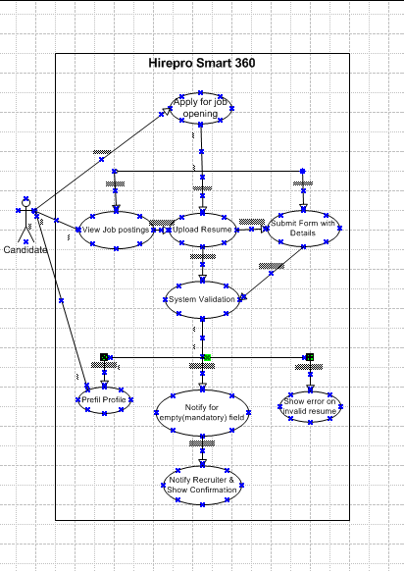

Use Case Specification – Hire Smart 360

1. Use Case Name
Apply for Job Opening

2. Use Case Description
This use case describes the process by which a candidate applies for a job through the Hire Smart 360 ATS. The candidate browses job listings, selects a position, uploads a resume, fills out the required fields, and submits the application.

3. Actors
Primary Actor: Candidate
Secondary Actor: ATS System, HR Recruiter

4. Basic Flow
1. Candidate accesses the Hire Smart 360 portal.
2. Candidate views available job listings.
3. Candidate selects a desired job role.
4. Candidate fills out the application form and uploads resume.
5. System validates the input.
6. Candidate submits the application.
7. System sends acknowledgment to the candidate and alerts the recruiter.

5. Alternate Flow
If the candidate has already registered, they may log in to pre-fill data from their profile.

6. Exceptional Flows
- If required fields are left empty, system prompts user to complete them.
- If resume file format is invalid, system rejects upload.
- System fails to connect to server – prompts error message and retry option.

7. Pre-Conditions
- The candidate must have internet access.
- Job listings must be active on the portal.

8. Post-Conditions
- The application is stored in the ATS database.
- Notification is sent to the HR recruiter.

9. Assumptions
- Candidate has a valid email address.
- Recruiter will review the application within 48 hours.

10. Constraints
- Resume size must not exceed 5MB.
- Form submission timeout is 5 minutes.

11. Dependencies
- Resume parser service must be available.
- Job database should be up and functional.

12. Inputs and Outputs
Inputs: Candidate details, uploaded resume, selected job ID
Outputs: Confirmation message, application stored in system

13. Business Rules
- Only one application per job per user.
- Resume must be in PDF or DOCX format.
- Mandatory fields include Name, Email, and Resume.

14. Miscellaneous Information
- This use case supports localization in English.

