Capstone Project Prep 1, Part 3/3

Q1-
Functional Requirement:
Functional requirements define the specific behaviors, functions or operations of a systems. They describe what the system should do, outlining the necessary tasks, actions or activities it must perform to achieve its objectives.
Req. ID | Req. Name | Req. Description | Priority
FR001 | Farmer Registration | Farmer should able to register and login through the Application | 9
FR002 | Product Catalogue | Farmer should able to search for the available product (Fertilizer, Seeds, Pesticides) | 8
FR003 | Wishlist | User should be able to add the product in Wishlist | 7
FR004 | Shopping cart | Should allow farmers after logging into add the products to the shopping cart. | 9
FR005 | Payment Processing | Application should be able to manage multiple payment gateways to facilitate secure and convenient transactions | 9
FR006 | Order Quantity Placement | Farmer should able to place order for satisfying quantity for selected address and selected products. | 8
FR007 | Order History | Should allow to view past history including the order list and status of the order | 7
FR008 | Tracking details | User getting and email confirmation with a delivery tracker to track the status of order in real time | 8
FR009 | Order Confirmation | User should get confirmation details like order quality, delivery timeline on the specified ordered products | 7
FR010 | Customer Service | Should allow customer support to chat, email or on call. | 7
FR011 | Inventory Control | Should have update on the inventory needed if required. | 8
FR012 | Product review | Allow user to provide rating to the products they have purchased. | 7
FR013 | Return and refund Policy | Should allow user to avail for the user refund or a return if the product is damaged or doesn’t meet the criteria. | 9
FR014 | Manufacturer registration | Allow manufacturer to register and login | 9
FR015 | Product recommendation | Application should provide product recommendation according to the user history and order history | 7
FR016 | Product filtering | Should allow user to filter the product according to their needs | 8
FR017 | Account Management | Should allow user to manage their account via profile setting, password setting and email preferences | 9
FR018 | Order Confirmation | Should able to select the mode of confirmation (Phone, SMS, Email) | 8
FR019 | Manufacturer product listening | Should allow manufacturer to able to list their product | 8
FR020 | Social sharing | Application should allow users to share the product socially to anyone on social media | 7

Non-Functional Requirement:
Non-functional requirement will describe the qualities and attributes of a system, focusing on how the system performs rather than specific behaviors or functions.
Req. ID | Req. Name | Req. Description | Priority
NFR001 | Usability | Application should have and intuitive and user-friendly | 8
NFR002 | Performance | The application must load pages within 3 sec | 9
NFR003 | Security | The application must ensure secure user authentication | 9
NFR004 | Compatibility | The application should compatible with major web browser | 8
NFR005 | Response Time | The application should respond to user inputs within 2 sec | 7
NR006 | Representation | Visual Representation of the pages must be detailed | 7
NR007 | Auto Readable | OTP must be auto readable by the application | 7
NR008 | Session timeout | Session time out must be up to 2 min | 6
NR009 | Accuracy | Location must be accurate up to 50 mtr | 8
NR010 | Refresh | Pages must be refreshed after every 30 seconds | 6

Q2. Make wireframe and prototypes
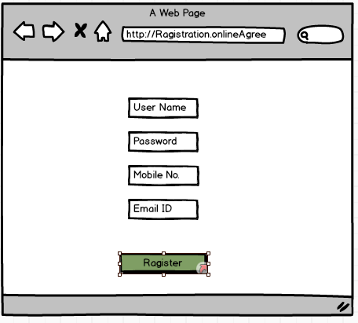 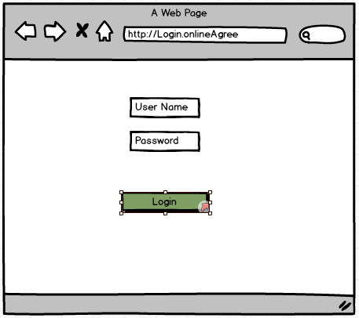 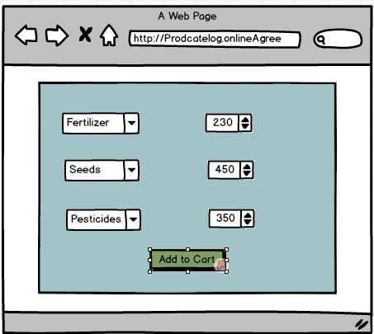
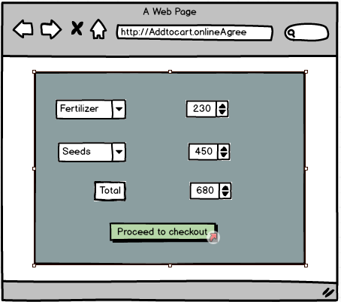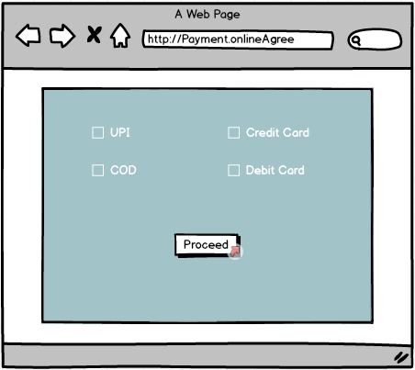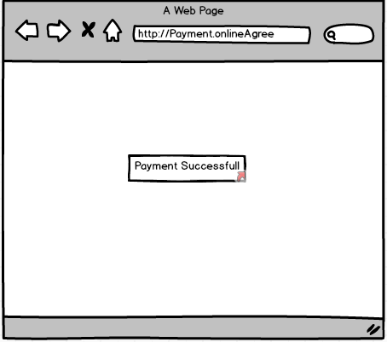

Q3. Tools (Visio, Balsamiq)
BA tools are the techniques to prepare a raw design, process flow diagram and prototype of an end product which will be coveraing all the aspects of the project requirement and epresent the activity of how the process flows inside the project. In business Analyst there are tools like MS visio, Balsmic, Axure RP which helps a Business Analyst to prepare Use case diagram, Activity Diagram, Wireframe and prototype.
MS Visio: Microsoft Visio is a powerful tool used to visually represent and communicate complex business processes, systems, workflows and organisational structures, It plays a crucial role in helping business analysts model and analyse various aspects of the business operations, enabling stakeholder to better understand, evaluate and optimize processes. We can prepare flow charts, org charts, building plans, floor plans, data flow diagrams, Process flow diagrams, business process modelling, swim lane diagram, 3D maps etc
Balsamiq: Balsamiq is rapid wireframing tool. It creates mock-ups and wireframes for websites, web apps and desktop software, it allows us to picture ideas and concepts through a simple drag-and-drop interface. The wireframes created using Balsamiq have a hand-drawn style. It’s designed to help business analyst, designers, product managers and developers quickly sketch out the basic structure and layout of a user interface without focusing on visual design details.
Axure RP: Axure RP stands for Axure rapid prototyping which is prototyping and wireframing tool used by business analyst, UXUI designers, product managers, and developers to create interactive, high-fidelity prototypes and wireframes for websites, applications and digital products. Unlike low-fidelity tools like Balsamiq, Axure RP allows users to build more detailed and interactive prototypes that closely mimic the final user experience (UX) and behavior of a product.

Q4. Prepare RTM
Requirement Traceability Matrix is a document used in business analysis, Project Management, and software development to ensure that all project requirements are being met throughout the project life cycle. It helps track the relationship between requirements and various project elements, ensuring that each requirement is linked to corresponding deliverables, test cases, and design specifications.
Req ID | Req Name | Req Description | Design | D1 | T1 | D2 | T2 | D3 | T3 | D4 | T4 | UAT
FR001 | Farmer Registration | Farmer should able to register and login through the Application | Y | Y | Y | Y | Y | Y | Y | Y | Y | N
FR002 | Product Catalogue | Farmer should able to search for the available product (Fertilizer, Seeds, Pesticides) | Y | Y | Y | Y | Y | Y | Y | Y | Y | N
FR003 | Wishlist | User should be able to add the product in Wishlist | Y | Y | Y | N | N | N | N | N | N | N
FR004 | Shopping cart | Should allow farmers after logging into add the products to the shopping cart. | Y | Y | Y | Y | N | N | N | N | N | N
FR005 | Payment Processing | Application should be able to manage multiple payment gateways to facilitate secure and convenient transactions | Y | Y | Y | N | N | N | N | N | N | N
FR006 | Order Quantity Placement | Farmer should able to place order for satisfying quantity for selected address and selected products. | Y | Y | Y | N | N | N | N | N | N | N
FR007 | Order History | Should allow to view past history including the order list and status of the order | Y | Y | Y | Y | Y | N | N | N | N | N
FR008 | Tracking details | User getting and email confirmation with a delivery tracker to track the status of order in real time | Y | Y | N | N | N | N | N | N | N | N
FR009 | Order Confirmation | User should get confirmation details like order quality, delivery timeline on the specified ordered products | Y | Y | N | N | N | N | N | N | N | N
FR010 | Customer Service | Should allow customer support to chat, email or on call. | Y | Y | Y | N | N | N | N | N | N | N
FR011 | Inventory Control | Should have update on the inventory needed if required. | Y | Y | Y | Y | Y | Y | Y | Y | Y | N
FR012 | Product review | Allow user to provide rating to the products they have purchased. | Y | Y | Y | N | N | N | N | N | N | N
FR013 | Return and refund Policy | Should allow user to avail for the user refund or a return if the product is damaged or doesn’t meet the criteria. | Y | Y | Y | N | N | N | N | N | N | N
FR014 | Manufacturer registration | Allow manufacturer to register and login | Y | Y | Y | Y | Y | Y | Y | Y | Y | N
FR015 | Product recommendation | Application should provide product recommendation according to the user history and order history | Y | Y | Y | N | N | N | N | N | N | N
FR016 | Product filtering | Should allow user to filter the product according to their needs | Y | Y | Y | N | N | N | N | N | N | N
FR017 | Account Management | Should allow user to manage their account via profile setting, password setting and email preferences | Y | Y | Y | Y | N | Y | Y | Y | Y | N
FR018 | Order Confirmation | Should able to select the mode of confirmation (Phone, SMS, Email) | Y | Y | N | N | N | N | N | N | N | N
FR019 | Manufacturer product listening | Should allow manufacturer to able to list their product | Y | Y | Y | Y | Y | Y | Y | Y | Y | N
FR020 | Social sharing | Application should allow users to share the product socially to anyone on social media | Y | Y | Y | Y | Y | Y | Y | Y | Y | Y

Req. ID | Req. Name | Req. Description | Design | D1 | T1 | D2 | T2 | D3 | T3 | D4 | T4 | UAT
NFR001 | Usability | Application should have and intuitive and user-friendly | Y | Y | Y | Y | Y | Y | Y | Y | Y | Y
NFR002 | Performance | The application must load pages within 3 sec | Y | Y | Y | Y | Y | Y | Y | Y | Y | N
NFR003 | Security | The application must ensure secure user authentication | Y | Y | Y | Y | Y | Y | Y | Y | Y | N
NFR004 | Compatibility | The application should compatible with major web browser | Y | N | N | N | N | N | N | N | N | N
NFR005 | Response Time | The application should respond to user inputs within 2 sec | Y | Y | Y | Y | Y | Y | Y | Y | Y | Y
NR006 | Representation | Visual Representation of the pages must be detailed | Y | Y | Y | Y | Y | Y | Y | N | N | N
NR007 | Auto Readable | OTP must be auto readable by the application | Y | Y | Y | N | N | N | N | N | N | N
NR008 | Session timeout | Session time out must be up to 2 min | Y | Y | Y | N | N | N | N | N | N | N
NR009 | Accuracy | Location must be accurate upto 50 mtr | Y | N | N | N | N | N | N | N | N | N
NR010 | Refresh | Pages must be refreshed after evry 30 seconds | Y | Y | Y | N | N | N | N | N | N | N

Q5. Test Case document
Test case documents are structured document used in software testing to define and outline the specific condition, steps and expected results for verifying the particular feature or functionality of a software application. They are essentials for ensuring that software meets its requirements and behaves as expected in different scenarios

Test case ID | TC001 | Test Schedule ID | XXXX
Project ID | Agri0213 | Test Case Name | User Registration
PM ID and Name | 34552 Mr. Vandanam | Tester ID and Name | 67542 Mr. Jason
Test Strategy ID | OAS001 | Project Name | Online Agriculture Store Project
Test plan ID | TOAS01 | Date of test | 10 OCT 2025
Scenario | To register new user inside web application using email and creating password
Link to that page | www.onlineagriculturestore.com
Pre-Condition | Internet connectivity should be stronger; Website URL is working
Post-Condition | Registration successful, User able to login using email ID and password
Input Data | Email ID, Mobile number, Name of the user
Expected Behavior | Once user register using name, email ID, mobile number and create password, System should show user created successfully.
Actual Behavior | After entering mandatory fields, if user click on register button, then system shows pop up saying “User created successfully”.
Result | Pass
Comments | NA

Test case ID | TC002 | Test Schedule ID | XXXX
Project ID | Agri0213 | Test Case Name | User Login
PM ID and Name | 34552 Mr. Vandanam | Tester ID and Name | 67544 Ms. Alekya
Test Strategy ID | OAS001 | Project Name | Online Agriculture Store Project
Test plan ID | TOAS01 | Date of test | 11 OCT 2025
Scenario | To login registered user using username and password
Link to that page | www.onlineagriculturestore.com
Pre-Condition | User already Registered
Post-Condition | Login successful, User able to search required product
Input Data | Username, Password
Expected Behavior | User enter Username and Password to login and system shows login successfully
Actual Behavior | After entering Username, password, if user clicks on Login button, then system shows pop up saying “Login successfully”
Result | Pass
Comments | NA

Test case ID | TC003 | Test Schedule ID | XXXX
Project ID | Agri0213 | Test Case Name | Add to cart
PM ID and Name | 34552 Mr. Vandanam | Tester ID and Name | 67542 Mr. Jason
Test Strategy ID | OAS001 | Project Name | Online Agriculture Store Project
Test plan ID | TOAS01 | Date of test | 12 OCT 2025
Scenario | User should be able to add selected products to cart
Link to that page | www.onlineagriculturestore.com
Pre-Condition | Products are available in inventory and add to cart is enabled
Post-Condition | Total prices will be shown, Payment option and add to cart is enabled
Input Data | Product ID, Product Pictures, Product Prices
Expected Behavior | Once Login, User will search products on the basis of requirements, and he must be able to add product in the cart
Actual Behavior | After selecting required products, User clicks on the Add to Cart option to add products in the cart option to add products in the cart for purchase
Result | Pass
Comments | NA

Test case ID | TC004 | Test Schedule ID | XXXX
Project ID | Agri0213 | Test Case Name | Apply Coupon Code
PM ID and Name | 34552 Mr. Vandanam | Tester ID and Name | 67544 Ms. Alekya
Test Strategy ID | OAS001 | Project Name | Online Agriculture Store Project
Test plan ID | TOAS01 | Date of test | 13 OCT 2025
Scenario | User should be able to add coupon code at the checkout time to avail discount
Link to that page | www.onlineagriculturestore.com
Pre-Condition | Coupon code must be valid
Post-Condition | Total price will be adjusted as per coupon code
Input Data | Coupon codes, Discount Codes
Expected Behavior | At the time of checkout, User must be able to enter coupon code to get the discount on total bill
Actual Behavior | After adding to cart, User puts coupon code and gets discount on total prices of the product
Result | Pass
Comment | NA

Test case ID | TC005 | Test Schedule ID | XXXX
Project ID | Agri0213 | Test Case Name | Payment
PM ID and Name | 34552 Mr. Vandanam | Tester ID and Name | 67542 Mr. Jason
Test Strategy ID | OAS001 | Project Name | Online Agriculture Store Project
Test plan ID | TOAS01 | Date of test | 14 OCT 2025
Scenario | User must be able to choose payments option and do the payment
Link to that page | www.onlineagriculturestore.com
Pre-Condition | Products added to cart and total price is calculated
Post-Condition | Redirected to 3rd party app or COD option
Input Data | Card details, UPI details, Payment method
Expected Behavior | User should be able to choose payment option from Net banking, UPI or COD
Actual Behavior | At the payments stage user is able to select options from net banking, Card payment, UPI or COD
Result | Pass
Comment | NA

Test case ID | TC006 | Test Schedule ID | XXXX
Project ID | Agri0213 | Test Case Name | Payment Confirmation
PM ID and Name | 34552 Mr. Vandanam | Tester ID and Name | 67544 Ms. Alekya
Test Strategy ID | OAS001 | Project Name | Online Agriculture Store Project
Test plan ID | TOAS01 | Date of test | 15 OCT 2025
Scenario | User should be get payment confirmation message in phone or mail.
Link to that page | www.onlineagriculturestore.com
Pre-Condition | Payment is successful
Post-Condition | Redirected to order confirmation page and expected delivery date
Input Data | Payment ID, Total Price
Expected Behavior | Once Payments are done and amount deducted from the user’s account, user should get text or mail confirmation for payment
Actual Behavior | After payment, User gets payment successful confirmation message or mail that payment has been successfully processed
Result | Pass
Comments | NA

Test case ID | TC007 | Test Schedule ID | XXXX
Project ID | Agri0213 | Test Case Name | Order Confirmation
PM ID and Name | 34552 Mr. Vandanam | Tester ID and Name | 67542 Mr. Jason
Test Strategy ID | OAS001 | Project Name | Online Agriculture Store Project
Test plan ID | TOAS01 | Date of test | 15 OCT 2025
Scenario | User should get text or mail for order confirmation
Link to that page | www.onlineagriculturestore.com
Pre-Condition | Payment is successful
Post-Condition | Tracking of order is enabled
Input Data | Product ID, Product Pictures, Product prices
Expected Behavior | Once Payments are done, user should get order confirmation containing order id, and expected delivery date
Actual Behavior | After payments done, User should get order confirmation containing order ID and expected delivery date
Result | Pass
Comment | NA

Test case ID | TC008 | Test Schedule ID | XXXX
Project ID | Agri0213 | Test Case Name | Cancel Order
PM ID and Name | 34552 Mr. Vandanam | Tester ID and Name | 67544 Ms. Alekya
Test Strategy ID | OAS001 | Project Name | Online Agriculture Store Project
Test plan ID | TOAS01 | Date of test | 16 OCT 2025
Scenario | User Should be able to cancel wrong order
Link to that page | www.onlineagriculturestore.com
Pre-Condition | Product already ordered, cancel window is open
Post-Condition | Order status is updated, Refund Initiated
Input Data | User account details, Order ID, Product ID
Expected Behavior | User should be able to cancel the order or orders done by mistake from cancel order page
Actual Behavior | User is able to cancel the order from cancel order page from the menu
Result | Pass
Comment | NA

Test case ID | TC009 | Test Schedule ID | XXXX
Project ID | Agri0213 | Test Case Name | Return of the Order
PM ID and Name | 34552 Mr. Vandanam | Tester ID and Name | 67542 Mr. Jason
Test Strategy ID | OAS001 | Project Name | Online Agriculture Store Project
Test plan ID | TOAS01 | Date of test | 17 OCT 2025
Scenario | User should be able to return any order which they did not like
Link to that page | www.onlineagriculturestore.com
Pre-Condition | Product already ordered, return window is open
Post-Condition | Order status is updated, Refund initiated
Input Data | Product ID, Order ID, Uder details
Expected Behavior | User must be able to return the order from return order page
Actual Behavior | User can return the order from the return order page with the help of order id and product id
Result | Pass
Comment | NA

Test case ID | TC010 | Test Schedule ID | XXXX
Project ID | Agri0213 | Test Case Name | Session out Timing
PM ID and Name | 34552 Mr. Vandanam | Tester ID and Name | 67544 Ms. Alekya
Test Strategy ID | OAS001 | Project Name | Online Agriculture Store Project
Test plan ID | TOAS01 | Date of test | 19 OCT 2025
Scenario | Application must be automatically session out after staying idle
Link to that page | www.onlineagriculturestore.com
Pre-Condition | User is logged in and inactive
Post-Condition | System should ask for re-login
Input Data | Product Id, Order ID, User ID
Expected Behavior | Application must be session out after being idle for 30 Seconds and should ask for login again
Actual Behavior | Application gets session out after being idle for 30 Seconds and asks for login again
Result | Pass
Comments | NA

Q6. DB diagram
DB Schema: DB schema is a blueprint that outlines the structure of the database, Including its table, fields, relationship, constraints and other characteristics.
ER Diagrams: An Entity relationship diagram is a visual representation of the relationships between entities in a database. It depicts the entities(tables), attributes (Properties/ Fields) and relationship between them.

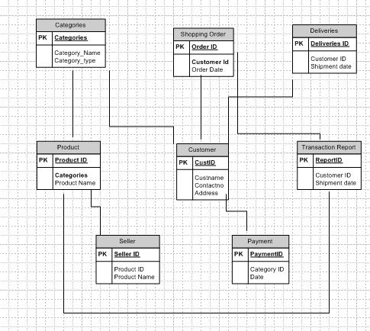

Q7. Data flow Diagram
A data flow diagram (DFD) is a graphical representation of the flow of data within a system. It shows how data moves from one part of the system to another and how data is transformed, stored and utilized within the system. DFDs are widely used in systems analysis and design to visualize data processes and the way information is handled, stored and transmitted between different system components.

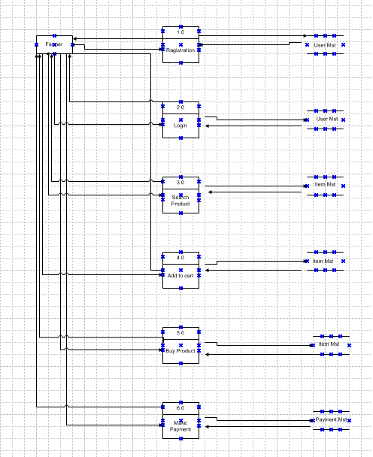

Q8. Change Request
Handling change requests in a project involves a systematic process to ensure that changes are effectively managed while minimizing disruption to the project’s scope, timeline and resources. Here are the steps typically followed to handled change requests.
1 Change Request Identification: Identify and document the change request, including the specific details of the requested change, the reason for the change and its potential impact on the project.
2. Change Impact Analysis: Assess the impact of the change on various aspects of the project, Such as scope, timeline, cost, resources and risks. Evaluate the feasibility and implications of implementing the change.
3. Change Evaluation: Review the change request with key stakeholders, Including project sponsors, clients and relevant team members. Discuss the potential benefits, risks associated with the change. Consider the project’s objectives, constraints and priorities in the evaluation process.
4. Change Prioritization: Prioritize the change request based on its urgency, Impact and alignment with project goals. Determine whether the change is critical and must be implemented immediately or can be scheduled for a future phase or release.
5. Change Approval: Obtain formal approval from the appropriate stakeholders, such as project sponsors or change control boards. Ensure that all stakeholders agree regarding the change and its implications.
6. Change Implementation: Incorporate the approved change into the project plan, including any necessary adjustments to the scope, schedule, budget or resources. Communicate the change to the project team and other relevant stakeholders. Update project documentation, such as requirements, design and test plans to reflect the approved change.
7. Change communication: Communicate the approved change to all relevant parties, including team members, clients and other stakeholders. Clearly explain the reason for the change, its impact on the project and any adjustments to expectations or deliverables.
8. Change Tracking and Documentation: Track the document all approved changes, including the rationale, approvals and implemented modifications. Maintain a change log or change register to ensure transparency and accountability throughout the project.
9. Change control and monitoring: Continuously monitor the impact of implemented changes on the project’s progress, risks and quality. Maintain open lines of communication with stakeholders to address any concerns or issues related to the approved changes. Monitor the project’s overall alignment with the revised scope, timeline and objectives.
By following these steps, a project can effectively manage change requests, ensuring that changes are evaluated, approved and implemented in a controlled manner, while minimizing disruptions and maintaining project success.
Q9. Change Request Vs an Enhancement
Change Request- A change request (CR) is a formal proposal to modify a project, product, process or system. It is typically used in project management, software development and various industries to handle modifications and improvements. A change request can arise at any point during project’s lifecycle, whether its due to new requirement or need for enhancements.
Enhancement – Enhancement refers to improvements or additions made to the software after its initial release. These changes are aimed at increasing the software’s value, performance or functionality based on evolving business needs user feedback, or technological advances. Enhancements can be part of the regular software maintenance cycle or occur as part of a new version or update.
As a business Analyst, my response to Ben and Kevin’s request would be classify it as an enhancement. A change request typically involves modifications to existing functionality or requirements, while an enhancement introduce new feature or capabilities that were not initially specified, In this case, the request to allow farmers to add their crop yields display them to the general public and enable selling through the application represents an enhancement because it introduces new functionality of an auction system for crop yields adds another layer of functionality to the application.
To address this enhancement request, I would follow the standard process for handling new requirements:
- Requirement Gathering: I will meet with Ben and Kevin to gather detailed requirements for the new functionality. This would involve understanding the specific feature they envision, such as the process for farmers to add and manage their crop yields, the display of products to the public and implementation of the auction system.

- Impact Analysis: I would analyze the impact of these enhancements on the existing project scope, timeline, budget and resources. This assessment would help determine the feasibility and potential implications of incorporating the requested features.

- Stakeholder Analysis: I would identify and involve relevant stakeholders, such as the project sponsor, development team and other key personnel to assess their perspectives and gather their inputs on the potential enhancements.

- Documentation and Communication: I would document the detailed requirements and changes in the project scope and communicate them to the project team, stakeholders and any other parties involved. This would ensure everyone is aware of the proposed enhancement and their implications.

- Evaluation and prioritization: This evaluation would consider factors such as the potential benefits, impact on project goals, alignment with business objectives and available resources.

- Planning and execution: If the enhancements are deemed feasible and approved, I would update the project plan, schedule and resources accordingly would collaborate with the development team and other stakeholders to incorporate the new feature into the application, ensuring proper testing and quality assurance.

By treating this request as an enhancement, the project can effectively manage the additional requirements and deliver the desired functionality while considering the impact on the ongoing project.

Q10. Estimations:
Estimation – Estimation in software Development life cycle refers to the process of predicting the resources (Time, Cost effort) required to complete a software development project or specific tasks within that project. Estimation is a critical part of the planning phase of SDLC, as it helps in setting realistic expectation, managing resources and determining the project’s feasibility.
Man-hours estimation in software development refers to the process of estimating the total amount of human effort required to complete a software development tasks, project or feature. It is typically expressed in terms of estimation in crucial for planning. Budgeting and scheduling the project. It helps determine resources requirement, assess project timelines and evaluate project feasibility.

Types of projects on the basis of Man- Hours:
- Small Project – Up to 500 Man-Hours
- Medium Project – Up to 1000 Man-Hours
- Large Project – Up to 1500 Man-Hours

Manhours Required: Total hours working per day X Total number of members X Total numbers of days worked over the specific period.
Number of working hours a day – 8 hours
Number of resources – 12
Time period provided – 18 months – 547 days- 78 Weeks (Including weekends and public holidays)
Assuming Weekends – 156
Assuming Public Holiday – 10
Total – 166
Total working days – 547-166= 381 working days
Hence, Estimated Manhours – 8 hours X 12 resources X 381 Days = 36,576 Man Hours.

Q 11. UAT
UAT- User acceptance testing is a crucial phase in the software development life cycle where the intended users of the system validate the software by testing it in a real world or production like environment. The primary goal of UAT is to ensure that the software meets the business requirements, functions as expected and is ready for deployment to the end users.
To handle the situation of testing the final product and successfully completing it, the business analyst can follow these steps:
- UAT Planning: Prepare a plan for User Acceptance Testing (UAT) in consultation with the client. This plan should include the scope of testing, test scenarios, test data and timelines.
- Test Environment Set up: Ensure that the required test environment is set up and available for the client to perform testing. This may include providing access to the testing environment, necessary test.
- Test Execution: Coordinate with the client to execute the planned test scenarios. Monitor the testing progress. Provide support for any questions or issues that arise, and track the test results.
- Defect Management: If any defects are identified during UAT, work closely with the client to understand the issues, document them and track their resolution. Collaborate with the development team to address the reported defects and verify their fixes.
- UAT Sign-off: Once the client has completed testing and is satisfied with the product’s functionality, obtain their formal sign-off or approval which includes RTM and closure documents. This indicated that the client has accepted the final product and is ready to move forward with its deployment.
Regarding the process to close the project, it typically involves the following steps:
- Final Documentation: Ensure that all project-related documentation is complete, including requirement, design documents, test cases, and user manuals. Review and update these documents to reflect the final product.
- Project Review: Conduct a project review meeting with key stakeholders, including the client, to discuss the overall project performance, achievements, and lessons learned, gather feedback and suggestions for improvements.
- Project Closure Report: Prepare a project closure report summarizing the project’s objectives, deliverables, timeline, budget and overall success. Include any important metrics or performance indicators.
- Handover or Deployment: Coordinate with the necessary teams, such as deployment or operations, to ensure a smooth transition of the final product to the production environment. Provide any necessary training or documentation to support the deployment process.
- Post Project Evaluation: After the product is deployed and operational, conduct a post-project to assess its performance, gather user feedback, and identity any areas for further improvement.

UAT Acceptance Process: The UAT Acceptance Process is the formal procedure through which stakeholder (Typically business user and clients) validates and approve the software application to ensure it meets business requirements and is ready for deployment. It is a critical phase in SDLC that involves testing the system in a real-world environment to ensure it works as intended before going live.
The UAT Acceptance process involves the following steps:
- Test Planning – Define the scope of UAT and identify the key features or functionalities to be tested.
- Test Execution: Perform the planned test scenarios, following the test cases provided. Validate the system’s behavior against the expected outcomes and verify that it meets the user’s acceptance criteria.
- Defect Reporting: If any issues or defects are identified during UAT, document them in a structured manner, including detailed steps to reproduce the problem. Communicate the issues with dev team for resolution.
- Defect Resolution: Collaborate with the dev team to address the reported defects. Verify the fixes provided by the dev team and retest the affected area.
- Sign-off: Once all test scenarios have been executed, defects have been resolved, and the system meets the user’s acceptance criteria, provide formal sign-ff or approval. This signifies that the client accepts the product as meeting their requirements.
- UAT closure: Document the UAT results, including the test execution summary any outstanding issues and the overall assessment of the product.
Q12: Project Closure Document
Project closure document: A project closure document is a formal document that signifies the conclusion of a project. It provides a detailed summary of the project’s performance, achievements, lesson learned and any remaining tasks or issues. The purpose of this document is to ensure that the project is officially closed and that all stakeholders have agreed that the project has met its objectives. The project closure is typically prepared by the project manager or the project team and is presented to stakeholders, including the client, team members and management.
The project closure document typically includes the following sections:
- Project Overview: This section provides an overview of the project, including its objective, scope, and stakeholders involved. It summarizes the project’s purpose and sets the context for the closure report.
- Project Achievements: Here, the document highlights the key achievements and deliverables of the project. It outlines the successful completion of milestones, tasks, and any significant accomplishments that were achieved.
- Project Timeline and budget: This section provides an overview of the project timeline, highlighting the start and end dates, major phases and milestones, It also includes information on the project budget including my significant deviation or changes.
- Lessons Learned: The lessons learned section reflects on the project successes and challenges. It includes a comprehensive analysis of what worked well and what could have been improved. It highlights valuable insights and recommendation for future projects.
- Stakeholder Feedback: This section gathers feedback from key stakeholders involved in the project. It includes their opinions, suggestions and any concerns they may have expressed. The feedback helps in assessing the overall satisfaction and identifying areas of improvements.
- Risks and issues: The closure document discusses the risks and issues encourages throughout the project. It outlines the actions taken to mitigate these risks and resolve any issues that arose during the project’s lifecycle.
- Project performance: This section evaluates the project’s performance against the defined objectives and success criteria. It assesses factors such as scope adherence, timeline adherence, budget performance, quality of deliverables, and customer satisfaction.
- Project Sign-off: The closure document includes formal sign-off or approval from key stakeholders, indicating their acceptance and satisfaction with the project’s outcomes. This signifies the official closure of the project.
- Project documentation: This section provides an overview of the project documentation, including the list of documents produced, their location and accessibility for future reference.
- Next steps and recommendations: The closure document outlines any recommended actions or next steps following the project’s closure. It may include suggestions for future improvements, additional tasks, or follow-up activities.

The project closure document serves as a final report that captures the project’s journey outcomes and key learnings. It provides a reference for future project’s helps in evaluating project success and facilitates knowledge transfer to stakeholders involves in the project.

S/N | Points to Include | Details | Ref. Include
1 | Did the client Sign off on the UAT Testing
 | Date of sign OFF | 22 Oct 2025 | Bus_Scope.docx
 | Name of the Resources | Mr. Tarun
2 | Objectives of the project
 | User Friendliness | Achieved
 | Customer satisfaction | ROI (Return of investment) in 6 to 12 months
 | More Categories | Achieved
3 | Functionalities worked on
 | Secured payment process | Achieved | FRD.Docx
 | Categories | Achieved
4 | Infrastructure
 | Software installed | Achieved | Procurement.docx
 | Laptops purchased | Achieved
5 | Funding
 | Amount approved | 2 Cr | Finan_detailes.xls
 | Amount used | 2 Cr
6 | Overall project info
 | Escalations | 30
 | Cust. Satisfaction | High
7 | Value to the company
 | Positive/ Negative | Company gained Successful integration of processes turnover by 25% increased efficiency by 20%.

