Use case diagram:

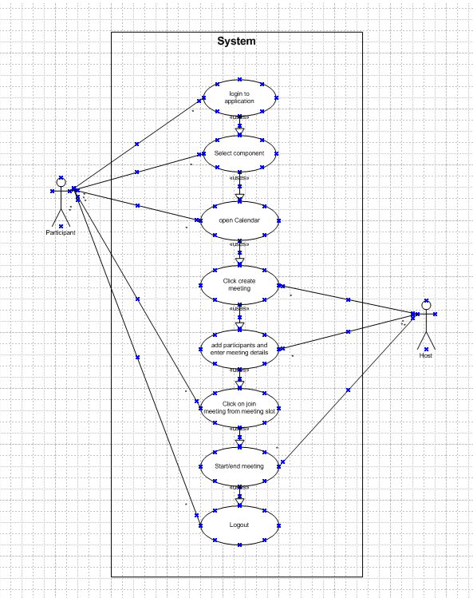

Activity Diagram:
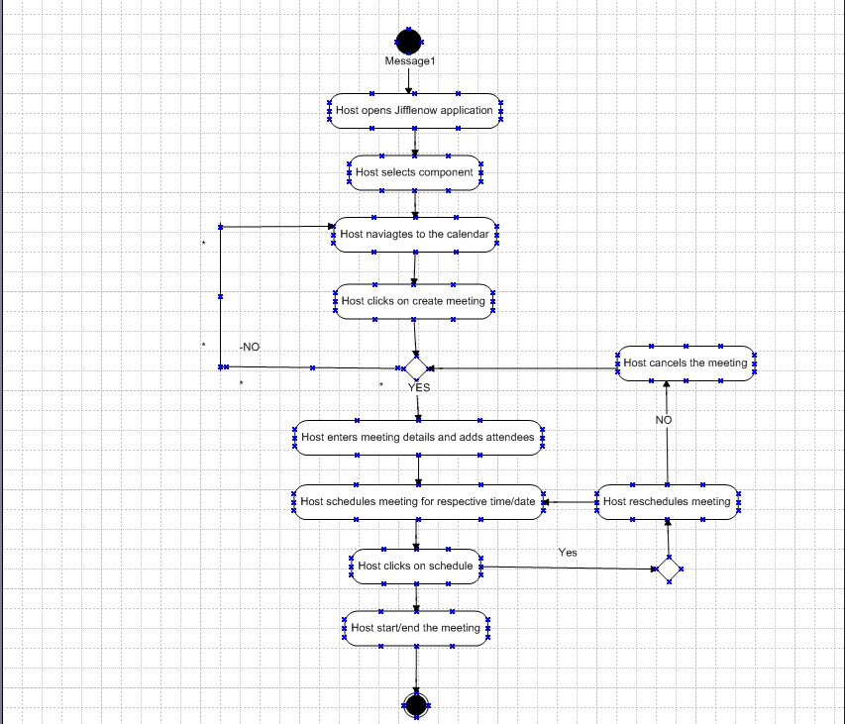

Use case specs 1 :

UC Name | Schedule meetings
UC # | 1.00
Primary Actor | Meeting host
Use Case Story | This use case enables the user to login create meeting by adding the participants and required details
Trigger | Host clicks on create meeting
Pre-Condition | User needs to have access to create meetings
Post-Condition | User should be able to schedule meetings and run it

Primary Flow (PF) | Title: Host is able to schedule the meeting
Primary Flow (PF) | Actor Action | System Response
Primary Flow (PF) | 1) User enters User ID
Primary Flow (PF) | 2) User enters password
Primary Flow (PF) | 3) User clicks on login button | 4) System validates User ID and password  If valid, go to next step  If invalid, go to Alternate Flow 1 (AF1)
Primary Flow (PF) | 5) User select a component
Primary Flow (PF) | 6) user clicks on the calendar icon | 7) user will be navigated to the meeting creation page
Primary Flow (PF) | 8) user clicks on the create meeting button | 9) User will be taken to the meeting creation page where the user selects participants and time slot
 | 10) User clicks on schedule button | 11) user will be redirected back to the calendar view with the meeting slot being created
Alternate Flow 1(AF1) | Title: Invalid credentials
Alternate Flow 1(AF1) | Actor Action | System Response
Alternate Flow 1(AF1) |  | 1) System displays the following error message: Invalid User ID and password. Please Re-try
Alternate Flow 1(AF1) | 2) Go to Step 1 of PF

Use case specs 2:

UC Name | Join meeting
UC # | 2.00
Primary Actor | participants
Use Case Story | This use case enables the user to login and join the meeting created
Trigger | User click on join meeting button
Pre-Condition | User needs to see the join meeting button
Post-Condition | User should be able to join meeting by clicking on join meeting

Primary Flow (PF) | Title: Host is able to schedule the meeting
Primary Flow (PF) | Actor Action | System Response
Primary Flow (PF) | 1) User enters User ID
Primary Flow (PF) | 2) User enters password
Primary Flow (PF) | 3) User clicks on login button | 4) System validates User ID and password  If valid, go to next step  If invalid, go to Alternate Flow 1 (AF1)
Primary Flow (PF) | 5) User select a component
Primary Flow (PF) | 6) user clicks on the calendar icon | 7) user will be navigated to the meeting creation page
Primary Flow (PF) | 8) user clicks on join button | 9) User will be taken to the join meeting page
 | 10) User joins the meetings
Alternate Flow 1(AF1) | Title: Invalid credentials
Alternate Flow 1(AF1) | Actor Action | System Response
Alternate Flow 1(AF1) |  | 1) System displays the following error message: Invalid User ID and password. Please Re-try
Alternate Flow 1(AF1) | 2) Go to Step 1 of PF

My experience as BA in the following fields

1. Requirement Gathering
- Role: Elicit, document, and validate business needs.
- Activities: Conduct stakeholder interviews, workshops, and surveys.
- Deliverables: Create documents like user stories and requirement specifications, ensuring alignment with business objectives.

2. Requirement Analysis
- Role:
Understand and organize gathered requirements, identifying conflicts or gaps.
- Activities:
Analyze requirements for feasibility, business value, and potential conflicts.
- Deliverables:
Develop detailed Business Requirements Documents (BRDs) and Software Requirements Specifications (SRSs)

3. Design
- Role: Provide business and user perspectives to the design team.
- Activities: Collaborate on wireframes and user interface (UI) mockups, ensuring designs align with business goals and user expectations.
- Deliverables: Input on user experience (UX) and functional design documents

4. Development
- Role: Act as a liaison, translating requirements and providing clarity to developers.
- Activities: Support the development team by answering questions and ensuring the solution being built aligns with the specifications.
- Deliverables: Clarifications and ongoing support to ensure requirements are met.

5. Testing
- Role: Facilitate testing efforts, verifying that the developed solution meets requirements and user needs.
- Activities: Define acceptance criteria, help create test cases, and participate in User Acceptance Testing (UAT).
- Deliverables: Validated software that meets defined criteria.

6. Deployment
- Role: Support the transition of the software to the production environment and monitor its performance.
- Activities: Assist with the deployment process and monitor the system's performance post-deployment.
- Deliverables: A successfully deployed system and ongoing feedback for maintenance

Screencomps

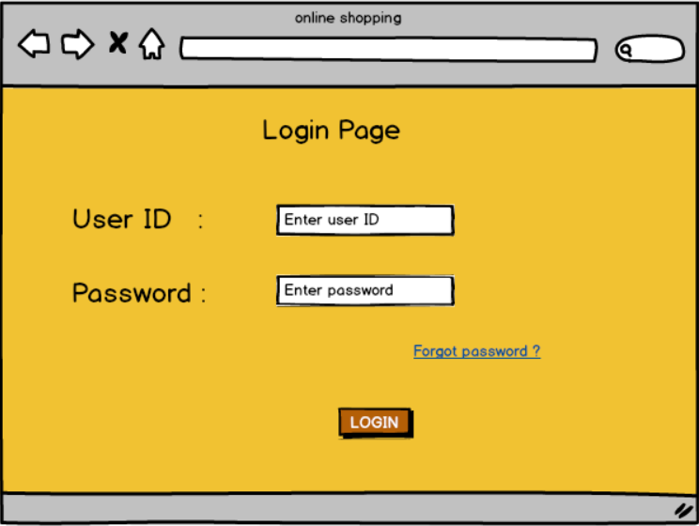

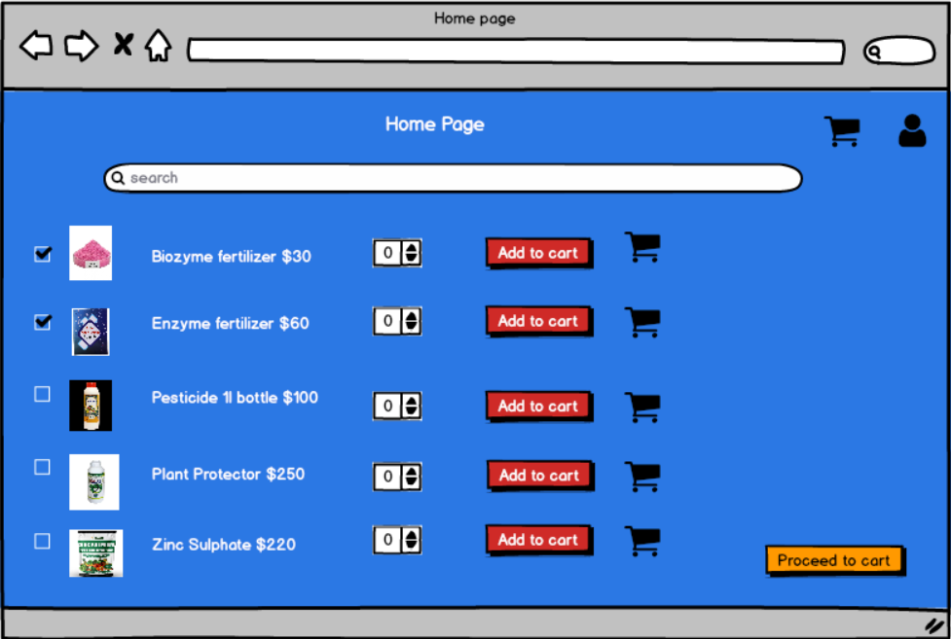

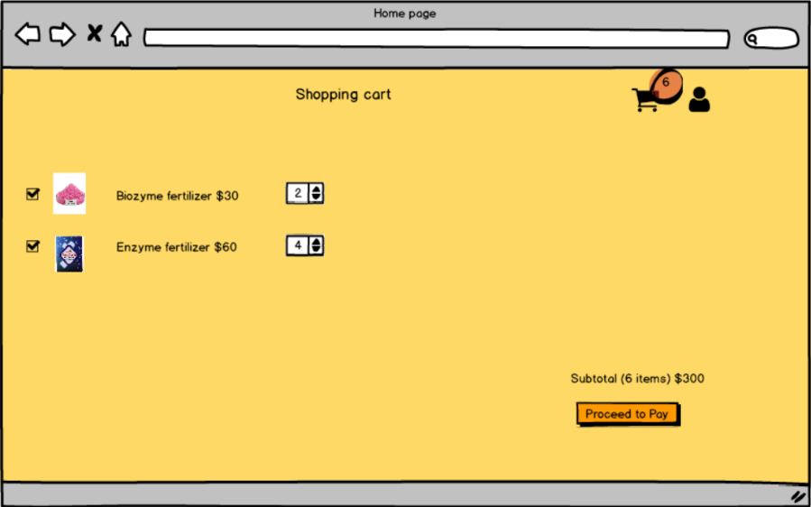
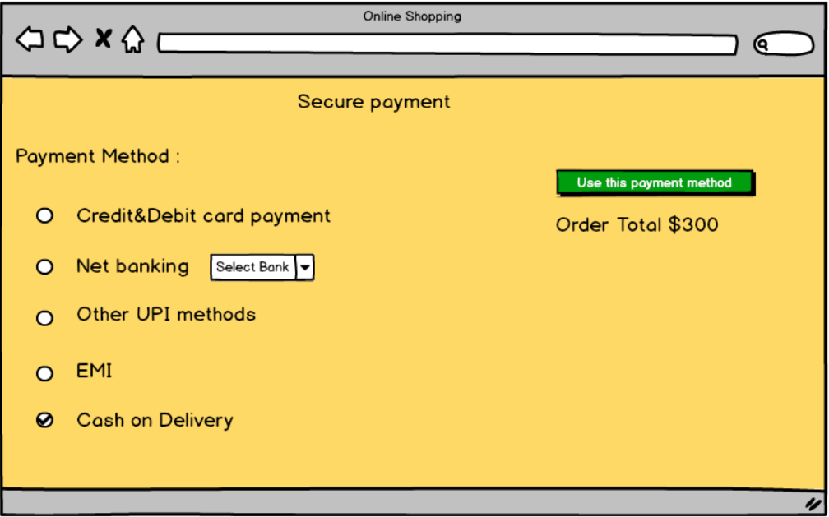

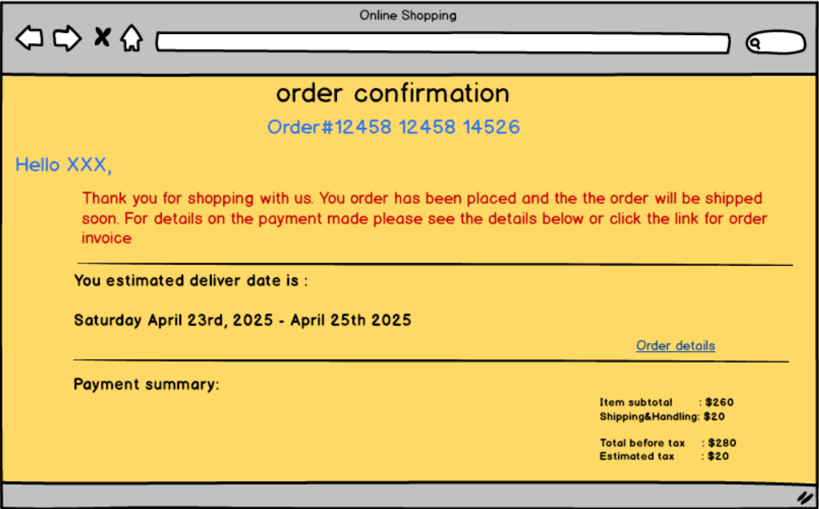

Tools used:
Tools used for preparing above pages was balasmiq. Where we can actually create a link to pages and see the slideshow. The main drawback of Balasmiq is that you cannot give inputs. Other than that there are so many options available. I find Balasmiq as the most comfortable tool for creating screencomps. There are lot of options available in the tool

