Agile Project BA Implementation

Document 1: Definition of Done

As Per Agile Extension to the BABOK® Guide v2, Definition of Done is a technique where the team agrees on, and prominently displays, a list of criteria, which must met before a backlog item, is considered done. That is the team has to create a well-defined, unambiguous, measurable, agreed-upon, and shared Definition of Done between all team members.
The best form of Definition of Done representation is a checklist of activities that has to demonstrate the agreed value and quality of a user story. So, this checklist should include:
- Acceptance criteria (to satisfy customer requirements for a product)
- Quality criteria (to satisfy quality requirements for a product)

Definition of Done may be defined for different levels of project work. For example, in Agile / Scrum framework these levels of work could be user story, sprint, and release.

Checklist for DOD:
- Produced code for presumed functionalities
- Code adheres to coding standards
- Code follows best practices
- Code is modular and maintainable
2. Assumptions of User Story met
- All acceptance criteria of the story are fulfilled
- Business rules and scenarios are covered
- No missing edge cases

3. Project builds without errors
- Code complies successfully with no build failures
- No critical warnings or dependency issue
- Build process is automated and repeatable

4. Unit tests written and passing
- Unit tests created for key functions and logic
- Minimum coverage standards met
- All tests run successfully in CI/CD
5. Project deployed on the test environment identical to production platform
- All code/configs are deployed to a full sandbox/staging org that mirrors production
- Deployment tested using change sets or DevOps tools
- No environment specific remain
6. Tests on devices/browsers listed in the project assumptions passed
- Salesforce app tested on key browsers
- Mobile testing on ios & Android for banker/customer access
- Responsive lightning components verified
7. Feature ok-ed by UX designer
- Lightning pages/components match approved UI/UX designs
- Layout, branding, and navigation are user-friendly
- Accessibility standards checked
8. QA performed & issues resolved
- QA team runs functional, regression, and integration tests
- Bugs found are logged in Jira and fixed
- No critical or high-severity defects remain
9. Feature is tested against acceptance criteria
- Each user story is validated with the Product Owner/business team
- Actual results match expected outcomes

10. Feature ok-ed by Product Owner
- Product Owner reviews and signs off on functionality and usability
- Business stakeholders confirm readiness for release
11. Refactoring completed
- Code cleaned for readability and maintainability
- Any redundant methods, unused variables, or extra logic removed
- Queries optimized to improve performance
12. Any configuration or build changes documented
- Salesforce object changes (fields, page layouts) recorded in a configuration log
- API connections, permission sets, and environment variables documented
13. Documentation updated
- User manuals, admin guides, and release notes updated
- Steps for deployment or rollback are recorded for future use
14. Peer Code Review performed
- Another Salesforce developer reviews Apex, Lightning components, and Flows
- Checks for scalability, governor limits, and secure coding
- Suggestions implemented before merging to main branch

Document 2- Product Vision

Scrum Project Name: | Salesforce Application
Venue: | Pune
Date: | Start Time  01-10-22025 | End Time:  30-09-2026 | Duration:  1 Year
Client: | Kotak Bank
Stakeholder List: | Project Stakeholders:  - BA  - Product Owner  - Salesforce Dev  - UI/UX Designers  - QA/Testers  - Scrum Master/Project Manager  - IT Security Team | Business Stakeholders:  - Retail Banking Heads & Managers  - Branch Managers & Relationship Managers  - Operations Team  - Marketing Team  - Compliance & Risk Team | 3rd Party Stakeholders:  - Salesforce  - Video Banking Vendor  - Cloud/Hosting Providers  - External QA/Testing Partners  - API/Integration Partners
Scrum Team
Scrum Master: | Priya Sharma
Product Owner: | Rohan Verma
Scrum Developer 1: | Ankit Shah
Scrum Developer 2: | Neha Kapoor
Scrum Developer 3: | Rahul Desai
Scrum Developer 4: | Sneha Lyer
Scrum Developer 5: | Arjun Patel
UI Designer: | Meera Singh
Tester | Kunal Rao
Business Analyst | Neha Richhariya

Vision- To make Kotak Bank’s Salesforce app more digital and easy, enabling faster and branch-free banking.
Target Group  - Kotak Bank customers and staff handling leads, services, and cross selling.  - Digital banking and CRM users across India. | Needs  - Customers need quick, paperless services; bankers need smarter tools to manage leads and serve clients immediately. | Product  - An enhanced Salesforce app with features like video banking, instant document vault, smart alerts, and one-click product applications.  - Yes, it is feasible because Salesforce already supports custom development, integrations, and security features needed for these enhancements. | Value  - Boosts customer satisfaction, lowers branch costs, grows cross-sell revenue, and strengthens digital banking.  - Grow digital adoption, reduce operational costs, and drive more product sales through seamless online engagement.  - he business model is to grow revenue by cross-selling products, cut branch costs with digital services, and keep customers loyal through fast, convenient banking.

Document 3: User stories

User Stories: - User Stories are short, simple description of a feature written from the end user’s perspective. They explain who the user is, what they need, and why they need it.
Example format: “As a (User), I want (feature) so that (benefit).”
In my Salesforce project, a user story could be. “As a customer, I want to upload KYC documents digitally so that I don’t have to visit a branch.”
Business Value (BV) The importance or benefit a feature brings to the business or customer.
Complexity Points (CP): The effort or difficulty estimated to build that feature (like story points).
Acceptance Criteria: Acceptance Criteria are the specific conditions that a product feature or user story must meet to be considered complete and successful. They act as a checklist for developers, testers, and the product owner to ensure that the delivered feature work as intended and satisfies the business need.
In simple terms, acceptance criteria tell the team “what success looks like” for each user story. They describe the exact behaviour, rules, and outcomes that the system should produce, including:
- Functional Requirements
- Edge cases
- Performance or security expectations.

User Story No: 1 | Tasks: 2 | Priority: High
Value Statement:

As a customer,
I want to connect with a banker through video
So that I can get services remotely

BV: 200 CP: 5
Acceptance Criteria:

Customer can start a secure video call from the app.
Banker joins within 1 min, and call is encrypted and recorded.

User Story No: 2 | Tasks: 2 | Priority: High
Value Statement:

As a customer,
I want to upload and store KYC documents
So that I don’t need branch visits

BV: 500 CP: 8
Acceptance Criteria:

Customer can upload PDFs/JPG/PNG file
Files encrypted
Banker can view in Salesforce

User Story No: 3 | Tasks: 2 | Priority: High
Value Statement:

As a banker,
I want real-time alerts about customer activities
So that I can cross-sell quickly

BV: 200 CP: 8
Acceptance Criteria:

Instant alerts on product interest
Notification shown in banker’s dashboard

User Story No: 4 | Tasks: 2 | Priority: High
Value Statement:

As a customer,
I want to book a branch appointment
So that I don’t need to wait for a long

BV: 200 CP:
Acceptance Criteria:

View available slots
Book/cancel appointment
Receive confirmation

User Story No: 5 | Tasks: 2 | Priority: Medium
Value Statement:

As a branch staff,
I want to manage walk-in queues
So that it can reduce customer waiting time

BV: 100 CP: 3
Acceptance Criteria:

Assign tokens
Track wait times
Notify customers when turn is near

User Story No: 6 | Tasks: 2 | Priority: High
Value Statement:

As a customer,
I want to apply for loans or cards in one click
So that this can save time

BV: 500 CP: 8
Acceptance Criteria:

One-step application
Pre-filled customer data
Confirmation displayed

User Story No: 7 | Tasks: 2 | Priority: Medium
Value Statement:

As a banker,
I want AI to suggest relevant products
So I can increase cross-sell

BV: 100 CP: 8
Acceptance Criteria:

AI generates product list
Suggestions match customer profile

User Story No: 8 | Tasks: 3 | Priority: Medium
Value Statement:

As a customer,
I want to set financial goals
So I can monitor savings progress

BV: 100 CP: 3
Acceptance Criteria:

Create/edit goals
View real time progress charts

User Story No: 9 | Tasks: 2 | Priority: High
Value Statement:

As a customer,
I want real-time alerts for transactions or new offers
So that I stay informed

BV: 500 CP: 5
Acceptance Criteria:

Alerts sent within 5 seconds
Users can enable/disable in settings

User Story No: 10 | Tasks: 2 | Priority: Medium
Value Statement:

As a User,
I want multi-factor login
So that my data stays safe

BV: 100 CP: 2
Acceptance Criteria:

MFA required on new devices
OTP or biometric login supported

User Story No: 11 | Tasks: 2 | Priority: High
Value Statement:

As a banker,
I want a dashboard to track leads and sales
So that I can make better decisions

BV: 200 CP: 8
Acceptance Criteria:

Dashboard shows real-time leads, revenue, and cross-sell metrics with export option
Dashboard refreshes in every 1 min

User Story No: 12 | Tasks: 2 | Priority: Medium
Value Statement:

As a customer,
I want to give quick feedback after a service
So the bank can improve

BV: 100 CP: 5
Acceptance Criteria:

Feedback form appears after key interactions, submissions stored in salesforce
Banker receives alert rating < 3 stars

User Story No: 13 | Tasks: 2 | Priority: High
Value Statement:

As a customer,
I want a chatbot to answer basic queries
So I get help anytime

BV: 500 CP: 8
Acceptance Criteria:

Chatbot answers FAQs 24/7
Creates tickets for complex issues

User Story No: 14 | Tasks: 3 | Priority: Medium
Value Statement:

As a customer,
I want to check loan eligibility instantly
So I save time

BV: 100 CP: 5
Acceptance Criteria:

Customer needs to enter basic information
Customer can see eligibility results within 10 seconds

User Story No: 15 | Tasks: 3 | Priority: Low
Value Statement:

As a user
I want dark mode
So the app is easier on my eyes

BV: 50 CP: 2
Acceptance Criteria:

Toggle is available in settings
It applies across screens

Document 4: Agile PO Experience

The Product Owner has a vision of the product keeping the domain/industry experience and the market need.
❖ Following are the responsibilities of PO in a project

Market Analysis: Market analysis is the process of studying the target market, customers, competitors, and industry trends to understand demand, opportunities, and risks for a product or service. It helps identify customer needs, buying behaviour, and market size.
By analysing competitors, it shows gaps and areas where your project can stand out.
It guides pricing, features, and positioning to attract the right audience.
Market analysis reduces risks by predicting challenges and helps make better business decisions. Overall, it ensures the project is relevant, profitable, and aligned with market demand.
Enterprise Analysis: Enterprise analysis means checking if a business idea or project is worth investing in. It involves studying the market opportunity, customer demand, competitors, and risks. This helps decide if the project aligns with company goals and can deliver profits. It ensures resources are used on ideas that real potential to succeed.
Product Vison and Roadmap:
Product Vision is the big-picture goal of the product—what it aims to achieve and the value it will bring to customers and the business. Product Roadmap is the step-by-step plan that shows how the product will reach that vision over time, including key features, timelines, and milestones.
Managing Product Features – Keeping track of all features, ensuring they meet business goals and customer needs.
- Managing Stakeholders Expectations: Regularly updating stakeholders on progress, explaining trade-offs, and aligning everyone on priorities.
- Prioritizing Needs: Deciding which features or changes should be delivered first based on importance and value.
- Prioritization of Epics, Stories, and Features: Ranking items in the backlog by critically (business impact/urgency) and ROI (return on investment) to focus on the highest-value work first.
Managing Product Backlog:
Prioritization of User Stories- Rank user stories by business value and urgency so the team works on the most important tasks first.
Reprioritization- Adjust the order of tasks when stakeholder needs, feedback, or market conditions change.
Epics Planning- Break big features (epics) into smaller user stories and schedule them across upcoming sprints for smooth delivery.
Managing Overall Iteration Progress:
Sprint progress review- Check the team’s progress during the sprint to make sure tasks are on track and issues are resolved quickly.
Reprioritization of sprints and epics- If priorities change or blockers appear, adjust the upcoming sprints or epic plans to match new business needs.
Sprint retrospectives with Business Analyst- After each sprint, discuss what went well, what needs improvement, and capture action items with the BA for the next sprint.

From this project, I have learned how to handle sprint meetings such as -
1. Sprint Planning Meeting – At the start of the sprint, the team and product owner sit together to decide which tasks or user stories they will work on next and how they will get it done.
2. Daily Scrum Meeting – A short 15-minute catch-up every day where members quickly share what they did yesterday, what they will do today, and if anything is blocking their work.
3. Sprint Review Meeting – At the end of the sprint, the team shows the finished work to stakeholders, gets feedback, and discusses any changes needed.
4. Sprint Retrospective Meeting – After the review, the team talks internally about what went well, what didn’t, and how they can work better in the next sprint.
5. Backlog Refinement Meeting – A regular session to check the product backlog, update priorities, and make sure upcoming tasks are clear and ready for future sprints.

Also, User stories creation and what things will be included in user stories such as
- User Story
As a (type of user),
I want (an action or feature)
So that (benefit or value)
For example:
As a customer,
I want to connect with a banker through video
So that I can get services remotely.
- Tasks:
Tasks are the smaller, detailed pieces of work that break the story into actionable steps. They describe how the team will build or deliver the feature (e.g., design screen, write code, test function) so the user story can be completed.
For Example:
Design the document upload screen (UI/UX).
Develop backend API for file upload and encryption.
- Priority:
Indicated the importance or urgency of the user story in the context of the overall project. Priorities are usually categorized as high, medium or low
For example:
High: Critical for the next release
Medium: Important but can wait for the next iteration
Low: Nice to have, can be considered later
- Acceptance Criteria:
A set of conditions or criteria that must met for the user story to be considered complete. These criteria help ensure that the implemented feature meets the user’s expectations.
For example:
Customer can start a secure video call from the app.
Banker joins within 1 min, and call is encrypted and recorded.
- Business Value:
Describes the value that user story brings to the business or end-user, it helps prioritize feature based on their impact.
For example:
High business value: Increases user engagement and satisfaction
Medium: Adds a useful feature but not critical
Low: Nice-to-have, minimal impact on users.
- Complexity Points:
An estimation of the complexity or difficulty of implementing the user story. Complexity points are often used in Agile methodologies for capacity planning and sprint commitments.
For example:

5-8 points: Medium complexity, may require some effort
13+ points: High complexity, may involve significant challenges.
- In Scrum, a product owner serves as the liaison between multiple areas of an organization. This person communicates with business stakeholders and collaborates closely with Scrum teams to keep all areas of the business informed on a project's development.
- The product owner develops a vision of a product’s function and operation, which in turn allows this Scrum team member to define product features and break those features into product backlog items.

Document 5: Product and sprint backlog and product and sprint burndown

Product Backlog:
- A master list of all features, enhancements, fixes, and tasks needed for the entire project/product.
- Managed by the Product Owner.
- Keeps changing as new ideas or requirements come up.
- Example (Salesforce project): Video banking, AI lead scoring, Document Vault, UPI integration, Dark mode UI.

User Story  ID | User Story | Tasks | Priority | BV | CP | Sprint
US01 | As a customer,  I want to connect with a banker through video  so that i can get services remotely. | - Create a user interface for the video call screen.  - Enable microphone and camera permissions for the customer. | High | 200 |  | 1

User Story  ID | User Story | Tasks | Priority | BV | CP | Sprint
US02 | As a customer,  I want to upload and store kyc documents  so that i don’t need branch visits. | - Design a form to upload KYC documents (PDF, JPG, PNG).  - Store uploaded documents securely in the database or cloud storage. | Highest | 500 | 5 | 1

User Story  ID | User Story | Tasks | Priority | BV | CP | Sprint
US03 | As a banker,  I want real-time alerts about customer activities  so that i can cross-sell quickly. | - Set up real-time notification system for key customer actions (e.g., large transactions).  - Display alerts on the banker dashboard with customer details. | Highest | 200 |  | 1

User Story  ID | User Story | Tasks | Priority | BV | CP | Sprint
US04 | As a customer,  I want to book a branch appointment  so that i don’t need to wait for a long. | - Create a form for customers to select branch, date, and time for an appointment.  - Save appointment details in the system and send confirmation to the customer. | High | 200 | 8 | 1

User Story  ID | User Story | Tasks | Priority | BV | CP | Sprint
US05 | As a branch staff,  I want to manage walk-in queues  so that it can reduce customer waiting time. | - Build an interface to view and manage current walk-in queue status.  - Add functionality to update customer queue positions in real time. | Medium | 100 | 3 | 1

User Story  ID | User Story | Tasks | Priority | BV | CP | Sprint
US06 | As a customer,  I want to apply for loans or cards in one click  so that this can save time. | - Add a one-click "Apply for Loan/Card" button on the customer dashboard.  - Pre-fill application form using existing customer data for faster submission. | High | 200 | 5 | 1

User Story  ID | User Story | Tasks | Priority | BV | CP | Sprint
US07 | As a banker,  I want AI to suggest relevant products  so that i can increase cross-sell. | - Integrate an AI engine to analyse customer data and generate product suggestions.  - Display AI-recommended products on the banker’s dashboard during customer interactions. | Medium | 100 |  | 1

User Story  ID | User Story | Tasks | Priority | BV | CP | Sprint
US08 | As a customer,  I want to set financial goals  so that i can monitor savings progress. | - Create a form for customers to set and name their financial goals with target amounts.  - Display progress tracker based on savings linked to each goal. | Medium | 100 | 3 | 1

User Story  ID | User Story | Tasks | Priority | BV | CP | Sprint
US09 | As a customer,  I want real-time alerts for transactions or new offers  so that i stay informed. | - Implement a notification system to send real-time transaction alerts to customers.  - Develop a feature to push new offer alerts based on customer preferences. | High | 500 | 8 | 1

User Story  ID | User Story | Tasks | Priority | BV | CP | Sprint
US10 | As a user,  I want multi-factor login  so that my data stays safe. | - Implement SMS or email OTP verification during login.  - Add support for authenticator apps (e.g., Google Authenticator) as a second login step. | Medium | 100 | 3 | 1

Sprint Backlog:
- A subset of the product backlog chosen for the current sprint (usually 2–4 weeks).
- Contains only the items the team commits to deliver in that sprint.
- Managed by the Development Team during the sprint.
- Example (Salesforce sprint): Secure login with MFA, Appointment booking screen, Queue management logic for Sprint 1.

User story ID | User story | Tasks | Owner | Status | Estimated effort
US01 | As a customer,  I want to connect with a banker through video  so that i can get services remotely. | - Create a user interface for the video call screen.  - Enable microphone and camera permissions for the customer. | John | Done | 6

User story ID | User story | Tasks | Owner | Status | Estimated effort
US02 | As a customer,  I want to upload and store kyc documents  so that i don’t need branch visits. | - Design a form to upload KYC documents (PDF, JPG, PNG).  - Store uploaded documents securely in the database or cloud storage. | Mary | Done | 8

User story ID | User story | Tasks | Owner | Status | Estimated effort
US03 | As a banker,  I want real-time alerts about customer activities  so that i can cross-sell quickly. | - Set up real-time notification system for key customer actions (e.g., large transactions).  - Display alerts on the banker dashboard with customer details. | Alex | Pending | 5

User story ID | User story | Tasks | Owner | Status | Estimated effort
US04 | As a customer,  I want to book a branch appointment  so that i don’t need to wait for a long. | - Create a form for customers to select branch, date, and time for an appointment.  - Save appointment details in the system and send confirmation to the customer. | Sarah | Pending | 4

User story ID | User story | Tasks | Owner | Status | Estimated effort
US05 | As a branch staff,  I want to manage walk-in queues  so that it can reduce customer waiting time. | - Build an interface to view and manage current walk-in queue status.  - Add functionality to update customer queue positions in real time. | Chris | Done | 7

User story ID | User story | Tasks | Owner | Status | Estimated effort
US06 | As a customer,  I want to apply for loans or cards in one click  so that this can save time. | - Add a one-click "Apply for Loan/Card" button on the customer dashboard.  - Pre-fill application form using existing customer data for faster submission. | Emily | Done | 5

User story ID | User story | Tasks | Owner | Status | Estimated effort
US07 | As a banker,  I want ai to suggest relevant products  so i can increase cross-sell. | - Integrate an AI engine to analyze customer data and generate product suggestions.  - Display AI-recommended products on the banker’s dashboard during customer interactions. | Kevin | Done | 8

User story ID | User story | Tasks | Owner | Status | Estimated effort
US08 | As a customer,  I want to set financial goals  so i can monitor savings progress. | - Create a form for customers to set and name their financial goals with target amounts.  - Display progress tracker based on savings linked to each goal. | Jessica | Pending | 2

User story ID | User story | Tasks | Owner | Status | Estimated effort
US09 | As a customer,  I want real-time alerts for transactions or new offers  so that i stay informed. | - Implement a notification system to send real-time transaction alerts to customers.  - Develop a feature to push new offer alerts based on customer preferences. | Ajay Kumar | Done | 4

User story ID | User story | Tasks | Owner | Status | Estimated effort
US10 | As a user,  I want multi-factor login  so that my data stays safe. | - Implement SMS or email OTP verification during login.  - Add support for authenticator apps (e.g., Google Authenticator) as a second login step. | Gautham | Done | 6

Product Burn Down Chart:
A product burn down chart shows the overall progress of the entire project. It tracks how much work (story points or backlog items) remains in the product backlog versus time. As sprints are completed, the line should move downward, showing that the team is getting closer to finishing the whole product. It helps stakeholders see if the project is on track for the planned release.

Sprint Burn Down Chart:
A sprint burn down chart shows the progress within a single sprint. It tracks the remaining tasks or hours for that sprint against the sprint days. The line goes down, as tasks are completed daily, helping the team monitor if they can finish all sprint backlog items before the sprint ends.

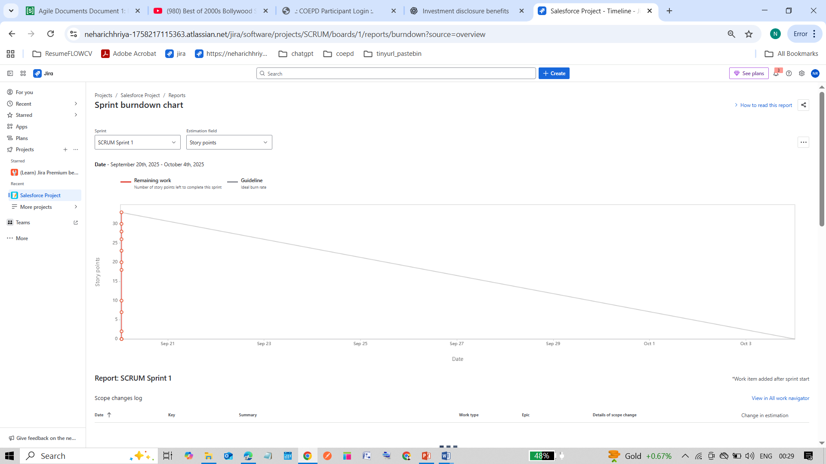

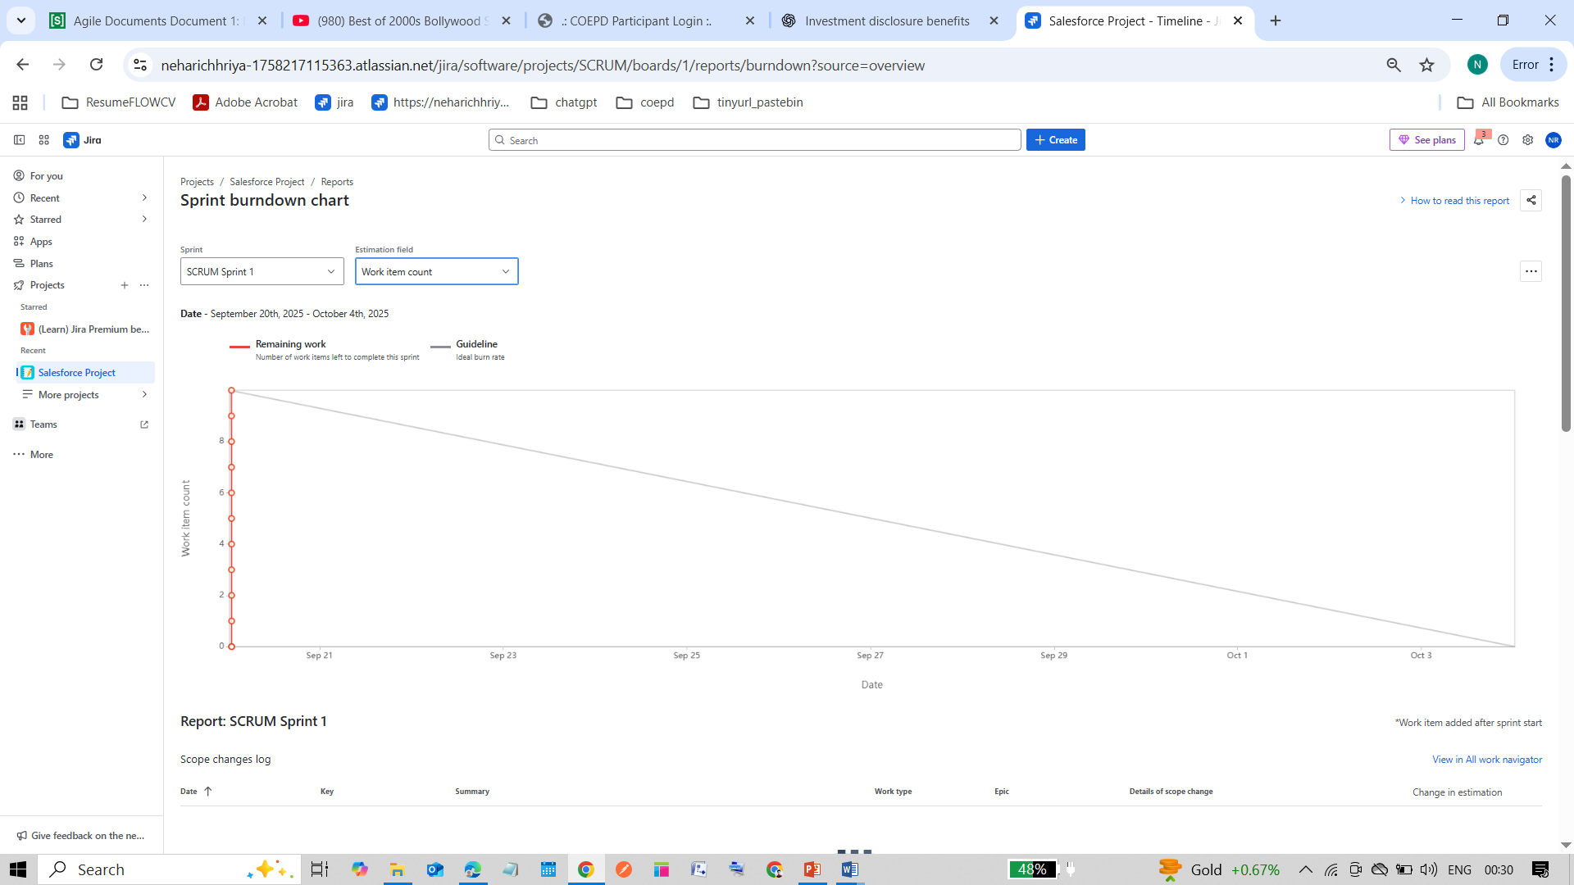

Document 6: Sprint meetings

Sprint meetings are the key discussions held during a sprint to plan, track, review, and improve the work.
They include Sprint Planning, Daily Scrum, Sprint Review, and Sprint Retrospective—each with a specific purpose to keep the team organized and on track.

Meeting Type 1: Sprint planning meeting

Date | 24-09-2025
Time | 10.00 am to 12.00 pm
Location | JW Marriot
Prepared By | Neha Richhariya
Attendees | Scrum Master | Rajesh Sharma
 | Product Owner | Ananya Mehta
 | Developer 1 | Ajay Singh
 | Developer 2 | Harsh Shah
 | UI Designer | Priya Kapoor
 | Tester | Rohit Verma
 | BA | Neha Richhariya

Agenda Topics:
Topic | Presenter | Time Allotted
Sprint goal discussion | Product Owner | 15 mins
Review Prioritized user stories | Business Analyst | 20 mins
Task estimation & story point assignment | Dev Team | 25 mins
Identify dependencies & risks | Scrum Master | 15 mins
Finalize sprint backlog & commitment | Entire Team | 20 mins
Set up daily scrum schedule | Scrum Master | 10 mins
Other Information:
Observers | - IT Security Team ( for MFA)  - Salesforce Admin
Resources | - People: Business Stakeholders from Kotak Bank, BA developer & training team.  - Time: 1 Year  - Budget: Rs. 2 Cr  - Other: Hardware, software, Network, Data infrastructure, Security.
Special Notes | Ensure all user stories have clear acceptance criteria before starting development.

Meeting Type 2: Sprint review meeting
Date | 24-09-2025
Time | 10.00 am to 12.00 pm
Location | JW Marriot
Prepared By | Neha Richhariya
Attendees | Scrum Master | Rajesh Sharma
 | Product Owner | Ananya Mehta
 | Developer 1 | Ajay Singh
 | Developer 2 | Harsh Shah
 | UI Designer | Priya Kapoor
 | Tester | Rohit Verma
 | BA | Neha Richhariya

Sprint Status | Things to demo | Quick updates | What’s next
Sprint: 1 done | Multi-Factor Login, Real-time Transaction Alerts, Customer Appointment Booking | All planned features completed | Deploy MFA and Alerts to Sandbox & start Sprint 2 planning
Meeting Type 3: Sprint retrospective meeting
Date | 24-09-2025
Time | 10.00 am to 12.00 pm
Location | JW Marriot
Prepared By | Neha Richhariya
Attendees | Scrum Master | Rajesh Sharma
 | Product Owner | Ananya Mehta
 | Developer 1 | Ajay Singh
 | Developer 2 | Harsh Shah
 | UI Designer | Priya Kapoor
 | Tester | Rohit Verma
 | BA | Neha Richhariya

Agenda | What went well | What didn’t go well | Questions | Reference
Sprint Analysis | All salesforce user stories completed on time. Successful demo of lead management and opportunity tracking modules | Delay in integration approval process with Salesforce Sandbox | Any additional testing needed before deployment? | PO, SM

Meeting Type 4: Daily Stand-up meeting:

Question | Name/Role | Week “X” (from dd-mm-yyyy to dd-mm-yyyy)
Question | Name/Role | Monday | Tuesday | Wednesday | Thursday | Friday | Saturday | Sunday
What did you do yesterday? | Developer 1 | Setup salesforce sandbox, created custom objects, and completed secure login with MFA | Integrated document vault upload API and tested encryption | Fixed MFA bugs, built appointment booking screen | Developed queue management logic and tested appointment module | Created banker performance dashboard and demo data for sprint review
What did you do yesterday? | Developer 2
What did you do yesterday? | Developer 3
What will you do today? | Developer 1 | Configure session timeout alerts and finalize MFA error handling | Start video banking module development | Build AI lead scoring and alerts | Test dashboards and prepare sprint review demo | Conduct sprint review and deploy updates to staging
What will you do today? | Developer 2
What will you do today? | Developer 3
What (if any) is blocking your progress? | Developer 1 | Minor sandbox latency | Waiting for API key for notification | Small data mismatch in test environment | None | None
What (if any) is blocking your progress? | Developer 2
What (if any) is blocking your progress? | Developer 3

