WATERFALL PROJECT

Documented by : V.Niharika
Date : 05-May-2025

Waterfall Deliverables - Part 2:
Project Integrity

Enhancement Project – Business Analyst Documentatio

Please prepare a
use case diagram,
activity diagram and
a use case specification document.

USE CASE DIAGRAM

ACTIVITY DIAGRAM

USE CASE SPECIFICATIONS :
Use Case 1: Manage Employee Details
Use Case Name: Manage Employee Personal Details
Use Case Description:
Employees can enter, view, and update their personal details in the portal.
Primary Actor: Employee
Secondary Actor: HR
Basic Flow:
- Employee logs into the portal.
- Employee navigates to "My Profile."
- Employee enters or updates personal details (name, ID, contact info, role, department).
- System validates and saves details.
- HR can view and verify employee details.
Alternate Flow:
- If required details are missing → System prompts for correction.
- If invalid data is entered → System rejects input.
Pre-Conditions:
- Employee must be registered in the system.
Post-Conditions:
- Employee details are stored and available for reporting and validation.
Dependencies:
- Integration with employee database.
Input: Employee profile details.
Output: Confirmation of update.
Business Rules:
- Mandatory fields (Name, ID, Department) must be completed.
- Only HR can override/update critical information.
Miscellaneous Information:
- Profile history must be logged for audit purposes.

Use Case 2: Punch In/Out (Attendance Logging)
Use Case Name: Punch In/Out
Use Case Description:
Employees record daily attendance by punching in at login and punching out at logout.
Primary Actor: Employee
Secondary Actor: System
Basic Flow:
- Employee logs into the portal.
- Employee clicks "Punch In."
- System records login time.
- At the end of work, employee clicks "Punch Out."
- System records logout time.
Alternate Flow:
- If employee forgets to punch in/out → HR adjusts attendance manually.
Pre-Conditions:
- Employee must be registered in the system.
Post-Conditions:
- Attendance log is captured and stored for reporting.
Dependencies:
- Time-tracking and database system.
Input: Punch In/Out action.
Output: Attendance log with timestamp.
Business Rules:
- Employees must punch in/out daily.
- HR can modify records with justification.
Miscellaneous Information:
- System should provide reminders if punch action is missed.

Use Case 3: Task Assignment
Use Case Name: Assign Task
Use Case Description:
Business Analyst assigns tasks to employees in the portal.
Primary Actor: Business Analyst
Secondary Actor: Employee
Basic Flow:
- Business Analyst logs into the portal.
- BA navigates to "Assign Task."
- BA enters task details (title, description, deadline, assignee).
- System stores the task.
- System notifies the assigned employee.
Alternate Flow:
- If task details are incomplete → System prompts for corrections.
Pre-Conditions:
- Employee and BA must exist in the portal.
Post-Conditions:
- Task appears in employee’s task list.
Dependencies:
- Task management and notification module.
Input: Task details (title, description, deadline, assignee).
Output: Task confirmation and notification to employee.
Business Rules:
- Only Business Analysts or authorized roles can assign tasks.
- Employees can only update progress, not reassign tasks.
Miscellaneous Information:
- Task status (Not Started, In Progress, Completed) must be tracked.

Use Case 4: Leave Request & Approval
Use Case Name: Apply for Leave
Use Case Description:
Employee applies for leave, manager reviews, and system updates status.
Primary Actor: Employee
Secondary Actor: Manager, System
Basic Flow:
- Employee logs into the portal.
- Employee selects "Apply Leave."
- Employee enters leave details (date, type, reason).
- System validates leave balance.
- System notifies manager with popup.
- Manager reviews and approves/rejects.
- System updates leave status.
- Employee receives popup notification.
Alternate Flow:
- If insufficient balance → System rejects automatically.
- If manager delays → Escalation alert is triggered.
Pre-Conditions:
- Employee must have leave balance.
Post-Conditions:
- Leave status is updated and recorded.
Dependencies:
- Integration with HR leave database.
Input: Leave request (employee ID, dates, reason).
Output: Approval/Rejection notification.
Business Rules:
- Leave cannot exceed available balance.
- Only manager or team leader can approve/reject.
Miscellaneous Information:
- System must keep leave history for compliance.

DOCUMENT 7- SCREENS AND PAGES

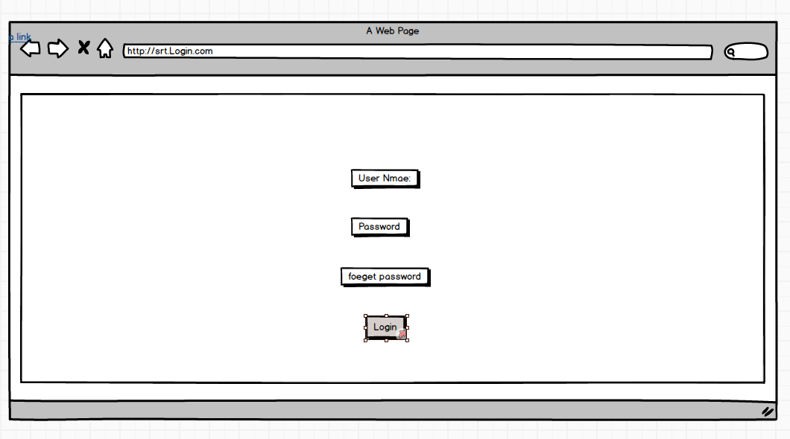

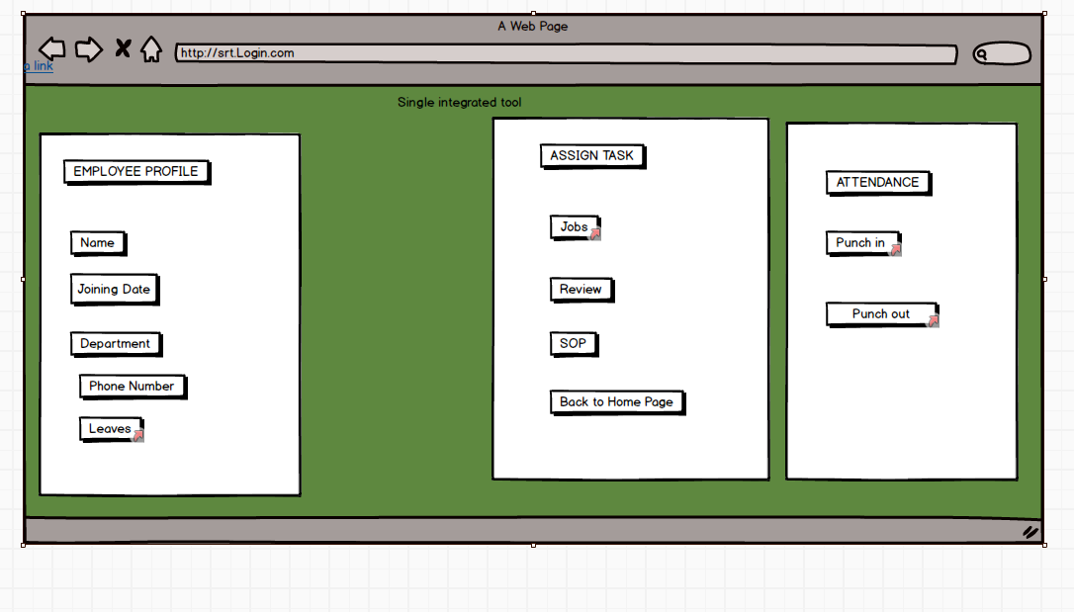
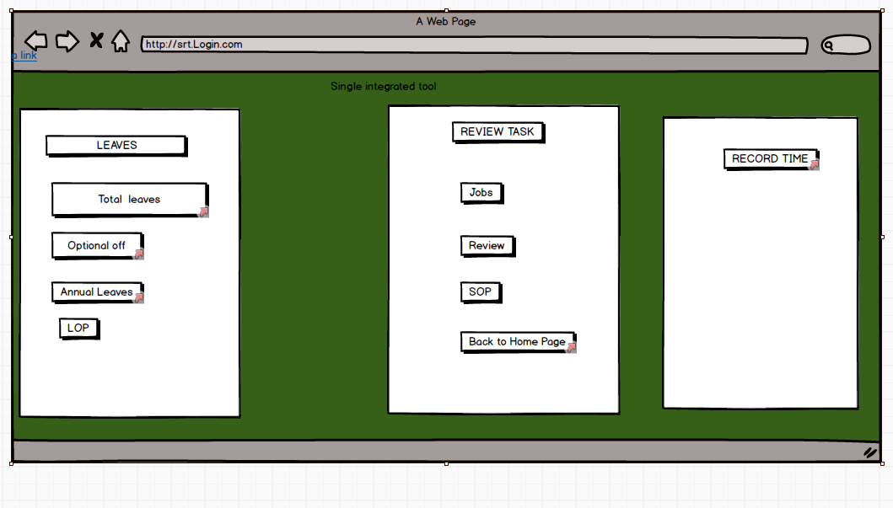

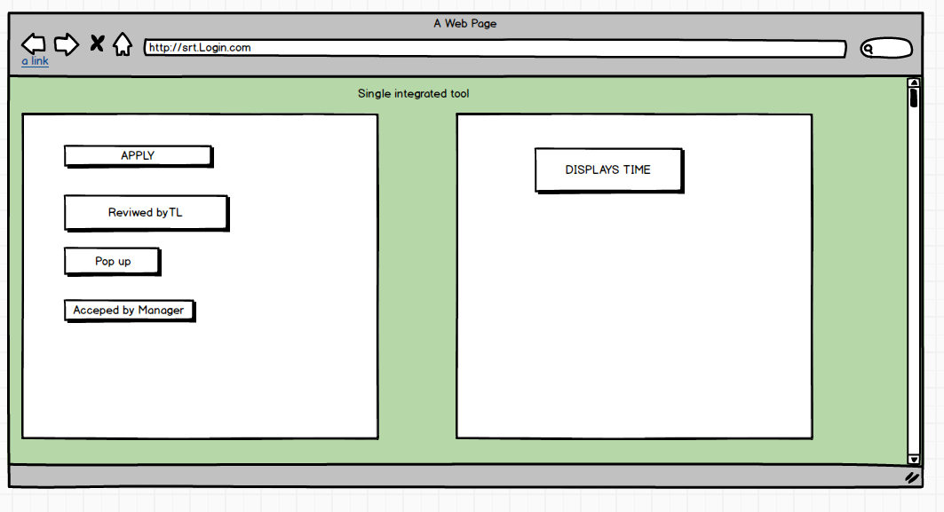

PROTO TYPES:

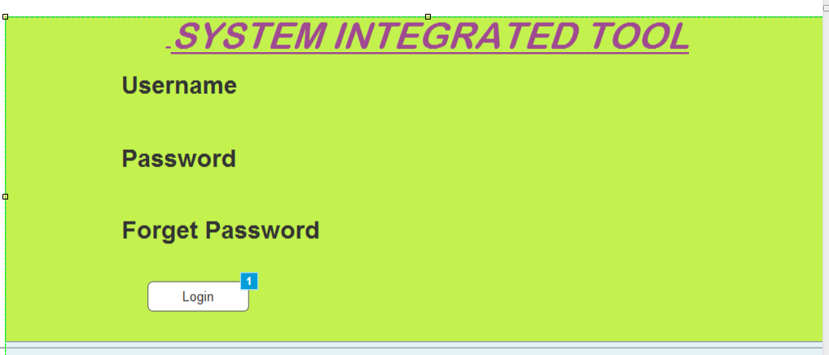

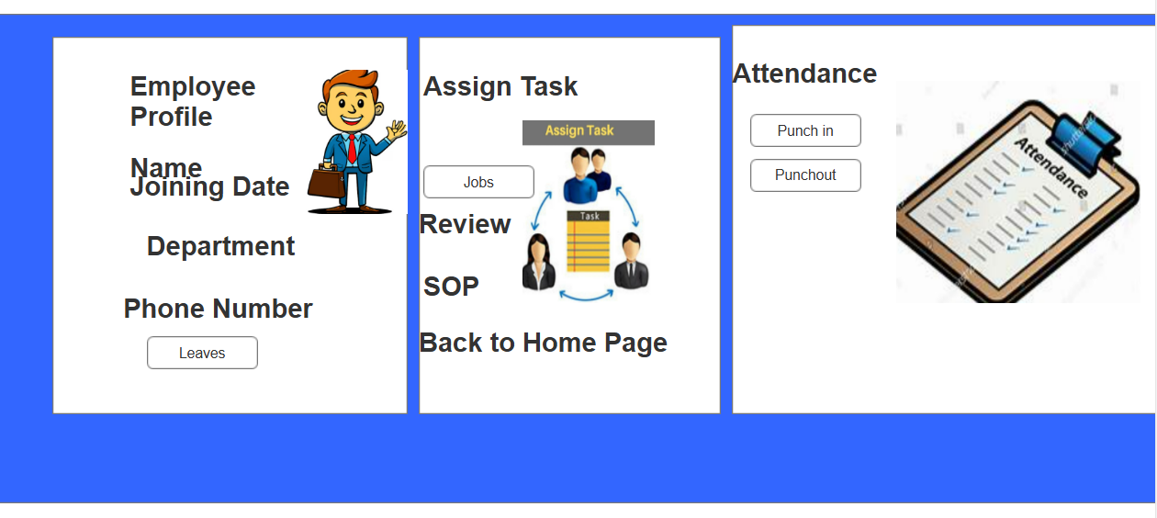

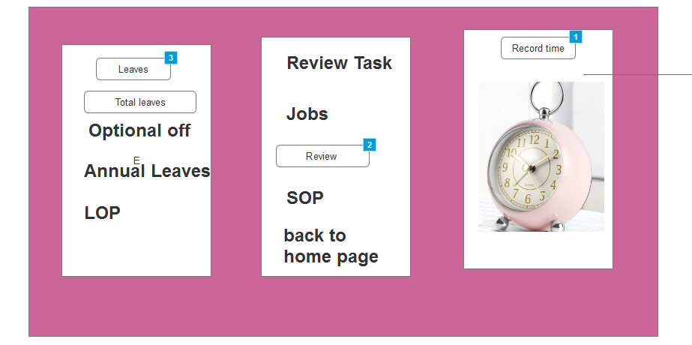

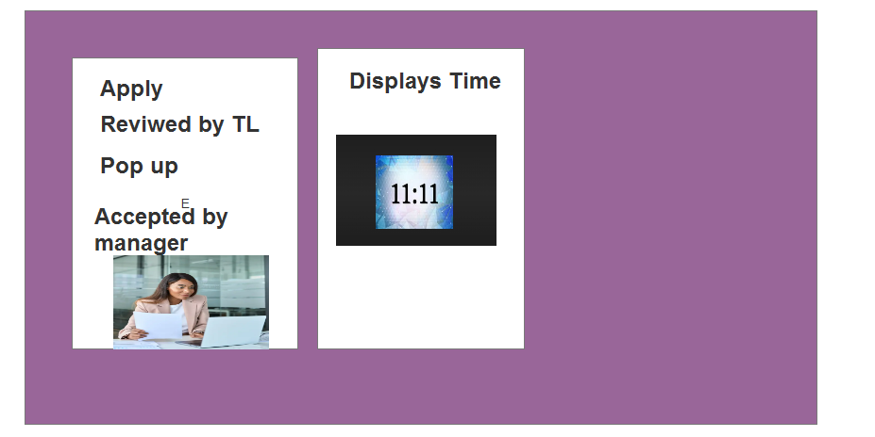

DOCUMENT 8- TOOLS-VISIO AND AXURE

Write a paragraph on your experience using Visio and Axure for the project.
For this project, I used Visio to create process flow diagrams, use case diagrams, and system workflows that clearly illustrated the employee details, attendance, task assignment, and leave approval processes. Visio helped in simplifying complex workflows and communicating them effectively to stakeholders. I also used Axure to build interactive prototypes of the portal, showcasing features like punch in/out, task assignment, and leave request approval. This gave stakeholders a hands-on view of the system’s functionality before development, ensuring alignment and reducing rework. Together, these tools enhanced clarity, improved collaboration, and supported smooth requirement validation..

DOCUMENT 9- BA EXPERIENCE

My Experience as a BA in the Project (Waterfall Model Phases)
- Requirement Gathering & Analysis
  - Conducted stakeholder meetings to understand needs.
  - Documented functional and non-functional requirements.
  - Defined business problems and identified key features (employee details, attendance, task assignment, leave).
- System Design
  - Created use case specifications and process flow diagrams in Visio.
  - Built interactive prototypes in Axure for early visualization.
  - Ensured requirements were mapped to solution design.
- Implementation
  - Collaborated with developers to clarify requirements.
  - Ensured correct translation of requirements into features.
  - Supported development by answering queries and refining details.
- Testing
  - Helped QA team with test case validation.
  - Maintained a Requirement Traceability Matrix (RTM).
  - Verified system features against business requirements.
- Deployment & Maintenance
  - Assisted in user training and onboarding.
  - Supported change management to ease adoption.
  - Gathered feedback for future enhancements.

