Nurturing Process - Capstone Project1 – Part -3/3 V2D2 Aug 2024
COEPD – Traditional Development
Capstone Project1 – Part -3/3 – 100 Marks - Pass 60 %
12 Questions
Instructions to follow:
1. Copy paste (either image, diagram or text) is not entertained. If done, the document will not be evaluated.
2. After submission of the answers of this prep exam, You should be prepared to attend viva and justify your answers in the prep exams. If in Viva, participant is NOT justifying the answers, Viva will be repeated until Candidates justify 60% correctness.
3. Mentor calls are scheduled only if the participant have submitted their task at least for one time.
(should apply their knowledge in this task first)
4. For attempting prep exams participant should be thorough on the topics using their references.
5.Please format the document properly (Always have a question no., question and answer).
6. Have a consistent format (Font name: Arial/ Calibri -Font size 12, Font Color: Black ).
7. Few Questions are related to the case study, check Questions thoroughly before you answer.
8.Answers should be elaborated in detail(*not as per the allotted marks).
9.Please focus on learning and applying the knowledge as this knowledge will be helpful in
contributing at your BA job.
10. In the evaluation, students must answer all questions and should be able to justify at least 60% content and correctness of each answer.

Online Agriculture Products Store

Mr. Henry, after being successful as a businessman and has become one of the wealthiest persons
in the city. Now, Mr. Henry wants to help others to fulfil their dreams. One day, Mr. Henry went to
meet his childhood friends Peter, Kevin and Ben. They live in a remote village and do farming. Mr.
Henry asked his friends if they are facing any difficulties in their day-to-day work.

Peter told Mr. Henry that he is facing difficulties in procuring fertilizers which are very important for
farm. Kevin said that he is also facing the same problem in-case of buying seeds for farming certain
crops. Ben raised his concern on lack of pesticides which could help in greatly reducing pests in
crops.

After listening to all his friends’ problems, Mr. Henry thought that this is a crucial problem faced not
only by his friends but also by so many other farmers. So, Mr. Henry decided to make an online
agriculture product store to facilitate remote area farmers to buy agriculture products. Through this
Online Web / mobile Application, Farmers and Companies (Fertilizers, seeds and pesticides
manufacturing Companies) can communicate directly with each other.

The main purpose to build this online store is to facilitate farmers to buy seeds, pesticides, and
fertilizers from anywhere through internet connectivity. Since new users are involved, Application
should be user friendly.

This new application should be able to accept the product (fertilizers, seeds, pesticides) details from the manufacturers and should be able to display them to the Farmers. Farmers will browse through these products and select the products what they need and request to buy them and deliver them to
farmers location.

Mr. Henry has given this project through his Company SOONY. In SOONY Company, Mr Pandu is
Financial Head and Mr Dooku is Project Coordinator. Mr. Henry , Mr Pandu , and Mr Dooku formed
one Committee and gave this project to APT IT SOLUTIONS company for Budget 2 Crores INR and
18 months Duration under CSR initiative. Peter, Kevin and Ben are helping the Committee and can
be considered as Stakeholders share requirements for the Project.

Mr Karthik is the Delivery Head in APT IT SOLUTIONS company and he reached out to Mr Henry
through his connects and Bagged this project. APT IT SOLUTIONS company have Talent pool
Available for this Project. Mr Vandanam is project Manager, Ms. Juhi is Senior Java Developer, Mr
Teyson, Ms Lucie, Mr Tucker, Mr Bravo are Java Developers. Network Admin is Mr Mike and DB
Admin is John. Mr Jason and Ms Alekya are the Tester. And you joined this team as a BA.

Your Team
Project Manager - Mr Vandanam Senior
Java Developer - Ms. Juhi
Java Developers - Mr Teyson, Ms Lucie, Mr Tucker, Mr Bravo
Network Admin - Mr Mike
DB Admin - Mr John.
Testers - Mr Jason and Ms Alekya
BA - You

Fertilizers, seeds, pesticides details from the manufacturers and should be able to display them to the Farmers.
To gather the business requirements from the client, you went to SOONY and met Mr. Henry. When Mr. Henry was asked about the project and what are they expecting from the project, Mr. Henry stated that he is expecting to have a login for all its users (fertilizers, seeds, pesticides manufacturers and Farmers) , a product catalog of fertilizers, seeds, pesticides, a search option to search for products, payment process, and delivery tracking.
After doing the stakeholder analysis, you have found out that Peter, Kevin, Ben are the key stakeholders and you have scheduled an appointment to meet them. After meeting with them and trying to gather the stakeholder requirements, Kevin said that, a Farmer should be able to browse through the products catalog once they visit the website and need to have a search option so that they can search for any product they need. Peter said that, if a farmer wants to buy any product or add them to buy-later list, they need to login first using their email id and password. If it is a new user, then they can create a new account by submitting their email ID and creating a secure password. Ben added saying that, Farmers needs to have an easy-to-use payment gateway which should include cash-on-delivery (COD), Credit/Debit card and UPI options so that the user’s experience should be better. Kevin mentioned that, a user gets an email confirmation regarding their order status. A delivery tracker to track the whereabouts of their order.
Identify Business Requirements (which includes Stakeholder Requirements)
BR001 – Farmers should be able to search for available products in fertilizers, seeds, pesticides
BR002 – Manufacturers should be able to upload and display their products in the application
Make suitable Assumptions and identify at least 10 Business Requirements.
List your assumptions
Give Priority 1 to 10 numbers ( 1 being low priority – 10 being high priority) to these Requirements after discussions with the stakeholders.
Req ID | Req Name | Req Description | Priority
BR001 | Farmer Search for Products | Farmers should be able to search for available  products in fertilizers, seeds, pesticides | 8
BR002 | Manufacturers  upload their  Products | Manufacturers should be able to upload and display their products in the application | 8

Once the requirements are finalized, as a business analyst, one of the major roles is to act as a liaison between the client and the project team. To gather the requirements correctly from the client side and then to deliver those requirements to the project team in a way they understand.
To make the project team understand the requirements, you need to convert those requirements into UML diagrams and screen mock-ups.
You will draw use case diagram
Prepare use case specs for all use cases
And you will all Activity diagrams required
Question 1 – Functional Requirements - 15 Marks
Identify minimum 20 functional requirements
Example:
Functional requirement: When an order is fulfilled, the local printer shall print a packing slip.
Non-Functional Requirement: Packing slips shall be printed on both sides of 4”x 6” white paper, the
standard size for packing slips used by local printers.
Req ID | Req Name | Req Description | Priority
FR0001 | Farmer Registration | Farmers should be able to register with the application | 8
FR0002 | Farmer Search for Products | Farmers should be able to search for available products in fertilizers, seeds, pesticides | 8
NFR0101 | Page Loading Time | Each Page should load within 2 seconds time | 9
NFR0102 | WCAG 2.1. | The system must meet Web Content Accessibility Guidelines WCAG 2.1. | 8

Answer:
Req ID | Functional Requirement | Description / Details
FR-01 | User Registration | System shall allow Farmers and Manufacturers to register using a valid email ID and secure password.
FR-02 | Secure Login/Logout | System shall provide secure login and logout functionality for all registered users.
FR-03 | Password Reset | System shall allow users to reset their password through email-based verification.
FR-04 | Role-Based Access | System shall differentiate roles (Farmer, Manufacturer, Admin) and grant permissions accordingly.
FR-05 | Profile Update | System shall allow users to view and update personal or business profile details (name, address, contact number).
FR-06 | Product Upload | System shall allow manufacturers to add, edit, and delete product listings including name, category, price, quantity, description, and images.
FR-07 | Product Display | System shall present a categorized catalog of all active products to farmers for browsing.
FR-08 | Advanced Search | System shall enable farmers to search products by keywords, category, brand, and price range.
FR-09 | Product Details View | System shall display detailed product information (price, stock availability, manufacturer details) when a farmer selects a product.
FR-10 | Shopping Cart | System shall allow farmers to add products to a cart and modify quantities before checkout.
FR-11 | Wishlist / Buy Later | System shall allow farmers to save products to a wishlist or “buy-later” list.
FR-12 | Order Placement | System shall capture delivery address and confirm orders after successful payment or COD selection.
FR-13 | Order Confirmation Email | System shall send an automated email to the farmer confirming order details and expected delivery date.
FR-14 | Multiple Payment Options | System shall support Cash-on-Delivery (COD), Credit/Debit Card, and UPI/Net-banking transactions.
FR-15 | Secure Payment Gateway | System shall process online payments through a PCI-DSS compliant, SSL-encrypted gateway.
FR-16 | Delivery Scheduling | System shall record delivery address and generate an estimated delivery timeline.
FR-17 | Real-Time Tracking | System shall allow farmers to track the status of their order (Packed, Shipped, Out for Delivery, Delivered).
FR-18 | Delivery Notifications | System shall send email/SMS updates when the order status changes.
FR-19 | User & Product Management (Admin) | Admin shall be able to activate/deactivate user accounts, approve or remove product listings, and monitor transactions.
FR-20 | Reporting & Analytics | System shall generate downloadable reports on sales, inventory, and user activity for the Admin.

Req ID | Non-Functional Requirement | Description / Details
NFR-01 | Performance | The system shall handle at least 10,000 concurrent users with page load times under 3 seconds.
NFR-02 | Scalability | The system shall support future expansion to additional product categories and regions without major changes to architecture.
NFR-03 | Availability | The system shall be available 99.5% of the time, with planned maintenance communicated to users.
NFR-04 | Security | The system shall implement SSL encryption for all data transmissions and comply with PCI-DSS standards for payments.
NFR-05 | Data Privacy | The system shall ensure user data is stored securely and comply with relevant data protection laws (e.g., Indian IT Act).
NFR-06 | Usability | The system shall provide an intuitive, easy-to-use interface for farmers with limited technical experience.
NFR-07 | Compatibility | The system shall be compatible with modern browsers (Chrome, Firefox, Edge) and mobile devices (iOS and Android).
NFR-08 | Reliability | The system shall ensure accurate processing of orders, payments, and delivery tracking without data loss.
NFR-09 | Maintainability | The system shall allow developers to update features, fix bugs, or add new modules with minimal downtime.
NFR-10 | Backup & Recovery | The system shall perform automatic daily backups and provide recovery within 24 hours in case of failure.
NFR-11 | Response Time | The system shall respond to user actions (search, add to cart, checkout) within 2–3 seconds under normal load.
NFR-12 | Error Handling | The system shall provide clear error messages for failures and log errors for administrator review.
NFR-13 | Auditability | The system shall maintain a complete audit trail of all user activities, including orders, payments, and product uploads.
NFR-14 | Localization | The system shall support multiple languages if required in future releases.
NFR-15 | Accessibility | The system shall comply with accessibility standards (WCAG 2.1) to accommodate users with disabilities.
NFR-16 | Transaction Integrity | The system shall ensure all transactions are processed with ACID compliance to prevent data inconsistency.
NFR-17 | Logging & Monitoring | The system shall log system performance metrics and errors and send alerts for critical issues.
NFR-18 | Session Management | The system shall automatically log out users after 15 minutes of inactivity to ensure security.
NFR-19 | Deployment | The system shall support deployment in cloud or on-premise environments as required by the organization.
NFR-20 | Compliance | The system shall comply with regulatory and legal requirements for e-commerce platforms and digital payments in India.

Question 2–Minimum 5 page designs - 15 Marks

Make wireframe and prototypes

Answer: Balasmiq – wireframe as follows.
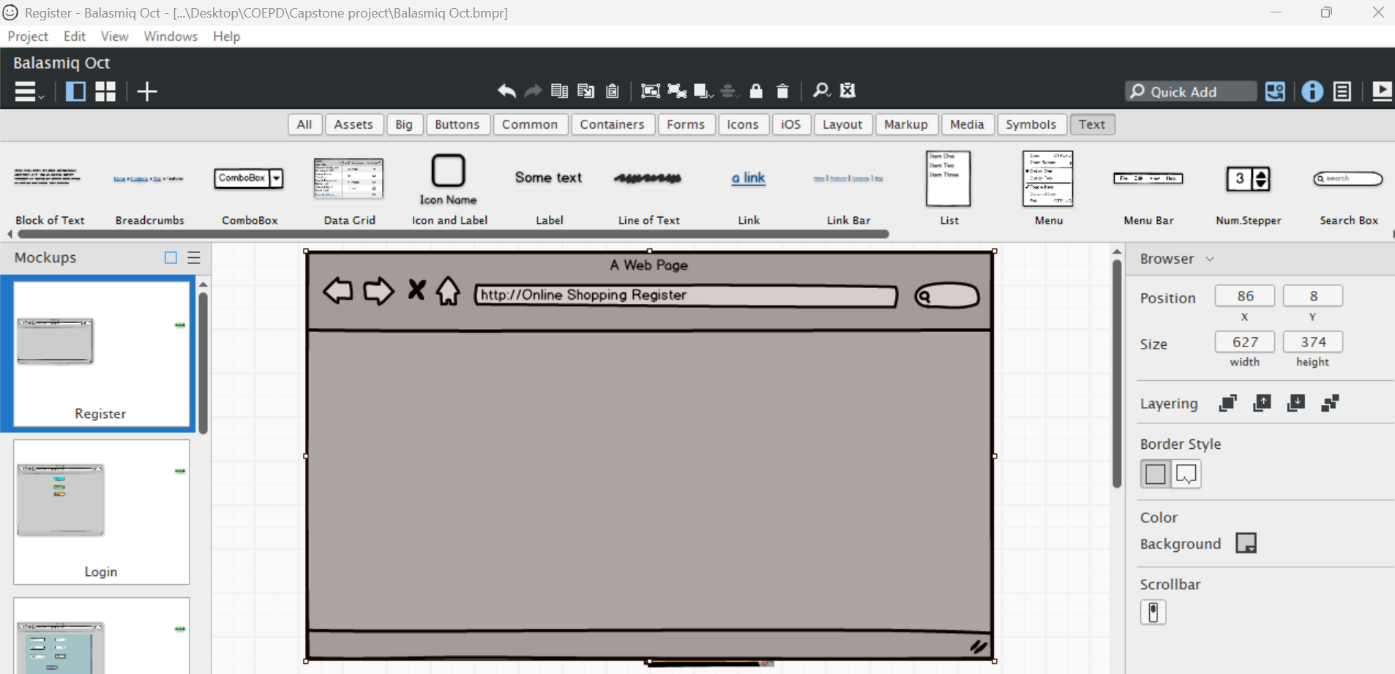

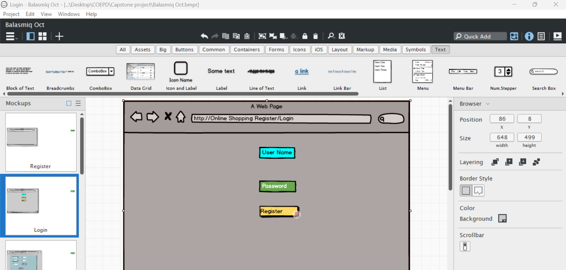
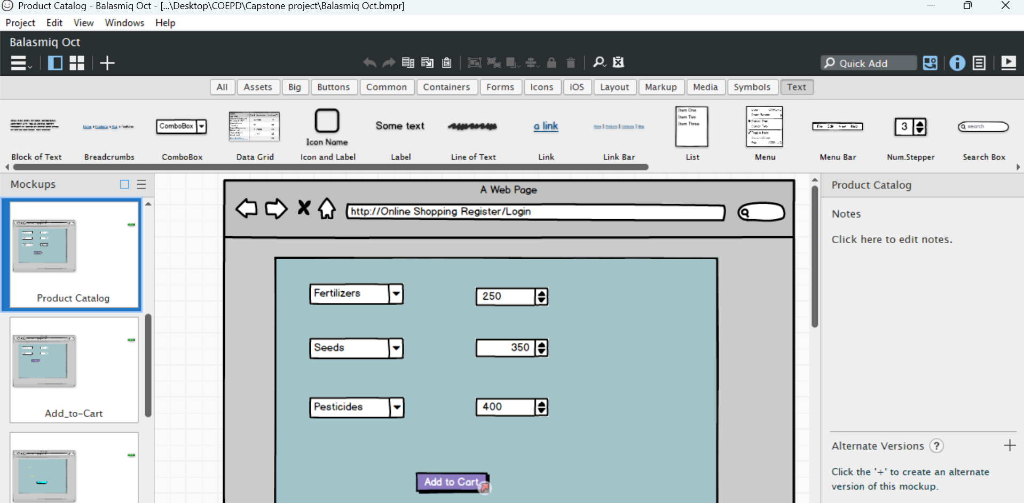
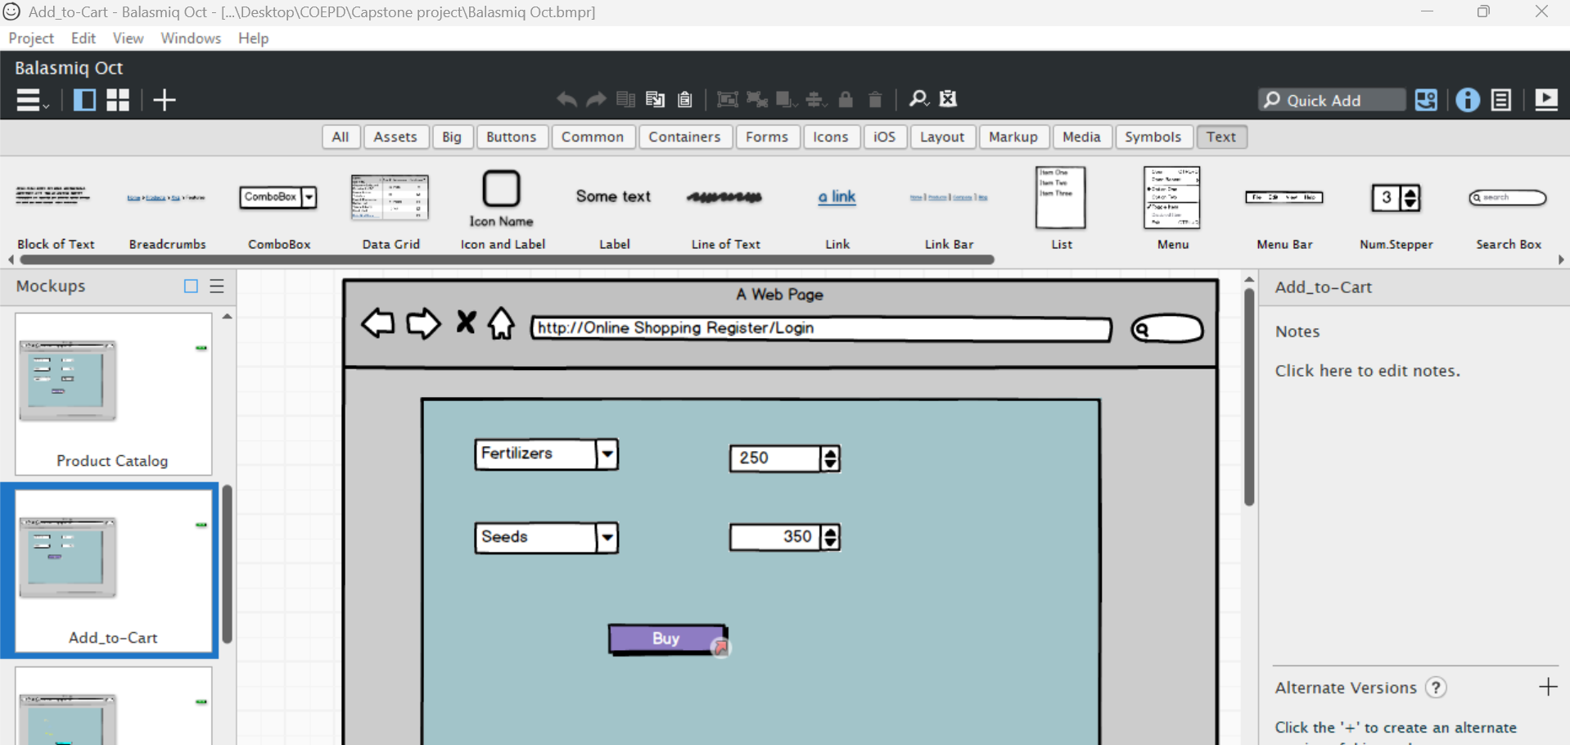
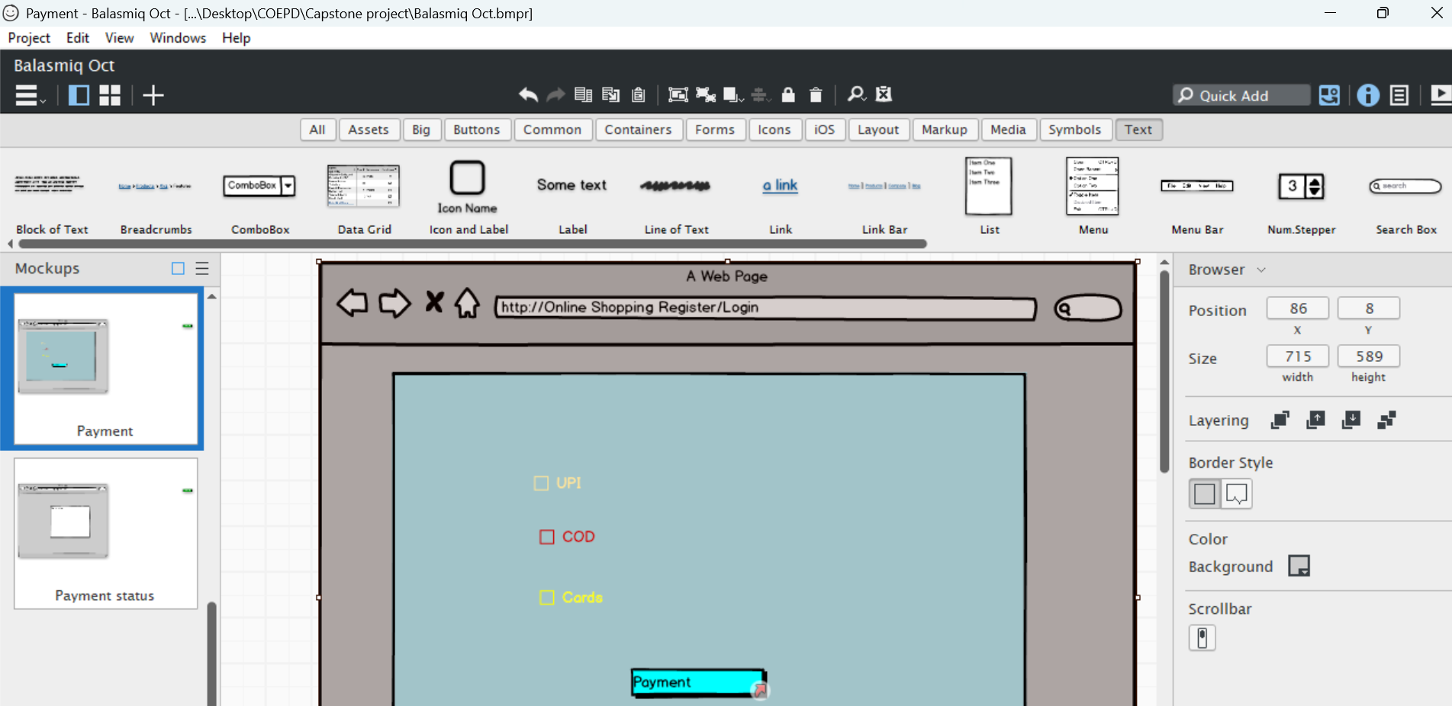
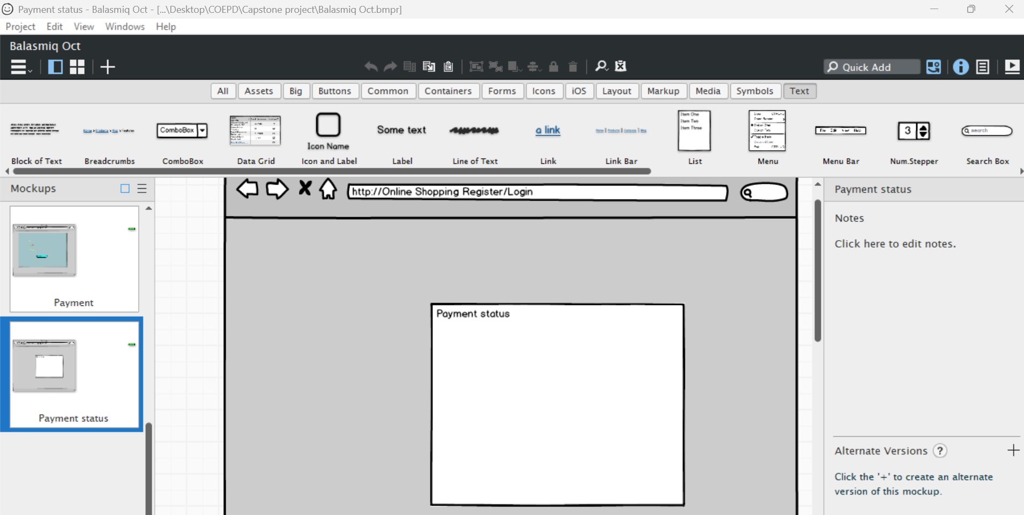
Axure RP : Prototypes as follows.

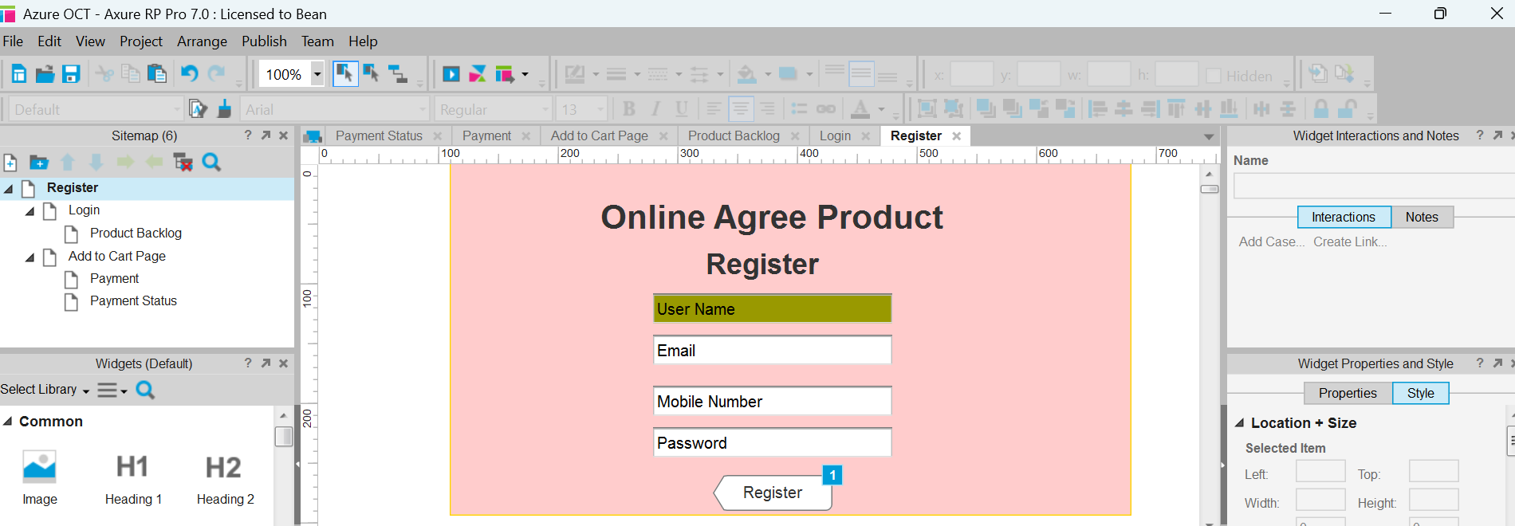

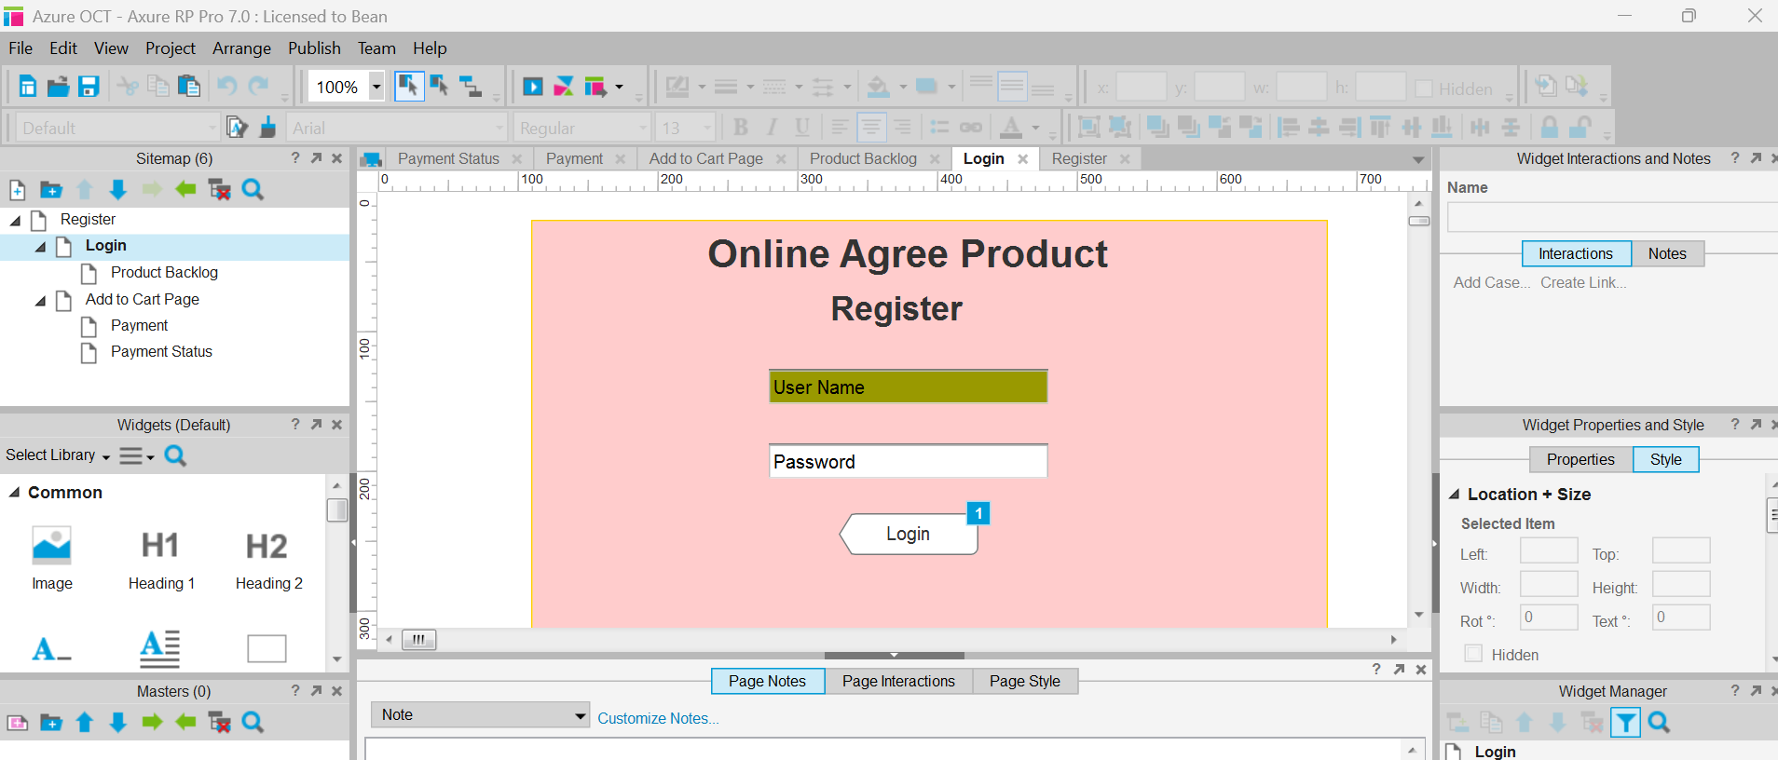
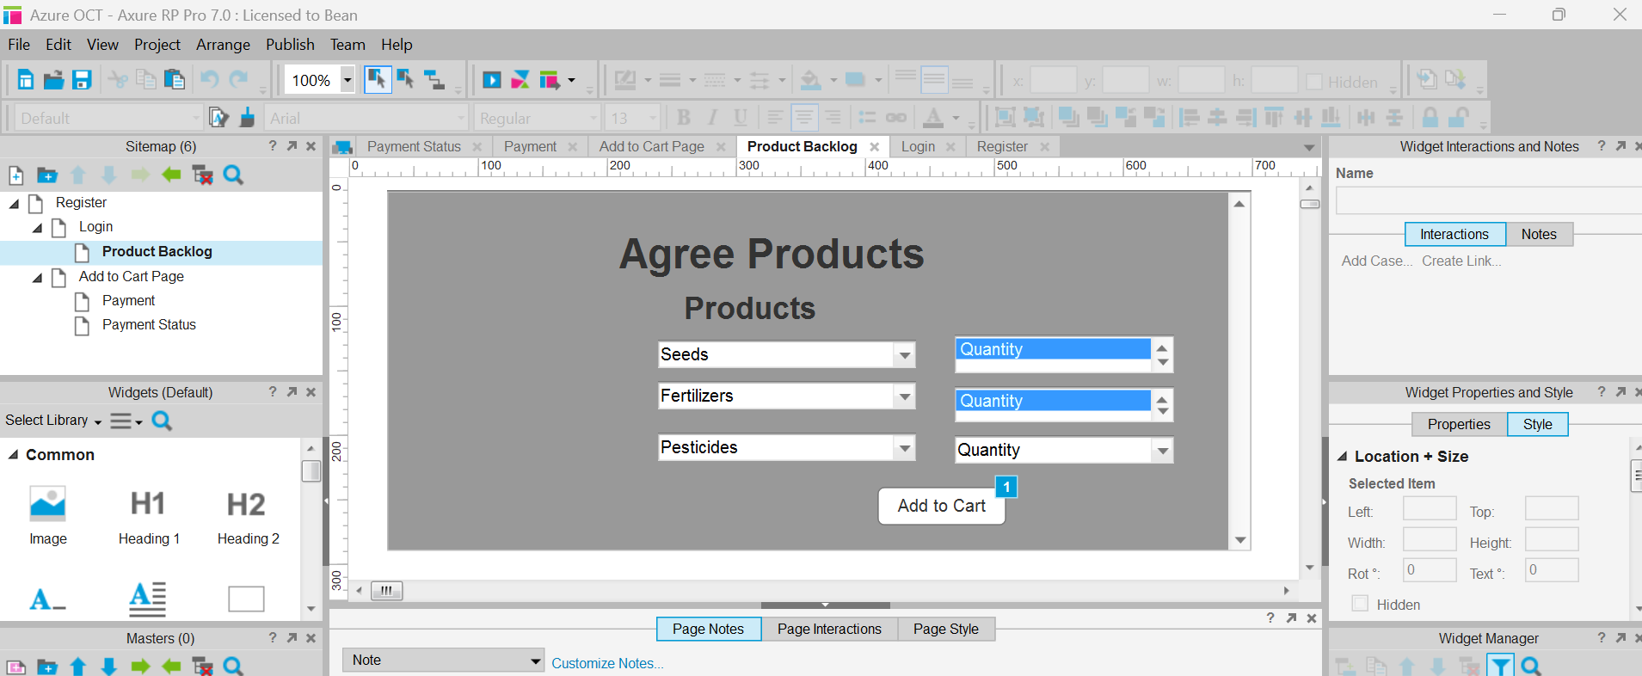

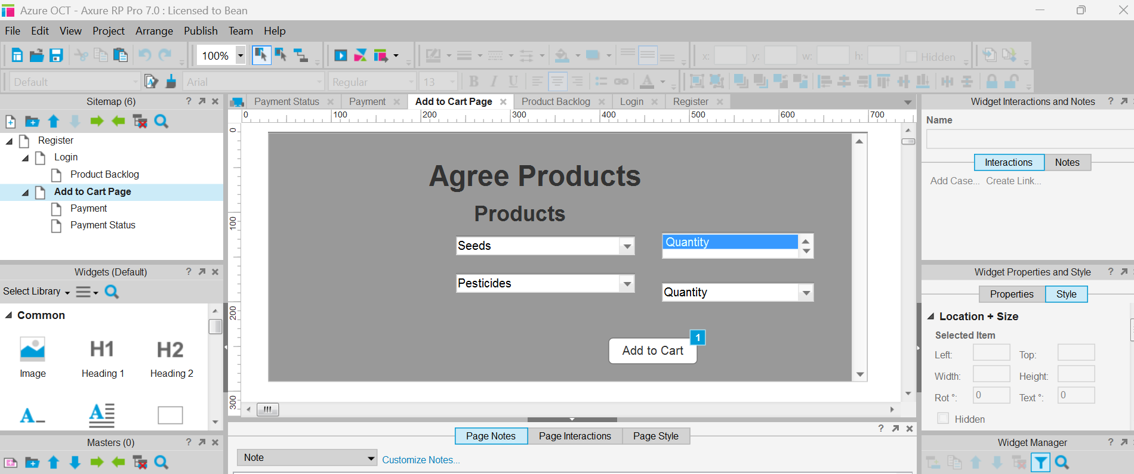
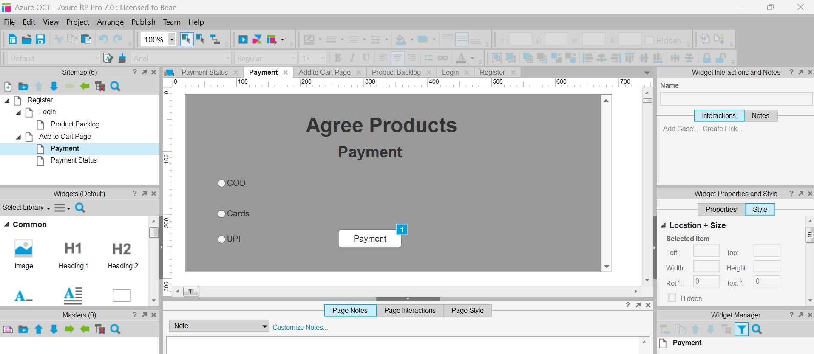
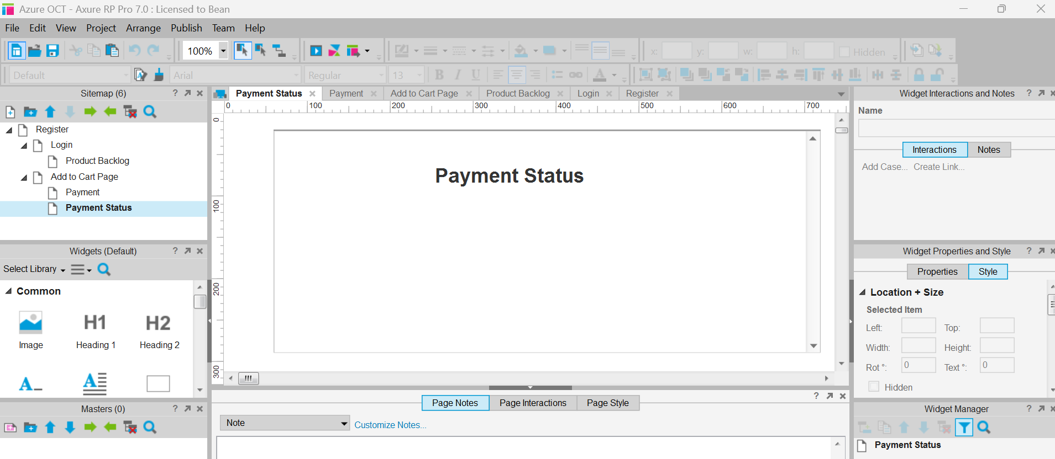

Question 3 – Tools (Visio, Balsamiq) - 15 Marks
Make a note of the Tools, which you are using for above concepts.
Answer :
Balsamiq Tool:
- Balsamiq studio is founded in March 2008 by Peddy Guilizzoni a former Adobe senior Software engineer.
- Balsamiq is used to create Web and Mobile Application user interface design tool for creating wireframes/mock-ups (drag and drop tool).
- Wireframe is a raw visual representation of the website or app design. It is like a blueprint.
- Wireframing helps the stakeholders to explain their requirements effectively of the system.
- A Mockup design is an improved version of the wireframe and it shows how the future system will look like.
MS Visio Tool:
- MS Visio is a diagramming and visualization tool used to create Flowcharts, Process maps, Organizational charts, UML diagram.
- MS Visio used for Process modelling for to create AS IS and TO BE process maps to understand and improve workflows.
- MS Visio used requirement visualization to convert requirement into Visual diagram like flowchart.
- It’s a system design and analysis to draw system architecture diagram, data flow diagrams and UML models.

Question 4 – RTM - 6 Marks
A business analyst’s key responsibilities are to keep track of the requirements and make sure that no requirement is missed.
Mr. Henry and peter have approached you regarding the current status of the project. How will you tackle this situation?
Answer:
RTM – It is a document to track the requirements throughout the project lifecycle, ensuring that they are met and that no requirements are overlooked.
Step 1: Review the RTM (Requirement Traceability Matrix)
I would present the updated RTM (Requirement Traceability Matrix) to show the current progress of each requirement across different stages — Design, Development (D1), Testing (T1), System Integration Testing (SIT), and User Acceptance Testing (UAT).

Step 2:
Prepare RTM:
Req ID | Req Name | Req Description | Design | D1 | T1 | SIT | T4 | UAT | Status Summary
FR0001 | Farmer Registration | Farmers should be able to register with the application | Complete | Complete | Complete | Complete | Complete | Incomplete | UAT pending – issue under testing
FR0002 | Farmer Search for Products | Farmers should be able to search for available products (fertilizers, seeds, pesticides) | Complete | Complete | Complete | Incomplete | Incomplete | Incomplete | SIT not completed due to integration bug
NFR0101 | Page Loading Time | Each page should load within 2 seconds | Complete | Complete | Complete | Incomplete | Incomplete | Incomplete | Performance testing pending
NFR0102 | WCAG 2.1 Compliance | The system must meet web accessibility standards (WCAG 2.1) | Complete | Complete | Complete | Incomplete | Incomplete | Incomplete | Accessibility testing not started

Step 3: Communicate Findings:

I would inform Mr. Henry and Peter that:
- All design and initial development phases are completed successfully.
- Testing and UAT are in progress, with some requirements pending due to integration and performance issues.
- The next steps will include defect fixing, regression testing, and final UAT validation.

Step 4: Action Plan

1. Coordinate with the development team to resolve issues in FR0002 and NFR0101.
2. Ensure UAT scripts are ready and users are scheduled for testing.
3. Update the RTM regularly to reflect the latest status for transparency.
4. Conduct a review meeting with stakeholders to align timelines.

Question 5 – 10 Test Case Documents - 10 Marks
Prepare 10 Test Case Documents:
Answer:
- A test case document is a detailed outline used by testers to ensure that a software application or system is working as expected.
- Test case document prepared by testing team.
- BA will tracking this test case documents.

Test cas ID | TC001 | Test case Name | FARM App Devps
Project ID | FARMAPP001 | Project Name | Online Shopping Application
PM ID | FARMAPP00CB | PM Name | XYZ
Test strategy ID | FARMAPPACH | Tester ID | TC001A
Test Plan ID | ABC001 | Tester Name | XYZAB
Test Schedule ID | ABC | Date of Test | 04-Oct-25
Scenario | Search for Product
Link to that Page
Test Case ID | Test Scenario | Test Case Description | Pre-Condition | Test Steps | Expected Result | Actual Result | Status (Pass/Fail)
TC001 | Farmer Registration | Verify that a new farmer can successfully register on the portal | Farmer not registered | 1. Open registration page  2. Enter all required details  3. Click on ‘Register’ | Farmer registration successful message displayed
TC002 | Farmer Login | Verify that a registered farmer can log in successfully | Farmer registered with valid credentials | 1. Open login page  2. Enter valid username and password  3. Click on ‘Login’ | Farmer dashboard displayed
TC003 | Invalid Login | Verify that login fails with incorrect password | Farmer registered | 1. Enter valid username and invalid password  2. Click on ‘Login’ | Error message displayed – “Invalid credentials”
TC004 | Product Search | Verify that farmer can search for available products | Products available in database | 1. Enter product name in search bar  2. Click on ‘Search’ | Relevant product list displayed
TC005 | Product Details | Verify that farmer can view product details | Product listed | 1. Click on any product name | Product details page displayed correctly
TC006 | Add Product (Manufacturer) | Verify that manufacturer can add new products | Manufacturer logged in | 1. Go to ‘Add Product’ page  2. Fill details  3. Upload image  4. Click ‘Submit’ | Product successfully added and pending admin approval
TC007 | Approve Product (Admin) | Verify that admin can approve new products | Product added and pending approval | 1. Login as Admin  2. Go to pending product list  3. Approve product | Product status changes to “Approved”
TC008 | Purchase Product | Verify that farmer can purchase a product | Farmer logged in and product available | 1. Select product  2. Add to cart  3. Proceed to checkout  4. Confirm order | Order placed successfully
TC009 | Payment Gateway | Verify that payment gateway works correctly | Farmer has valid card details | 1. Enter payment details  2. Click on ‘Pay Now’ | Payment successful confirmation displayed
TC010 | View Order History | Verify that farmer can view past orders | Farmer logged in and has previous orders | 1. Navigate to ‘Order History’ | List of previous orders displayed

Question 6 – DB Design – 8 Marks
After the requirements are thoroughly explained to the entire project team by business analyst, the Database architects have decided to do the database design and also to represent the in-flow and out-flow of data.
Draw database schema and ER diagram
Answer : database schema and ER diagram
Database schema

Question 7 – Data Flow Diagram - 3 Marks
What is a data flow diagram? Draw a data flow diagram to represent the in-flow and out-flow of data when a Farmer is placing an order for the product.
Answer :
Data Flow Diagram:
- (DFD) Data Flow Diagram is a graphical Representation of the flow of data within a system. It visually shows how data moves from on process to another, How it’s stored, and where it ends up.
- It helps analyst and designers understand the flow of data within a system, identify potential bottlenecks or inefficiencies and communicate system requirements to stakeholders.

Question 8 – Change Request - 10 Marks
Due to change in the Government Taxation structure. We should change the Tax structure
How do you handle change requests in a project?
Answer:
- A change request is a formal proposal to alter system, Product or Project.
- Understand the scope of change request and document the change request.
- Do the impact analysis- Project scope, Schedule, Budget, resources and risks.
- Prioritize the change request based on its urgency, Importance, Impact on project.
- Seek approval from project sponsor for the change request.
- Communicate the change request and its potential Impacts to all relevant stakeholders including project team.
Steps to Handle a Change Request in a Project

1. Identify and Document the Change

- The trigger: Government updates the taxation policy.
- As a Business Analyst, document:
- The source of change (Government circular or notification)
- The impacted areas (modules, reports, calculations)
- The urgency and effective date of change
- Output: Change Request Form / Change Request Document (CRD)

2. Log the Change Request

- Enter the CR in the Change Request Register / Tracker.
- Assign a unique CR ID.
- Record details like: Description of change
- Date raised
- Requested by (Business / Compliance Team)
- Impacted system / process

3. Impact Analysis (by BA & Technical Team)

- Business Impact: Which business rules and processes are affected?

- System Impact: Which modules, interfaces, or reports need changes?

- Timeline Impact: Will it delay ongoing development or testing?

- Cost Impact: Any increase in budget or resource requirement?

4. Review & Approval

- Present the CR and impact analysis to:

- Project Manager

- Sponsor / Change Control Board (CCB)

- Compliance or Finance (if required)

They decide whether to:

- Approve

- Reject

- Defer the change

Output: Approved / Rejected Change Request

- 5. Update Project Plan

- If approved:

- Update:

- Project scope

- Schedule (add new tasks)

- Budget (if applicable)

- Documentation (BRD, FRD, SRS, RTM)

6. Implement the Change

- Developers modify tax calculation logic.

- QA team performs testing (unit, integration, UAT).

- Business validates new tax rates as per government rule.

8. Closure

- Once verified and deployed successfully:

- Update Change Request status to “Closed”.

Question 9 – Change Request Vs an Enhancement - 5 Marks
As the project is in process, Ben and Kevin have contacted you. The reason is to inform you that they want the Farmers to sell their crop yields through this application i.e. Farmers should be able to add their crop yields or products and display to general public and should be able to sell them. They also want to introduce Auction system for their Crop yields. As a BA, what will be your response?
Is this a change request or an enhancement???
Answer:
In this case, adding Crop yields or product and display to general public in application would be considered Enhancement as it involves adding new features to the system.
As a Business analyst you should document the requirements and work with the development team to determine the feasibility and impact of the new features. You should also consider the potential benefits, risks and costs associated with the enhancement before making any recommendations to the client.

Question 10 – Estimations - 6 Marks
Come up with estimations – How many Manhours required.
Answer:
- Man hours the required efforts of the resources to complete the project. There are three types of projects:
- Small: UPto 500 Hours
- Medium : Upto 1000 Hours
- Large: Upto 1500 Hours
Anlysis:
- Estimated Man-Hours (for 11 Members, 18 Months)

- Total Working Hours per Month (per person): 160 hrs

- Total for 11 Members (per month): 1,760 hrs

- Total for 18 Months: 1,760 × 18 = 31,680 Man-Hours (approx.)

Role Allocation % Estimated Hours

Project Manager 10% 3,168 hrs
Business Analyst 10% 3,168 hrs
UI/UX Designer 10% 3,168 hrs
Frontend Developers 25% 7,920 hrs
Backend Developers 25% 7,920 hrs
DBA 5% 1,584 hrs
QA Testers (2) 10% 3,168 hrs
DevOps Engineer 5% 1,584 hrs
Total 100% 31,680 hrs

Question 11 – UAT – 6 Marks
Project has finally completed all the stages i.e., design, development, testing etc. Now, it is the role of a business analyst to contact the client for testing of the final product and have to successfully complete it. How are you going to handle this situation? And once it is done, what will be the process to close the project?
Explain UAT Acceptance process
Answer:
- Planning : In this step, Blue Prints are made to implement UAT testing for every feature that needs to test and minimum standards for accepting the test.
- Designing : Here the test cases are designed to hide all the possibilities of software packages in a real world environment.
- UAT Testers : A testing team consists of a end users that meet the criteria for implementing testing. They should know the test cases to run and understand functionalities.
- Bug Fixing : Whatever Bugs are found in the UAT testing, the development team should work on them and make it software error free.
- Sign off : After removing all the bugs, the testing team indicates Acceptance of the completion of the bugs. In this phase, all stakeholders come to a conclusion that the software is ready to GO LIVE and sign it off.

Question 12 – Project Closure Document - 6 Marks
Explain Project closure document
Answer :
- A Project closure document, also known a project closure report is a formal document that summarizes the key outcomes, lessons learned and final details of a completed project.
- It serves as a comprehensive record of the projects accomplishments, challenges and overall performance, providing valuable insights for stakeholders and future projects.

Points to be included into Project closure documents are:

- Project overview

- Achievements

- Lessons Learned

- Quality assurance

- Resource Utilization

- Risk Management

- Challenges

Sr. No. | Points to Include | Details | Ref Link
1 | Did the Client Sign off on the UAT Testing |  | Business Scope Docs.docx
 | Date of Sign off | 10-Oct-25
 | Name of the resource | Mr. Dinesh
2 | Objective of the Project
 | User Friendliness | Achieved
 | Customer Satisfaction | ROI in 12 Months
 | More Categories | Achieved
3 | Functionalities worked on
 | Secure Payment processing | Achieved
 | Crops Purchased | Achieved
4 | Infrastructure
 | Software Purchased | Achieved
5 | Funding |  | Finance Breakdown.docx
 | Amount Approved | 2 Crores | Finance Breakdown.docx
 | Amount used | 1.5 Crores | Finance Breakdown.docx
6 | Overall Project information
 | Escalations | 50
 | Customer Satisfaction | High
7 | Value of the company
 | Positive/Negative | Positive 90%
 | Positive/Negative | Increased Clients
 | Positive/Negative | Trained staff
 | Positive/Negative | New Project in Pipeline

