- Identify minimum 20 functional requirement.
Functional requirements define the specific behaviour, functions, or operations of a system. They describe what system should do, outlining the necessary task, actions or activities it must perform to achieve its objectives.

Req ID | Req Name | Req Description | Priority
FR001 | Farmer Registration | The system shall allow farmers to register and create their profile. | 8
FR002 | Manufacturer Registration | The system shall allow manufacturers to register. | 8
FR003 | Product Search | The system shall provide product search with filters such as category and price. | 8
FR004 | Product Details View | The system shall display detailed product information to users. | 8
FR005 | Add to cart | User should be able to add product to cart. | 9
FR006 | Wishlist management | User should be able to manage their Wishlist, including adding or removing the products. | 6
FR007 | Shopping Cart | The system shall provide a shopping cart to add, update, or remove products. | 9
FR008 | Online Payment | The system shall enable secure payments via cards, UPI, and net banking. | 9
FR009 | Order Confirmation | The system shall generate an order confirmation after payment. | 9
FR010 | Order Tracking | The system shall allow users to track their orders in real-time. | 9
FR011 | Notifications | The system shall send SMS/Email notifications for order updates. | 8
FR012 | Product Feedback | The system shall allow farmers to rate and review purchased products. | 7
FR013 | Order Cancellation | The system shall allow users to cancel orders before dispatch. | 9
FR014 | Multilingual Support | The system shall provide multiple language options for farmers. | 8
FR015 | Stock Update | The system shall allow manufacturers to update product stock details. | 9
FR016 | User ratings and reviews | User should be able to provide the ratings and reviews for the products they have purchased. | 6
FR017 | Query Submission | The system shall allow farmers to submit queries to manufacturers. | 7
FR018 | Query Response | The system shall allow manufacturers to reply to farmer queries. | 7
FR019 | Refund Processing | The system shall process refunds for cancellations or failed deliveries. | 9
FR020 | Manufacturer product listing | Manufacturer should be able to list their product in the catalog. | 8

- Identify minimum 20 non-functional requirement.
Non functional requirement will describe the quality and attributes of a system, focusing on how the system behaves rather than specific behaviour and functions.

Req ID | Req Name | Req Description | Priority
NFR001 | Response Time | The system shall respond to user actions within 3 seconds. | 9
NFR002 | Portability | The system shall run on web browsers and mobile devices across multiple platforms. | 8
NFR003 | Localization | The system shall support multiple currencies and regional date formats. | 6
NFR004 | Security | The system shall ensure the secure user authentication | 9
NFR005 | Scalability | The system shall be scalable to accommodate future growth in users and products. | 8
NFR006 | Page load time | Each page should load within 2 seconds of time. | 9
NFR007 | Maintainability | The system shall allow easy maintenance and updates without disrupting services. | 7
NFR008 | Performance | The system should work fast even if many farmers and manufacturers use it at the same time. | 9
NFR009 | Usability | The system should be simple and easy to use for farmers and manufacturers. | 8
NFR010 | Reliability | The system should work correctly and not fail during normal use. | 8

- Make wireframes and prototypes
Wireframe: It is a blueprint or skeleton of a web page. It shows layout structure and placement of element without designing details such as colors. Its main purpose is to plan how information will be arranged.
Prototype: It is interactive version of the wireframe. It shows how system actually works. It allows button clicks, page navigation.
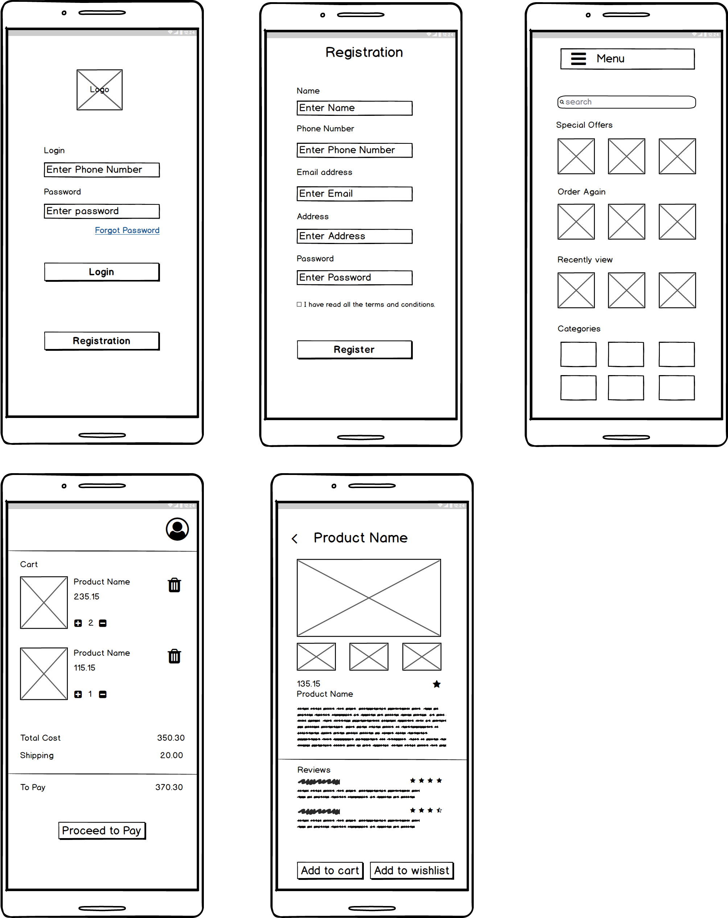

- Make note of tools which you are using for above concepts
- Balsamiq: It is used to create web and mobile application user interface design tool for creating wireframes. Wireframe is a raw visual representation of website. It is like a blueprint.
- Azure RP: It is a powerful tool for creating highly interactive prototypes for web, mobile and desktop application with screen navigation. It has clickable buttons, input and output. It is used during starting of the project and design phase.
- Microsoft Visio: It is used for creating diagrams, flowcharts and wireframes. It offers a wide range of templates and shapes to create visual representation of processes and systems.

- As a business analyst key responsibilities are to keep track of the requirements and make sure no requirements are missed. Mr. henry and peter have approached you regarding the current status of the project. How will you tackle this situation.
It is a document that help to track the requirement throughout the project lifecycle, ensuring all requirements are during development and testing phase.
The Yes/No values are based on whether the requirement has been fully designed, tested, and approved. For example, if a feature is designed but not yet tested, it shows Yes in design but No in testing. If it’s demoed and accepted by the client, UAT is Yes. This way, RTM provides transparency — stakeholders can see at what stage each requirement stands and why
Req ID | Req Name | Req Description | D1 | T1 | D2 | T2 | D3 | T3 | D4 | T4 | UAT
FR001 | Farmer Registration | Farmers should be able to register and create their profile. | Yes | Yes | Yes | Yes | Yes | Yes | No | No | Yes
FR002 | Manufacturer Registration | Manufacturers should be able to register. | Yes | Yes | Yes | Yes | Yes | No | No | No | No
FR003 | Product Search | Provide product search with filters such as category and price. | Yes | Yes | Yes | No | Yes | No | No | No | No
FR004 | Product Details View | Display detailed product information to users. | Yes | Yes | Yes | Yes | Yes | No | No | No | No
FR005 | Add to Cart | User should be able to add product to cart. | Yes | Yes | Yes | Yes | Yes | Yes | No | No | No
FR006 | Wishlist Management | User should be able to manage wishlist. | Yes | Yes | Yes | No | Yes | No | No | No | No
FR007 | Shopping Cart | Provide a cart to add, update, or remove products. | Yes | Yes | Yes | Yes | Yes | Yes | No | No | No
FR008 | Online Payment | Enable secure payments via cards, UPI, and net banking. | Yes | Yes | Yes | Yes | Yes | Yes | No | No | No
FR009 | Order Confirmation | Generate order confirmation after payment. | Yes | Yes | Yes | Yes | Yes | Yes | Yes | No | No
FR010 | Order Tracking | Allow users to track their orders in real-time. | Yes | Yes | Yes | Yes | Yes | No | No | No | No

Req ID | Req Name | Req Description | D1 | T1 | D2 | T2 | D3 | T3 | D4 | T4 | UAT
NFR001 | Response Time | The system shall respond to user actions within 3 seconds. | Yes | Yes | Yes | No | No | No | No | No | No
NFR002 | Portability | The system shall run on web browsers and mobile devices. | Yes | Yes | Yes | Yes | No | No | No | No | No
NFR003 | Localization | The system shall support multiple currencies and date formats. | Yes | Yes | No | No | No | No | No | No | No
NFR004 | Security | The system shall encrypt sensitive data using SSL/TLS protocols. | Yes | Yes | Yes | Yes | No | No | No | No | No
NFR005 | Scalability | The system shall support growth in users and products. | Yes | No | No | No | No | No | No | No | No
NFR006 | Page Load Time | Each page should load within 2 seconds. | Yes | Yes | Yes | No | No | No | No | No | No
NFR007 | Maintainability | The system shall allow easy maintenance and updates. | Yes | No | No | No | No | No | No | No | No
NFR008 | Performance | The system should work fast under heavy usage. | Yes | Yes | No | No | No | No | No | No | No
NFR009 | Usability | The system should be simple and easy to use. | Yes | Yes | Yes | No | No | No | No | No | No
NFR010 | Reliability | The system should work correctly without failures. | Yes | No | Yes | No | No | No | No | No | No

- Prepare 10 test case document
A test case document is a detailed outline used by tester to ensure that a system is working as expected.
Test Case Id | TC01 | Test Case Name | Farmers Registration
Project Id | 12345 | Project name | Online Agriculture Store
PM id | 123 | PM Name | Mr. Vandanam
Test Strategy Id | T1452 | Tester Id | S111
Test Plan Id | T1453 | Tester Name | ABC
Test Scheduled Id | T1454 | Date of Test | 11-09-2025
Scenarios | Verify farmer registration with all valid inputs.
Link to that page
Input Data | Name = " ABC"  Mobile No. = " 123456"  Alternate Mobile No. =" 14875"  Email="abc@gmail.com"  Address="AHD"  Password="DDdsa"
Expected Behaviour | Account should be created.  User should be redirected to home page
Actual Behaviour | Account gets created and user is redirected to home page.
Comments
Results (Pass/Fail) | Pass

Test Case Id | TC02 | Test Case Name | Farmers Registration
Project Id | 12345 | Project name | Online Agriculture Store
PM id | 123 | PM Name | Mr. Vandanam
Test Strategy Id | T1452 | Tester Id | S111
Test Plan Id | T1453 | Tester Name | ABC
Test Scheduled Id | T1454 | Date of Test | 11-09-2025
Scenarios | Verify farmer registration with missing mandatory fields.
Link to that page
Input Data | Name = " "  Mobile No. = " "  Alternate Mobile No. =" 14875"  Email=" "  Address="AHD"  Password=" "
Expected Behaviour | Error message: “Please fill all mandatory details”
Actual Behaviour | Error message is displayed
Comments | Validation works fine
Results (Pass/Fail) | Pass

Test Case Id | TC03 | Test Case Name | Farmers Login
Project Id | 12345 | Project name | Online Agriculture Store
PM id | 123 | PM Name | Mr. Vandanam
Test Strategy Id | T1452 | Tester Id | S111
Test Plan Id | T1453 | Tester Name | ABC
Test Scheduled Id | T1454 | Date of Test | 11-09-2025
Scenarios | Verify login functionality with correct mobile No/password.
Link to that page
Input Data | Mobile No. = " 123456"  Password="DDdsa"
Expected Behaviour | Login should be successful.  User should be redirected to home page
Actual Behaviour | Login is successful.  User is redirected to home page
Comments
Results (Pass/Fail) | Pass

Test Case Id | TC04 | Test Case Name | Farmers Login
Project Id | 12345 | Project name | Online Agriculture Store
PM id | 123 | PM Name | Mr. Vandanam
Test Strategy Id | T1452 | Tester Id | S111
Test Plan Id | T1453 | Tester Name | ABC
Test Scheduled Id | T1454 | Date of Test | 11-09-2025
Scenarios | Verify login fails with incorrect password.
Link to that page
Input Data | Mobile No. = " 123456"  Password="Dqesa"
Expected Behaviour | Error message should be displayed “Invalid Login Credentials”
Actual Behaviour | Error message is displayed “Invalid Login Credentials”
Comments
Results (Pass/Fail) | Pass

Test Case Id | TC05 | Test Case Name | Product Search
Project Id | 12345 | Project name | Online Agriculture Store
PM id | 123 | PM Name | Mr. Vandanam
Test Strategy Id | T1452 | Tester Id | S111
Test Plan Id | T1453 | Tester Name | ABC
Test Scheduled Id | T1454 | Date of Test | 11-09-2025
Scenarios | Verify the product search for keyword “fertilizers”
Link to that page
Input Data | Search keyword = “fertilizers”
Expected Behaviour | Relevant fertilizer products should be listed.
Actual Behaviour | Product list is displayed correctly
Comments
Results (Pass/Fail) | Pass

Test Case Id | TC06 | Test Case Name | Product Search
Project Id | 12345 | Project name | Online Agriculture Store
PM id | 123 | PM Name | Mr. Vandanam
Test Strategy Id | T1452 | Tester Id | S111
Test Plan Id | T1453 | Tester Name | ABC
Test Scheduled Id | T1454 | Date of Test | 11-09-2025
Scenarios | Verify behavior when search keyword has no matching products.
Link to that page
Input Data | Search keyword = “ysh”
Expected Behaviour | Message should be displayed “No product found”
Actual Behaviour | Message is displayed “No product found”
Comments
Results (Pass/Fail) | Pass

Test Case Id | TC07 | Test Case Name | Add product to cart
Project Id | 12345 | Project name | Online Agriculture Store
PM id | 123 | PM Name | Mr. Vandanam
Test Strategy Id | T1452 | Tester Id | S111
Test Plan Id | T1453 | Tester Name | ABC
Test Scheduled Id | T1454 | Date of Test | 11-09-2025
Scenarios | Verify farmer can add product to shopping cart.
Link to that page
Input Data | Select product = “acc”  Quantity = 3
Expected Behaviour | Product should be added to cart and cart should get updated.
Actual Behaviour | Product added successfully.
Comments
Results (Pass/Fail) | Pass

Test Case Id | TC08 | Test Case Name | Cart Quantity Update
Project Id | 12345 | Project name | Online Agriculture Store
PM id | 123 | PM Name | Mr. Vandanam
Test Strategy Id | T1452 | Tester Id | S111
Test Plan Id | T1453 | Tester Name | ABC
Test Scheduled Id | T1454 | Date of Test | 11-09-2025
Scenarios | Verify cart updates on quantity change.
Link to that page
Input Data | For product “acc” change quantity from 3 to 1
Expected Behaviour | Cart should get updated with new quantity.
Actual Behaviour | Cart gets updated
Comments
Results (Pass/Fail) | Pass

Test Case Id | TC09 | Test Case Name | Payment
Project Id | 12345 | Project name | Online Agriculture Store
PM id | 123 | PM Name | Mr. Vandanam
Test Strategy Id | T1452 | Tester Id | S111
Test Plan Id | T1453 | Tester Name | ABC
Test Scheduled Id | T1454 | Date of Test | 11-09-2025
Scenarios | Verify checkout with valid card payment.
Link to that page
Input Data | Card number = 4111111111111111, CVV = 123
Expected Behaviour | Order should be placed successfully, confirmation message should be shown
Actual Behaviour | Order confirmed.
Comments
Results (Pass/Fail) | Pass

Test Case Id | TC10 | Test Case Name | Online Payment via UPI
Project Id | 12345 | Project name | Online Agriculture Store
PM id | 123 | PM Name | Mr. Vandanam
Test Strategy Id | T1452 | Tester Id | S111
Test Plan Id | T1453 | Tester Name | ABC
Test Scheduled Id | T1454 | Date of Test | 11-09-2025
Scenarios | Verify checkout with valid UPI payment.
Link to that page
Input Data | Mode=UPI,  ID=test@upi
Expected Behaviour | Payment should be successful.
Actual Behaviour | Transaction failed
Comments | Defect raised
Results (Pass/Fail) | Fail

- Draw database schema and er diagram
DB schema is a blueprint that outlines the structure of database, including its table fields, relationships, constraints and other characteristics.
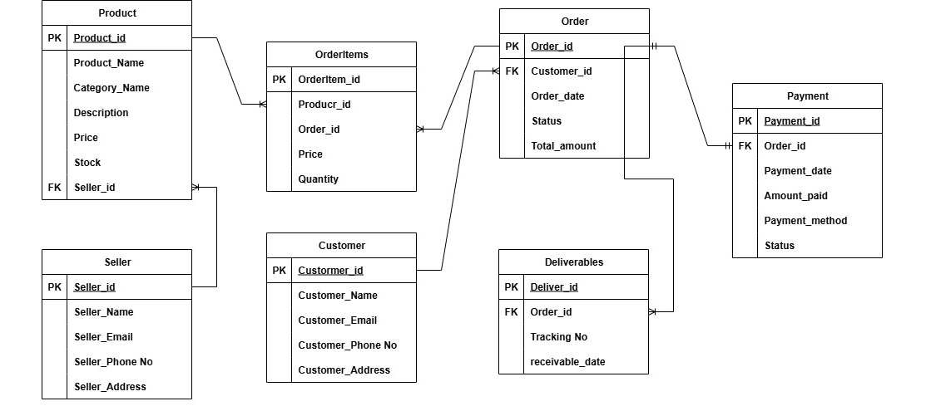
ER diagram is a visual representation of between entities in a database. It depicts the entities(tables), attributes(fields) and relationships between them.
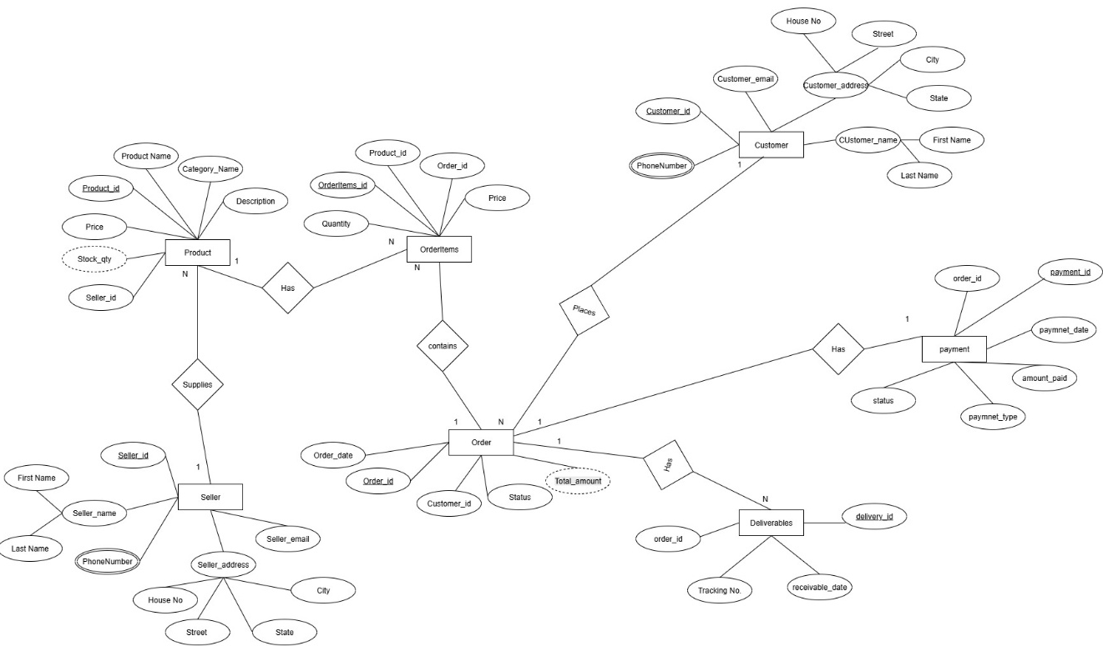

- What is data flow diagram? Draw a data flow diagram to represent the in flow and out-flow of the data when a farmer is placing an order for a product.
A DFD is a graphical representation of the flow of data within a system. It visually shows how data moves from one process to another, how it is stored and where it ends up.
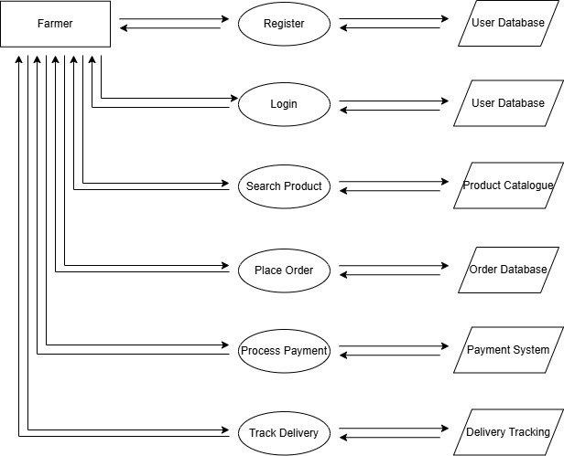

- Due to change in government taxation structure, we should change the tax structure. How do you handle change request in project?
Change request is a alteration or modification to a given requirement or product.
In this scenario a change request has come due to the change in government tax structure. As a BA I would analyze the request and clarify the stakeholders exactly what the request is asking us to do in the project. I will follow the below steps to change the project as per the requirement.
- Acknowledge Change request: I will log into the change request tracker and record the details like requester name, date, description of change, impact, urgency.
- Understand the change request: Discuss with the stakeholder to get the understanding to new taxation rules. Will get the idea about what exactly need to change in the system.
- Impact analysis: Collaborate with the technical team to analyze the impacted modules. (order calculation, payment, invoice). Estimate the time, cost and ris of implementing the change.
- Approval: Present the changes required and other details to the project manager and stakeholders. Decide the change request will be added in the current release or next release
- Update requirement: Modify the documents if needed.
- Keep the stake holder informed about the change.
- Finally, I will ensure that all approved change requests are traceable during development and testing, and reflected in UAT

- As the project is in process, Ben and Kevin have contacted you. The reason is to inform you that they want the Farmers to sell their crop yields through this application i.e. Farmers should be able to add their crop yields or products and display to general public and should be able to sell them. They also want to introduce Auction system for their Crop yields. As a BA, what will be your response? Is this a change request or an enhancement???
Since the requirement introduced is entirely a new business capability that was not originally in scope, this will be classified as enhancement. The below steps are to follow enhancement request.
- Acknowledge the request: Confirm that you have understood their requirement.
- Documentation: Record the enhancement request.
- Conduct the elicitation: Use techniques like Workshops, Brainstorming, Prototyping, Use Case Specification.
- Impact Analysis: Collaborate with the technical team to analyze the impacted modules. Estimate the time, cost and risk of implementing the change.
- Approval: Present the changes required and other details to the project manager and stakeholders. Stakeholders decide whether to approve, defer, or reject.
- Update requirement: Modify the documents BRD, SRS, RTM, Process Flow, Wireframes. Ensure the new scope is signed off.
- Plan development and testing: Align with Project Manager to include in sprint/release planning.
- Keep stakeholders updated.
- UAT: Farmers test crop selling + auction in UAT. Collect sign-off before final release.

- Come up with estimations - How many Manhours required
Number of working hours a day: 8 hours.
Number of resources: 12
Time period: 18 months = 547 days = 78 weeks (including holidays and weekends)
Weekends = 156
Public holidays = 10
Total = 166
Working days = 156 – 166 = 381
Manhours = 8 * 12 * 381 = 36576 hours

- Project has finally completed all the stages i.e., design, development, testing etc. Now, it is the role of a business analyst to contact the client for testing of the final product and have to successfully complete it. How are you going to handle this situation? And once it is done, what will be the process to close the project? Explain UAT Acceptance process
UAT is the final stage of the software development lifecycle where the end users of the system test the product to ensure that it meets their requirements and ready for deployment. This involves following steps
- Planning: Prepare the UAT plan, define entry/exit criteria, identify test scenarios, test data and timelines and schedule UAT sessions with the client
- Test execution: Ensure that the required test environment is set up and available to client for testing. The client stakeholders (farmers and committee) will execute test cases on the final product
- Defect management: Any issues reported during UAT will be logged, tracked, and assigned to the development/QA team
- UAT signoff: Once all business-critical requirements are successfully tested and stakeholders confirm satisfaction, I will prepare the UAT Acceptance Form and obtain formal sign-off from Mr. Henry and the committee.
Regarding the project closure:
- Final documentation: Ensure that all project related documentation is complete, including requirements, design documents, test cases and user manuals. Deliver all finalized documents (BRD, SRS, RTM, Test Cases, UAT Reports, User Manuals) to the client.
- Project review: Conduct a review meeting with the client and internal team to discuss project outcomes, challenges, and lessons learned.
- Project closure: Get formal closure approval from the client committee confirming that scope is delivered and project objectives are met.
- Handover: Coordinate with necessary teams to ensure a smooth transition of the final product to the production environment. Provide training to farmers/manufacturers, and hand over credentials, source code, and maintenance details.
- Post project evaluation: Conduct a post-implementation evaluation (after go-live) to check system performance, user adoption, and note improvement areas for future projects.

- Explain project closure document?
It is a formal document that summarizes the key outcomes, lessons learned and final details of a completed project. It serves as a comprehensive record of the project accomplishments, challenges and overall performance, providing valuable insights for stakeholder and future project.
This includes the section as:
- Project overview: this section provides the overview of project, including its objectives, scope and stakeholders involved and also project’s purpose.
The project was initiated to develop an Online Agriculture Product Store that enables farmers and manufacturers to connect with buyers for products such as fertilizers, seeds, and pesticides
- Achievements: The document highlights the key achievements of the project, successful completion of tasks.
The project successfully delivered all core modules including customer registration, product search, order placement, payment processing, and delivery tracking.
- Timeline and budget: This section provides the overview of project timeline, start and end dates, and also the project budget.
- Lessons Learned: This reflects on project’s successes and challenges. It is the analysis of what worked well and what could have been improved.
During the course of the project, the team learned the importance of clear requirement gathering and effective stakeholder communication.
- Quality Assurance: Quality assurance is also emphasized by providing a summary of all testing phases, including unit testing, integration testing, and user acceptance testing. It confirms that the product was validated against requirements, defects were identified and resolved, and final approval was obtained from the client.
- Resource Utilization: The document also covers resource utilization by comparing the planned versus actual use of manpower and skills, highlighting how effectively the resources were managed throughout the project.
The project team members were effectively allocated across design, development, testing, and deployment activities.
- Risk Management: Risk management is discussed, explaining the risks identified, the mitigation strategies used, and the final outcomes of those risks.
Several risks such as delays in requirement sign-offs, technical challenges with database integration, and changes in regulatory requirements were identified.
- Challenges: Challenges faced during the project are also captured, including issues such as scope changes, technical difficulties, or dependency on external vendors, along with the measures taken to overcome them. This provides transparency on how the team handled obstacles and maintained delivery standard

S/N | Points to Include | Details | Reference Link1
1 | Did the client sign off on the UAT testing
1 | Date of Signoff | 12-Mar-26
1 | Name of the resource
2 | Objectives of the project
2 | User friendliness | Achieved
2 | Customer satisfaction | ROI (Return of Investment) in 6 to 12 months
2 | More Categories | Achieved
3 | Functionalities worked on
3 | Secured payment process | Achieved
3 | Categories | Achieved
4 | Infrastructure
4 | Software installed | Achieved
4 | Laptops purchased | Achieved
5 | Funding
5 | Amount approved | 2 Crores
5 | Amount used | 2 Crores
6 | Overall project information
6 | Escalations | 30
6 | Customer satisfaction | High
7 | Value to the company
7 | Positive/Negative | Company has gained successful integration of process, increased turnover by 25%, increased efficiency by 20%.

