Capstone Project1 – Part -3
Online Agriculture Products Store

Question 1 – Functional Requirements
Identify minimum 20 functional requirements
Answer: Functional Requirements defines the specific behaviour, functions, or operations of a system. They Describe what the system should do , outlining the necessary tasks, actions or activities it must perform to achieve its objectives.
Req ID | Req Name | Functional Requirement Description
FR001 | Farmer Registration | Farmers should be able to register with the system using email ID and password.
FR002 | Manufacturer Registration | Manufacturers should be able to register with the system.
FR003 | Login | Users (Farmers and Manufacturers) should be able to log in securely.
FR004 | Password Recovery | Users should be able to recover/reset forgotten passwords.
FR005 | Product Catalog View | Farmers can view available products categorized under seeds, fertilizers, and pesticides.
FR006 | Product Search | Farmers can search for specific products using keywords.
FR007 | Add to Wishlist | Farmers can add products to a wishlist or "buy later" list.
FR008 | Add to Cart | Farmers can add selected products to cart.
FR009 | Place Order | Farmers can place an order by selecting products and providing delivery details.
FR010 | Order Confirmation Email | System should send a confirmation email after the order is placed.
FR011 | Delivery Tracking | Farmers can track their order status in real time.
FR012 | Upload Product Details | Manufacturers can upload product details (name, type, price, stock).
FR013 | Product Edit/Delete | Manufacturers can edit or delete their product listings.
FR014 | Payment – COD | COD option should be available to farmers during checkout.
FR015 | Payment – UPI | UPI payment should be available to farmers.
FR016 | Payment – Credit/Debit Cards | Farmers should be able to pay using cards.
FR017 | Admin Login | Admin should be able to log in to manage application.
FR018 | Admin Dashboard | Admin should monitor users, products, and orders.
FR019 | Feedback Collection | Farmers should be able to rate and review products.
FR020 | Notifications | System should notify users via email or SMS on order status changes.
Non Functional Requirements : It describes the qualities and attributes of a system, focusing on how the system performs rather than the specific behaviours or functions.
Req ID | Req Name | Non-Functional Requirement Description
NFR0101 | Page Loading Time | Each page should load within 2 second’s time.
NFR0102 | Accessibility Compliance | The system must comply with accessibility standards.
NFR0103 | Uptime | The application should have 99.5% uptime availability per month.
NFR0104 | Scalability | The system should support at least 1000 concurrent users.
NFR0105 | Mobile Responsiveness | The application should be responsive and work on all screen sizes.
NFR0106 | Browser Compatibility | The system should work across all major browsers (e.g Chrome, Firefox, Edge).
NFR0107 | Data Encryption | All sensitive data should be encrypted using industry-standard protocols.
NFR0108 | Secure Password Storage | Passwords must be stored using secure algorithms
NFR0109 | Backup Frequency | The database should be backed up daily.
NFR0110 | Recovery Time Objective (RTO) | The system should be recoverable within 2 hours after failure.
NFR0111 | Logging and Auditing | All user activities should be logged for security and auditing.
NFR0112 | Session Timeout | User sessions should time out after 15 minutes of inactivity.
NFR0113 | Language handling | The system should support English and Hindi languages.
NFR0114 | Error Handling | Meaningful error messages should be displayed for all known failures.
NFR0115 | Response Time | API response times should not exceed 2 second.
NFR0116 | System Maintenance Notification | Users should be notified at least 24 hours before scheduled maintenance.
NFR0117 | Legal Compliance | The system should comply with Indian IT and Data Privacy laws.
NFR0118 | Data Retention | Order and transaction data should be stored for at least 12 months.
NFR0119 | Version Control | Application should maintain version control for all deployments.
NFR0120 | Continuous Monitoring | System health and performance should be monitored 24/7 with alerts.

Question 2: Make wireframe and prototypes

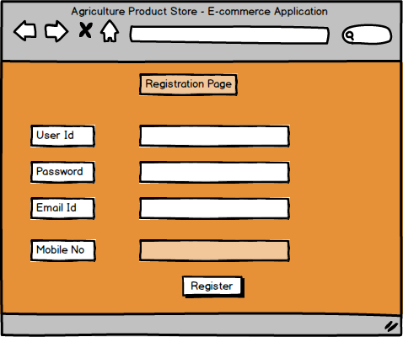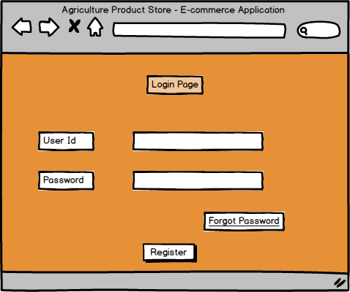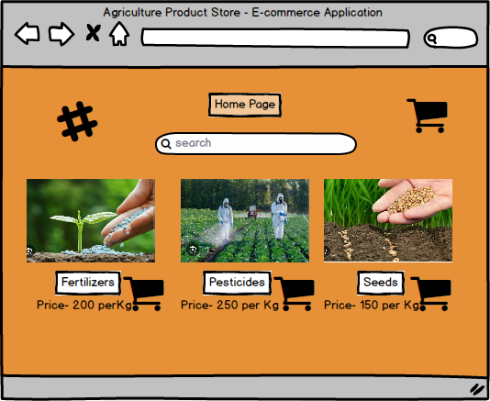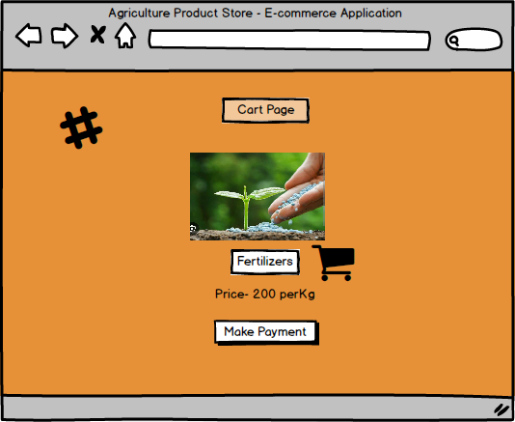
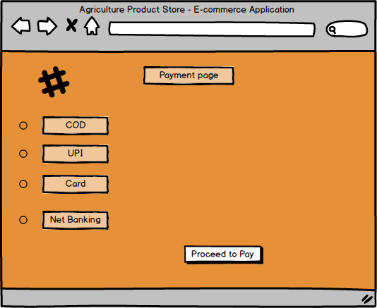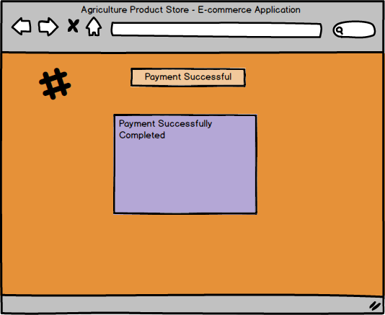

Question 3: Make a note of the Tools, which you are using for above concepts.
Answer: Tools which are mostly used are
Balsamiq- Balsamiq is a quick , low fidelity wireframing tool that can be used to wireframe any kind of software interface like desktop, web, mobile etc. It is a rapid tool used to create mockups and prototypes for user interface.
MS Visio- It’s a diagramming and vector graphics application that allows users to create a wide range of visual representations, including flowcharts, network diagrams and other visual representation of complex information.
Azure RP- It is more advanced prototyping tool used to create high fidelity, interactive wireframes and prototypes for web and mobile applications. Axure allows users to build prototypes without needing to write code, making it easier to test and refine designs before development begins. Axure is used mostly at research and design phase of the project.
Draw.Io- It is a free open source diagramming application that allows users to create various types of diagrams and charts, including flowcharts, UML diagrams.

Features | Axure RP | Balsamiq
Tool Type | Prototyping & Wireframing Tool | Wireframing Tool
Primary Use | Interactive Prototypes & Functional Specs | Low-Fidelity Wireframes
Complexity | More advance and require more time to master | Less advance and simpler tool to learn and use
Mockups / Prototypes | More powerful with advance prototyping features | more focused on creating wireframes and mock-ups
Output formats | Supports HTML, CSS and JavaScript | Supports PNG and PDF
Team Collaboration | Allows team to work on the same project simultaneously, share design assets, manage changes and comments more efficiently | Only one person can involve
Cost | Subscription-based pricing model which is costly | More affordable with onetime fee

Question 4 – RTM
A business analyst’s key responsibilities are to keep track of the requirements and make sure that no requirement is missed.
Mr. Henry and peter have approached you regarding the current status of the project. How will you tackle this situation?
Answer: RTM is a Document that tracks the requirements throughout the project life cycle, ensuring that they are met and not overlooked during the entire SDLC.
Req ID | Req Name | Req Description | Design | Code | Unit Testing | Component Testing | System Testing | SIT | UAT
FR001 | Farmer Registration | Farmers should be able to register with the system using email ID and password. | Completed | Completed | Completed | Completed | Completed | Completed | Completed
FR002 | Manufacturer Registration | Manufacturers should be able to register with the system. | Completed | Completed | Completed | Completed | Completed | Completed | Completed
FR003 | Login | Users (Farmers and Manufacturers) should be able to log in securely. | Completed | Completed | Completed | Completed | Completed | Completed | Completed
FR004 | Password Recovery | Users should be able to recover/reset forgotten passwords. | Completed | Completed | Completed | Completed | Completed | Completed | Completed
FR005 | Product Catalog View | View categorized products (seeds, fertilizers, pesticides). | Completed | Completed | Completed | Completed | Completed | Completed | Completed
FR006 | Product Search | Search for specific products using keywords. | Completed | Completed | Completed | Completed | Completed | Completed | Completed
FR007 | Add to Wishlist | Add products to a wishlist or "buy later" list. | Completed | Completed | Completed | Completed | Completed | Completed | Completed
FR008 | Add to Cart | Add selected products to cart. | Completed | Completed | Completed | Completed | Completed | Completed | Completed
FR009 | Place Order | Place order by selecting products and providing delivery details. | Completed | Completed | Completed | Completed | Completed | Completed | Completed
FR010 | Order Confirmation Email | Send confirmation email after the order is placed. | Completed | Completed | Completed | Completed | Completed | Completed | Completed
FR011 | Delivery Tracking | Track order status in real time. | Completed | Completed | Completed | Completed | Completed | Completed | Completed
FR012 | Upload Product Details | Manufacturers upload product details (name, type, price, stock). | Completed | Completed | Completed | Completed | Completed | Completed | Completed
FR013 | Product Edit/Delete | Manufacturers edit or delete their listings. | Completed | Completed | Completed | Completed | Completed | Completed | Completed
FR014 | Payment – COD | COD option during checkout. | Completed | Completed | Completed | Completed | Completed | Completed | Completed
FR015 | Payment – UPI | UPI payment option. | Completed | Completed | Completed | Completed | Completed | Completed | Completed
FR016 | Payment – Credit/Debit Cards | Card payment option. | Completed | Completed | Completed | Completed | Completed | Completed | Completed
FR017 | Admin Login | Admin login to manage application. | Completed | Completed | Completed | Completed | Completed | Completed | Completed
FR018 | Admin Dashboard | Admin monitors users, products, and orders. | Completed | Completed | Completed | Completed | Completed | Completed | Completed
FR019 | Feedback Collection | Farmers rate and review products. | Completed | Completed | Completed | Completed | Completed | Completed | Completed
FR020 | Notifications | Notify users via email or SMS on order status changes. | Completed | Completed | Completed | Completed | Completed | Completed | Completed
NFR0101 | Page Loading Time | Each page should load within 2 seconds. | Completed | Completed | Incomplete | Completed | Completed | Completed | Completed
NFR0102 | Accessibility Compliance | System must comply with WCAG 2.1. | Completed | Completed | Incomplete | Completed | Completed | Completed | Completed
NFR0103 | Uptime | Application should have 99.5% uptime. | Completed | Completed | Incomplete | Incomplete | Completed | Completed | Completed
NFR0104 | Scalability | Support at least 1000 concurrent users. | Completed | Completed | Incomplete | Incomplete | Completed | Completed | Completed
NFR0105 | Mobile Responsiveness | Application should work on all screen sizes. | Completed | Completed | Completed | Completed | Completed | Completed | Completed
NFR0106 | Browser Compatibility | Support Chrome, Firefox, Edge browsers. | Completed | Completed | Completed | Completed | Completed | Completed | Completed
NFR0107 | Data Encryption | Encrypt sensitive data using standards. | Completed | Completed | Incomplete | Incomplete | Completed | Completed | Completed
NFR0108 | Secure Password Storage | Store passwords using secure hash like bcrypt. | Completed | Completed | Incomplete | Incomplete | Completed | Completed | Completed
NFR0109 | Backup Frequency | Database should be backed up daily. | Completed | Completed | Incomplete | Incomplete | Completed | Completed | Completed
NFR0110 | Recovery Time Objective | Recover system within 2 hours of failure. | Completed | Completed | Incomplete | Incomplete | Completed | Completed | Completed
NFR0111 | Logging and Auditing | Log all user activities. | Completed | Completed | Completed | Completed | Completed | Completed | Completed
NFR0112 | Session Timeout | Timeout after 15 minutes of inactivity. | Completed | Completed | Completed | Completed | Completed | Completed | Completed
NFR0113 | Localization | Support English and Hindi languages. | Completed | Completed | Completed | Completed | Completed | Completed | Completed
NFR0114 | Error Handling | Display meaningful error messages. | Completed | Completed | Completed | Completed | Completed | Completed | Completed
NFR0115 | Response Time | API response time should be ≤ 1 second. | Completed | Completed | Completed | Completed | Completed | Completed | Completed
NFR0116 | System Maintenance Notification | Notify users 24 hrs before maintenance. | Completed | Completed | Incomplete | Incomplete | Completed | Completed | Completed
NFR0117 | Legal Compliance | Comply with Indian IT and Data Privacy laws. | Completed | Completed | Incomplete | Incomplete | Completed | Completed | Completed
NFR0118 | Data Retention | Store data for at least 12 months. | Completed | Completed | Incomplete | Incomplete | Completed | Completed | Completed
NFR0119 | Version Control | Maintain version control for deployments. | Completed | Completed | Incomplete | Incomplete | Completed | Completed | Completed
NFR0120 | Continuous Monitoring | Monitor system 24/7 with alerts. | Completed | Completed | Incomplete | Incomplete | Completed | Completed | Completed

Question 5 – Prepare 10 Test Case Documents
Answer: A test case is a detailed, documented set of steps that are executed to verify a specific feature or functionality of an application, ensuring it behaves as expected. It outlines the inputs, execution steps and expected results, acting as a guide for testers.
Test case Id | TC001 | Test case name | Farmer Registration
Project Id | AGRI001 | Project name | Online Agriculture Products Store
PM ID | PM001 | PM Name | Mr. Vandanam
Test Strategy ID | TS001 | Tester ID | T001
Test Plan ID | TP001 | Tester Name | Mr. Jason
Test Schedule ID | SCH001 | Date of Test | 04-08-2025
Scenario | Register as a new farmer using email
Link to that Page: | /register-farmer
Input Data | Set1 :valid email, valid password | Set2: existing email | Set 3: missing email | Set4: short password
Expected Behaviour | Successful registration or error message | Successful registration or error message | Successful registration or error message | Successful registration or error message
Actual Behaviour | Entered a valid email Id and Password for registration | Error Pop up - Entre either a new mail id or login as n existing user | Error Email id not entered | Error pop up Entre a valid password meeting the password security criteria
comments | Password in meeting the secturiy strength and theuser account is created | If the user is already registered with the entered email id error will pop up, 1)then user needs to login as existing user with the password and if user forgot the password they can regenerate the password by clicking on forgot password. 2) or need to register with a new ID | Correct and unique Email Id needs to be entered for registration | Password needs to meet the security criteria, meeting the minimum charater norms, 1 upper case , 1 special charater etc.
Result (Pass/Fail) | Pass | Pass | Pass | Pass
Test case Id | TC002 | Test case name | Login with credentials
Project Id | AGRI001 | Project name | Online Agriculture Products Store
PM ID | PM001 | PM Name | Mr. Vandanam
Test Strategy ID | TS002 | Tester ID | T001
Test Plan ID | TP002 | Tester Name | Mr. Jason
Test Schedule ID | SCH002 | Date of Test | 04-08-2025
Scenario | Login using valid and invalid credentials
Link to that Page: | /login
Input Data | Set1 :valid email/password | Set2: invalid password | Set 3: Invalid User Id | Set4: Either the user id or password left blank
Expected Behaviour | Redirect to Home Page or Show error | Redirect to Home Page or Show error | Redirect to Home Page or Show error | Redirect to Home Page or Show error
Actual Behaviour | Entered a valid email Id and Password for login | Error Pop up - Entre Valid password for login or reset the password by clicking on forgot the password | Error Pop up- "Entre a valid user Id for login" if forgotten- " click on forgot user id for retival" | Error- Check "invalid user Id or password" re-entre with correct credentials
comments | UserId/Email Id entered is correct along with the correct password and page is redirected to the home page | User entered an invalid password due to which error pop up stating " either entre a correct password for login" or " Reset the password by clicking forgot password" | Correct user Id need s to be entered for login. If the user forgets they can click on forgot user id option for retrival and they will get a link on the registered email id for retrival | Either the user id or password left blank, then the error will be pop up either incorrect user id or password , kindly entre correct details for login
Result (Pass/Fail) | Pass | Pass | Pass | Pass
Test case Id | TC003 | Test case name | Product Search
Project Id | AGRI001 | Project name | Online Agriculture Products Store
PM ID | PM001 | PM Name | Mr. Vandanam
Test Strategy ID | TS003 | Tester ID | T001
Test Plan ID | TP003 | Tester Name | Mr. Jason
Test Schedule ID | SCH003 | Date of Test | 04-08-2025
Scenario | Search for a product in catalogue
Link to that Page: | /catalogue
Input Data | Set1 :Search through Variants like seeds , pesticides or fertilizers | Set2: Search by clicking on all products | Set 3: Search by Reviews | Set4: Serach by Price Filter
Expected Behaviour | Show relevant products or No results | Show relevant products or No results | Show relevant products or No results | Show relevant products or No results
Actual Behaviour | User selected the specific Category like seeds , pesticides or fertilizers and then the page is redirected to the product under the specific category selected from where the user will select the product | user can also directly mention the specfic product detail for selection e.g Sugarcane Seeds- product found and added to cart . 2nd senario can be user may search for mango Seed - and error may pop up " no results" | User select the 5* rated product within the product sub- category and all the product with 5* rating will come for selection and if there is no 5 * rated product in the particular sub category then the error weill pop up that no results found | User set the Price range within the product sub- catergory less than rs500 and all the product under this range will pop up for selection
comments | User should select the product the from the sub category once selected if they want to change the category , they will have to click on back button for the main menu | user will be able to search only those products which are listed by the manufacturers. Else the error will pop up for no results found | User will apply the search criteria based on reviews and rating given by the previous buyers of the products | User to select the product from sub category depending upon the price range available by comparing the price to competition
Result (Pass/Fail) | Pass | Pass | Pass | Pass

Test case Id | TC004 | Test case name | Add to Wishlist
Project Id | AGRI001 | Project name | Online Agriculture Products Store
PM ID | PM001 | PM Name | Mr. Vandanam
Test Strategy ID | TS004 | Tester ID | T001
Test Plan ID | TP004 | Tester Name | Mr. Jason
Test Schedule ID | SCH004 | Date of Test | 04-08-2025
Scenario | Add selected product to wishlist
Link to that Page: | /Catalogue
Input Data | Set1 :logged in user | Set2: not logged in | Set 3: product out of stock | Set4: invalid product ID
Expected Behaviour | Product added to wishlist / prompt login | Product added to wishlist / prompt login | Product added to wishlist / prompt login | Product added to wishlist / prompt login
Actual Behaviour | User has selected the product and added to its wishlist directly as the user has already logged in with app | User has selected the product and try adding the same to the wishlist , but as the user is not logged in as the session expires, " error will pop up for-"login to add product to wishlist"" | The selected product is out of stock while adding to wishlist, then error will pop up" product out of stock "- "Select for notification when available" | The user selected the invalid Product Id while selecting the product to wishlist - error will pop up "enter valid product id"
comments | User is already login while adding the product to wishlist and the selected product is available with the manufacturer | User is searching the product catalogue without login in the portal | The product selected is out of stock and the post selcting for notification the usre will receive the notification on mail once the product is available | If the user enters the valid product id again the product can be added to the wishlist for future order
Result (Pass/Fail) | Pass | Pass | Pass | Pass

Test case Id | TC005 | Test case name | Place Order using COD
Project Id | AGRI001 | Project name | Online Agriculture Products Store
PM ID | PM001 | PM Name | Mr. Vandanam
Test Strategy ID | TS005 | Tester ID | T001
Test Plan ID | TP005 | Tester Name | Mr. Jason
Test Schedule ID | SCH005 | Date of Test | 04-08-2025
Scenario | Complete order process with COD
Link to that Page: | /checkout
Input Data | Set1 :cart with 1 product | Set2: multiple products added to cart | Set 3: Empty Cart | Set4: Invalid Address
Expected Behaviour | Order placed or validation shown | Order placed or validation shown | Order placed or validation shown | Order placed or validation shown
Actual Behaviour | User select the option "Pay with " and the page will be redirected to Payment method then user select the payment method as "COD" then page will redirect to option "Place COD" and the order will be placed | User select the option "Pay with " and the page will be redirected to Payment method then user select the payment method as "COD" then page will redirect to option "Place COD" and the order will be placed | System will show empty cart, and a pop message" select the product to cart". | User select the option "Pay with " and error pop up " please select a valid address to proceed further". The user will then check and select a valid address to proceed further and select the payment method as "COD" then page will redirect to option "Place COD" and the order will be placed
comments | Post adding the products to cart user will check the overall billing details and proceed to the payment option page | After adding multiple products to cart, user will check billing details and proceed to the payment option page | With an Empty cart order cannot be placed | After selecting a valid address the order is placed selecting COD payment option.
Result (Pass/Fail) | Pass | Pass | Pass | Pass

Test case Id | TC006 | Test case name | Payment using UPI
Project Id | AGRI001 | Project name | Online Agriculture Products Store
PM ID | PM001 | PM Name | Mr. Vandanam
Test Strategy ID | TS006 | Tester ID | T001
Test Plan ID | TP006 | Tester Name | Mr. Jason
Test Schedule ID | SCH006 | Date of Test | 04-08-2025
Scenario | Make payment through UPI
Link to that Page: | /payment
Input Data | Set1 :valid UPI | Set2: incorrect UPI | Set 3: expired session | Set4: blank UPI
Expected Behaviour | Payment success or failure message | Payment success or failure message | Payment success or failure message | Payment success or failure message
Actual Behaviour | User select the option "Pay with " and the page will be redirected to Payment method then user select the payment method as "UPI" and then page will redirect to select UPI payment option ( CRED, Gpay, Entre UPI ID). User select Gpay then the page will redirect to the Gpay and enters pin to proceed and payment Successful | User select the option "Pay with " and the page will be redirected to Payment method then user select the payment method as "UPI" and then page will redirect to select UPI payment option ( CRED, Gpay, Entre UPI ID). User select "entre UPI ID" Error will pop " Invalid UPI ID" - Failure message will be displaced " order cannot be placed" | User select the option "Pay with " and the page will be redirected to Payment method then user select the payment method as "UPI" and then page will redirect to select UPI payment option ( CRED, Gpay, Entre UPI ID). User select Gpay - Error will pop up "expired Session" | User select the option "Pay with " and the page will be redirected to Payment method then user select the payment method as "UPI" and then page will redirect to select UPI payment option ( CRED, Gpay, Entre UPI ID). User select "entre UPI ID" without entering UPI Id user procced to make payment error will Pop up "Entre UPI ID" to "Payment failure"
comments | order is placed as the correct UPI payment mode selected and entered a valid Pin to make payment successful | UPI Id entered is invalid, Payment failure message will pop up | User has kept the payment page open for long due to which the session got invalid | Its is assumed that the user has left the UPI ID as blank and tried to place the order
Result (Pass/Fail) | Pass | Pass | Pass | Pass

Test case Id | TC007 | Test case name | Delivery Tracking
Project Id | AGRI001 | Project name | Online Agriculture Products Store
PM ID | PM001 | PM Name | Mr. Vandanam
Test Strategy ID | TS007 | Tester ID | T001
Test Plan ID | TP007 | Tester Name | Mr. Jason
Test Schedule ID | SCH007 | Date of Test | 04-08-2025
Scenario | Check status of placed order
Link to that Page: | /orders/track
Input Data | Set1 :valid order ID | Set2: invalid Order ID | Set 3: no internet | Set4: cancelled order
Expected Behaviour | Show correct delivery status or error | Show correct delivery status or error | Show correct delivery status or error | Show correct delivery status or error
Actual Behaviour | User can click on the order details and select the product for which the delivery status needs to checked. Select check delivery status and the page will redirect to the live tracking page or else user can click on delivery tracking link and entre the order ID for live tracking | If user go with select the delivery tracking link and enters a wrong order ID the error will pop" Enter valid order ID" | If user go with select the delivery tracking link and enters a order ID the error will pop" Check your internet connectivity" | User can click on the order details and select the product for which the delivery status needs to checked. Select check delivery status and the page will redirect to the live tracking page and delivery status shown as "cancelled order as product not available"
comments | follow the normal process to get the product tracking | Once the user enters a valid order ID , can get the live tracking of the order | Due to no/low internet connectivity error pop up | It is assumed that the munufacturer has not updated the stock details in the application and once the order is placed while packaging the product seems to be unavailable and the system is updated and order got cancelled
Result (Pass/Fail) | Pass | Pass | Pass | Pass

Test case Id | TC008 | Test case name | Upload Product (Manufacturer)
Project Id | AGRI001 | Project name | Online Agriculture Products Store
PM ID | PM001 | PM Name | Mr. Vandanam
Test Strategy ID | TS008 | Tester ID | T001
Test Plan ID | TP008 | Tester Name | Mr. Jason
Test Schedule ID | SCH008 | Date of Test | 04-08-2025
Scenario | Add new product to catalog
Link to that Page: | /manufacturer/upload
Input Data | Set1 :all valid fields | Set2: missing price | Set 3: invalid category | Set4: blank fields
Expected Behaviour | Product uploaded or error shown | Product uploaded or error shown | Product uploaded or error shown | Product uploaded or error shown
Actual Behaviour | manufacturer enters user ID and password and login in the portal and go to the product upload page and select the category (seeds) for uploadling the product and enters all valid filed likes specification, price,available quantity,etc and then press on submit- Product is upoaded | manufacturer enters user ID and password and login in the portal and go to the product upload page and select the category (seeds) for uploadling the product and enters all valid filed likes specification, available quantity,but price per unit column left blank and click on submit - Error will pop up " missing price" | If the manufacturer clicked on pestisides as category and filled the product details of seed then while submitting the error will pop up "select valid Category " | manufacturer enters user ID and password and login in the portal and go to the product upload page and select the category (seeds) for uploadling the product and while entering few of the mandatory columns left black - error will pop up " fill the blank field for submitting)
comments | All valids details has to be entered to get the product uploaded | once the user re-enter the correct product details along with price and submit then product is then uploaded | Once the user select the correct category as seeds he can upload the product details | All valids details has to be entered to get the product uploaded
Result (Pass/Fail) | Pass | Pass | Pass | Pass

Test case Id | TC009 | Test case name | Order Confirmation Email
Project Id | AGRI001 | Project name | Online Agriculture Products Store
PM ID | PM001 | PM Name | Mr. Vandanam
Test Strategy ID | TS009 | Tester ID | T001
Test Plan ID | TP009 | Tester Name | Mr. Jason
Test Schedule ID | SCH009 | Date of Test | 04-08-2025
Scenario | Confirm email sent after placing order
Link to that Page: | /orders/summary
Input Data | Set1 :valid email | Set2: invalid email | Set 3: unsubscribed user | Set4: bulk order
Expected Behaviour | Email with order details sent | Email with order details sent | Email with order details sent | Email with order details sent
Actual Behaviour | Once the Order is placed the Email confirmation is sent to emial id | Once the Order is placed the Email confirmation is sent to the mentioned emial id error pop up invalid email id. Message sent to the contact no registered - "Enter a valid email id for order confirmation " user update the same is portal and within 24hrs confirmation mail received | If the Email id is not mentioned in the information and customer has registered through contact no , then post placing the order error will pop stating that enter a valid emial id for receiving order confirmation once info page updated within 24hrs mail confirmation received | Once the Order is placed the Email confirmation is sent to emial id - along with details of each product ordered along with the quantity individually
comments | Valid emial id entered in the information details | Its outomated, if the email is bounced the msg will sent to the registred number | Its outomated, if the email id is not mentioned the msg will sent to the registred number | if the user has placed a bulk order then single mail needs to be send for order mail confirmation
Result (Pass/Fail) | Pass | Pass | Pass | Pass

Test case Id | TC010 | Test case name | Session Timeout
Project Id | AGRI001 | Project name | Online Agriculture Products Store
PM ID | PM001 | PM Name | Mr. Vandanam
Test Strategy ID | TS010 | Tester ID | T001
Test Plan ID | TP010 | Tester Name | Mr. Jason
Test Schedule ID | SCH010 | Date of Test | 04-08-2025
Scenario | User is logged out after inactivity
Link to that Page: | Any private page
Input Data | Set1 :idle 10 mins | Set2:idle 15 mins | Set 3: idle 20 mins | Set4: background refresh
Expected Behaviour | Logout after 15 mins or keep alive | Logout after 15 mins or keep alive | Logout after 15 mins or keep alive | Logout after 15 mins or keep alive
Actual Behaviour | user has left the page open for 10 min post which they tries to use the page again- the current seach page is still operational and alive | user has left the page open for 15 min post which they tries to use the page again- the current seach page is not active and user has to re initaite the search and redirected to the home page | user has left the page open for 20 min post which they tries to use the page again- its redirected to the login page to re entre the login credentials | User has clicked the refresh button, the page will be redirected to the login page
comments | Assumed that the user has not closed the page and the page is open but unused | Portal is left unattended and user has just checked it at 15th min so the page has redirected to the home page | user has to entre the login credential again to access the homepage | user has to relogin again for to access the home page
Result (Pass/Fail) | Pass | Pass | Pass | Pass

Question 6 – DB Design
After the requirements are thoroughly explained to the entire project team by business analyst, the Database architects have decided to do the database design and also to represent the in-flow and out-flow of data.
Draw database schema and ER diagram
Answer:
ER Diagram : ER diagram is a visual representation of how different entities( like people, Objects or Concepts) relate to each other within a system.

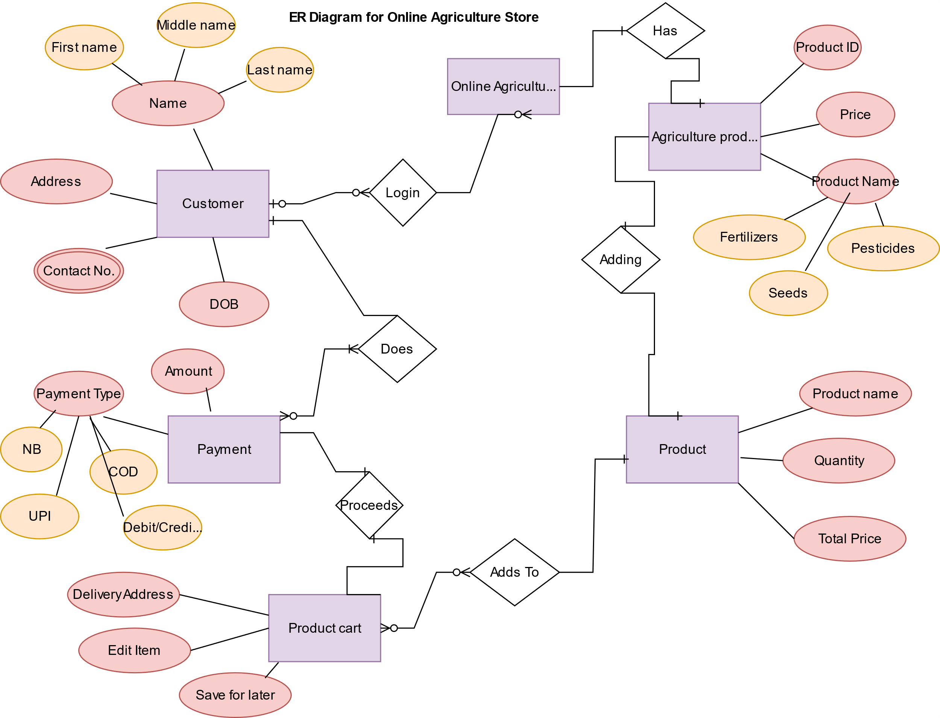

DB Schema: DB Schema is a blueprint that outlines the structure of a database, including its tables, fields, relationships, constraints and other characteristics.

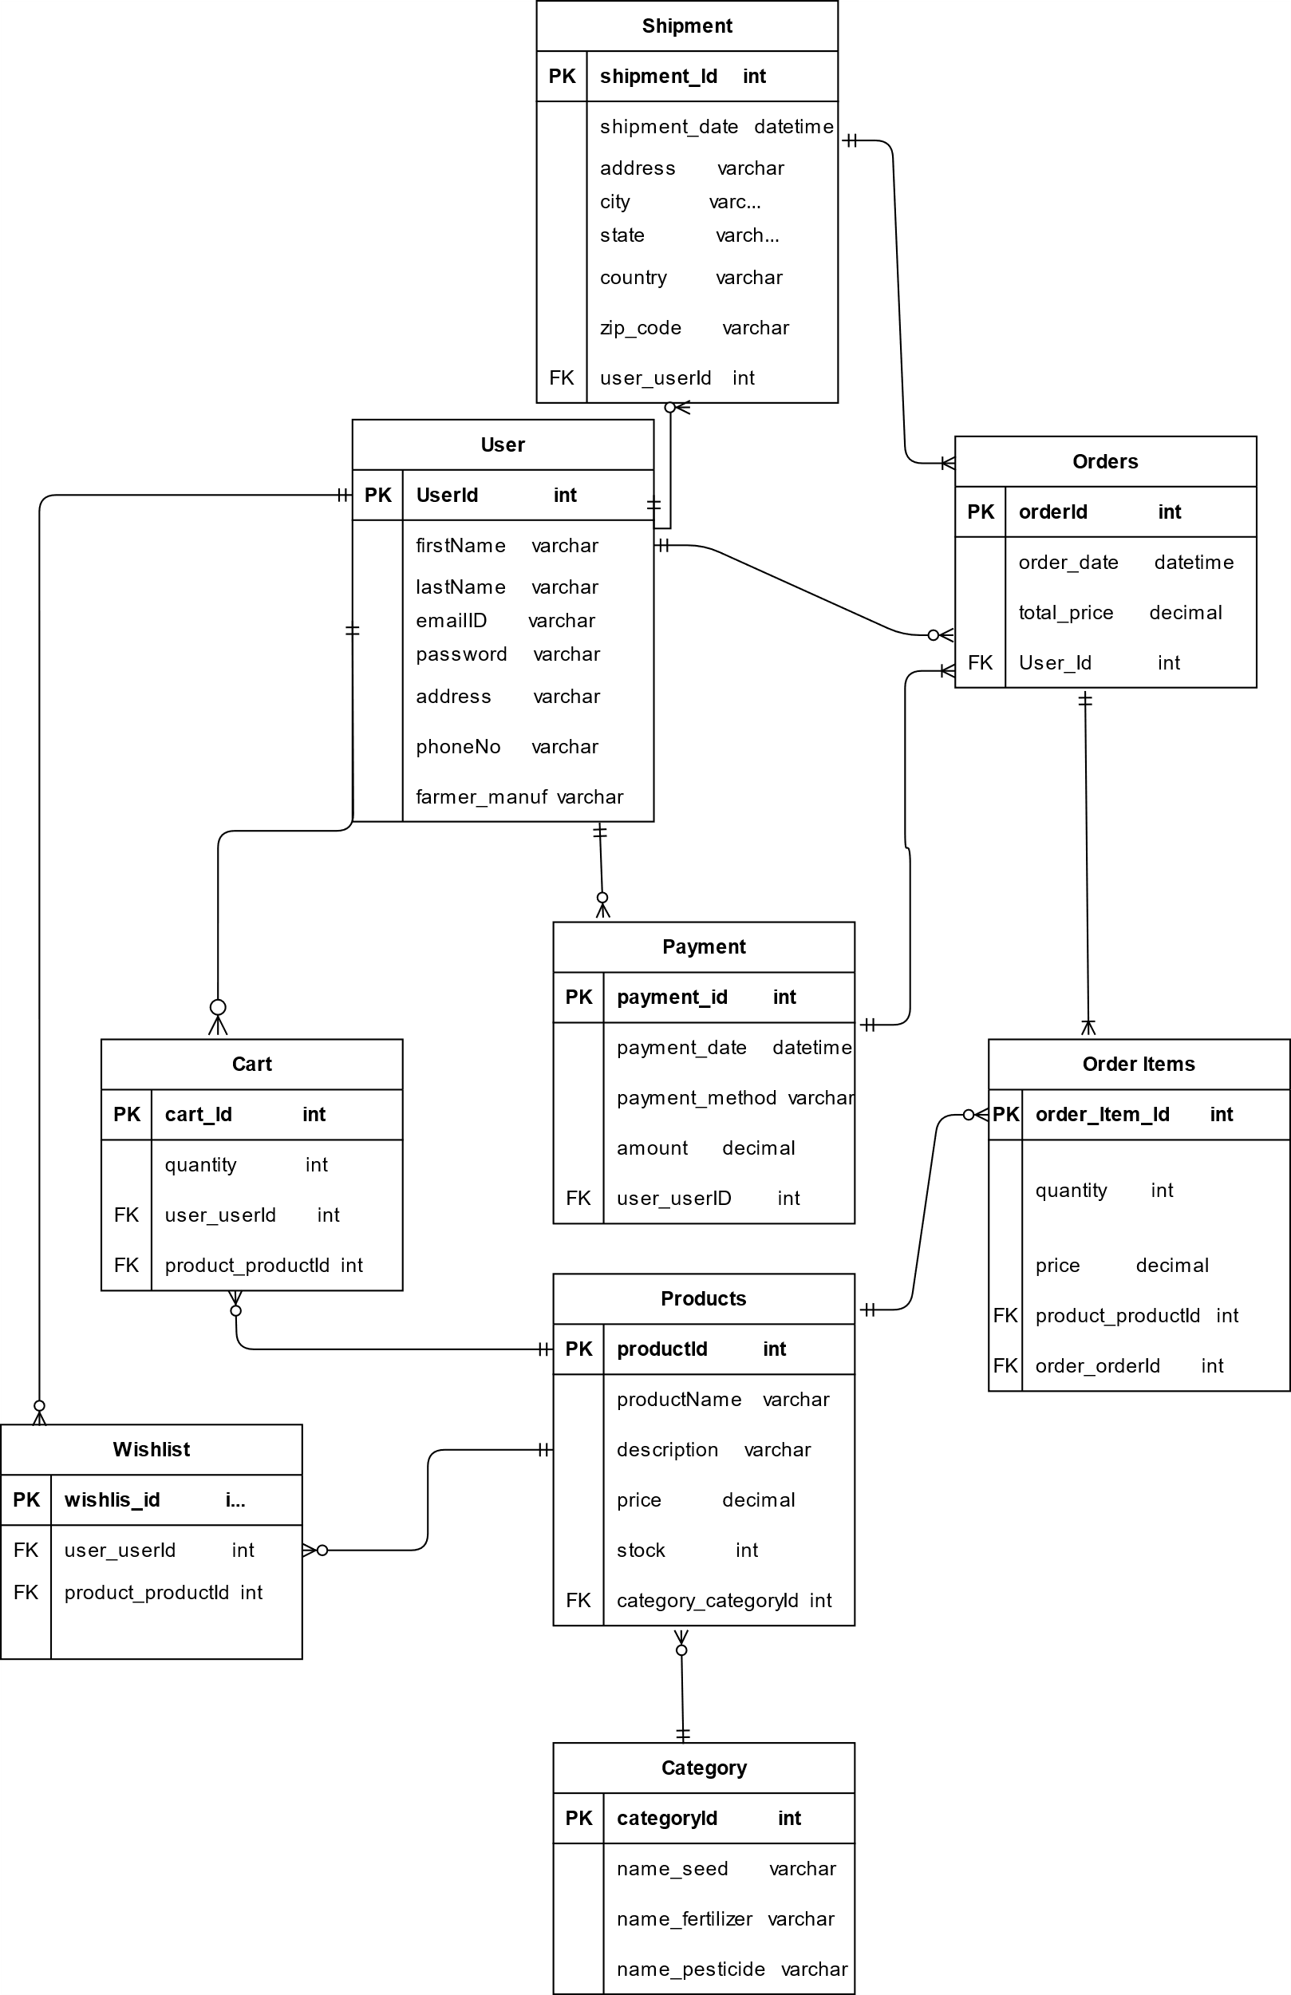

Question 7 : What is a data flow diagram? Draw a data flow diagram to represent the in-flow and out-flow of data when a Farmer is placing an order for the product
Answer: A Data Flow Diagram (DFD) is a visual representation of how data moves through a system, showing:
- Processes (what the system does)
- Data stores (where information is kept)
- External entities (users or systems that interact with the system)
- Data flows (how data is transferred between entities, processes, and stores)

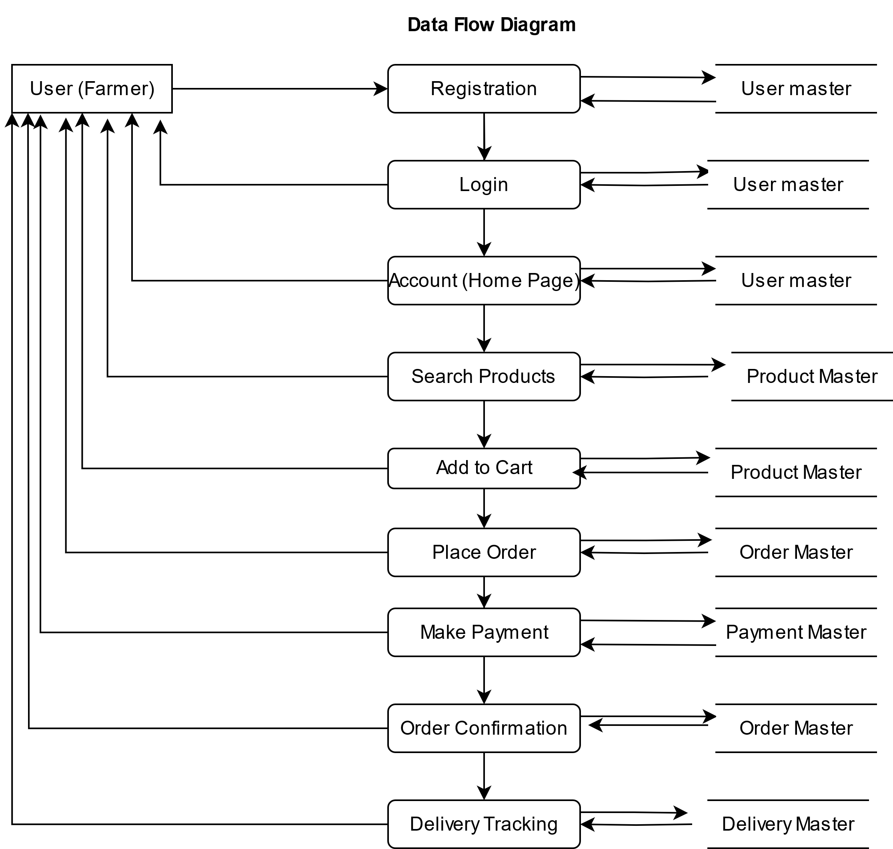

Question 8: Due to change in the Government Taxation structure . we should change the Tax structure How do you handle change requests in a project?
Answer: A change request is a formal proposal to alter a system, product or project.
Handling change requests in a project—Government Taxation structure—requires a systematic and controlled approach to ensure it doesn't negatively impact scope, time, cost, or quality.
Steps to Handle Change Requests
1. Receive the Change Request
- Capture the request formally (e.g., Change Request Form or email).
- Ensure details like reason, type of change, impacted modules (e.g., tax calculation), and requester (e.g., Mr. Henry) to be mentioned.
- Understands the scope of the change request
- Record the change request in the Change Request Log
2. Impact Analysis
- The BA needs to analyse the potential impact of the change on various aspects of the project, including technical , design , project schedule, budget and resources.
- BA assesses whether the change is feasible to implement, considering factors like cost time and available resources.
3. Prioritize Changes
- BA helps to prioritize change requests based on factors like urgency, impact, and alignment with goals
- BA ensures the changes are traceable throughout the project life cycle, maintaining clear audit trail.
4. Seek Approval & Implement Changes
- Present the impact report to the CCB (e.g., Mr. Henry, Mr. Pandu, Mr. Dooku).
- CCB decides to approve, reject, or defer the change
- BA facilitates the approval process, ensuring that the CCB has all the necessary information to make an informed decision
- Once approved, the BA works with the project team to implement the change, updating relevant documentation plan. Update BRD, SRS, RTM, Test Cases.
- Developers implement and push updated tax logic.
- QA team performs regression and validation testing.
- Ensure UAT sign-off

5. Track & Communicate
- Clear and Consistent communication with stakeholders is crucial throughout the change management process
- Update project plan and share progress/status in team meetings.
- Document all outcomes

Question 9
As the project is in process, Ben and Kevin have contacted you. The reason is to inform you that they want the Farmers to sell their crop yields through this application i.e. Farmers should be able to add their crop yields or products and display to general public and should be able to sell them. They also want to introduce Auction system for their Crop yields. As a BA, what will be your response? Is this a change request or an enhancement???
Answer: This request from Ben and Kevin—to allow farmers to sell their crop yields and introduce an auction system—is considered a major enhancement, not just a regular change request.
Change Request: Usually involves modifying existing features (e.g., update tax logic)
Enhancement: Involves adding new functionalities or modules to the existing scope.
Adding crop selling and auction features requires:
- New UI screens (for crop listing, bidding)
- New DB tables (for yields, bids, sellers)
- New user flows (buyer & seller functionality)
- New business logic (auction timer, bidding rules)
- Legal/compliance changes (since farmers now become sellers)
Hence, it’s not just a modification but an expansion of the application’s core scope
As a Business Analyst, My response will be:
1) Acknowledge the Request
Thank you Ben and Kevin for sharing your ideas. It’s a great initiative to empower farmers.
2) Record It as an Enhancement Request
Log it in the Enhancement Request Log with ID, description, requester, and date.
3) Conduct Feasibility & Impact Analysis
Coordinate with:
- Technical team – Is it feasible in the current timeline and architecture?
- PM & Finance – Does it affect budget or duration?
- QA team – Additional testing and UAT needs?
- Legal – Selling crops involves compliance, licenses?
4) Present to the Change Control Board (CCB)
CCB will decide to:
- Approve as a future release
- Include in Phase 2
- Add to current project with timeline/cost revision
Finally, it’s an enhancement because it adds new business capabilities to the system and was not part of the original project scope.

Question 10 : Come up with estimations – How many Manhours required
To estimate manhours for your Online Agriculture Products Store project, we’ll break down the work into key phases, assign roles, and estimate effort based on a medium-complexity e-commerce platform.
Phase | Role(s) Involved | Estimated Manhours
Requirement Gathering & Analysis | Business Analyst | 110
UI/UX Design | UI/UX Designer, BA, PM | 90
Database Design | DB Architect, BA | 60
Application Architecture | Technical Architect | 60
Development – Frontend | Java Developers (Web & Mobile UIs) | 100
Development – Backend | Java Developers (Business Logic, API) | 80
Integration (Payment, Email) | Java Developers | 60
Testing – Unit + Component | Developers + Testers | 60
Testing – System & SIT | QA Testers | 90
UAT Support | Business Analyst + QA | 80
Deployment & Go Live | DevOps, PM, Network Admin | 80
Project Management | Project Manager | 90
Documentation & Handover | BA, QA, PM | 40

Analysis
- Total estimated manhour is approx. 1000hrs considering which the project size is considered to be medium
- Since the budget is ₹2 Crores and duration is 18 months, it aligns with a reasonably sized team and structured delivery
- Considering the project , new and enhanced infrastructure is not required.
Question 11: Explain UAT Acceptance process
Answer: Once the project has reached the final stage (design, development, testing completed), the Business Analyst plays a critical role in facilitating the User Acceptance Testing (UAT) and ensuring successful closure.
Planning Stage: At this stage, the Business Analyst should:
- Prepare the UAT Plan: Define scope, objectives, entry/exit criteria, timelines, and deliverables.
- Identify UAT Testers: Work with the client (Mr. Henry and stakeholders like Peter, Kevin, Ben) to identify users who will perform UAT.
- Schedule UAT Window: Finalize UAT start and end dates, environment readiness, and testing slots.
- Share Documents: Distribute finalized RTM, test cases, and walkthrough instructions to the client.
Deliverables: UAT Plan, Test Cases, UAT Schedule, Environment Setup Confirmation
Designing Stage: In this stage, the BA supports by:
- Reviewing UAT test scenarios with testers to ensure full coverage of business flows.
- Preparing UAT Test Data and ensuring test accounts and access are configured.
- Ensuring that the application has migrated to UAT environment and is stable.
Deliverables: UAT Test Scenarios, UAT Test Data, Login Credentials for Testers
UAT testers Stage: During this critical phase:
- The client-side testers execute test cases based on real-world usage.
- The BA monitors progress and provides clarifications.
- Defects, feedback, or suggestions are logged in a UAT Defect Tracker (Excel or tool like Jira).
Deliverables: UAT Execution Tracker, Daily Progress Reports, Issue Log

Bug Fixing Stage: BA ensures:
- All bugs and feedback raised during UAT are communicated to the dev and QA teams.
- Fixes are delivered quickly and revalidated in UAT.
- Updated versions of test cases are marked Passed after re-testing.
Deliverables: Bug Reports, Retest Status, Updated UAT Logs
Sign off Stage: Finalization of UAT:
- Once all critical UAT issues are resolved and test cases pass, the BA collects formal sign-off from the client.
- A UAT Sign-Off Document is prepared and signed by client representatives.
- This signifies that the product meets the business expectations.
Deliverables: Signed UAT Acceptance Form, Final UAT Report, Handover document for go-live preparation
Post-UAT: Project Closure
After UAT sign-off:
- Prepare Project Closure Document summarizing work completed, issues resolved, client sign-off, and learnings.
- Final handover of:
  - System documentation
  - User manuals
  - Access credentials
- Schedule a Project Retrospective to capture feedback.
- Officially close contracts and team involvement.

Question 12: Explain Project closure document
Answer: The Project Closure Document is a formal, final document that confirms the successful completion of a project and its acceptance by the client. It marks the official closure of all project activities.
It is a formal document that summarizes the key outcomes, lesson learned, and final details of the completed project. It serves as a comprehensive record of the project accomplishments, challenges and overall performance providing valuable insights for stakeholders and future projects.
Project Closure documents must contain below mentioned points-
Project Overview:
The project aimed to build an online web/mobile application for farmers to purchase agricultural products (fertilizers, seeds, pesticides) directly from manufacturers. It also includes modules like product catalogue, login, search, order, payment, delivery tracking, and admin management. The project was delivered under a CSR initiative led by Mr. Henry through SOONY Company and executed by APT IT SOLUTIONS within a budget of ₹2 Crores and a duration of 18 months.
Achievements:
-Successful deployment of a user-friendly, scalable platform for farmers and manufacturers.
- Seamless integration of login, cart, payment, and delivery features.
- Positive client feedback and full UAT sign-off.
- Platform now serves farmers in remote villages with 24/7 access to agriculture products.
Lesson learned:

- Early stakeholder involvement ensures better requirement clarity.
- Maintaining a well-documented RTM helps in tracking scope changes.
- Frequent demos improve client alignment and minimize final-stage rework.
- Effective collaboration among cross-functional teams leads to timely delivery.

Quality Assurance:

- All modules passed Unit, Integration, System, and UAT testing stages.
- Defects identified during UAT were fixed promptly and retested.
- Compliance with non-functional requirements like response time, security, accessibility, and uptime.
- Functional and non-functional test cases were validated against business requirements.

Resource Utilization:
- Resources were efficiently allocated: BA, PM, Developers, Testers, DB & Network Admins.
- All team members adhered to assigned timelines.
- No major resource delays or bottlenecks observed.
- Effective communication and coordination among onshore (client) and offshore (development) teams.

Risk management:
-Major risks identified included integration delays, scope changes, and resource unavailability.
- Scope creep was mitigated through strict change control process.
- Regular status reviews and weekly internal meetings helped in early risk detection.
- UAT delays due to connectivity issues at client location were resolved via alternate test environment support.

Challenges:
-Late introduction of feature enhancement requests (e.g., crop auction module).
- Handling non-tech-savvy users required focus on user-friendly UI/UX.
- Limited access to live users during requirement gathering phase caused minor iterations.
- Ensuring delivery tracking with real-time updates across rural regions with limited connectivity.

S.no | Points to include | Details | Reference Link
1 | Did the client signed off on the UAT testing
 | Date of the signoff: | 6th August 2025
 | Name of the Resource: | Mr. Henry | UAT Sign-Off Document
2 | Objectives of the Project
 | User Friendliness | Achieved | BRD
 | Customer Satisfaction | ROI in 6 months | BRD
 | Digital platform to connect Farmers and Manf. | Achieved | BRD
3 | Functionalities worked on
 | Farmer/Manufacturer Registration | Achieved | SRS Document / RTM
 | Product Catalog & Search | Achieved | SRS Document / RTM
 | Add to Cart / Wishlist | Achieved | SRS Document / RTM
 | Secure Login | Achieved | SRS Document / RTM
 | Payments (UPI/COD/Cards) | Achieved | SRS Document / RTM
 | Order Tracking | Achieved | SRS Document / RTM
 | Feedback & Notifications | Achieved | SRS Document / RTM
4 | Infrastructure
 | Web/Mobile Hybrid Application | Achieved
 | Backend in Java | Achieved
 | Security: Encrypted communication, secure password storage | Achieved
5 | Funding
 | Amount Approved | Rs. 2 Crore | Project Proposal / Funding Approval Letter
 | Amount Used | Rs. 1.98 Crore | Project Proposal / Funding Approval Letter
6 | Overall Project Information
 | Project Duration | 18 months | Weekly Status Reports / Project Tracker
 | Project Team | BA, PM, Java Devs, Testers, Network & DB Admins | Weekly Status Reports / Project Tracker
 | Escalations | 50 | Weekly Status Reports / Project Tracker
 | Delivery Status | Completed and Live | Weekly Status Reports / Project Tracker
 | Customer Satisfaction | High | Weekly Status Reports / Project Tracker
7 | Value of the Company
 | Positives/ Negatives | SOONY Company has enhanced its brand image through social impact.
 | Positives/ Negatives | The digital platform strengthens the rural economy and increases farmer independence and accessibility
 | Positives/ Negatives | Trained Employees
 | Positives/ Negatives | New Project in Pipeline
 | Positives/ Negatives | Increased Clients

