Assignment 1:
1. BRD
Project Name: Dairy
Project ID:
Version ID:
Author: Krishna Babhulgaonkar
1. Document Revisions:
Date | Version Number | Document Changes
25/07/2025 | 0.1 | Changes in Initial Draft
27/07/2025 | 0.12 | Changes in Functional Requirement Specifications
28/07/2025 | 0.13 | Changes in Supplementary Specification Document
29/07/2025 | 0.14 | Changes in Functional Requirement Document

2. Approvals:
Role | Name | Title | Signature | Date
Project Sponsor | Miss. Shreya
Business Owner | Mr. Chandrasen
Project Manager | Mr. Subhash
System Architect | Miss. Swarali
Development Lead | Mr. Hursh
User Experience Lead | Mr. Shyam
Quality Lead | Mr. Rohit
Content Lead | Mr. Avi

3. RACI Chart:
Name | Position | * | R | A | S | C | I
Miss. Shreya | Project Sponsor
Mr. Subhash | PM
Miss. Swarali | System Architect
Mr. Hursh | Developer
Mr. Avi | Content
Mr. Krishna | BA

4. Introduction:
4.1 Business Goals
- The main purpose of this project is to manage inventory of company which spreads pan India and provides quick delivery to customers.
- Company needs to streamline their operations across all manufacturing plants, warehouses and suppliers.
- It gives real time inventory details and order tracking details.
- It will reduce transportation cost and delivery time so that customer get fastest delivery.
4.2 Business Objectives
- Main business objective is to reduce waste out materials, avoid stock outs and maintain fresh inventory.
- Additionally, it also deliver products within time by maintaining product quality.
4.3 Business Rules
- All items should have barcode to track.
- Employee and customer has to register in application for login.
- All items should inputted in system.
- All delivery persons should be tracked at time of delivery.
- Items should be tracked batch wise.
4.4 Background
- Customer wants to build an application to manage inventory across all manufacturing plants and warehouses.
- So that it will become easy to manage inventory, maintain fresh and variety stock as per requirement.
- It will also help to reduce waste out materials and maintain quality.
- Customer needs to expand his business by reaching direct to end users for that he needs consumer portal.
- From portal end users directly order, it will reduce time and make delivery faster as customer can arrange products from nearest warehouse location.

4.5 Project Objective
- To develop a software system for a dairy company with manufacturing plants and warehouses across the country.
- The purpose of this project is to track real time management of inventory, work in progress, finished goods and deliver products to customer as per their requirements.
- Customer also wants a consumer portal so that consumer able to order required products.
- Customer can track end users orders and deliver orders in specific time.

4.6 Project Scope
- Inventory Management:
- Real-time tracking of raw materials and finished goods across all plants and warehouses.
- Monitor stock levels, stock life, and temperature of warehouse to maintain quality of food
- There should be alerts for low stock and near-expiry products.
- Fastest Customer Delivery:
- Optimize dispatch operations to ensure the quickest delivery using geographic proximity, traffic data, and stock availability.
- Integrate routing algorithms for dynamic delivery planning.
- Enable order tracking and ETA notifications for customers.

Stakeholders:
- Internal:
  - Manufacturing Plant Managers
  - Warehouse Managers
  - Logistics/Dispatch Team
  - Inventory Controllers
  - IT Department
- External:
  - Distributors/Retailers
  - End Customers (if B2C delivery is involved)
  - Delivery Partners (if third-party logistics is used)

Key Functional Modules:
- Inventory Management Module:
- Item Master and SKU definitions
- Warehouse and Plant stock tracking
- Batch management with expiry and temperature info
- Stock transfer between warehouses/plants
- Alerts and reporting dashboard
- Order Management Module:
- Capture orders from customers (B2B/B2C)
- Allocate order to nearest warehouse/plant with available stock
- Handle returns and cancellations
- Logistics & Delivery Optimization Module:
- Route planning using GIS and real-time traffic
- Assign delivery vehicle and schedule dispatch
- Real-time delivery tracking and status updates
- Delivery performance reporting
- Analytics & Reporting:
- Inventory turnover, wastage, and shelf-life reports
- Delivery time metrics and delay analysis
- Demand forecasting and replenishment planning

Special Considerations (Ice-cream & Milk Specific):
- Temperature-controlled logistics and monitoring (cold chain).
- Expiry date tracking and FIFO/LIFO stock handling.
- High spoilage risk requiring fast-moving logistics.
- Seasonal demand forecasting.

5. Assumptions
- If we login company and consumer portals then company and consumer should able to login in portal.
- If consumer logged in portal then consumer should able to search products, buy products and purchase them as per requirement.
- If company employee logged in portal then employee should able to manage inventory (raw materials, work in progress, ordering all types of milk and ingredients), manage reports of inventory.

6. Constraints:
- Time: 5 Months
- Cost: Rs. 50 Lakhs
- Resources: Technology, Hardware, Software, Timeframe
- Scope: Faster delivery of products and manage inventory

7. Risks:
- Technological Risks: System downtime, Bugs in system
- Skill Risks: Lack of training, untrained employees
- Political Risk: PEP involve
- Business Risk: Coordinate between testers, developers and stakeholders
- Requirement Risk: Incomplete Requirement Gathering, Changes in Requirements
- Other Risk: Changes in weather condition

8. Business Process Overview:
- Company employee and consumer has to register in application so that they can able to do login in application.
- After login in application company employee able to manage inventory like raw materials, work in progress items, finished goods, waste out materials, manage all types of ingredients used for ice cream and milk products.
- From portal company employee can manage reports so that he/she able to know status of inventory and able to get know about expired products.
- After login in consumer portal, he/she can search products, buy products as per their requirements.

8.1 Legacy System (AS-IS)
- Currently customer has no application so they are facing difficulties in managing stock of milk products and ice – cream.
- They are unknown about excess stock, raw materials and work in progress items.
- Customer has to reach out with retailers and wholesalers sell his products and reach at ground level/end user consumers.
8.2 Proposed Recommendations (TO-BE)
- We can make it easier by directly connecting portal so that customer can track his inventory and get exact status of stock.
- From that he/she can get idea about expired products, finished goods and warehouse stock.
- Consumer can receive orders in less time as customer has warehouses across India and get fresh products.
- It will definitely help company to grow and increase its turnover.

9. Business Requirements
- Company employee should able to login application to check with inventory.
- Company employee should able to make enter all inventory details in application.
- Company employee should able to access inventory portal to manage and enter inventory details.
- Customer should able to register in application to login.
- Customer should able to search products as per their requirements.
- Customer should able to purchase product.
- Customer should able to select payment options and make payment.
- Customer should able to get notification and order status aver mail and SMS.

10. Appendices
10.1 List of Acronyms
10.2 Glossary of Terms

2. Process Flow Diagram:

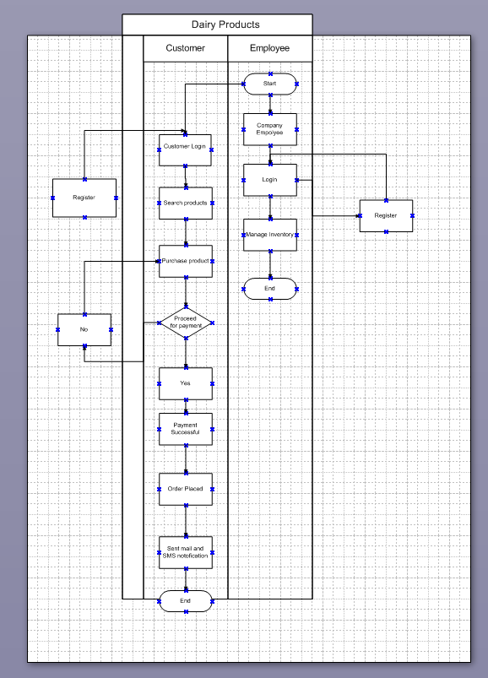

Assignment 2:
1. Write an introduction letter to a client introducing yourself as a business analyst in charge of working with the client and his team to start the business understanding process.

Subject: Introduction - Business Analyst for Business Understanding Process
Dear Sir/Madam,
My name is Krishna, and I am a Business Analyst at Wipro. I'm writing to introduce myself as the individual who will be working with you and your team to initiate the business understanding process for our upcoming project. I am eager to collaborate with you and your team to ensure a thorough understanding of your business needs and objectives.
Over the next few weeks, I will be focusing on engaging with your team to gather information, understand your current processes, and identify key requirements for the project. This will involve data analysis, conducting interviews, workshops, document analysis. My goal is to establish a strong foundation for the project by ensuring we have a clear and shared understanding of your business goals, challenges, and desired outcomes.
I look forward to our collaboration and am confident that, through open communication and active participation, we can achieve a successful project outcome. Please feel free to reach out to me at +91 8149700463 or krishna.11@rediffmail.com if you have any questions.

Sincerely,
Krishna Babhulgaonkar
Business Analyst
Wipro

2. Prepare a brief BRD and SRS for a project- Horoscope or Ticketing system or online store.

BRD – Business Requirement Document
Project Name: Online Retail Store
Prepared By: Krishna Babhulgaonkar
Date: 3 August, 2025

1. Purpose
To create an online store platform that helps users to browse, search, and purchase products online. The platform should support user registration, product management, shopping cart, order management, and payment processing.

2. Business Objectives
- Increase product visibility and customer reach
- Enable secure online transactions
- Provide good shopping experience
- Improve order processing efficiency

3. Scope
- Product catalog with search option
- User account management
- Shopping cart and checkout
- Payment gateway integration
- Order history and tracking
- Admin dashboard for managing inventory and orders

4. Assumptions and Constraints
- Users must have internet access
- System must be mobile-responsive
- Initial launch in one region with USD as currency

Software Requirements Specification (SRS)
Project Name: Online Retail Store
Prepared By: Krishna Babhulgaonkar
Date: 3 August, 2025
1. Purpose
This document outlines the functional and non-functional requirements for the online store application.

2. Description
The system is a standalone web application to be hosted on cloud servers.

2.2 User Classes and Characteristics
- Guest Users: Can browse products, search, view details
- Registered Users: Can purchase items, view order history
- Admins: Manage products, users, and orders

3. Functional Requirements

3.1 User Registration and Authentication
- Users can sign up and log in with email/password
- Passwords stored using cache memory

3.2 Product Catalog
- View product listings with pagination
- Filter products by category, price, brand
- View product details and reviews

3.3 Shopping Cart
- Add/remove items to/from cart
- Update item quantities
- View cart summary

3.4 Checkout and Payments
- Collect shipping address
- Process payment via third-party gateway
- Generate order confirmation

3.5 Order Management
- View past orders and their status
- Cancel or return eligible orders

3.6 Admin Panel
- CRUD operations on products
- View and manage user accounts
- Monitor and update order status

4. Non-Functional Requirements
- Performance: Page load under 3 seconds
- Security: Use HTTPS, secure payment APIs, SQL/NoSQL injection prevention
- Scalability: Support up to 10,000 concurrent users
- Usability: Mobile-first responsive design
- Availability: 99.5% uptime

5. External Interfaces
- Payment Gateway API
- Email Service for order confirmations
- Database – MySQL

3. Make an ERD of creating a support ticket/Ticketing life cycle.

Answer:

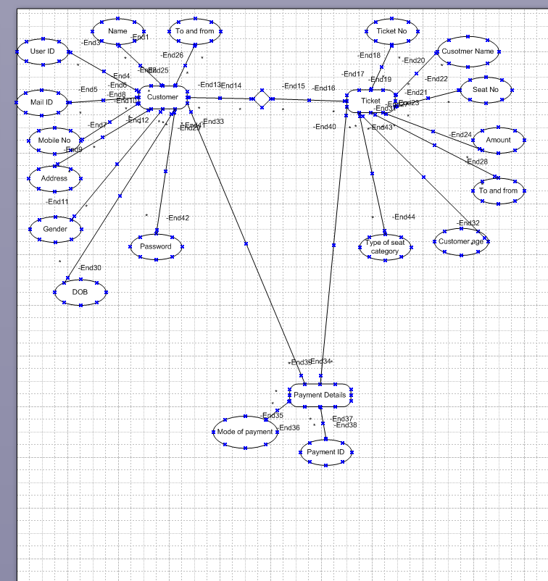

4. User story of shopping from ecommerce.

Answer:

User Story: 01 | Task: Register |  | Priority: High
As a user
I am able to register in application
So that
I am able to login.
BV: 200 |  | CP:3
Acceptance Criteria: Application, mobile, Registration page

User Story: 02 | Task: Login |  | Priority: High
As a user
I am able to login in application
So that
I am able to search and buy products.
BV: 200 |  | CP: 3
Acceptance Criteria: Valid user id and password, login page

User Story: 03 | Task: Search |  | Priority: High
As a user
I am able to search product
So that
I am able to buy products.
BV: 200 |  | CP: 3
Acceptance Criteria: search products, search bar

User Story: 04 | Task: Add to cart |  | Priority: High
As a user
I want to add product in cart
So that
I can purchase it later.
BV: 200 |  | CP:3
Acceptance Criteria: List of products, login credentials

User Story: 05 | Task: Payment method selection |  | Priority: High
As a user
I am able to select payment method
So that
I am able to select payment method for payment.
BV: 200 |  | CP: 3
Acceptance Criteria: selected product, price of that product and options for payment

User Story: 06 | Task: View Details |  | Priority: High
As a customer
I am able to view specification
So that
I am able to get specific details before purchasing.
BV: 200 |  | CP: 3
Acceptance criteria: List of products, details of product

User story: 07 | Task: Account creation |  | Priority: High
As a user
I want to create my account
so that
I can save my information and track my orders
BV: 200 |  | CP: 3
Acceptance Criteria: name of user, mob no, email id

User Story: 08 | Task: save payment details |  | Priority: High
As a user
I want to save my payment details
so that
I can save my payment information for future purchase.
BV: 200 |  | CP: 3
Acceptance Criteria: Payment window, card details

User Story: 09 | Task: Order tracking |  | Priority: High
As a user
I am able to track my order
So that
I can know when to expect delivery.
BV: 200 |  | CP: 3
Acceptance Criteria: Order details, status of order

User Story: 10 | Task: Review and Feedback |  | Priority: High
As a user
I am able to write review and feedbacks on products
So that
Other can also know about product quality
BV: 200 |  | CP: 3
Acceptance Criteria: review and feedback window

User Story: 11 | Task: Product comparison |  | Priority: High
As a user
I am able to compare products
So that
I can choose best product.
BV: 200 |  | CP: 3
Acceptance Criteria: Show products, compare option

User Story: 12 | Task: Recommendations |  | Priority: High
As a user
I want recommendation
So that
I can purchase various products.
BV: 200 |  | CP: 3
Acceptance Criteria: Recommendations, product list

User Story: 13 | Task: wish list |  | Priority: High
As a user
I want specific wish list function
So that
I am able to save items which I like.
BV: 200 |  | CP:3
Acceptance Criteria: Wish list button, Login
User Story: 14 | Task: Customer support |  | Priority: High
As a user
I am able to contact customer support
So that
I can get easily answers for my queries.
BV: 200 |  | CP: 3
Acceptance Criteria: login, customer contact no, feedback

User Story: 15 | Task: |  | Priority: High
As a user
I want to be able create multiple wish list
So that
I can save items in different category.

BV: 200 |  | CP: 3
Acceptance Criteria: Wish list button, Login, categories

User Story: 16 | Task: Share wish list |  | Priority: Medium
As a user
I want able to share wish list with other
So that
Others can view my wish list.
BV: 100 |  | CP: 1
Acceptance Criteria: Wish list, share list button

User Story: 18 | Task: sort and filter |  | Priority: High
As a user
I am able to sort and filter my wish list items
So that
I can get clear idea about specific category.

BV: 200 |  | CP: 3
Acceptance Criteria: wish list, sort, filter button

User Story: 19 | Task: delivery status |  | Priority: High
As a user
I want able to check delivery status before ordering
So that
I can get date when order is going to arrive.
BV: 200 |  | CP: 3
Acceptance Criteria: Order details, address with pin code and date of delivering

User Story: 20 | Task: select from wish list |  | Priority: High
As a user
I am able to select items from wish list
So that
I am able to order from my wish list.
BV: 200 |  | CP: 3
Acceptance Criteria: all wish lists, category wise wish list

User Story: 21 | Task: offers |  | Priority: High
As a user
I am able to avail offers
So that
I can avail discounts by adding offers.
BV: 200 |  | CP: 3
Acceptance Criteria: Order details, purchase option, text box to enter offer code

User Story: 22 | Task: Manage products |  | Priority: High
As a admin
I am able to manage products
So that
I am able to add, delete or modify and update products.
BV: 200 |  | CP: 3
Acceptance criteria: List of all products, edit option to update products.

User Story: 23 | Task: Notification |  | Priority: High
As a user
I am able to get notification about order
So that
I will get details about order.
BV: 200 |  | CP: 3
Acceptance Criteria: Mobile no, email id, order details

User Story: 24 | Task: Notification |  | Priority: High
As a admin
I am able to get notification about order
So that
I will get details about order.
BV: 200 |  | CP: 3
Acceptance Criteria: Mobile no, email id, order id and details

User Story: 25 | Task: Inventory Management |  | Priority: High
As a vendor
I am able to manage my inventory
So that
I can sell variety of products.
BV: 200 |  | CP: 3
Acceptance Criteria: Vendor user ID and password, access for inventory management

User Story: 26 | Task: Feedback and reviews |  | Priority: High
As a vendor
I am able see feedback and reviews
So that
I can understand about any shortfalls in product.

BV: 200 |  | CP: 3
Acceptance Criteria: Vendor user ID and password, review window

User Story: 27 | Task: Report generation |  | Priority: High
As a vendor
I am able to generate reports
So that
I can watch out about selling of various products.
BV: 200 |  | CP: 3
Acceptance Criteria: Vendor user ID and password, access for report generation

User Story: 28 | Task: Notification update |  | Priority: High
As a user
I want notification on mail, SMSs about new products
So that
I can add them or purchase.
BV: 200 |  | CP: 3
Acceptance Criteria: e Mail, Mobile no.,
User Story: 29 | Task: report generation |  | Priority: High
As a vendor
I want to generate product wise report
So that
I am able to get update or trending products.
BV: 200 |  | CP: 3
Acceptance Criteria: Vender user ID and password, filter option for product

User Story: 30 | Task: customer addition |  | Priority: High
As a admin
I want to add more users
So that
It will increases sell and visits for application.
BV: 200 |  | CP: 3
Acceptance Criteria: Login and password

User Story: 31 | Task: Vendor addition |  | Priority: High
As a admin
I want to add more vendors
So that
It will increase variety of products.
BV: 200 |  | CP: 3
Acceptance Criteria: Login and password of admin

User Story: 32 | Task: Report generation |  | Priority: High
As a admin
I want to generate total reports
So that
I am able to understand about sell.
BV: 200 |  | CP: 3
Acceptance Criteria: Admin ID and password

User Story: 33 | Task: Report generation |  | Priority: High
As a admin
I want to generate product or category wise reports
So that
I am able to generate specific report.
BV: 200 |  | CP: 3
Acceptance Criteria: Admin user ID and password

User Story: 34 | Task: Register |  | Priority: High
As a vendor
I want to do registration
So that
I am able to register in application.
BV: 200 |  | CP:3
Acceptance Criteria: Name, mobile no., email id

User Story: 35 | Task: Login |  | Priority: High
As a vendor
I want to do login
So that
I am able to login in application and upload products.
BV: 200 |  | CP: 3
Acceptance Criteria: Successful Vendor registration

User Story: 36 | Task: Payment status |  | Priority: High
As a vendor
I want to see payment status
So that
I am able to confirm about payment
BV:200 |  | CP:3
Acceptance Criteria: vendor login id and password

User story: 37 | Task: Payment report |  | Priority
As a vendor
I want to generate payment report
So that
I am able to see how much transactions are done and pending.
BV: 200 |  | CP: 3
Acceptance Criteria: Vendor user id and password

User Story: 38 | Task: Payment report |  | Priority: High
As a admin
I want to generate payment report
So that
I am able to see how much transactions are done and pending.
BV: 200 |  | CP: 3
Acceptance Criteria: Admin user ID and password

User Story: 39 | Task: Order tracking |  | Priority: High
As a vendor
I want to track order
So that
I am able to track order.
BV: 200 |  | CP: 3
Acceptance Criteria: login id and password, order tracking option

User Story: 40 | Task: user and vendor report generation |  | Priority: High
As a admin
I want to generate reports
So that
I am able to generate user and vendor report.
BV: 200 |  | CP: 3
Acceptance Criteria: admin login id and password

