Question 1 – Functional Requirements
Answer:
Req ID | Req Name | Req Description | Priority
FR-0001 | User Registration | The system shall allow new users (Farmers/Manufacturers) to create an account by providing email ID and password. | 9
FR-0002 | User Login/Authentication | The system shall allow existing users to log in using valid credentials. | 9
FR-0003 | Password Management | The system shall allow users to reset or update their password in case they forget it. | 7
FR-0004 | Role-based Access | The system shall support different roles: Farmers (buyers) and Manufacturers (sellers). | 8
FR-0005 | Manufacturer Product Upload | The system shall allow manufacturers to add product details (type, price, description, stock availability). | 9
FR-0006 | Product Catalog | The system shall display all available products in a categorized product catalog (Seeds, Fertilizers, Pesticides). | 9
FR-0007 | Product Search | The system shall allow farmers to search for products by name, keyword, or category. | 9
FR-0008 | Product Details View | The system shall allow users to view detailed information of a product including manufacturer, price, and stock details. | 8
FR-0009 | Shopping Cart / Buy-Later | The system shall allow farmers to add products to a shopping cart or to a "buy later" list. | 8
FR-0010 | Order Placement | The system shall allow farmers to place an order for selected products from the cart. | 9
FR-0011 | Payment Methods | The system shall allow farmers to pay via Cash on Delivery (COD), Credit/Debit Card, or UPI. | 9
FR-0012 | Payment Confirmation | The system shall confirm successful or failed transaction to the buyer. | 8
FR-0013 | Delivery Tracking | The system shall allow farmers to track the current status and location of their order. | 9
FR-0014 | Order History | The system shall maintain and display order history for each user. | 7
FR-0015 | Email Notifications | The system shall send email updates to farmers regarding order placement, dispatch, and delivery. | 8
FR-0016 | Manufacturer Notifications | The system shall notify manufacturers whenever a new order is placed for their products. | 7
FR-0017 | Secure Access | The system shall ensure secure access to user accounts and sensitive payment data using industry-standard encryption and authentication measures. | 9
FR-0018 | Product Stock Management | The system shall allow manufacturers to update and manage stock availability of products. | 8
FR-0019 | User Profile Management | The system shall allow users to view and edit their profile details such as email, password, delivery address, and contact number. | 7
FR-0020 | Admin Dashboard | The system shall provide admin with ability to monitor user activity, product listings, and transactions. | 6

Non-Functional Requirements

Req ID | Req Name | Req Description | Priority
NFR-0101 | Response Time | The system shall load product catalog pages within3 secondsunder normal load. | 9
NFR-0102 | Concurrent Users | The system shall support at least100,000 concurrent userswithout performance degradation. | 9
NFR-0103 | Scalability | The application shall be scalable to support a50% increase in users each year. | 8
NFR-0104 | Data Encryption | All sensitive data (passwords, payment details) shall be stored and transmitted using AES-256 encryption. | 9
NFR-0105 | Authentication Strength | Passwords shall meet security criteria (minimum 8 characters, 1 uppercase, 1 digit, 1 special character). | 9
NFR-0106 | Session Timeout | User sessions shall automatically expire and log out after15 minutes of inactivity. | 8
NFR-0107 | System Uptime | The application shall have a minimum uptime of 99.5% monthly availability. | 9
NFR-0108 | Disaster Recovery | The system shall be recoverable from disaster within4 hourswithno data loss greater than 15 minutes (RPO). | 8
NFR-0109 | Order Processing Accuracy | The system shall ensure 99.9% accuracyin processing and tracking farmer orders. | 9
NFR-0110 | Transaction Integrity | The system shall ensureatomic transactionsfor payments (no partial payments recorded). | 9
NFR-0111 | UI/UX Simplicity | The platform shall have auser-friendly and intuitive interface so that farmers with minimal digital literacy can use it. | 9
NFR-0112 | Multi-language Support | The application shall supportat least 3 regional languagesfor farmers in remote areas. | 8
NFR-0113 | Accessibility Compliance | The platform shall comply with WCAG 2.1 accessibility standards for differently-abled users. | 7
NFR-0114 | Cross-Platform Support | The application shall run on Web, Android, and iOS platforms. | 9
NFR-0115 | Modular Architecture | The system shall be built on a modular architecture (micro services preferred) to facilitate easy updates. | 8
NFR-0116 | Documentation | All system modules shall be documented withuser guides and technical design documents. | 7
NFR-0117 | Payment Gateway Integration | The system shall support integration withUPI, Credit/Debit cards, and COD payment gateways seamlessly. | 9
NFR-0118 | Data Privacy Compliance | The system shall comply withIT Act 2000 (India) & GDPR standards regarding data privacy. | 9
NFR-0119 | System Logging | The system shall maintain logs for all significant activities (login, payment, order)with retrieval for 1 year. | 8
NFR-0120 | Alert System | The system shall automatically trigger alerts forfailed payments, server downtime, or security violations. | 8

Question 2–Minimum 5-page designs
Answer:
Homepage:
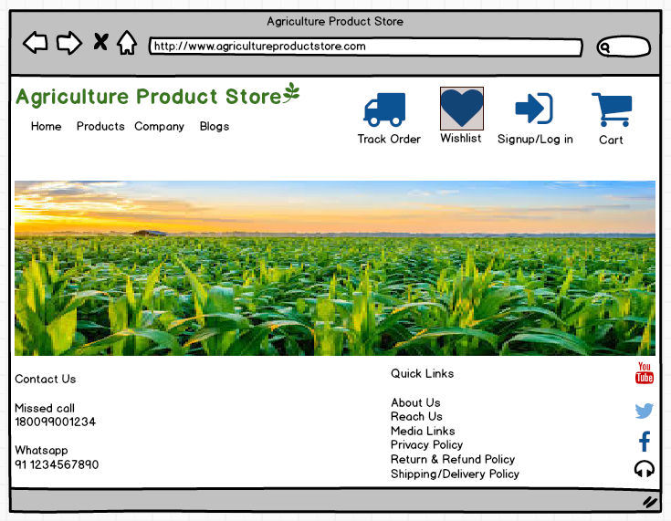

Product Page

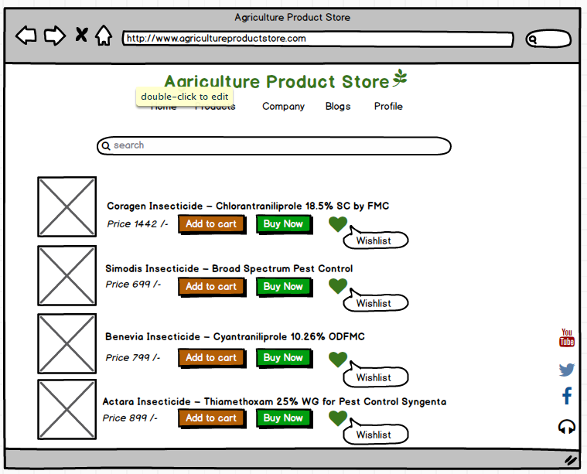

Login / Signup Page

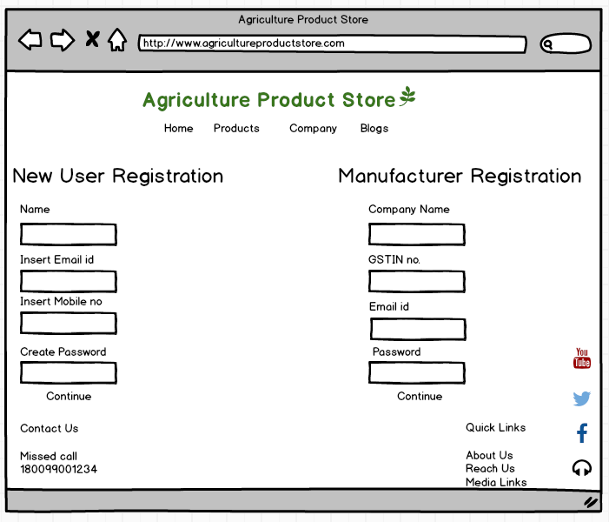

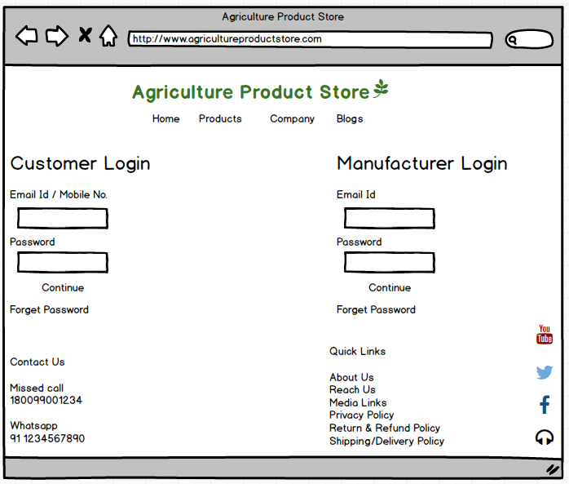

Shopping Cart

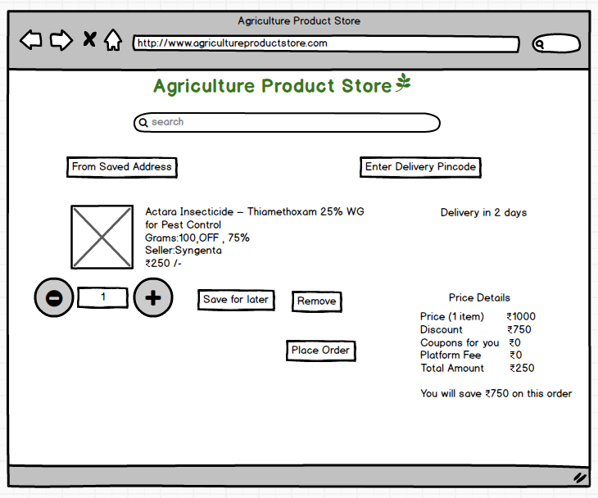

Order Tracking

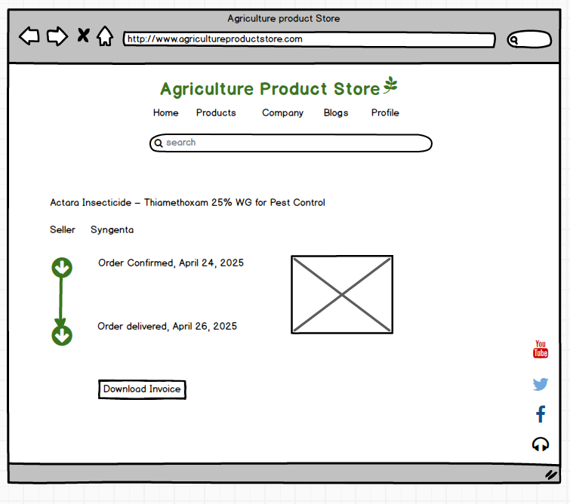

Prototype

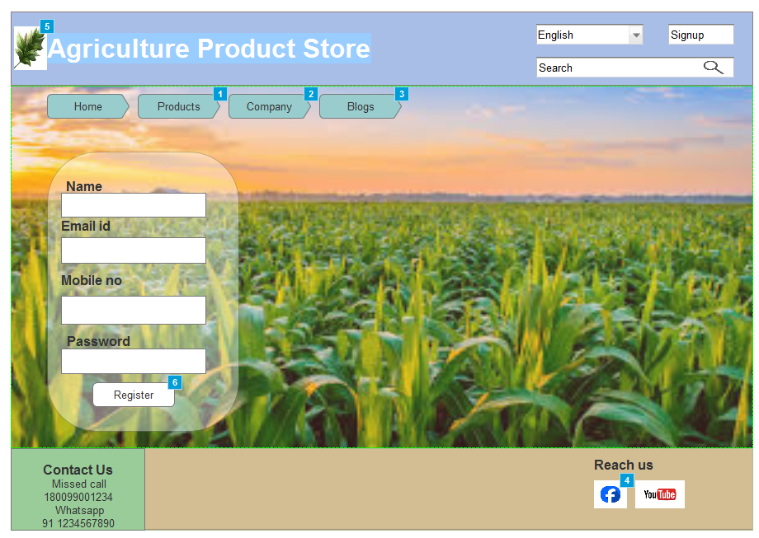

Question 3 – Tools (Visio, Balsamiq)
Answer
Tools Used for Wireframes and Prototypes
1. Microsoft Visio
- Used for creating flowcharts, process diagrams, use case diagrams, and high-level schematic wireframes for system design and documentation.
- Benefits: Excellent for professional documentation, process mapping, and visually representing system workflows and interactions between components.
2. Balsamiq Mock-ups
- Used for quick, low-fidelity wireframes and user interface (UI) prototyping. Enables rapid visualization of application screens, user flows, and interface components.
- Benefits: Intuitive drag-and-drop interface, designed for brainstorming UI layouts, stakeholder reviews, and gathering feedback before development begins.
For the above concepts, Azure Rp and Balsamiq are primary tools used for wireframing, prototyping, and communicating design ideas effectively with stakeholders and teams

Microsoft Azure
- Cloud computing platform to host, deploy, and manage web and mobile applications.
- Capabilities for Prototyping & Development:
  - Azure App Services: Host deployment-ready prototypes and proof-of-concept apps quickly.
  - DevOps: Use Azure DevOps for agile project management, CI/CD, code versioning, and collaborative workflow.
  - Integration: Seamlessly integrate prototype workflows from Visio/Balsamiq and deploy apps in the cloud for stakeholder review or live testing.
  - Azure for Developers: Provides scaffolding, infrastructure, and scaling options for moving from prototype to production

Question 4 – RTM
Answer
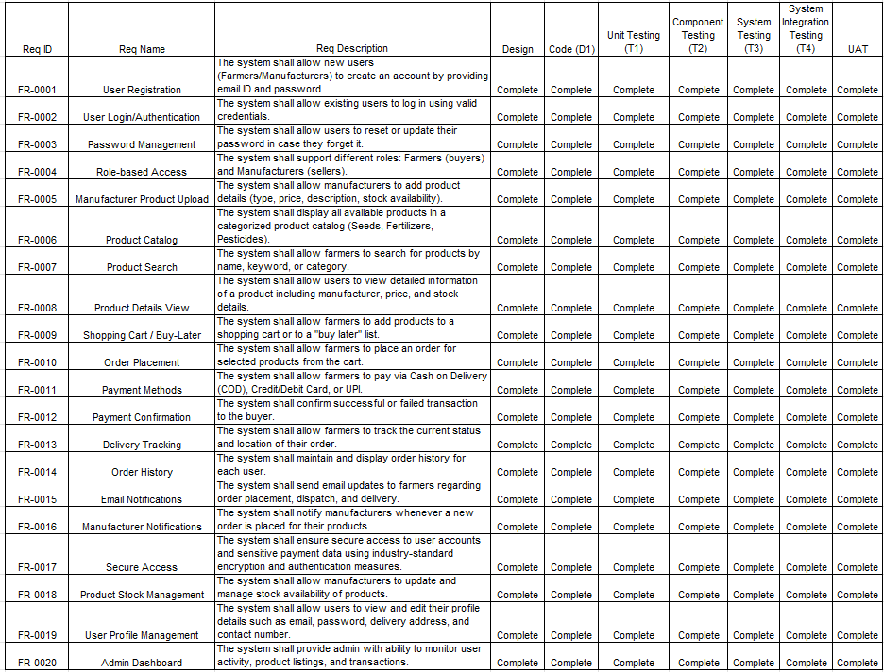

Non-functional Requirements
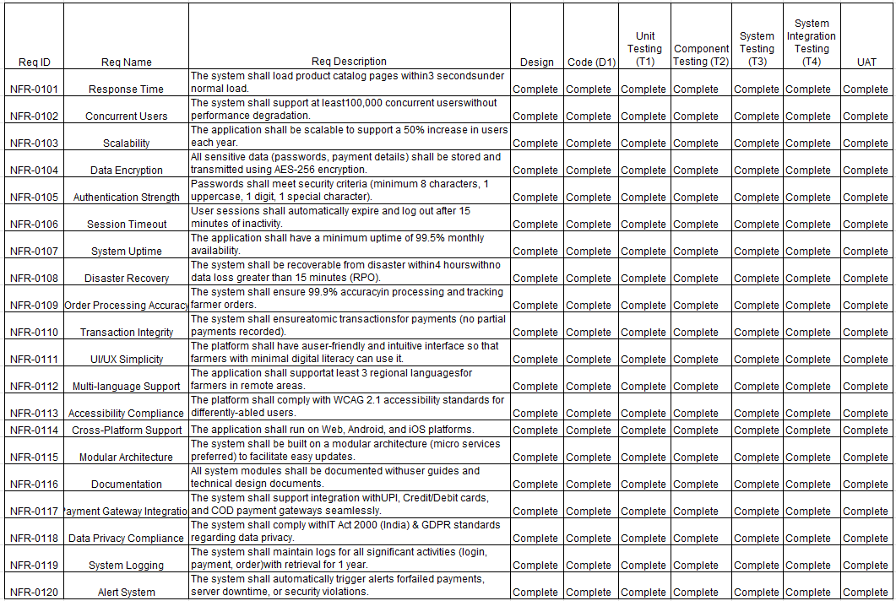
Answer

Question 5 – 10 Test Case Documents
Answer
 | Test Case ID | TC001 | Test Case Name | User Registration
 | Project ID | AGRO-001 | Project Name | Online Agriculture Store
 | PM ID | PM01 | PM Name | Mr.Vandanam
 | Test Strategy ID | TS01 | Tester ID | TST01
1 | Test Plan ID | TP01 | Tester Name | Ms.Alekya
 | Test Schedule ID | TSCH01 | Date of Test | 09-09-2025
 | Scenario | Register new user with valid and invalid data
 | Link to that page | http://onlineagriculturestore.com/register
 | Input Data | Email: peter@mail.com, Password: Peter@123
 | Expected Behaviour | Account created, confirmation email sent
 | Actual Behaviour | Account created, email received
 | Comments | Success, Confirmation matches
 | Resul (Pass/Fail) | Pass

 | Test Case ID | TC002 | Test Case Name | User Login
 | Project ID | AGRO-001 | Project Name | Online Agriculture Store
 | PM ID | PM01 | PM Name | Mr.Vandanam
 | Test Strategy ID | TS01 | Tester ID | TST02
2 | Test Plan ID | TP01 | Tester Name | Mr.Jason
 | Test Schedule ID | TSCH02 | Date of Test | 09-09-2025
 | Scenario | Login using valid credentials
 | Link to that page | http://onlineagriculturestore.com/login
 | Input Data | Email: peter@mail.com, Password: Peter@123
 | Expected Behaviour | User Dashboard Loads
 | Actual Behaviour | Dashboard Loads
 | Comments | Login Matches expected
 | Resul (Pass/Fail) | Pass

 | Test Case ID | TC003 | Test Case Name | Product Search
 | Project ID | AGRO-001 | Project Name | Online Agriculture Store
 | PM ID | PM01 | PM Name | Mr.Vandanam
 | Test Strategy ID | TS02 | Tester ID | TST01
3 | Test Plan ID | TP01 | Tester Name | Ms.Alekya
 | Test Schedule ID | TSCH03 | Date of Test | 09-09-2025
 | Scenario | Search for fertilizer products
 | Link to that page | http://onlineagriculturestore.com/products
 | Input Data | Search Term: "Fertilizer"
 | Expected Behaviour | Fertilizer products listed
 | Actual Behaviour | Fertilizer products displayed
 | Comments | Search is correct
 | Resul (Pass/Fail) | Pass

 | Test Case ID | TC004 | Test Case Name | Payment Gateway-UPI
 | Project ID | AGRO-001 | Project Name | Online Agriculture Store
 | PM ID | PM01 | PM Name | Mr.Vandanam
 | Test Strategy ID | TS02 | Tester ID | TST02
4 | Test Plan ID | TP01 | Tester Name | Mr.Jason
 | Test Schedule ID | TSCH04 | Date of Test | 09-09-2025
 | Scenario | Make Payment via UPI
 | Link to that page | http://onlineagriculturestore.com/payment
 | Input Data | UPI ID: testupi@okicici, Amount: ?500
 | Expected Behaviour | Payment comfirmation screen displays
 | Actual Behaviour | confirmation page displays
 | Comments | Transaction Successful
 | Resul (Pass/Fail) | Pass

 | Test Case ID | TC005 | Test Case Name | Delivery Tracking Status
 | Project ID | AGRO-001 | Project Name | Online Agriculture Store
 | PM ID | PM01 | PM Name | Mr.Vandanam
 | Test Strategy ID | TS03 | Tester ID | TST01
5 | Test Plan ID | TP01 | Tester Name | Ms.Alekya
 | Test Schedule ID | TSCH05 | Date of Test | 09-09-2025
 | Scenario | Display order delivery status
 | Link to that page | http://onlineagriculturestore.com/order-tracking
 | Input Data | Order ID: 54674
 | Expected Behaviour | Order status and location appears
 | Actual Behaviour | Order Status and location shown
 | Comments | info matches expectation
 | Resul (Pass/Fail) | Pass

 | Test Case ID | TC006 | Test Case Name | Add products to cart
 | Project ID | AGRO-001 | Project Name | Online Agriculture Store
 | PM ID | PM01 | PM Name | Mr.Vandanam
 | Test Strategy ID | TS02 | Tester ID | TST01
6 | Test Plan ID | TP02 | Tester Name | Ms.Alekya
 | Test Schedule ID | TSCH06 | Date of Test | 09-09-2025
 | Scenario | Adding products to shopping cart
 | Link to that page | http://onlineagriculturestore.com/product-details
 | Input Data | Product: Maize Seeds
 | Expected Behaviour | Product appears in cart with correct details
 | Actual Behaviour | Product added successfully
 | Comments | Cart updates correctly
 | Resul (Pass/Fail) | Pass

 | Test Case ID | TC007 | Test Case Name | Payment Gateway-Card
 | Project ID | AGRO-001 | Project Name | Online Agriculture Store
 | PM ID | PM01 | PM Name | Mr.Vandanam
 | Test Strategy ID | TS02 | Tester ID | TST02
7 | Test Plan ID | TP02 | Tester Name | Mr.Jason
 | Test Schedule ID | TSCH07 | Date of Test | 09-09-2025
 | Scenario | Process payment through credit/debit card
 | Link to that page | http://onlineagriculturestore.com/payment
 | Input Data | Card No: 4111111111111, Expiry: 01/25, CVV: 123
 | Expected Behaviour | Payment confirmation shown
 | Actual Behaviour | Payment transaction completed
 | Comments | Card payment processed
 | Resul (Pass/Fail) | Pass

 | Test Case ID | TC008 | Test Case Name | Password Reset
 | Project ID | AGRO-001 | Project Name | Online Agriculture Store
 | PM ID | PM01 | PM Name | Mr.Vandanam
 | Test Strategy ID | TS01 | Tester ID | TST01
8 | Test Plan ID | TP01 | Tester Name | Ms.Alekya
 | Test Schedule ID | TSCH08 | Date of Test | 09-09-2025
 | Scenario | Password reset for valid and invalid users
 | Link to that page | http://onlineagriculturestore.com/password-reset
 | Input Data | Email: peter@mail.com
 | Expected Behaviour | Reset link sent to valid emails
 | Actual Behaviour | Reset link sent successfully
 | Comments | Invalid emails handled
 | Resul (Pass/Fail) | Pass

 | Test Case ID | TC009 | Test Case Name | Order History Display
 | Project ID | AGRO-001 | Project Name | Online Agriculture Store
 | PM ID | PM01 | PM Name | Mr.Vandanam
 | Test Strategy ID | TS03 | Tester ID | TST02
9 | Test Plan ID | TP03 | Tester Name | Mr.Jason
 | Test Schedule ID | TSCH09 | Date of Test | 09-09-2025
 | Scenario | Display order history for logged-in user
 | Link to that page | http://onlineagriculturestore.com/order-history
 | Input Data | User: kevin@mail.com
 | Expected Behaviour | List of past orders with status shown
 | Actual Behaviour | Correct order history displayed
 | Comments | History matches user orders
 | Resul (Pass/Fail) | Pass

 | Test Case ID | TC010 | Test Case Name | Email Notification
 | Project ID | AGRO-001 | Project Name | Online Agriculture Store
 | PM ID | PM01 | PM Name | Mr.Vandanam
 | Test Strategy ID | TS03 | Tester ID | TST01
10 | Test Plan ID | TP03 | Tester Name | Ms.Alekya
 | Test Schedule ID | TSCH10 | Date of Test | 09-09-2025
 | Scenario | Confirmation email on order placement
 | Link to that page | http://onlineagriculturestore.com/order-confirmation
 | Input Data | Order ID: 12345, Email: kevin@mail.com
 | Expected Behaviour | Email sent with order details and tracking link
 | Actual Behaviour | Email received with correct info
 | Comments | Notification sent correctly
 | Resul (Pass/Fail) | Pass

Question 6 – DB Design
Answer

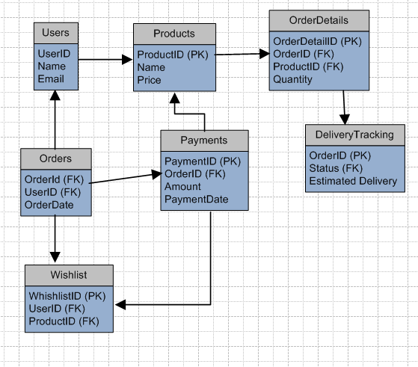

Question 7 – Data Flow Diagram
Answer

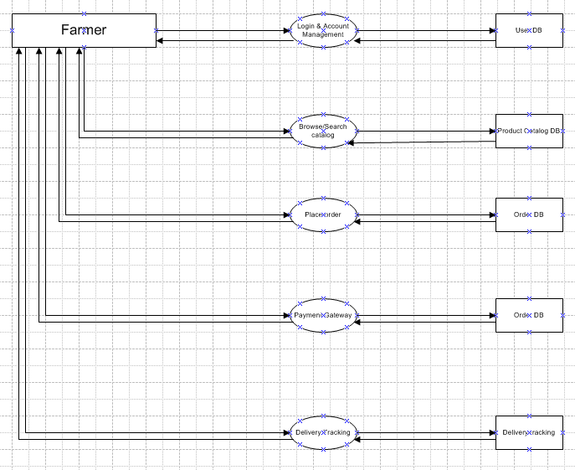

Question 8 – Change Request
Answer
Change Request Process Steps
- Initiation: The change request is formally submitted, detailing the requested change, its rationale, scope, and impact. In this scenario, updates to the taxation structure would be documented clearly by stakeholders or business analysts.
- Impact Analysis: The project team (BA, project manager, delivery head, developers, testers, DB admin) evaluates the implications: how the change in tax structure affects system design, payment processing, reporting modules, compliance, and user experience.
- Stakeholder Review & Approval: The change is presented to the project’s decision-making committee (Mr. Henry, Mr. Pandu, Mr. Dooku) and other stakeholders for review. Approval or feedback is given before any action is taken.
- Resource and Timeline Assessment: Adjustments are made to project budget, timelines, and resources if required (since taxation changes often require additional development and testing).
- Implementation: The technical team (developers, testers, DB admin) updates coding, database structure, and user interfaces as per the new taxation policies. The change is also reflected in the payment module and financial reports.
- Testing & Validation: QA testers (Mr. Jason, Ms. Alekya) ensure the changes function correctly, comply with the new government regulations, and don’t negatively impact other system components.
- Deployment: The updated modules are rolled out to production environment by network and database admin teams.
- Communication: Stakeholders, and especially end users, are notified about changes, typically via email and notifications within the application.
- Documentation & Closure: All changes are documented, project records are updated, and the change request is formally closed.

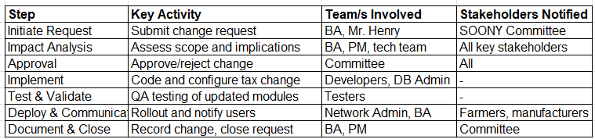

Question 9 – Change Request Vs an Enhancement
Answer
Change Requests vs. Enhancements
- A change request is a formal proposal to alter the baseline scope, requirements, or deliverables of a project. This includes introducing new functionalities not previously documented, such as a farmer-to-consumer sales module and an auction marketplace.
- An enhancement generally refers to improving or extending the capabilities of existing features without changing the fundamental scope, such as optimizing navigation or adding more search filters.
Since the initial requirements focused on providing an agricultural product store for farmers to buy (fertilizers, seeds, pesticides), enabling the sale of crop yields and designing a complete auction system constitutes a significant shift in functionality. These changes involve major design, database, and user experience alterations, requiring re-analysis, approval, and likely adjustments to the project timeline or budget.
Selling Crops and Auction System: Impact
- These new modules involve complex business logic, additional user interfaces for sellers and buyers, real-time bidding processes, and payment/distribution workflows distinct from the existing e-commerce flow for Agri-inputs.
- E-commerce platforms for agricultural products do commonly include direct sales and auction features, but integrating them now requires formal assessment, design, and stakeholder agreement since they were not part of the original Statement of Work.

As a BA my response
- Acknowledge Ben and Kevin’s suggestions and confirm their value for both farmers and customers.
- Clarify that these additions are classified as change requests and will be formally documented and presented to the project committee for review and approval.
- Initiate detailed requirements gathering for the crop sale and auction functionalities to assess their impact, feasibility, and alignment with project goals.
- Communicate the potential influence on timeline, budget, and project resources as part of the change request management process.

Question 10 – Estimations
Answer
Manhours Required = Total hours working per day * Total number of members * Total number of days worked over the specific period

Number of working hours a day = 8 hours
Number of Resources = 11 hours
Time period provided = 18 months = 547 days = 78 weeks (including weekends and public holidays)
Assuming weekends = 156
Assuming public holidays = 10
Total = 166
547-166 = 381 working days
Hence, estimated manhours = 8 hours * 11 resources * 381 days = 33,528 hours required.

Question 11 – UAT / Explain UAT Acceptance process
Answer
- UAT Planning:
Prepare a plan for User Acceptance Testing (UAT) in consultation with the client. This plan should include the scope of testing, test scenarios, test data, and timelines.
- Test Environment Setup:
Ensure that the required test environment is set up and available for the client to perform testing. This may include providing access to the testing environment, necessary test accounts, and any additional resources needed for testing.
- Test Execution:
Coordinate with the client to execute the planned test scenarios. Monitor the testing progress, provide support for any questions or issues that arise, and track the test results.
- Defect Management:
If any defects are identified during UAT, work closely with the client to understand the issues, document them, and track their resolution. Collaborate with the development team to address the reported defects and verify their fixes.
- UAT Sign-off:
Once the client has completed testing and is satisfied with the product's functionality, obtain their formal sign-off or approval. This indicates that the client has accepted the final product and is ready to move forward with its deployment.
Regarding the process to close the project, it typically involves the following steps:
- Final Documentation:
Ensure that all project-related documentation is complete, including requirements, design documents, test cases, and user manuals. Review and update these documents to reflect the final product.
- Project Review:
Conduct a project review meeting with key stakeholders, including the client, to discuss the overall project performance, achievements, and lessons learned. Gather feedback and suggestions for improvement.
- Project Closure Report:
Prepare a project closure report summarizing the project's objectives, deliverables, timeline, budget, and overall success. Include any important metrics or performance indicators.
- Handover or Deployment:
Coordinate with the necessary teams, such as deployment or operations, to ensure a smooth transition of the final product to the production environment. Provide any necessary training or documentation to support the deployment process.
- Post-Project Evaluation:
After the product is deployed and operational, conduct a post-project evaluation to assess its performance, gather user feedback, and identify any areas for further improvement.
UAT Acceptance Process
The User Acceptance Testing (UAT) Acceptance process involves the following steps:
- Test Planning:
Define the scope of UAT and identify the key features or functionalities to be tested. Prepare test scenarios and test cases based on user requirements.
- Test Execution:
Perform the planned test scenarios, following the test cases provided. Validate the system's behaviour against the expected outcomes and verify that it meets the user's acceptance criteria.
- Defect Reporting:
If any issues or defects are identified during UAT, document them in a structured manner, including detailed steps to reproduce the problem. Communicate the issues to the development team for resolution.
- Defect Resolution:
Collaborate with the development team to address the reported defects. Verify the fixes provided by the development team and ensure that the issues are fully resolved.
- Sign-off:
Once all test scenarios have been executed, defects have been resolved, and the system meets the user's acceptance criteria, provide formal sign-off or approval. This signifies that the client accepts the product as meeting their requirements
- UAT Closure:
Document the UAT results, including the test execution summary, any outstanding issues, and the overall assessment of the product
*Communicate the closure of UAT to all stakeholders involved in the testing process.
The UAT Acceptance process ensures that the final product meets the client's expectations and is ready for deployment. It serves as a final validation before the project is considered complete and ready for closure.

Question 12 – Project Closure Document / Explain Project closure document
Answer
A project closure document is a comprehensive report that summarizes the entire project's lifecycle, outcomes, and lessons learned. It serves as a formal record of the project's completion and provides important information for future reference. The document typically includes the following sections.
- Project Overview:
This section provides an overview of the project, including its objectives, scope, and stakeholders involved. It summarizes the project's purpose and sets the context for the closure report.
- Project Achievements:
Here, the document highlights the key achievements and deliverables of the project. It outlines the successful completion of milestones, tasks, and any significant accomplishments that were achieved.
- Project Timeline and Budget:
This section provides an overview of the project timeline, highlighting the start and end dates, major phases, and milestones. It also includes information on the project's budget, including any significant deviations or changes.
- Lessons Learned:
The lessons learned section reflects on the project's successes and challenges. It includes a comprehensive analysis of what worked well and what could have been improved. It highlights valuable insights and recommendations for future projects.
- Stakeholder Feedback:
This section gathers feedback from key stakeholders involved in the project. It includes their opinions, suggestions, and any concerns they may have expressed. The feedback helps in assessing the overall satisfaction and identifying areas for improvement.
- Risks and Issues:
The closure document discusses the risks and issues encountered throughout the project. It outlines the actions taken to mitigate these issues.
- Project Performance:
This section evaluates the project's performance against the defined objectives and success criteria. It assesses factors such as scope adherence, timeline adherence, budget performance, quality of deliverables, and customer satisfaction.
- Project Sign-off:
The closure document includes formal sign-off or approval from key stakeholders, indicating their acceptance and satisfaction with the project's outcomes. This signifies the official closure of the project.
- Project Documentation:
This section provides an overview of the project documentation, including the list of documents produced, their location, and accessibility for future reference.
- Next Steps and Recommendations:
The closure document outlines any recommended actions or next steps following the project's closure. It may include suggestions for further improvements, additional tasks, or follow-up activities.
The project closure document serves as a final report that captures the project's journey, outcomes, and key learnings. It provides a reference for future projects, helps in evaluating project success, and facilitates knowledge transfer to stakeholders involved in the project.

