Mock 4

A company is having manufacturing plants and warehouses in various parts of the country. They manufacture ice-cream and milk products. They want to build software to achieve two goals.
• Manage the inventory
• Quickest delivery to the customers

Assignment 1:

1. Please make a BRD which can be presented to the client along with complete development and resource plan.

Answer – Business Requirements Document (BRD)

Project Title: Inventory and Delivery Optimization System (IDOS)
Client: Chetna Ice cream and Milk Product Pvt. Ltd
Prepared By: Piyush Chaudhary – Business Analyst
Date: 09-11-2025

- Project Overview: Chetna Ice cream and Milk Product Pvt. Ltd operate multiple manufacturing plants and warehouses across the country, producing ice cream and milk-based products. Due to the perishable nature of these goods, the organization requires a robust, integrated software system to:
- Efficiently manage inventory across all locations.
- Enable quickest and cost-effective delivery of products to customers.
The proposed solution, Inventory and Delivery Optimization System (IDOS), will provide real-time visibility, data-driven decision support, and automation across the supply chain.

- Business Objectives:
- Centralized Inventory Control - Real-time tracking of raw materials and finished goods across plants and warehouses.
- Optimize Delivery Time - Ensure the fastest delivery route and optimal warehouse selection for each order.
- Minimize Spoilage - Track expiry, maintain temperature compliance, and reduce wastage.
- Improve Decision Making - Provide actionable dashboards and reports for management.
- Enhance Customer Experience - Enable on-time, transparent, and trackable deliveries.

- Scope:
IN – Scope:
- Inventory management for plants and warehouses.
- Integration with manufacturing and order modules.
- Stock level monitoring with alerts (reorder, expiry).
- Route optimization and delivery scheduling.
- Warehouse-to-customer delivery assignment automation.
- Real-time dashboards for inventory and logistics.
- Mobile and web-based access for stakeholders.

OUT – Of – Scope:
- Financial accounting or billing systems.
- Vendor procurement management.
- Human resource management.
- Hardware procurement (IoT devices, scanners, etc.) — unless specified.
- Third-party logistics integration (optional for future phase).

- AS-IS and TO-BE process summary:

Process | AS-IS | TO-BE
Inventory Tracking | Managed manually or via spreadsheets | Automated, real-time stock updates via system
Order Fulfilment | Warehouse selection done manually | Automated warehouse allocation based on location & stock
Delivery | Drivers decide routes | AI-based route optimization and GPS tracking
Reporting | Periodic manual reports | Live dashboards and analytics
Decision Making | Based on manual data and experience | Based on real-time analytics and forecasting

- Functional Requirements:
- Role-based access for Admin, Warehouse Manager, Delivery Staff, Customer
- Add/update stock, track movement, set reorder levels, batch/expiry tracking
- Order creation, assignment, and status updates
- Manage multiple warehouse details, capacity, and stock transfer
- Auto-route optimization, GPS integration, delivery tracking
- Real-time KPIs (inventory levels, delivery times, wastage)
- SMS/email alerts for order updates, low stock, delivery status

- Non – Functional Requirements:
- Performance - System must process up to 10,000 transactions/hour
- Availability - 99.5% uptime with cloud hosting
- Scalability - Easily add new warehouses or product lines
- Security - Role-based access, data encryption, audit logs
- Usability - Responsive, intuitive web and mobile UI

- Development and Resource Plan:

Project Timeline – 6 Months

Phase | Duration | Deliverables | Resource Required
Requirement Gathering | 2 weeks | BRD, SRS | BA, PM, Client
Design (UI/Architecture) | 3 weeks | Wireframes, ER diagrams, mock-ups | Architect, Designer, BA
Development | 10 weeks | Core modules (Inventory, Delivery, Dashboard) | Developers, QA
Integration & Testing | 4 weeks | UAT, bug fixes | OA, BA
Deployment & Training | 2 weeks | Live system, user training | BA, Developer, Client
Post-Go-Live Support | 2 weeks | Stabilization, maintenance | Maintenance Team

Resource Plan:
Role | Responsibility | Count
Project Manager | Project execution | 1
Business Analyst | Requirement documentation | 1
UI/UX Designer | Wireframes, mock-ups | 1
Backend Developer | Core logic, APIs | 2
Frontend Developer | Web & mobile interfaces | 2
QA Engineer | Testing & quality assurance | 1
Support Engineer | Maintenance post-deployment | 1

- RACI Matrix:

R: Responsible | A: Accountable | C: Consulted | I: Informed
Activity | Project Manager | BA | Developer | QA | Client
Requirements Gathering | A | R | C | C | I
Design | A | R | C | I | C
Development | A | C | R | I | I
Testing | A | I | C | R | I
Deployment | A | C | R | C | I
Approval & Sign-Off | R | C | I | I | A

- Expected Benefits:
- 30–40% reduction in product wastage.
- 25% improvement in delivery time.
- Centralized inventory visibility across all plants.
- Better forecasting and production planning.
- Increased customer satisfaction through timely deliveries.
- Risk and Mitigation:

Risk | Impact | Mitigation
Data migration errors | High | Conduct trial migrations and data validation
Staff resistance to change | Medium | Provide user training and change management
Network downtime | Medium | Implement redundant cloud infrastructure
Integration delays | Medium | Early testing and vendor alignment

- Conclusion: The proposed Inventory and Delivery Optimization System (IDOS) will transform the current manual and disconnected operations into a data-driven, automated, and efficient ecosystem. It will enhance visibility, minimize waste, improve delivery performance, and enable faster decision-making — driving both operational excellence and customer satisfaction.

2. Prepare process flow diagram using your imagination.

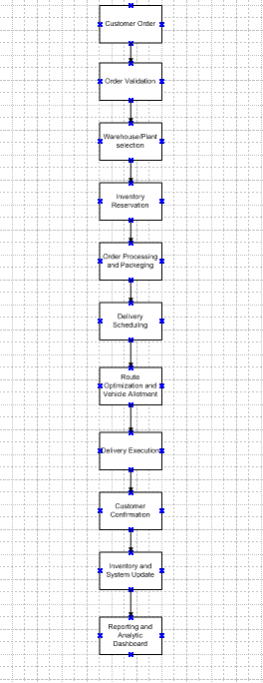

Assignment 2:

1. Write an introduction letter to a client introducing yourself as a business analyst in charge of working with the client and his team to start the business understanding process.

Answer: Introduction Letter to Client

To,
The Client,
Chetna Ice cream and Milk Product Pvt. Ltd

Subject: Introduction as Business Analyst for Inventory and Delivery Optimization System (IDOS)

Dear Client,

I hope this message finds you well.
My name is Piyush Chaudhary, and I have recently been assigned as the Business Analyst for your project. I will be your primary point of contact for understanding your business requirements, gathering functional details, and ensuring that our solution aligns with your organization’s goals and expectations. As part of the business understanding phase, I’ll be working closely with you and your team to:
- Gain a detailed understanding of your current processes and challenges.
- Identify key objectives and success metrics for the proposed solution.
- Document and validate requirements to form the foundation of a clear, actionable roadmap for the project.

I look forward to collaborating with you and your stakeholders to ensure we capture every critical aspect of your operations and deliver a solution that meets your strategic needs.

Please let me know a convenient time for our discovery meeting so we can initiate this process together.

Thank you for your time and cooperation. I’m excited to begin this engagement and contribute to the success of your project.

Warm regards,
Piyush Chaudhary
Business Analyst
Piyushchaudhary013@gmail.com
Contact No - 8435877136

2. Prepare a brief BRD and SRS for a project- Horoscope or Ticketing system or online store.

Answer: Business Requirement Document (BRD)

Project: Online Store
Prepared BY: Piyush Chaudhary
Date: 09-11-2025

- Project Overview: The objective of this project is to design and develop a comprehensive Online Store Platform that enables customers to browse, purchase, and track products through a secure and user-friendly digital interface.
The platform will serve as a digital sales channel, allowing the company to expand its market reach, improve customer experience, and streamline order and inventory management.

- Business Objectives:
- Establish an online platform for direct customer purchases.
- Provide a seamless, intuitive, and secure online shopping journey.
- Automate order processing, inventory tracking, and payments.
- Capture analytics to understand customer behaviour and sales trends.

- Scope:
In-Scope:
- Website and mobile-responsive online store.
- Product catalog management (categories, filters, descriptions, pricing).
- Shopping cart and secure checkout.
- User account management (registration, login, profile, order history).
- Integration with payment gateways (credit/debit cards, UPI, wallets).
- Order management and automated email notifications.
- Inventory synchronization with backend system.
- Basic analytics dashboard

Out-Of-Scope:
- In-store POS integration (future phase).
- Vendor or supplier management system.
- Third-party marketplace
- Advanced AI recommendations

- Key Stakeholders:

Role | Responsibility
Project Sponsor | Approves budget and final deliverables
Business Analyst | Requirement gathering and documentation
Project Manager | Project planning and delivery oversight
Development Team | Designs and builds the system
QA Team | Ensures software quality and compliance
Marketing Team | Handles online promotions and campaigns

- Business Requirements:

ID | Requirements | Description
BR1 | User Registration & Login | Customers can create and manage accounts.
BR2 | Product Browsing | View, filter, and search for products.
BR3 | Shopping Cart | Add, update, or remove products from cart.
BR4 | Secure Checkout | Multiple payment options
BR5 | Order Tracking | Users can view order status and history.
BR6 | Admin Dashboard | Manage products, categories, inventory, and orders.
BR7 | Notification System | Email/SMS alerts for order confirmation, shipment, and delivery.

- Expected Benefits:
- New online sales channel increases overall business reach.
- 24/7 shopping convenience improves satisfaction and loyalty.
- Reduces manual order handling and administrative overhead.
- Insights from user and sales data enable smarter business strategies.
- Establishes digital presence in a fast-growing e-commerce market.

Software Requirement Specification (SRS):

Project Title: Online Store
Prepared By: Piyush Chaudhary
Date: 09-11-2025

- Introduction: The Online Store Platform will allow customers to browse, search, purchase, and track products online.
It will include a web application (and mobile-responsive interface) for end-users and an admin dashboard for managing products, inventory, and orders.
The system will serve as a digital sales channel, reduce manual order handling, and provide data insights to improve decision-making.
It will support role-based access for customers, administrators, and managers.

- Functional Requirements:

ID | Functionality | Description
FR1 | User Management | - Customers can register, log in, and manage profiles.  - Password reset and account verification via email.
FR2 | Product Catalog | - Display products with categories, filters, and search options.  - Each product includes description, price, and image gallery.
FR3 | Shopping Cart | - Add, edit, or remove products.  - Cart auto-updates total cost and applicable taxes.
FR4 | Checkout & Payment | - Secure checkout with multiple payment modes (credit/debit cards, UPI, wallets).  - Generate order ID and confirmation email after successful payment.
FR5 | Order Management | - View order history and current order status (Pending, Shipped, Delivered).  - Admin can update order status and manage dispatch.
FR6 | Inventory Management | - Automatic stock deduction upon order confirmation.  - Low-stock alerts for admin.
FR7 | Notification System | - Send real-time notifications via email/SMS for order placement, shipping, and delivery.

- Non-Functional Requirements:

ID | Module | Description
NFR1 | Performance | The system should support at least 1,000 concurrent users and handle 10,000 transactions per hour.
NFR2 | Scalability | Should support addition of new product categories, payment gateways, and modules in future.
NFR3 | Security | All sensitive data (passwords, card info) must be encrypted. Role-based access control must be enforced.
NFR4 | Availability | The system must maintain 99.5% uptime.
NFR5 | Usability | User interface should be intuitive and responsive on desktop and mobile devices.

- Technology Stack:
- Frontend - React.js / Angular (responsive design using HTML5, CSS3, JavaScript)
- Backend - Node.js / Java Spring Boot
- Database - MySQL / PostgreSQL
- Server & Hosting - AWS / Azure / Google Cloud

- System User:
- Customer - Browse products, place orders, make payments, and track delivery status.
- Administrator - Manage product catalog, stock levels, user accounts, and reports.
- Manager - Monitor sales analytics and oversee order fulfilment.

- Expected Output:
- A fully functional online store accessible via web and mobile browsers.
- Admin dashboard for centralized management of products, users, and orders.
- Automated order confirmation, tracking, and customer notification system.
- Data reports for sales, customers, and product performance.
- Secure payment processing.

- Conclusion: The proposed Online Store Platform will serve as a scalable and secure e-commerce solution designed to enhance customer convenience, improve operational efficiency, and drive business growth.
By integrating online sales, inventory control, and real-time reporting, the system will provide the company with a modern digital presence and long-term competitive advantage.

3. Make an ERD of creating a support ticket/Ticketing life cycle.

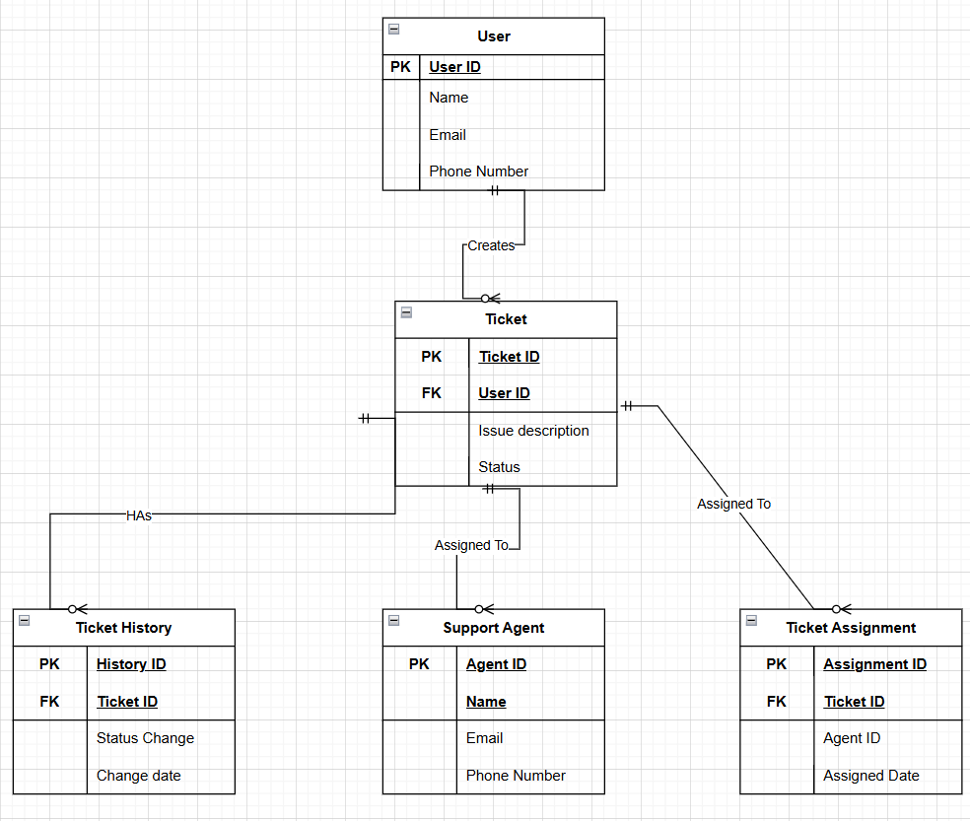

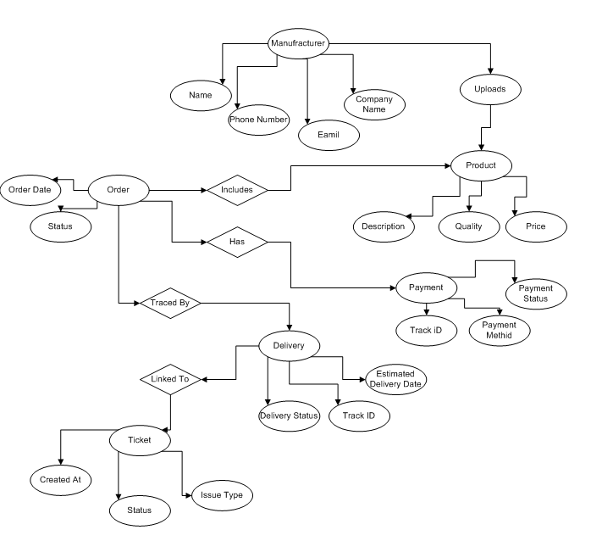

4. User story of shopping from ecommerce.
20 User stories -
User Story No: 1 | Tasks: |  | Priority: High
Value Statement: As a user, I want to register and create an account so that I can save my personal details and order history.
BV: L |  | CP: 3
Acceptance Criteria:
- Registration form validates all fields.
- Confirmation email sent.
- User can log in after activation.

User Story No: 2 | Tasks: |  | Priority: High
Value Statement: As a user, I want to log in securely so that I can access my account safely.
BV: L |  | CP: 2
Acceptance Criteria:
- Login requires correct credentials.
- Password encrypted.
- Error message for invalid login.

User Story No: 3 | Tasks: |  | Priority: High
Value Statement: As a user, I want to browse products by category so that I can easily find what I want.
BV: L |  | CP: 3
Acceptance Criteria:
- Categories display correct product list.
- Filters and search bar functional.

User Story No: 4 | Tasks: |  | Priority: High
Value Statement: As a user, I want to search for products using keywords so that I can quickly find specific items.
BV: L |  | CP: 5
Acceptance Criteria:
- Search results are relevant and fast.
- Autosuggestions appear while typing.

User Story No: 5 | Tasks: |  | Priority: High
Value Statement: As a user, I want to view detailed product information so that I can make an informed purchase decision.
BV: L |  | CP: 3
Acceptance Criteria:
- Product page shows images, price, description, and stock status.

 | User Story No: 6 | Tasks: |  | Priority: High
 | Value Statement: As a user, I want to add products to my cart so that I can review and purchase multiple items together.
 | BV: L |  | CP: 2
Acceptance Criteria:
- Item added to cart successfully.
- Cart updates quantity and price automatically.
User Story No: 7 |  | Tasks: |  | Priority: Medium
Value Statement: As a user, I want to update or remove items in my cart so that I can manage my purchases easily.
BV: M |  |  | CP: 2
Acceptance Criteria:
- Items update instantly.
- Total cost recalculates correctly.

User Story No: 8 | Tasks: |  | Priority: Medium
Value Statement: As a user, I want to apply discount codes or coupons so that I can save money on purchases.
BV: M |  | CP: 3
Acceptance Criteria:
- Valid coupons reduce total cost.
- Invalid codes show appropriate message.

User Story No: 9 | Tasks: |  | Priority: High
Value Statement: As a user, I want to choose different payment options so that I can pay through my preferred method.
BV: L |  | CP: 5
Acceptance Criteria:
- Supports UPI, card, wallet, and COD.
- Successful transaction confirmation message shown

User Story No: 10 | Tasks: |  | Priority: High
Value Statement: As a user, I want to checkout securely so that my personal and payment information is protected.
BV: L |  | CP: 5
Acceptance Criteria:
- SSL encryption active.
- Order placed only after successful payment.

User Story No: 11 | Tasks: |  | Priority: Medium
Value Statement: As a user, I want to receive an order confirmation email/SMS so that I have proof of my purchase.
BV: M |  | CP: 2
Acceptance Criteria:
- Email/SMS sent automatically with order summary.
User Story No: 12 | Tasks: |  | Priority: High
Value Statement: As a user, I want to track my order status so that I know when to expect delivery.
BV: L |  | CP: 3
Acceptance Criteria:
- Shows order status: Placed, Shipped, out for delivery, Delivered.
- Real-time updates visible.

User Story No: 13 | Tasks: |  | Priority: Medium
Value Statement: As a user, I want to view my order history so that I can track my past purchases.
BV: M |  | CP: 3
Acceptance Criteria:
- Displays list of all previous orders with date, price, and status.

User Story No: 14 | Tasks: |  | Priority: Medium
Value Statement: As a user, I want to cancel an order before dispatch so that I can change my decision if needed.
BV: M |  | CP: 3
Acceptance Criteria:
- Cancellation option available until dispatch.
- Refund initiated automatically if prepaid.

User Story No: 15 | Tasks: |  | Priority: Medium
Value Statement: As a user, I want to add products to a Wishlist so that I can purchase them later.
BV: M |  | CP: 2
Acceptance Criteria:
- Wishlist persists after logout.
- Product can be moved from Wishlist to cart.

User Story No: 16 | Tasks: |  | Priority: Medium
Value Statement: As a user, I want to rate, and review purchased products so that I can share my experience.
BV: M |  | CP: 3
Acceptance Criteria:
- Only verified buyers can post reviews.
- Ratings displayed publicly.
User Story No: 17 | Tasks: |  | Priority: Medium
Value Statement: As a user, I want to receive notifications on deals or offers so that I don’t miss discounts.
BV: M |  | CP: 3
Acceptance Criteria:
- Users receive email/SMS/app alerts for deals.
- Option to unsubscribe.

User Story No: 18 | Tasks: |  | Priority: High
Value Statement: As an admin, I want to manage product inventory so that stock levels are always up to date.
BV: L |  | CP: 5
Acceptance Criteria:
- Admin can add/edit/delete products.
- Low-stock alerts triggered automatically.

User Story No: 19 | Tasks: |  | Priority: High
Value Statement: As an admin, I want to view sales and revenue reports so that I can analyse performance.
BV: L |  | CP: 5
Acceptance Criteria:
- Dashboard displays sales trends, top products, and total revenue.

User Story No: 20 | Tasks: |  | Priority: High
Value Statement: As a system, I want to send automated status updates so that users remain informed without manual intervention.
BV: L |  | CP: 3
Acceptance Criteria:
- Trigger-based emails for order placed, shipped, and delivered.
- Logs maintained for all notifications.

