Name: Deepika Shekhawat
Nurturing Process - Capstone Project1 – Part -2/3
COEPD – Traditional Development
Capstone Project1 – Part -2/3 – 100 Marks - Pass 60 %
12 Questions

Online Agriculture Products Store
Mr. Henry, after being successful as a businessman, has become one of the wealthiest persons in the city. Now, Mr. Henry wants to help others to fulfil their dreams. One day, Mr. Henry went to meet his childhood friends Peter, Kevin and Ben. They live in a remote village and do farming. Mr. Henry asked his friends if they are facing any difficulties in their day-to-day work.
Peter told Mr. Henry that he is facing difficulties in procuring fertilizers which are very important for farm. Kevin said that he is also facing the same problem in-case of buying seeds for farming certain crops. Ben raised his concern on lack of pesticides which could help in greatly reducing pests in crops.
After listening to all his friends’ problems, Mr. Henry thought that this is a crucial problem faced not only by his friends but also by so many other farmers. So, Mr. Henry decided to make an online agriculture product store to facilitate remote area farmers to buy agriculture products. Through this Online Web / mobile Application, Farmers and Companies (Fertilizers, seeds and pesticides manufacturing Companies) can communicate directly with each other.
The main purpose to build this online store is to facilitate farmers to buy seeds, pesticides, and fertilizers from anywhere through internet connectivity. Since new users are involved, Application should be user friendly.
This new application should be able to accept the product (fertilizers, seeds, pesticides) details from the manufacturers and should be able to display them to the Farmers. Farmers will browse through these products and select the products what they need and request to buy them and deliver them to farmers location.
Mr. Henry has given this project through his Company SOONY. In SOONY Company, Mr Pandu is Financial Head and Mr Dooku is Project Coordinator. Mr. Henry , Mr Pandu , and Mr Dooku formed one Committee and gave this project to APT IT SOLUTIONS company for Budget 2 Crores INR and
18 months Duration under CSR initiative. Peter, Kevin and Ben are helping the Committee and can be considered as Stakeholders share requirements for the Project.
Mr Karthik is the Delivery Head in APT IT SOLUTIONS company and he reached out to Mr Henry through his connects and Bagged this project. APT IT SOLUTIONS company have Talent pool Available for this Project. Mr Vandanam is project Manager, Ms. Juhi is Senior Java Developer, Mr
Teyson, Ms Lucie, Mr Tucker, Mr Bravo are Java Developers. Network Admin is Mr Mike and DB
Admin is John. Mr Jason and Ms Alekya are the Tester. And you joined this team as a BA.
Question 1 – Audits - 5 Marks
4 Quarterly Audits are planned Q1 , Q2, Q3, Q4 for this Project What is your knowledge on how these Audits will happen for a BA ?

Quarter 1 Audit Report
Requirement Gathering: -
Stage | Requirement Gathering phase- 12weeks (Week-1 to Week 12)
Completed | 12 weeks
Checklist
 | BRD Document
 | Stakeholder Elicitation report
 | Duplicate reports
 | Client signoff reports/Functionalities
 | Email communication: - To, cc, bcc

Quarter 2 Audit Report.
Requirement Analysis: -
Stage | Requirement Analysis phase  -12 weeks (Week-12 to Week 24)
Completed | 12 weeks
Checklist
 | UML diagrams
 | Business requirements to functional requirements
 | Client signoff document’s check
 | Requirement traceability matrix doc control
 | Email communication: - To, cc, bcc

Stage | Design phase-12 weeks (Week-24 to Week 36)
Completed | 12 weeks
Checklist
 | Usage of tools
 | Documented Evidence on client communication
 | Verification of Test cases
 | Stakeholders MOM
 | Email communication: - To, cc, bcc
Quarter 3 Audit Report - Design: -

Quarter 4 Audit Report
Develop and Testing: -
Stage | Development phase- 18 weeks (Week-36 to Week- 54)  Testing Phase- 14 ( week 54 to week 68)
Completed | 32 weeks
Checklist
 | JAD session report
 | End user manual preparation
 | On call with Stakeholders
 | BA and developer MOM
 | Email communication: - To, cc, bcc

Test case reports
Training reports to clients
Technical commination to testing team
Lesson learnt document
Email communication: - To, cc, bcc

Question 2 – BA Approach Strategy - 6 Marks
Before the Project is going to Kick Start, The Committee asked Mr Karthik to submit BA Approach Strategy
Write BA Approach strategy (As a business analyst, what are the steps that you would need to follow to complete a project – What Elicitation Techniques to apply, how to do Stakeholder Analysis RACI/ILS, What Documents to Write, What process to follow to Sign off on the Documents, How to take Approvals from the Client, What Communication Channels to establish n implement, How to Handle Change Requests, How to update the progress of the project to the Stakeholders, How to take signoff on the UAT- Client Project Acceptance Form )
Your Team
Project Manager - Mr Vandanam Senior Java Developer - Ms. Juhi
Java Developers - Mr Teyson, Ms Lucie, Mr Tucker, Mr Bravo Network Admin - Mr Mike
Db Admin - Mr John.
Testers - Mr Jason And Ms Alekya

BA - You Technical Team have assembled to discuss on the Project approach and have finalised to follow 3-tier architecture for this project.

Ans. A Business analysis (BA) approach strategy is to show how business analysis work is conducted which describes the expected outcome of the project. It helps the key stakeholders understand the role of business analyst and set expectations. There are few key considerations creating a BA approach doc they are
- Methodology: - Understand and organise the team
- Deliverables: - Define the project specific deliverables
- Activities: - Identify the activities needed to produce the deliverables.

As a BA steps to complete a project we need to define the following steps: -
- What Elicitation Techniques to apply?
Requirement analysis is to dig the information from the stakeholders before starting the project to gather as much as information possible from the stakeholders. Requirement elicitation serves as the foundation in documenting the requirements before starting a project.
There are 11 elicitation techniques to apply accordingly: -
- Brainstorming: -Group of 8 -10, Ideas can be reviewed and analyses, Ideas come with experience, Innovative ideas can come up.
- Interviews: - Asking questions to a person or group through formal or informal way.
- Focus groups: - Attendee’s of 6-12 through which they elicit ideas and attribute about a specific product in an interactive group environment
- JAD (Joint application development): - Users directly involve in development process involving stakeholders and system analyst by collaborating to identify needs which leads to customer satisfaction and a smaller number of errors.
- Survey/Questionnaire: - Geographically remote and obtaining minimum system requirements.
- Document analysis: - Reading a specific document and understanding the product, process and project such as user manuals, interface details etc
- Prototype: - Screen mock-ups for which there are no manual or existing system to determine the requirements
- Use cases: - Process of gathering and defining the requirements for a software system.
- Workshops: - Structured approach to gather requirements workshops are used to scope, discover, define, prioritize
- Reverse engineering: - Also known as back engineering 2 types: Black box & White Box reverse engineering.

Black Box Testing is a way of software testing in which the internal structure or the program or the code is hidden and nothing is known about it.
White Box Testing is a way of testing the software in which the tester has knowledge about the internal structure or the code or the program of the software.

- Observation: - Observing, shadowing users or even doing part of their job. There are 2 types: - 1 Passive/invisible: - BA observes SME through business routine but does not asks questions
2 Active/visible: - While BA observes the current process and take notes and ask questions and dialogues with the workers.

- How to do Stakeholder Analysis RACI/ILS
Stake holder analysis is based on RACI and ILS matrix. Steps of identifying stake holders are
- Identify the stakeholders
- Stake holders listing document
- Stakeholders’ summary
- RACI matrix
Stake holder analysis helps in identifying the key stake holders who are responsible for the project outcome, identifying them is the key task and categorising them in RACI matrix plays an important role, Project manager usually does a RACI matrix in a real time project
RACI matrix: -
R- Responsible- Responsible to create the document
A- Accountable- Accountable for the delivery of the project
C- Consulted- Providing inputs
I-Informed- Must be informed for any deviation and update of the project

RACI matrix plays an important role in identifying and in easy terms called as sorting out the stake holder in RACI way.
It is very effective and been proven to showcase good results in the projects with a great successful outcome
ILS: - Identify List Summary.

Power Interest grid: - Here all the influential stake holders will be identified who are interested in Stake holders’ analysis using RASI AND ILS.
R/A/C/I | Name of the resource | Designation | Details
Responsible | Mr. Vandanam  MS. Juhi  Mr John | Project Manager  Senior Jawa developer  Data base admin | Contacted and facilitated through email, phone
Accountable | Mr. Vandanam  Mr Karthik  Mr. Akshay Raj | Project Manager  Delivery head  Business analyst | Contacted and facilitated through email, phone
Consulted | Mr. Karthik  Mr Peter, Kevin and Ben  Mr Mike  Mr XYZ | Delivery head  Stake -holders  (Requirement sharing)  Network Admin  Hr Head | Contacted and facilitated through email, phone
Informed | Mr Henry  Mr Pandu  Mr. Dooku  Mr xyz | Committee head  Client BA | Contacted and facilitated through email, phone

- What Documents to Write, what process to follow to Sign off on the Documents
As a BA there are several documents to write they are: -
- Project initiation document (PID): - Defines project problems, solution, key stakeholders.
- Business case: - Business case provided detailed overview of the problem, solution, estimated timelines, resources needed, Budget for the project.
- Requirement Management plan: - This defines how req will be gathered, documented and managed throughout the project phase
- User stories: - High level requirements from end users’ perspective
- Use cases: - Describes the interaction between users and the system

- What process to follow to Sign off on the Documents,
Sign off document: - A sign-off sheet is a business document that confirms agreement on the status of a project or goal. It requires signatures from relevant individuals or stakeholders to acknowledge that they have reviewed the matter and are satisfied. Specifically, a project sign-off sheet serves to formally close a project or acknowledge the delivery of a key deliverable. It includes details such as the project's intended goals, whether they were met, key deliverables, comments, and the project start and end dates. All involved parties sign this document to legally close the project. Additionally, if a project is broken down into multiple deliverables, a deliverable sign-off sheet focuses on individual deliverables and indicates satisfaction with their completion
Happens usually through
- Email
- Face to face discussions
- Stakeholders meet etc.

How to take Approvals from the Client
As a Business Analyst (BA), obtaining client approval is crucial to ensure project success. Here are the steps you can follow to secure approvals from clients:
- Understand Client Needs:
- Requirement Gathering: - Gather requirements through proper and precise elicitation from the clients or stakeholders Identifying why an online agriculture store is to build a product or service.

- Scope and Goals: Define the project's scope and goals early on during project initiation. This understanding will help you address risks and issues effectively.

- Document Requirements: - Documenting all requirements, needs, resources, risks, and stakeholders. Prepare a Business Requirement Document (BRD) and System Requirement Specifications (SRS) based on the gathered information

- Approval Process: - Once requirements are adequately documented, seek approvals from clients and stakeholders. Without client approvals, project delays or scope creep may occur.

What Communication Channels to establish and implement
As a business analyst (BA), establishing effective communication channels is crucial for successful project implementation. Here are some key communication channels to consider:
- Status Reports: Regular status reports help keep stakeholders informed about project progress, milestones, and potential issues.
- Presentations: Use presentations to convey complex information, share findings, and discuss requirements with various stakeholders.
- Video Conferencing: Virtual meetings via video conferencing platforms facilitate real-time discussions, especially when team members are geographically dispersed.
- Chats or Emails: Written communication through chats or emails allows for communication, document sharing, and quick updates.
- Interactive Visuals: Visual aids, such as diagrams, flowcharts

How to Handle Change Requests: -
Change requests by the client is also BA risk as for a change request being a BA we should again Document the change request in (CRL Change Request Log) while a CCB (Change control board) will be appointed then a BA will go through a feasibility study, Effort estimation, Impact analyses (cost and timeframe effected) then the BA will send the request to CCB team to approve or decline the change request. This also can be a huge BA risk.
Will have change Request form then we will do impact analysis, how far we can make the changes- is the change within the budget and timeline- then we have to take approval from PM

How to update the progress of the project to the Stakeholders
As a Business Analyst (BA), effectively communicating project progress to stakeholders is crucial. Here are some steps you can follow:
Project Status Reports: Create regular project status reports. These updates provide high-level information about project progress, risks, and budget.
- Include details such as completed work, upcoming tasks, budget summary, action items, and any issues or risks.
Frequency: Decide how often to share reports based on your project's timeline. Some projects benefit from weekly reporting, while others may need monthly updates.
Communication Channels:
- Hold regular status update meetings.
- Send timely updates via email or project management tools.
- Be available to answer questions and address concerns.
Engage and involving Stakeholders:
- Invite stakeholders to participate in project-related activities, like brainstorming sessions or design reviews.

How to take signoff on the UAT- Client Project Acceptance Form

UAT prepration-conduct UAT-Fix Issues-Acceptance Form-Final Review Meeting and obtain signoff

UAT Client sigh off form is the form which as a BA is taken from the client as a acceptance of the developed software there are steps to take the sign off form they are: -
Prepare the Form: Create a document that outlines the key aspects of the project, including the project title, summary, timeline and the budget.
Review with Stakeholders: Schedule a meeting with relevant stakeholders, including the client, project sponsor, and project team. Present the form and discuss the project's outcomes, success criteria, and any lessons learned.
Obtain Signatures: During the meeting, ensure that all necessary parties review and agree to the content of the form. Collect their signatures as a formal acknowledgment of project acceptance.

Question 3 – 3-Tier Architecture - 5 Marks
Explain and illustrate 3-tier architecture?

3 Tier architecture has 3 layers
- Application layer
- Business logic layer
- Data base layer
Data flowing from the 3 layers explains the 3 tier architecture where the information is passed.

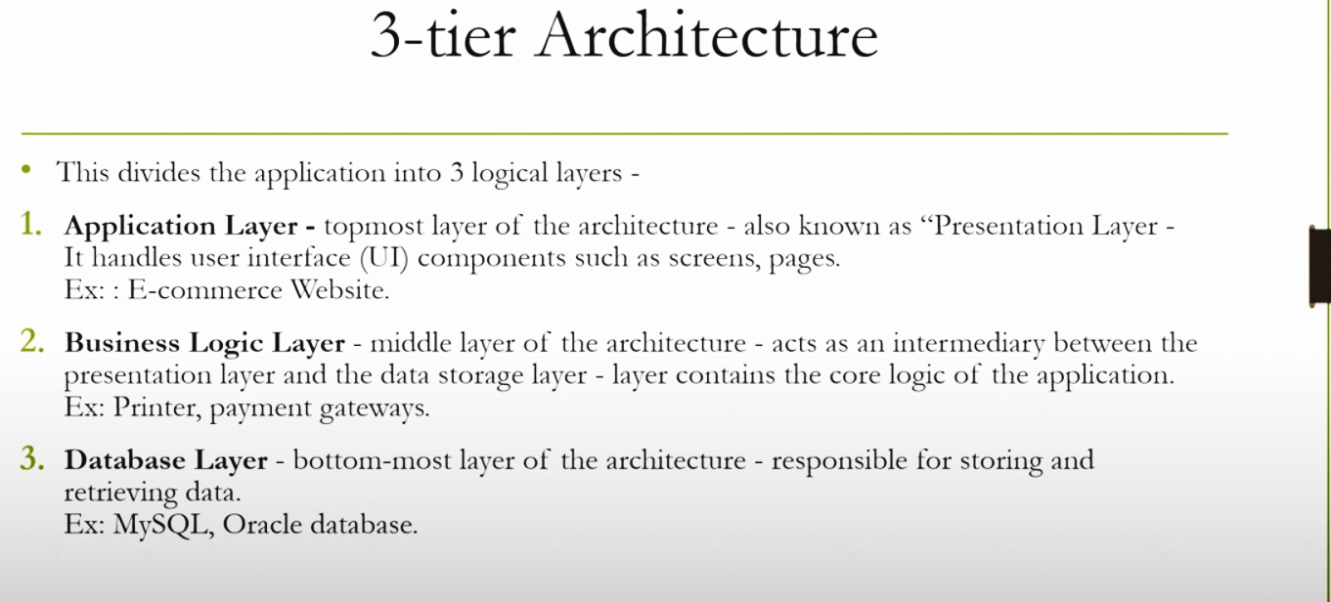

Front end layer (Phone, tablet, desktop)
Application layer

Takes the info from the application layer and the date base layer.
Business logic layer

Has the data / storing the data

Data Layer
3 Tier Architecture

Example: - I want to buy a cricket bat and I approached the showroom (DATA LAYER) selling cricket bats. And asked I want a SG bat.
Information will be passed to the Business logic layer as the BAT is not available within the showroom Business logic layer connects to the 3rd party looking out for a SG bat.
Once the information is procured the information of YES/NO will store in the Data layer and will be given to the front end the customer.

Q4. Business Analyst should keep What points in his/her mind before he frames a Question to ask to the Stakeholder (5W 1H – SMART – RACI – 3 Tier Architecture – Use Cases, Use case Specs, Activity Diagrams, Models, Page designs)
Ans. Starting the project BA role is to follow elicitation techniques (To ask questions) to the stakeholders to get the information about the outcome, Elicitation plays a key role in knowing the requirements of the project. As a BA their a re different types of elicitation technique to choose from
As the project is for Online Agriculture store BA should first understand what are the needs of the stakeholders, what is the output required, What needs to be worked on, What gap is being filled, How to procure data, What is the budget of the project, What is the speculated timeline etc are the key questions to be asked for a elicitation requirements.

5W 1H: - 5W- who, what, when, why, where
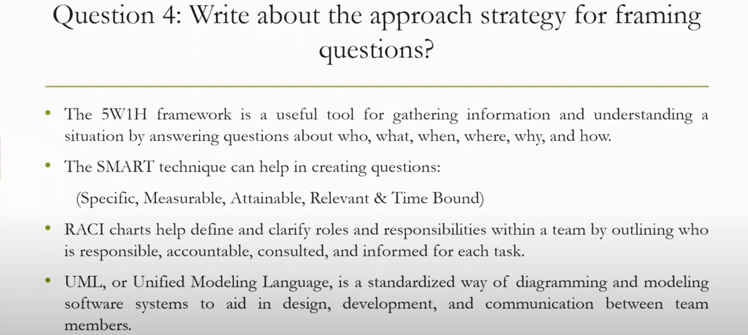
1H- How
5W 1H framework is a Questioning tool used to write down and frame different questions to the client where a details information would be shared, it is useful to gather information and understand the current situations by desired answers.
SMART: -
S | Specific | Goal should be specific
M | Measurable | Is the project measurable with the given matrix
A | Attainable | Can we achieve the target of the project within the time and budget
R | Relevant | Is the project as per the stakeholders requirements
T | Time bound | It should be within the time frame.

RACI: -
R- Responsible- Responsible to create the document
A- Accountable- Accountable for the delivery of the project
C- Consulted- Providing inputs
I-Informed- Must be informed for any deviation and update of the project
RACI matrix plays an important role in identifying and in easy terms called as sorting out the stake holder in RACI way.
It is very effective and been proven to showcase good results in the projects with a great successful outcome. RACI defines the stakeholders responsible to fit in the project and playing an important role in identifying the key/ Important stake holders. It defines to clarify roles and responsibilities who is responsible, accountable, consulted and informed for each task.

3 Tier architecture: - has 3 layers
- Application layer
- Business logic layer
- Data base layer
Data flowing from the 3 layers explains the 3-tier architecture where the information is passed. Here in elicitation techniques 3 tier architecture works as a medium where as a BA we get to know the information shared by the requester will it fit in application layer, business logic layer or data base layer.

3 Tier architecture
Front end layer (Phone, tablet, desktop)
Application layer

Takes the info from the application layer and the date base layer.
Business logic layer

Has the data / storing the data

Data Layer

Use Case: - Use Cases serve as practical tools that help business analysts, developers, and stakeholders identify needs, set goals, and improve collaboration. They provide a structured approach to defining the interactions between systems and users, ensuring that software and systems deliver the intended functionality

Use case Specs: - A use case specification captures the requirements, typically of a system, in the form of a use case. It contains descriptive steps in a logical sequence. This document helps users understand the requirements. Used the unified modelling language (UML). As a business analyst, understanding use cases and how they're structured provides a solid foundation for transitioning to user stories. Use case speciation’s have 2 flows: -
- Basic Flow/ Positive flow
- Alternate flow/ Negative flow
Basic flow: - In positive flow there would be no error which would be causing and all the information runs smoothly without any concern. Every fault in the basic flow leads to a negative flow
Alternate flow: - In alternate flow there is a problem raised and needs to be addressed and different approach needs to be followed.
Here as BA while questioning the stakeholders/clients we need to think in both the way whether the information provided is following a basic flow or a negative flow.

Page Designs: - Page designs or website designs are crucial for creating a User friendly and appealing online website where the clients are attracted and retained.

Q5. As a Business Analyst, What Elicitation Techniques you are aware of? ( BDRFOWJIPQU)
Ans. BDRFOWJIPQU are the different sorts of elicitation technique lets decode it: -
BDRFOWJIPQU
Brainstorming
Document analysis
Reverse engineering
Focus groups
Observation
Workshops
JAD
Interviews
Prototype
Questionnaire/ Survey
Use cases

There are 11 elicitation techniques to apply accordingly: -
- Brainstorming: -Group of 8 -10, Ideas can be reviewed and analyses, Ideas come with experience, Innovative ideas can come up.
- Document analysis: - Reading a specific document and understanding the product, process and project such as user manuals, interface details etc
- Reverse engineering: - Also known as back engineering 2 types: Black box & White Box reverse engineering.
- Focus groups: - Attendees of 6-12 through which they elicit ideas and attribute about a specific product in an interactive group environment
- Observation: - Observing, shadowing users or even doing part of their job. There are 2 types: 1 Passive/invisible: - BA observes SME through business routine but does not ask questions
2 Active/visible: - While BA observes the current process and take notes and ask questions and dialogues with the workers.

- Workshops: - Structured approach to gather requirements workshops are used to scope, discover, define, prioritize
- JAD (Joint application development): - Users directly involve in development process involving stakeholders and system analyst by collaborating to identify needs which leads to customer satisfaction and a smaller number of errors.
- Interviews: - Asking questions to a person or group through formal or informal way.
- Prototype: - Screen mock-ups for which there are no manual or existing system to determine the requirements
- Survey/Questionnaire: - Geographically remote and obtaining minimum system requirements.
- Use cases: - Process of gathering and defining the requirements for a software system.

Q6. Which Elicitation Techniques can be used in this Project and Justify your selection of Elicitation Techniques?
Prototyping
Document Analysis
Use case Specs
Brainstorming

Ans. As a BA given a choice, I would choose Document Analysis as Elicitation Techniques can be used in this Project.
I would justify it by stating that document analysis would help in documenting the current system for example (SOONY Company) which has been already established and running successfully. We would gather majority of information by this technique where a BA would analyse how would the Key stakeholders work and what are their needs and wants. To generalize details for the new system could include interface details for the application, User manuals etc
Advantages: - Could be la lot of information and easy to transfer to the upcoming online Agriculture application requirements documentations
Disadvantages: - Existing documents may often be old and out of date. Systems, Interfaces, requirements, Software application might have changed in all recognition. Keen observation and care need to be taken as it may not reflect what you need from a new system.
Document analysis can be an important gathering phase, Evaluating the document of the present system can assist when making the AS-IS /Current state of the project and process the documents and also when driving the Gap analysis for the scope of the project.
Steps involve: -
Prepare for document analysis: - Evaluate which existing system and business documentation are relevant and appropriate to be studied
Analysing the document: - Study the evaluated document and identifying relevant business details, Questions for follow-up with SME’S
Post Document analysing/wrap up: - Review and confirm the selected details with SME’S. Obtaining the follow-up questions.

Q7. Make suitable Assumptions and identify at least 10 Business Requirements.
Identify Business Requirements (which includes Stakeholder Requirements)
BR001 – Farmers should be able to search for available products in fertilizers, seeds, pesticides
BR002 – Manufacturers should be able to upload and display their products in the application
Fertilizers, seeds, pesticides details from the manufacturers and should be able to display them to the Farmers.
To gather the business requirements from the client, you went to SOONY and met Mr. Henry. When Mr. Henry was asked about the project and what are they expecting from the project, Mr. Henry stated that he is expecting to have a login for all its users (fertilizers, seeds, pesticides manufacturers and Farmers) , a product catalog of fertilizers, seeds, pesticides, a search option to search for products, payment process, and delivery tracking. After doing the stakeholder analysis, you have found out that Peter, Kevin, Ben are the key stakeholders and you have scheduled an appointment to meet them. After meeting with them and trying to gather the stakeholder requirements, Kevin said that, a Farmer should be able to browse through the products catalog once they visit the website and need to have a search option so that they can search for any product they need. Peter said that, if a farmer wants to buy any product or add them to buy-later list, they need to login first using their email id and password. If it is a new user, then they can create a new account by submitting their email ID and creating a secure password. Ben added saying that, Farmers needs to have an easy-to-use payment gateway which should include cash-on-delivery (COD), Credit/Debit card and UPI options so that the user’s experience should be better. Kevin mentioned that, a user gets an email confirmation regarding their order status. A delivery tracker to track the whereabouts of their order
Ans. Business requirements are the requirements which are prescribed as the needs for the application Online agriculture store, Reading the needs of the requirements it helps us segregate the data efficiently and have a clear understanding on how the project needs and wants a are prescribed.

S.No | Requirements | Requirements category | Description
1 | BR001 | Search | Farmers should be able to search for available products in fertilizers, seeds, pesticides
2 | BR002 | Upload and display | Manufacturers should be able to upload and display their products in the application
3 | BR003 | Browse | Farmers should able to browse the product catalog one they visit the website
4 | BR004 | Login | Farmers need to login using email id and password
5 | BR005 | Payment Gateway | Farmers need to have easy to use payment gateway including  COD/Credit/Debit and UPI options
6 | BR006 | Tracking Delivery | Users getting an email confirmation with a delivery tracker to track the status of the order.
7 | BR007 | Add to cart | Farmers can browse and them to buy later list
8 | BR008 | Registration | To buy any products clients need to first register submitting email id and creating a secure password
9 | BR009 | Customer service | For any concerns clients can contact the manufacturers and sort out the concern emerging
10 | BR0010 | Inventory control | Having the inventory in stock whenever needed as the stock does not go out of stock from the website

The above are the suitable assumptions for business requirements.

Q8. List your assumptions
Ans. Assumptions are based on the project. As the project is for Online Agriculture store as BA my assumptions are as follows: -
Assumption-1: - User must be able to login through a link or any social media extensions
Assumption-2: - User being a Farmer would have a clear understanding on the need of the products required for the crop.
Assumption-3: - As most of the farming people are from remote areas, online application would create a huge impact in the competitive market.
Assumption-4: - Manufacture’s need to have a clear understanding on the needs of the farmers requirements and should deliver them with ease and timely manner.
Assumption-5: - Users should be able to login through application or browser.
Assumption-6: - Payment gateways should be swift and user friendly for different forms of payment.
Assumption-7: - Attempting failure to login to the account there should be a security application which sends the registered email id the information of a failed login.
Assumption-8: Product description should be clear and available in multiple languages assuming most of the users being farmers may find difficulties and would prefer their regional language.

Q9. Give Priority 1 to 10 numbers ( 1 being low priority – 10 being high priority) to these

S.No | Requirements | Requirements category | Description | Priority
1 | BR001 | Search | Farmers should be able to search for available products in fertilizers, seeds, pesticides | 8
2 | BR002 | Manufactures Upload and display their products | Manufacturers should be able to upload and display their products in the application | 8
3 | BR003 | Browse | Farmers should able to browse the product catalogue one they visit the website | 9
4 | BR004 | Login | Farmers need to login using email id and password | 10
5 | BR005 | Payment Gateway | Farmers need to have easy to use payment gateway including  COD/Credit/Debit and UPI options | 8
6 | BR006 | Tracking Delivery | Users getting an email confirmation with a delivery tracker to track the status of the order. | 9
7 | BR007 | Add to cart | Farmers can browse and them to buy later list | 5
8 | BR008 | Registration | To buy any products clients need to first register submitting email id and creating a secure password | 9
9 | BR009 | Customer service | For any concerns clients can contact the manufacturers and sort out the concern emerging | 10
10 | BR0010 | Inventory control | Having the inventory in stock whenever needed as the stock does not go out of stock from the website | 8

Q10. Draw use case diagram
Ans. Use case is considered mother of all diagrams. The vital position of a use case will be on how to draw external interfaces. Use case diagrams only showcase positive flow.
Use case diagram only have 4 major elements: -
- The Actor- That the system you are describing interacts with
- The System- {The rectangular box}
- The Use cases- Services the system knows to perform
- The lines- Lines that represent relationship between the elements.

Use case Description: -
Customers: -
- Register/ Creating new account - Through email and set a unique password
- Login to the account- Using web or mobile application- Compulsion /Include
- Browse the products – add to cart
- Place order from the cart- UPI, card – debit, credit, Net banking, COD
System: -
- Will accept the authentication
- Have the product descriptions of the displayed products
- Payment gateway- Easy to use/ UPI, card – debit, credit, Net banking, COD
- Email confirmation sent- After customer placed order email confirmation is sent regarding order status to track.
Actors: -
- Primary Actor- Customer
- Secondary Actor- POS system back end

Essential use case: -
- Weiste (Product catalogue)
- Booking an order
Supporting use case: -
- Customer login
- Check availability of products
- Adding to cart
- Payments: - Card, COD, UPI etc.
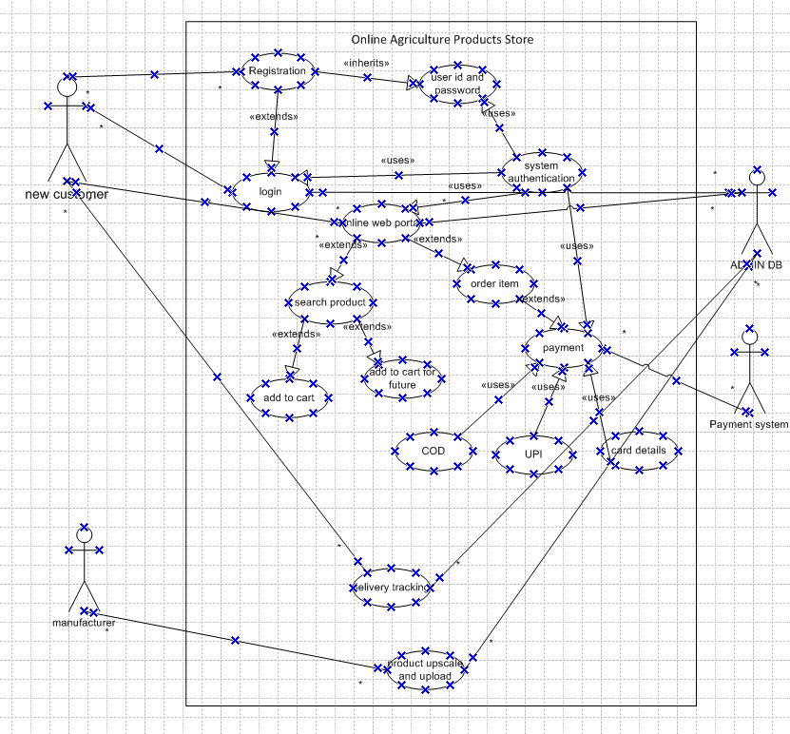
Q11. Prepare use case specs for all use cases
Ans. Use cases specifications provide a detailed information of each use case and its purpose, Actor’s involved, Pre conditions, Post conditions. They provide a detailed and structured information for further proceedings of the project.
A use case specification documents which provides a detailed description of a use case, outlining how users(actors) will interact with the system to achieve a specific goal.
1.Usecase: - User Login -
- Description: - Farmer or Manufacturer can login to their account
- Actors: - Farmer, Manufacturers
- Pre conditions: - Farmer and manufacturer have valid User ID and password
- Post conditions: - User is authenticated and logged into the portal

2.Usecase: -
Browse Product catalogue-
- Description: - Farmer can browse through the online portal for (Fertilizers, Seeds and pesticides)
- Actors: - Farmer
- Pre conditions: - Farmer has to login through user ID and Password
- Post conditions: - The product catalogue is displayed
3. Use Case: - Search Products-
- Description: - Farmer can search specified products in the catalogue
- Actors: - Farmer
- Pre conditions: - Farmer has to login and the product catalogue is displayed
- Post conditions: - Portal displays the searched product
4. Use Case: - User Registration-
- Description: - Farmer or manufacturer can create new account
- Actors: - Farmer
- Pre conditions: - Has to enter valid email id and share the details
- Post conditions: - Users account is created
5. Use Case: Add to Cart-
- Description: - Farmer can products to the cart for future purchase
- Actors: - Farmer
- Pre conditions: - Farmer has to login and the product catalogue is displayed
- Post conditions: - Selected products are added to the cart
6. Use Case: Make Purchase-
- Description: - Farmer can buy selected products
- Actors: - Farmer
- Pre conditions: - Farmer has to login and the product catalogue is displayed
- Post conditions: - Transaction is completed
7 Use Case: Payment flow-
- Description: - Farmer can choose the mode of payment and complete the purchase
- Actors: - Farmer
- Pre conditions: - Farmer has to select products for the purchase
- Post conditions: - Payment is processed and confirmed
8. Order Confirmation: -
- Description: - Portal sends an email confirmation to the farmer about the confirm status
- Actors: - System
- Pre conditions: - Purchase transaction is complete
- Post conditions: - Email or SMS confirmation is sent to the farmer
9. Delivery tracking: -
- Description: - Farmer can track the delivery status of the order.
- Actors: - Farmer
- Pre conditions: - Farmer had made the purchase and received the order status tracking
- Post conditions: - Delivery status is displayed

To present the overall overview here is the tabular format: -
USE CASE ID | UC001
Use Case Name | Online Agriculture application
Created By | Mr. Vikash kumar singh Last Updated by June 12th 2024
Date Created | June 10th 2024 Last Revision date June 14th 2024
Actor | Farmers/users, POS back-end system
Description | This is to create a seamless and user-friendly application for online application store for customers(farmers) to place order for products: - (Fertilizers, seeds, pesticides)
Pre- Condition | Customers to register using email id and create a secure password
Post Condition | After registering customer can place an order from the website
Normal Flow of events/Basic flow/Happy flow | Step-1 Website holds all the products for the customers to order  Step-2 Customer can search for products they need in the website using search option  Step-3 If the farmer wants to buy new product or add them to buy later, they need to login their user id and password  Step-4 New user can create a new account by submitting their email id and secure the password  Step-5 Farmers can place an order by searching in the website  Step-6 Farmers need to use easy to use payment gateway for payment  (COD, Cars- Debit card/credit card, UPI payment)  Step -7 User gets and email confirmation once the order is placed  Step- 8 User can track the delivery using the delivery tracker and find the whereabouts of the order
Alternate Flow | At step-3 If the farmer wants to buy new product or add to buy later, they need to login and if the user is not able to login it will redirect to Forgot username/Password page  At step-5 If the farmers do not find any specific product, they can interact with the manufacturers for help  At step-6 If the users have issues with the payment (Payment not through/server busy/ Payment accepted but confirmation not sent) Alert message or the notification about the payment details should be sent to the requesters registered email id  At step- 8 If the customer placed order and the delivery tracking of the product doesn’t show then the customer should get notification about the tracking with an updated tracking detail
Exceptions  Frequency of use  Assumptions | If internet connectivity is lost during pacing an order /Or the server is busy in the website then / Server is busy please try later notification is shown.  High  It is assumed that the customer has knowledge about the products  If the assumed that customer has knowledge about the internet connect  If is assumed that customer has knowledge on online payments process

Q12. Activity diagrams (minimum 5) Activity Diagrams
Ans. An activity diagram is essentially a flow chart showing flow of the diagram control from activity to activity, Speaks and explains of all activity through system perspective but not actor perspective.
Here 5 activities in the above case study are segregated as: -
- Adding to cart
- Payment
- Delivery
- Cancellation
- Customer Profile

Activity diagram is UML behavior diagram which shows flow of control or object flow with emphasis on the sequence and conditions of the flow. The actions coordinated by activity models can be initiated because other actions finish executing, because objects and data become available, or because some events external to the flow occur.

1. Payment
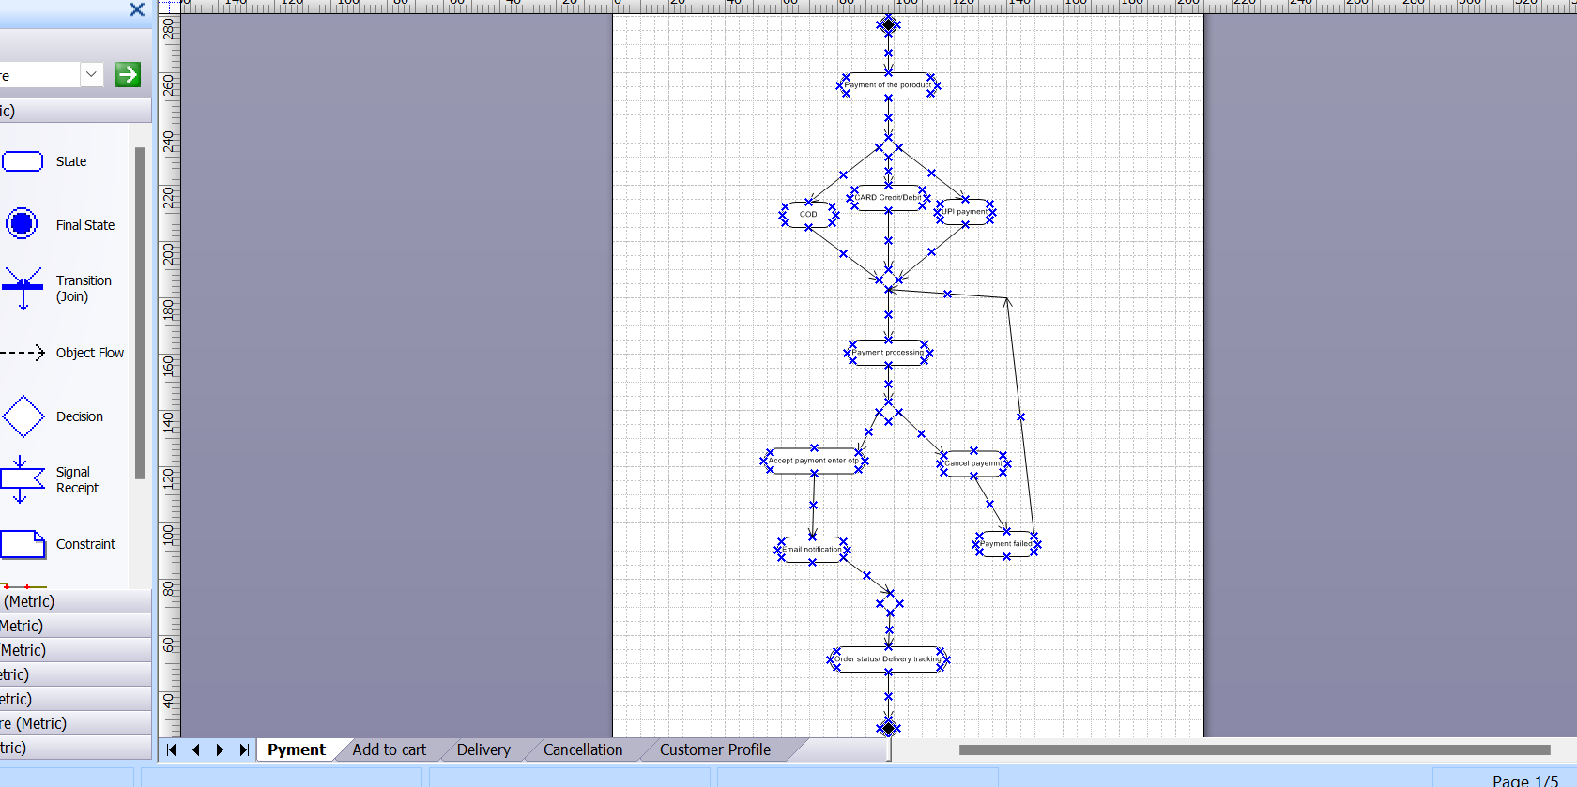
2. Add to cart:-

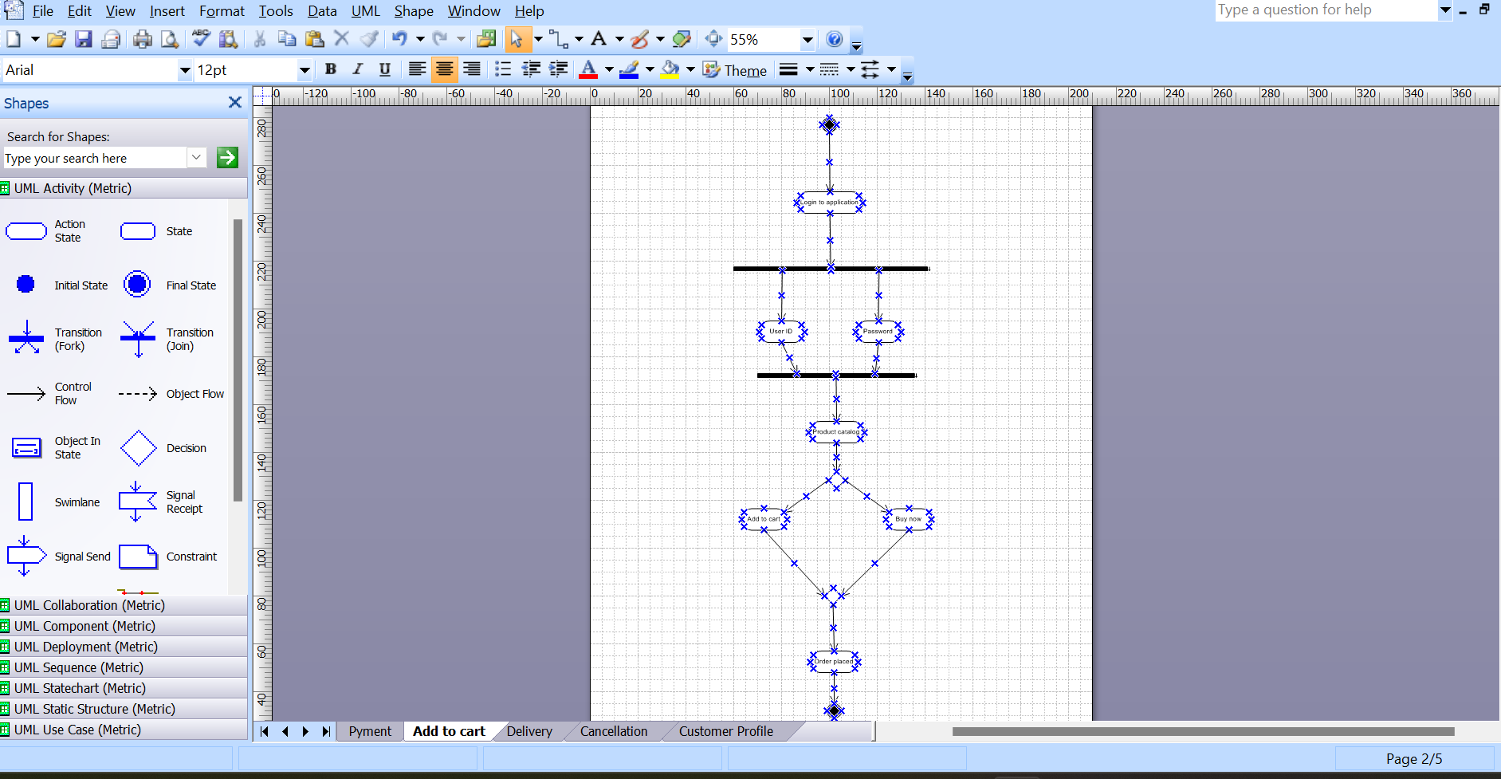
3.Delivery
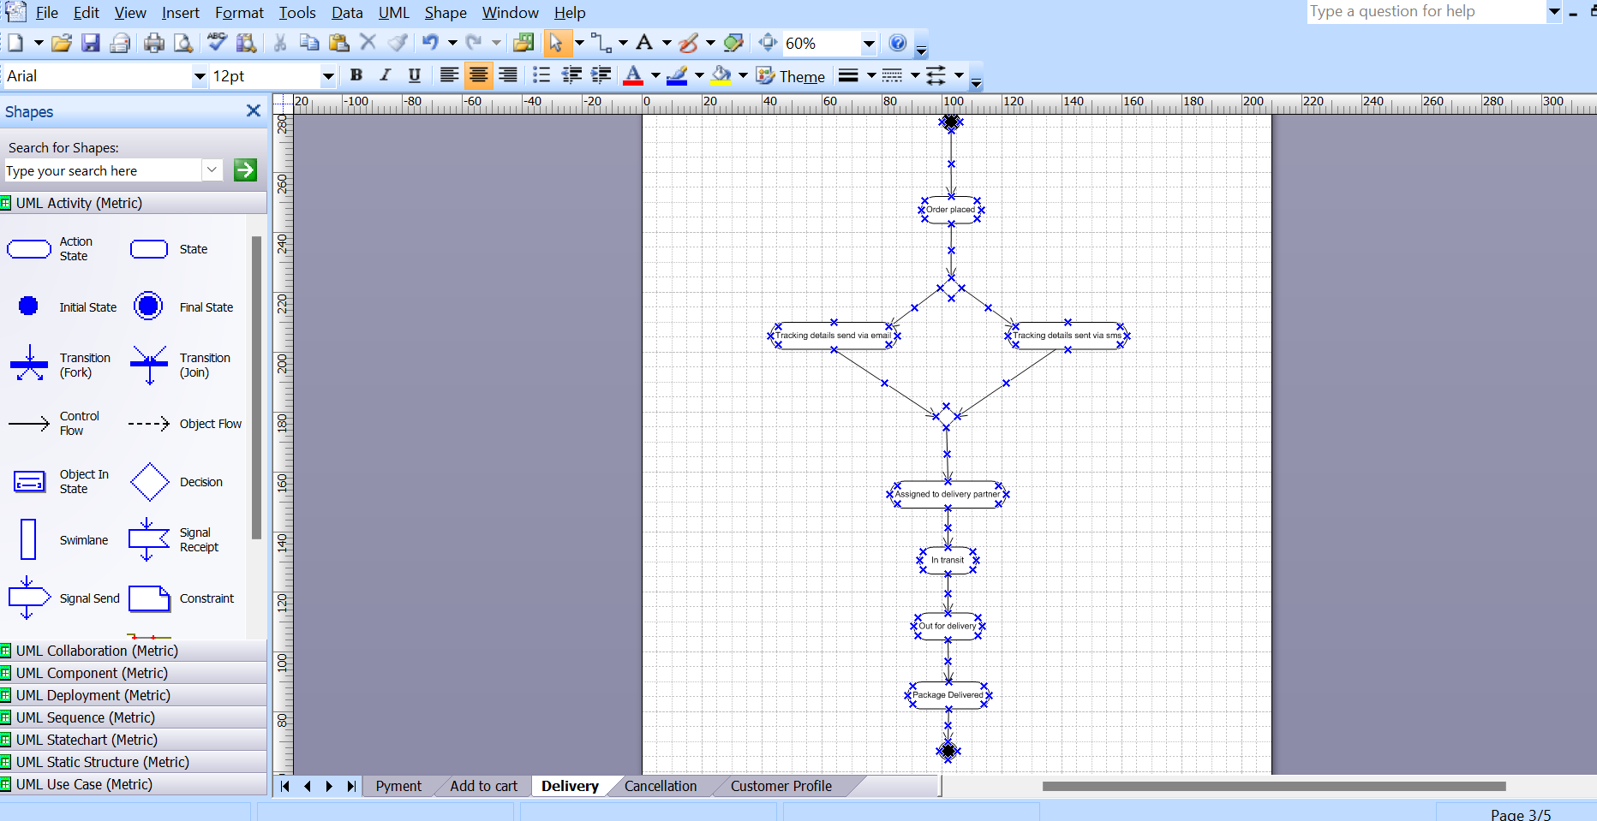

4.Cancellation: -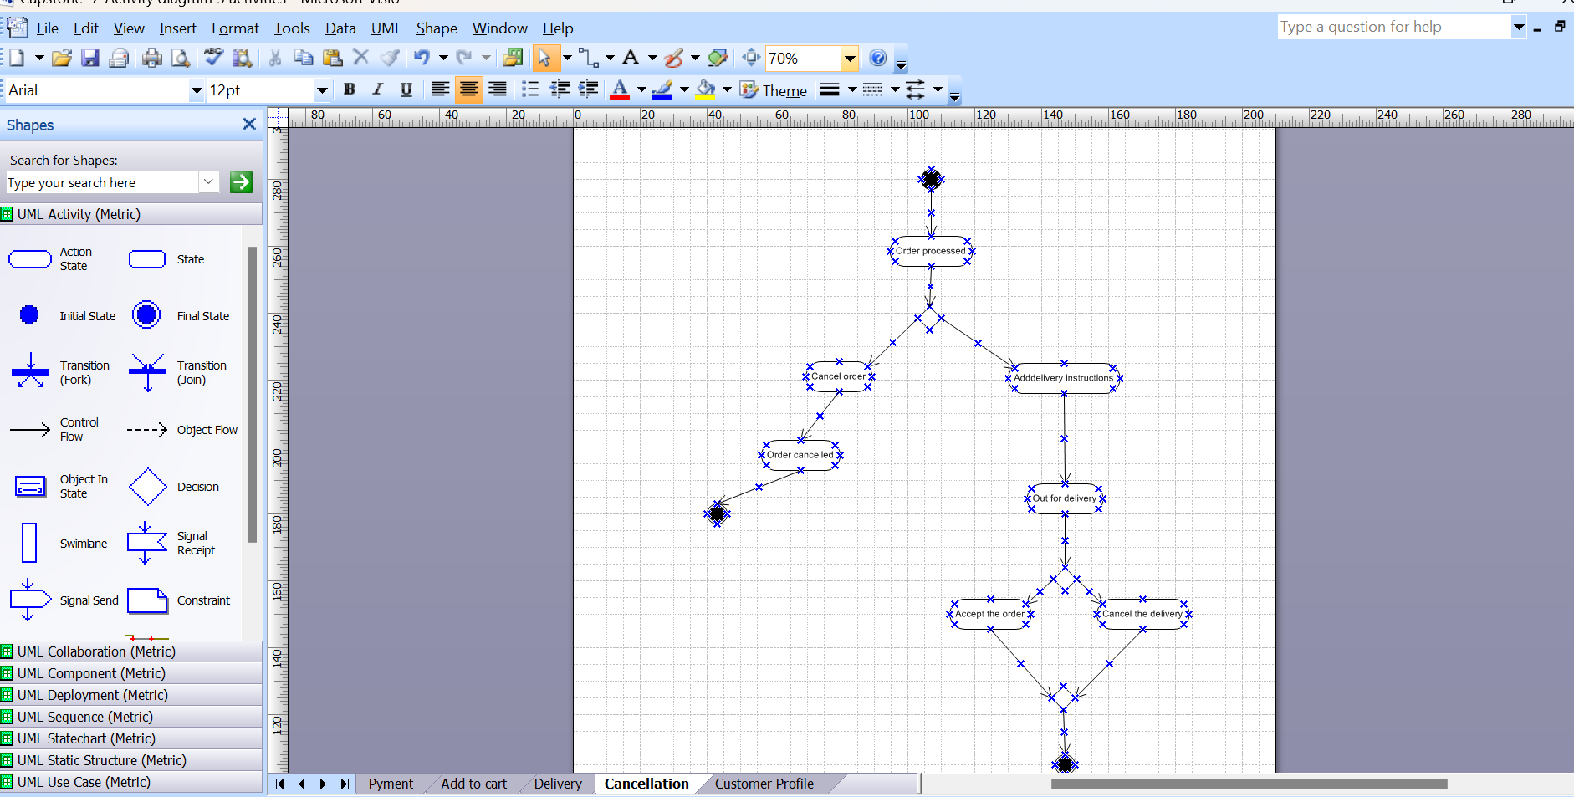

5. Customer Profile: -
