Document 1: Definition of Done (DoD)

Purpose
The Definition of Done is a technique used by Agile teams to define the minimum conditions that must be met for any backlog item—such as a user story, feature, or increment—to be considered complete and ready for delivery.

It represents a shared understanding across the Scrum team (Product Owner, Developers, Scrum Master, Business Analyst, QA, and others) and acts as a quality control gate to prevent incomplete or unverified work from moving forward.

Definition of Done Criteria Checklist
The following checklist applies to user stories, and can be scaled for sprint or release level based on project governance:

# | DoD Item | Description
1 | ✅ Acceptance Criteria Met | All user story acceptance criteria (Given–When–Then) are fulfilled and verified
2 | ✅ Quality Criteria Met | Feature meets agreed non-functional requirements (performance, security, UX)
3 | ✅ Code Developed | Functionality implemented and aligned with story expectations
4 | ✅ Unit Tests Written & Passing | Unit tests are created and pass successfully with expected coverage
5 | ✅ Project Builds Without Errors | No compilation or runtime errors in the build pipeline
6 | ✅ Deployed in Test Environment | Feature is deployed and functional in a staging environment identical to production
7 | ✅ Cross-Platform/Device Testing Passed | Validated on all supported browsers, screen sizes, and devices per scope
8 | ✅ UX Review Completed | UX/UI design verified and signed off by UX designer
9 | ✅ QA Verified | Manual and/or automated testing conducted by QA; all critical bugs resolved
10 | ✅ PO Sign-Off | Product Owner reviews and approves story for release
11 | ✅ Peer Code Review Done | Code reviewed by peers; all feedback resolved and approved
12 | ✅ Refactoring Done (if needed) | Code has been cleaned up or optimized per review outcomes
13 | ✅ Configuration & Build Changes Documented | Any new scripts, parameters, or build changes are documented for DevOps/support
14 | ✅ User Documentation Updated | End-user guides, help files, or feature documentation updated if applicable

Levels of Definition of Done

Level | Description
User Story DoD | Used to validate completion of individual backlog items
Sprint DoD | All committed stories meet their DoD and integration testing is done
Release DoD | Regression tested, performance validated, stakeholder approval secured, deployment plan created

Definition of Done – Project Hydrogen Reach (Power2X Expansion)

1. Definition of Done – User Story Level
Each user story is considered “Done” when the following criteria are met:

# | DoD Item | Tailored to P2X Context
1 | Acceptance Criteria Met | All functional and non-functional acceptance criteria (e.g., real-time data, alert logic) are satisfied
2 | Data Validated | Real-time data from sensors or mock APIs reflects accurate hydrogen metrics (e.g., kg/hr, tank %, pressure)
3 | Code Developed & Integrated | Fully implemented and merged into development branch with no blocking issues
4 | Unit Tests Written & Passed | Tests cover data logic, alert rules, and business calculations (e.g., thresholds, emissions)
5 | QA Tested | Functionality validated by QA against test cases derived from acceptance criteria
6 | UX Validated | Control panel/dashboards reviewed and signed off by UX/UI team for usability in field environments
7 | Cross-Device Compatibility | Responsive testing passed for tablets and desktops used by plant supervisors/site engineers
8 | Security Checks Passed | Authentication/authorization implemented and validated (role-based access, if applicable)
9 | PO Review & Sign-Off | Product Owner validates completion against expectations and backlog priority
10 | Documentation Updated | Functional description and user help (tooltips, feature notes) completed
11 | Peer Code Review Done | Code reviewed and approved by at least one developer with comments resolved
12 | Refactoring Completed | Any technical debt addressed before marking as Done

2. Definition of Done – Sprint Level
A sprint is considered “Done” when:

# | DoD Item
1 | All committed user stories meet their DoD
2 | Integrated testing completed across new and enhanced modules (E2E flow)
3 | Performance validated for any data-heavy modules (e.g., analytics dashboard)
4 | Sprint Demo conducted with key stakeholders (Ops, Engineering, Product)
5 | Sprint Retrospective held with action items captured
6 | Increment deployed to staging/test environment and stable
7 | Backlog updated with any carry-forward or enhancement requests
8 | Documentation (tech + user) reviewed and published internally

3. Definition of Done – Release Level
A release is considered “Done” when:

# | DoD Item
1 | All sprint-level DoD items met for final sprint in the release
2 | Regression Testing and UAT completed with sign-off from business users and SMEs
3 | Compliance checks passed (e.g., safety protocols, carbon reporting, data logs)
4 | Integration validated with external systems (e.g., SCADA, IoT sensors, weather APIs)
5 | Training delivered to end users and support teams (virtual or onsite)
6 | Deployment Plan finalized with rollback and escalation protocols defined
7 | Production Go-Live checklist completed and signed off
8 | Post-implementation support process initiated (SLAs, ticketing, monitoring)
9 | Lessons Learned documented and included in release retrospective
10 | All release documentation stored in knowledge base (functional, technical, support)

Document 2: Product Vision – Scrum Project
Project Name: Project Hydrogen Reach – Power2X (P2X) Expansion
Venue: Delhi
Date: 05/07/2023
Start Time: 02/04/2023
End Time: 12/05/2024
Client: H2e Power
Duration: 18 months

Stakeholder List
Sustainability Lead – Mr. Thomas
Operations Manager – Mr. Vincent Chang
Energy Systems Engineer – Mr. Rohit sharma
IT Solution Architect – Mr. Dheeraj
Compliance/Regulatory Expert – Mr. Kumawat
Field Supervisors, Plant Engineers – Mr. Pravin
Data Analytics & Reporting Team – Mr. Amol

Scrum Team
Role | Name
Scrum Master | Ms. Yamini Chavhan
Product Owner | Ms. Patty Tan
Scrum Developer 1 | Mr Zubair
Scrum Developer 2 | Mr. Abhijit
Scrum Developer 3 | Mr. Arpit
Scrum Developer 4 | Ms. Monica
Scrum Developer 5 | Mr. Nitesh

Vision: What is your overarching goal for the product?
To develop a scalable, intelligent, and real-time hydrogen monitoring platform that supports green hydrogen production, storage, and operational optimization in alignment with the organization's sustainability and digital transformation goals.

Target Group
Category | Details
Market Segment | Clean Energy, Hydrogen Infrastructure, Industrial IoT
Target Users | Plant Supervisors, Field Engineers, Sustainability Officers, Data Analysts
Target Customers | Internal Operations, Green Hydrogen Business Units, Regulatory Compliance Teams

Needs – What Problem Does the Product Solve?
- Lack of real-time monitoring across hydrogen production and distribution assets
- Manual data collection from sensors and SCADA systems
- Delayed alerting and operational response
- Inefficiencies in regulatory reporting and compliance tracking
- Outdated UX/UI and low accessibility (mobile/tablet)

Product – What Is It? What Makes It Desirable and Special?
Attribute | Description
Product Type | Web and mobile-enabled Hydrogen Monitoring and Management System
Key Features | Real-time dashboards, alert systems, predictive analytics, IoT integration, regulatory reporting
Differentiators | Sustainability-aligned, customizable thresholds, low-latency data ingestion, clean UI, field-ready design
Technology Edge | Built on scalable architecture, open APIs, integrates with grid/weather/SCADA systems

Value – How Will It Benefit the Company?
Aspect | Value Proposition
Business Goals | - Improve hydrogen infrastructure efficiency  - Reduce downtime and safety incidents  - Support emissions tracking and regulatory compliance
Feasibility | Yes — Developed using Agile, leveraging proven cloud, IoT, and analytics technologies
Business Model | Internal optimization tool with strategic business impact; may evolve into commercializable product
Strategic Benefit | Positions the organization as a technology leader in green hydrogen, enabling a measurable shift toward carbon neutrality

Document 3: User Stories – Project Hydrogen Reach (Power2X Expansion)

User Story HR-001: Real-Time Hydrogen Production Dashboard
As a plant supervisor
I want to view real-time hydrogen output from electrolyzers
So that I can monitor production and react quickly to operational issues
BV: 8 CP: 5 Priority: High

Acceptance Criteria:
Given I am logged into the dashboard
When I access the production module
Then I see hydrogen output updated every minute in kg/hr

Given production drops below threshold
When the system detects the drop
Then an alert is displayed and emailed to relevant stakeholders

Given I select a time filter
When I choose daily/weekly/monthly
Then I see corresponding trend data

User Story HR-002: Electrolyzer Efficiency Tracker
As a sustainability officer
I want to track electrolyzer efficiency over time
So that I can optimize energy usage and improve sustainability KPIs
BV: 7 CP: 6 Priority: High

Acceptance Criteria:
Given system receives energy input and output data
When data is available for a selected time range
Then system calculates and displays electrolyzer efficiency %

Given efficiency drops below set threshold
When anomaly is detected
Then alert is triggered and logged
User Story HR-003: Hydrogen Storage Monitoring
As a site engineer
I want to receive alerts when storage tanks are 90% full
So that I can initiate offloading and avoid overflow

BV: 6 CP: 4 Priority: Medium

Acceptance Criteria:
Given real-time tank level data is available
When storage level > 90%
Then system sends SMS/email alert

Given I have admin access
When I open alert settings
Then I can configure the threshold value

Given alerts are generated
When I open alert dashboard
Then I see alert log with timestamps

User Story HR-004: Hydrogen Distribution Mapping Tool
As a logistics planner
I want to view real-time distribution data on a map
So that I can track deliveries and optimize routes

BV: 7 CP: 6 Priority: Medium

Acceptance Criteria:
Given GPS/location data is enabled for distribution units
When I open the map view
Then I see locations and movement of all hydrogen trucks in real time

Given I click on a truck icon
When I expand its details
Then I see pressure, volume, destination, and ETA

User Story HR-005: Regulatory Emission Reporting Module
As a compliance analyst
I want to generate emissions reports for authorities
So that I can ensure compliance with environmental standards

BV: 9 CP: 7 Priority: High

Acceptance Criteria:
Given system has access to production and emissions data
When I select a report type and time period
Then the system generates and downloads report in PDF/CSV

Given I generate a report
When data is missing or incomplete
Then system displays validation errors

User Story HR-006: Improve UX/UI of Control Panels (Enhancement)
As a field operator
I want to navigate control panels easily on a tablet
So that I can respond faster during field inspections

BV: 6 CP: 4 Priority: Medium

Acceptance Criteria:
Given I open the control panel on a tablet
When I navigate through different tabs
Then the layout is responsive and clearly readable

Given I select a module
When I use touch gestures
Then system responds without layout breaks

User Story HR-007: Add Analytics Export for Hydrogen Data (Enhancement)
As a data analyst
I want to export analytics from the dashboard
So that I can do deeper analysis in third-party tools

BV: 5 CP: 3 Priority: Low

Acceptance Criteria:
Given analytics module is open
When I click "Export"
Then system generates a CSV/Excel file with all relevant data

Given I export a file
When file is downloaded
Then it contains timestamped readings, labels, and trend summaries

User Story HR-008: Security and Authentication Upgrade (Enhancement)
As a system admin
I want to enforce role-based access controls
So that I can protect sensitive modules from unauthorized access

BV: 8 CP: 5 Priority: High

Acceptance Criteria:
Given user roles are defined
When a user logs in
Then they see only the modules allowed for their role

Given a new user is created
When I assign a role
Then permissions are applied immediately

User Story HR-009: Workflow Automation for Alert Escalation (Enhancement)
As a shift supervisor
I want to automatically escalate critical alerts
So that I can ensure timely issue resolution

BV: 7 CP: 5 Priority: Medium

Acceptance Criteria:
Given a critical alert is generated
When it remains unresolved for 15 minutes
Then system escalates to next level via SMS and email

Given I configure escalation settings
When I save changes
Then they are applied in the next alert cycle

Summary Table of User Stories
No. | Title | BV | CP | Type | Priority
HR-001 | Hydrogen Production Dashboard | 8 | 5 | New Feature | High
HR-002 | Electrolyzer Efficiency Tracker | 7 | 6 | New Feature | High
HR-003 | Hydrogen Storage Monitoring | 6 | 4 | New Feature | Medium
HR-004 | Hydrogen Distribution Mapping Tool | 7 | 6 | New Feature | Medium
HR-005 | Emissions Reporting Module | 9 | 7 | New Feature | High
HR-006 | Improve UX/UI of Control Panels | 6 | 4 | Enhancement | Medium
HR-007 | Analytics Export Functionality | 5 | 3 | Enhancement | Low
HR-008 | Security and Authentication Upgrade | 8 | 5 | Enhancement | High
HR-009 | Alert Escalation Automation | 7 | 5 | Enhancement | Medium

Document 4: Agile PO Experience
Project: Project Hydrogen Reach – Power2X (P2X) Expansion
Approach: Agile (Scrum)

Role Overview
The Product Owner (PO) in this project plays a crucial role in aligning the product with the hydrogen industry's clean energy goals, balancing market opportunity, enterprise value, and stakeholder needs. The PO bridges the business vision with the Scrum delivery team to ensure focused, value-driven iterations.

Key Responsibilities of the Product Owner

1. Market Analysis
- Conducted thorough analysis of the green hydrogen and Power2X industry trends
- Benchmarked against similar hydrogen monitoring solutions in the market
- Identified gaps in real-time visibility, data automation, and predictive maintenance

2. Enterprise Analysis
- Evaluated internal operational challenges in existing hydrogen systems
- Worked with business leadership to validate the market opportunity and ROI
- Identified value streams including production optimization, emissions compliance, and asset tracking

3. Product Vision and Roadmap
- Developed a product vision focused on sustainability, scalability, and digital intelligence
- Designed a roadmap containing:
New Features: Real-time dashboards, alerting tools, emissions reporting
Enhancements: UX improvements, automation workflows, analytics exports
- Mapped feature delivery across 5–6 Agile sprints

4. Managing Product Features
Collected needs from stakeholders across Operations, Compliance, Engineering, and IT
Prioritized features and user stories based on:
- Regulatory urgency
- Operational impact
- Business value (BV)
- Complexity points (CP)

Balanced stakeholder expectations through constant grooming and reviews

5. Managing Product Backlog
- Created and refined a prioritized backlog with epics, features, and user stories
- Reprioritized stories based on field feedback and sprint velocity
- Collaborated with the BA to ensure backlog alignment with evolving needs

6. Managing Overall Iteration Progress
- Reviewed sprint progress and removed roadblocks for the team
- Reordered backlog items as needed after retrospectives or mid-sprint reviews
- Participated in joint retrospectives with the Scrum Master and Business Analyst to refine team processes

Scrum Meetings Led / Attended by PO
The Product Owner actively contributed to and often facilitated the following Agile ceremonies:

- Sprint Planning Meetings – Defined sprint goals and selected backlog items for the sprint
- Daily Scrum Meetings – Reviewed blockers, clarified scope, supported team alignment
- Sprint Review Meetings – Demonstrated completed work to stakeholders, gathered feedback
- Sprint Retrospective Meetings – Evaluated outcomes and contributed to continuous improvement
- Backlog Refinement Sessions – Reviewed stories, updated priorities, and confirmed acceptance criteria

User Story Contribution and Governance
The Product Owner was involved in defining, validating, and reviewing user stories in collaboration with the Business Analyst. Key inclusions:

Attribute | Example
Story No | HR-002, HR-003, etc.
Tasks | Functional breakdown for Dev/QA
Priority | Based on ROI, compliance urgency, and user demand
Acceptance Criteria | Defined in Gherkin format for clarity
BV & CP | Business Value and Complexity Points used for prioritization

Cross-Functional Collaboration
The PO served as the bridge between business vision and technical execution, ensuring all areas of the business—from regulatory bodies to field engineers—remained informed and engaged.

Key Learnings from This Project
- How to define and drive a product vision aligned with sustainability goals
- Importance of balancing stakeholder expectations with sprint velocity
- Effective prioritization using MoSCoW and WSJF
- Practical use of Agile ceremonies to ensure transparency and continuous delivery
- Deepened understanding of hydrogen systems and industrial IoT integration

Document 5: Product & Sprint Backlog + Burndown Charts
Product Backlog
User Story ID | User Story | Tasks | Priority | BV | CP | Sprint
HR-001 | Real-time Hydrogen Production Dashboard | Data integration, UI design, alert setup, QA, UX approval | High | 8 | 5 | Sprint 1
HR-002 | Electrolyzer Efficiency Tracker | Formula logic, sensor connection, visualization, testing | High | 7 | 6 | Sprint 1
HR-003 | Hydrogen Storage Monitoring | Alert logic, notification setup, threshold settings | Medium | 6 | 4 | Sprint 2
HR-004 | Hydrogen Distribution Mapping Tool | GIS integration, live truck data, info popups | Medium | 7 | 6 | Sprint 2
HR-005 | Emission Reporting Module | Compliance logic, report generator, format validations | High | 9 | 7 | Sprint 3
HR-006 | Improve UX/UI of Control Panels | UI adjustments, testing on tablets, responsive layout | Medium | 6 | 4 | Sprint 3
HR-007 | Export Analytics to CSV/Excel | Data filter, export feature, format alignment | Low | 5 | 3 | Sprint 4
HR-008 | Role-based Access Control (RBAC) | Auth logic, user-role mapping, access control setup | High | 8 | 5 | Sprint 4
HR-009 | Alert Escalation Workflow Automation | Escalation logic, SMS/email setup, admin settings | Medium | 7 | 5 | Sprint 5

Sprint Backlog – Sprint 1
User Story ID | User Story | Tasks | Owner | Status | Estimated Effort (hrs)
HR-001 | Real-time Hydrogen Dashboard | Backend integration, UI, alerts, testing | Dev1, QA1 | In Progress | 32
HR-002 | Electrolyzer Efficiency Tracker | Formula logic, data ingestion, charting, testing | Dev2, QA2 | To Do | 28

Deliverables for Each Sprint

Sprint | Key Deliverables
Sprint 1 | Hydrogen dashboard + Efficiency tracking
Sprint 2 | Storage alerts + Distribution map
Sprint 3 | Compliance reporting + UX enhancements
Sprint 4 | Export functionality + Access control
Sprint 5 | Alert automation + System final QA + UAT

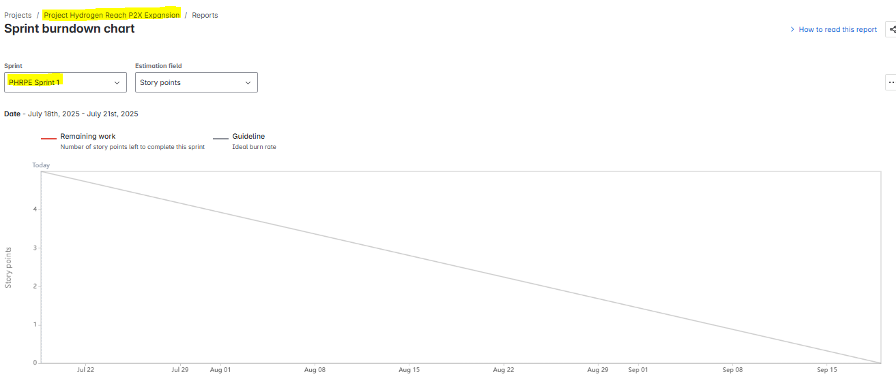
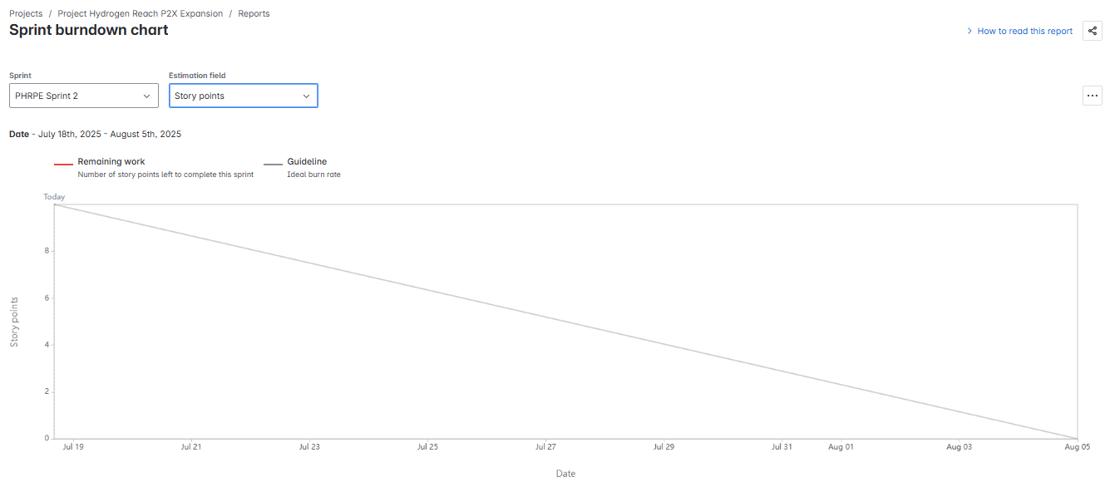
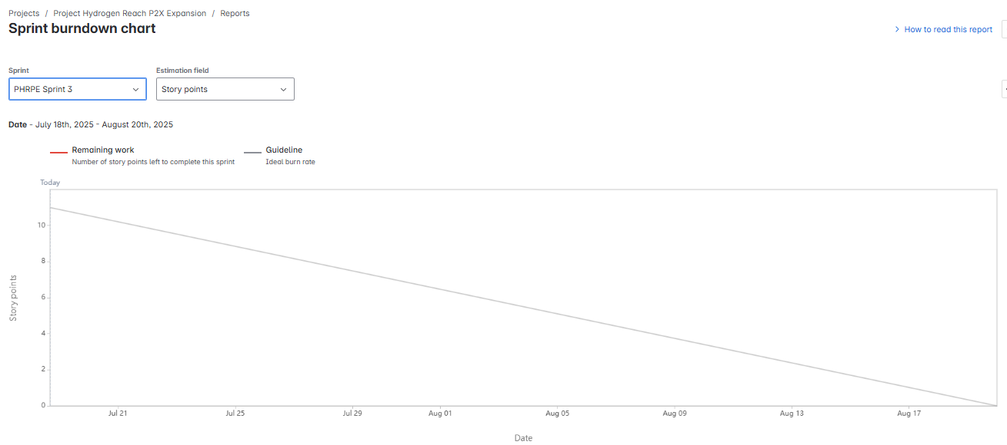
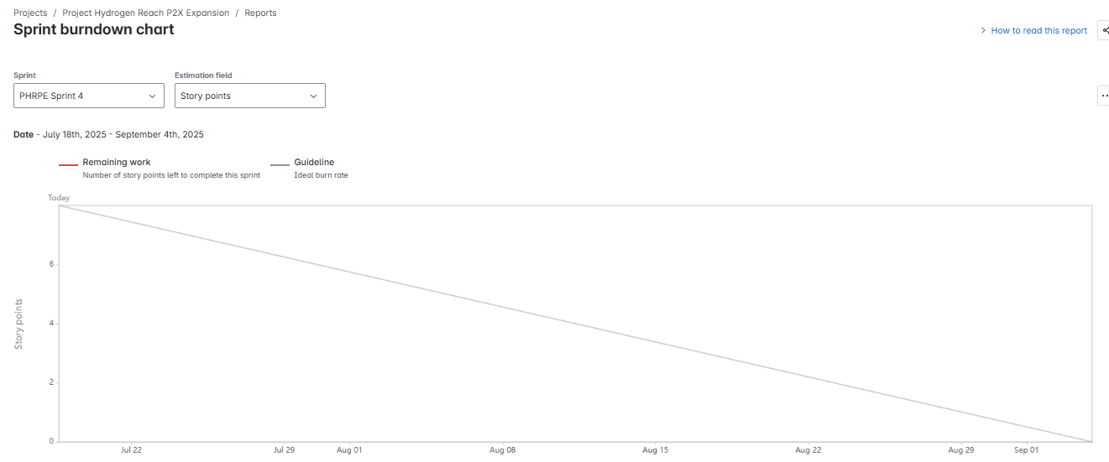
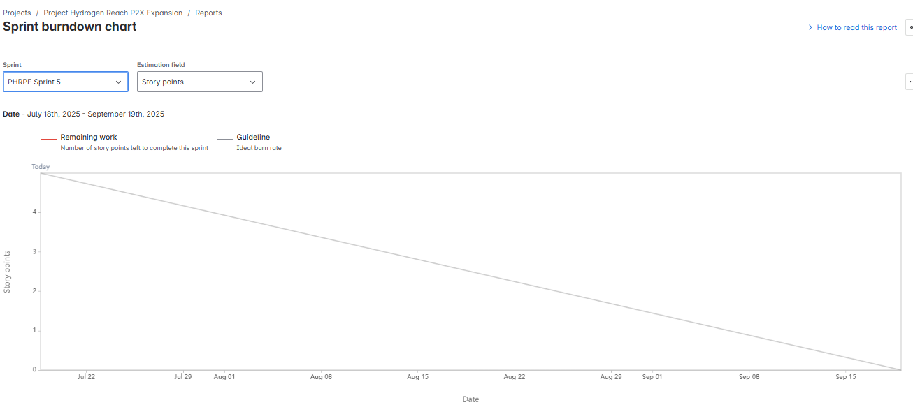

Product Burndown Chart:
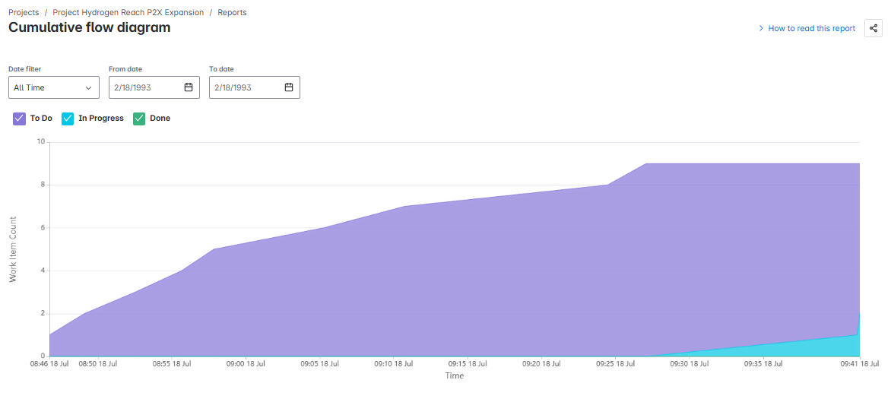
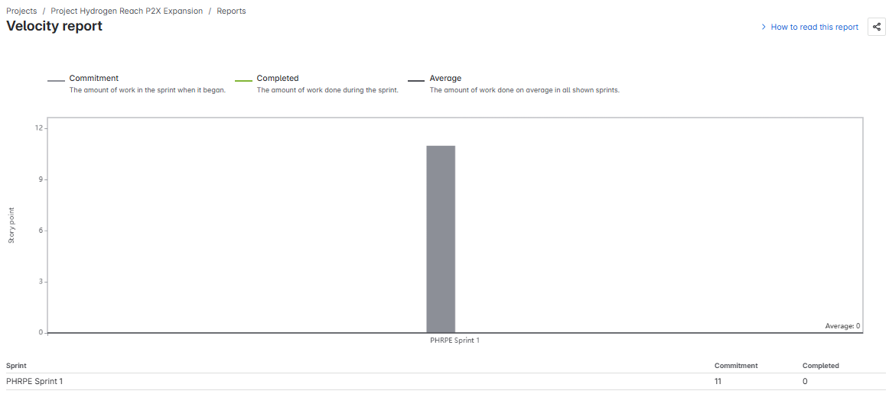

Document 6: Sprint Meetings – Project Hydrogen Reach (Power2X Expansion)

Meeting Type 1: Sprint Planning Meeting
Field | Details
Date | 15-04-2023
Time | 11:00am
Location | Pune
Prepared By | Yamini – Business Analyst
Attendees | PO, Scrum Master, Devs, QA, SME

Agenda Topics
Topic | Presenter | Time Allotted
Sprint Goal Definition | Product Owner | 10 mins
Review of Prioritized Backlog Items | Business Analyst | 15 mins
Estimation (CP, hours) | Dev Team | 15 mins
Capacity Planning | Scrum Master | 10 mins
Final Sprint Scope & Commitment | Entire Team | 10 mins

Other Details
Observers: Mr. Mayur, Mr. Dadasaheb
Resources Used: Jira, Figma (for UI), Confluence
Special Notes: Ensure dependencies for HR-001 and HR-002 are confirmed before starting development.

Meeting Type 2: Sprint Review Meeting
Field | Details
Date | 22/04/2023
Time | 10:30AM
Location | Teams
Prepared By | Yamini Chavhan
Attendees | Scrum Team, Stakeholders

Discussion Points
- Sprint Status: Completed 2/2 planned stories (HR-001, HR-002)
- Demo Items:
- ▫ Real-time Hydrogen Dashboard
- ▫ Electrolyzer Efficiency Tracker
- Quick Updates: No open bugs; UAT feedback positive
- What’s Next: Move to Sprint 2: Storage Monitoring + Distribution Mapping

Meeting Type 3: Sprint Retrospective Meeting
Field | Details
Date | 25/04/2023
Time | 2:30PM
Location | Teams call, Pune
Prepared By | Scrum Master / BA (Yamini)
Attendees | Entire Scrum Team

Agenda
Section | Notes/Comments
What went well | Collaboration between Dev & QA was smooth
What didn’t go well | Some confusion around alert thresholds
Questions Raised | Should QA start testing mid-sprint?
Reference Docs | Jira Sprint Board, Confluence Notes

Meeting Type 4: Daily Stand-Up Meeting Log
Sprint Week X – [15-04-2024] to [29-04-2023]
Status Update Table
Question | Name/Role | Mon | Tue | Wed | Thu | Fri | Sat | Sun
What did you do yesterday? | Developer 1
 | Developer 2
 | Developer 3
What will you do today? | Developer 1
 | Developer 2
 | Developer 3
Any blockers? | Developer 1
 | Developer 2
 | Developer 3

