04 BA Mock - Case study
Which Method Fits This Case?
For the ice-cream & milk products company:
Since delivery speed and inventory are dynamic and will likely need refinements (route optimization, warehouse stocking, delivery time calculation, etc.), Agile is the better fit.
Agile allows building MVP (Minimum Viable Product) first (like a basic inventory and delivery module), then iterating.
However, since this is a corporate project, the BRD & SRS can still follow a Waterfall-style documentation upfront, but execution can be Agile.
Waterfall Method
When useful:
- Requirements are fixed, stable, and clear from the start.
- Little scope for changes.
- Regulatory or compliance-heavy environments.
Pros:
- Clear documentation (good for BRD, SRS, process flows).
- Easy for client to review progress step-by-step.
Cons:
- Not flexible if requirements change later.
- Delays in delivery of actual usable software (client sees results late).
Agile Method
When useful:
- Requirements are evolving or unclear.
- Continuous feedback from stakeholders is required.
- System needs incremental improvements (e.g., delivery optimization, dashboards).
Pros:
- Faster releases (client sees working features early).
- Flexibility to adjust features based on feedback.
- Better suited for integration with real-time logistics, route optimization, and scaling.
Cons:
- Requires strong collaboration and continuous involvement of client.
- Documentation can be lighter (unless balanced with Agile documentation practices).
Best Approach:
A Hybrid Model:
Use Waterfall for documentation & initial planning (BRD, SRS, ERD, process flows), then Agile for development & delivery.
This way:
- The client gets formal documentation (important for contracts & clarity).
- Development team works in Agile sprints, releasing features step by step.
Assignment 1: BRD for Dairy (Ice-Cream & Milk) Inventory + Quickest Delivery
BRD (Business Requirements Document)
Project Title
Integrated Inventory and Logistics Management System for Ice-Cream and Dairy Products Manufacturer
Executive Summary
This project aims to digitalize and centralize inventory and distribution operations at multiple manufacturing plants and warehouses, ensuring real-time inventory control and efficient customer delivery. The transformation from manual management to automated, data-driven processes will minimize errors, cost, and delivery times, thereby boosting profitability and customer satisfaction.
Project Overview
The company manufactures and distributes ice-cream and milk products through plants and warehouses across the country. The organization intends to build a centralized software system to Manage inventory across plants, warehouses, and distribution points.
Ensure quickest delivery of products to customers by optimizing order allocation and route planning.
1.Business Goals:
- Fast, efficient tracking and resolution of customer/service tickets.
- Reduce response times.
- Improve customer satisfaction.
2. Objectives
- Real-time visibility of stock levels.
- Automated inventory replenishment alerts.
- Smart order allocation from nearest warehouse/plant.
- Route optimization for fastest delivery.
- Improved customer satisfaction and reduced wastage.
3. Key Stakeholders
- Client Sponsor: CEO / Director of Operations
- Business Users: Plant managers, Warehouse managers, Delivery managers
- IT Team: Developers, Testers, Database admins
- End Users: Customers placing orders
4. Key Features / Requirements
- Centralized dashboard for inventory monitoring.
- Stock movement tracking (Plant → Warehouse → Customer).
- Order fulfillment system with location-based delivery logic.
- Integration with transport/logistics partners.
- Mobile app for delivery staff.
- Reporting & analytics (stock, sales, wastage, delivery times).
5. Constraints & Assumptions
- System should support both web and mobile platforms.
- Peak seasonal demand should be handled without downtime.
- Compliance with food safety regulations.
6. KPIs (Key Performance Indicators)
- Inventory Accuracy ≥ 98%
- Delivery SLA ≤ 30 minutes (urban), ≤ 2 hours (rural)
- Wastage Reduction ≥ 15% in 6 months
- Customer Satisfaction ≥ 90% positive feedback
Development & Resource Plan
1. Methodology
- Agile Scrum – 2-week sprints, incremental delivery.
2. Team Structure
- Business Analyst (1) – Requirement gathering, documentation
- Project Manager (1) – Planning, tracking
- Developers (4) – Backend, frontend, mobile app
- UI/UX Designer (1) – User-friendly design
- QA/Testers (2) – Functional & performance testing
- DevOps Engineer (1) – Deployment, monitoring
3. Timeline (High-level)
- Requirement Gathering & BRD: 2 weeks
- Design (UI/UX + Architecture): 2 weeks
- Development: 10–12 weeks
- Testing: 3 weeks
- Deployment & Training: 2 weeks
- Go-live: ~20 weeks total

Process flow diagram :
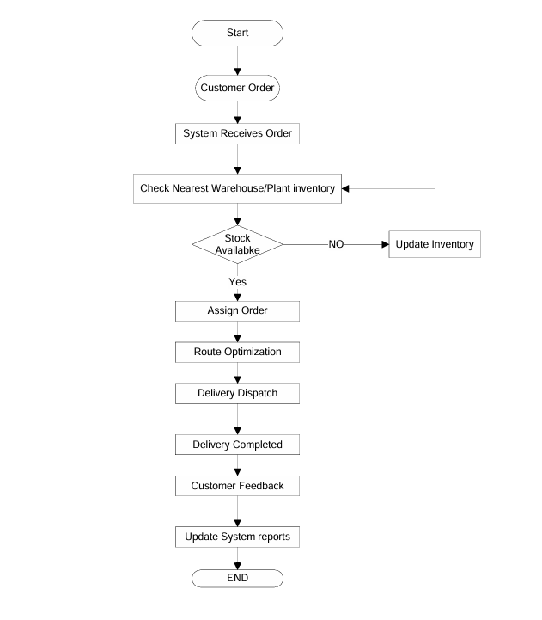
Introduction Letter
Subject: Introduction – Business Analyst for Upcoming Project
Dear Coepd,
I am Likhitha, the Business Analyst assigned to work with you and your team for the upcoming project. My role will be to bridge the gap between your business needs and the technical team, ensuring that the solution we build aligns with your goals.
Over the coming weeks, I will collaborate closely with your stakeholders to gather requirements, document processes, and create structured specifications for development. I look forward to understanding your vision and translating it into a successful solution.

Best Regards,
Likhitha
Business Analyst

Brief BRD Business Requirement Document (BRD)
Project Name: Inventory & Delivery Management System
Project ID: IFD-001
Version ID: 1.0
Author: Business Analyst Team
Date: September 04, 2025
1. Document Revisions
Date | Version | Document Changes
4-Sep-25 | 1 | Initial Draft
2. Approvals
Role | Name | Title
Project Sponsor | Mr. Arvind Rao | CEO
Business Owner | Ms. Likhitha Sharma | COO
Project Manager | Mr. Rajiv Menon | PM
System Architect | Mr. Ajay Kulkarni | Enterprise Architect
Development Lead | Ms. Ritu Agarwal | Tech Lead
UX Lead | Mr. Naveen Patel | UI/UX Specialist
Quality Lead | Ms. Ananya Gupta | QA Lead
Content Lead | Mr. Kiran Das | Documentation Specialist

3. RASCI Chart
Codes Used: R = Responsible, A = Accountable, S = Supports, C = Consulted, I = Informed
Name | Position | R | A | S | C | I
Arvind Rao | CEO (Sponsor) |  | A |  | C | I
Likhitha Sharma | COO (Business Owner) |  | A |  | C | I
Rajiv Menon | Project Manager | R | A |  |  | I
Ajay Kulkarni | Architect | R |  |  | C | I
Development Team | Developers | R |  |  |  | I
QA Team | Testers |  |  | R | C | I
Regional Managers | Stakeholders |  |  |  | C | I
4. Introduction
4.1 Business Goals
  - Enable real-time inventory visibility across all plants and warehouses.
  - Ensure quickest possible delivery of ice-cream and milk products.
  - Reduce manual errors and product wastage.
  - Increase customer satisfaction through timely service.

4.2 Business Objectives
  - Build a centralized software system for inventory management.
  - Automate delivery routing & logistics optimization.
  - Provide mobile access for warehouse and delivery staff.
  - Generate analytical reports for sales, stock, and delivery efficiency.
4.3 Business Rules
  - Inventory must follow FIFO (First In, First Out) method.
  - Expired products cannot be dispatched.
  - Each warehouse must update stock levels daily.
  - Delivery timelines: Milk ≤ 12 hours, Ice-cream ≤ 6 hours.
4.4 Background
Currently, stock is managed manually using spreadsheets, and deliveries are coordinated by calls/emails. This causes delays, stockouts, and customer dissatisfaction. The company aims to adopt a modern IT solution to automate and scale its operations.
4.5 Project Objective
To develop a web and mobile-based Inventory & Delivery Management System that integrates warehouses, manufacturing plants, and logistics, ensuring real-time tracking, minimal wastage, and optimized delivery.
4.6 Project Scope
**In-Scope Functionality:**
  - Inventory management (plants & warehouses)
  - Stock alerts & automated replenishment
  - Delivery scheduling and route optimization
  - Barcode/RFID-based stock tracking
  - Reports & dashboards (sales, wastage, delivery time)
  - User access control & audit logs
**Out-of-Scope Functionality:**
  - E-commerce ordering system
  - Integration with external CRMs (future phase)
  - AI-driven demand forecasting
5. Assumptions
  - Stable internet available at all warehouses.
  - Delivery staff are trained in using mobile app.
  - ERP integration APIs are accessible.
6. Constraints
  - Must comply with FSSAI guidelines for storage/transport.
  - Must maintain 99.9% uptime.
  - Delivery must work in low-network areas.

7. Risks (Detailed)
7.1 Technological Risks
- Risk: Failure of integration with third-party courier APIs (e.g., BlueDart, Delhivery).
- Likelihood: Medium
- Impact: High – Delivery tracking and order status updates may be delayed.
- Mitigation: Build API fallback mechanisms, maintain multiple courier integrations, and enable offline syncing.

- Risk: Server downtime or performance bottlenecks during peak season (summer demand surge).
- Likelihood: High
- Impact: High – Order processing delays, affecting customer satisfaction.
- Mitigation: Cloud-based auto-scaling, load balancing, and database optimization.
7.2 Skills Risks
- Risk: Lack of skilled staff for route optimization algorithm development.
- Likelihood: Medium
- Impact: Medium – Delayed delivery module implementation.
- Mitigation: Hire logistics domain experts, conduct team training, and consider outsourcing critical components.

- Risk: Inadequate training for warehouse staff using the new system.
- Likelihood: High
- Impact: Medium – Errors in stock entry could affect reporting accuracy.
- Mitigation: Provide user-friendly UI, conduct training workshops, and create SOPs (Standard Operating Procedures).
7.3 Political / Regulatory Risks
- Risk: Changes in food safety regulations (FSSAI/ISO compliance).
- Likelihood: Low
- Impact: High – Could require system modifications.
- Mitigation: Continuous monitoring of regulations and flexible system design for compliance updates.

- Risk: Government restrictions on cold chain logistics in certain regions.
- Likelihood: Low
- Impact: Medium – Delivery timelines may be extended.
- Mitigation: Alternative route planning and contracts with multiple logistics providers.

7.4 Business Risks
- Risk: Resistance to change from employees used to manual systems.
- Likelihood: High
- Impact: Medium – Slower adoption and data quality issues.
- Mitigation: Change management strategies, incentives for adoption, continuous support.

- Risk: Loss of revenue due to system downtime in peak season.
- Likelihood: Medium
- Impact: High
- Mitigation: Disaster recovery plan, backup servers, 24/7 support.

7.5 Requirements Risks
- Risk: Incorrect requirement gathering from warehouse managers.
- Likelihood: Medium
- Impact: High – Could lead to system redesign later.
- Mitigation: Conduct multiple requirement workshops, create prototypes, and get sign-offs.

- Risk: Scope creep due to requests for additional features (e.g., e-commerce).
- Likelihood: High
- Impact: Medium – Project delays and cost overrun.
- Mitigation: Strict scope management, phased rollouts, and change request process.

7.6 Environmental Risks
- Risk: Power outages in rural warehouses.
- Likelihood: High
- Impact: Medium – Delayed stock updates.
- Mitigation: Offline mode in mobile app, use of UPS systems.

- Risk: Extreme weather (heat waves/floods) affecting delivery routes.
- Likelihood: Medium
- Impact: High – Spoilage of dairy products.
- Mitigation: Real-time GPS route reallocation, refrigerated trucks, contingency stock in nearby warehouses.
8. Business Process Overview
8.1 Legacy System (AS-IS)
  - Manual inventory tracking via Excel sheets.
  - Delivery orders managed by calls and emails.
  - Lack of real-time visibility, frequent stockouts, and delays.
8.2 Proposed System (TO-BE)
  - Centralized inventory system with barcode scanning.
  - Automated delivery routing using GPS & algorithms.
  - Mobile app for warehouse and delivery staff.
  - Real-time dashboards for managers.
9. Business Requirements
**Functional Requirements:**
- Manage product inventory across multiple plants/warehouses.
- Track stock movement in real-time.
- Automate replenishment alerts.
- Delivery route optimization with GPS tracking.
- User management with role-based access.

**Non-Functional Requirements:**
- System uptime: 99.9%.
- Mobile responsiveness.
- Multi-language support (English + Regional).
- Secure authentication (OAuth/SSO).
10. Appendices
**10.1 List of Acronyms**
  - ERP: Enterprise Resource Planning
  - FIFO: First In First Out
  - GPS: Global Positioning System
**10.2 Glossary of Terms**
Stockout: Situation where product is unavailable
Replenishment: Restocking items automatically
**10.3 Related Documents**
Software Requirement Specification (SRS)
Feasibility Study Report
SRS (Software Requirements Specification) of Project:
Client: IceFresh Dairy Pvt. Ltd.
Project: Inventory & Delivery Management System
Date: September 04, 2025
Record of Revisions
Version | Date of Release / Revision | Prepared / Revised By | Reviewed By | Approved By | Reasons for Revisions
1 | 4-Sep-25 | Business Analyst Team | Project Manager | Client Representative | Initial Draft
1.0 Introduction
1.1 Overview
The purpose of this document is to specify the software requirements for the Inventory and Delivery Management System for IceFresh Dairy Pvt. Ltd. The system will support managing stock levels across multiple plants and warehouses while ensuring the quickest possible delivery to customers.
1.2 Acronyms and Definitions
Term | Description
ERP | Enterprise Resource Planning
SRS | Software Requirements Specification
API | Application Programming Interface
1.3 Operational Requirements
1.3.1 Software Requirements
  - Web application with mobile compatibility
  - Database: MySQL or PostgreSQL
  - Backend: Java/.NET/Python
  - Frontend: Angular/React
1.3.2 Hardware Requirements
  - Minimum server configuration: 16 GB RAM, 8 Core CPU, 500 GB SSD
  - Client system: 4 GB RAM, Dual Core CPU, Internet connectivity
1.4 References
  - Business Proposal
  - Client Requirement Workshops
  - Industry Best Practices
1.5 Design and Implementation Constraints
  - Must comply with food safety regulations
  - Integration with existing ERP systems
  - High availability with 99.9% uptime
  - Scalable architecture
1.6 Assumed Factors That Could Affect Requirements
The system depends on stable internet connectivity across warehouses and plants. External courier service API integration timelines may affect delivery features.
2.0 System Overview
2.1 Current System
Currently, inventory is managed manually through spreadsheets, and deliveries are coordinated via phone calls and emails. This results in delays and errors.
2.2 Proposed System
The proposed system will automate stock tracking, warehouse management, and delivery routing using optimized algorithms. It will provide real-time stock updates, auto-generate delivery schedules, and track shipments.
2.3 Benefits of Proposed System
  - Real-time inventory visibility
  - Reduction in delivery delays
  - Automated replenishment alerts
  - Cost savings due to optimized logistics
  - Improved customer satisfaction
3.0 UI Requirements
The system will have the following modules:
  - Dashboard: Overview of stock and deliveries
  - Inventory Module: Stock management per location
  - Delivery Module: Route optimization & shipment tracking
  - Reports: Sales, delivery efficiency, wastage analysis
  - Admin Panel: User management and role-based access
4.0 Other Parameters
4.1 Acceptance
The client will review and accept the system upon delivery of:
  - Functional Prototypes
  - Fully deployed Application
  - Documentation (Installation/User Manual)
The design and implementation of the Inventory and Delivery Management System must adhere to several constraints:
1. Regulatory Constraints
  - Compliance with FSSAI (Food Safety and Standards Authority of India) guidelines for storage and transportation of dairy products.
  - Adherence to GDPR/Local Data Protection Laws for handling customer and vendor information.
2. Technology Constraints
  - The system must be compatible with existing ERP modules used by the client.
  - The backend must be developed in Java / .NET / Python to ensure scalability.
  - The database must support high concurrency and large datasets (MySQL/PostgreSQL recommended).
3. Operational Constraints
  - The application must support real-time stock updates from multiple warehouses.
  - Mobile application must work in low-network rural areas where warehouses are located.
  - Delivery route optimization should consider perishable product timelines (ice cream has a limited storage duration).
4. Performance Constraints
  - Inventory updates must be reflected within 5 seconds across all connected systems.
  - Delivery allocation algorithms must process orders within 30 seconds for bulk orders.
  - System availability target: 99.9% uptime.
5. Hardware Constraints
  - Servers must run on 16 GB RAM, 8-Core CPU, 500 GB SSD or equivalent cloud resources.
  - Warehouse systems must include barcode/RFID scanners for stock entry.
6. Standards and Conventions
  - RESTful APIs must follow JSON standards for integration.
  - Database naming conventions should align with client’s existing ERP.
  - Coding standards: ISO/IEC 25010 quality model for maintainability and performance.
Several external and internal assumptions could influence the effectiveness of the system:
1. Dependency on External Services
  - Integration with third-party courier APIs (e.g., BlueDart, Delhivery) for tracking shipments may cause delays if their service is unavailable.
  - Payment gateways for online orders must comply with RBI regulations.
2. Infrastructure Assumptions
  - Stable internet connectivity is assumed at all warehouses and plants. If internet disruptions occur, synchronization delays may affect real-time updates.
  - Hardware devices like barcode scanners, GPS trackers, and handheld devices are assumed to be procured and maintained by the client.
3. Business Process Assumptions
  - Warehouses will follow FIFO (First In, First Out) method to avoid expired product dispatch.
  - Delivery staff will be trained to use the mobile app for order tracking and route navigation.
  - Stock entry is assumed to be performed correctly by warehouse staff; errors in data entry may affect reporting.
4. Scalability Assumptions
  - The system is expected to scale for at least 10 manufacturing plants and 50 warehouses.
  - Any expansion beyond this will require additional infrastructure investment.
5. Environmental Factors
  - Power outages in remote warehouses could affect real-time data capture.
  - Extreme weather conditions may affect delivery timelines, requiring contingency planning in the system.

ERD :
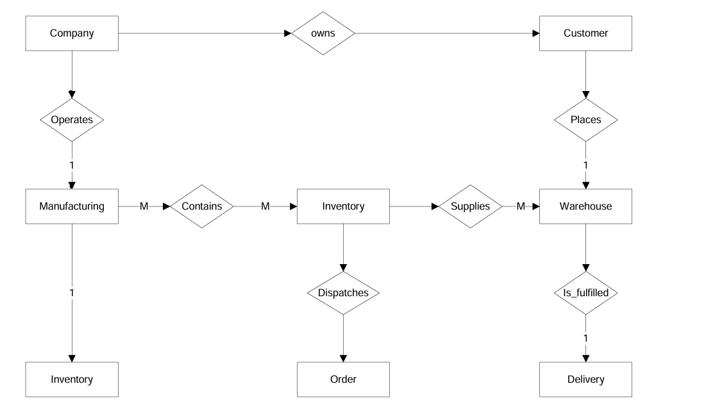
Dataschema of Support Ticket view
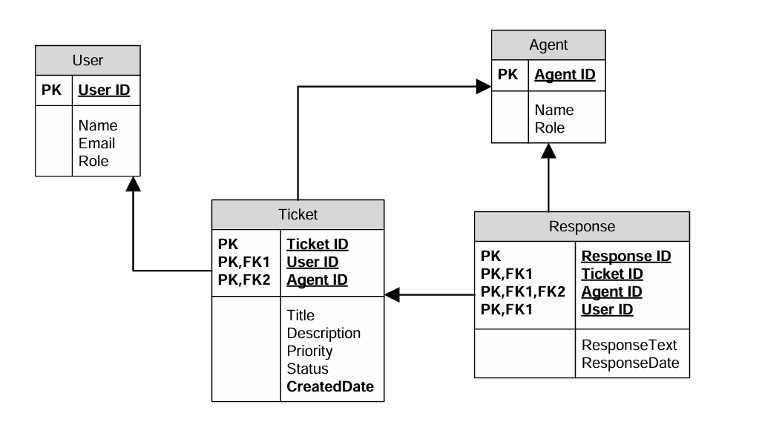
User story of shopping from ecommerce
Sprint 1
User story No : US001 Task: 1 Priority : Highest
As a New User
I WANT TO register with email/phone
SO THAT I can create an account and start shopping.
BV : 300 CP : 5
ACCEPTANCE CRITERIA
- User can sign up with email/phone
- Password encrypted
- Confirmation email/SMS sent

User story No : US002 Task: 2 Priority : Highest
As a Registered User
I WANT TO log in securely
SO THAT I can access my account safely.
BV : 200 CP : 4
ACCEPTANCE CRITERIA
- Login with email/phone + password
- Incorrect credentials show error
- Auto logout after inactivity

User story No : US003 Task: 3 Priority : High
As a Customer
I WANT TO search products
SO THAT I can find items to purchase.
BV : 200 CP : 4
ACCEPTANCE CRITERIA
- Search by category, brand, price
- Relevant results displayed

User story No : US004 Task: 4 Priority : High
As a Customer
I WANT TO filter products
SO THAT I can narrow down choices.
BV : 200 CP : 4
ACCEPTANCE CRITERIA
- Filter by price, ratings, availability
- Dynamic filtering updates results

User story No : US005 Task: 5 Priority : Highest
As a Customer
I WANT TO add products to cart
SO THAT I can purchase later.
BV : 300 CP : 5
ACCEPTANCE CRITERIA
- Add/remove items from cart
- Cart updates instantly

Sprint 2
User story No : US006 Task: 6 Priority : Medium
As a Customer
I WANT TO save items to wish list
SO THAT I can purchase them later.
BV : 100 CP : 2
ACCEPTANCE CRITERIA
- Add/remove items from wishlist
- Wishlist persists after logout

User story No : US007 Task: 7 Priority : High
As a Customer
I WANT TO view product details
SO THAT I can make informed purchase.
BV : 200 CP : 4
ACCEPTANCE CRITERIA
- Show name, price, description, reviews
- Zoom product image

User story No : US008 Task: 8 Priority : Low
As a Customer
I WANT TO sort products
SO THAT I can easily compare options.
BV : 50 CP : 1
ACCEPTANCE CRITERIA
- Sort by price, popularity, ratings
- Default sorting applied

User story No : US009 Task: 9 Priority : Highest
As a Customer
I WANT TO view cart
SO THAT I can check selected items before checkout.
BV : 300 CP : 5
ACCEPTANCE CRITERIA
- View cart summary
- Update quantities
- Remove items

User story No : US010 Task: 10 Priority : Medium
As a Customer
I WANT TO apply discount codes
SO THAT I can save money.
BV : 200 CP : 3
ACCEPTANCE CRITERIA
- Enter promo code
- Validation applied instantly

Sprint 3
User story No : US011 Task: 11 Priority : Highest
As a Customer
I WANT TO checkout securely
SO THAT I can complete purchase safely.
BV : 300 CP : 5
ACCEPTANCE CRITERIA
- Multiple payment options
- Encrypted transaction
- Confirmation shown

User story No : US012 Task: 12 Priority : High
As a Customer
I WANT TO select delivery address
SO THAT I can receive my order at preferred location.
BV : 200 CP : 4
ACCEPTANCE CRITERIA
- Add/manage multiple addresses
- Default address selection

User story No : US013 Task: 13 Priority : Medium
As a Customer
I WANT TO choose delivery option
SO THAT I can receive products conveniently.
BV : 200 CP : 3
ACCEPTANCE CRITERIA
- Standard & express delivery options
- Estimated delivery date shown

User story No : US014 Task: 14 Priority : Highest
As a Customer
I WANT TO track order status
SO THAT I can know progress of my order.
BV : 300 CP : 5
ACCEPTANCE CRITERIA
- Order status visible in account
- Notifications on updates

User story No : US015 Task: 15 Priority : Medium
As a Customer
I WANT TO receive invoice
SO THAT I can keep record of purchases.
BV : 200 CP : 3
ACCEPTANCE CRITERIA
- Invoice generated automatically
- Downloadable PDF invoice

Sprint 4
User story No : US016 Task: 16 Priority : Highest
As a Customer
I WANT TO receive order confirmation
SO THAT I can be sure my purchase is successful.
BV : 300 CP : 5
ACCEPTANCE CRITERIA
- Email/SMS confirmation sent
- Order number generated

User story No : US017 Task: 17 Priority : High
As a Customer
I WANT TO track shipment
SO THAT I can know delivery timeline.
BV : 200 CP : 4
ACCEPTANCE CRITERIA
- Shipment tracking number visible
- Courier updates linked

User story No : US018 Task: 18 Priority : High
As a Customer
I WANT TO return items
SO THAT I can resolve issues with wrong/damaged products.
BV : 200 CP : 4
ACCEPTANCE CRITERIA
- Return request form available
- System validates return policy

User story No : US019 Task: 19 Priority : Medium
As a Customer
I WANT TO get refund status
SO THAT I can know when refund will be credited.
BV : 200 CP : 3
ACCEPTANCE CRITERIA
- Refund tracking in account
- Email notification when refund processed

User story No : US020 Task: 20 Priority : Medium
As a Customer
I WANT TO rate and review products
SO THAT I can share feedback.
BV : 200 CP : 3
ACCEPTANCE CRITERIA
- Give star ratings
- Add text review
- Review visible to others

Sprint 5
User story No : US021 Task: 21 Priority : Low
As a Customer
I WANT TO manage profile
SO THAT I can update personal details.
BV : 100 CP : 2
ACCEPTANCE CRITERIA
- Update name, phone, address
- Save changes instantly

User story No : US022 Task: 22 Priority : Medium
As a Customer
I WANT TO change password
SO THAT I can keep account secure.
BV : 200 CP : 3
ACCEPTANCE CRITERIA
- Old password required
- Password strength validation

User story No : US023 Task: 23 Priority : High
As a Customer
I WANT TO reset password
SO THAT I can recover account.
BV : 200 CP : 4
ACCEPTANCE CRITERIA
- Password reset link via email/SMS
- Temporary OTP supported

User story No : US024 Task: 24 Priority : High
As a Customer
I WANT TO contact support
SO THAT I can resolve issues.
BV : 200 CP : 4
ACCEPTANCE CRITERIA
- Support ticket creation
- Chat/email support option

User story No : US025 Task: 25 Priority : Medium
As a Customer
I WANT TO view order history
SO THAT I can review past purchases.
BV : 200 CP : 3
ACCEPTANCE CRITERIA
- Order list visible
- Filter by date range

Sprint 6
User story No : US026 Task: 26 Priority : Highest
As a Admin
I WANT TO add/edit products
SO THAT customers can view updated catalog.
BV : 300 CP : 5
ACCEPTANCE CRITERIA
- Add/edit product details
- Upload images

User story No : US027 Task: 27 Priority : High
As a Admin
I WANT TO manage inventory
SO THAT stock is always updated.
BV : 200 CP : 4
ACCEPTANCE CRITERIA
- Update product quantities
- Low stock alerts triggered

User story No : US028 Task: 28 Priority : Medium
As a Admin
I WANT TO manage users
SO THAT I can keep accounts under control.
BV : 200 CP : 3
ACCEPTANCE CRITERIA
- View all registered users
- Suspend/activate accounts

User story No : US029 Task: 29 Priority : High
As a Admin
I WANT TO manage orders
SO THAT I can ensure smooth operations.
BV : 200 CP : 4
ACCEPTANCE CRITERIA
- View all orders
- Update order status

User story No : US030 Task: 30 Priority : Medium
As a Admin
I WANT TO generate sales reports
SO THAT I can analyze performance.
BV : 200 CP : 3
ACCEPTANCE CRITERIA
- Generate daily/weekly/monthly reports
- Export as PDF/Excel

Sprint 7
User story No : US031 Task: 31 Priority : Low
As a Admin
I WANT TO apply discounts
SO THAT customers can avail offers.
BV : 100 CP : 2
ACCEPTANCE CRITERIA
- Create/update discount codes
- Set expiry date

User story No : US032 Task: 32 Priority : Medium
As a Customer
I WANT TO receive notifications
SO THAT I can stay updated.
BV : 200 CP : 3
ACCEPTANCE CRITERIA
- Push/email/SMS notifications
- Configurable preferences

User story No : US033 Task: 33 Priority : Low
As a Customer
I WANT TO view recommendations
SO THAT I can find relevant products.
BV : 100 CP : 2
ACCEPTANCE CRITERIA
- Show related products
- Personalized suggestions

User story No : US034 Task: 34 Priority : High
As a Customer
I WANT TO use guest checkout
SO THAT I can purchase without account.
BV : 300 CP : 4
ACCEPTANCE CRITERIA
- Guest checkout option
- Prompt to create account later

User story No : US035 Task: 35 Priority : Medium
As a Customer
I WANT TO track loyalty points
SO THAT I can redeem benefits.
BV : 200 CP : 3
ACCEPTANCE CRITERIA
- Points visible in account
- Redemption at checkout

Sprint 8
User story No : US036 Task: 36 Priority : Low
As a Customer
I WANT TO subscribe to newsletter
SO THAT I can receive offers.
BV : 100 CP : 2
ACCEPTANCE CRITERIA
- Subscribe/unsubscribe option
- Confirmation email sent

User story No : US037 Task: 37 Priority : Low
As a Customer
I WANT TO upload profile picture
SO THAT I can personalize my account.
BV : 100 CP : 1
ACCEPTANCE CRITERIA
- Upload image file
- Preview before saving

User story No : US038 Task: 38 Priority : Medium
As a Admin
I WANT TO manage reviews
SO THAT I can ensure quality feedback.
BV : 200 CP : 3
ACCEPTANCE CRITERIA
- Approve/reject reviews
- Flag inappropriate content

User story No : US039 Task: 39 Priority : High
As a Customer
I WANT TO save multiple payment methods
SO THAT I can checkout faster.
BV : 200 CP : 4
ACCEPTANCE CRITERIA
- Save cards securely
- Select default payment method

User story No : US040 Task: 40 Priority : High
As a Customer
I WANT TO use COD option
SO THAT I can pay on delivery.
BV : 300 CP : 4
ACCEPTANCE CRITERIA
- Cash on Delivery option available
- COD limited by region

