- Business Requirement Document (BRD)
Project Title
Inventory & Delivery Management System for Dairy Products

Project Overview
The company operates multiple manufacturing plants and warehouses across the country, producing ice-cream and milk products. Currently, managing inventory and ensuring timely delivery to customers is challenging. The proposed system will streamline inventory management and enable fastest possible delivery by optimizing warehouse operations, tracking stock, and integrating logistics.

Business Objectives
- Maintain real-time inventory visibility across all plants and warehouses.
- Ensure optimum stock levels to reduce wastage (especially for perishable items).
- Enable fastest delivery routes using warehouse proximity and logistics optimization.
- Provide management with dashboards & reports for decision-making.

In-Scope Functionality
- Inventory tracking (stock in, stock out, transfers).
- Automatic alerts for low stock & expiry date tracking.
- Customer order management (online + offline).
- Delivery optimization (assign nearest warehouse, shortest route).
- Integration with third-party logistics providers.
- Role-based user access (Admin, Plant Manager, Warehouse Staff, Delivery Partner).

Out-of-Scope Functionality
- HR/Payroll system.
- Financial accounting module.
- Customer-facing mobile app (only internal web + dashboard for Phase 1).

Stakeholders
- Business Owner/Client – Strategic decision making.
- Plant Managers – Production & stock updates.
- Warehouse Staff – Handling inventory.
- Delivery Partners – Managing transportation.
- Customers – Receiving timely deliveries.
- IT Team – Developers, testers, support engineers.

Requirements (High Level)
- System must allow plants to update finished goods inventory.
- Warehouses must automatically sync stock levels.
- Customer orders should auto-allocate from the nearest warehouse.
- System should provide delivery route optimization (fastest path).
- Management should access real-time dashboards.

Resource & Development Plan
Team Structure:
- Business Analyst (1) – Requirement gathering, documentation, client communication.
- Project Manager (1) – Planning, timelines, monitoring.
- Developers (4) – Backend (2), Frontend (2).
- QA Testers (2) – Functional + performance testing.
- UI/UX Designer (1) – Wireframes & mockups.
- Database Engineer (1) – Data modeling, performance optimization.
Timeline (Agile – 5 Sprints, 2 weeks each = 10 weeks)
- Sprint 1: Requirement finalization, wireframes, architecture.
- Sprint 2: Inventory module.
- Sprint 3: Order & warehouse module.
- Sprint 4: Delivery & logistics module.
- Sprint 5: Reports, dashboards, UAT & Go-live.

Expected Benefits
- Improved efficiency in stock management.
- Faster delivery improving customer satisfaction.
- Reduced wastage for perishable items.
- Real-time decision making for management.

2. Process Flow Diagram (PFD)
Here’s a simple flow you can show to your client:
Customer Places Order
↓
Check Nearest Warehouse
↓
Is Stock Available?
┌─────────────┐
│ Yes │────→ Allocate Order → Assign Delivery Partner → Deliver Product → Update Inventory
└─────────────┘
│ No
↓
Redirect to Next Nearest Warehouse → Allocate Order
Simplified Process:
- Customer order captured.
- System checks stock availability at nearest warehouse.
- If available → order confirmed → delivery scheduled.
- If not available → system checks next nearest warehouse.
- Delivery executed → system updates inventory in real time.
Assignment 2

1. Introduction Letter (Business Analyst → Client)
Subject: Introduction as Business Analyst for Your Project
Dear Javier,
I hope this message finds you well. My name is Gouthami Palepu, and I will be working as the Business Analyst for your upcoming project. My role will involve understanding your business needs, gathering requirements, and ensuring smooth communication between your team and our development team.
Over the next few weeks, I will work closely with you and your stakeholders to capture requirements, document processes, and translate them into functional specifications for the technical team. This will help us build a solution that aligns with your business goals and adds real value to your operations.
I look forward to collaborating with you and your team. Please feel free to share any initial inputs or expectations so we can start the business understanding process effectively.
Best Regards,
Gouthami Palepu
Business Analyst

2. BRD & SRS (Choose – Online Ticketing System Example)
Business Requirement Document (BRD)
Project Title: Online Ticketing System
Objective:
To create a platform where customers can book tickets (movies, events, travel) online with secure payments and real-time seat/availability updates.
Business Needs:
- Simplify ticket booking for customers.
- Provide a centralized system to manage events/tickets.
- Offer digital payment and e-ticket options.
In Scope:
- Ticket search & booking.
- Payment gateway integration.
- E-ticket generation.
- Seat availability management.
Out of Scope:
- Offline bookings (manual counters).
- Vendor management.
Stakeholders:
- Customers
- Event organizers
- Admins
- IT/Development team
Benefits:
- Faster bookings.
- Reduced manual errors.
- Customer satisfaction.

Software Requirement Specification (SRS)
Functional Requirements:
- Customers should be able to search for events and book tickets.
- System should integrate with multiple payment gateways.
- Users should receive e-ticket confirmation via email/SMS.
- Admins should manage events, seats, and ticket availability.
Non-Functional Requirements:
- Performance: The system must support 500+ concurrent users.
- Security: All transactions must be encrypted.
- Usability: Mobile-friendly responsive design.
- Availability: 99.9% uptime.

3. ERD – Support Ticket / Ticketing Lifecycle
Here’s a simple Entity Relationship Diagram (ERD)
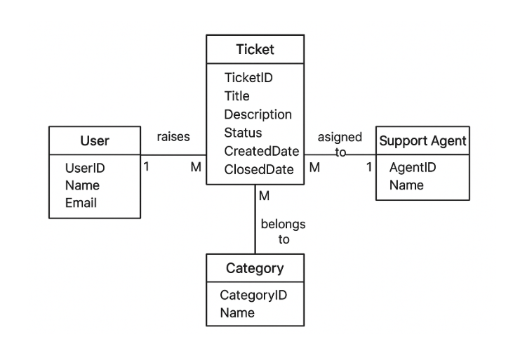
Entities:
- User (UserID, Name, Email)
- Ticket (TicketID, Title, Description, Status, CreatedDate, ClosedDate)
- Support Agent (AgentID, Name, Role)
- Category (CategoryID, Name, Priority)
Relationships:
- A User raises a Ticket (1:M).
- A Ticket is assigned to a Support Agent (M:1).
- A Ticket belongs to a Category (M:1).
- A Support Agent handles many Tickets (1:M).

4. User Story – Shopping from eCommerce
Epic: Online Shopping

User Story No: 1
Tasks: 02 | Priority: Low
As a customer,
I want to search products by name or category,
so that I can quickly find what I need.
BV: 500 | CP: 2
Acceptance Criteria:
- User can enter product name in search bar.
- System returns matching results within 2 seconds.
- User can filter results by category, price, or rating.
- If no results are found, system displays “No products found.”

User Story No: 2
Tasks: 02 | Priority: HIGH
As a customer,
I want to make a secure payment,
so that I can complete my order confidently.
BV: 500 | CP: 5
Acceptance Criteria:
- System supports multiple payment methods (Card, UPI, Wallet).
- Payment transactions are encrypted (SSL/TLS).
- Successful payment generates an order confirmation.
- Failed payment prompts retry or alternative option.

User Story No: 3
Tasks: 02 | Priority: HIGH
As a customer,
I want to track my order status,
so that I know when my product will arrive.
BV: 500 | CP: 5
Acceptance Criteria:
- User can see status updates (Placed → Processed → Shipped → Delivered).
- System sends email/SMS updates at each stage.
- Order tracking page is accessible from “My Orders.”
- Delivery estimate is shown.

User Story No: 4
Tasks: 02 | Priority: HIGH
As an admin,
I want to manage product inventory,
so that the website always shows updated availability.
BV: 500 | CP: 5
Acceptance Criteria:
- Admin can add, update, or remove products.
- System updates stock in real time after each purchase.
- Out-of-stock items are marked as “Unavailable.”
- Low-stock alerts are generated automatically.

User Story No: 5
Tasks: 02 | Priority: HIGH
As a customer,
I want to add products to a cart,
so that I can purchase multiple items together.
BV: 500 | CP: 5
Acceptance Criteria:
- User can add any available product to cart.
- Cart icon updates with number of items.
- User can view, edit, or remove items from cart.
- Cart persists until checkout or manual removal.

