Q.01 | Identify Business Process Model for Online Agriculture Store – (Goal, Inputs, Resources, Outputs, Activities, Value created to the end Customer).
A.01 | Goal: To make an online agriculture product store to facilitate remote area farmers to buy  Agriculture products.
A.01 | Inputs: Farmers, Manufacturers, Project Manager, Business Analysts, Logistic Partners
A.01 | Resource: Warehouse, Software, Office Space, Logistics
A.01 | Outputs: Online agriculture store, Direct communication between farmers and manufacturers for  agriculture products, Increase in crop production, Rise in sales of agricultural  Products.
A.01 | Activities: Online store, Timely delivery of agriculture products.
A.01 | Value: Access to wide range of Agriculture products to farmers, Increase in sales of agriculture  products
Q.2 | Mr Karthik is doing SWOT analysis before he accepts this project. What Aspects he Should consider as Strengths, as Weaknesses, as Opportunity and as Threats.
A.2 | Strength Weakness  Farmers Input Finding quality manufacturers  Project Team Farmers ability to use online/mobile application  Manufacturer’s interest Supply chain disruptions  Inventory management  Opportunities Threats  Expansion of online stores Competitors ability to replicate the business model  Expansion into new product categories Changes in farmers buying habits  Logistic concerns
Q.3 | Mr Karthik is trying to do feasibility study on doing this project in Technology (Java), Please help him with points (HW SW Trained Resources Budget Time frame) to consider in feasibility Study.
A.3 | Technology : Based on the data base servers, Payment gateways, Security and API’s
A.3 | Hardware: Based on storage, Backup systems, Network infrastructure.
A.3 | Software: Based on shopping cart software, content management system, and payment gateway  Software
A.3 | Resources: Project Management team, Business Analysts, Software developers,  Farmers/Manufacturers

 | Budget: Various costs involved such as development costs, hardware costs.
 | Time frame: Based on resources, No. of features.
Q.4 | Mr Karthik must submit Gap Analysis to Mr Henry to convince to initiate this project.  What points (compare AS-IS existing process with TO-BE future Process) to showcase in the GAP Analysis.
Current State:

- Non availability of online store for agriculture products
- Farmers’ struggle to get desired agriculture products on time
- Customers data unavailable to increase the sales of agriculture products

Desired State:

- Online agriculture store will ensure the availability of agriculture products to farmers
- Increase in the sales of agriculture products
- Better inventory management based on customer data
- Expansion to global level with new product categories
- Better supply chain traceability
- Continued investment in emerging technologies to enhance the customer experience

Q.5 | List down different risk factors that may be involved (BA Risks And process/Project Risks).
BA Risks

- Incomplete requirements
- Domain
- Change in requirement

Process/Project Risks

- Scope risks
- Stakeholders risks
- Collaboration with manufacturers
- Collaboration with logistics team

Q.6 | Perform stakeholder analysis (RACI Matrix) to find out the key stakeholders who can take Decisions and Who are the influencers.

A.6
  R/A/C/I | Name | Designation | Details
  Responsible | Mr.Doku | Project Coordinator | Email: doku@gmail.com  Ph.No.:02025215256  Reach Out: 9 am to 12 am IST
  Responsible | Mr.Ben | SME | Email: ben@gmail.com  Ph.No.:02025215257  Reach Out: 10 am to 14 pm IST
  Responsible | Ms. Juhi | Sr. Java Developer | Email: juhi@gmail.com  Ph.No.:020252152586  Reach Out: 11 am to 15 pm IST
  Accountable | Mr Vandanam | Project Manager | Email: vandanam@gmail.com  Ph.No.:020252152587  Reach Out: 9 am to 16 pm IST
  Accountable | Mr.Harin | Business Analyst | Email: harin@gmail.com  Ph.No.:020252152587  Reach Out: 11 am to 15 pm IST
  Accountable | Mr.Doku | Client SPOC | Email: doku@gmail.com  Ph.No.:02025215216  Reach Out: 9 am to 12 am IST
  Consulted | Mr Pandu | Financial Head | Email: doku@gmail.com  Ph.No.:02025215296  Reach Out: 9 am to 11 am IST
  Consulted | Mr Mike | Network Admin | Email: mike@gmail.com  Ph.No.:02025215246  Reach Out: 11 am to 12 am IST
  Informed | Mr.Henry | Sponsor | Email: henry@gmail.com  Ph.No.:02025215296  Reach Out: 11:30 am to 14 pm IST
  Informed | Mr Karthik | Delivery Head | Email: karthik@gmail.com  Ph.No.:02025215226  Reach Out: 9 am to 12 am IST
Q.7 | Help Mr Karthik to prepare a business case document
A.7 | The project is initiated to make online agriculture product store. Farmers are struggling to get the necessary seeds, pesticides and fertilizers on time which is having significant implications on crop productions. With the help of online agriculture product store, farmers will be able to procure required seeds, fertilisers and pesticides on time which will improve the quality and quantity of crops. Moreover, manufacturers of agriculture products will be able to increase the sales of their products and have better control on inventory management.  The collaboration of farmers and manufacturers will help reduce the cost of crops which would benefit the common man. In order to execute this project, project team, business analysts, development team, manufacturers and farmers are required. Since this is a first time project, the change is not required to adopt the new technology. The users and manufacturers will be trained to carry out the respective tasks. The time frame to cover ROI is estimated to be 15 months after project completion. Stakeholders shall be identified using ILS and RACI matrix.
Q.8 | Four SDLC Methodologies
A.8 | - Sequential - Waterfall Model  - Iterative – RUP  - Evolutionary – Spiral  - Agile – Scrum
Q.9 | Waterfall RUP Spiral and Scrum Models
- Sequential - Waterfall Model

- Waterfall model is a traditional model and it follows a structured approach with each phase having specific deliverables.
- At the end of each phase a review takes place to determine if the project is running fine.
- The model works well for smaller projects where requirements are very well understood.

- Iterative – RUP

- RUP stands for Rational Unified Process, Where phase/ module wise (long term project) application is developed. Hence we can track the defects at early stages. This avoids the downward flow of the defects
- Change request is welcomed in every phase of development.
- This model is called heavy weight process model.
- The model has multiple stages which require more resources and more budgets.

- Evolutionary – Spiral

- The spiral model is a risk-driven process model generator for software projects.
- It has four phases: Planning, Risk Analysis, Engineering and Evaluation.
- A software project repeatedly passes through these phases in iterations (called Spirals in this model).
- The baseline spiral, starting in the planning phase, requirements is gathered and risk is assessed. Each subsequent spiral builds on the baseline spiral.

- Agile – Scrum

Agile has four main values and twelve principles which describes the methodology.

4.1 Four main Values

- Individuals and interactions over processes and tools
- Working software over comprehensive documentation
- Customer collaboration over contract negotiation
- Responding to change over following a plan

4.2 Twelve Principles of Agile Software

- Satisfy the customer through early and continuous delivery of valuable software.
- Welcome changing requirements, even late in development.
- Agile processes harness change for the customer's competitive advantage.
- Deliver working software frequently, from a couple of weeks to a couple of months, with a preference to the shorter timescale.
- Business people and developers must work together daily throughout the project.
- Build projects around motivated individuals. Give them the environment and support they need, and trust them to get the job done.
- The most efficient and effective method of conveying information to and within a development team is face-to-face conversation.
- Working software is the primary measure of progress.
- Agile processes promote sustainable development. The sponsors, developers, and users should be able to maintain a constant pace indefinitely.
- Continuous attention to technical excellence and good design enhances agility.
- Simplicity--the art of maximizing the amount of work not done--is essential.
- The best architectures, requirements, and designs emerge from self-organizing teams.
- At regular intervals, the team reflects on how to become more effective, then tunes
and adjusts its behaviour accordingly.

Q.10 | Waterfall Vs V-Model
 | The cost of Waterfall model is low as compare to V Model. In Waterfall model, testing activity starts at later stage whereas; in V model the activity starts at first stage. The Waterfall model moves in linear way unlike V model which does not move in linear way. The customer involvement in V model is more as compare to Waterfall model.
Q.11 | Justify your choice.
To make online store for agriculture products, it is better to go with V model. First of all, the budget for this project is sufficient to go with V model as it would provide more assurance on project’s success. Secondly, the testing activity starts at early stage in V model which would ensure timely identification of the deficiencies in the project.

Further to this, Farmers involvement is more in this project as it would benefit them in the long run. Manufacturers and logistic team would also be expected to participate in the project with excitement as result of their own benefits. V model provides the confidence of delivering the project on time.

So considering all the above factors, it is better to go with V model than Waterfall model.

Q.12 | Gantt Chart
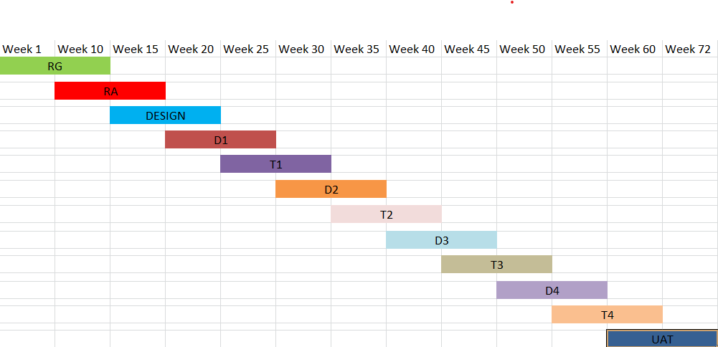

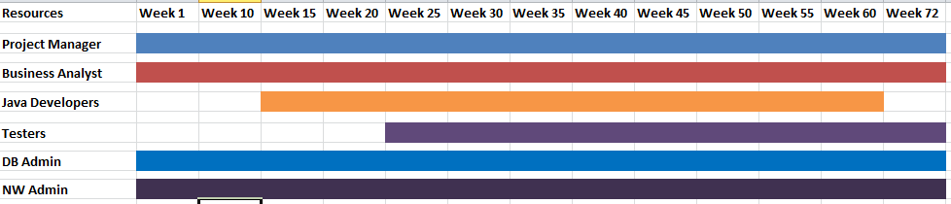

Q.13 | Fixed Bid Vs Billing
A.13 | In the Fixed Bid projects, the cost is fixed and it is agreed in advance whereas, in Billing projects the cost is not fixed and it depends on the efforts. The Fixed Bid projects are rigid and predefined, however, the billing projects are flexible and can evolve throughout the process.  Vendor bears the risk in Fixed Bid project and in Billing projects, the client bears the risk. The flexibility is low in Fixed bid projects as compare to Billing projects. A Fixed bid is suited for short, clear project and billing project is suited for long dynamic project.
Q.14 | Preparer Timesheets of a BA in various stages of SDLC.
A.14
  Design Timesheet of a BA
  Date | Task / Activity | Actionable Item | Start Time | End Time | Duration
  08/09/25 | Requirement Gathering | Client Workshop | 10.00 AM | 1:00 PM | 03
  08/09/25 | Preparing BRD | Draft BRD | 2:00 PM | 5:00 PM | 03
  09/09/25 | Use Case Diagram | Draft Use case diagram | 10.00 AM | 1:00 PM | 03
  09/09/25 | Activity Diagram | Draft Activity Diagram | 2:00 PM | 5:00 PM | 03
   |  |  |  |  | 12
  Development Timesheet of a BA
  Date | Task / Activity | Actionable Item | Start Time | End Time | Hours
  10/09/25 | Requirement Gathering with Dev Team | Workshop with stake holders | 11.00 AM | 1:00 PM | 02
  10/09/25 | Preparing user stories | Stories added to backlog | 3:00 PM | 5:00 PM | 02
  11/09/25 | Acceptance criteria Documentation | For dev team reference | 10.00 AM | 1:00 PM | 03
  11/09/25 | UAT test case review | Review with QA | 2:00 PM | 5:00 PM | 03
   |  |  |  |  | 10
  Testing Timesheet of a BA
  Date | Task / Activity | Actionable Item | Start Time | End Time | Hours
  12/09/25 | Reviewing test scenarios | Verified coverage vs BRD | 10.00 AM | 1:00 PM | 03
  12/09/25 | UAT Planning with Stakeholders | Draft UAT plan | 2:00 PM | 5:00 PM | 03
  13/09/25 | Defect Triage Meeting | Defect analysis | 10.30 AM | 12:30 PM | 02
  13/09/25 | Validating Fixes against Requirement | Validation activity | 2:00 PM | 5:00 PM | 03
   |  |  |  |  | 11
  UAT Timesheet of a BA
  Date | Task / Activity | Actionable Item | Start Time | End Time | Hours
  14/09/25 | Preparing UAT Test Plan | Draft UAT Plan | 10.00 AM | 1:00 PM | 03
  14/09/25 | Reviewing UAT Test scenarios | Validated vs BRD | 2:00 PM | 5:00 PM | 03
  15/09/25 | Coordinating UAT Execution | Providing support to testers | 10.00 AM | 1:00 PM | 03
  15/09/25 | Defect Triage with Dev & QA | Defect analysis | 2:00 PM | 5:00 PM | 03
  16/09/25 | Preparing UAT sign-off report | Meeting with client for sign-off | 10.00 AM | 1:00 PM | 03
  Deployment n Implementation Timesheet of a BA
  Date | Task / Activity | Actionable Item | Start Time | End Time | Hours
  17/09/25 | Deployment Readiness review | Checklist Verification | 10.00 AM | 1:00 PM | 03
  17/09/25 | Preparing user training material | Draft training slides | 2:00 PM | 5:00 PM | 03
  18/09/25 | Supporting Go Live cutover activities | Monitor Migration | 11.00 AM | 1:00 PM | 02
  18/09/25 | User Training / Demo session | Conduct training | 2:00 PM | 5:00 PM | 03
  19/09/25 | Post- Deployment Validation | Verification of critical flows | 9:00 AM | 12:00 PM | 03
  19/09/25 | Hypercare support | Address user queries | 2:00 PM | 4:00 PM | 02
   |  |  |  |  | 16

