Question 1 – Write Agile Manifesto – 8 Marks
Answer:
The Agile Manifesto was introduced in 2001 by a group of software developers to overcome rigid and documentation-heavy traditional approaches. It focuses on adaptability, collaboration, and customer-centric delivery.
The 4 Core Values of Agile Manifesto are:
- Individuals and Interactions over Processes and Tools
  - Emphasis is on effective communication, collaboration, and problem-solving rather than being restricted by rigid tools or processes.
  - Example in Scrum Foods: Customer support chat and team collaboration tools are more valuable than strict process documentation.
- Working Software over Comprehensive Documentation
  - Focus on delivering functional product increments instead of spending months on detailed documentation.
  - Example: Delivering a working "Restaurant Registration Module" in Sprint 1 is more useful than preparing lengthy requirement documents.
- Customer Collaboration over Contract Negotiation
  - Encourages continuous involvement of customers in the development cycle instead of just relying on initial agreements.
  - Example: Scrum Foods involves restaurant owners and customers during sprint reviews to validate usability.
- Responding to Change over Following a Plan
  - Agile embraces change and adapts quickly to evolving requirements.
  - Example: If customers demand UPI integration instead of only card payments, Scrum Foods team can adapt in the next sprint.
The 12 Agile Principles supporting the manifesto are:
- Customer satisfaction through early and continuous delivery of valuable software.
- Welcome changing requirements, even late in development.
- Deliver working software frequently (weeks rather than months).
- Business people and developers must work together daily.
- Build projects around motivated individuals and provide support.
- Face-to-face communication is the most effective method.
- Working software is the primary measure of progress.
- Agile processes promote sustainable development.
- Continuous attention to technical excellence enhances agility.
- Simplicity—the art of maximizing the amount of work not done—is essential.
- The best architectures, requirements, and designs emerge from self-organizing teams.
- Regularly reflect and adjust behavior for effectiveness.

Q2 – 40 User Stories with Acceptance Criteria, BV & CP (Scrum Foods Project)
No. | User Story | Acceptance Criteria | BV | CP
1 | As a Delivery Boy, I want to register so that I can deliver orders. | Registration form with Name, ID, Mobile, Email, Address; Register button; Success message. | 500 | 2
2 | As a Restaurant Owner, I want to view orders so that I can prepare food accordingly. | Orders shown in tabular list with ID, item, status. | 500 | 2
3 | As a Customer, I want to add address so that I can get food at my location. | Text box for address; Rule: Within 5 km radius. | 500 | 2
4 | As a Customer, I want to select payment mode so that I can pay easily. | Show radio buttons (UPI, Card, COD); Only one selectable. | 500 | 3
5 | As an Admin, I want to view restaurants so that I can approve them. | List restaurants, verify details, Approve/Reject button, notification sent. | 500 | 2
6 | As a Customer, I want to view price so that I can decide what to order. | Display menu prices clearly. | 50 | 1
7 | As a Customer, I want delivery boy’s contact so that I can call if needed. | Show delivery boy name, number, picture in tracking. | 50 | 1
8 | As a Restaurant Owner, I want to provide time slots so that customers know hours. | Add opening/closing times; Update success message. | 100 | 2
9 | As a Business Owner, I want restaurant revenue reports so that I can monitor income. | Select dates, region; Generate & download in Excel. | 200 | 3
10 | As a Regional Admin, I want to manage regional restaurants so that I can track them. | Select restaurants, dates; Generate & download performance report. | 200 | 3
11 | As an Admin, I want regional revenue reports so that I can view region-wise performance. | Dropdown for region; Show tabular revenue; Export Excel/PDF. | 100 | 3
12 | As a Customer, I want to chat with regional admin so that I can request refunds. | Text fields; Show order ID; Submit button; Generate issue ID. | 200 | 2
13 | As a Customer, I want to search restaurants so that I can find food easily. | Search bar by name/cuisine; Show results instantly. | 500 | 2
14 | As a Customer, I want to filter menu by cuisine so that I can find specific food. | Filters by cuisine, veg/non-veg, price range. | 300 | 3
15 | As a Customer, I want to track my order live so that I know ETA. | Map tracking; Status updates (Picked, Out for Delivery). | 1000 | 5
16 | As a Customer, I want to cancel order so that I can stop unwanted delivery. | Cancel button; Confirm prompt; Refund if prepaid. | 500 | 3
17 | As a Customer, I want to rate food so that others know quality. | Rating scale 1–5; Comment box; Save review. | 300 | 2
18 | As a Customer, I want to reorder from history so that I save time. | Show past orders; Reorder button adds to cart. | 200 | 2
19 | As a Delivery Boy, I want to view assigned orders so that I can deliver them. | List new & pending orders; Accept/Reject option. | 400 | 3
20 | As a Delivery Boy, I want to update status so that customers get updates. | Status buttons (Picked up, Delivered); Notify customer. | 500 | 2
21 | As a Delivery Boy, I want to view earnings so that I can track income. | Daily/weekly/monthly reports; Export option. | 300 | 2
22 | As a Restaurant Owner, I want to add/edit menu so that customers see options. | Add items, price, description; Save/Update/Delete. | 600 | 4
23 | As a Restaurant Owner, I want to view feedback so that I can improve. | Show feedback linked to orders; Avg. rating. | 300 | 2
24 | As a Regional Admin, I want to manage delivery boys so that I can assign regions. | Add/Remove/Edit delivery boys; Link to restaurants. | 400 | 3
25 | As a Regional Admin, I want to handle customer issues so that problems are solved. | List customer complaints; Assign to support; Close issue. | 300 | 3
26 | As an Admin, I want to manage Regional Admins so that I control hierarchy. | Add/Edit/Delete regional admins; Access control. | 400 | 3
27 | As an Admin, I want to resolve escalated issues so that service is maintained. | View escalations; Provide resolution; Notify stakeholders. | 200 | 2
28 | As a Business Owner, I want sales reports so that I can analyze trends. | Generate reports by month/year; Charts included. | 500 | 4
29 | As a Business Owner, I want to approve payments so that restaurants get paid. | List pending payments; Approve/Reject option. | 400 | 3
30 | As a Customer, I want to apply promo codes so that I get discounts. | Text field for coupon; Validate; Apply discount. | 300 | 2
31 | As a Customer, I want multiple addresses so that I can order at different places. | Add, Edit, Delete addresses; Choose at checkout. | 200 | 2
32 | As a Customer, I want to save favorite restaurants so that I reorder faster. | Add to Favorites; Quick access on homepage. | 150 | 1
33 | As a Customer, I want notifications so that I get updates. | Push/email/SMS for order status, offers. | 200 | 3
34 | As a Restaurant Owner, I want to view revenue reports so that I know performance. | Select date range; Generate report in Excel. | 300 | 2
35 | As a Restaurant Owner, I want to raise issues so that admin resolves them. | Form with description; Submit button; Generate ticket ID. | 200 | 2
36 | As a Delivery Boy, I want to raise issues so that I can report problems. | Submit issue form; Attach order ID; Track status. | 200 | 2
37 | As a Customer, I want COD payment so that I can pay on delivery. | Option at checkout; Delivery boy collects cash. | 500 | 2
38 | As a Customer, I want refund tracking so that I know status. | Show refund initiated/completed with date. | 200 | 2
39 | As an Admin, I want to approve delivery boy registration so that only verified join. | List delivery boys; Approve/Reject option. | 400 | 3
40 | As a Business Owner, I want dashboards so that I see KPIs. | Dashboard with orders, revenue, top restaurants, issues. | 600 | 4

Question 3 – What is Epic? Write 2 Epics – 5 Marks
Answer:
Epic:
An Epic is a large user story that is too big to be completed in a single sprint. It needs to be broken down into smaller user stories for implementation. Epics usually represent a big feature or functionality.
Examples of Epics in Scrum Foods:
- Epic 1 – Customer Order Management
  - Description: End-to-end order process from placing an order, payment, tracking, to cancellation.
  - User Stories:
    - Add food items to cart
    - Select payment method
    - Track order in real-time
    - Cancel an order
    - Provide feedback & rating
  - BV: 1000 (high importance for business revenue).
  - CP: 20 (complex because multiple modules & integration required).
- Epic 2 – Restaurant Partner Management
  - Description: Complete onboarding and management of restaurant partners.
  - User Stories:
    - Restaurant registration
    - Upload menu & prices
    - Manage availability (time slots)
    - View orders and revenues
    - Resolve issues
  - BV: 800 (critical for business expansion).
  - CP: 15 (moderate complexity).

Question 4 – What is the difference between BV and CP – 2 Marks
Answer:
Aspect | Business Value (BV) | Complexity Points (CP)
Meaning | Importance of the feature to the business | Effort/complexity required to develop the feature
Estimated By | Stakeholders / Product Owner | Development Team
Measurement | Currency notes (1000, 500, 100, etc.) | Story Points (1, 2, 3, 5, 8, 13, etc.)
Purpose | Helps prioritize features | Helps estimate workload
Example (Scrum Foods) | Payment Gateway Integration = High BV (essential for business) | But CP may be medium (standard APIs exist)

Question 5 – Explain about Sprint – 5 Marks
Answer:
A Sprint is a time-boxed iteration in Scrum where a potentially shippable product increment is developed.
- Duration: Fixed (commonly 2 weeks, as in Scrum Foods project).
- Goal: Deliver working software that provides business value.
- Sprint Activities:
  - Sprint Planning – Team decides which user stories from product backlog will be included.
  - Daily Scrum – 15-min stand-up meetings where developers answer 3 questions:
    - What did I do yesterday?
    - What will I do today?
    - Any impediments?
  - Development Work – Coding, testing, integration.
  - Sprint Review – Stakeholders inspect product increment and give feedback.
  - Sprint Retrospective – Team reflects on improvements for the next sprint.
Example (Scrum Foods):
- Sprint 1 may focus on core functionalities like Customer Registration, Restaurant Registration, Order Placement, and Payment Integration.
- By end of Sprint 1, a working increment (MVP) is ready for demo.

Question 6 – Explain Product Backlog and Sprint Backlog – 5 Marks
Answer:
1. Product Backlog:
- A master list of all features, enhancements, bug fixes, technical work, and requirements needed in the product.
- Owned and prioritized by the Product Owner.
- Continuously updated and refined through backlog grooming sessions.
- Items are ordered based on Business Value (BV) and stakeholder needs.
Example in Scrum Foods:
- Items like “Customer Registration,” “Add to Cart,” “UPI Payment Integration,” and “Restaurant Revenue Report” sit in the Product Backlog.
2. Sprint Backlog:
- A subset of the product backlog that the Scrum Team commits to completing in a Sprint.
- Created during Sprint Planning.
- Owned by the Development Team.
- Contains selected User Stories + Tasks to deliver by end of Sprint.
Example in Scrum Foods:
- Sprint 1 Sprint Backlog may include:
  - Customer Registration (BV: 500, CP: 2)
  - Restaurant View Orders (BV: 500, CP: 2)
  - Customer Address Management (BV: 500, CP: 2)
  - Payment Mode Selection (BV: 500, CP: 3)

Question 7 – What is Impediments Log? Write 2 Impediments – 5 Marks
Answer:
Impediments Log is a record of obstacles, blockers, or challenges faced by the Scrum Team during the sprint that affect progress. The Scrum Master owns this log and ensures impediments are resolved.
Examples of Impediments in Scrum Foods Project:
- Technical Impediment:
  - Integration with payment gateway (e.g., UPI API not working as expected).
  - Impact: Blocks testing of payment module.
- Resource Impediment:
  - One developer is unavailable due to illness, reducing team velocity.
  - Impact: Delay in completing assigned user stories.

Question 8 – Explain Velocity of the Team – 1 Marks
Answer:
- Velocity is the total number of Story Points (CP) completed by the team in a Sprint.
- It helps forecast how many Product Backlog Items (PBIs) the team can complete in future sprints.
Example in Scrum Foods:
- Sprint 1 → Team committed to 50 CP, completed 45 CP.
- Velocity = 45 CP.
- Future sprints can be planned around 45 CP capacity.

Question 9 – Draw Sprint Burn Down Chart and Product Burn Down Chart – 3 Marks
Answer:
- Sprint Burn Down Chart:
  - Shows remaining work (CP) vs time (days) within a sprint.
  - Helps track if the sprint goal is achievable.
- Product Burn Down Chart:
  - Shows overall project progress (total story points left) across multiple sprints.
  - Helps stakeholders track release readiness.
- Sprint Burn Down Chart: X-axis = Days of Sprint, Y-axis = Story Points Remaining. Line trends downward toward zero.
- Product Burn Down Chart: X-axis = Sprint Numbers, Y-axis = Total Remaining Story Points. Line trends downward over time.
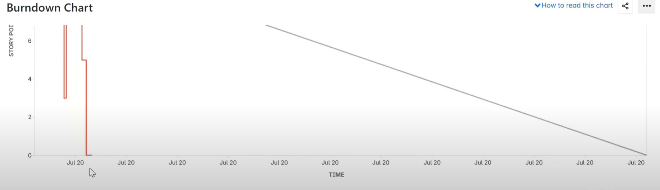

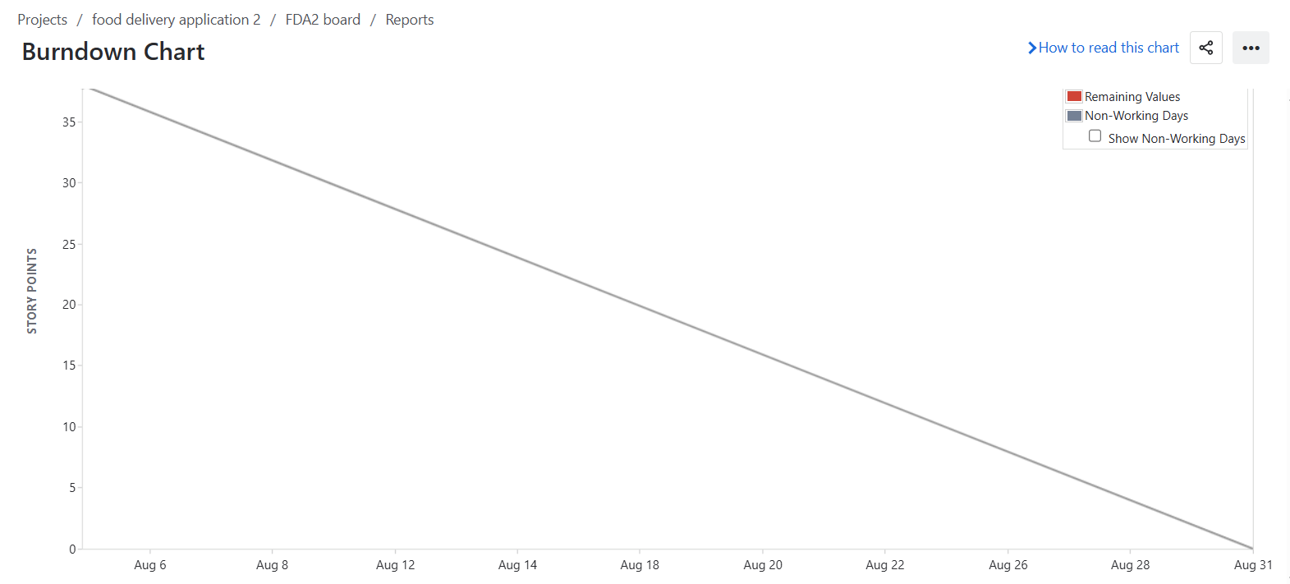

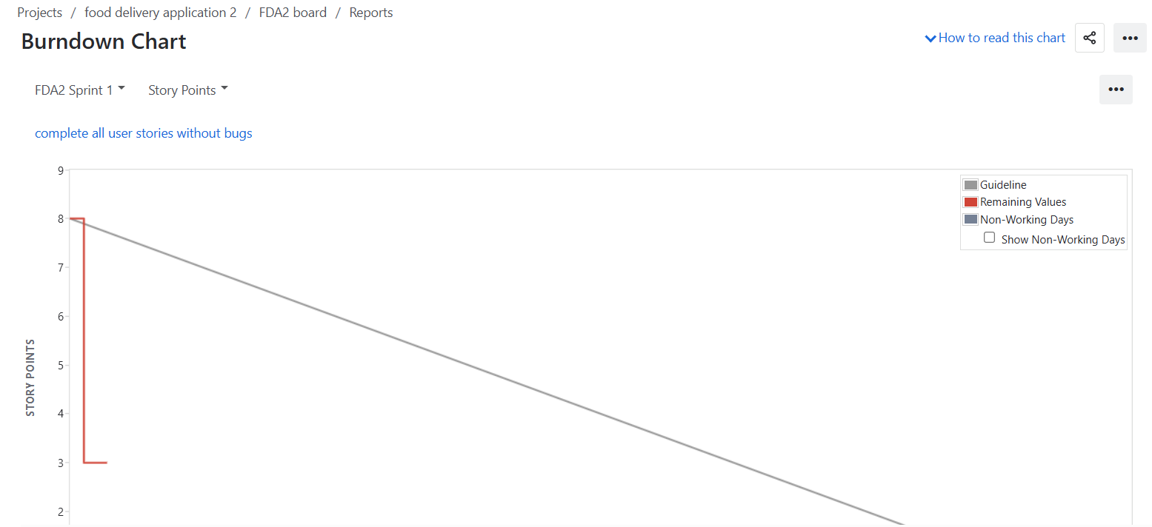

Question 10 – Explain about Product Grooming – 2 Marks
Answer:
- Also called Backlog Refinement.
- Regular meeting (mid-sprint) where Product Owner and Team review and refine the product backlog.
- Activities include:
  - Adding new items.
  - Re-prioritizing items.
  - Breaking epics into smaller stories.
  - Estimating BV and CP.
- Helps ensure backlog is always “ready” for the next sprint.
Example in Scrum Foods:
- Adding “Discount Coupons” as a new user story after customer feedback.
- Splitting “Order Tracking” into smaller stories (Map Tracking, Delivery Boy Contact, ETA Display).

Question 11 – Explain the roles of Scrum Master and Product Owner – 3 Marks
Answer:
Scrum Master:
- Acts as a servant-leader for the team.
- Removes impediments, ensures scrum practices are followed.
- Facilitates meetings (Daily Scrum, Retrospectives, Sprint Review).
- Shields team from outside distractions.
Product Owner (YOU in this project):
- Represents the voice of the customer/stakeholder.
- Owns and prioritizes the product backlog.
- Defines product vision and roadmap.
- Ensures delivered increments provide maximum business value.
📌 Example in Scrum Foods:
- Scrum Master (Satya Rathnakar) ensures smooth sprint execution.
- Product Owner (You) prioritize features like “Payment Options” over “Discount Coupons” based on stakeholder needs.

Question 12 – Explain all Meetings Conducted in Scrum Project – 8 Marks
Answer:
Scrum Framework includes 5 major ceremonies:
- Sprint Planning:
  - Team decides which PBIs to include in the sprint backlog.
  - Discuss sprint goal.
- Daily Scrum (Stand-up):
  - 15 minutes daily.
  - Developers answer 3 questions (yesterday’s work, today’s work, impediments).
- Sprint Review:
  - Held at end of sprint with stakeholders.
  - Product increment demonstrated.
  - Feedback gathered.
- Sprint Retrospective:
  - Team-only meeting after sprint review.
  - Discusses lessons learned, process improvements.
- Backlog Grooming (Product Refinement):
  - Optional, continuous activity.
  - Prepares backlog items for upcoming sprints.
📌 In Scrum Foods Sprint 1:
- Planning: Chose 10 user stories.
- Daily Scrum: Developers updated tasks.
- Review: Demoed Registration and Payment.
- Retrospective: Noted delay due to API issues.
- Grooming: Added “Restaurant Discounts” for next sprint.

Question 13 – Explain Sprint Size and Scrum Size – 2 Marks
Answer:
- Sprint Size: Duration of the sprint (commonly 2 weeks in Scrum Foods).
- Scrum Size: Duration of each daily scrum (15 mins → 1 day iteration checkpoint).
📌 Example:
- Scrum Foods project → Sprint Size = 2 weeks, Scrum Size = 1 day.

Question 14 – Explain DOR and DOD – 2 Marks
Answer:
- DOR (Definition of Ready):
  - Criteria that a user story must meet before it can be picked up for sprint.
  - Example: Story must have clear acceptance criteria, estimated BV & CP.
- DOD (Definition of Done):
  - Criteria that a story must meet to be considered “completed.”
  - Example: Code developed, tested, integrated, accepted by PO.
📌 Example in Scrum Foods:
- DOR: “Customer Address Feature” → Must have business rule (within 5 km).
- DOD: Feature works, passes testing, visible to customers, ready for release.

Question 15 – Explain Prioritization Techniques and MVP – 3 Marks
Answer:
Prioritization Techniques:
- MoSCoW Method: Must Have, Should Have, Could Have, Won’t Have.
- Kano Model: Classifies features into basic, performance, and delight factors.
- 100-Point Method: Stakeholders distribute points among features.
- WSJF (Weighted Shortest Job First): Prioritize based on ROI vs Effort.
MVP (Minimum Viable Product):
- The smallest product version that delivers value and can be released to customers.
- Helps test market quickly with minimal cost.
📌 Example in Scrum Foods:
- MVP: Registration, Restaurant Menu, Payment, Order Tracking.
- Features like “Discount Coupons” or “AI Recommendations” can come later.

Question 16 – Difference between Business Analyst and Product Owner – 3 Marks
Answer:
Aspect | Business Analyst (BA) | Product Owner (PO)
Focus | Requirements gathering, documentation, analysis | Maximizing product value
Role | Works with stakeholders to identify needs | Owns product backlog & priorities
Decision Making | Suggests solutions but does not own final call | Final decision maker for backlog
In Scrum Foods | BA may document user needs for order tracking | PO prioritizes which feature gets built first

Question 17 – Prepare a Sample Resume of 3yrs Exp Product Owner – 3 Marks
Answer:
📌 Sample Resume (Product Owner – 3 Years Experience)
Name: Swapnil Ninawe
Email: swapninu@gmail.com | Phone: 7057193160 | LinkedIn: [Profile Link]

Professional Summary:
Product Owner with 3 years of experience in Agile-Scrum environments, specializing in backlog management, stakeholder engagement, and delivering high-value digital products. Proven ability to translate business requirements into actionable user stories, prioritize features, and deliver successful product increments.

Key Skills:
- Agile & Scrum Frameworks
- Product Backlog Management
- User Story Writing (BV & CP Estimation)
- Sprint Planning & Execution
- Stakeholder Management
- Jira, Confluence, MS Azure DevOps
- Wireframing & Requirement Analysis

Work Experience:
Product Owner | Scrum Foods (COEPD IT Solutions) | Aug 2022 – Present
- Owned product backlog of online food delivery platform.
- Defined product vision and roadmap.
- Wrote 40+ user stories with BV & CP.
- Prioritized MVP features (Registration, Payment, Tracking).
- Coordinated with 8-member Scrum Development team.
- Improved sprint velocity by 20% through effective backlog grooming.
Business Analyst | XYZ Tech Solutions | Jul 2020 – Jul 2022
- Gathered requirements for fintech applications.
- Prepared BRD, FRD, and Use Cases.
- Assisted Product Owner in backlog refinement.

Education:
MBA – Finance & Operations | [University Name] | [Year]
BCA – Computer Applications | [University Name] | [Year]

Certifications:
- Certified Scrum Product Owner (CSPO)
- Agile Business Analyst Certification (COEPD)

