Question 1 – Functional Requirements
Req ID | Req Name | Req Description | Priority
FR0001 | Farmer Registration | Farmers should be able to register with the application | 8
FR0002 | Farmer Search for Products | Farmers should be able to search for available products in fertilizers, seeds, pesticides | 8
FR0003 | Farmers add product to wishlist | Farmers should be able to add the products to wishlist | 7
FR0004 | Multiple payment options | Farmers will have multiple payment options. | 9
FR0005 | Farmers track order | Farmers should be able to track the order | 6
FR0006 | New user registration | New user can create account by email id and password | 8
FR0007 | Order history view | Allow users to view their order history | 5
FR0008 | Reviews and ratings | User should be able to rate and review the product | 4
FR0009 | Return and refund policy | Farmers should be able to return product and get refund | 7
FR0010 | Estimated delivery date | Farmers should get an estimated delivery date of product | 5
FR0011 | Search option | Implementation of search bar to allow farmers to find product | 10
FR0012 | Search through image | Farmers should be able to upload picture of product to search easily | 6
FR0013 | Similar product | When a product is unavailable, similar products should be suggested to the farmer | 8
FR0014 | Multiple language support | Application should support multiple language for better accessibility | 7
FR0015 | Notification Alerts | Users should get notifications of offers, deals, delivery update and payments | 9
FR0016 | Order Cancellation | Farmers should be able to cancel order. | 9
FR0017 | Product Filtering | Products should be listed based on reviews and ratings | 5
FR0018 | Product Inventory Management | Manufacturers should be able to manage stock levels of their listed products. | 7
FR0019 | Users | Users should be able to apply promo or discount codes at checkout. | 6
FR0020 | Email and SMS | The system should send email/SMS notifications to farmers about order confirmations, delivery updates, offers, and payment status. | 7

Non-Functional Requirements

Req ID | Req Name | Req Description | Priority
NFR0101 | Page Loading Time | Each Page should load within 2 seconds time | 9
NFR0102 | WCAG 2.1 | The system must meet Web Content Accessibility Guidelines WCAG 2.1 | 8
NFR0103 | Response Time | System should respond to user actions within 1 second. | 9
NFR0104 |  | The system should have 99.9% uptime to ensure high availability. | 10
  System Availability
NFR0105 | Security | User data should be encrypted and stored securely | 10
NFR0106 | Data Backups | System should take daily automated backups | 7
NFR0107 | Scalability | System should be able to handle 10,000 concurrent users without performance issues | 8
NFR0108 | Login attempt limitations | System should ask to create new account after 6 consecutive failed login attempts | 8
NFR0109 |  | Application should support regional language preferences for farmer interface | 5
  Localization
NFR0110 | Logging & Monitoring | All critical actions and errors should be logged and monitored in real time. | 8
Question 2–Minimum 5-page designs
Make wireframe and prototypes
- Home Page of Online Agriculture Store
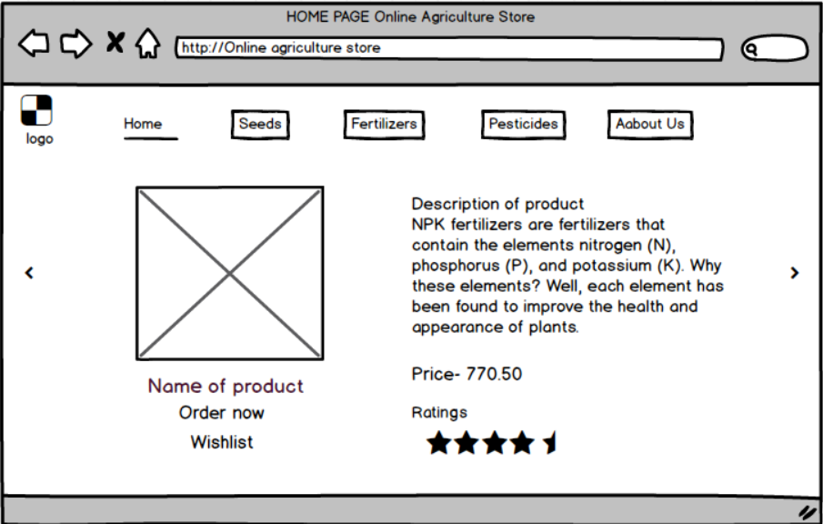
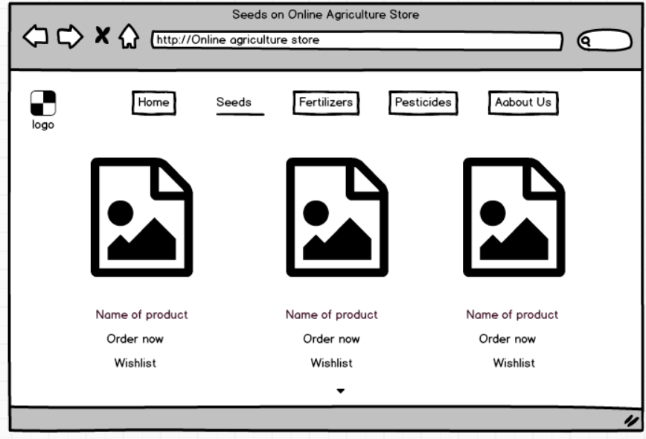
- List of products

- My Orders Page
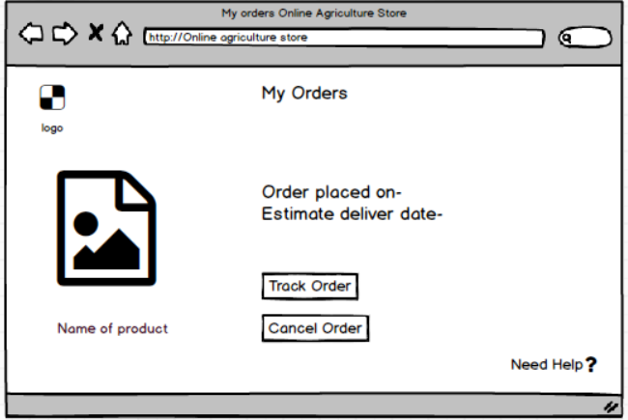

- Registration page
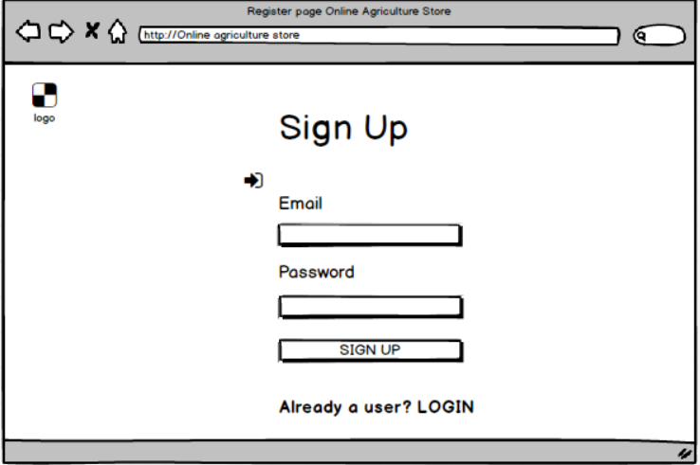

- My Order History
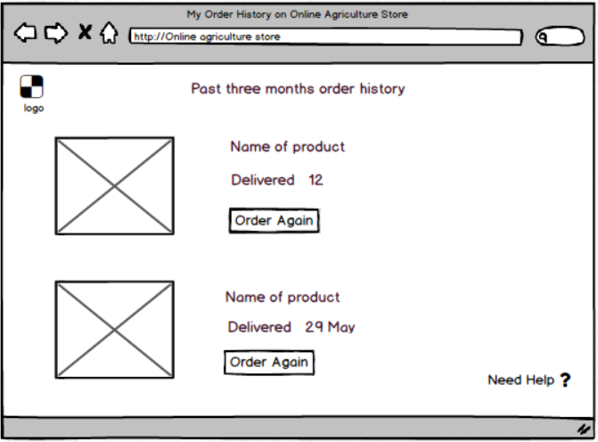

Question 3 – Tools (Visio, Balsamiq)
1. Balsamiq
Balsamiq is a low-fidelity wireframing tool that helps quickly sketch UI layouts.
It provides a drag-and-drop interface with ready-made components like buttons, fields, and containers.
It’s intentionally “rough” in look to encourage fast feedback and iteration.
Great for early-stage ideation, user journey mapping, and stakeholder discussions.
It emphasizes structure over style, keeping focus on functionality rather than visuals.
Allows for quick creation of clickable prototypes to simulate flow.
Easy export options to PDF or PNG for sharing.
Helps in mapping out navigation, UI components, and feature layout clearly.

2 Microsoft Visio
MS Visio is a diagramming tool used for creating flowcharts, ER diagrams, activity diagrams, and more.
Highly customizable with a rich library of shapes and templates.
Suitable for designing UML diagrams, process flows, and architecture visuals.
Integrates well with other Microsoft Office products for documentation.
Allows precise alignment and formatting for professional-looking charts.
Especially useful for system flows, RACI charts, and process design.
Supports real-time collaboration in Office 365 versions.
Can be used for creating BPMN, DFDs, network diagrams, and more.
Offers export to PDF, PNG, or Visio-native formats.
Widely used by BAs, Architects, PMs, and DevOps teams.

Question 4 – RTM –

Req ID | Req Name | Req Description | Design | D1 | T1 | T2 | T3 | T4 | UAT
FR0001 | Farmer Registration | Farmers should be able to register with the application | D1 | Done | Done | Done |  |  | Done
FR0002 | Farmer Search for Products | Farmers should be able to search for available products in fertilizers, seeds, pesticides | D2 | Done | Done | Done | Done |  | Done
FR0003 | Order Cancellation | Farmers should be able to cancel order. | D3 | Done | Done |  | Done |  | Done
FR0004 | Farmers add product to wishlist | Farmers should be able to add the products to wishlist | D4 | Done | Done |  |  | Done | Done
FR0005 | Multiple payment options | Farmers will have multiple payment options. | D5 | Done | Done |  |  | Done | Done
FR0006 | New user registration | New user can create account by email id and password | D1 | Done |  | Done | Done |  | Done
FR0007 | Farmers track order | Farmers should be able to track the order | D3 | Done | Done | Done | Done |  | Done
FR0008 | Product Filtering | Products should be listed based on reviews and ratings | D6 | Done |  | Done |  |  | Done
FR0009 | New user registration | New user can create account by email id and password | D1 | Done |  | Done |  | Done | Done
FR0010 | Search option | Implementation of search bar to allow farmers to find product | D7 | Done | Done |  |  |  | Done
FR0011 | Email and SMS | The system should send email/SMS notifications to farmers about order confirmations, delivery updates, offers, and payment status. | D8 | Done | Done |  | Done | Done | Done
FR0012 | Order history view | Allow users to view their order history | D6 | Done |  |  |  |  | Done
FR0013 | Return and refund policy | Farmers should be able to return product and get refund | D6 | Done | Done | Done |  | Done | Done
FR0014 | Order Cancellation | Farmers should be able to cancel order. | D3 | Done |  | Done | Done |  | Done
FR0015 | Reviews and ratings | User should be able to rate and review the product | D6 | Done | Done |  |  | Done | Done
Question 5 – 10 Test Case Documents
- Products search
Test Case id | PQ786TS001 | Test case name | Search Query
Project Id | PQ786 | Project Name | Online Agriculture Store
PM Id | 4869 | PM Name | Mr Vandanam
Test Strategy Id | PQ786TS001 | Tester Id
Test Plan Id | PQ786TS002 | Tester Name
Test Schedule Id | PQ786TS003 | Date of Test
Scenario:
Verify that the user can search products by entering keywords in the search bar
 | Set 1 | Set 2 | Set 3 | Set 4 | Set 5
Input Data | Fertilizer for groundnut crop | Tomato F1 seeds  Organic | ROGOR INSECTICIDE  Spray form | Okra or Lady Finger  Hybrid seeds | Vermicompost  Plant fertilizers
Expected Behavior | List of different products should appear | Show organic tomato seeds | Show the product and its details | List of Different lady finger hybrid seeds | Show the exact same product
Actual Behavior
Comments
Result Pass/Fail

- Register using email ID and password.
Test Case id | PQ786TS002 | Test case name | Search Query
Project Id | PQ786 | Project Name | Online Agriculture Store
PM Id | 4869 | PM Name | Mr. Vandanam
Test Strategy Id | PQ786TS001 | Tester Id
Test Plan Id | PQ786TS002 | Tester Name
Test Schedule Id | PQ786TS003 | Date of Test
Scenario:
Verify that a new farmer can successfully register using email ID and password.
 | Set 1 | Set 2 | Set 3 | Set 4 | Set 5
Input Data | Enter wrong id  Correct password | Enter correct Id and correct password | Enter wrong id and wrong password | Keep the id box empty  enter the password | Keep Password box empty and enter id
Expected Behaviour | Pop up message showing “Wrong id” | Pop up showing “login successful” | Pop up showing “verify your id & password” | Pop up showing “Enter the id” | Pop up showing “Enter the password”
Actual Behaviour
Comments
Result Pass/Fail
- Verify that logged-in farmers can add a product to the wishlist
Test Case id | PQ786TS003 | Test case name | Search Query
Project Id | PQ786 | Project Name | Online Agriculture Store
PM Id | 4869 | PM Name | Mr. Vandanam
Test Strategy Id | PQ786TS001 | Tester Id
Test Plan Id | PQ786TS002 | Tester Name
Test Schedule Id | PQ786TS003 | Date of Test
- Scenario:
Verify that logged-in farmers can add a product to the wishlist

 | Set 1 | Set 2 | Set 3 | Set 4 | Set 5
Input Data | Search for product and add it to wishlist
Expected Behaviour | Pop showing “Added to wiahlist”
Actual Behaviour
Comments
Result Pass/Fail

- Validate that a farmer can add products to cart and complete checkout
Test Case id | PQ786TS004 | Test case name | Search Query
Project Id | PQ786 | Project Name | Online Agriculture Store
PM Id | 4869 | PM Name | Mr. Vandanam
Test Strategy Id | PQ786TS001 | Tester Id
Test Plan Id | PQ786TS002 | Tester Name
Test Schedule Id | PQ786TS003 | Date of Test
Scenario:
Validate that a farmer can add products to cart and complete checkout

 | Set 1 | Set 2 | Set 3 | Set 4 | Set 5
Input Data | Search for fertilizer  Organic  Tomato | Search for Capsicum farming seeds  Hybrid seeds | Search product  Add product to cart | Add address  and checkout delivery date | Select payment mode
Expected Behaviour | System displays a list of matching products | System displays a list of matching products | System adds the product in cart | System shows “Your order has been placed successfully” | Multiple Payment methods are displayed on screen
Actual Behaviour
Comments
Result Pass/Fail

- Verify that all payment methods (COD, UPI, Card) are available and functional.
Test Case id | PQ786TS005 | Test case name | Search Query
Project Id | PQ786 | Project Name | Online Agriculture Store
PM Id | 4869 | PM Name | Mr. Vandanam
Test Strategy Id | PQ786TS001 | Tester Id
Test Plan Id | PQ786TS002 | Tester Name
Test Schedule Id | PQ786TS003 | Date of Test
Scenario:
Verify that all payment methods (COD, UPI, Card) are available and functional.

 | Set 1 | Set 2 | Set 3 | Set 4 | Set 5
Input Data | Add product to cart and select payment method as COD | Add product to cart and select payment method as UPI | Add product to cart and select payment method as Card
Expected Behaviour | order is placed successfully and a confirmation message is displayed. User is informed that payment will be made at delivery. | Product is added to cart on selecting UPI, the user is redirected to UPI payment gateway, completes transaction, and sees a successful payment confirmation | Product is added to cart; on selecting Card, user enters card details securely, payment is processed, and a success message is shown with order confirmation.
Actual Behaviour
Comments
Result Pass/Fail

- Ensure that a farmer can view the delivery status after placing an order.
Test Case id | PQ786TS006 | Test case name | Search Query
Project Id | PQ786 | Project Name | Online Agriculture Store
PM Id | 4869 | PM Name | Mr. Vandanam
Test Strategy Id | PQ786TS001 | Tester Id
Test Plan Id | PQ786TS002 | Tester Name
Test Schedule Id | PQ786TS003 | Date of Test
Scenario:
Ensure that a farmer can view the delivery status after placing an order

 | Set 1 | Set 2 | Set 3 | Set 4 | Set 5
Input Data | Order placed successfully and delivery is pending dispatch | order has been shipped | Order is out for delivery | Order is delivered | Order was cancelled or returned
Expected Behaviour | The system displays: “Order placed. Awaiting dispatch.” | The system shows: “Shipped – Your order is on the way” | The system updates status: “Out for Delivery – Expected by 12/5/25” | The user sees: “Delivered – Your order was delivered on 5/5/25 | The system displays: “Cancelled – No delivery. Refund initiated.” or “Returned Refund in process.”
Actual Behaviour
Comments
Result Pass/Fail

- Validate that the user can cancel an order before it is dispatched

Test Case id | PQ786TS007 | Test case name | Search Query
Project Id | PQ786 | Project Name | Online Agriculture Store
PM Id | 4869 | PM Name | Mr. Vandanam
Test Strategy Id | PQ786TS001 | Tester Id
Test Plan Id | PQ786TS002 | Tester Name
Test Schedule Id | PQ786TS003 | Date of Test
Scenario:
Validate that the user can cancel an order before it is dispatched

 | Set 1 | Set 2 | Set 3 | Set 4 | Set 5
Input Data | Order placed, status = ‘Pending dispatch’, user clicks Cancel Order | Order placed 2 mins ago, still in ‘Processing’ stage, user clicks Cancel | User tries to cancel an order that is already shipped | Order has multiple items, 1 item is still pending, user cancels entire order | User clicks cancel, system requests confirmation, user confirms
Expected Behaviour | Order is successfully cancelled; user sees: “Order cancelled successfully. Refund will be processed” | Order is cancelled and removed from active orders list. | System displays: “Cancellation not allowed. Order already shipped.” | System cancels entire order and confirms cancellation. | Order is cancelled after confirmation; status updates to Cancelled.
Actual Behaviour
Comments
Result Pass/Fail

- Check if confirmation emails and SMS are sent after order placement
Test Case id | PQ786TS008 | Test case name | Search Query
Project Id | PQ786 | Project Name | Online Agriculture Store
PM Id | 4869 | PM Name | Mr. Vandanam
Test Strategy Id | PQ786TS001 | Tester Id
Test Plan Id | PQ786TS002 | Tester Name
Test Schedule Id | PQ786TS003 | Date of Test
Scenario:
Check if confirmation emails and SMS are sent after order placement

 | Set 1 | Set 2 | Set 3 | Set 4 | Set 5
Input Data | Valid order placed with registered email and phone number | Order placed using UPI payment method |  | Invalid or missing phone number in user profile | Order placed, but email server is temporarily down
  Order placed with multiple items
Expected Behaviour | Email and SMS confirmation sent with Order ID, product details, and estimated delivery date. | Email and SMS sent confirming successful payment and order placement. | Email and SMS list all items ordered and total price in one message each. | Only email confirmation is sent | SMS confirmation is sent; email queued and retried until successfully delivered.
Actual Behaviour
Comments
Result Pass/Fail

- Verify that users can see their past orders listed with correct details.
Test Case id | PQ786TS009 | Test case name | Search Query
Project Id | PQ786 | Project Name | Online Agriculture Store
PM Id | 4869 | PM Name | Mr. Vandanam
Test Strategy Id | PQ786TS001 | Tester Id
Test Plan Id | PQ786TS002 | Tester Name
Test Schedule Id | PQ786TS003 | Date of Test
Scenario:
Verify that users can see their past orders listed with correct details.

 | Set 1 | Set 2 | Set 3 | Set 4 | Set 5
Input Data | User logs into account with past orders placed | User placed an order 6 months ago | User placed an order with multiple items in one transaction | User placed a cancelled or returned order | New user with no previous orders logs in
Expected Behaviour | Order history page displays a list of past orders with product names, dates, prices, and statues | System displays even older orders with complete details unless auto-deletion/archive policy is applied. | All products in that order appear under a single order ID with correct item breakdown | Cancelled/returned orders are shown with appropriate status tags like "Cancelled", "Returned", "Refunded". | Order history page displays message like "No past orders found" with a link to start shopping.
Actual Behaviour
Comments
Result Pass/Fail

- Verify that the user can initiate a return and get a refund
Test Case id | PQ786TS010 | Test case name | Search Query
Project Id | PQ786 | Project Name | Online Agriculture Store
PM Id | 4869 | PM Name | Mr. Vandanam
Test Strategy Id | PQ786TS001 | Tester Id
Test Plan Id | PQ786TS002 | Tester Name
Test Schedule Id | PQ786TS003 | Date of Test
Scenario:
Verify that the user can initiate a return and get a refund

 | Set 1 | Set 2 | Set 3 | Set 4 | Set 5
Input Data | User selects a delivered product within the return window (e.g., 7 days) | User tries to return a product after the return period has expired | User selects wrong item delivered and uploads photo as proof | User selects "Product defective" as reason and requests refund to UPI | User attempts to return an already returned item
Expected Behaviour | System allows return request to be initiated and confirms via email/SMS. Refund process begins | System shows an error message like "Return period expired. Cannot initiate return” | System accepts return request and marks reason as "Wrong item delivered" with verification steps | System accepts return, asks for UPI ID, and initiates refund. Confirmation message shown | System blocks the return and shows message "Item already returned – return not allowed again"
Actual Behaviour
Comments
Result Pass/Fail

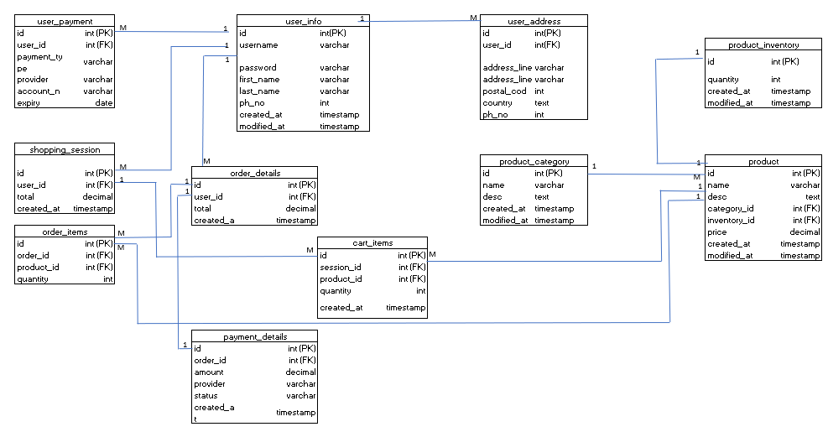
Question 6 – DB Design –

Question 7 – Data Flow Diagram

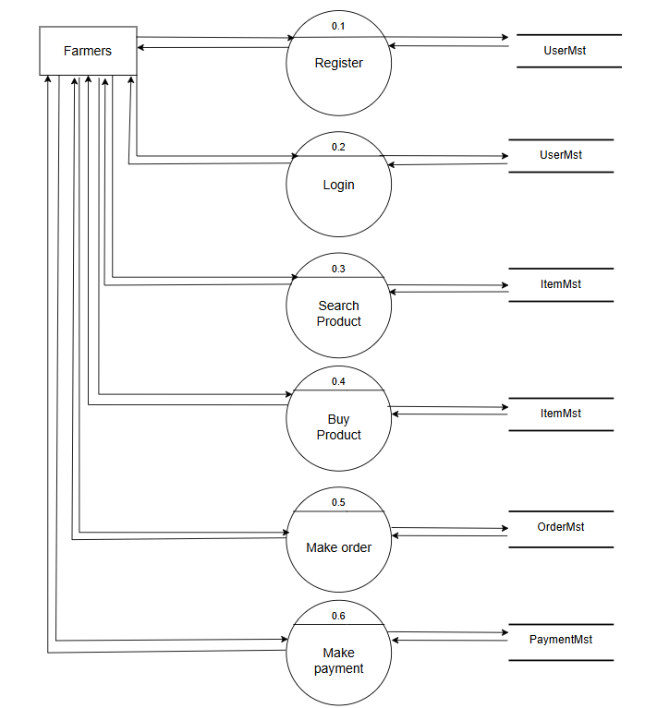

Question 8 – Change Request
Understand the scope of change
Discuss with stakeholders and product owners, tax consultants to clearly understand what exactly needs to change.
Refer to the original Business Requirements Document (BRD) and Scope Statement. If it's within the agreed scope proceed. If out-of-scope initiate formal Change Request (CR) documentation.
Perform analysis – Impact analysis, Effort Estimation and Feasibility study.
Present the changes which are to be done to Stakeholders.
Once change request is approved the Update all impacted documents: SRS, RTM, Test Cases, Diagrams, Inform all stakeholders BA, Dev, QA, UI/UX, PM and Implement the change through the standard development life cycle.

Question 9 – Change Request Vs an Enhancement –
Yes, this is an enhancement, not a change to existing functionality. It adds new capabilities and user roles, so it needs to go through formal impact analysis and approval before integration.
Action plan as BA-
Document the enhancement request
Conduct the feasibility study and Impact analysis again
Effort estimation and cost analysis
Update the documents
Present the enhancement to Change control board or Stakeholders

Question 10 – Estimations -
As per the case study, the duration of project is 18 months and the current team size is around 15 members. This project will come under medium project.
As the trained resources are available, trainers are not required.
As the structure of the project is available, New and enhanced infrastructure not requires so for medium project upto 1000 Hours are required.

Question 11 – UAT
In UAT process Planning is first step. Blue prints are made to implement UAT testing for every feature that needs to test and minimum standards for accepting the test.
Next step is designing. Here the test cases are designed to hide all the possibilities of software packages in real world environment.
UAT Testers- Testing team consists of end users that meet the criteria for implementing testing. The end users must have expertise in subject matters
Bug fixing- If the bugs are found in UAT the development team should fix it and try to make error free software.
Sign Off- After bug fixing the testing team indicated acceptance of the completion of the bug. In this phase, all the stakeholders come to a conclusion that the software if ready to GO LIVE and sign it off.

Question 12 – Project Closure Document –
Sr.No | Points to include | Details | Reference link
1 | Did the client signed off on the UAT Testing
 | Date of signoff:
 | Name of resource:
2 | Objectives of project
 | User friendliness | Achieved
 | Customer satisfaction | ROI in 6 months
 | More categories | Achieved
3 | Functionalities worked on
 | Secure payment processing | Achieved
 | Categories | Achieved
4 | Infrastructure
 | Software Installed | Achieved
 | Laptops purchased | Achieved
5 | Funding
 | Amount approved | 2 Crores
 | Amount used | 1.5 Crores
6 | Overall project Information
 | Escalations | 50
 | Customer satisfaction | High
7 | Value to the company
 | Positive/Negative | Positive 90%  -Company has gained over the competitors  -Trained Employees  -Entered in Agriculture Domain

